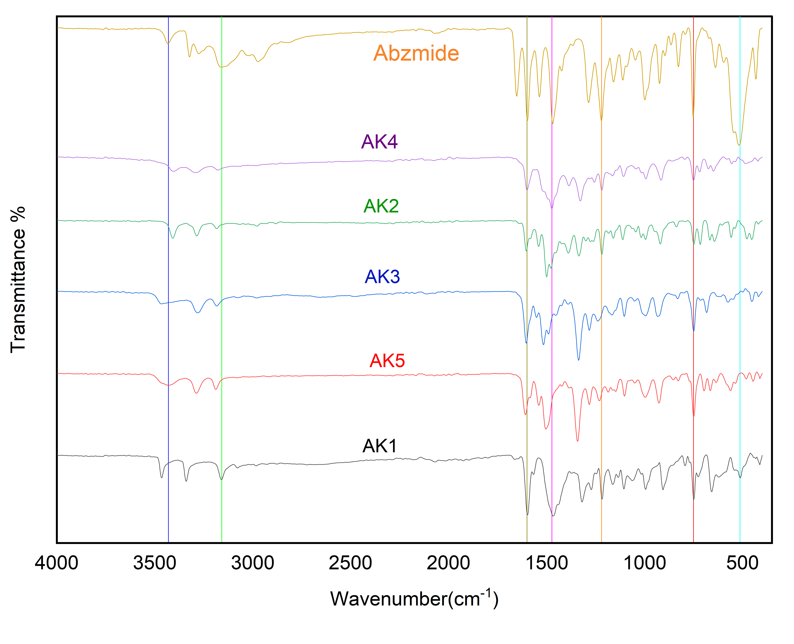
Figure S1 AK-M complexes FTIR spectra of Abzemide Ligand

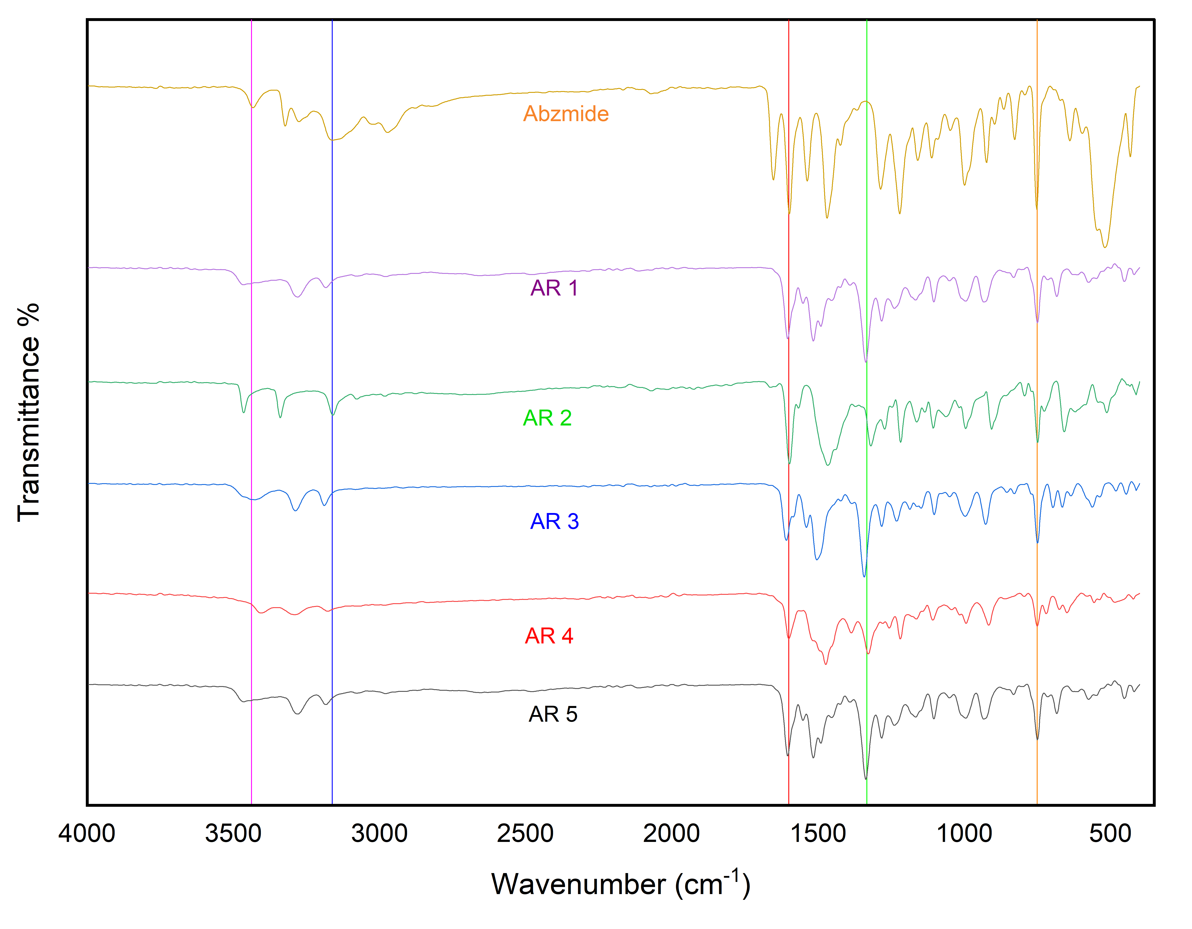

Figure S2 AR-M complexes FTIR spectra of Abzemide Ligand

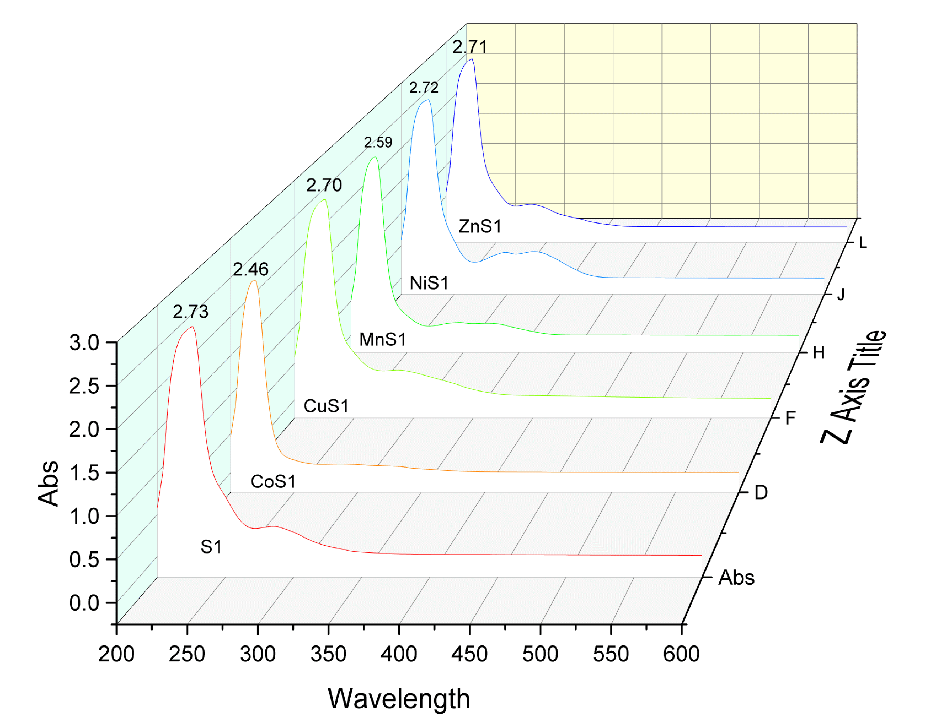
Figure S3 Uv-Vis spectra of 1:1 (AK-M) complexes

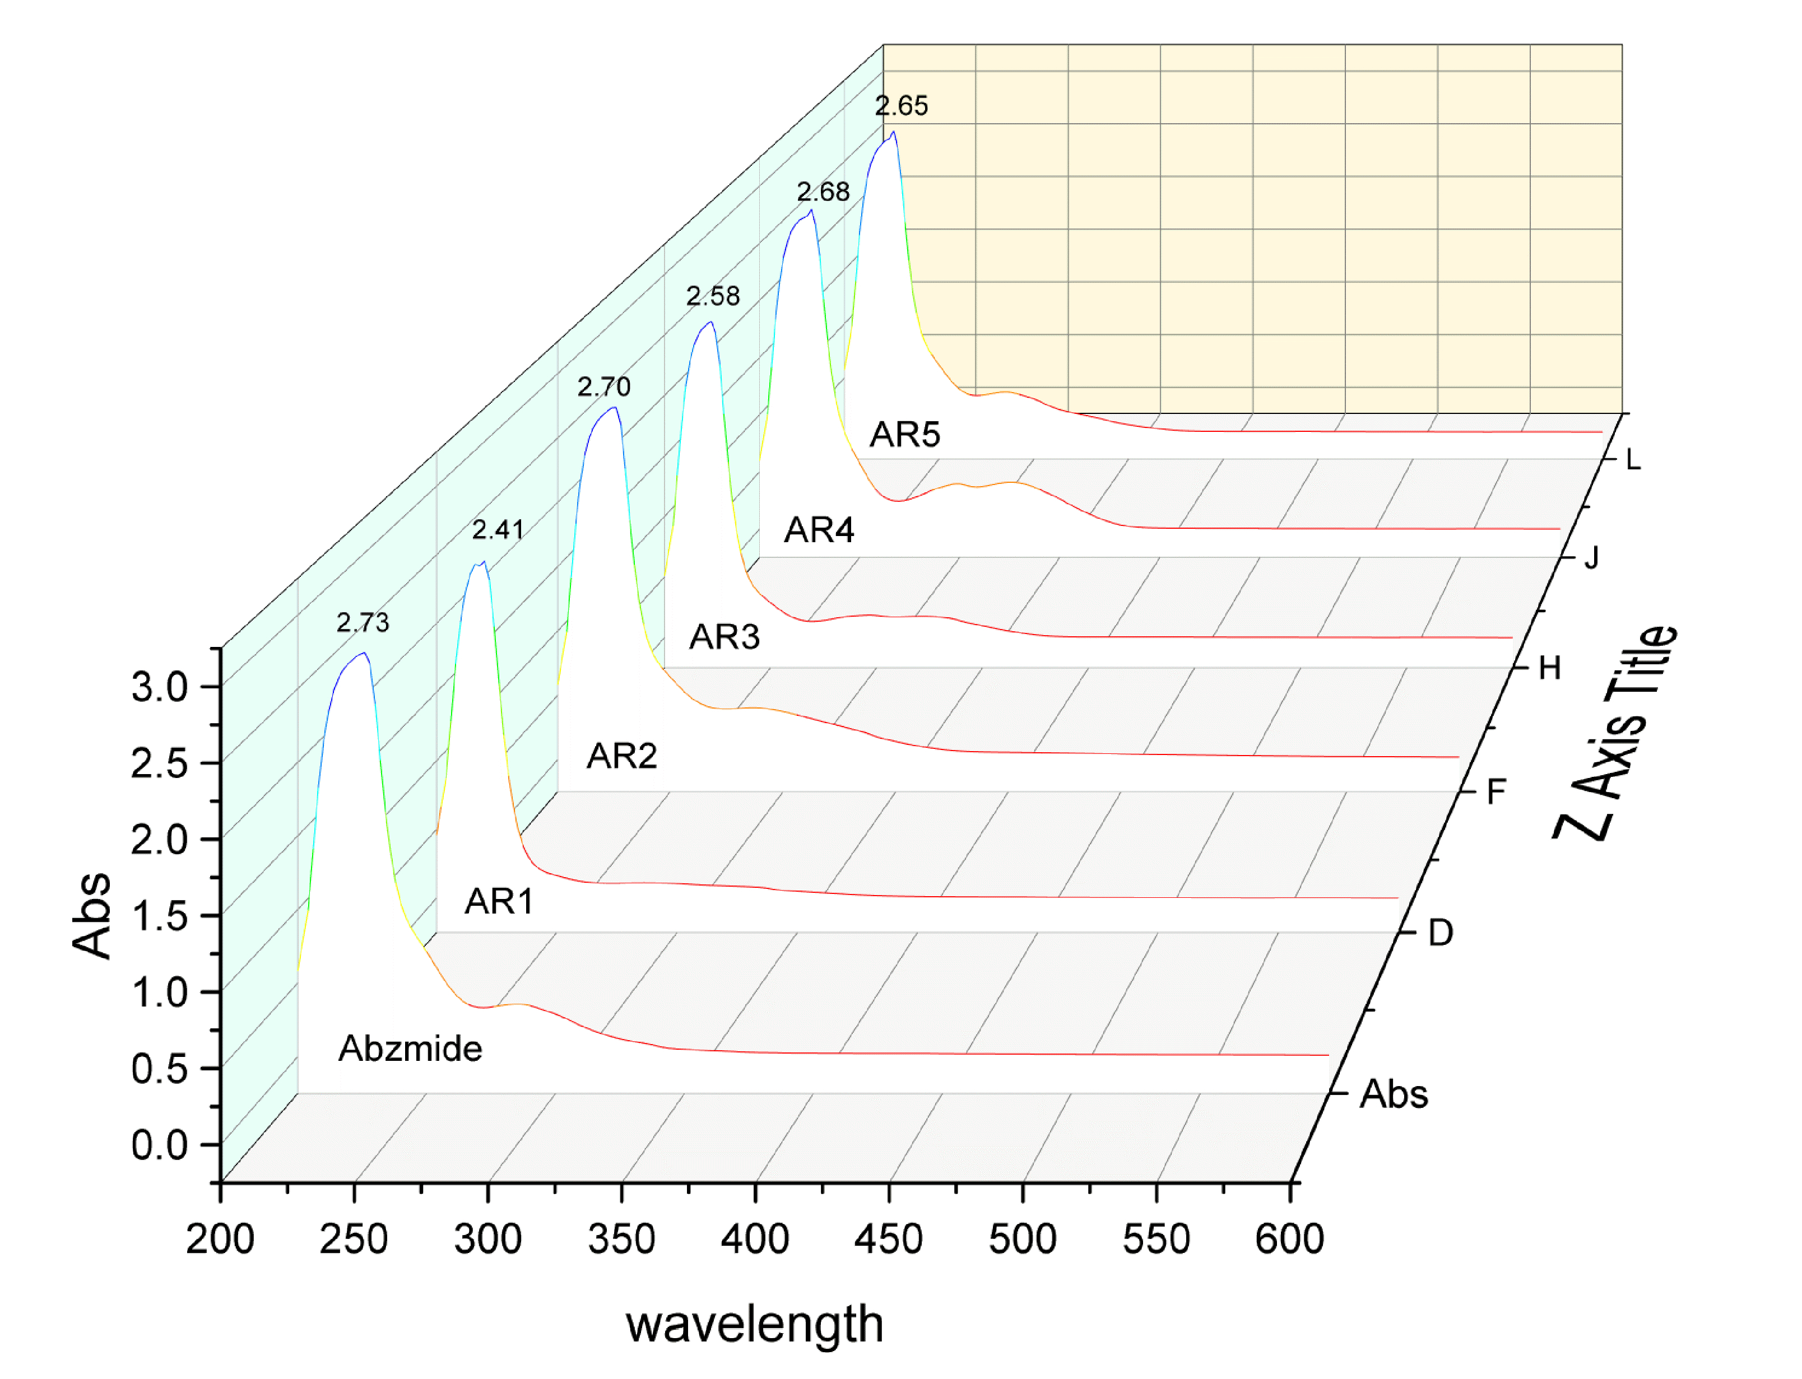

Figure S4 Uv-Vis spectra of 1:1 (AR-M) complexes

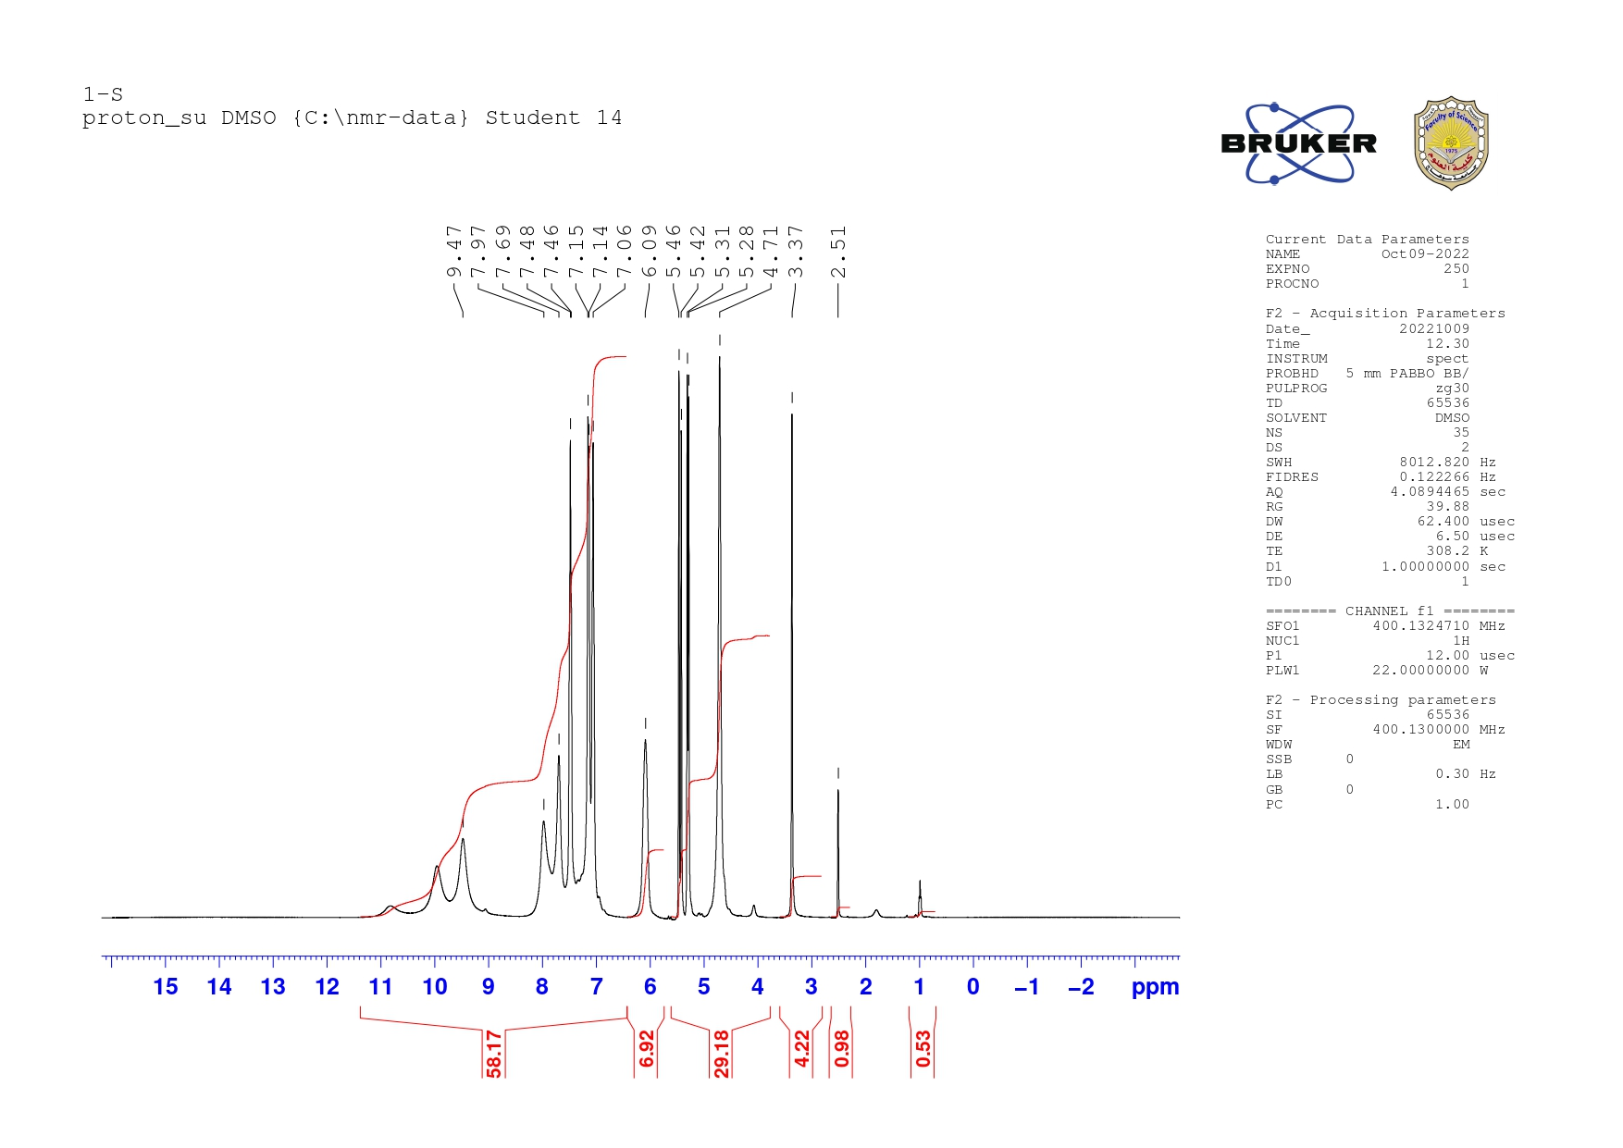
Figure S5 HNMR spectra of ligand Abzemide

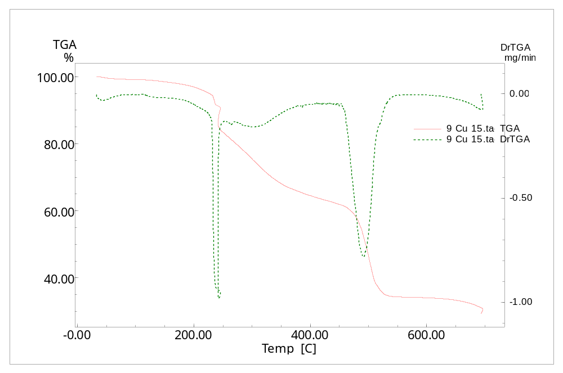
Figure S6 AK2 complex TGA

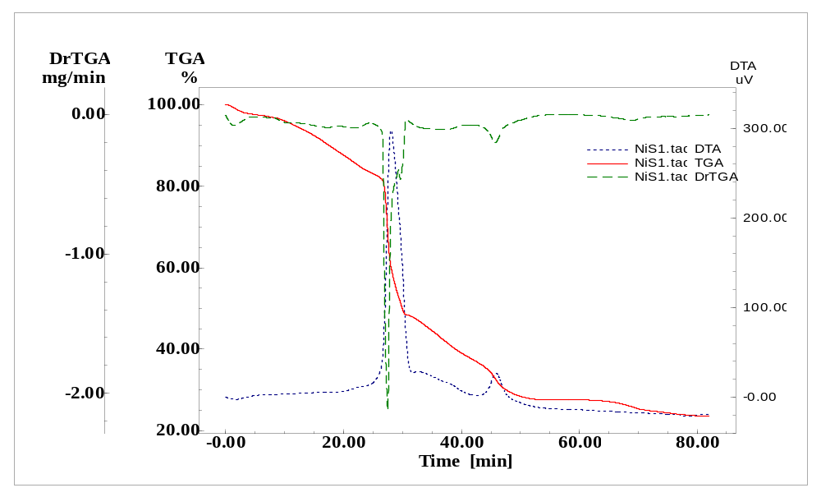
Figure S7 AK3 complex TGA

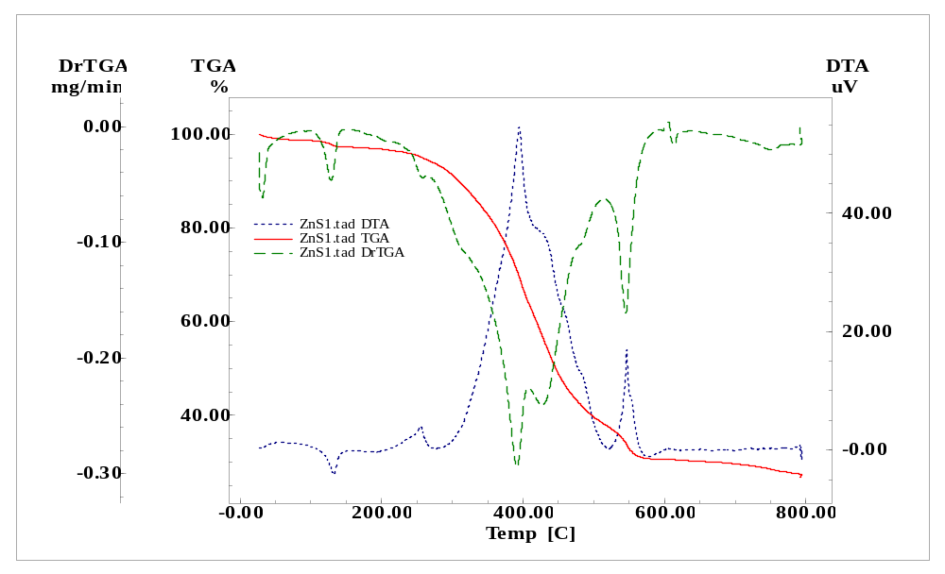
Figure S8 AK5 complex TGA
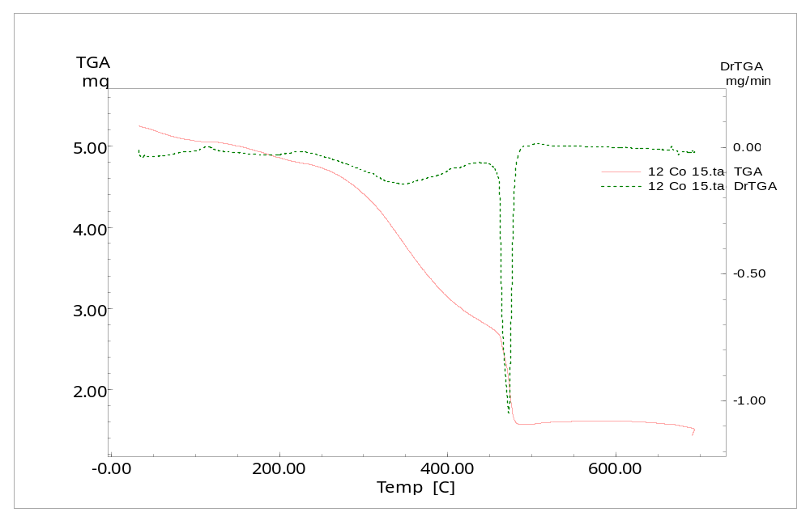
Figure S9 Ligand-Co complex TGA

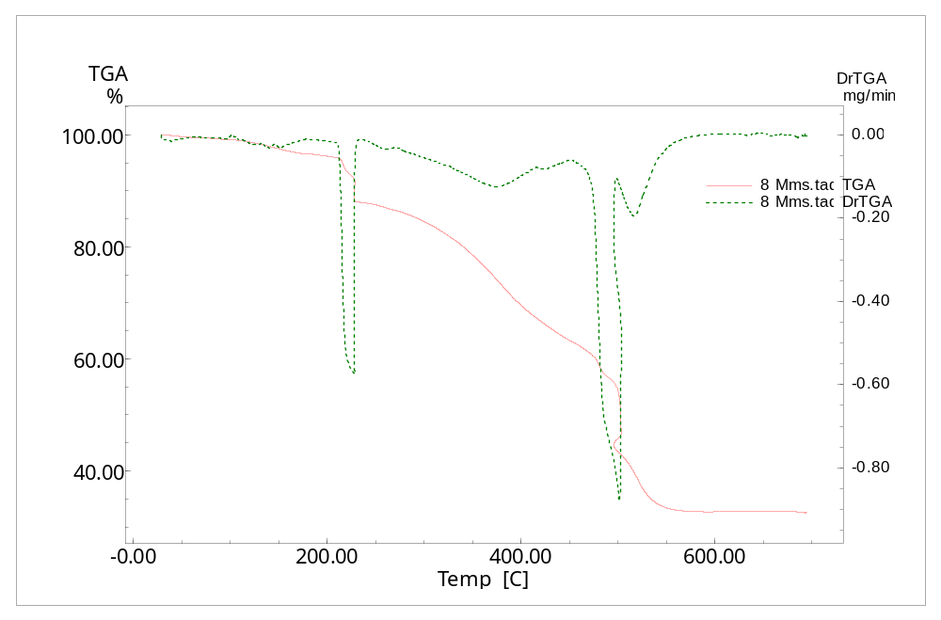
Figure S10 Ligand-Mn complex TGA
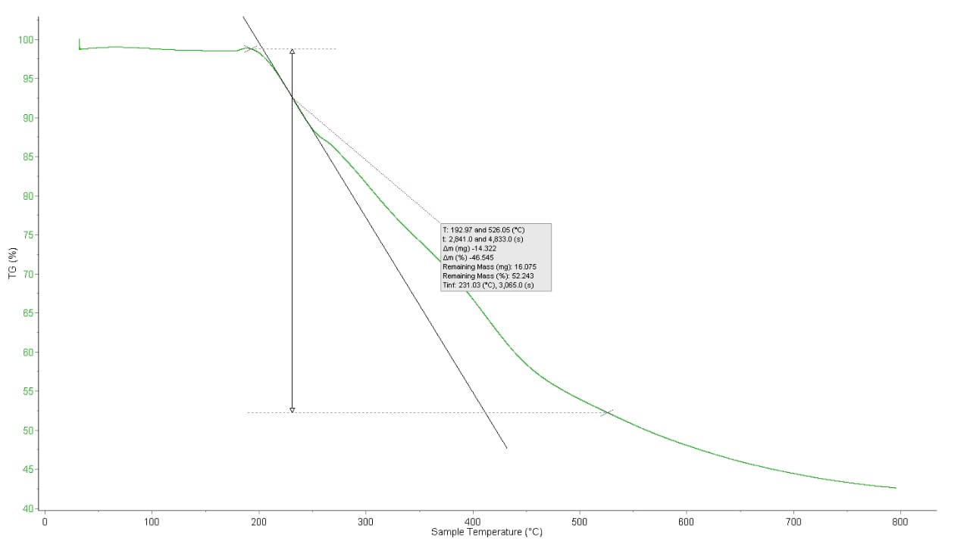
Figure S11 AR1 complex TGA

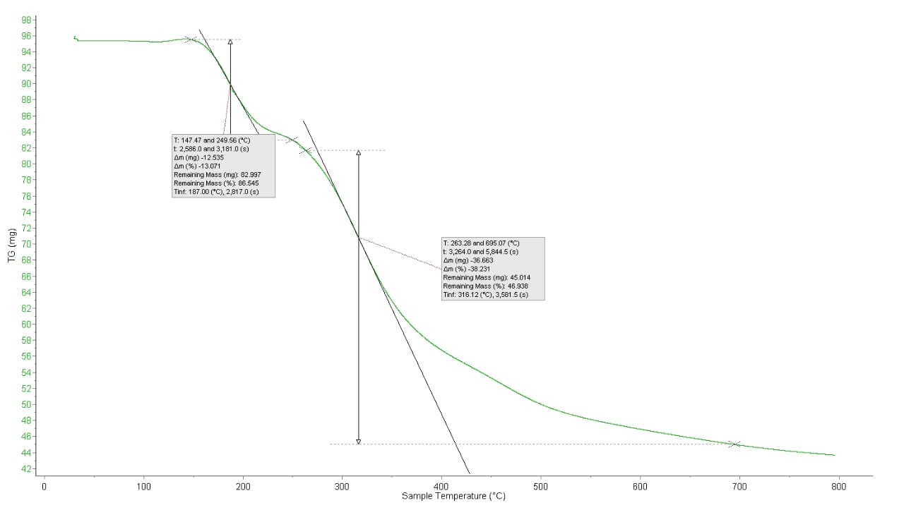
Figure S12 AR2 complex TGA

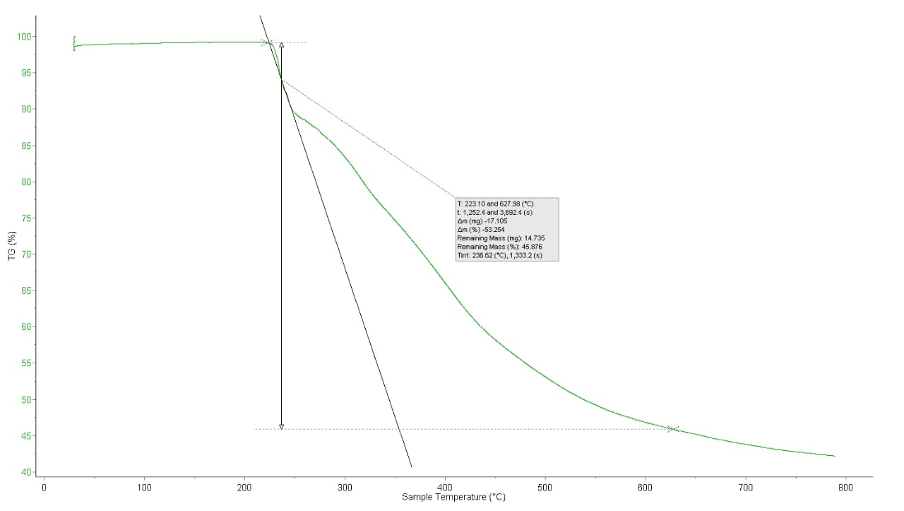

Figure S13 AR3 complex TGA

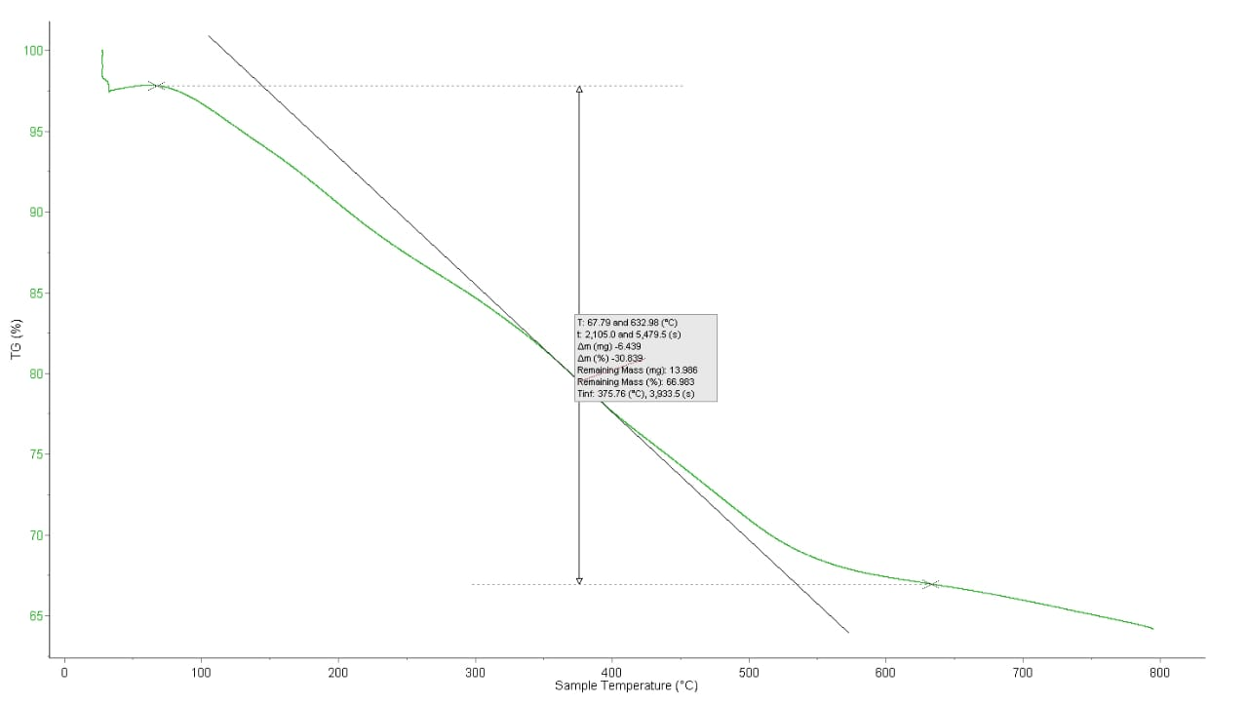

Figure S14 AR4 complex TGA

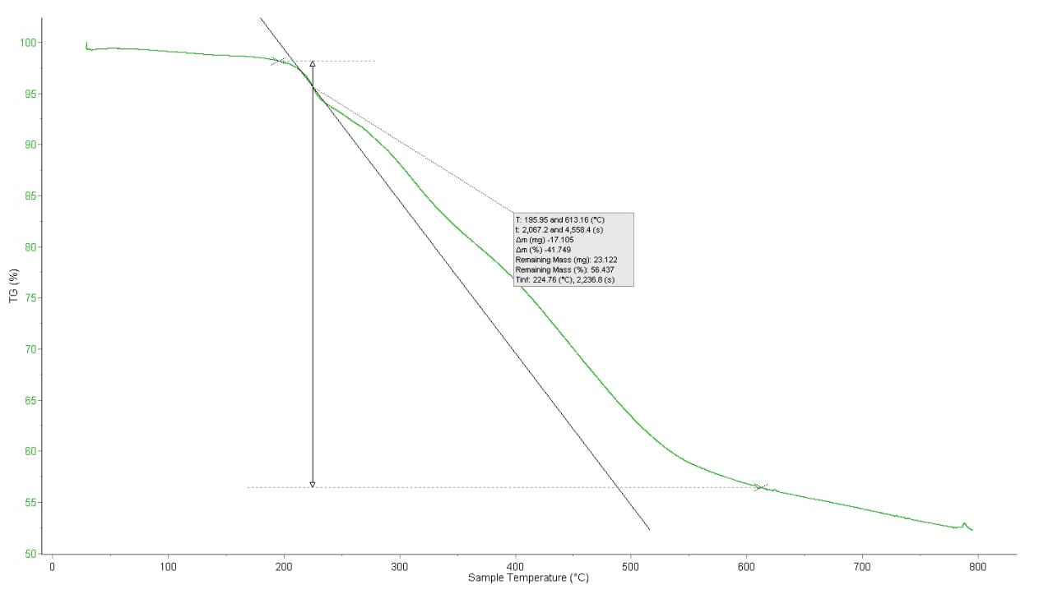

Figure S15 AR5 complex TGA

M05 | 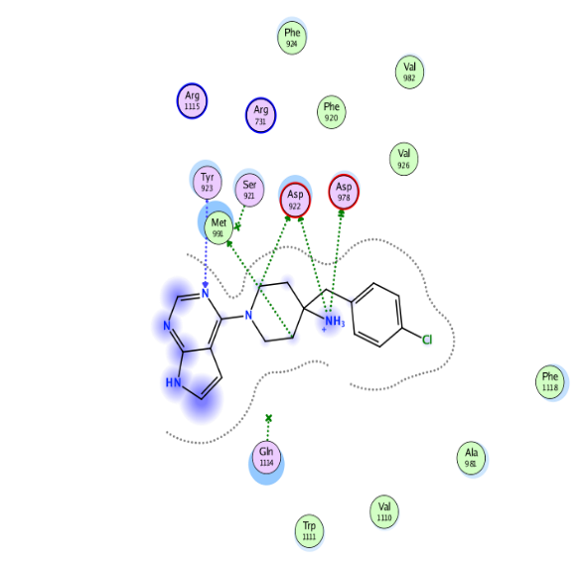  A | 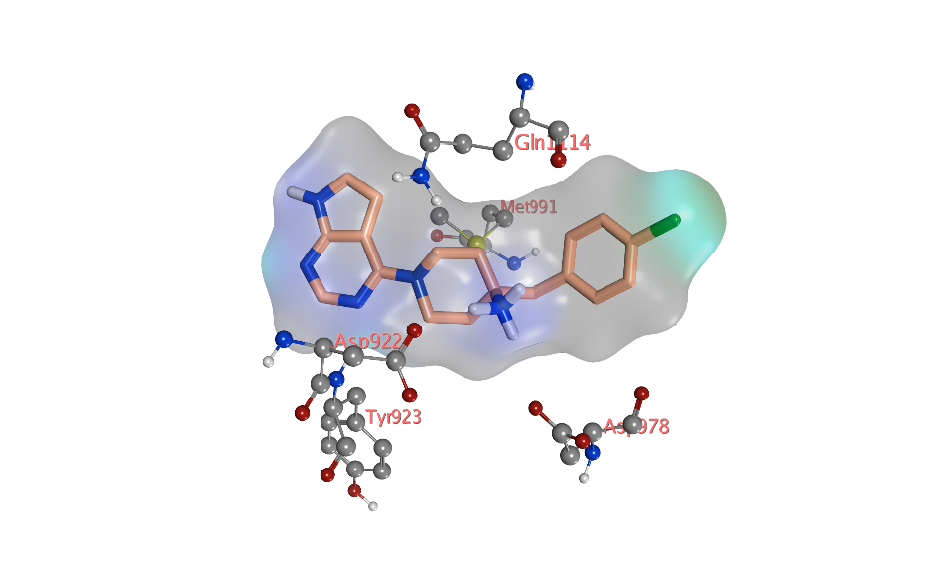  B
Ak4 | 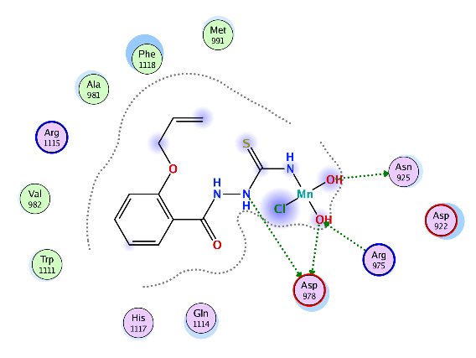  C | 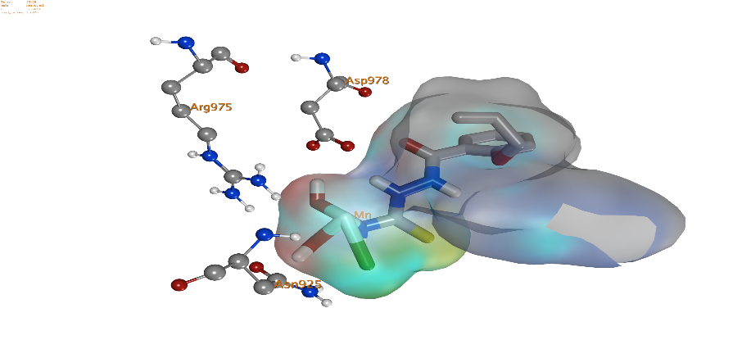  D
Ak5 | 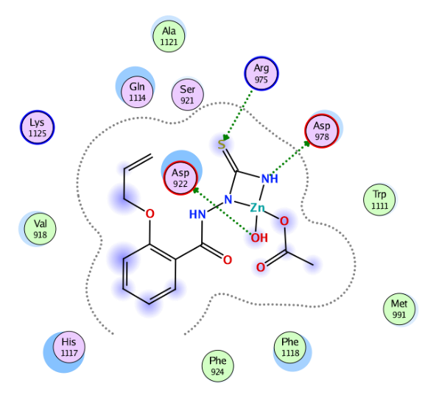  E | 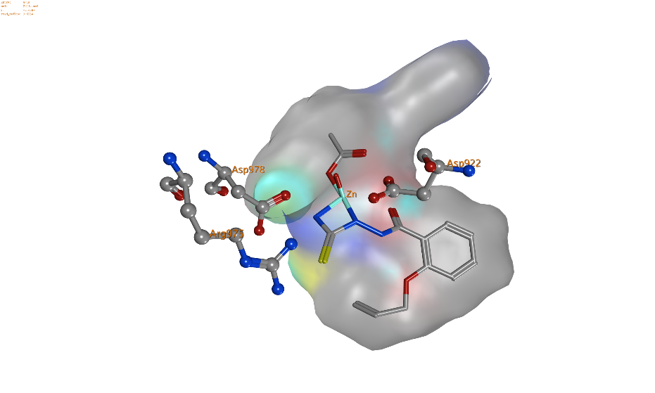  F
AR4 | 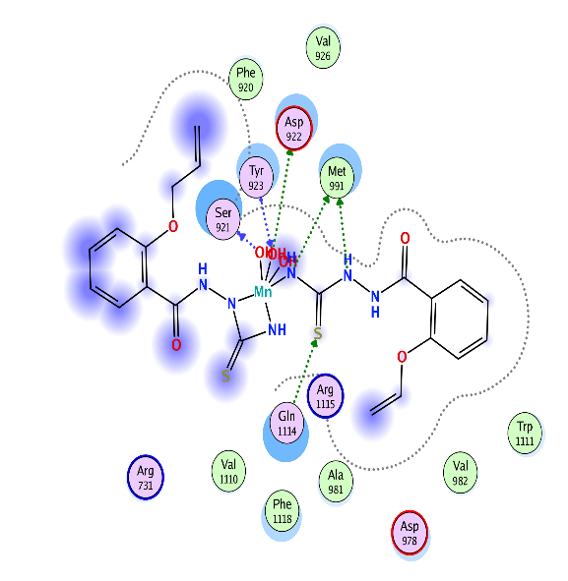  G | 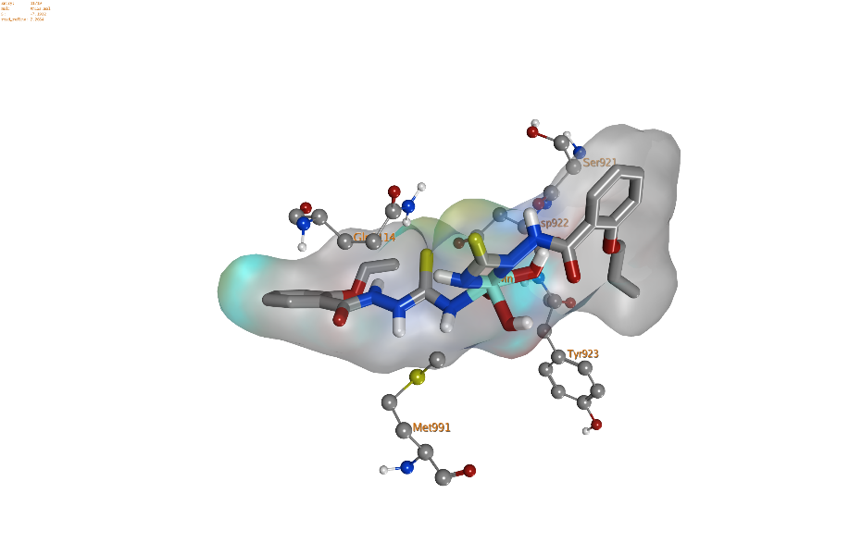  H
AR5 | 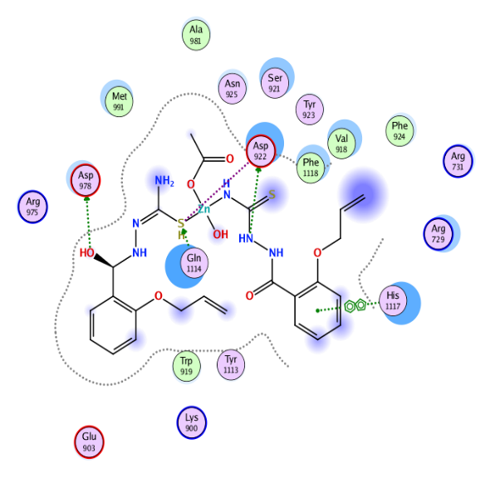  I | 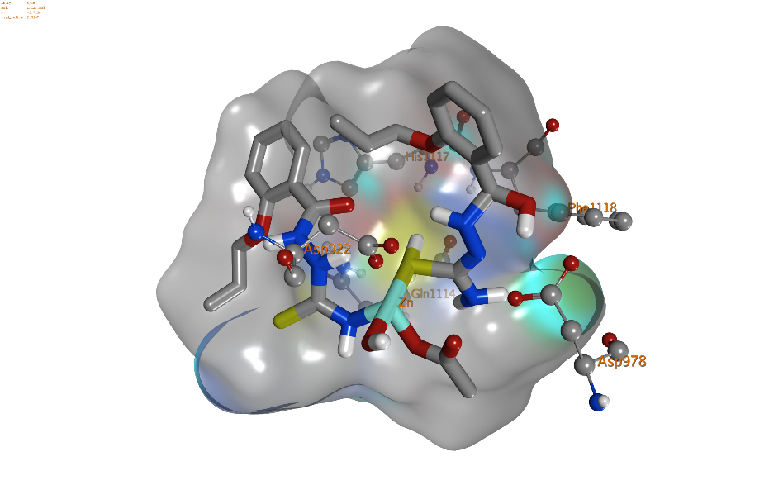  J

Figure S16 Molecular Docking Visualizations of Ligand-TRPM7 Complexes (PDB ID: 8W2L): Structural Binding Poses for AK and AR Series

Table S1: Docking Results of Ligands with TRPM7 Protein (PDB ID: 8W2L): Hydrogen Bond Interactions, Binding Poses, Scores, RMSD, and Interaction Profiles
Ligand | H.B Interaction with protein | Pose | Score | RMSD | Interaction
CoCrys M05  PDB 8W2L | ASP 922  ASP 978  Met 991  Try 923  Ser 921  Gln 1114 | 2 | -7.45 | 1.45 | 6-position ligand exposure  ASP 922, Met 991, ASP 978, 4 H.B as side chain acceptor,  Try 923, 1 H.B as backbone donor
Mn-L (1:1) | ASP 978 (2)  Arg 975  ASn925 | 1 | -7.7679 | 1.6275 | ASP 978, Asn 925, 3 H.B as side chain acceptor  Arg 975, 1 H.B as side chain donor
Mn-L (1:1) | LYS1125 (2)  GLU903  Arg 975  ASn925  Phe1118 | 2 | -6.6546 | 3.4646
Mn-L (1:1) | LYS1125  Arg 975  ASn925  ASP 978 | 4 | -6.0334 | 1.5489
Mn-L (1:1) | ASP 978  LYS1125 (2)  Arg 975 | 5 | -5.9292 | 1.6208
Mn-L (1:2) | ASP 922 (3)  Ser 921 (2)  Tyr 923 (2)  Val 926 (1) | 1 | -8.0330 | 2.8189
Mn-L (1:2) | ASP 922 (1)  Ser 921 (1)  Tyr 923 (1)  Met991 (2)  Gln1114(1) | 2 | -7.1912 | 2.2664 | ASP 922, Met 991, 3 H.B as side chain donor  Gln 1114, 1 H.B as side chain acceptor  Ser 921, 1 H.B as backbone acceptor  Try 923, 1 H.B as backbone donor  15- position ligand exposure
Mn-L (1:2) | ASP 922  Ser 921  Met 991 | 3 | -7.1447 | 2.7666
Mn-L (1:2) | ASP 922 (2)  Met 993 (1) | 4 | -6.8974 | 3.8856
Mn-L (1:2) | Ser 921 (1)  Tyr 923 (1)  Gln1114(2) | 5 | -6.7340 | 3.2256
Zn-L(1:1) | Asn 925  ASP 978 | 1 | -7.2616 | 1.3001
Zn-L(1:1) | Phe1118 | 2 | -6.5512 | 1.4466
Zn-L(1:1) | ASP 922  Met 991 | 3 | -5.8864 | 2.1892
Zn-L(1:1) | ASP 922  ASP 978  Arg 975 | 4 | -5.6587 | 1.6284 | Arg 975, 1 H.B as side chain donor ASP 978, ASP 922, 2 H.B as side chain acceptor
Zn-L(1:1) | ASP 922  Asn 925 | 5 | -5.5628 | 2.2419
Zn-L(1:2) | ASP 922 (2)  ASP 978  Gln 1114  Phe1118  His1117 | 1 | -9.7118 | 2.5187 | His 1117, 1 H.B as arene-arene interaction  ASP 978, 1 H.B as side chain acceptor  Gln 1114, 1 H.B as side chain donor  ASP 922, 2 H.B as side chain acceptor
Zn-L(1:2) | Arg 975  Asn 925  ASP 978 (2)  LYS1125 (2) | 2 | -7.3336 | 1.1888
Zn-L(1:2) | ASP 978  Asn 922  Ala 981 | 3 | -6.6728 | 2.2860

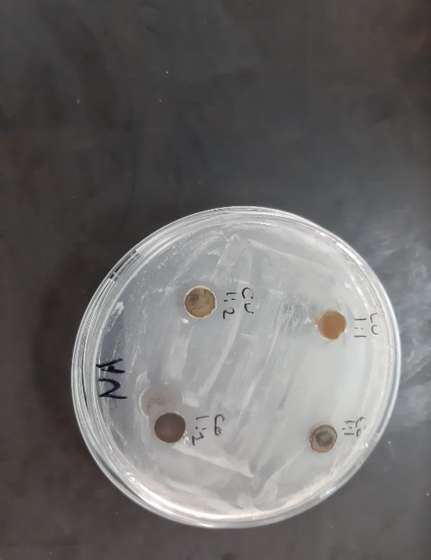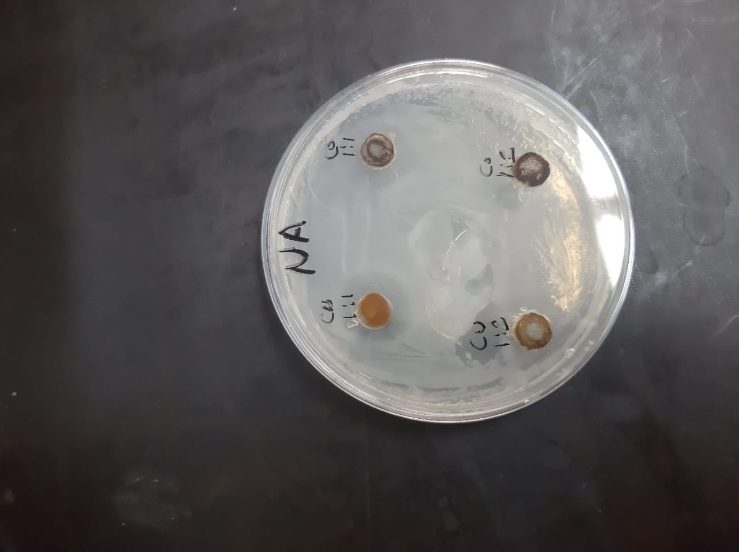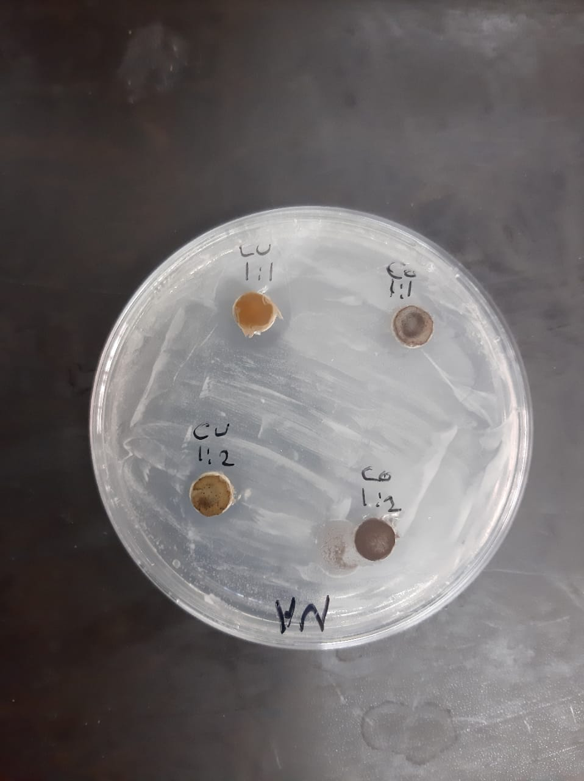
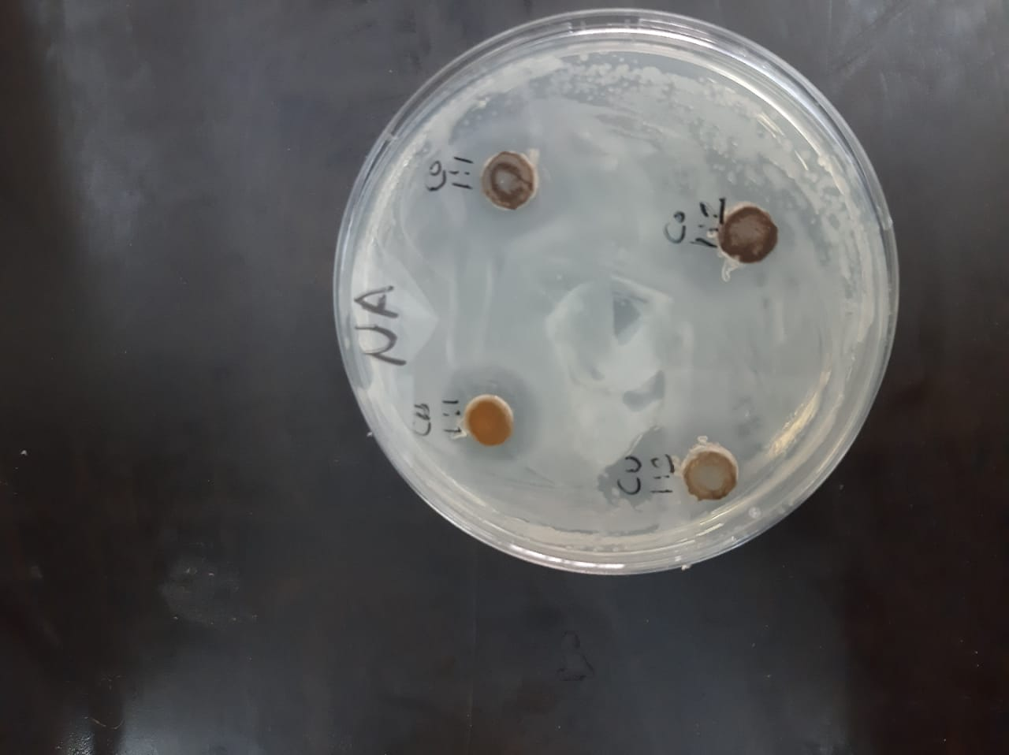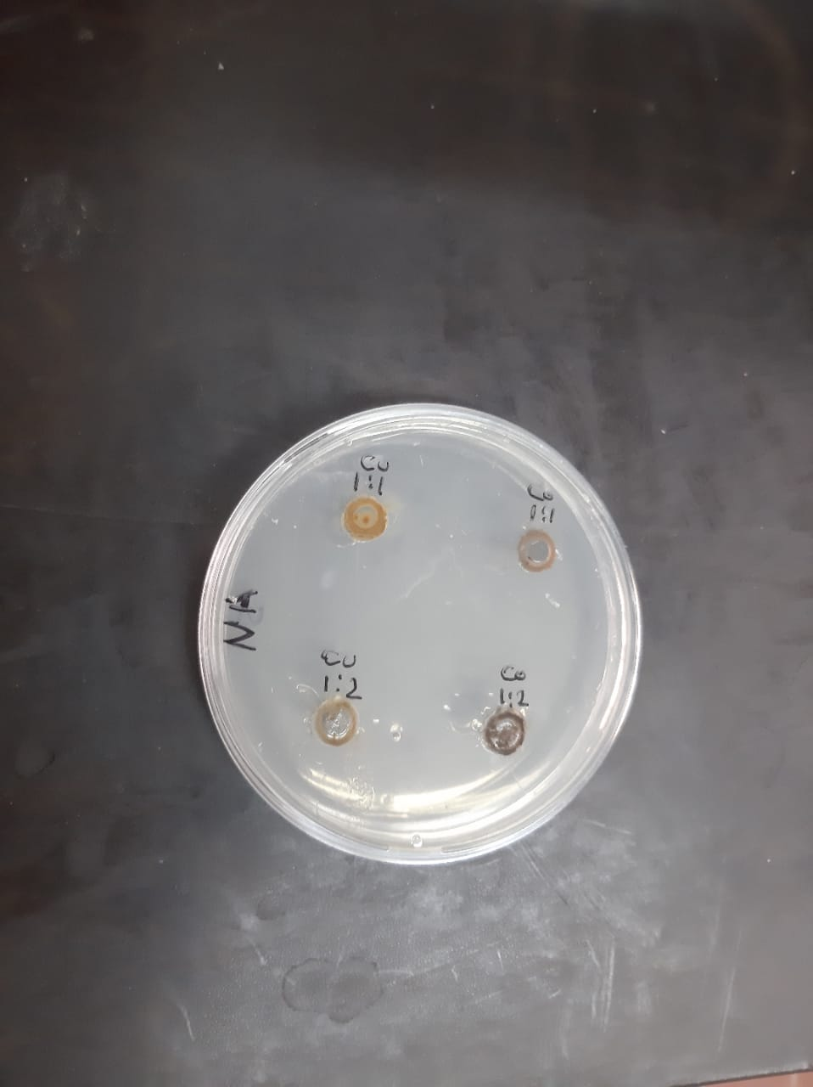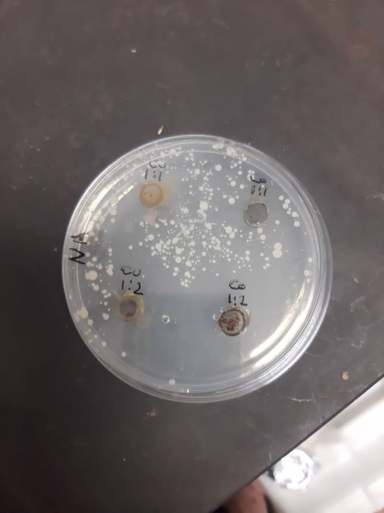

Photo S1: Representative photos present zones of inhibition due to the tested ligands and their complexes against tested microbes, arrows indicate the inhibition zones.

