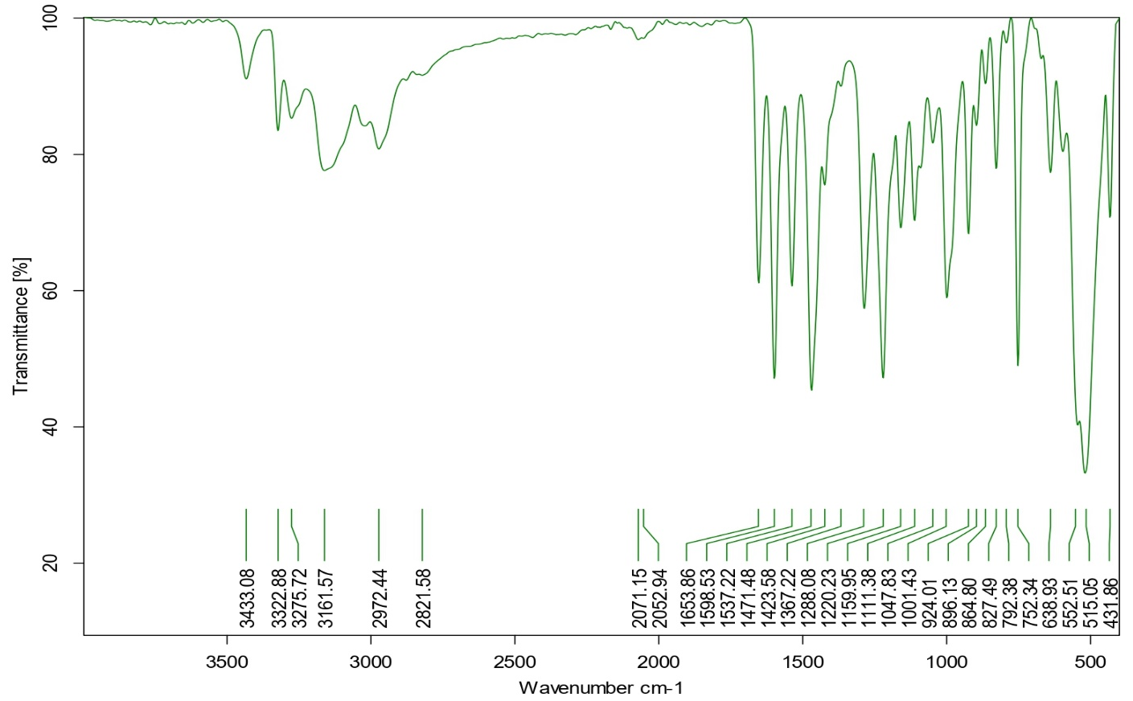
Figure S1 FTIR spectra of S1 Ligand

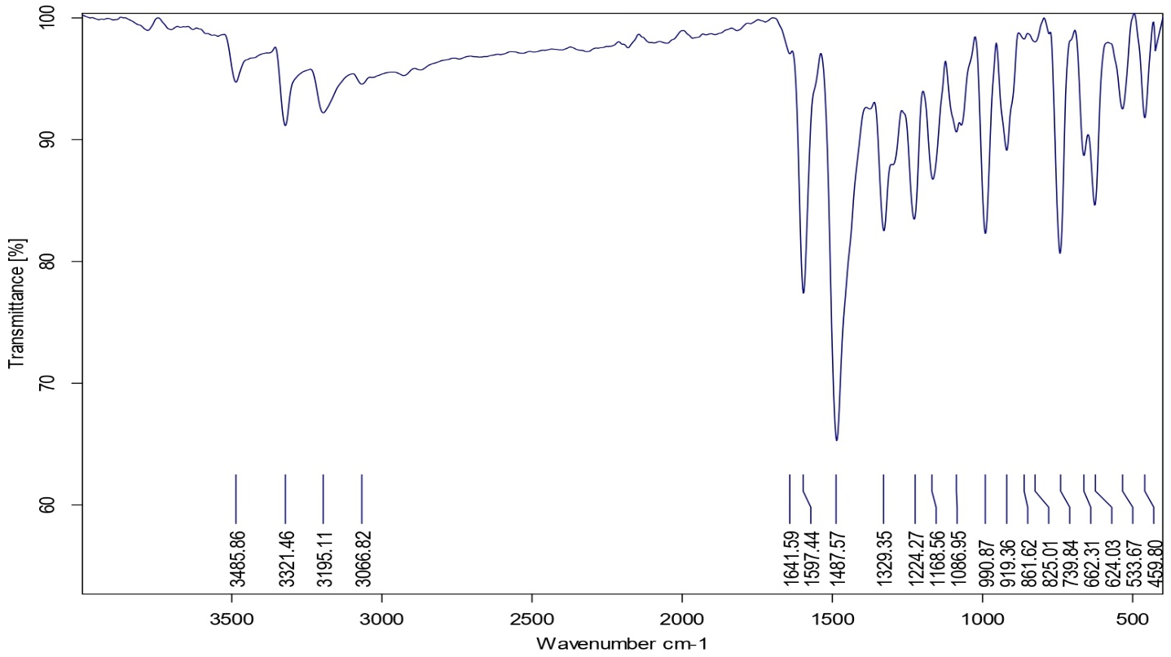
Figure S2 FTIR spectra of Co S1 complex 1:1
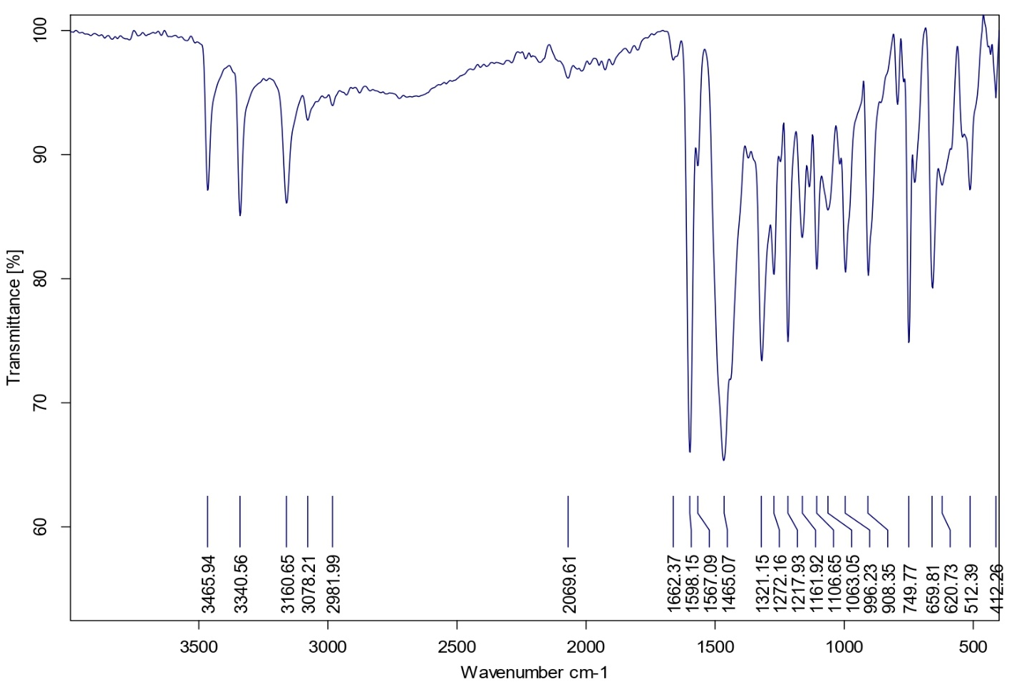

Figure S3 FTIR spectra of Mn S1 complex 1:1

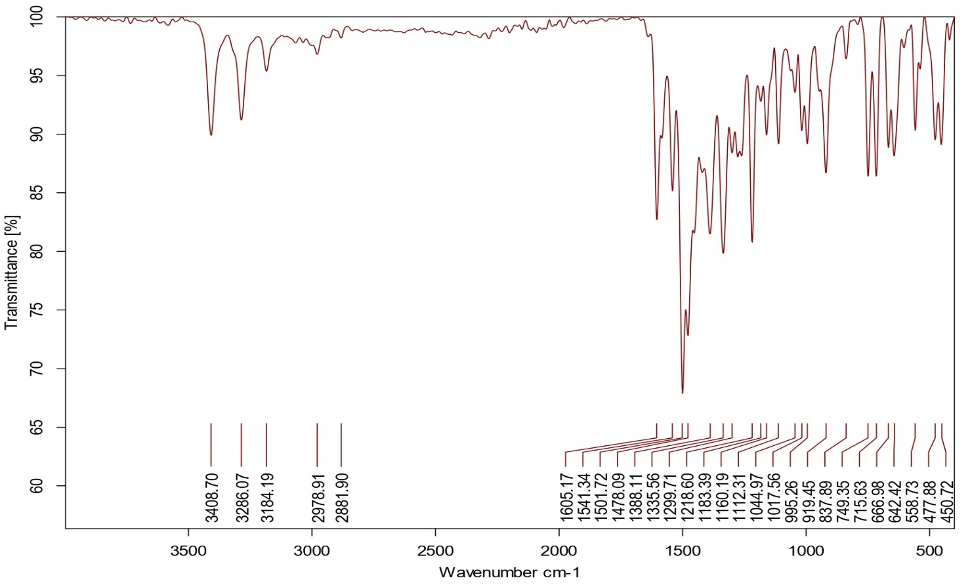
Figure S4 FTIR spectra of Zn S1 complex 1:1

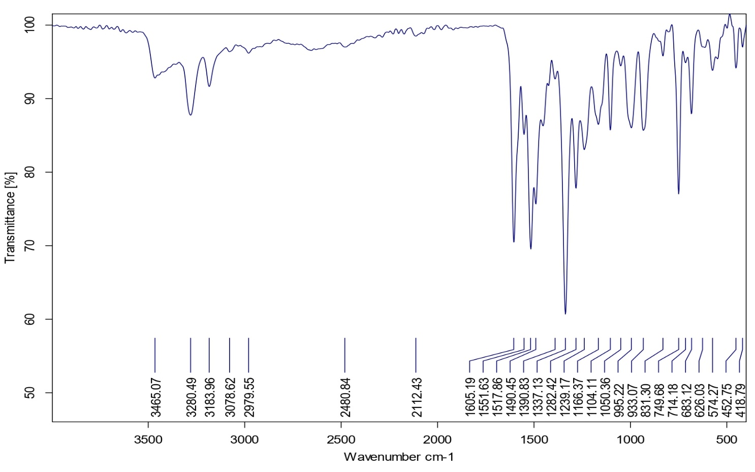
Figure S5 FTIR spectra of Ni S1 complex 1:1

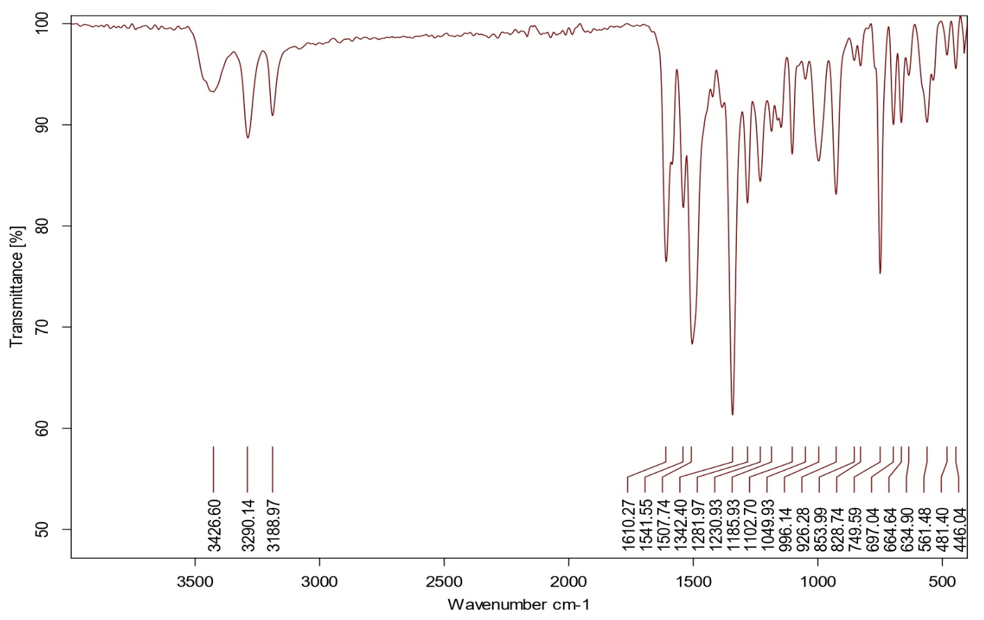
Figure S6 FTIR spectra of Cu S1 complex 1:1

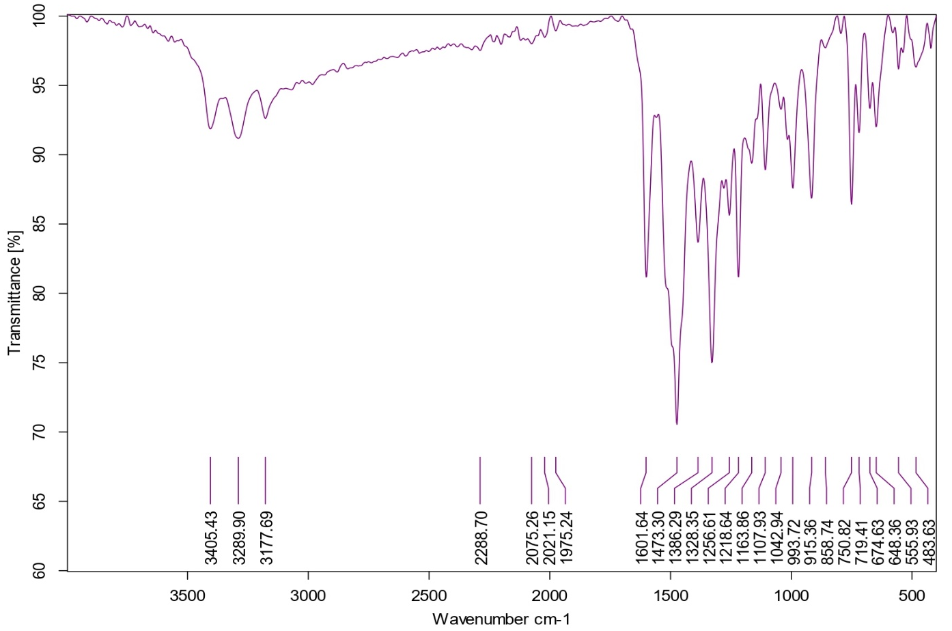
Figure S7 FTIR spectra of Co S1 complex 1:2

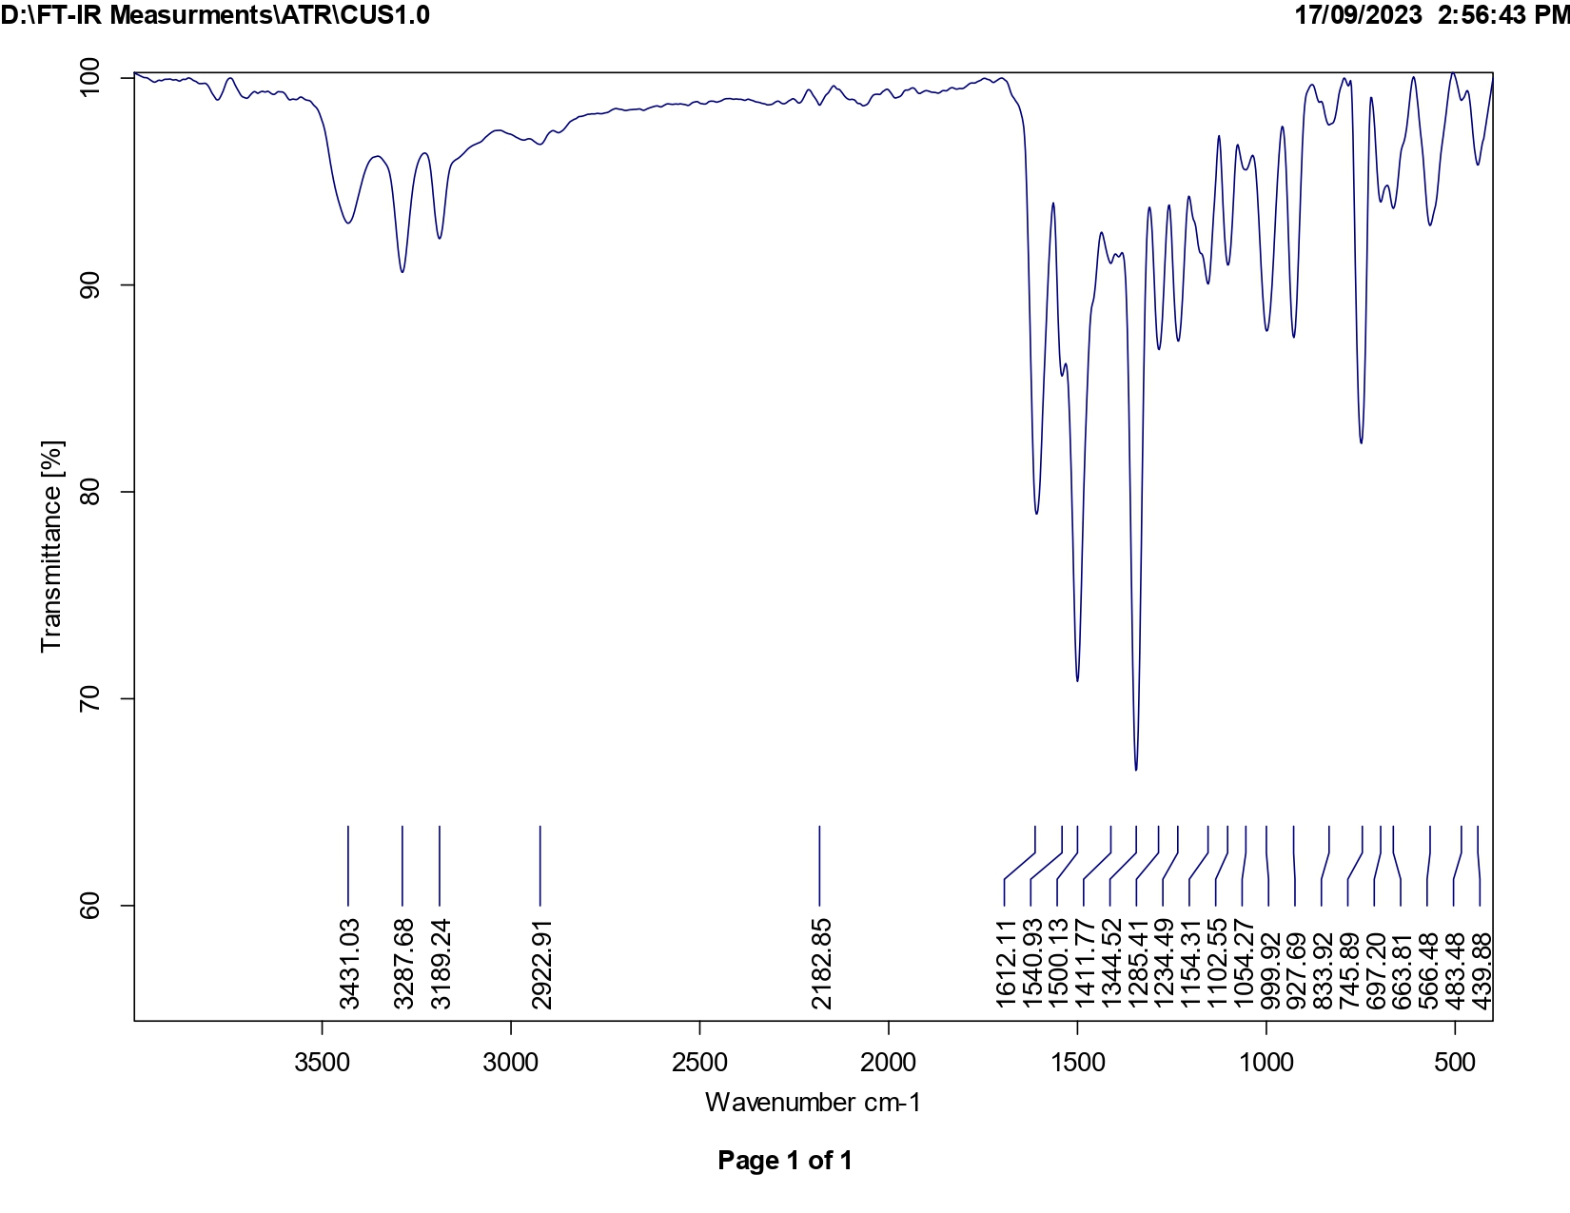
Fig. S8 FTIR spectra of Cu S1 complex 1:2
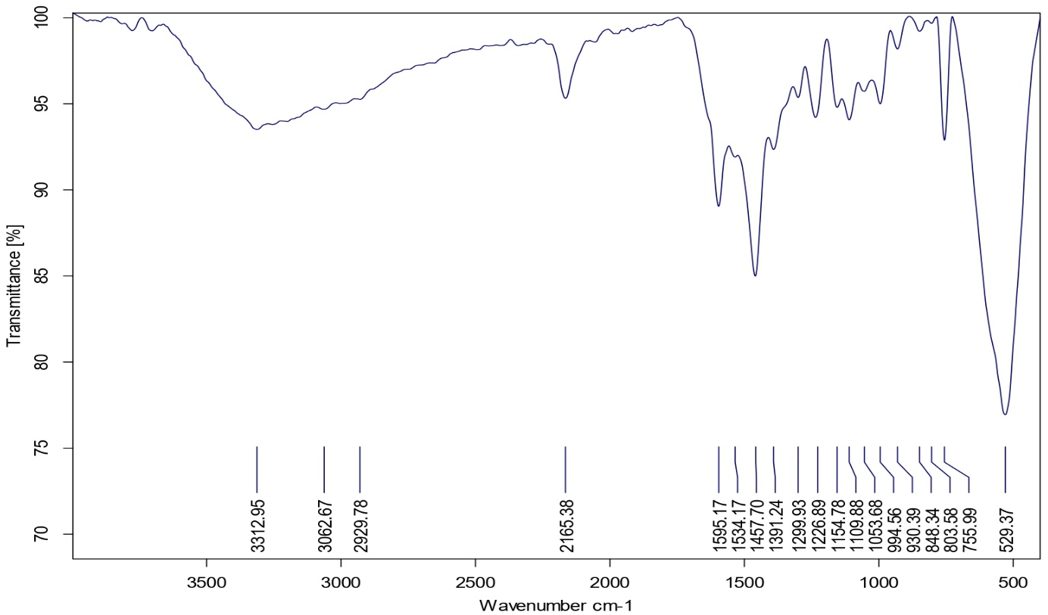
Fig. S9 FTIR spectra of Mn S1 complex 1:2

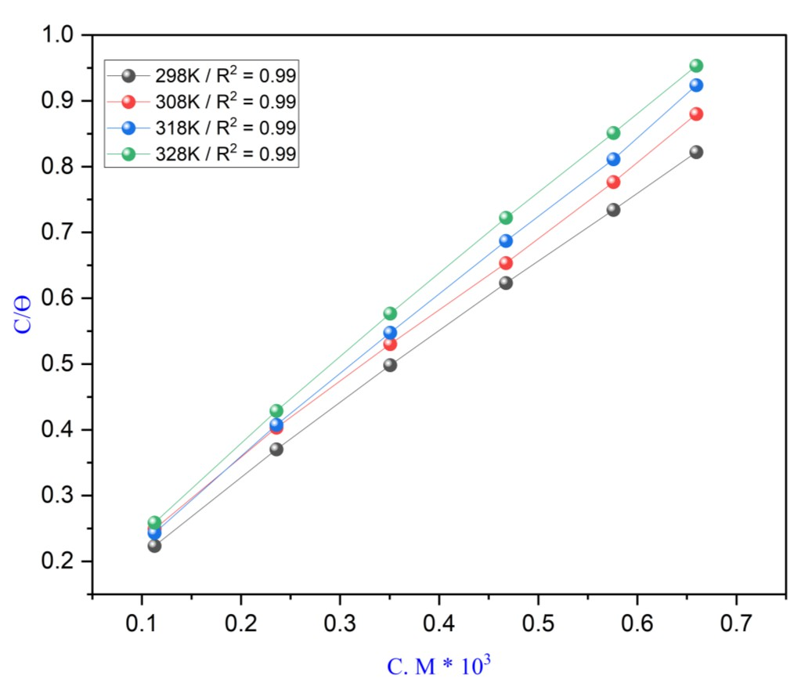
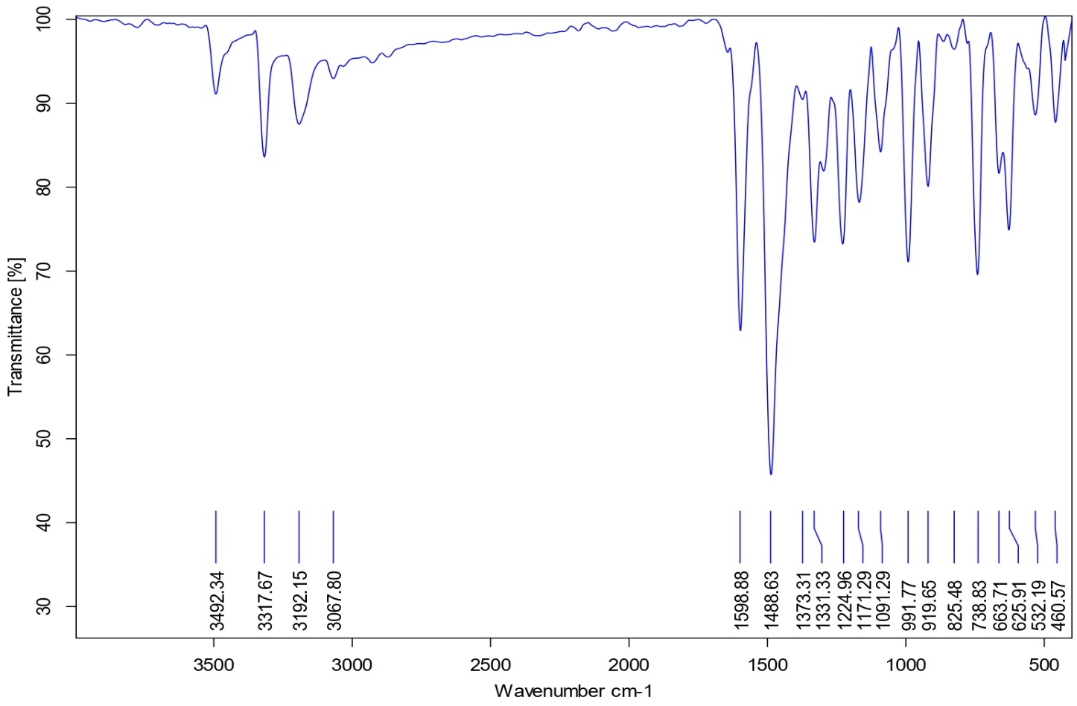

Fig. S10 FTIR spectra of Ni S1 complex 1:2

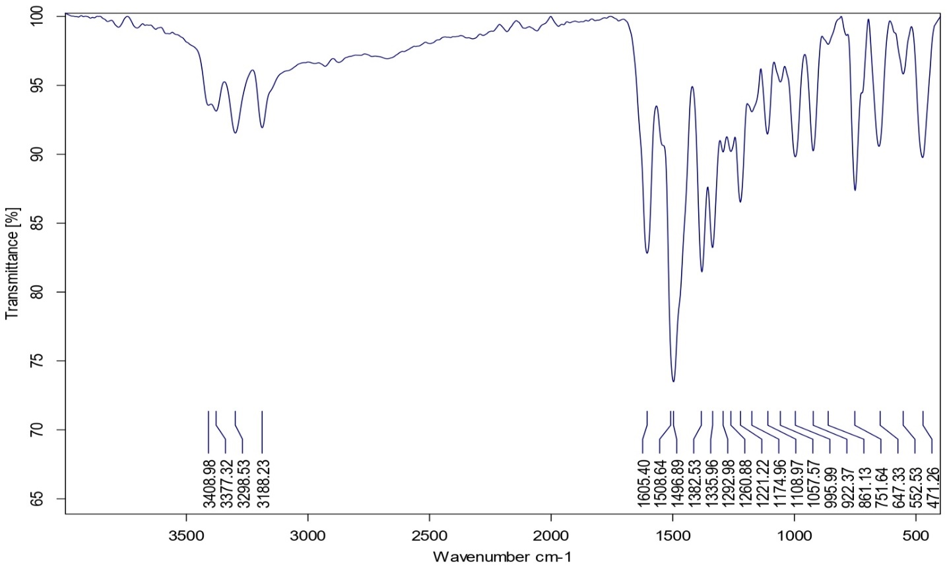

Fig. S11 FTIR spectra of Zn S1 complex 1:2

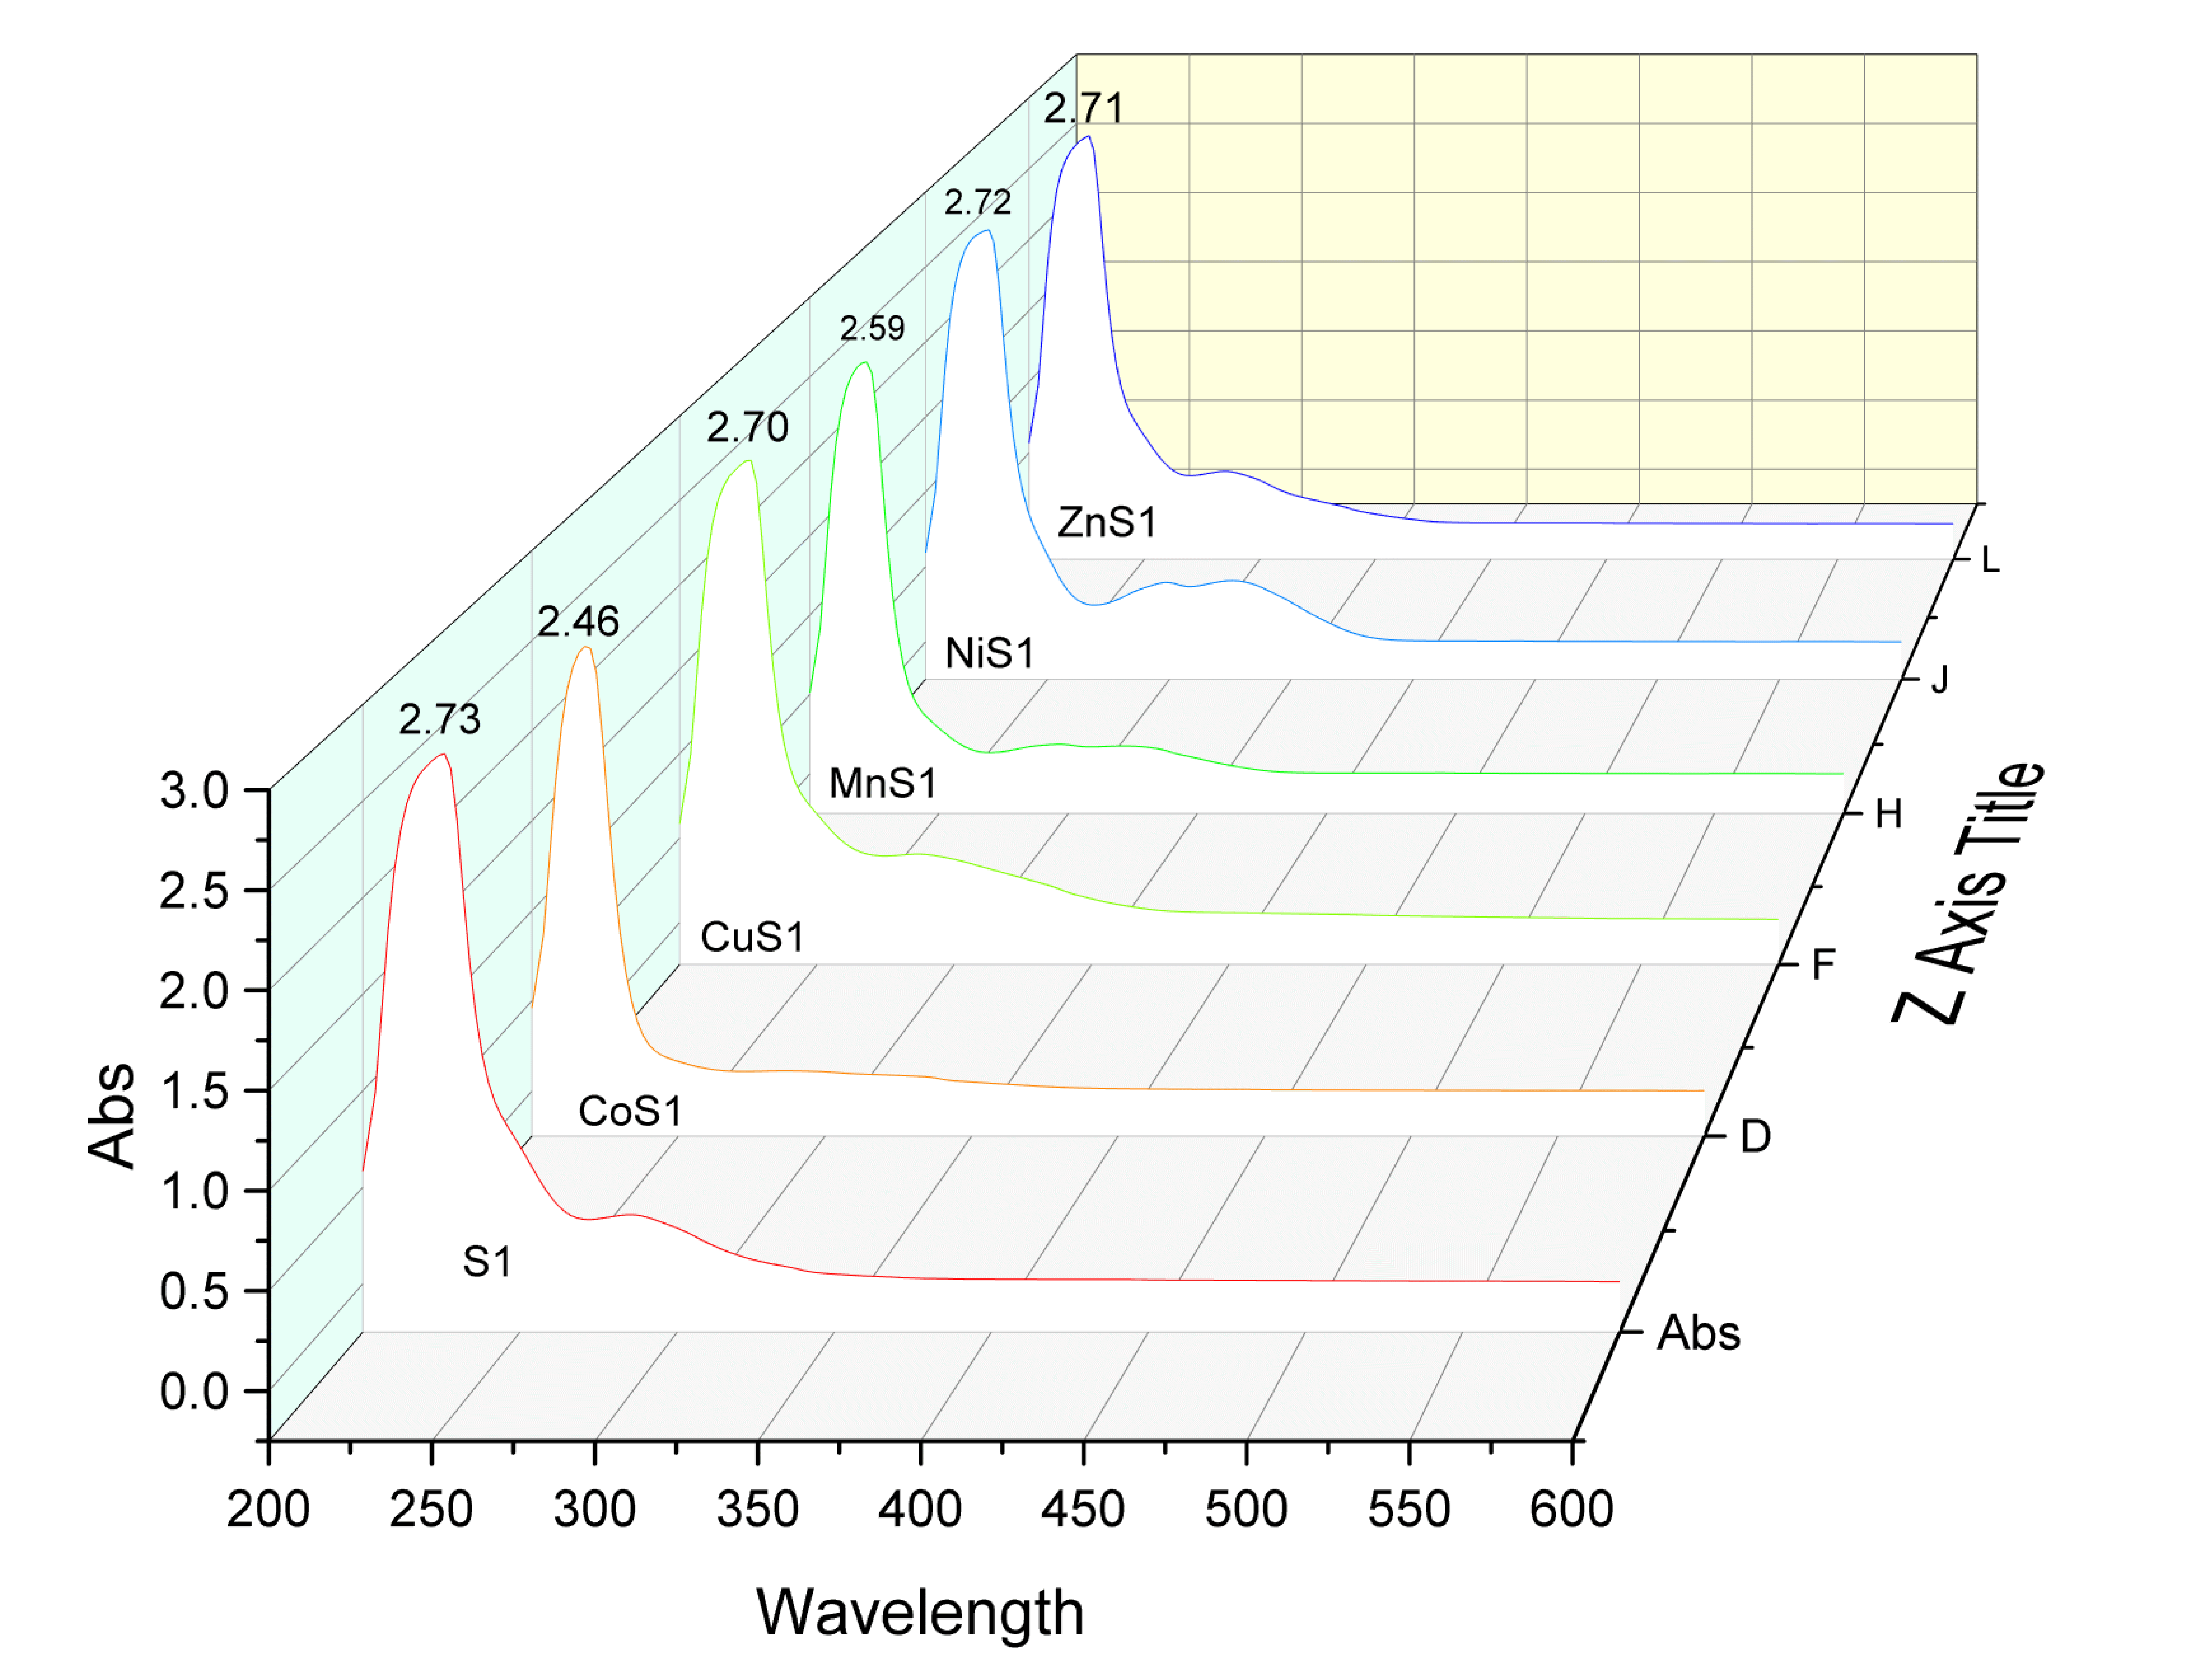
Figure S12 Uv-Vis spectra of 1:1 ligand metal complexes
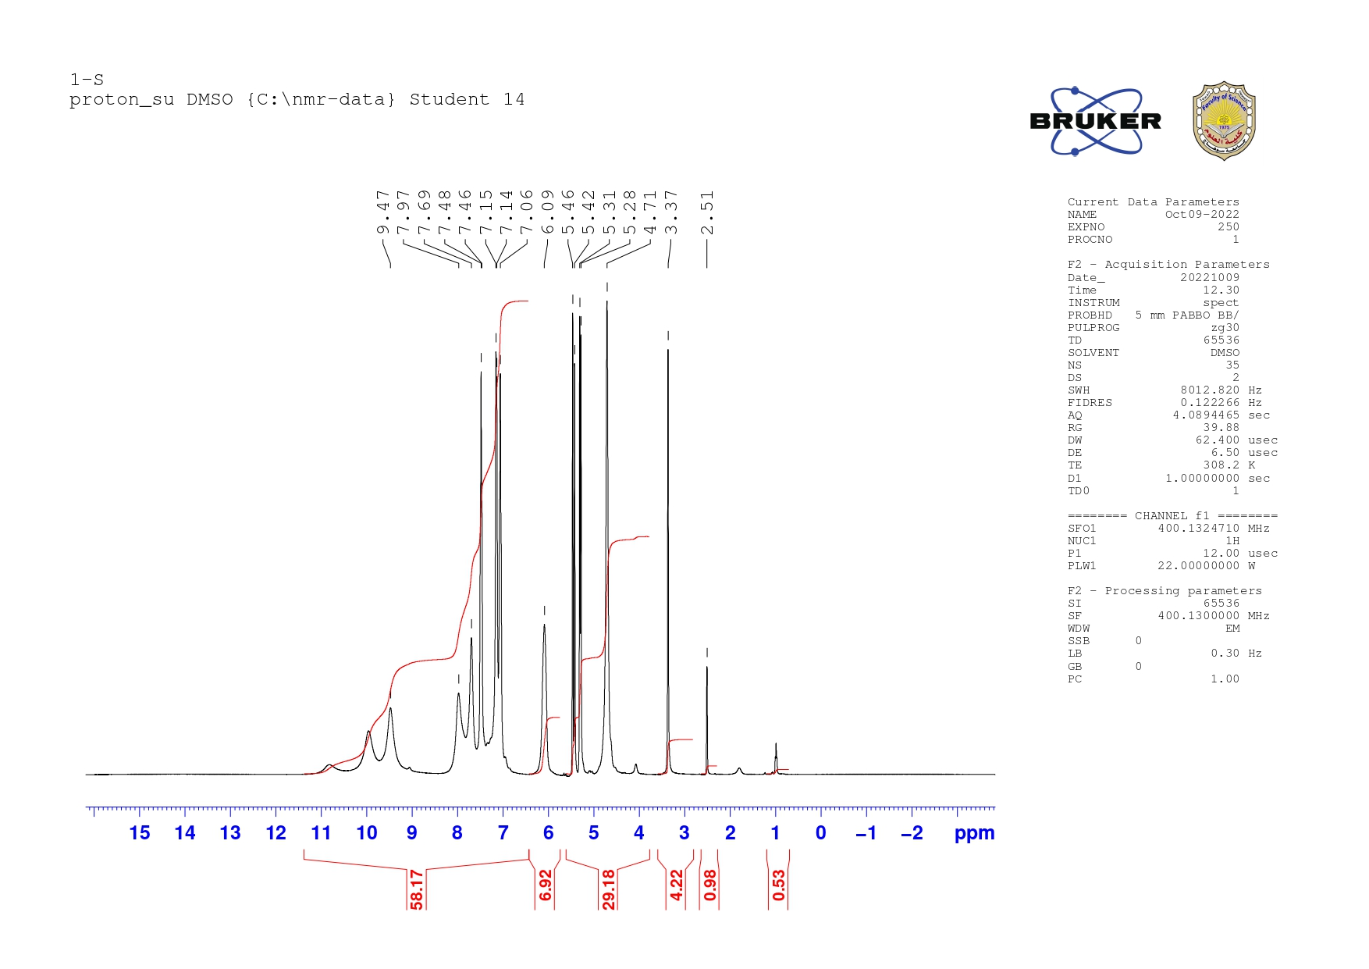
Figure S13 HNMR spectra of ligand S1

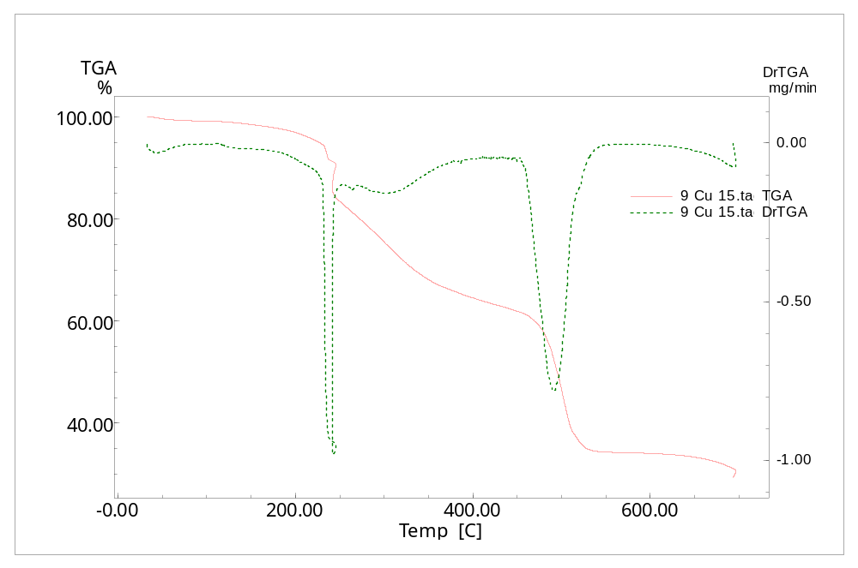
Figure S14 Ligand-Cu complex TGA

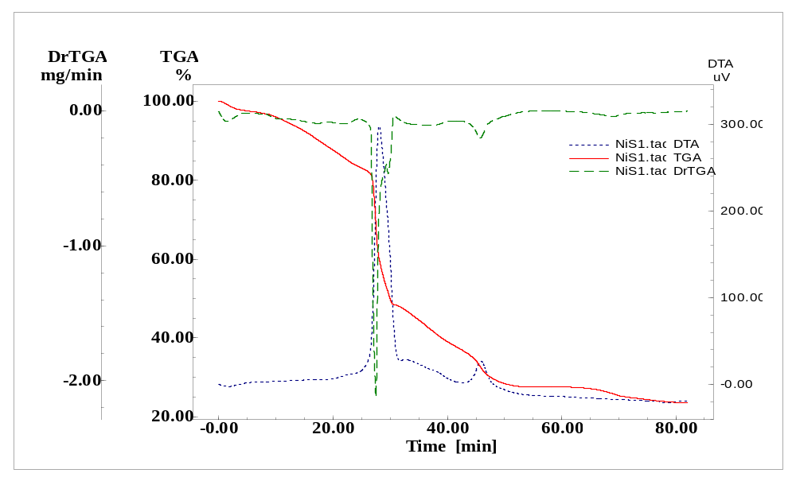
Figure S15 Ligand-Ni complex TGA

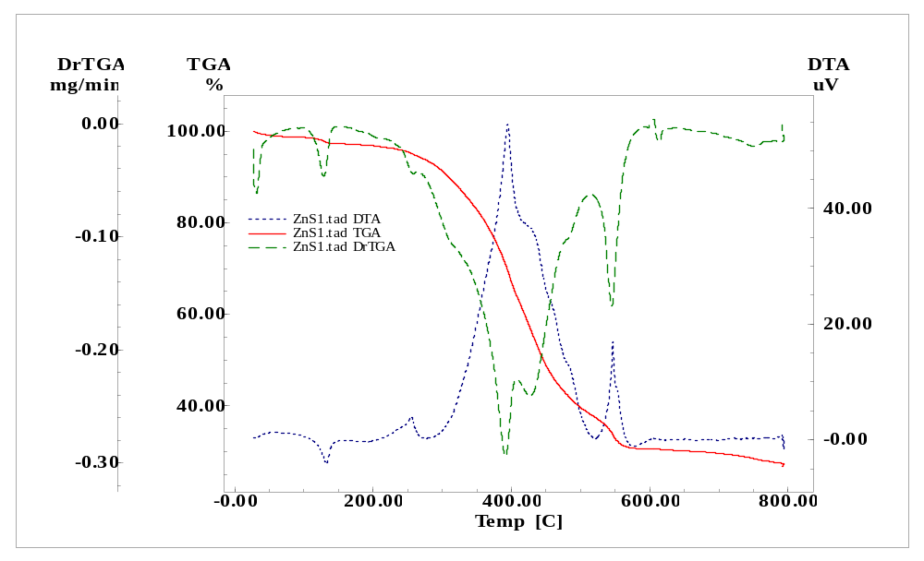
Figure S16 Ligand-Zn complex TGA
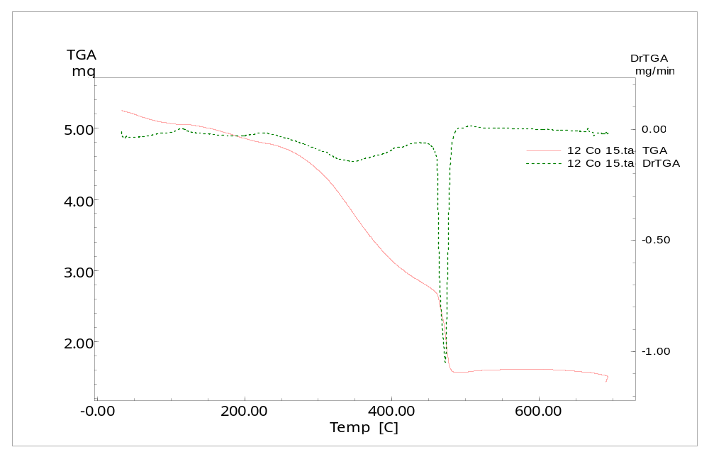
Figure S17 Ligand-Co complex TGA

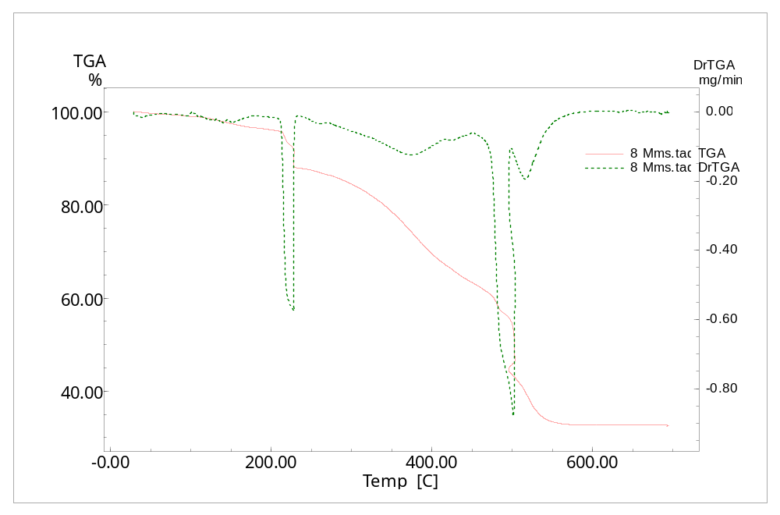
Figure S18 Ligand-Mn complex TGA
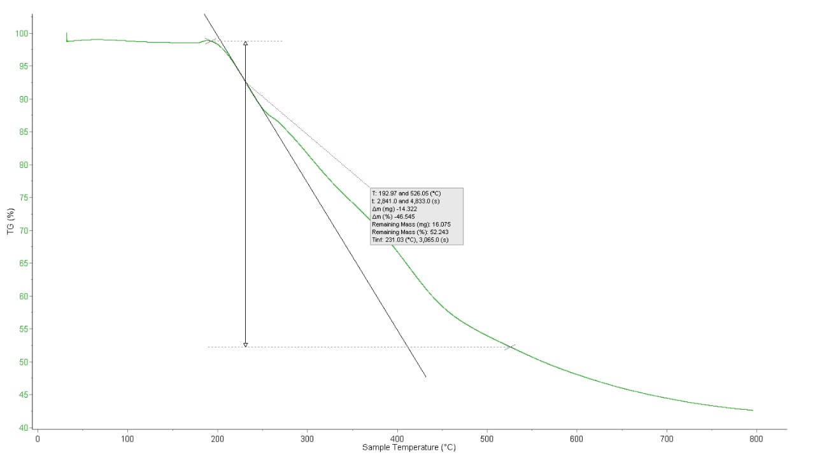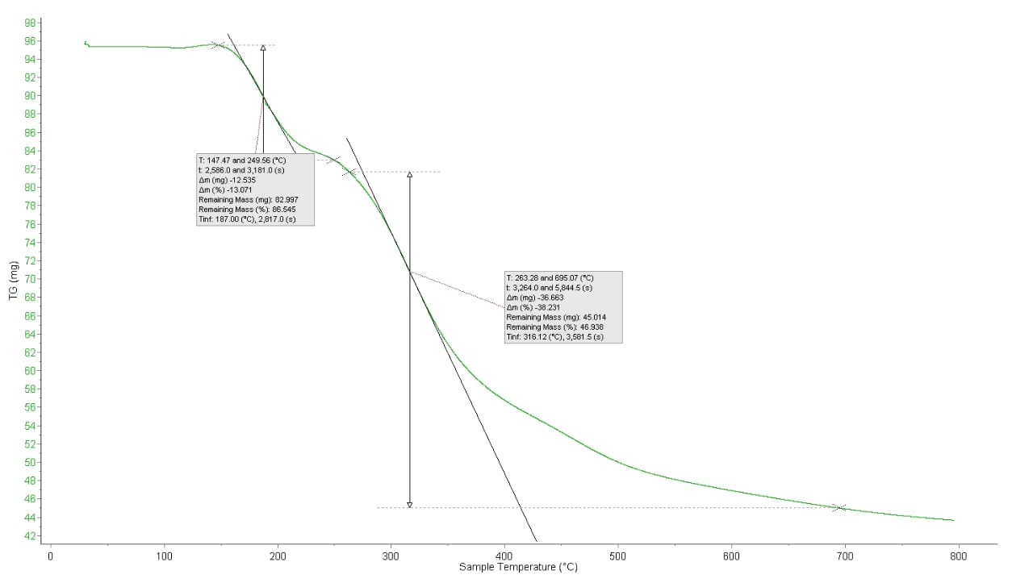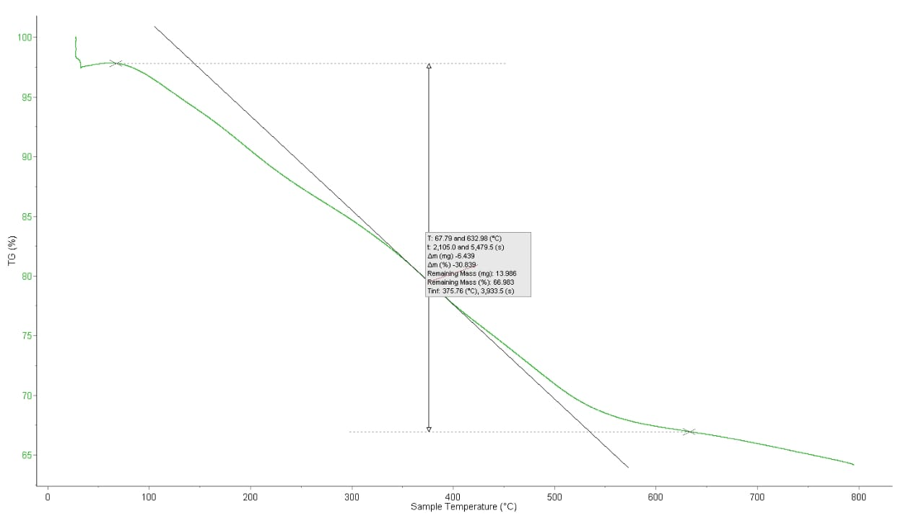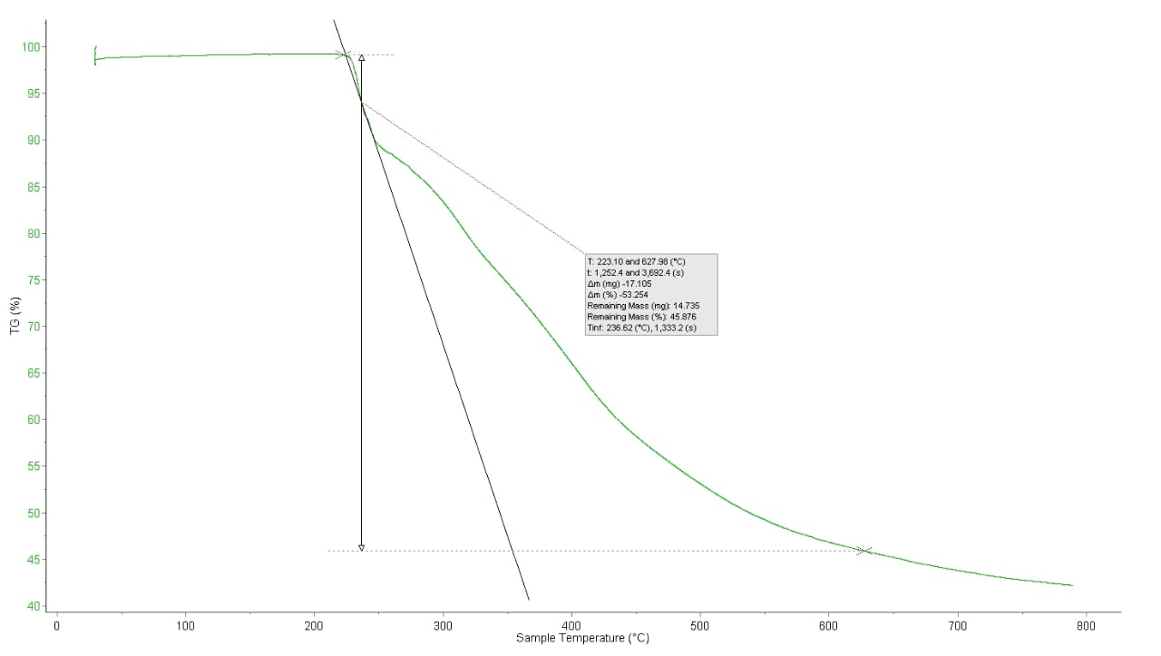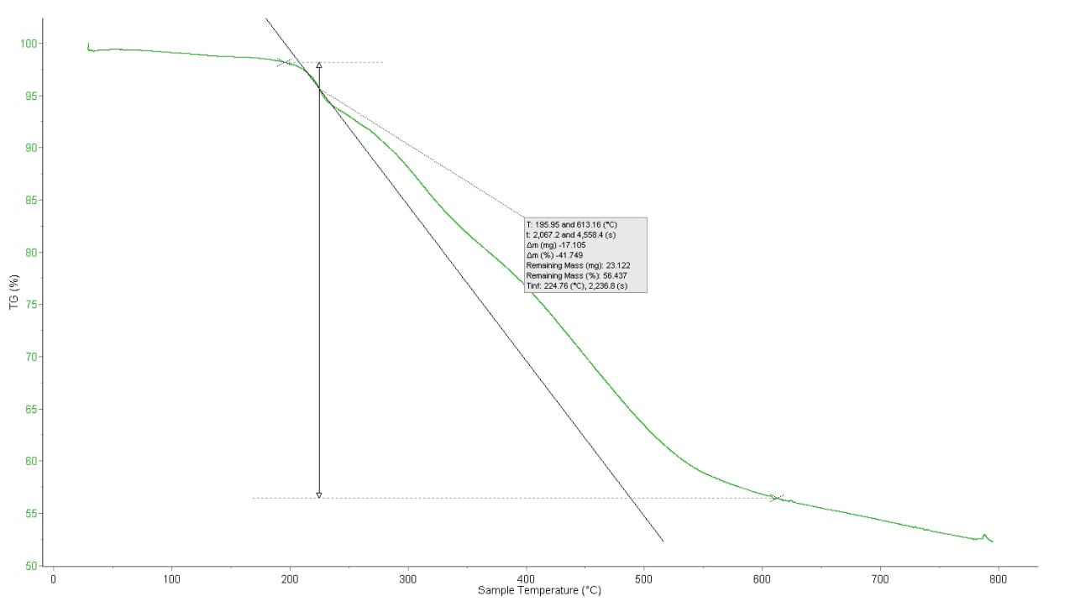

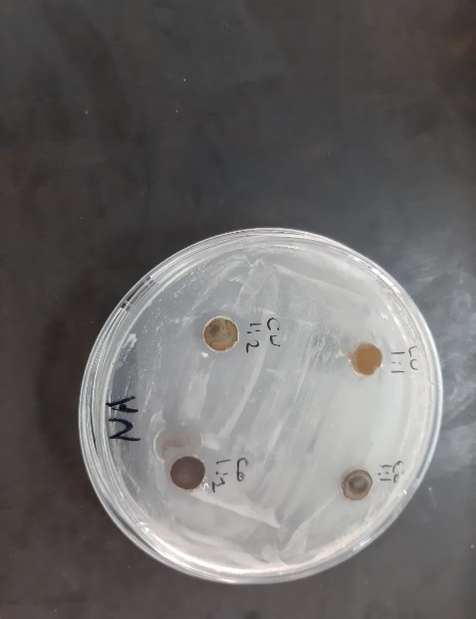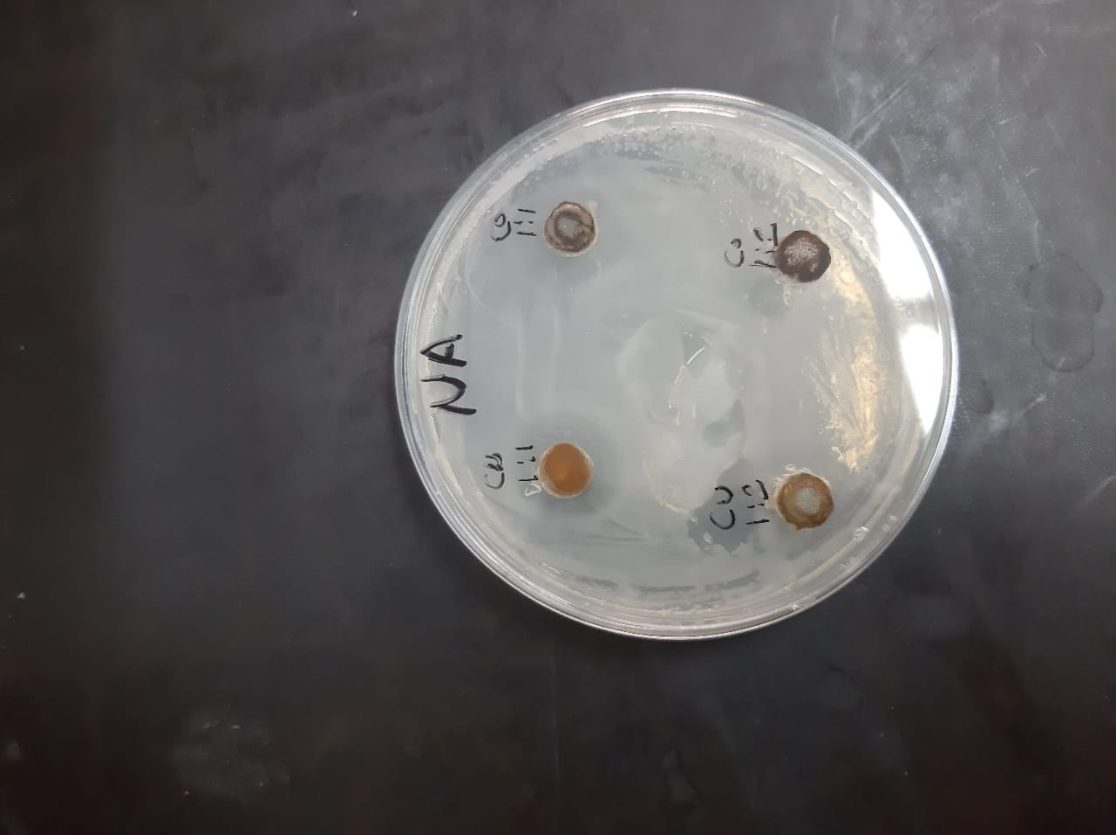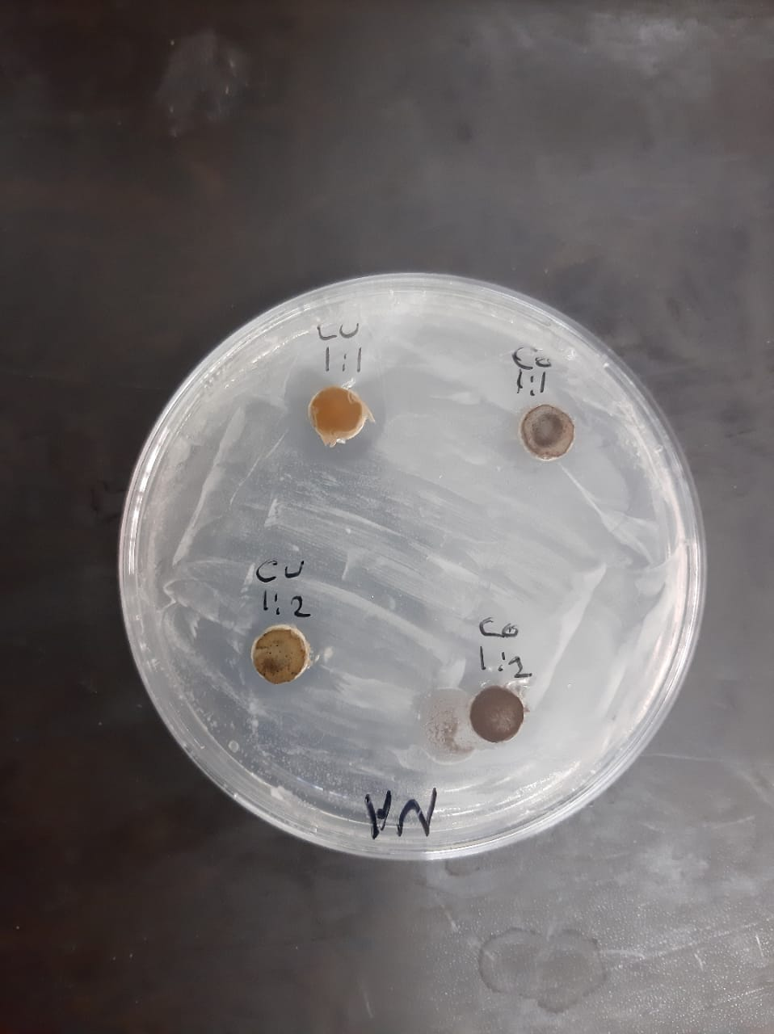
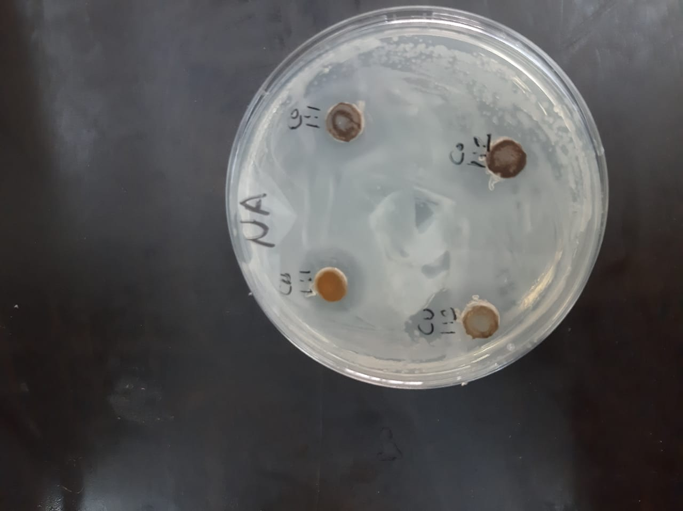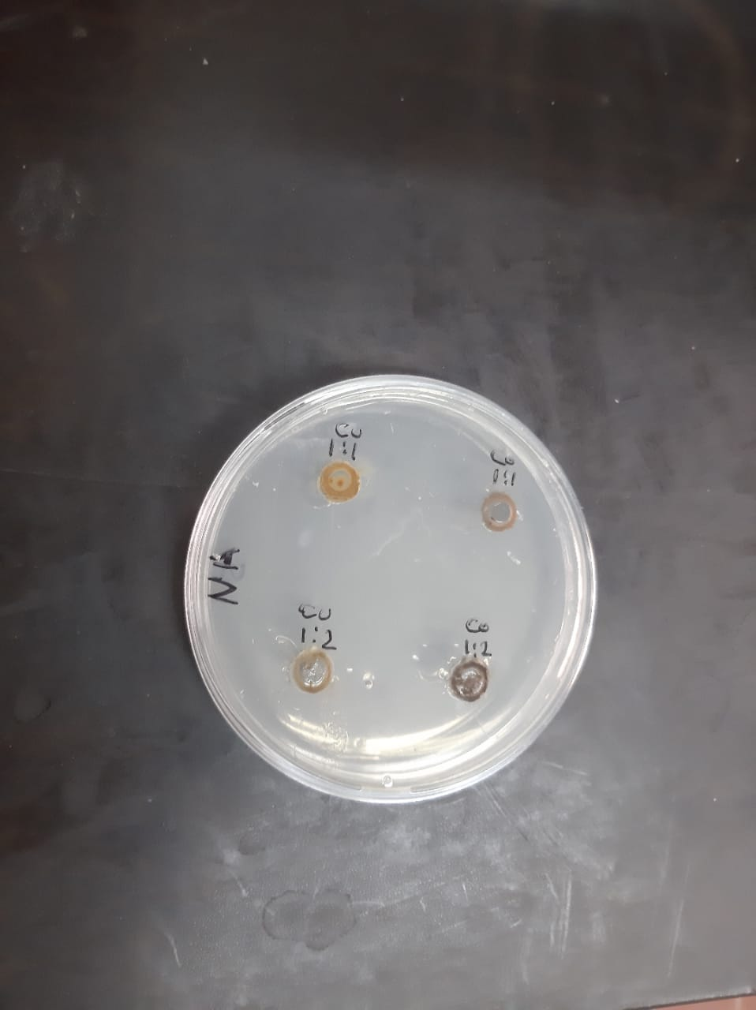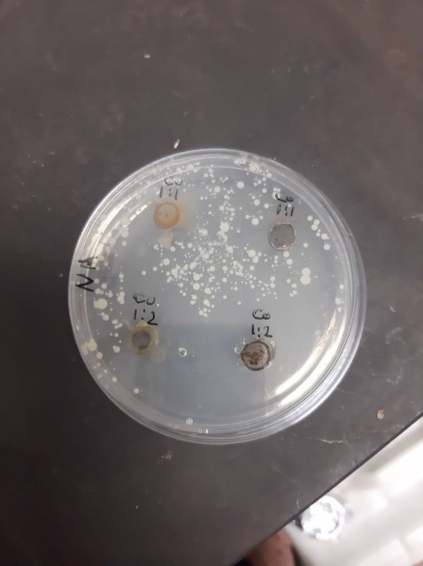

Photo S1: Representative photos present zonesof inhibition due to the tested ligands and their complexes against tested microbes, arrows indicate the inhibition zones.

