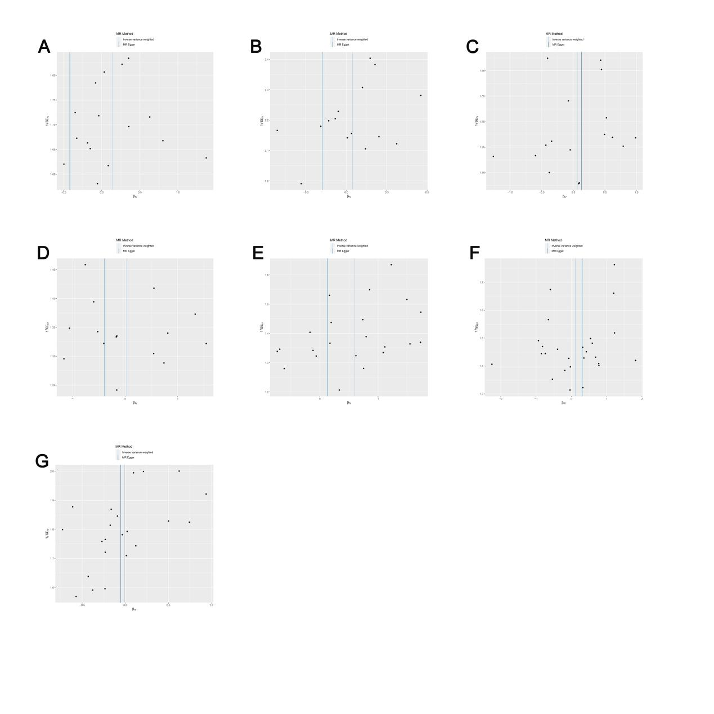
Supplementary Figure S1. Funnel plots visually display the overall heterogeneity of MR estimates for all results: (A) heterogeneity analysis for Anti-helicobacter pylori IgG seropositivity on pancreatic cancer; (B) heterogeneity analysis for Helicobacter pylori CagA antibody levels on pancreatic cancer; (C) heterogeneity analysis for Helicobacter pylori Catalase antibody levels on pancreatic cancer; (D) heterogeneity analysis for Helicobacter pylori GroEL antibody levels on pancreatic cancer; (E) heterogeneity analysis for Helicobacter pylori OMP antibody levels on pancreatic cancer; (F) heterogeneity analysis for Helicobacter pylori UREA antibody levels on pancreatic cancer; (G) heterogeneity analysis for Helicobacter pylori VacA antibody levels on pancreatic cancer.
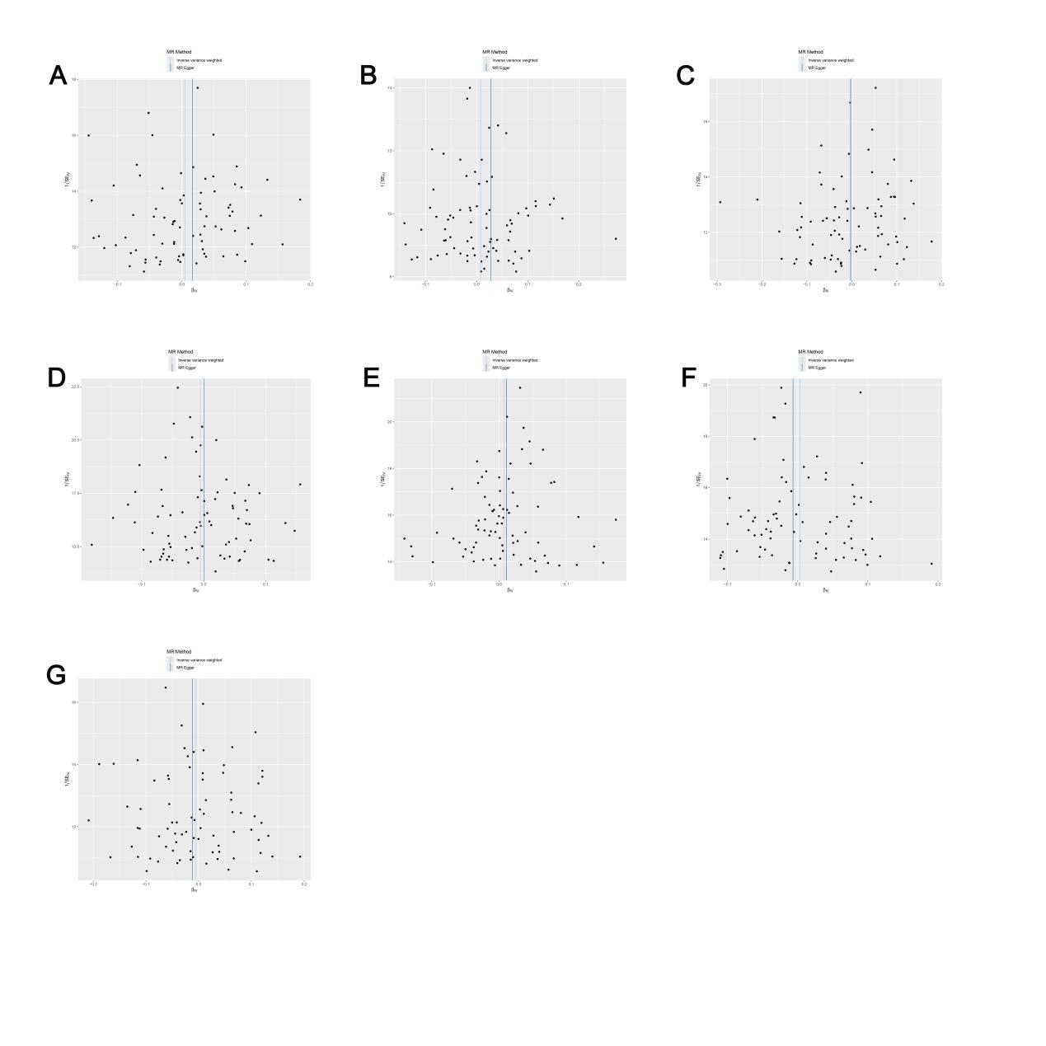
Supplementary Figure S2. Funnel plots visually display the overall heterogeneity of MR estimates for all results: (A) heterogeneity analysis for pancreatic cancer on Anti-helicobacter pylori IgG seropositivity; (B) heterogeneity analysis for pancreatic cancer on Helicobacter pylori CagA antibody levels; (C) heterogeneity analysis for pancreatic cancer on Helicobacter pylori Catalase antibody levels; (D) heterogeneity analysis for pancreatic cancer on Helicobacter pylori GroEL antibody levels; (E) heterogeneity analysis for pancreatic cancer on Helicobacter pylori OMP antibody levels; (F) heterogeneity analysis for pancreatic cancer on Helicobacter pylori UREA antibody levels; (G) heterogeneity analysis for pancreatic cancer on Helicobacter pylori VacA antibody levels.
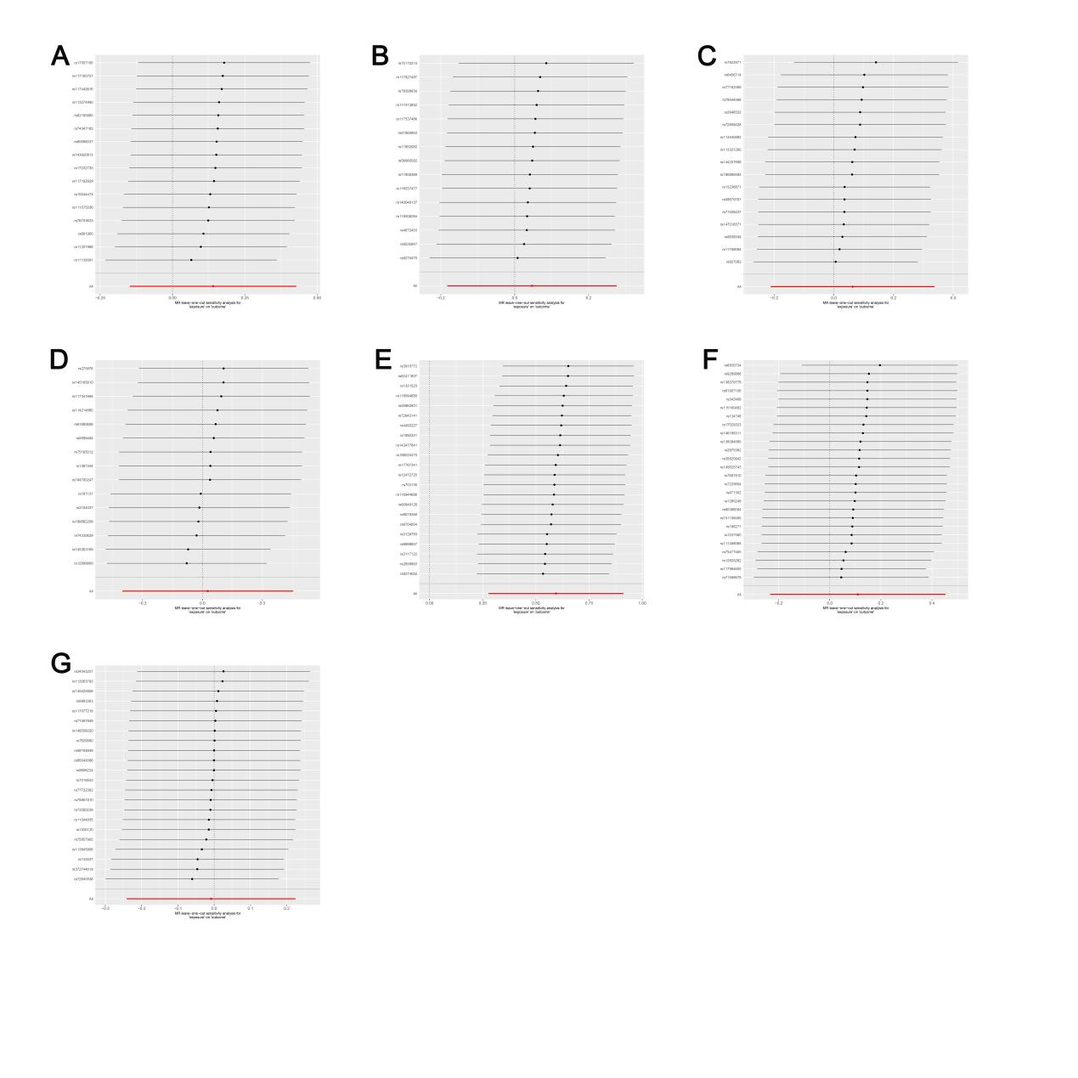
Supplementary Figure S3:Leave-one-out analysis of the effect of individual SNPs of MR analysis results:(A) Leave-one-out analysis for Anti-helicobacter pylori IgG seropositivity on pancreatic cancer; (B) Leave-one-out analysis for Helicobacter pylori CagA antibody levels on pancreatic cancer; (C) Leave-one-out analysis for Helicobacter pylori Catalase antibody levels on pancreatic cancer; (D) Leave-one-out analysis for Helicobacter pylori GroEL antibody levels on pancreatic cancer; (E) Leave-one-out analysis for Helicobacter pylori OMP antibody levels on pancreatic cancer; (F) Leave-one-out analysis for Helicobacter pylori UREA antibody levels on pancreatic cancer; (G) Leave-one-out analysis for Helicobacter pylori VacA antibody levels on pancreatic cancer.
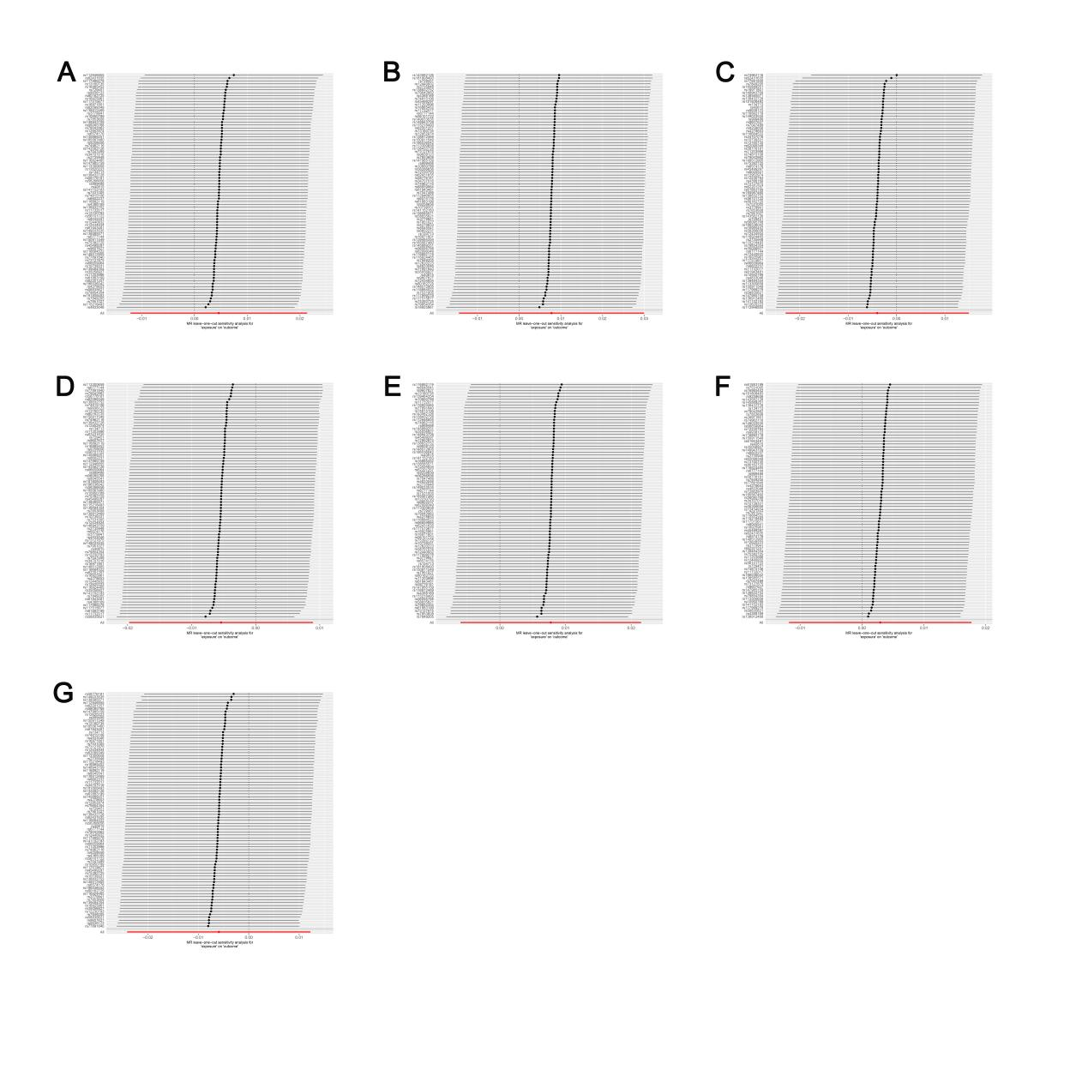
Supplementary Figure S4: Leave-one-out analysis of the effect of individual SNPs of MR analysis results: (A) Leave-one-out analysis for pancreatic cancer on Anti-helicobacter pylori IgG seropositivity; (B) Leave-one-out analysis for pancreatic cancer on Helicobacter pylori CagA antibody levels; (C) Leave-one-out analysis for pancreatic cancer on Helicobacter pylori Catalase antibody levels; (D) Leave-one-out analysis for pancreatic cancer on Helicobacter pylori GroEL antibody levels; (E) Leave-one-out analysis for pancreatic cancer on Helicobacter pylori OMP antibody levels; (F) Leave-one-out analysis for pancreatic cancer on Helicobacter pylori UREA antibody levels; (G) Leave-one-out analysis for pancreatic cancer on Helicobacter pylori VacA antibody levels.

