Supplementary Methods
Mouse bulk RNA-seq preparation and analysis
Total RNA was isolated from frozen cortex, hippocampus, and midbrain tissues using TRIzol reagent (Thermo Fisher Scientific), according to the manufacturer’s protocol. RNA quality was assessed with the Quant-iT RiboGreen RNA Assay Kit (Invitrogen, #R11490) and Agilent TapeStation using RNA ScreenTape (#5067-5576). Only samples with an RNA Integrity Number (RIN) > 7.0 were utilized for library preparation. RNA libraries were prepared using the TruSeq Stranded Total RNA Library Prep Gold Kit (Illumina, #20020599), which includes ribosomal RNA depletion. mRNA fragmentation was performed under elevated temperatures in the presence of divalent cations. First-strand cDNA was synthesized using SuperScript II Reverse Transcriptase (Invitrogen, #18064014) with random primers, followed by second-strand synthesis incorporating dUTP. After end repair, A-tailing, and adapter ligation, libraries were PCR-amplified, quantified using the KAPA Library Quantification Kit (Roche, #KK4854), and quality-checked with Agilent D1000 ScreenTape (#5067-5582). Paired-end sequencing (2 × 150 bp) was performed on an Illumina NovaSeq X platform (Macrogen Inc., Seoul, South Korea). Raw reads were aligned to the mouse reference genome (mm10) and quantified at the gene level using FeatureCounts. Gene counts were processed in R (v4.3.0) using the DESeq2 package (v1.38.0). Genes with counts per million (CPM) > 0.5 in at least two samples were retained (~21,800 genes). Samples were grouped by brain region and experimental condition. Variance stabilizing transformation (VST) was applied for visualization. Principal component analysis (PCA) was used to assess sample clustering. Differential expression analysis was conducted using DESeq2 for each brain region, with contrasts defined as PD-myr vs. PD-veh and PD-veh vs. WT. Genes with absolute log₂ fold change > 0.58 and adjusted p < 0.05 were considered differentially expressed. Gene annotation was performed using the org.Mm.eg.db and AnnotationDbi packages.
Differentially expressed genes were analyzed for Gene Ontology (GO) and Kyoto Encyclopedia of Genes and Genomes (KEGG) pathway enrichment using clusterProfiler. Data visualization included volcano plots (EnhancedVolcano), heatmaps (pheatmap), and dot plots (ggplot2). Gene Set Enrichment Analysis (GSEA) was performed using the gseGO function in the clusterProfiler package, based on gene rankings reflecting transcriptional rescue effects, calculated as the average expression in WT and PD-myr conditions relative to PD-veh. Z-score–normalized heatmaps were used to visualize condition-specific and reversed expression patterns.
Patient-derived neuron culture and mitophagy imaging
Human iPSC-derived neural progenitor cells (NPCs) (ATCC, ACS-5003) were expanded in DMEM/F-12 (ATCC, 30-2006) supplemented with NPC Growth Kit components (ATCC, ACS-3003), following the manufacturer’s instructions. For differentiation, NPCs were plated on Cell Basement Membrane Gel–coated 12-well plates and cultured in Dopaminergic Neuron Differentiation Medium (ATCC, ACS-3004) with medium changes every 2–3 days. Neuronal differentiation was performed for 3 weeks prior to experimentation.
NPCs underwent electroporation with a mitochondrially targeted Keima plasmid (mt-Keima; provided by Dr. Dong-Ryeol Ryu) using the Neon Transfection System (Thermo Fisher Scientific) in accordance with the manufacturer’s protocol (1 × 10⁶ cells in 10 µL buffer with 5 µg plasmid DNA). After electroporation, cells were plated and maintained in NPC growth medium containing puromycin for 3 weeks to allow stable mt-Keima expression prior to neuronal differentiation. Myriocin (10 or 50 µM) or vehicle (0.1% DMSO) was applied for 48 hours to mt-Keima–expressing dopaminergic neurons. Following pre-treatment, cells were either fixed or subjected to live-cell imaging. Live-cell mitophagy imaging was performed using a confocal microscope (FV3000RS, Olympus, Tokyo, Japan) equipped with 445 nm and 561 nm lasers. Neutral mitochondria were excited at 445 nm and mitolysosomes at 561 nm, with emission collected at 590–645 nm. Laser power, gain, and exposure were kept constant across all samples. Mitophagic activity was quantified by calculating the 561/445 intensity ratio per cell using ImageJ ¹.
For mitochondrial morphology analysis, neurons were fixed with 4% paraformaldehyde for 15 minutes, permeabilized with 0.1% Triton X-100 for 10 minutes, and blocked with 5% normal goat serum. Samples were incubated overnight at 4°C with anti-TOM20 antibody (D8T4N, Rabbit mAb; Cell Signaling Technology, #42406S), followed by Alexa Fluor 647–conjugated donkey anti-rabbit IgG (Abcam, ab150075) and DAPI (Thermo Fisher, D1306, 1 μg/mL). Images were captured using a 60× oil-immersion objective on the FV3000RS confocal microscope. Mitochondrial morphology was quantified using the Mitochondria Analyzer plugin for ImageJ ². Image preprocessing included background subtraction, contrast enhancement (Contrast Limited Adaptive Histogram Equalization—CLAHE), and adaptive thresholding. Morphological metrics—aspect ratio, form factor, branch length, and junction count—were extracted per cell. Outliers were excluded based on automated thresholding quality control, and batch-mode analysis was performed using optimized parameters from representative datasets.
Midbrain organoid differentiation and imaging
Midbrain organoids were generated from human iPSC lines derived from healthy individuals (iXCells, Cat# 30HU-002) and patients with PD (iXCells, Cat# 30HU-003). Cells were maintained under feeder-free conditions in Human iPSC Feeder-Free Growth Medium (MD-0019) on Matrigel-coated plates and passaged with ReLeSR (STEMCELL Technologies). To induce organoid formation, dissociated iPSCs were seeded into AggreWell™800 plates and cultured using the STEMdiff™ Midbrain Organoid Differentiation Kit (STEMCELL Technologies, Cat# 100-1096) per the manufacturer’s instructions. Organoids were expanded (Days 6–25), differentiated (Days 25–43), and subsequently maintained in STEMdiff™ Neural Organoid Maintenance Medium (Cat# 100-0120) beyond Day 43. On Day 50, organoids were treated with 50 μM myriocin (Sigma-Aldrich, Cat# M1177) or vehicle (0.1% DMSO) for 48 hours. After treatment, organoids were fixed in 4% paraformaldehyde (PFA) for 30 minutes at room temperature, cryoprotected overnight in 30% sucrose at 4 °C, embedded in optimal cutting temperature (OCT) compound, and cryosectioned at 20 μm thickness. Sections were permeabilized in 0.3% Triton X-100 for 10 minutes and blocked in 5% normal goat serum for 1 hour at room temperature.
Sections were incubated overnight at 4 °C with primary antibodies: anti-Tuj1 (BioLegend, 801213, 1:500), anti–phospho-α-synuclein (Abcam, ab184674, 1:1000), and DAPI (Thermo Fisher, D1306, 1 μg/mL). After PBS washes, sections were incubated for 1 hour at room temperature with Alexa Fluor 647–conjugated anti-rabbit IgG (Abcam, ab150075) for Tuj1 labeling and PE-conjugated anti-mouse IgG (F(ab′)₂; Cell Signaling Technology, #8887S) for phospho–α-synuclein. Whole-slide images were acquired using the FV3000RS confocal microscope. Z-stack images were collected at 20× magnification and reconstructed using maximum intensity projection. Imaging parameters were maintained constantly across experimental groups. Representative images were selected from a minimum of three organoids per condition.
Ceramide treatment in midbrain organoids and immunohistological analysis
To assess the effects of exogenous ceramide species on α-synuclein pathology, Day 50 midbrain organoids were treated with either C16 Ceramide (d18:1/16:0; Avanti Polar Lipids, Cat# 10681) or C24:1 Ceramide (d18:1/24:1(15Z); Avanti Polar Lipids, Cat# 62530) at a final concentration of 10 μM for 48 hours. Ceramide stock solutions were prepared in ethanol and diluted in organoid maintenance medium immediately prior to administration. Vehicle control groups were treated with an equivalent volume of ethanol (0.1%).
Statistical analysis
Statistical analyses were performed using GraphPad Prism (version 10.0) and R (version 4.3.0). All data are presented as mean ± standard error of the mean (SEM), unless otherwise noted. Prior to the application of parametric tests, datasets were assessed for normality using the Shapiro–Wilk test. Comparisons between two groups were performed using unpaired two-tailed Student’s t-test or Mann–Whitney U test, as deemed appropriate. For multiple group comparisons, one-way ANOVA followed by Dunnett’s post hoc test was used.
For behavioral analyses (e.g., open field, Y-maze), statistical comparisons were made using unpaired t-tests or one-way ANOVA, as each animal was tested once per condition.
For RNA-seq data, differential expression analysis was conducted using DESeq2 with Benjamini–Hochberg correction to control the false discovery rate (FDR); genes with adjusted p < 0.05 and |log₂ fold change| > 0.58 were considered significantly differentially expressed. Enrichment analyses (GO, KEGG, GSEA) used adjusted p < 0.05 as a significance threshold.
For imaging-based quantification (e.g., mt-Keima ratios, aggregate counts, fluorescence intensity, morphological metrics), individual cells or organoids were designated as independent biological units (n values defined in figure legends). All image acquisition and quantification were performed under blinded conditions. Statistical significance was set at p < 0.05. Exact statistical tests and sample sizes (n) are indicated in the figure legends.
Ethics
Human postmortem brain tissues were obtained from the Korea Brain Bank. The use of these samples was approved by the Institutional Review Board of Gwangju Institute of Science and Technology (IRB No. 20230504-BR-71-02-02). A waiver of informed consent was granted as the study utilized anonymized, postmortem biospecimens. All samples were de-identified and handled in accordance with the Declaration of Helsinki. All experimental protocols were approved by the Institutional Animal Care and Use Committee of the Gwangju Institute of Science and Technology (No. GIST-2022-041).

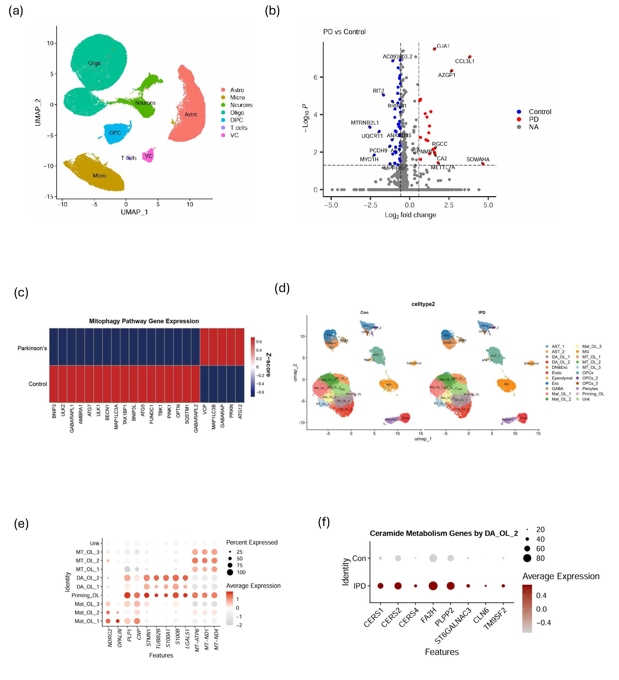
Supplementary Figure 1. Cell type–specific transcriptomic signatures reveal inflammatory activation, mitophagy suppression, and dysregulated ceramide metabolism in Parkinson’s disease brains. (a) UMAP plot of single-nucleus RNA-seq data from postmortem human midbrain (GSE243639), showing clustering into major cell types: astrocytes, microglia, oligodendrocytes, oligodendrocyte precursor cells, neurons, T cells, and vascular cells. (b) Volcano plot of differentially expressed genes in dopaminergic neurons (cluster_0) comparing PD and control samples. Genes involved in inflammatory responses (GJA1, AZGP1, CCL3L1) were significantly upregulated in PD, while dopaminergic signaling–related genes such as RIT2 were downregulated. Adjusted p-values were calculated using the Wilcoxon rank-sum test with Benjamini–Hochberg correction. (c) Heatmap displaying the Z-score expression of genes involved in mitophagy (e.g., PINK1, PRKN, BNIP3L) in dopaminergic neurons. PD samples showed reduced expression of key mitophagy regulators, suggesting impaired mitochondrial clearance in vulnerable neuronal populations. (d) UMAP projection of an independent midbrain single-nucleus transcriptomic dataset (GSE156776), showing 22 transcriptionally distinct cell populations identified from PD and control donors. Cell-type annotations were based on canonical marker expression. (e) Dot plot visualizing marker gene expression across oligodendrocyte subclusters from the GSE156776 dataset. Subclusters included mitochondria-enriched oligodendrocytes (MT_OL), disease-associated oligodendrocytes (DA_OL), priming oligodendrocytes, and mature oligodendrocytes. Notably, DA_OL_2 cells exhibited high expression of both mitochondrial genes (MT-ATP6, MT-ND1, MT-ND4) and oligodendrocyte lineage markers (CNP, PLP1), implicating a metabolically primed, disease-associated state. (f) Dot plot showing expression of ceramide metabolism–related genes (e.g., CERS1, CERS2, FA2H, PLPP2) in DA_OL_2 cells, stratified by condition (control vs. idiopathic PD). PD-derived DA_OL_2 cells exhibited consistently higher expression of these genes, indicating enhanced ceramide biosynthetic activity within this glial subtype.

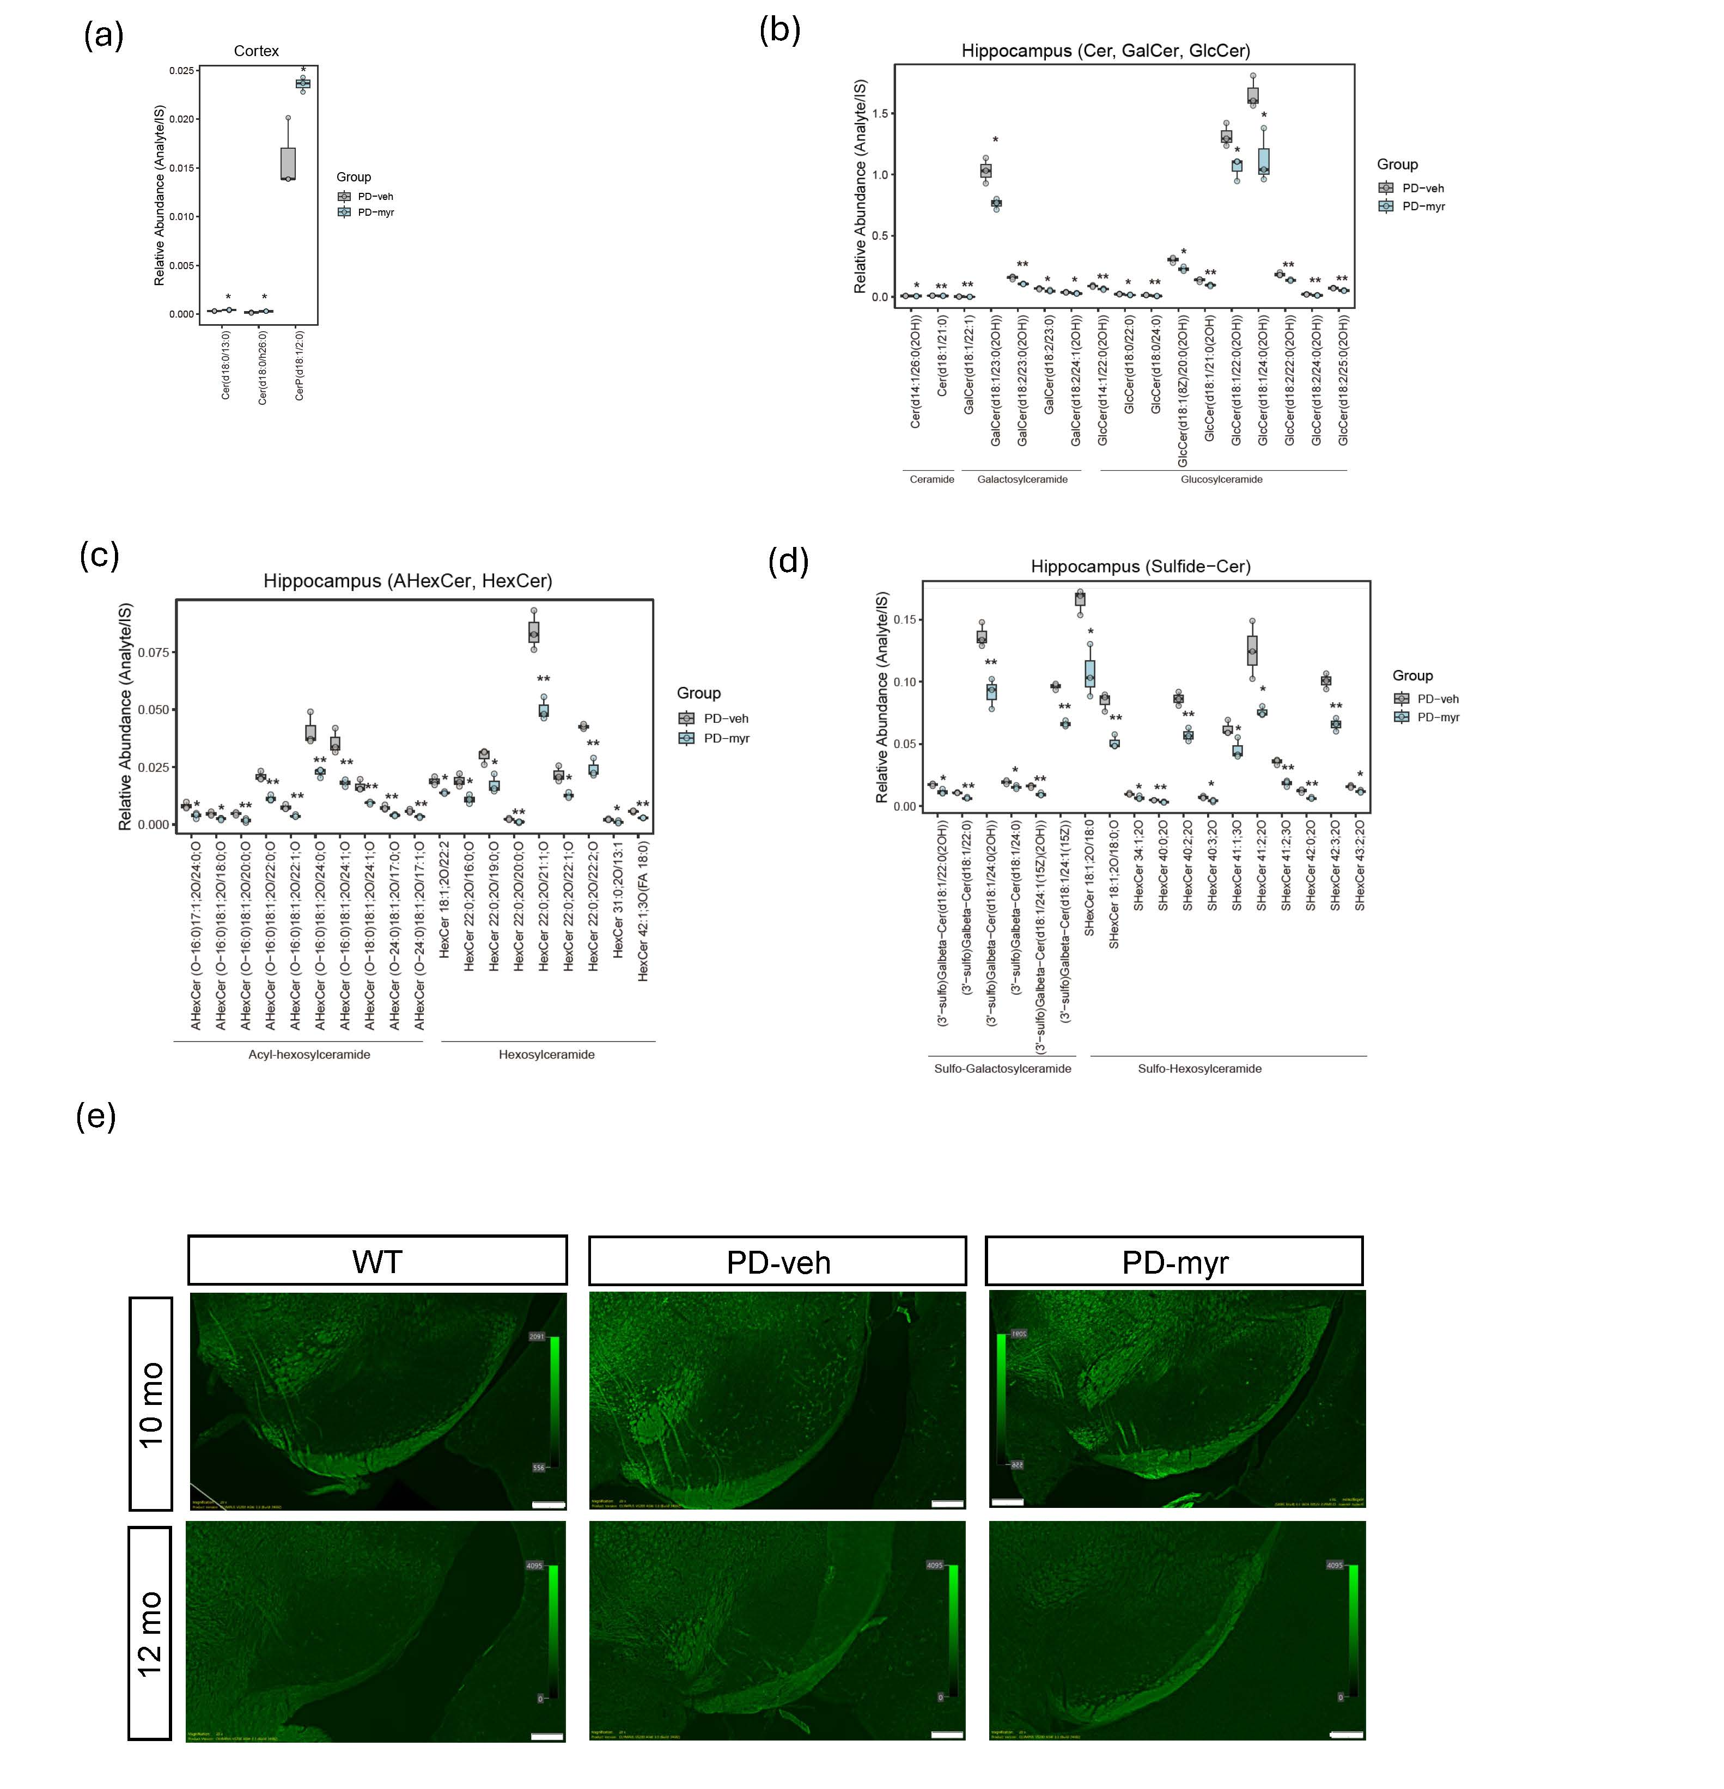
Supplementary Figure 2. Myriocin reduces ceramide species and α-synuclein aggregation in the hippocampus of A53T α-synuclein transgenic mice. (a) Boxplot showing reduced total ceramide levels in the cortex of myriocin-treated A53T transgenic (PD-myr) mice compared to vehicle-treated (PD-veh) and wild-type (WT) controls, as quantified by UPLC-Orbitrap-MS. (b–d) Group-wise comparison of hippocampal sphingolipid subclasses, including ceramides, hexosylceramides (HexCer), galactosylceramides (GalCer), glucosylceramides (GlcCer), acylceramides (ACer), sulfatide-ceramides, and alpha-hydroxyceramides (AHexCer). Myriocin treatment significantly reduced several disease-associated lipid species in PD-myr mice relative to PD-veh. (e) Representative immunofluorescence images of Thioflavin S staining in hippocampal sections from WT, PD-veh, and PD-myr mice at 10 and 12 months of age. Myriocin treatment reduced Thioflavin S–positive protein aggregates in both time points. Scale bars, 200 μm. All ceramide measurements were performed by UPLC-Orbitrap-MS, and statistical differences were assessed using Student’s t-test. N = 3–5 mice per group.

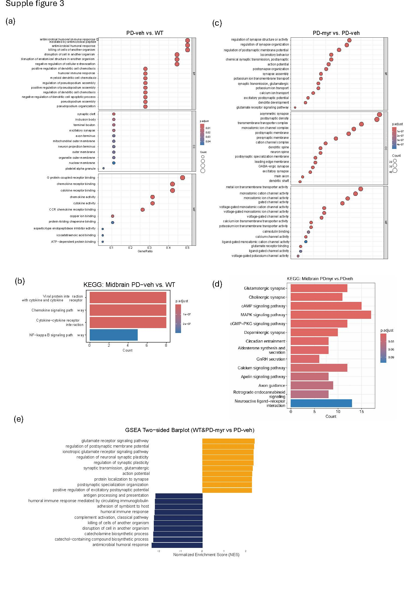
Supplementary Figure 3. Myriocin treatment reverses immune-related transcriptional signatures and enhances neuronal signaling pathways in the midbrain of A53T mice. (a) Gene Ontology (GO) enrichment analysis of biological processes (BP) for differentially expressed genes (DEGs) in the midbrain of vehicle-treated A53T mice compared to WT controls (PD-veh vs. WT). Immune activation and inflammatory response pathways were predominantly upregulated in PD-veh mice. (b) KEGG pathway enrichment analysis of DEGs from the same comparison (PD-veh vs. WT). Notable enrichment was observed for cytokine–cytokine receptor interaction, chemokine signaling, and neuroinflammation-related pathways. (c) GO BP enrichment of DEGs between myriocin-treated and vehicle-treated A53T mice (PD-myr vs. PD-veh), showing significant upregulation of pathways related to synaptic transmission, ion transport, and neuronal differentiation upon myriocin treatment. (d) KEGG enrichment of DEGs in the same comparison (PD-myr vs. PD-veh), indicating restoration of neuronal signaling pathways including glutamatergic and dopaminergic synapses, MAPK, and cAMP signaling following myriocin administration. (e) GSEA was performed on a ranked gene list constructed to capture transcriptional rescue effects ([(WT + PD-myr)/2] – PD-veh), revealing bidirectional modulation of neuronal and immune pathways. Synaptic signaling, neurotransmitter release, and neurogenesis-related pathways were enriched in the upregulated direction (yellow), whereas immune response and cytokine signaling pathways were enriched in the downregulated direction (blue), supporting dual modulation of neuronal and inflammatory programs by myriocin.

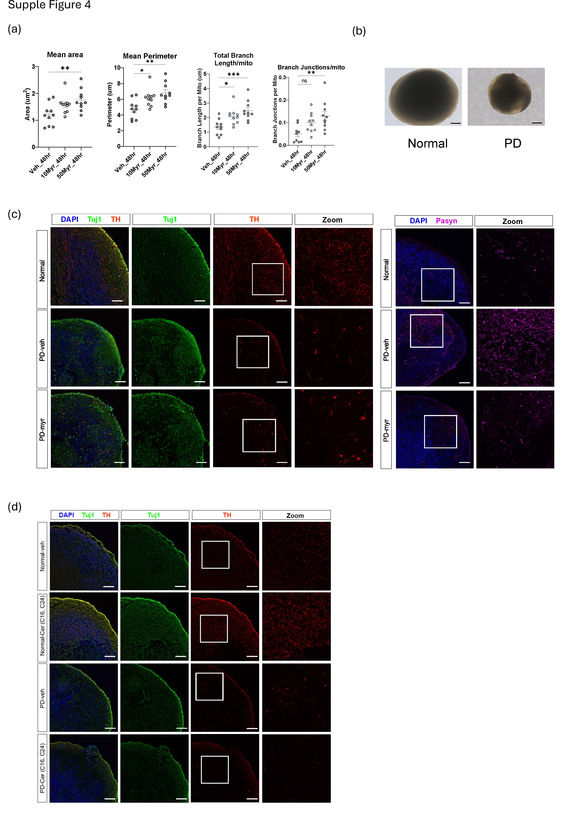
Supplementary Figure 4. Myriocin rescues dopaminergic neuronal loss and reduces α-synuclein aggregation in PD patient-derived midbrain organoids. (a) Quantification of mitochondrial morphology in patient-derived neurons treated with vehicle or myriocin (10 μM or 50 μM) for 48 hours. Morphological parameters including mitochondrial area, perimeter, total branch length, and branch junctions per mitochondrion were measured using Mitochondria Analyzer in ImageJ. Data represents SEM from n = 10 cells per condition. *p < 0.05, **p < 0.01, ***p < 0.001 by one-way ANOVA followed by Dunnett’s post hoc test for multiple comparisons. (b) Representative brightfield images of midbrain organoids generated from healthy control (Normal) and Parkinson’s disease (PD) iPSC lines. PD-derived organoids exhibited reduced size and irregular morphology, consistent with impaired neurodevelopment. Scale bars, 100 μm. (c) Immunofluorescence images of midbrain organoid sections from healthy control, PD-vehicle, and PD-myriocin groups. Left: Co-staining for Tuj1 (green), tyrosine hydroxylase (TH; red), and DAPI (blue) showed preservation of dopaminergic neurons following myriocin treatment. Right: Staining for phospho–α-synuclein (pS129; magenta) and DAPI (blue) revealed reduced α-synuclein aggregation in myriocin-treated PD organoids. Zoomed panels highlight representative regions. Scale bars, 100 μm. (d) Representative immunofluorescence images of midbrain organoids supplemented with either disease-relevant ceramides (C16 and C24) or vehicle control. Ceramide treatment reduced TH-positive neuronal area, especially in PD-derived organoids, suggesting exacerbation of neurodegenerative pathology. Staining for Tuj1 (green), TH (red), and DAPI (blue). Scale bars, 100 μm.

References
1 Calvelli, H. et al. in Methods in cell biology Vol. 155 557-579 (Elsevier, 2020).
2 Chaudhry, A., Shi, R. & Luciani, D. S. A pipeline for multidimensional confocal analysis of mitochondrial morphology, function, and dynamics in pancreatic β-cells. American Journal of Physiology-Endocrinology and Metabolism 318, E87-E101 (2020).

