Supplementary material information
Contents
Figure S1. Exposure-response relationship between ozone concentration and cardiovascular mortality in Zhejiang province in summer. 1
Table S1. Definitions of Different Temperature and Humidity Levels 1

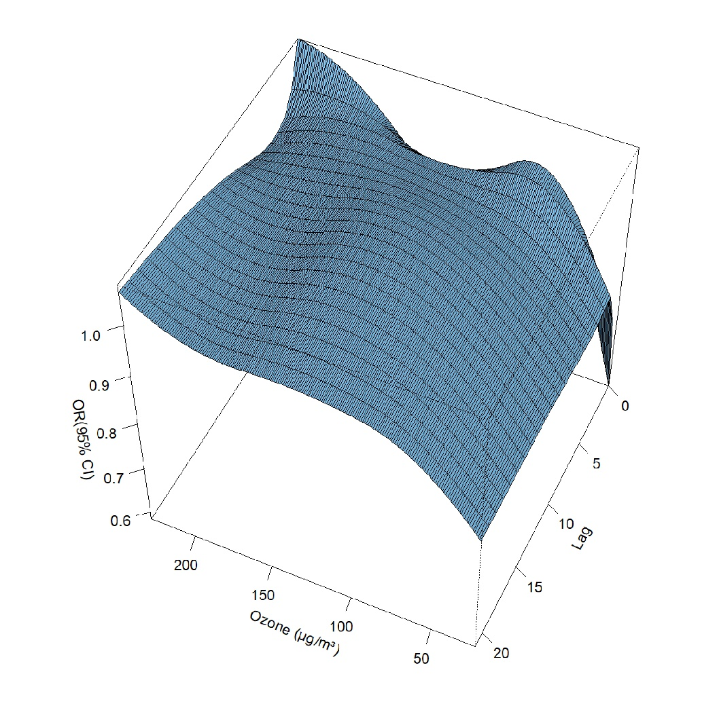
Figure S1. Exposure-response relationship between ozone concentration and cardiovascular mortality in Zhejiang province in summer. Three-dimensional surface plot of ozone concentration and lag days association with mortality risk

Table S1. Definitions of Different Temperature and Humidity Levels
Variable | Definition | abbreviation
High Temperature | T > P95 | HT
Low Temperature | T < P5 | LT
Mean Temperature | P5 ≤ T ≤ P95 | MT
High Humidity | RH ≥ 70% | HH
Mean Humidity | 40% ≤ RH < 70% | MH
Low Humidity | RH ≤ 40% | LH

