Supplemental A

Supplemental Methods

Pilot Study

Participants
The pilot study involved 33 children aged 3 to 11 years, recruited at the North Carolina Zoo between May 8 and May 10, 2024. Five children did not complete the testing session, resulting in a final sample of 28 participants see Table 1A for age distribution. Semi-structured interviews were conducted with a random sample of 8 children.

Image Changes and Replacements
During pilot testing, responses were reviewed for consistency and accuracy. Four pairs were replaced on the first day due to unintended elements (e.g., “a basketball would hit you”) or a lack of variation in responses (>75% selection). On the second day, another four pairs were replaced for similar reasons. Five additional pairs were introduced to increase category representation, including comparisons of lawns versus pollinator gardens and rainforest versus urban scenes. The pilot data was for exploratory purposes and was not included.

Table A1. Demographic Characteristics of Pilot Study Participants
Characteristic | n | %
Gender
F | 22 | 66.7
M | 11 | 33.3
Age
3 | 1 | 3
4 | 4 | 12.1
5 | 3 | 9.1
6 | 3 | 9.1
7 | 4 | 12.1
8 | 8 | 24.2
9 | 3 | 9.1
10 | 2 | 6.1
11 | 5 | 15.2
Included in analysis | 28 | 84.8
Excluded (any ND) | 5 | 15.2
Total | 33 | 100
Note. The table summarizes gender and age distributions for the full pilot sample (N = 33) and notes the final analytic sample (n = 28) after excluding five participants who did not complete testing (i.e., provided no data on more than 1 item).

Image Selection Procedures
A total of 60 images were curated to represent three factors: Wildlife Tolerance, Backyard Biophilia, and Biophilic Travel. Each factor included 20 images, organized into 10 pairs evenly divided between biodiverse and non-biodiverse settings. Images were required to exceed 1 MB in size and have a resolution of at least 72 dpi, and were captured at eye level under favorable weather conditions, adhering to criteria from Han (2007).
Backyard Biophilia: Images contrasted biodiverse yards and gardens (e.g., pollinator gardens with >80% woodland or native plant coverage) with non-biodiverse settings (e.g., traditional lawns and non-native shrub landscaping). Some images included age-appropriate activities, such as soccer or playgrounds.
Wildlife Tolerance: Twenty-nine images were initially evaluated by a panel of four experts and 13 undergraduates using the Delphi method⁴⁴. After revisions based on panel recommendations, 12 images were pilot tested, leading to the removal of four items. The final set included eight images (four pairs), depicting choices between biodiverse wildlife groups (including species from the FSSC-R list, e.g., bears, wolves, beetles) and less biodiverse, safer alternatives. One paired set featured U.S. wildlife; another featured Congolese wildlife.
Biophilic Travel: Images depicted biodiverse tropical rainforests and coral reefs versus non-biodiverse urban environments or chlorinated swimming pools. Species composition and relative abundance were estimated via digital photograph analysis and supported by a large language model (ChatGPT, OpenAI) to calculate diversity indices and generate visual field estimates. Green space estimates and reef biodiversity cover were derived using pixel-based image analysis calculations conducted via OpenAI's GPT-4, which includes multimodal image interpretation capabilities. All estimates were confirmed by two authors.

Table A2. Image Characteristics and Metrics

Backyard Biophilia
 | Species number | % vegetation | Shannon–Wiener Index (B)
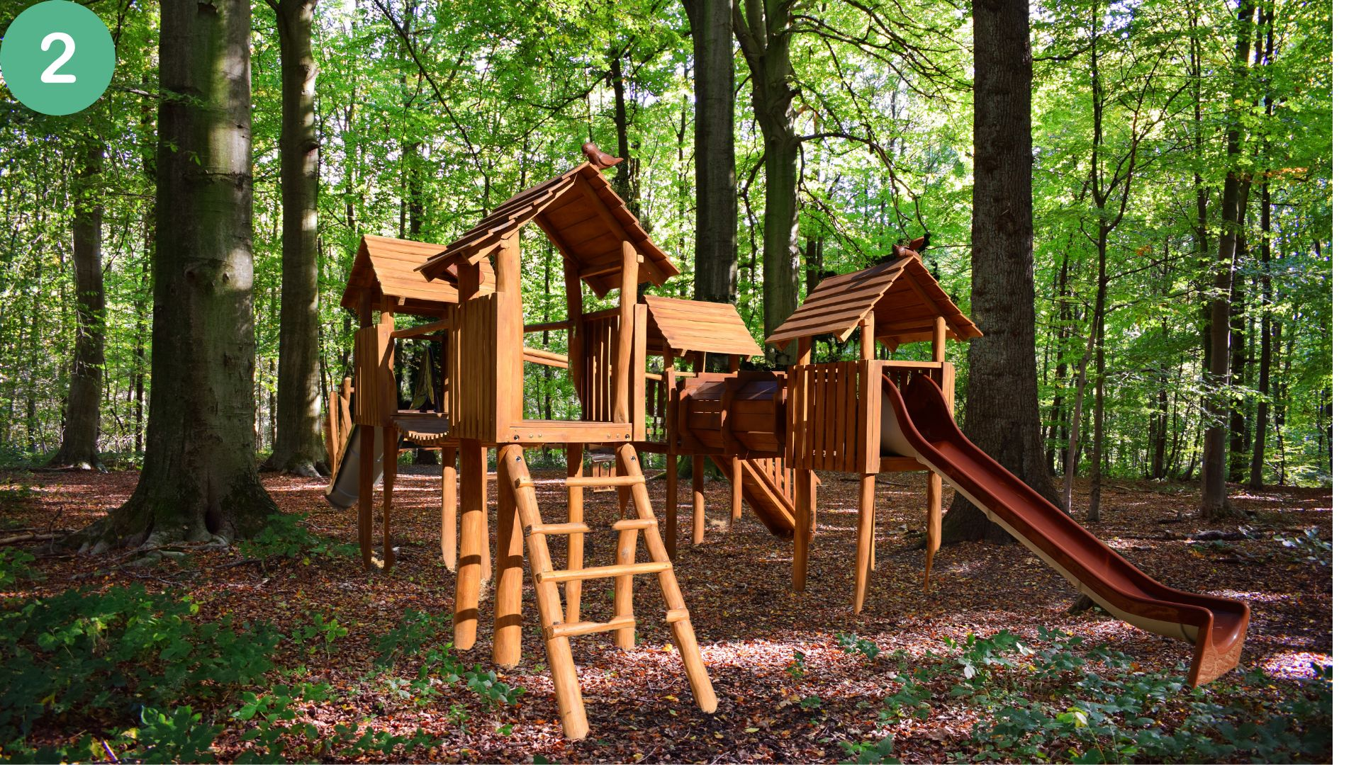 | 6 | 60 | 1.39 | American Beech (Fagus grandifolia) – 6 individuals – 40%  Oak (Quercus sp.) – 1 individual – 10%  Poison Ivy (Toxicodendron radicans) – 30%  Understory Shrubs (unidentified) – 15%  Vines/Saplings (unidentified) – 5%
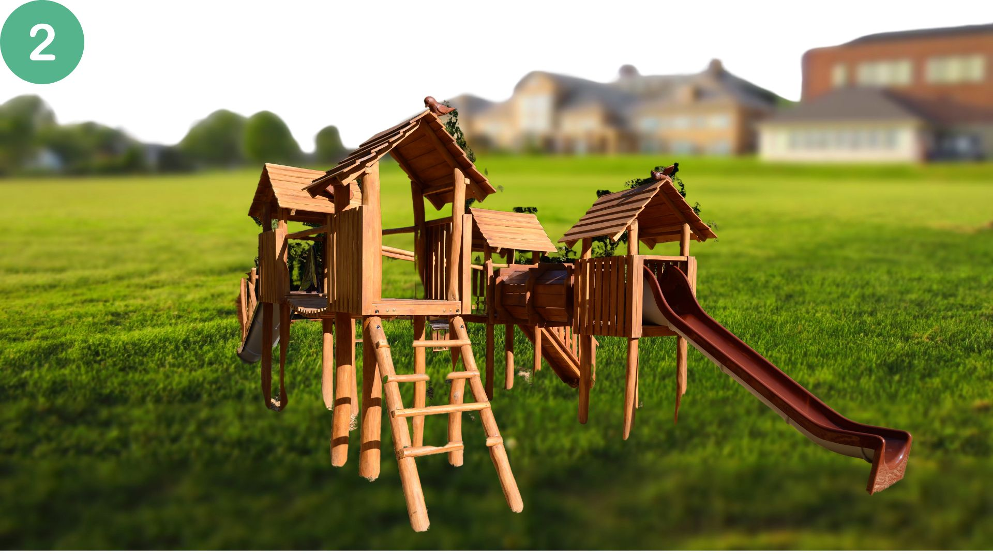 | 4 | 60 | 1.51 | Mown Lawn Grass Estimated % coverage: ~85% Species count: 1  Distant Trees / Shrubs (blurred background), Estimated % coverage: ~10% Species count: ~3 (broad estimate due to image blur)
 |  | 95% | 1.19 | Light green hedges – 1 species – 45% cover  Gray-green hedges (center of shapes) – 1 species – 30% cover  Background hedge (tall, dense, dark green wall) – 1 species – 20% cover  Grass lawn (pathways) – 1 species – 5% cover
 | 8-12 | 90% | 1.83 | Nettle (yellow flowers) – 1 species – 20% cover  Dianthus (pink flowers) – 1 species – 10% cover  Other pink flowers – 1 species – 10% cover  Hemlock (conifer) – 1 species – 10% cover  Purple flowers – 1 species – 10% cover  Ground cover (mixed herbs) – 2–3 species – 30% cover  Vine on bench – 1 species – 10% cover
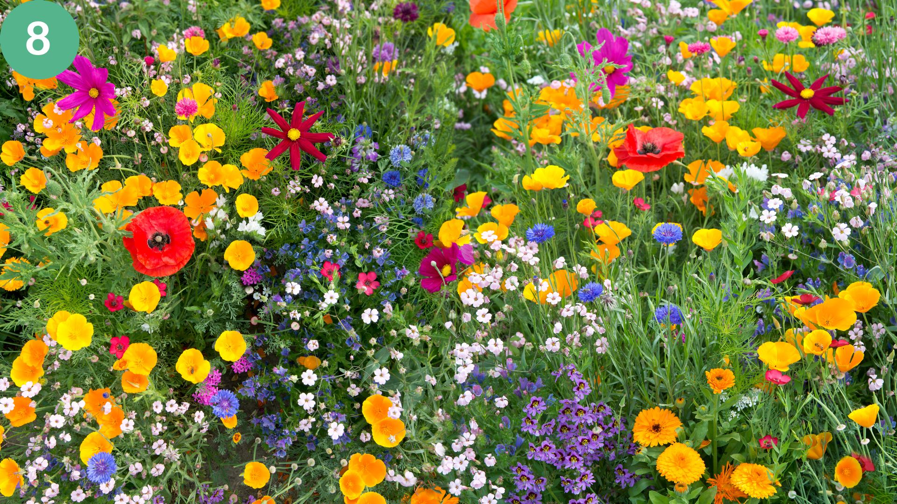 | 9 | 100 | 2.108 | California poppies (orange/yellow) – 25%  Calendula (orange) – 10%  Red poppies – 10%  Cosmos (red/pink) – 10%  Light pink flowers – 10%  Cornflowers (blue) – 10%  Pink flowers (species 1) – 10%  Pink flowers ( species 2) – 10%  Purple flowers – 5%
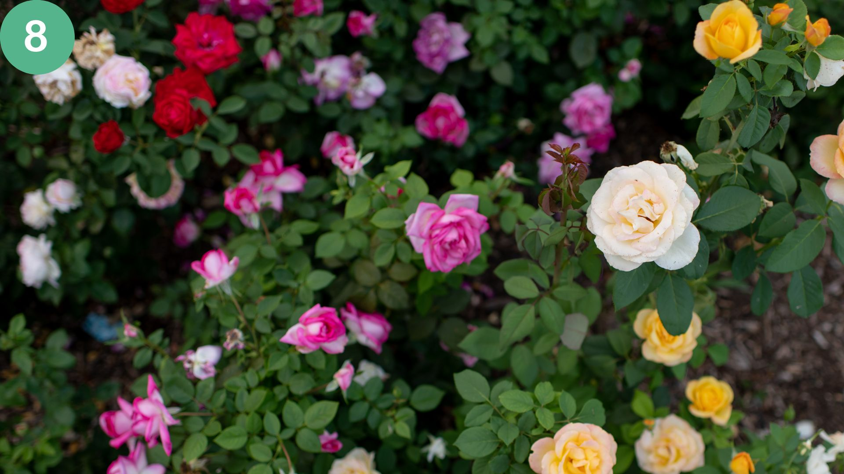 | 1 | 100 |  | Rose sp
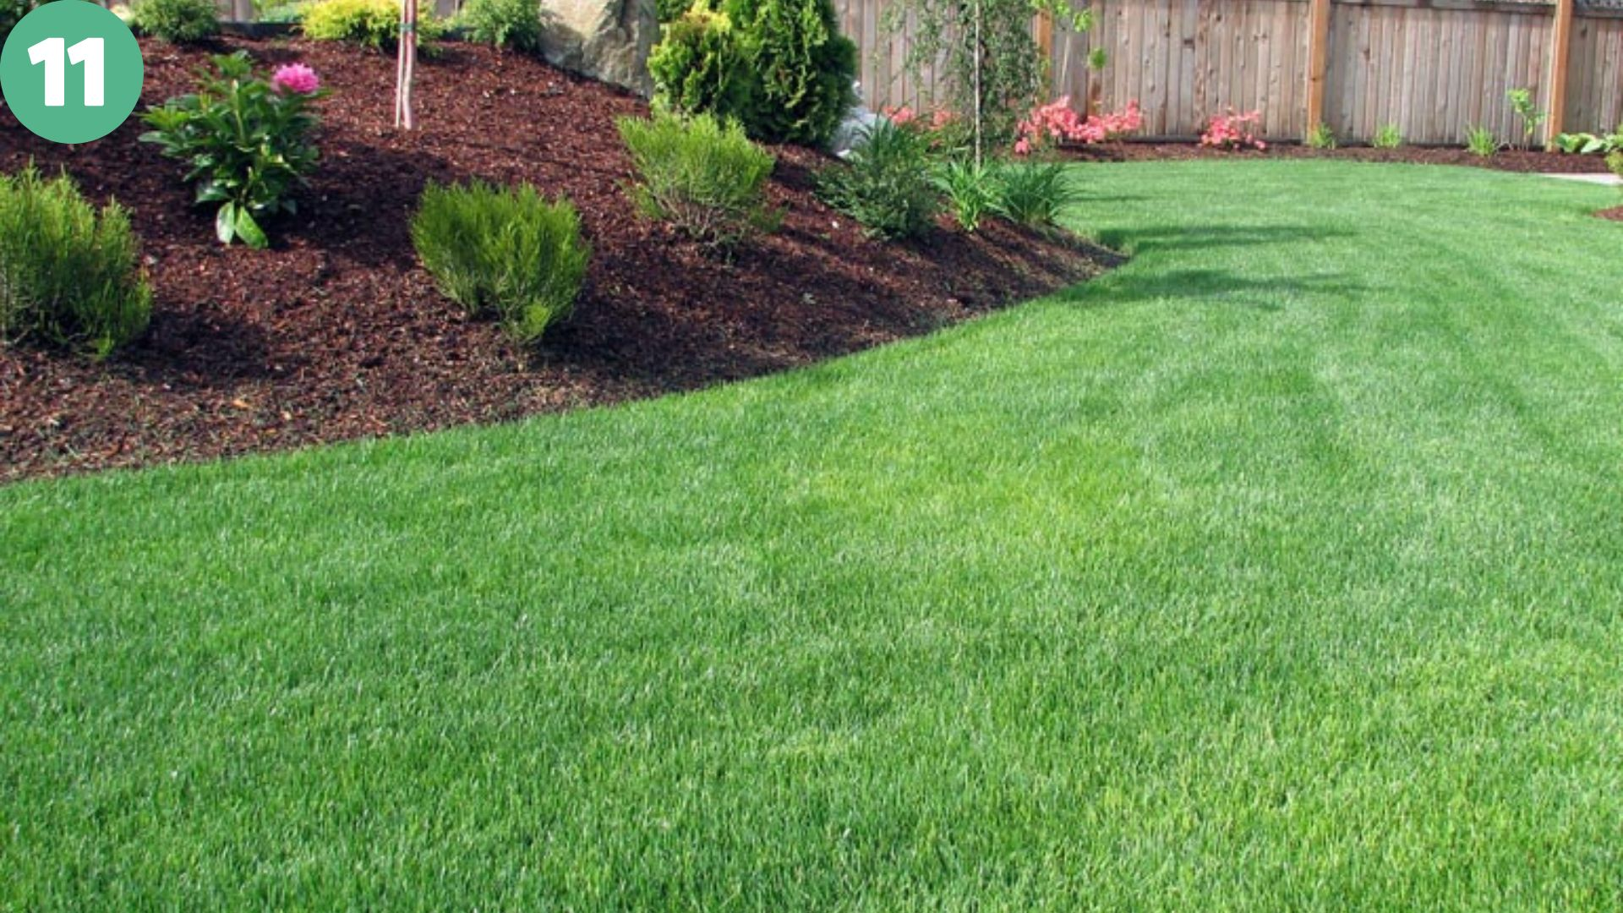 | 7 | 75 | 1.133 | Lawn Grass – 1 species – 70% cover  Boxwood or Low Shrubs – 1 species – 8% cover  Peony (pink flowering shrub) – 1 species – 4% cover  Daylilies (sprouting foliage near mulch) – 1 species – 4% cover  Conifers (small evergreen shrubs/trees) – 1 species – 5% cover  Azaleas (flowering shrubs along back fence) – 1 species – 6% cover  Weeping Cherry Tree – 1 species – 3% cover
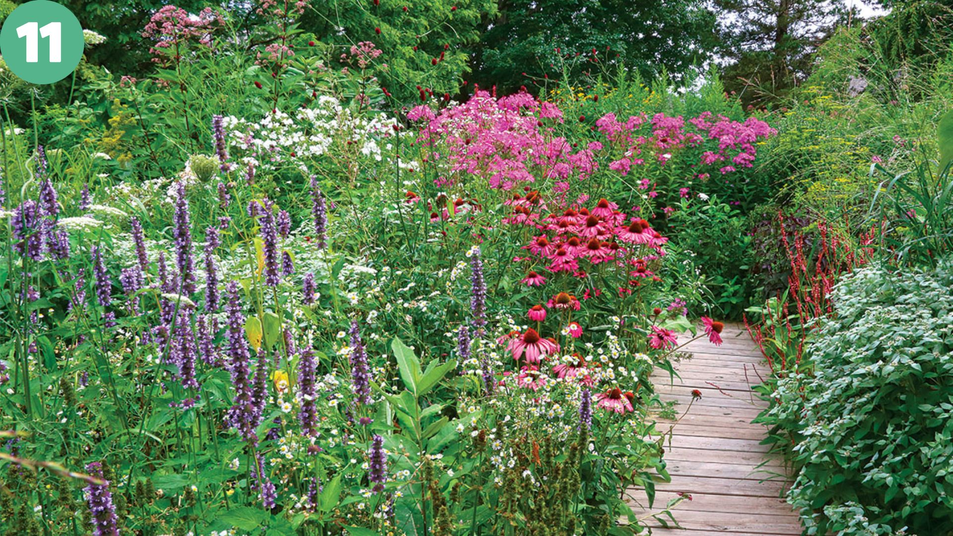 | 16 | 90 | 2.63 | Salvia (purple flower spikes) – 1 species – 15% cover  Echinacea (pink coneflowers) – 1 species – 10% cover  Phlox (tall pink flowers) – 1 species – 10% cover  Fleabane (white daisy-like flowers) – 1 species – 5% cover  Joe Pye Weed (tall pink clusters) – 1 species – 5% cover  Persicaria (red flower spikes) – 1 species – 5% cover  Red flower species (additional) – 2 species – 10% cover total  Common Milkweed (Asclepias syriaca) – 1 species – 5% cover  Mountain Mint (Pycnanthemum spp.) – 1 species – 10% cover  Grasses (various) – 1 species – 10% cover  Broad-leaved foliage plants (non-flowering) – 1 species – 5% cover  Other herbaceous plants (background/edge) – 1 species – 5% cover  Mature Trees (various species) – 4 species – <1% cover each
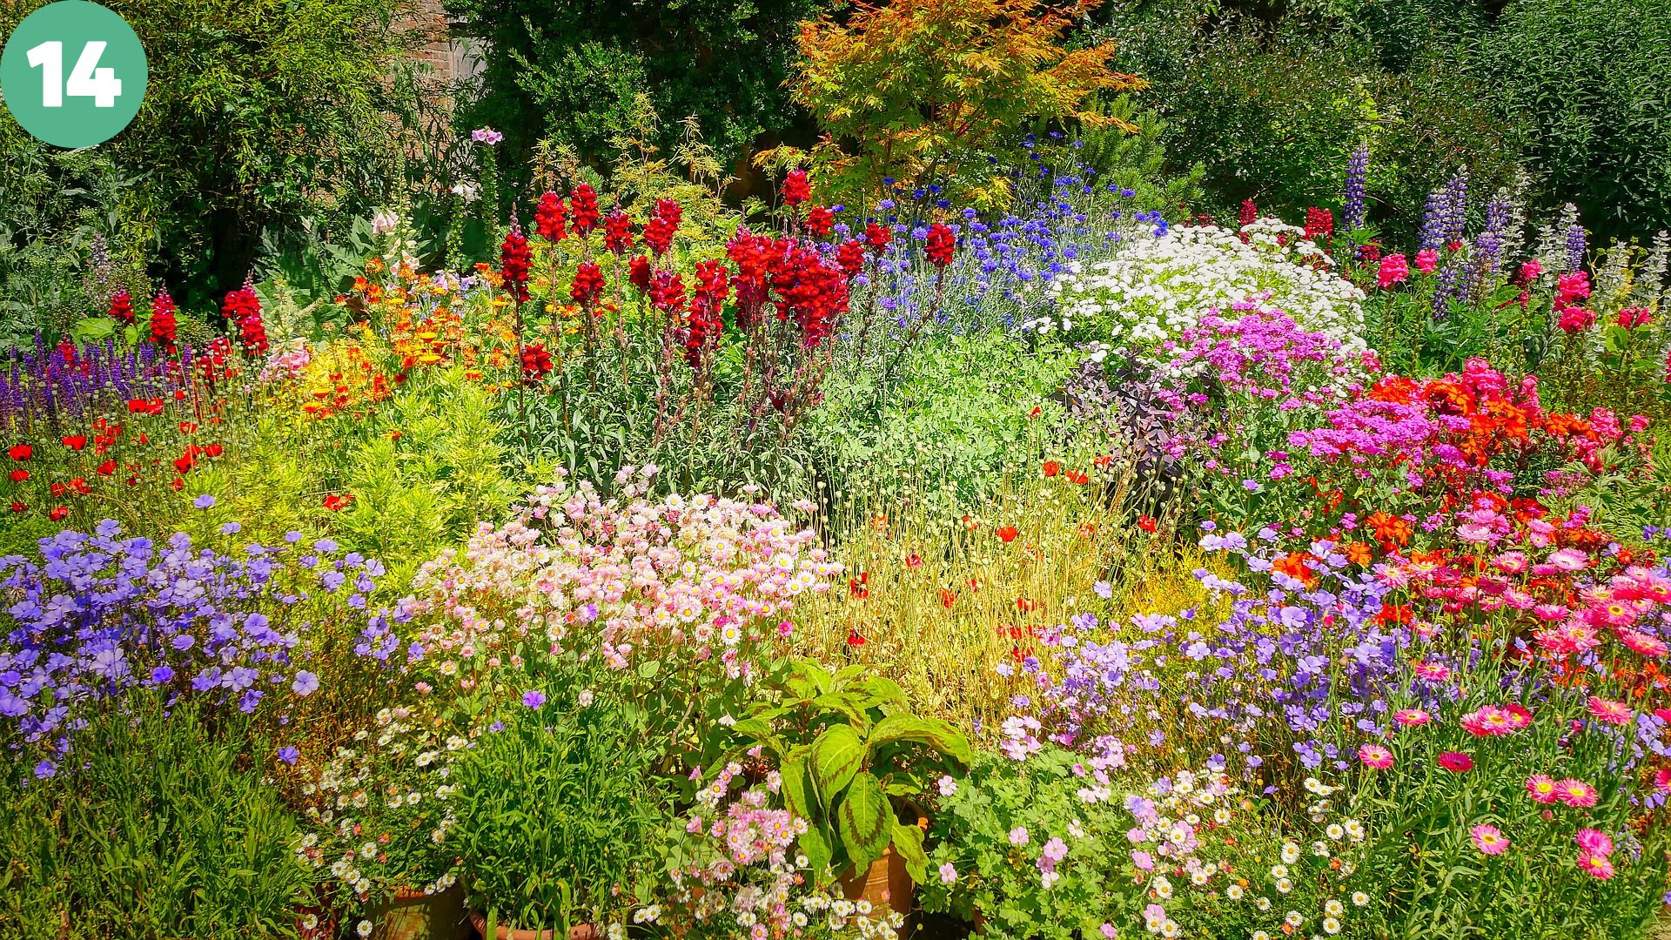 | 14 | 100 | 2.64 | California poppy – 5%  Orange calendula – 5%  Red poppy – 7%  Red/pink cosmos – 6%  Blue cornflower – 8%  Purple salvia – 7%  Phlox – 7%  Tall red snapdragon – 10%  Foxglove – 4%  Fleabane – 5%  Pink geranium – 6%  Lupine – 8%  Japanese maple – 12%  Unknown pink flower #1 – 5%  Unknown pink/purple flower #2 – 5%
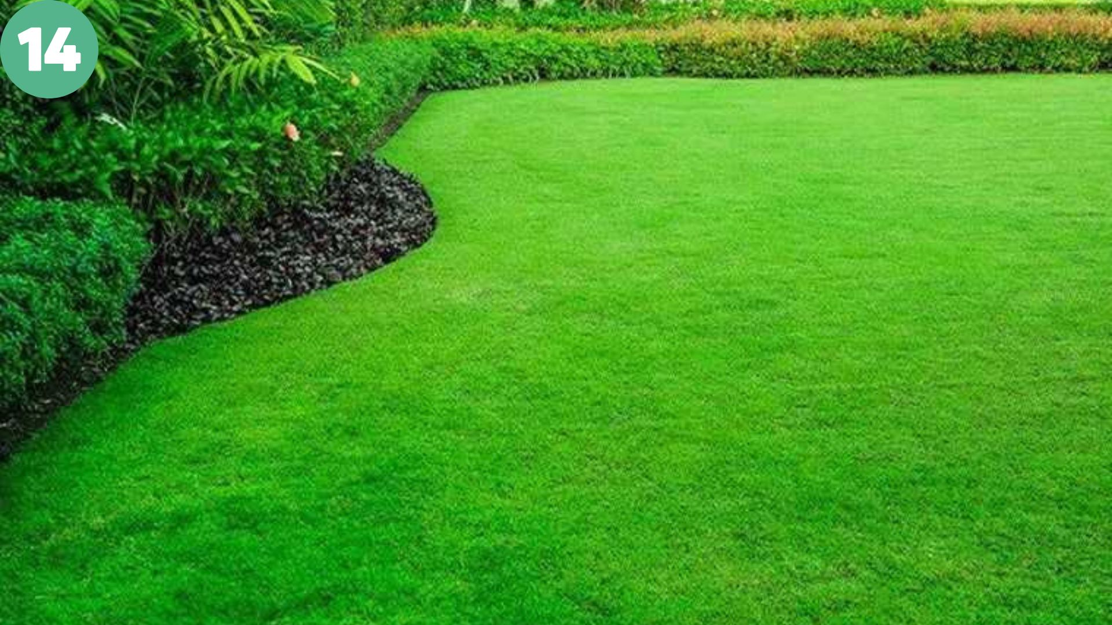 | 5 | 95 | 0.47 | Turfgrass (lawn) – 1 species – 85% cover  Shrubs (mid-ground, 2 types) – 2 species – 5% cover  Tall hedge (background) – 1 species – 3% cover  Groundcover (black-leaved plant) – 1 species – 2% cover

Wildlife human interaction
 | Species number | Total number | Shannon–Wiener Index (H') | Pielou’s Evenness (J')
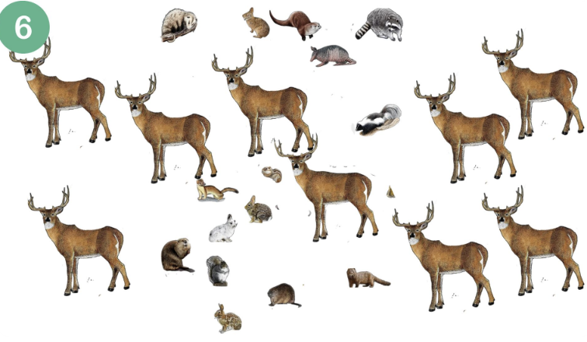 | 11 | 20 | 1.94 | 0.81
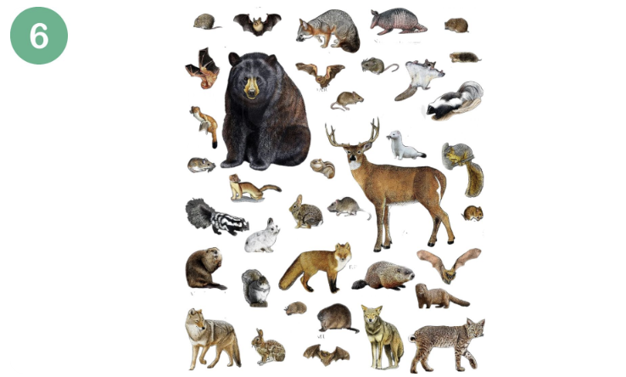 | 19 | 24 | 2.87 | 0.97
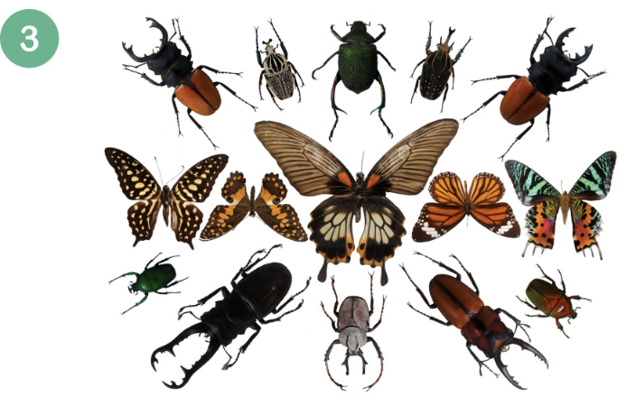 | 13 | 14 | 0.96 | 0.87
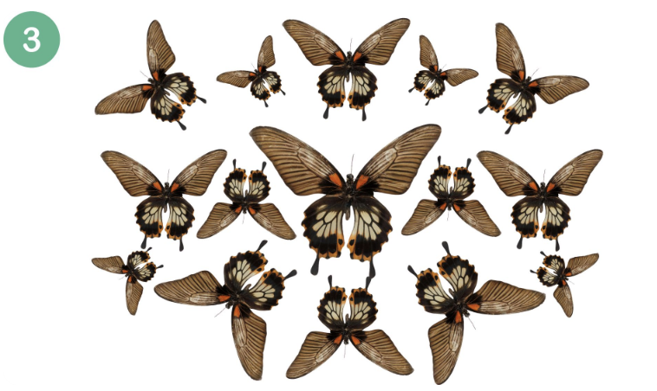 | 1 | 16 | 0 | 0
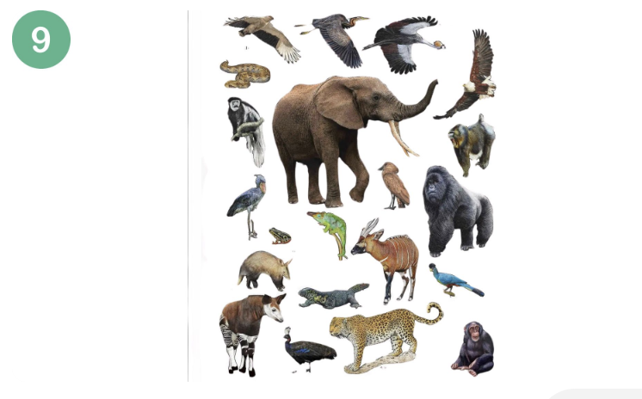 | 22 | 22 | 3.09 | 1.0
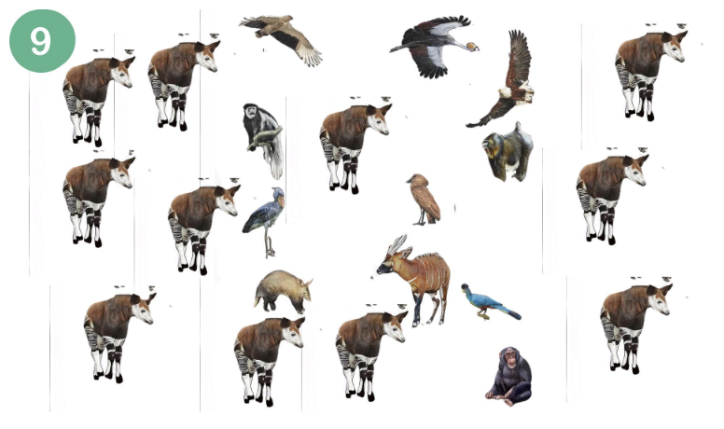 | 13 | 23 | 1.89 | 0.76
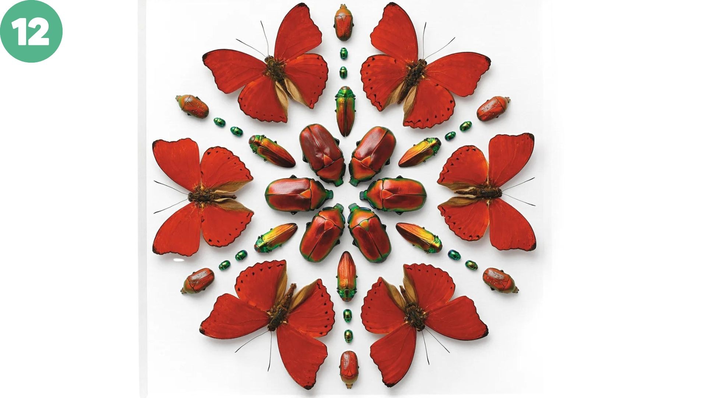 | 5 | 36 | 1.56 | 0.97
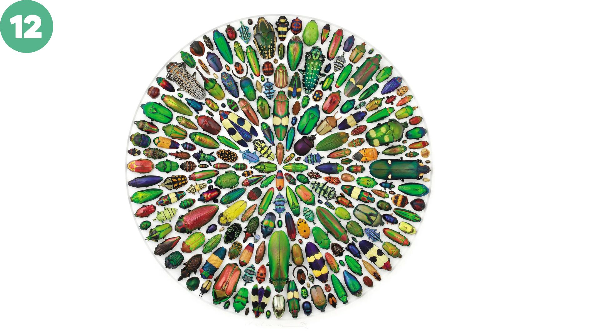 | 131 | 144 | 4.83 | 0.99
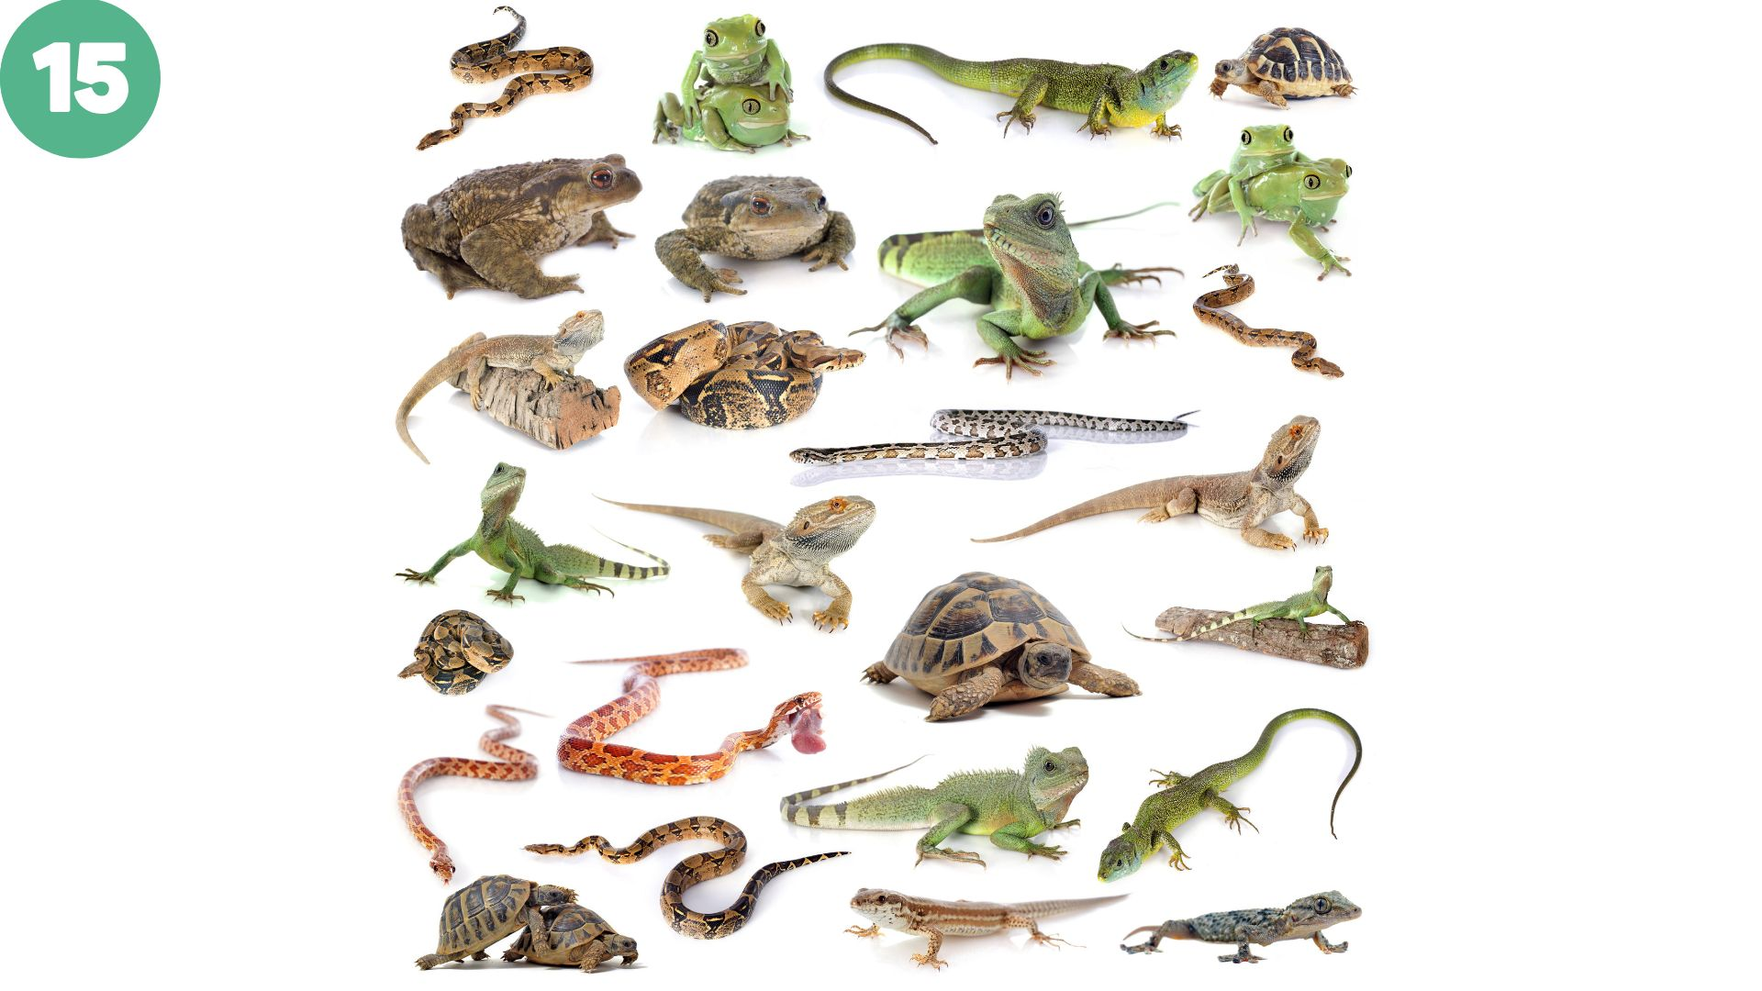 | 15 | 21 | 2.62 | 0.97
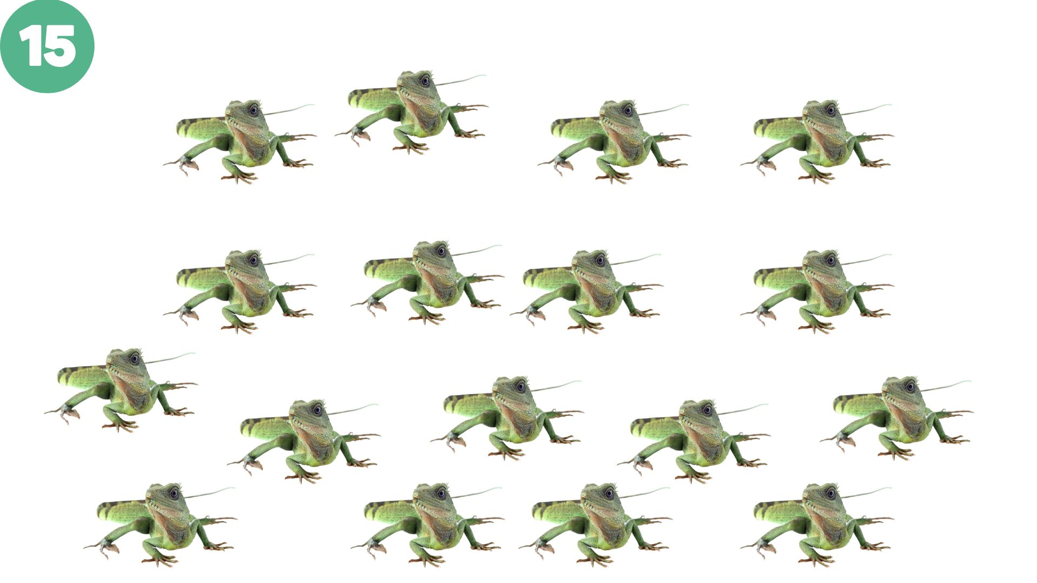 | 1 | 17 | 0 | 0

Biophilic Travel
 | % greenspace | Description
 | 90–95% | Very high green cover, typical of tropical rainforest landscapes.
 | 15–20% | Low green cover, though it reflects a relatively greener section of an urban setting thanks to planned tree-lined boulevards.
 | 85–90% | Very high green cover, consistent with dense tropical forest imagery.
 | 25–30% | moderate green cover in a built environment with concentrated but limited greenery.
 | 20–25% | Low-to-moderate green cover for an urban landscape.
 | 85–90% | Very high green cover, typical of a mature, tropical rainforest scene
 | 5–10% | Very low green cover; indoors with a few sparse palms and plants
 | 0% | No biodiversity
 | 40–50% | High coral reef presence including coral formations, anemones, and reef structures

Demographic Characteristics

Table A3. Full characteristics of children who participated stratified by country, gender, and age, including missing data
 |  | TOTAL |  |  |  | US |  |  |  | Congo
 |  | (n=310) |  |  |  | (n=133) |  |  |  | (n=177)
Sample characteristic | n | ND | % | ND | n | ND | % | ND | n | ND | % | ND
Demographics | 295 | 15 | ` | 5% | 124 | 9 | 93% | 7% | 171 | 6 | 96% | 3%
Gender
Male | 139 | 6 | 45% | 2% | 57 | 6 | 43% | 5% | 82 | 0 | 46% | 1%
Female | 156 | 9 | 50% | 3% | 67 | 3 | 50% | 2% | 89 | 6 | 50% | 3%
Age, years
3 | 12 | 3 | 4% | 1% | 12 | 3 | 9% | 2% | 0 | 0 | 0% | 0%
4 | 11 | 1 | 4% | 0% | 11 | 1 | 8% | 1% | 0 | 0 | 0% | 0%
5 | 16 | 3 | 5% | 1% | 15 | 3 | 11% | 2% | 1 | 0 | 1% | 0%
6 | 20 | 3 | 6% | 1% | 20 | 2 | 15% | 2% | 0 | 1 | 0% | 0%
7 | 10 | 1 | 3% | 0% | 9 | 0 | 7% | 1% | 2 | 0 | 1% | 0%
8 | 21 | 1 | 7% | 0% | 16 | 0 | 12% | 0% | 5 | 1 | 3% | 0%
9 | 25 | 0 | 8% | 0% | 14 | 0 | 11% | 0% | 11 | 0 | 6% | 0%
10 | 59 | 2 | 19% | 1% | 14 | 0 | 11% | 0% | 47 | 0 | 25% | 1%
11 | 50 | 1 | 16% | 0% | 3 | 0 | 2% | 0% | 48 | 0 | 27% | 0%
12 | 50 | 1 | 16% | 0% | 7 | 0 | 5% | 0% | 44 | 0 | 24% | 0%
13 | 16 | 0 | 5% | 0% | 3 | 0 | 2% | 0% | 13 | 0 | 7% | 0%
>14 | 0 | 4 | 0% | 2% | 0 | 0 | 0% | 0% | 0 | 4 | 0% | 2%

Abbreviations: ND= missing or incomplete data

Supplemental Results

Biophobia Score Distribution
Figure 1A illustrates the distribution of biophobia scores among children in the United States and the Democratic Republic of Congo. Biophobia scores reflect the average level of aversive response to animals, assessed across multiple trials, with possible values ranging from 0 (no fear) to 2 (high fear). The histogram shows the percentage of children in each country corresponding to each mean score, while the overlaid dashed lines represent normal curve approximations for each group. Both distributions approximate normality, with slightly higher variability in the Congolese sample. This pattern supports the prediction of individual variability in biophobia and suggests that strong fear responses to animals are not universally elevated in either cultural context.

Figure A1. Histogram of biphobia scores in US and Congolese children

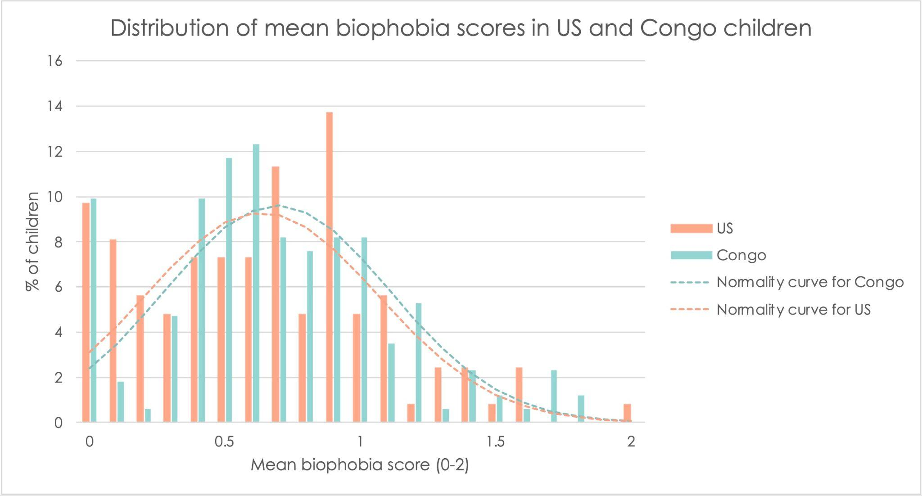
Note. Bars represent the percentage of children in each country with a given mean biophobia score (range: 0–2). Dashed lines indicate normal curve approximations for each group. Biophobia reflects aversive responses to animals across multiple trials.

Figures A2 displays the distribution and normality of biophilia scores across the primary factors measured in the study. Each histogram represents children’s average responses to different dimensions of biophilic attraction, with scores ranging from 0 (no attraction) to 2 (high attraction). Dashed lines indicate normal curve approximations for each factor. The distributions for all biophilia factors were approximately normal, with no evidence of floor or ceiling effects. This pattern supports the hypothesis that biophilia reflects a temperament trait characterized by individual variability.

Figures A2. Normality and distribution of biophilia factors

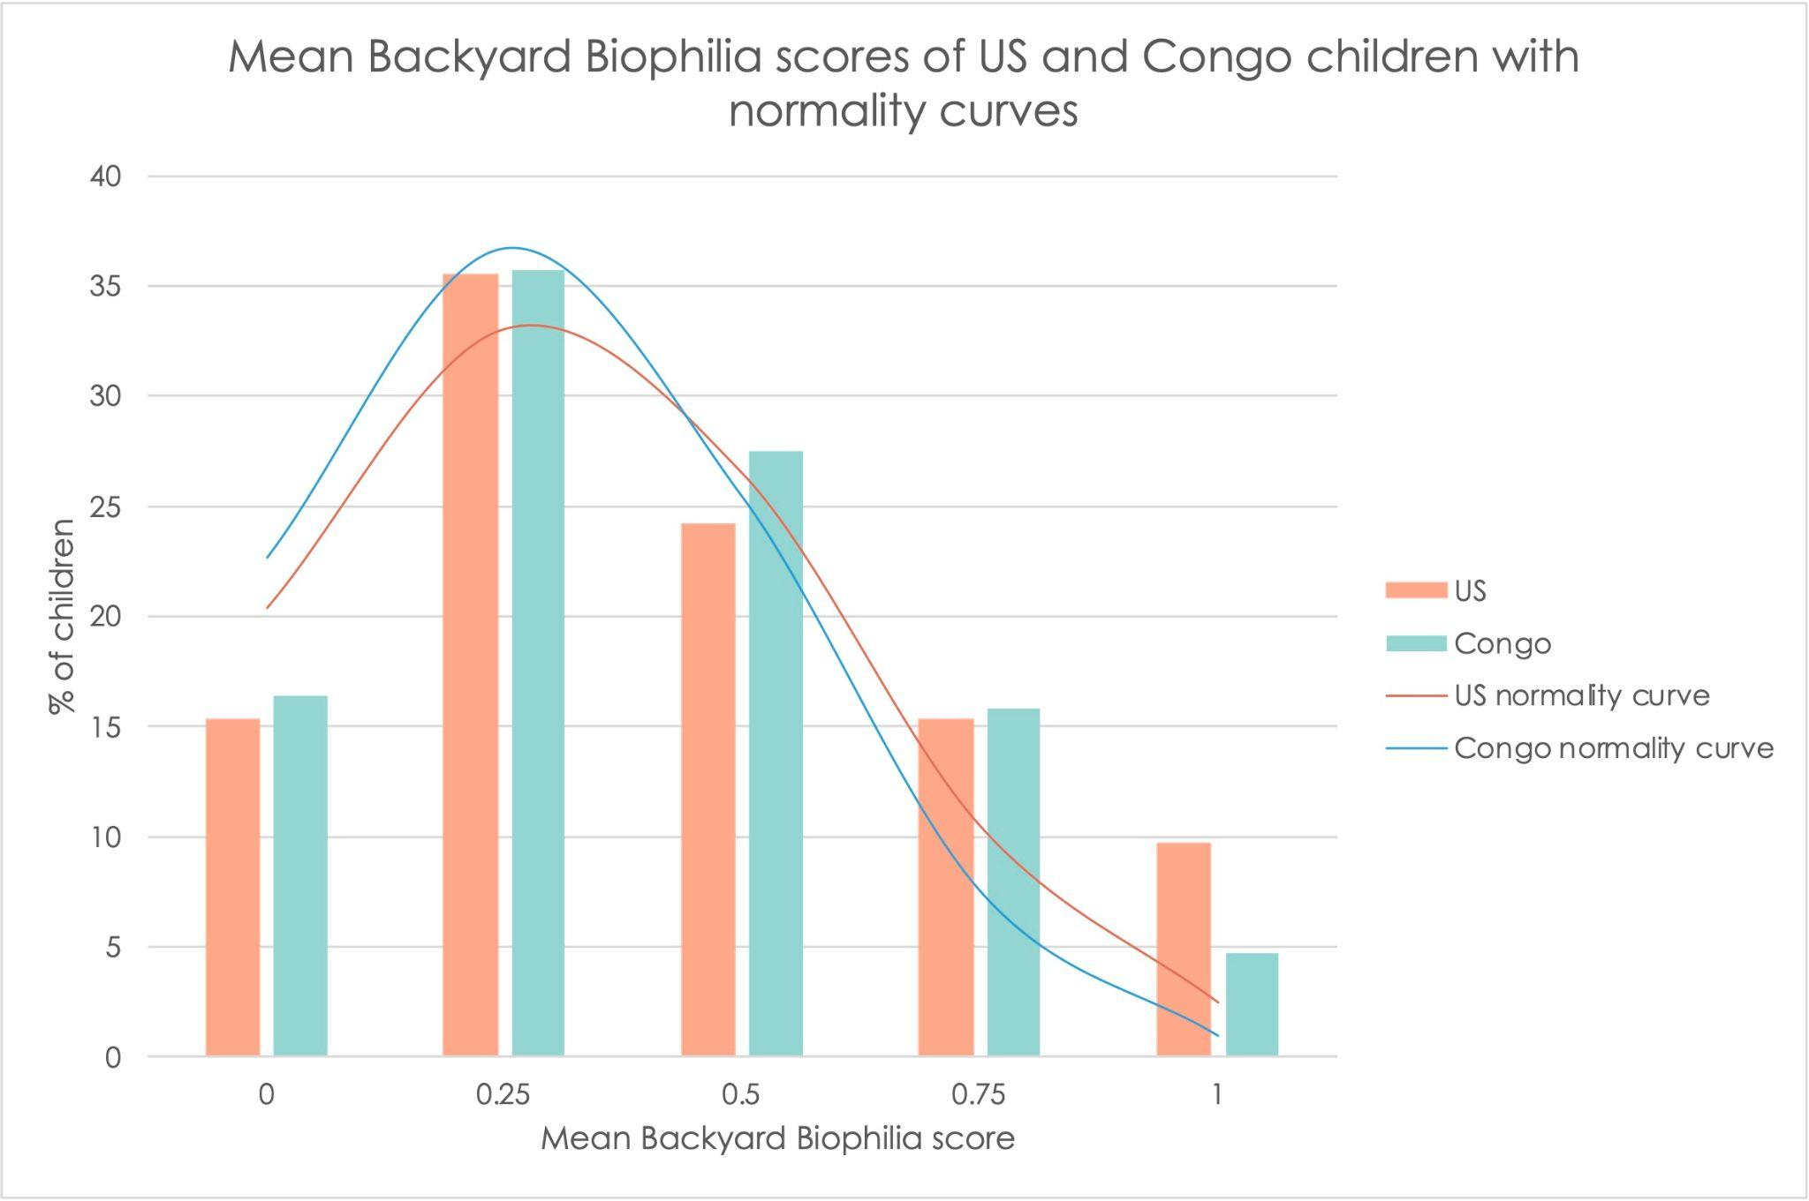
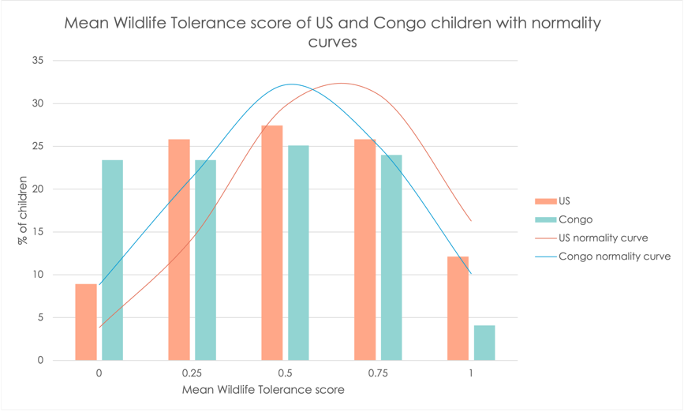
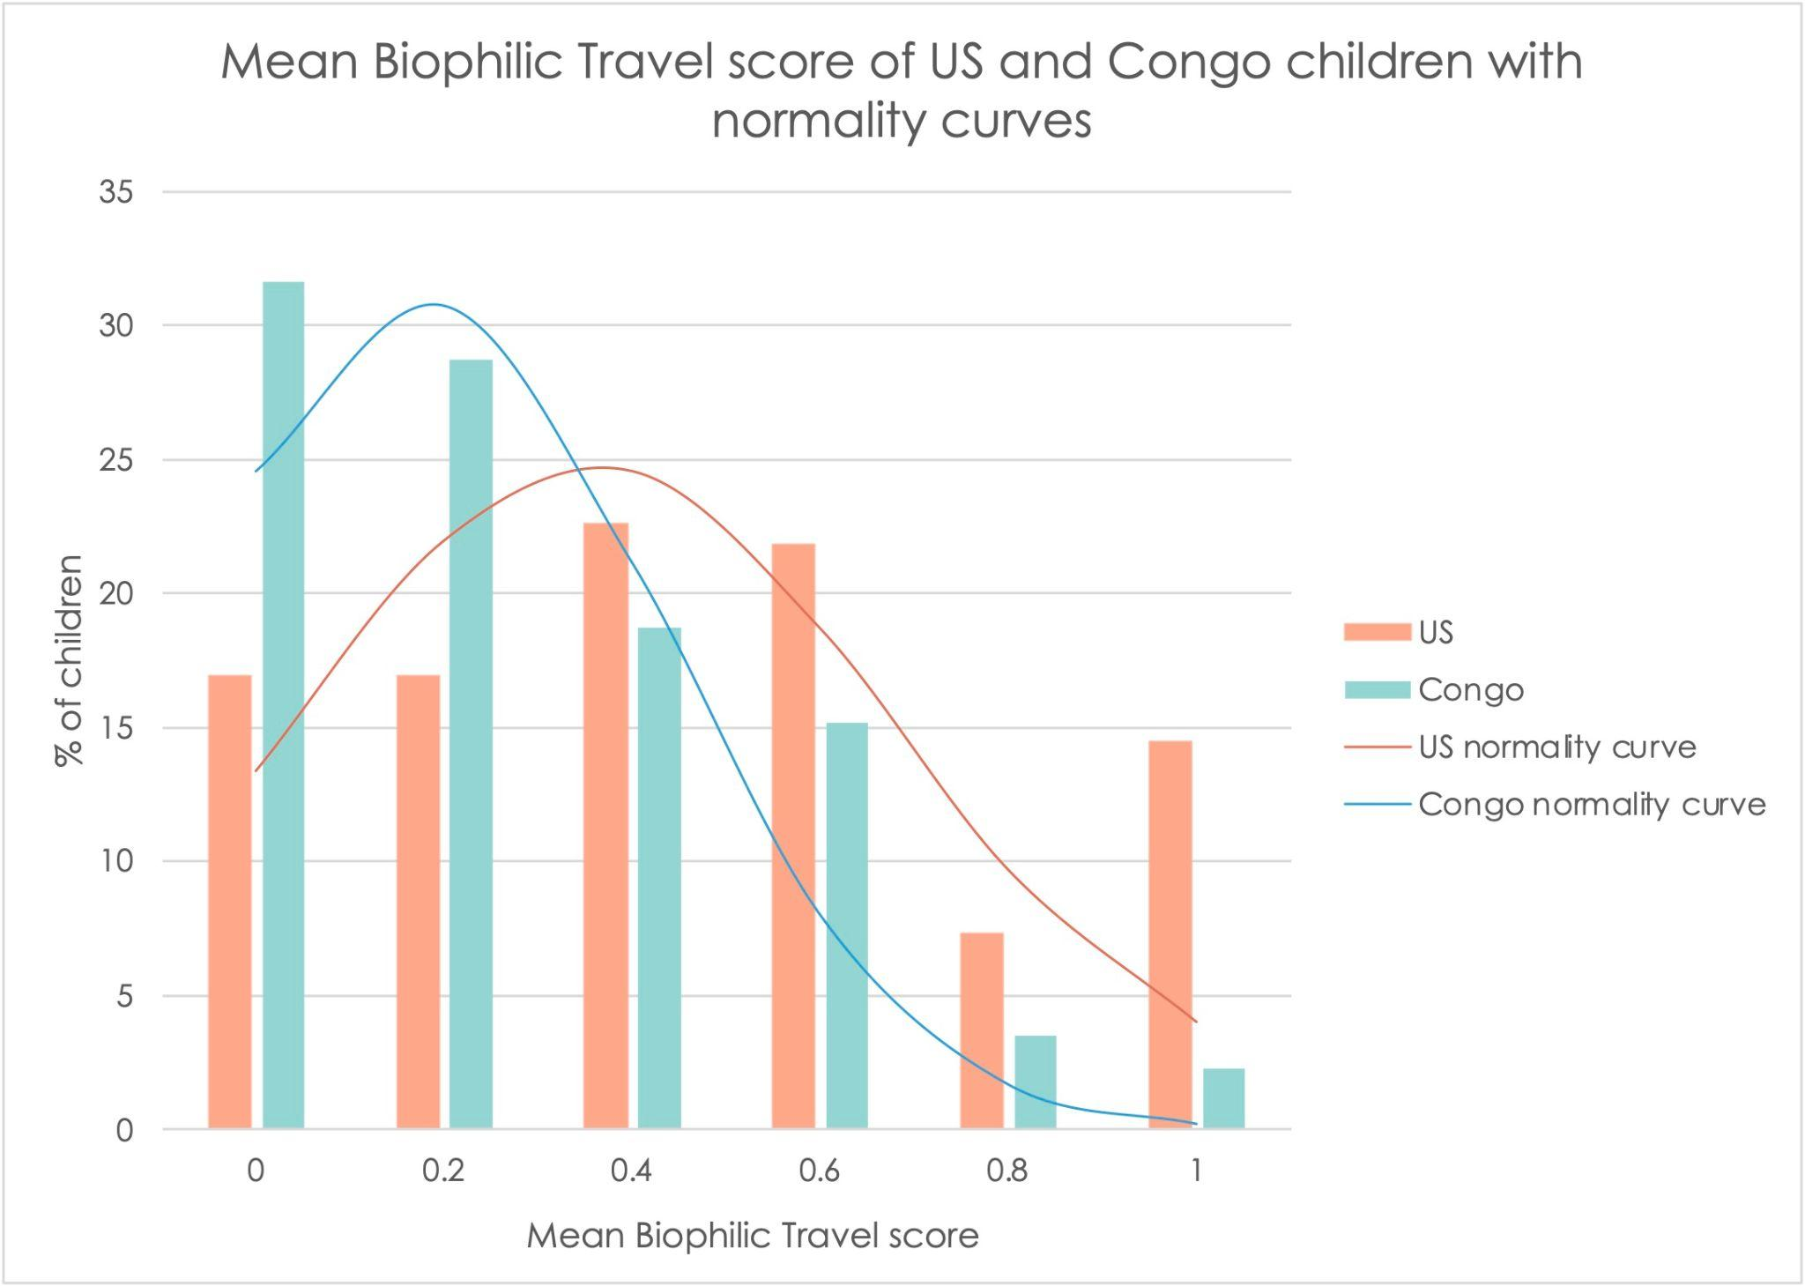

Independent Samples t-Tests

Figure A3 presents the results of independent samples t-tests comparing biophilia scores between children in the United States and the Democratic Republic of Congo across three domains: Wildlife Tolerance, Backyard Biophilia, and Biophilic Travel. Mean scores for each group are displayed with 95% confidence intervals, and asterisks denote statistically significant differences (p < .01). Effect sizes (Cohen’s d) are reported beneath each domain, indicating the magnitude of group-level differences. U.S. children showed significantly higher biophilia scores in the Wildlife Tolerance and Biophilic Trave domains, while no significant difference was observed in Backyard Biophilia. These results highlight both cultural variability in biophilic preferences and the importance of instrument sensitivity in detecting such differences.

Figure A3. Independent samples t test of biophilic factors in children in the United States and Congo.

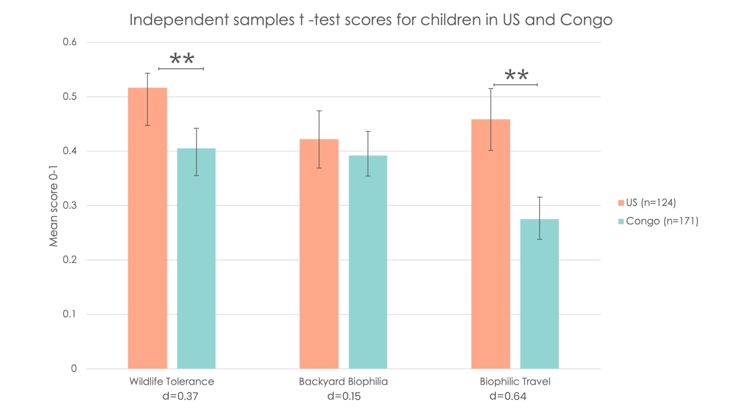
Note: Mean Wildlife Tolerance, Backyard Biophilia, and Biophilic Travel scores for children in the United States and Congo. Error bars represent 95% confidence intervals. Asterisks indicate statistically significant differences between countries (p < .01). Effect sizes (Cohen’s d) are reported below each factor.

Biophobia Results
Table A4 presents the results of independent samples t-tests comparing fear responses to individual animals between children in the United States and the Democratic Republic of Congo. For each animal, mean fear scores and standard deviations are reported by country, along with test statistics, p-values, confidence intervals for the mean difference, and Cohen’s d effect sizes. Negative t and Cohen’s d values indicate higher fear in the Congolese sample, while positive values reflect higher fear in the U.S. sample. Statistically significant differences (p < .05) are bolded. U.S. children reported significantly more fear of spiders, ants, and beetles, while Congolese children showed significantly higher fear of larger mammals and reptiles, such as bears, snakes, wolves, and lizards. These results reveal both cross-cultural differences in specific animal fears and broad variability in biophobic responses.

Table A4. Independent samples t-test results for fear of individual animals in U.S. and Congolese children

Animal | M (US) | SD (US) | M (Congo) | SD (Congo) | t(df) | p | 95% CI (Mean Diff) | Cohen's d [95% CI]
Bears | 1.0 | 0.8 | 1.3 | 0.8 | -3.58 (293) | 0.001 | [-0.53, -0.15] | -0.42 [-0.66, -0.19]
Snakes | 1.0 | 0.8 | 1.3 | 0.8 | -2.86 (293) | 0.005 | [-0.45, -0.08] | -0.34 [-0.57, -0.10]
Wolves | 0.9 | 0.9 | 1.2 | 0.8 | -3.05 (293) | 0.003 | [-0.49, -0.11] | -0.36 [-0.59, -0.13]
Spiders | 0.9 | 0.8 | 0.6 | 0.7 | 3.95 (293) | 0.001 | [0.18, 0.53] | 0.47 [0.23, 0.70]
Bats | 0.6 | 0.7 | 0.7 | 0.8 | -0.78 (293) | 0.434 | [-0.24, 0.10] | -0.09 [-0.32, 0.14]
Beetles | 0.7 | 0.8 | 0.5 | 0.7 | 2.43 (293) | 0.016 | [0.04, 0.40] | 0.29 [0.05, 0.52]
Ants | 0.5 | 0.7 | 0.2 | 0.5 | 4.04 (293) | 0.001 | [0.15, 0.44] | 0.48 [0.24, 0.71]
Lizards | 0.3 | 0.6 | 0.6 | 0.8 | -3.50 (293) | 0.001 | [-0.45, -0.13] | -0.41 [-0.65, -0.18]
Cats | 0.2 | 0.5 | 0.3 | 0.6 | -1.17 (293) | 0.242 | [-0.21, 0.05] | -0.14 [-0.37, 0.09]
Birds | 0.1 | 0.4 | 0.2 | 0.5 | -1.50 (293) | 0.135 | [-0.21, 0.03] | -0.18 [-0.41, 0.06]
Note: Animals are listed in order of highest to lowest fear score in US children. Means (M) and standard deviations (SD) are reported separately for U.S. and Congolese participants. t-tests reflect independent group comparisons. Negative t and Cohen’s d values indicate higher fear reported in the Congo sample, except where direction is reversed (e.g., spiders, ants). Significant comparisons are bolded. CI = confidence interval.

An independent samples t-test further revealed no significant difference in overall biophobia scores between U.S. (M = 0.64, SD = 0.43) and Congolese (M = 0.69, SD = 0.42) children, t(293) = –1.13, p = .26, with a small and nonsignificant effect size (Cohen’s d = –0.13).
Unique Capture of Attraction: To assess whether the biophilia instrument uniquely captured active attraction to biodiversity rather than simply reflecting low levels of fear, we examined the associations between biophobia and each biophilia domain. As reported in Prediction 5, none of the biophilia domains were significantly correlated with biophobia in either the U.S. or Congolese samples. Correlation coefficients were small and nonsignificant across all pairings (e.g., Wildlife Tolerance–Biophobia, U.S.: r = .000, p = .999; Congo: r = .011, p = .890), suggesting that fear-based responses and preference-based engagement operate as independent constructs.
Furthermore, country-level differences were robust in biophilia (Wildlife Tolerance and Biophilic Trave), but not in biophobia. Taken together, these findings support the conclusion that the preference-based biophilia instrument captures dimensions of attraction that cannot be inferred from the absence of fear alone, reinforcing its validity as a distinct and necessary tool for assessing children's orientation toward biodiversity.

Correlational Analyses

Correlation of Biophobia factors
Table A5 reports Pearson correlations between biophobia and three biophilic factors—Backyard Biophilia, Biophilic Travel, and Wildlife Tolerance—in children from the United States and the Democratic Republic of Congo. Correlation coefficients (r) and associated p-values are provided for each relationship. In both samples, biophobia was not significantly correlated with any of the biophilic domains, suggesting that fear of animals and attraction to biodiversity are largely independent constructs in early development. These findings support the hypothesis that biophobia and biophilia operate along distinct dimensions, rather than existing as opposite ends of a single continuum.

Table A5. Correlations Between Biophobia and Biophilic Factors in U.S. and Congolese Samples
Variable | Backyard Biophilia (r, p) | Biophilic Travel (r, p) | Wildlife Tolerance (r, p)
U.S. sample (N = 124)
Biophobia | .131 (.146) | –.068 (.454) |  | .000 (.999)
Congolese sample (N = 171)
Biophobia | .089 (.247) | .034 (.661) |  | .011 (.890)
Note. Pearson correlations are reported. Values are presented as r (p-value). *p < .05. **p < .01.

Factor Analysis and Principal Component Analysis (PCA)
Table A6 displays exploratory item-level correlations between specific biophobia items and biophilic engagement items, following a factor analytic approach to structure the biophilia dimensions. An oblimin rotation was applied to allow for factor intercorrelations, yielding a three-factor solution consistent with theoretical expectations: Backyard Biophilia (BB), Wildlife Tolerance (WT), and Biophilic Travel (BT). Principal Component Analysis (PCA) was then used to reduce dimensionality and summarize preferences across these factors. The table reports Pearson correlations between select Wildlife Tolerance items and fear responses to animals (e.g., bats, snakes, bears, wolves) in both the U.S. and Congolese samples. No significant associations emerged, and most correlations were near zero. These results suggest limited direct correspondence between specific aversive responses and preferences for biophilic engagement, further supporting the conceptual distinction between biophobia and biophilia as independent constructs.

Table A6. Exploratory Item-Level Correlations Between Biophobia Items and Biophilic Engagement Items
Variables | US r | US p | Congo r | Congo p
WT- bug group x beetle fear | .071 | .432 | .02 | .793
WT-deer group × Bats fear | .049 | .589 | –.023 | .769
WT-okapi group × Snakes fear | –.038 | .673 | .031 | .690
WT-deer group × Bears fear | –.024 | .793 | –.111 | .150
WT-deer group × Wolves fear | –.067 | .463 | –.065 | .399
WT Q15 × Snakes fear | –.069 | .448 | –.004 | .961
Note. Pearson correlations (r) and two-tailed significance levels (p) are reported separately for U.S. and Congolese samples.

