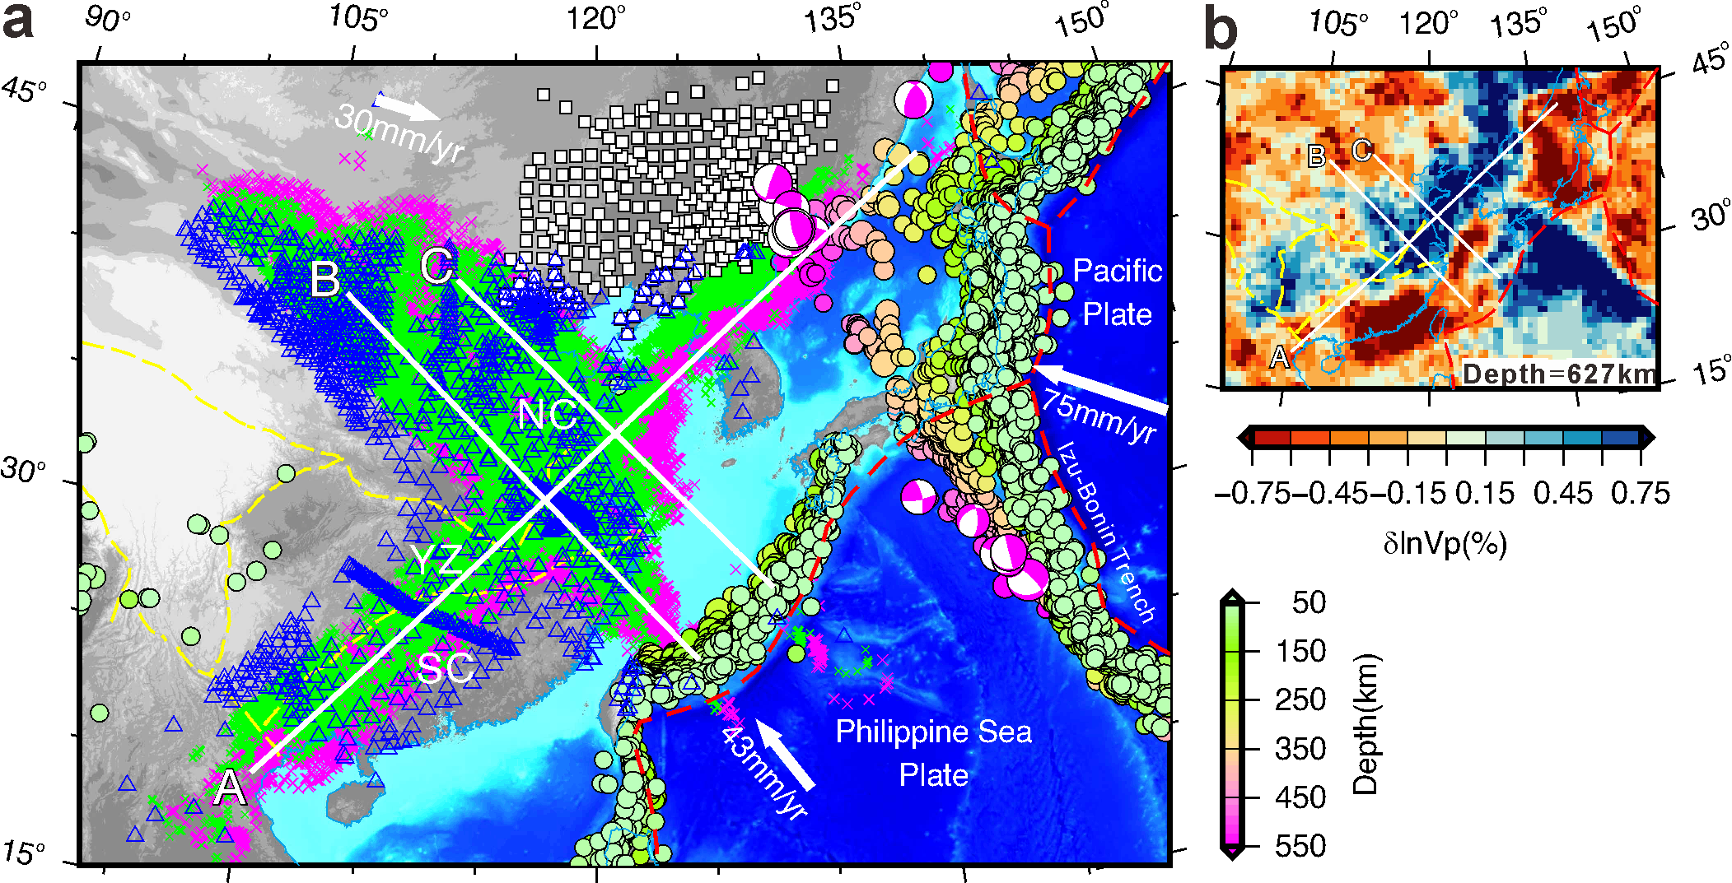
Extended data Fig. 1 | Piercing points at 410 and 660 km depths (green and purple crosses, respectively) of the RFs used in the study. The up-right panel shows the P-wave tomographic image of the model UU-P07⁴⁹, instead of the S-wave tomographic model FWEA23¹⁷, for the stagnant slabs. Other annotations as in Fig. 1.

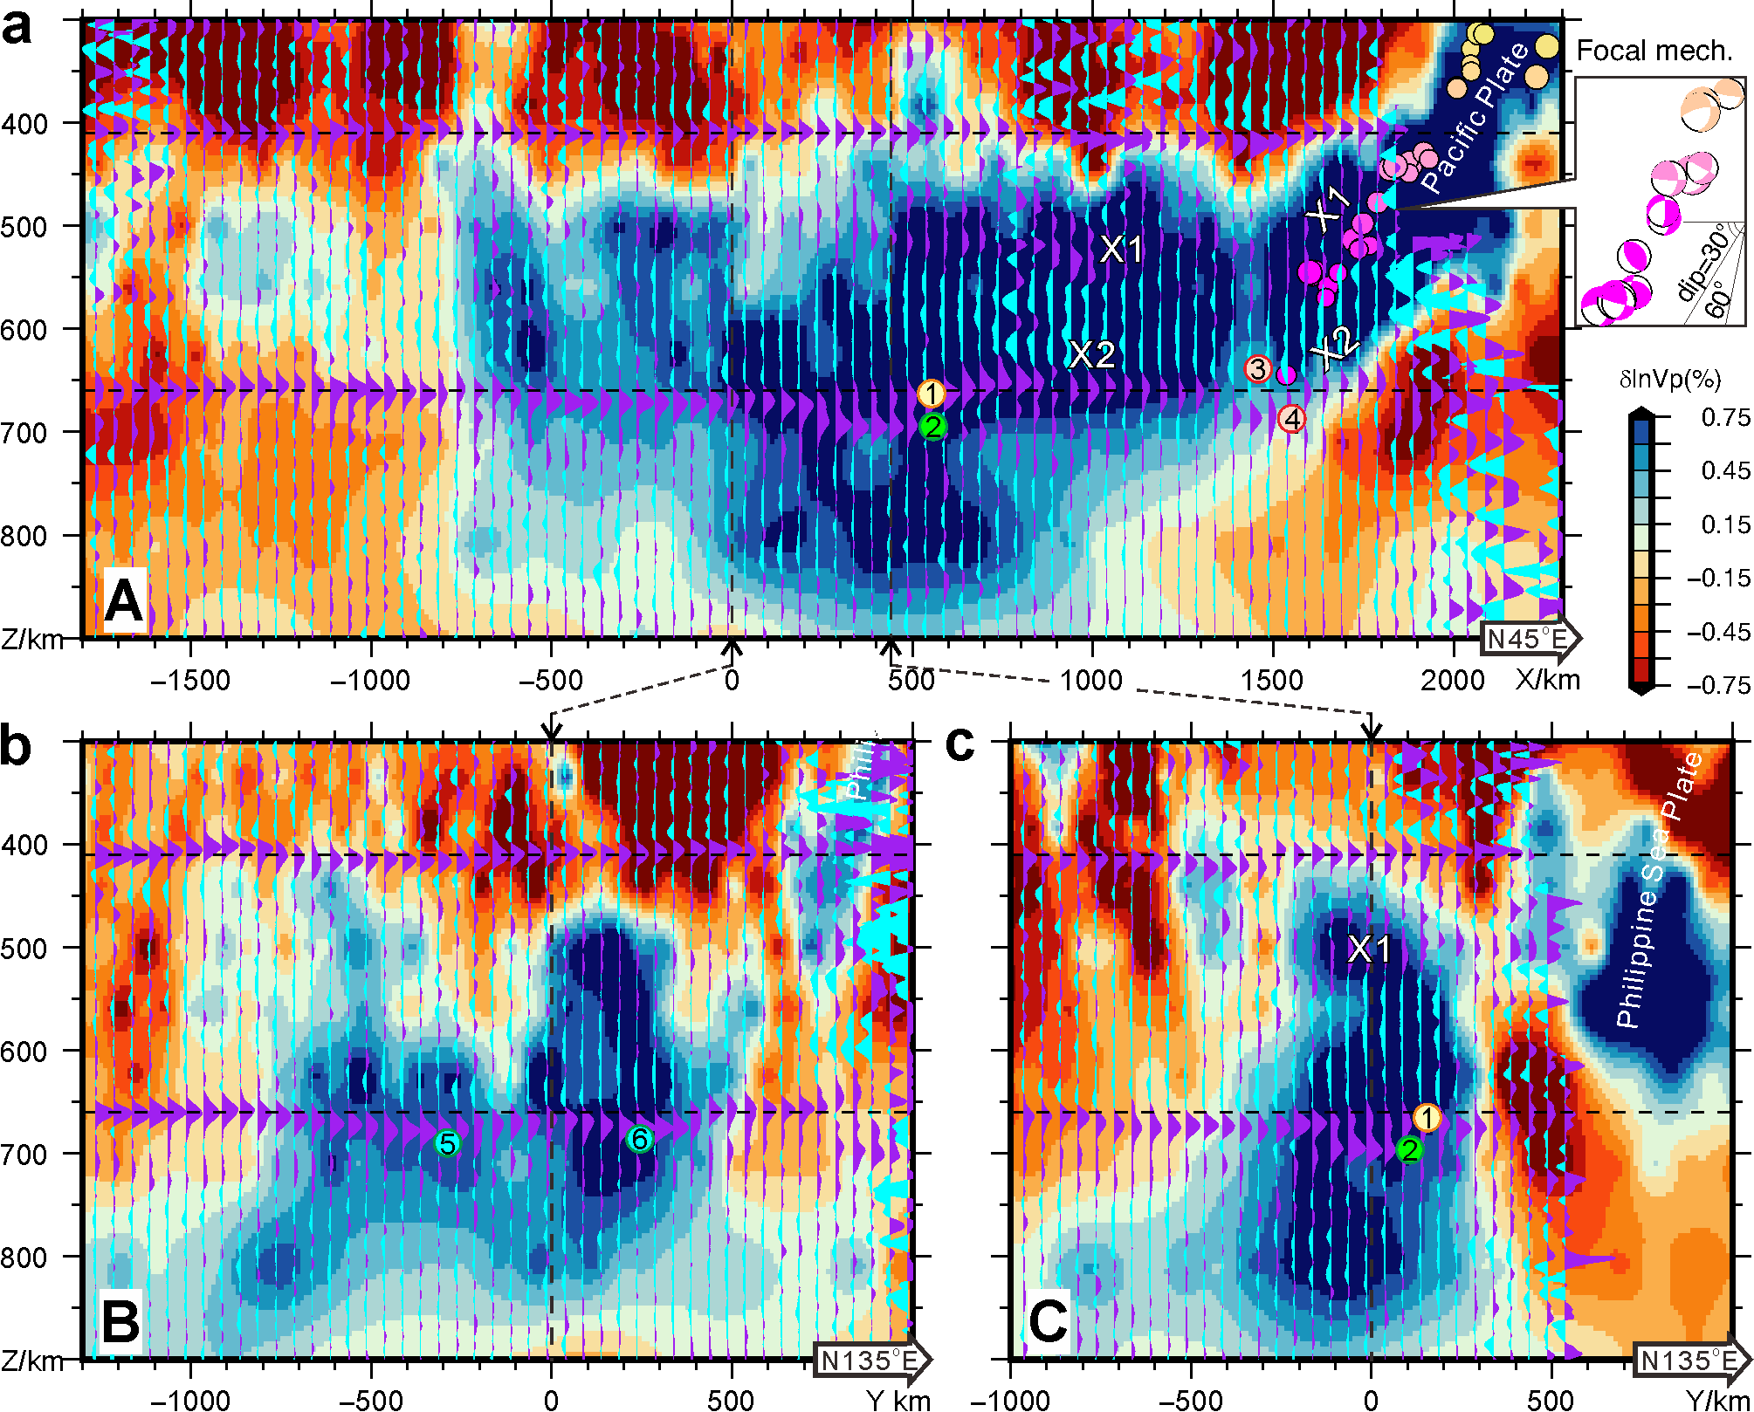
Extended data Fig. 2 | Receiver function cross-sections of the MTZ structure across the stagnant slabs. The cross-sections are similar to Fig. 2 but superimposed on the P-wave tomographic images of the model UU-P07⁴⁹ instead of the S-wave tomographic model FWEA23¹⁷. Other annotations as in Fig. 2.

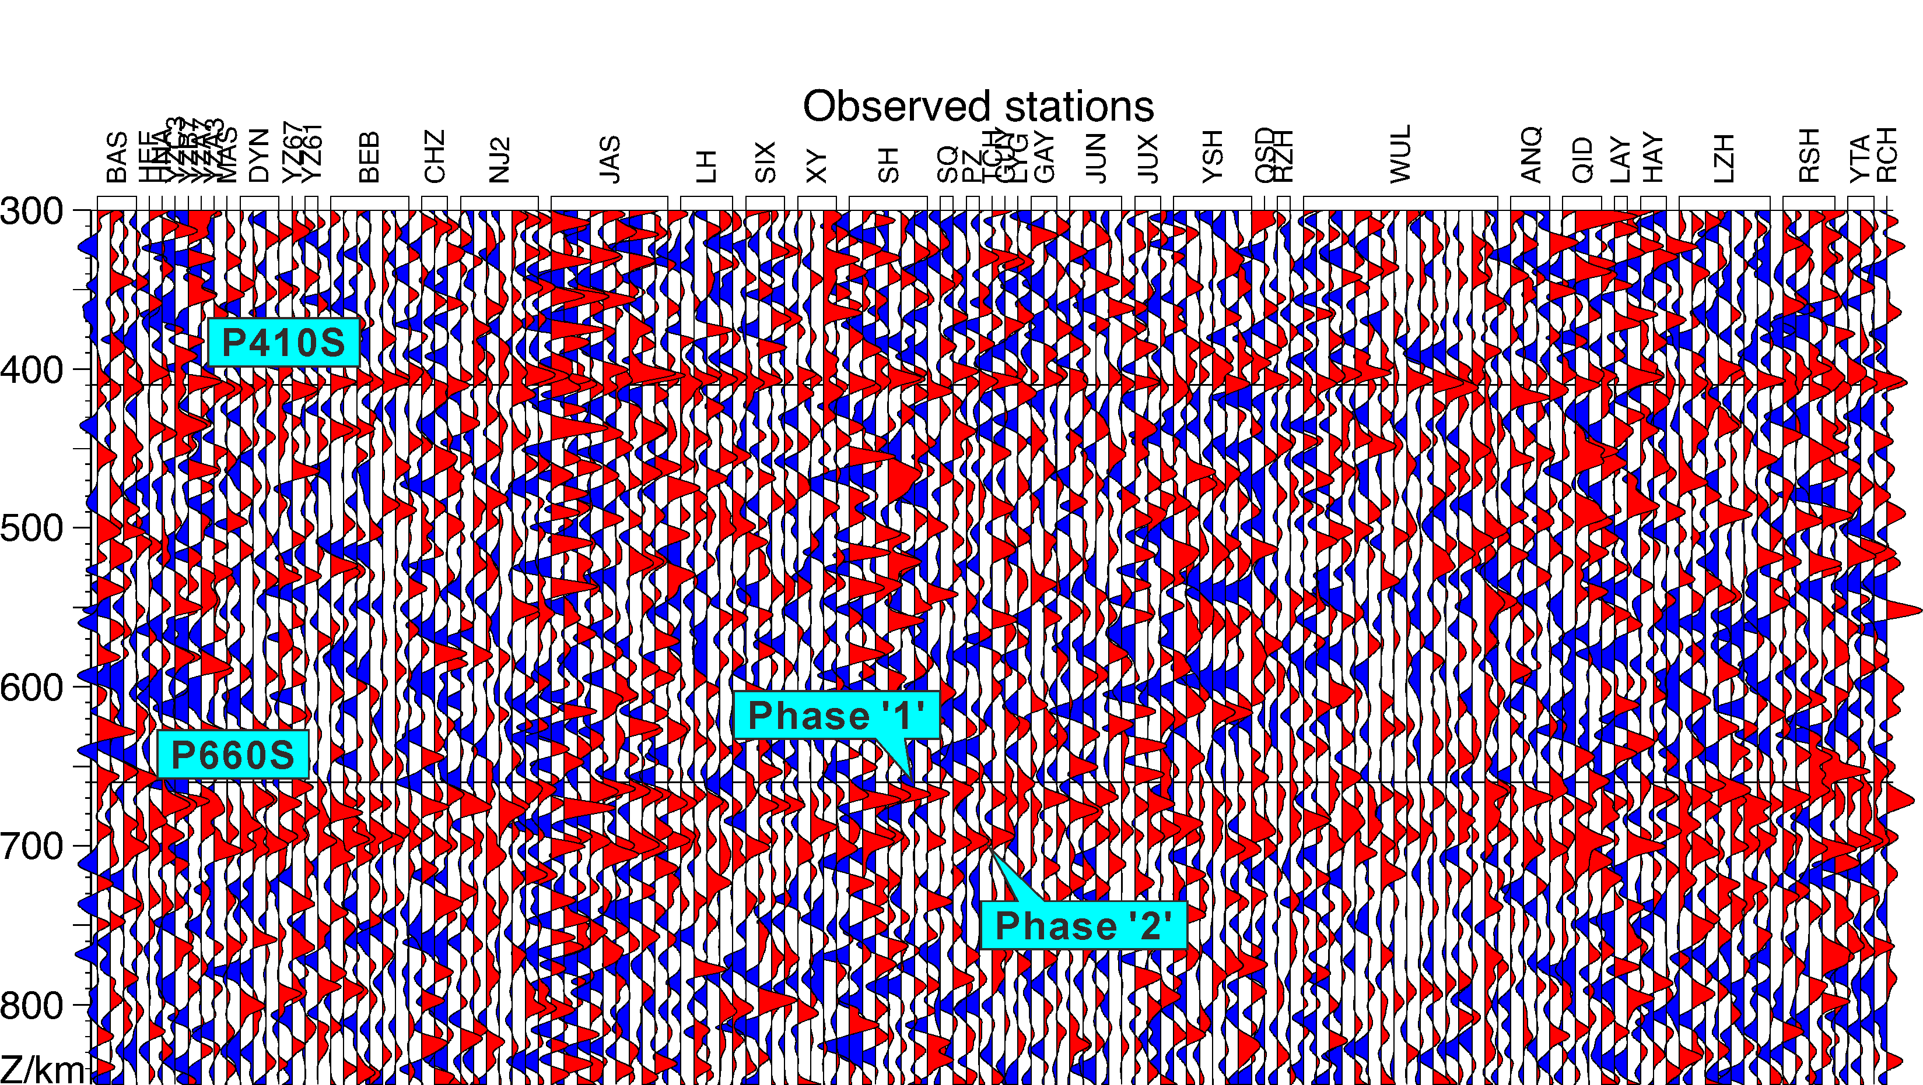
Extended data Fig. 3 | Sample receiver functions for the double phases '1' and '2' observed near the base of the MTZ. Note both phases '1' and '2' can be simultaneously observed at single RF records. Therefore, the double phases imaged in the stacked cross-sections are unlikely artifacts induced by inaccurate parameters in the 3-D wave-speed model used in the migration of RFs from time to depth.

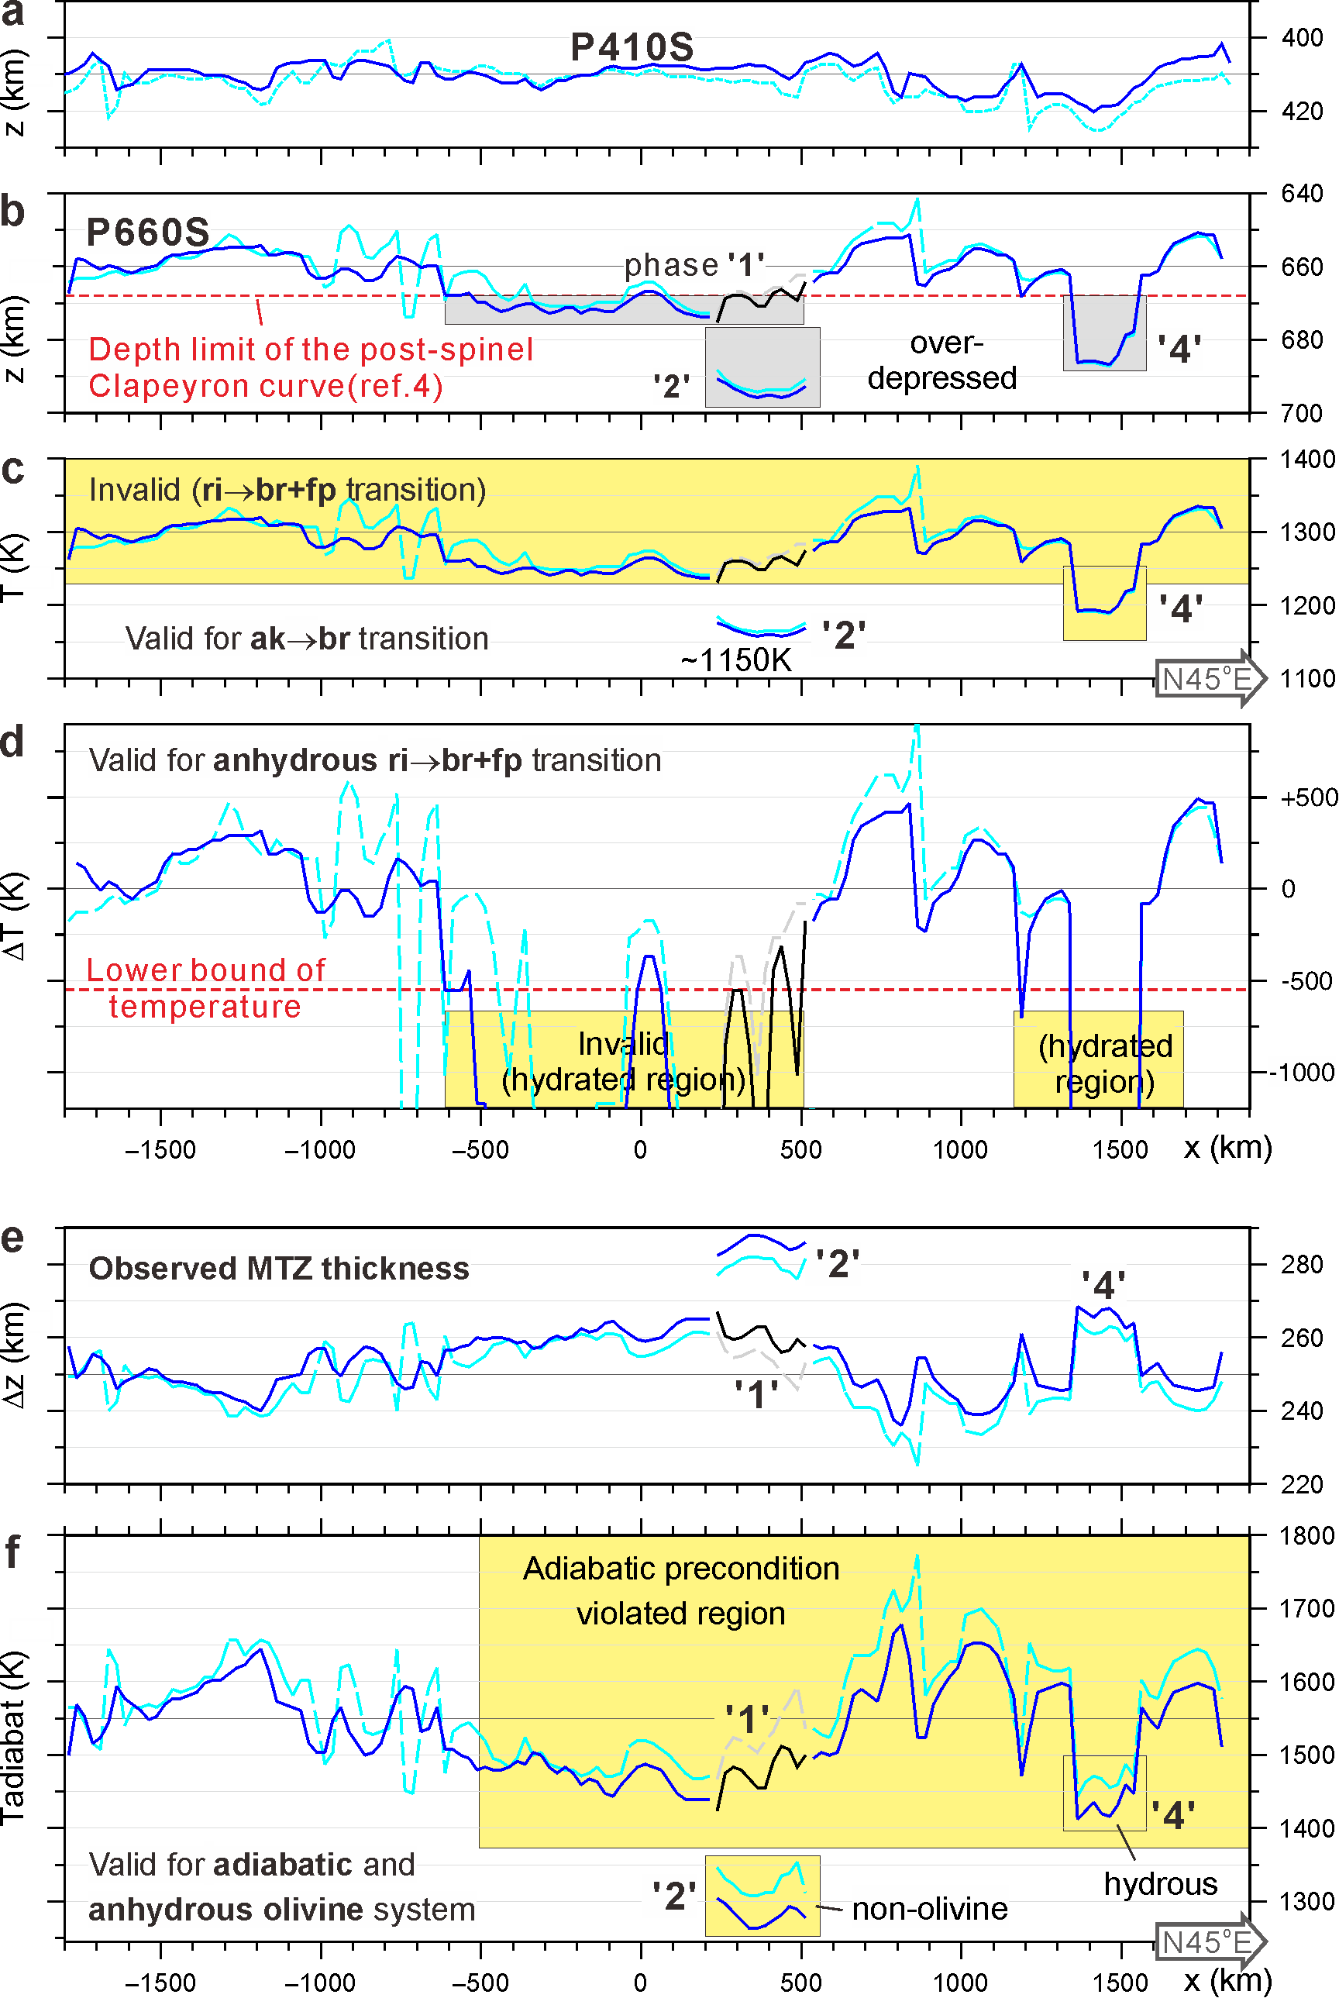
Extended data Fig. 4 | Estimates of mantle temperatures from the MTZ structure observed along profile A. a,b, Observed depths of the 410- and 660-km discontinuities along the profile (cf. Extended data Table 2). Solid (and dashed) curves are corrected (and not corrected) with the 3-D tomographic model TX2019²¹. c,d, Variation of the mantle temperature along the profile estimated from the observed discontinuity depths and the Clapeyron slope curves⁴ respectively for the akimotoite-bridgmanite and post-spinel phase transitions. e,f, Observed MTZ thicknesses and variation of mantle adiabatic temperature (Tadiabat) along the profile estimated from the theoretical relationship between the thickness and temperature³⁰. Inappropriate estimations are marked yellow, shown for references.

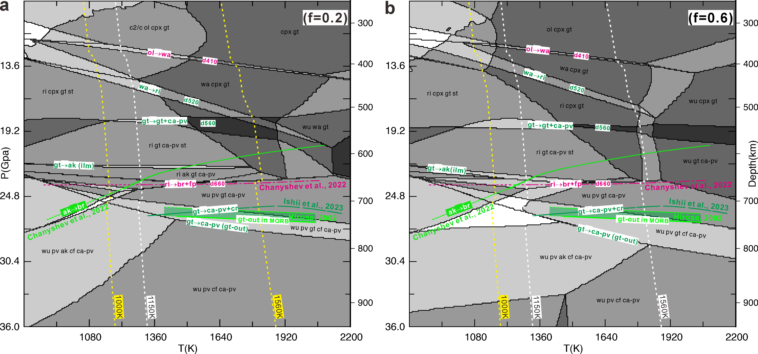
Extended data Fig. 5 | Phase transition diagrams for basalt fractions f=0.2 (a) and f=0.6 (b). The thermodynamic code Perple X²⁸ and the elastic parameter database of ref. 29 are used in the calculation. The yellow and white dashed lines represent the 1000, 1560 and 1150 K adiabats for the piclogite mantle²⁷. Purple and green curves showing recent results for post-spinel, akimotoite-bridgmanite and post-garnet transition boundaries determined via in situ X-ray diffraction multi-anvil techniques^{4,9}. ol, olivine; cpx, clinopyroxene; c2/c, pyroxene; wa, wadleyite; ri, ringwoodite; pv, perovskite; wu, magnesio-wuestite; gt, garnet with Fe-majorite/Ca-majorite; fp, ferropericlase; ak, akimotoite (ilmenite-structure); br, bridgmanite (pv or ca-pv); cf, Ca-ferrite; cr, corundum.

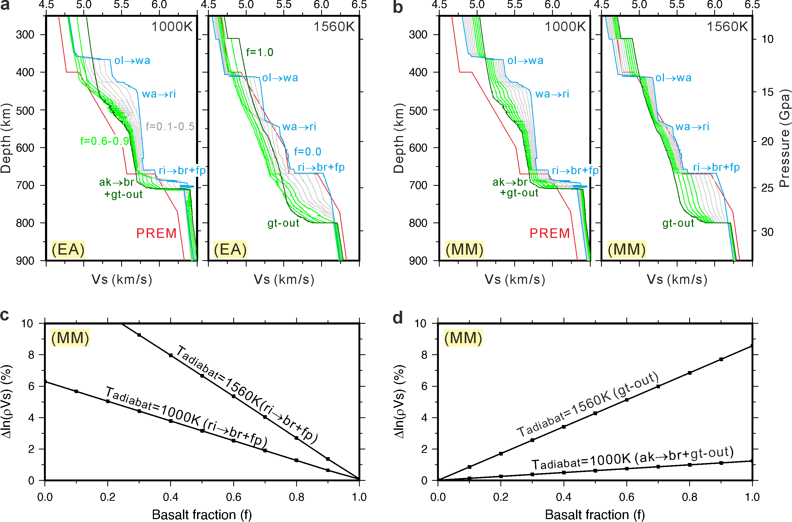

Extended data Fig. 6 | Theoretical variations of shear-wave velocity (Vs) and wave-impendence contrast (Δln(ρVs)) with depth along different adiabats. a,b, Depth curve of Vs along the 1000K and the 1560K adiabats (cf. Extended data Fig. 5), respectively for the equilibrium assemblage(EA) and mechanical mixture(MM) mantle⁴⁸, obtained with the thermodynamic code Perple X²⁸ and the elastic parameter database of ref. 29. The PREM Vs model is shown in red for reference. c,d, Variations of impendence contrast (Δln(ρVs)) with basalt fraction(f) along different mantle adiabatic temperatures for the post-spinel (ri→br+fp) and the akimotoite (ak→br+gt-out) phase-transition boundaries. f is the relative fraction of basalt, ranging from 0 to 1, corresponding to variations in mantle composition from harzburgite (in cyan) to basalt (in dark green; cf. Extended data Table 1). Abbreviations as in Extended data Fig. 5.

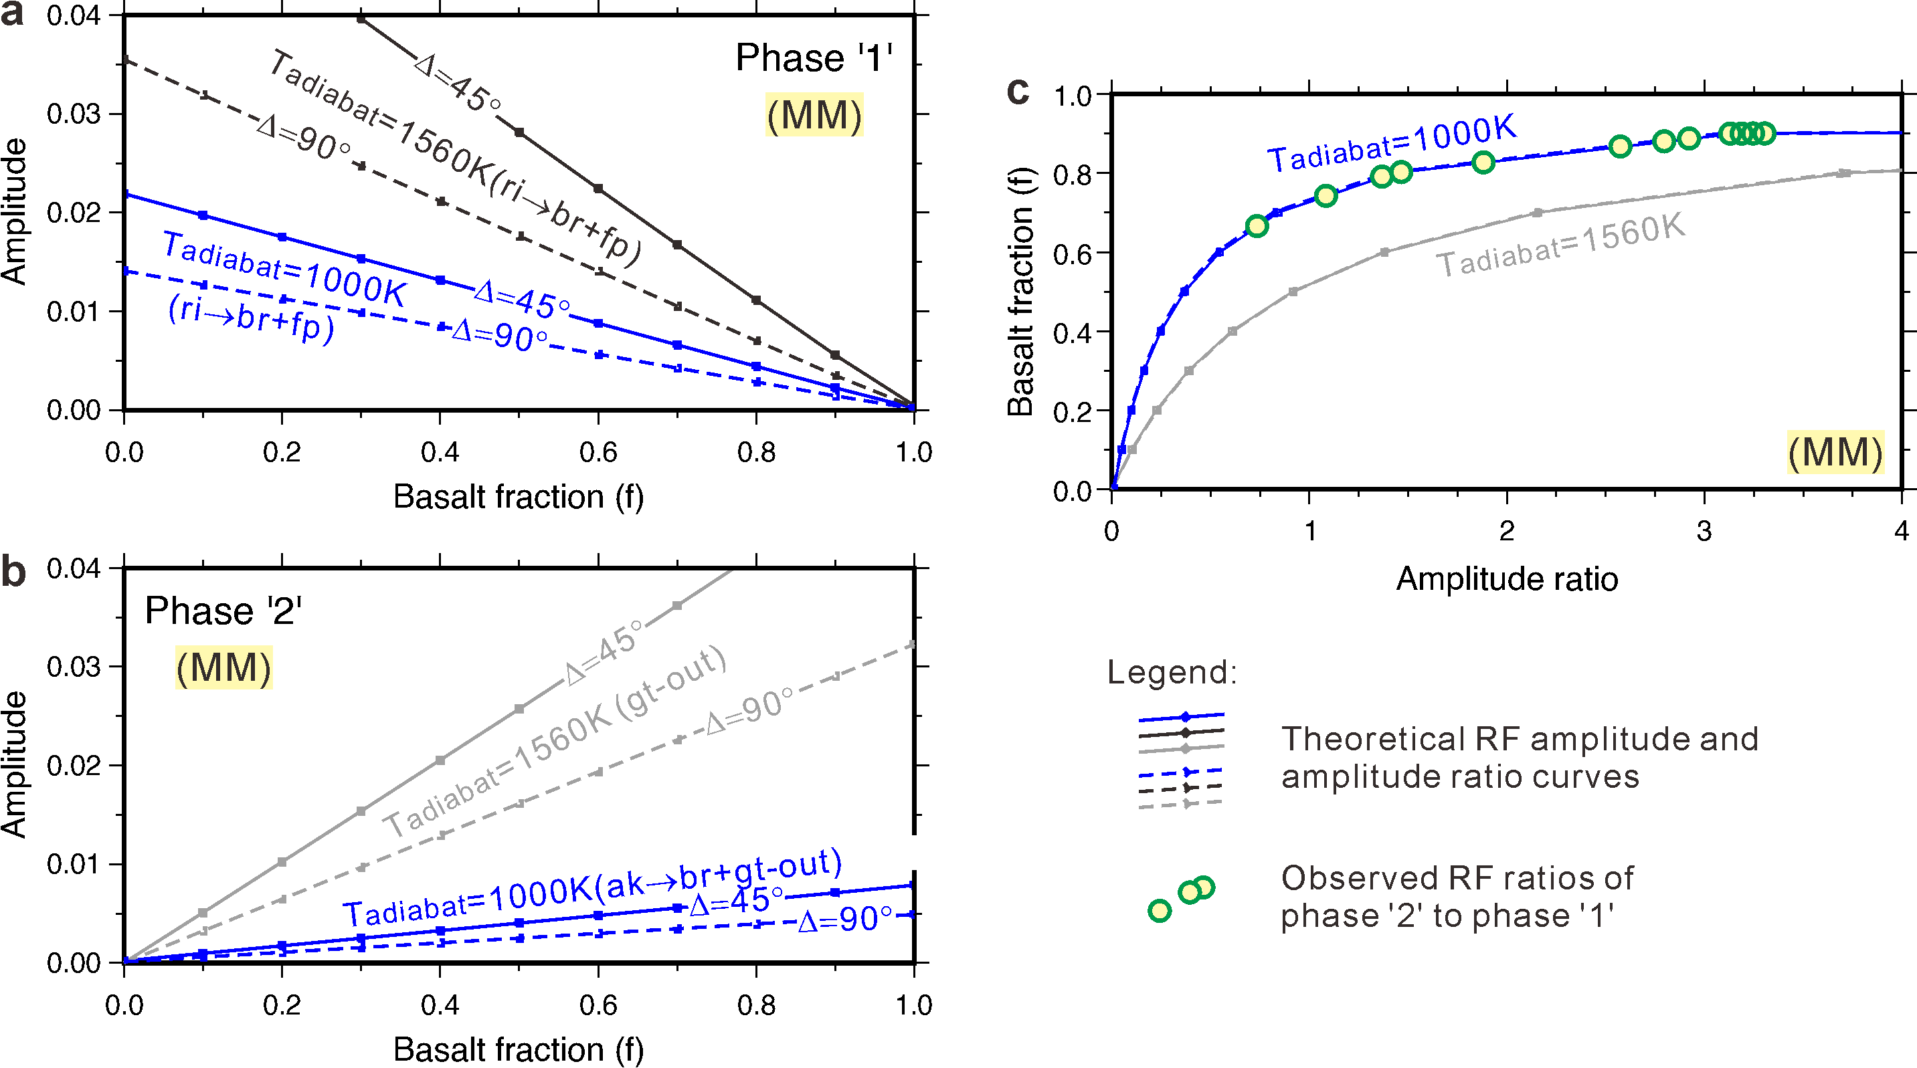
Extended data Fig. 7 | Theoretical variations of RF amplitude and RF-amplitude ratio with basalt fraction. a,b, Theoretical RF amplitude for the post-spinel (ri→br+fp) and the akimotoite (ak→br+gt-out) phase-change boundaries (interpretations of phase '1' and '2') , respectively, computed based on the parameters shown in Extended data Figs. 6c and 6d. Ray parameters of 7.5 and 4.5 seconds per degree are used in the calculation of the theoretical RF amplitudes, bracketing seismic waves with epicentral distances (Δ) ranging from 45 to 90 degrees. c, Theoretical RF amplitude ratio of phase '2' to phase '1' with basalt fraction (f). Note the influence of ray parameters on RF amplitude is removed in the RF-amplitude ratio. Yellow filled circles are the RF ratios observed along profile A in Fig. 2. Abbreviations as in Extended data Fig. 5.

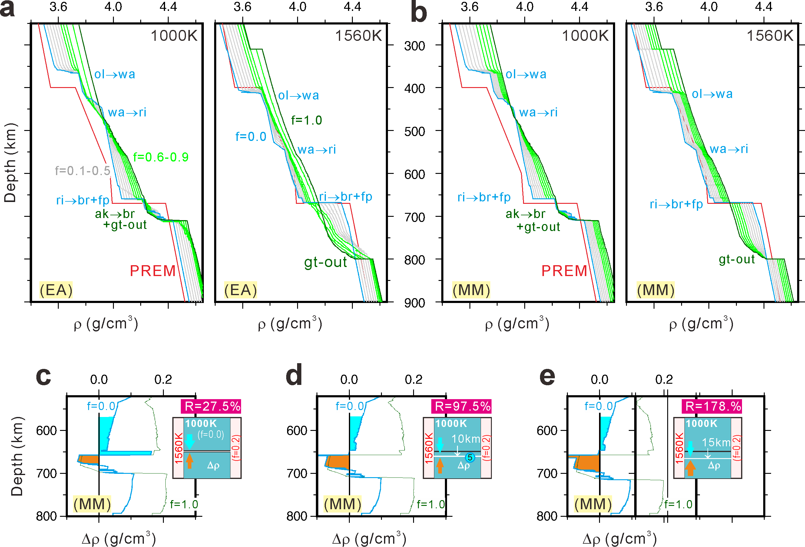

Extended data Fig. 8 | Theoretical variations of densities (ρ) and density contrasts (Δρ) with depth. a,b, Depth curves of ρ along the 1000 K and 1560 K mantle adiabats for different basalt fractions(f), respectively for the equilibrium assemblage(EA) and mechanical mixture(MM) mantle, obtained using the thermodynamic code Perple X²⁸ and the elastic parameter database of ref. 29. The PREM density model is shown in red for reference. c,d,e, Depth curves of Δρ for the harzburgite slab (with a mantle adiabatic temperature of 1000K) with respect to the pyrolitic surrounding mantle (with a mantle adiabatic temperature of 1560K), showing that the negative Δρ thereby upward buoyancy increases significantly with the excess depression of the post-spinel phase-transition boundary, and a gravitational equilibrium is nearly reached for an excess depression of 10 km, with a upward- to downward-buoyancy ratio R=97.5%. Brown and cyan shaded areas are approximately proportional to the upward and downward buoyancies of the slab assemblages, respectively. Abbreviations as in Extended data Fig. 5.

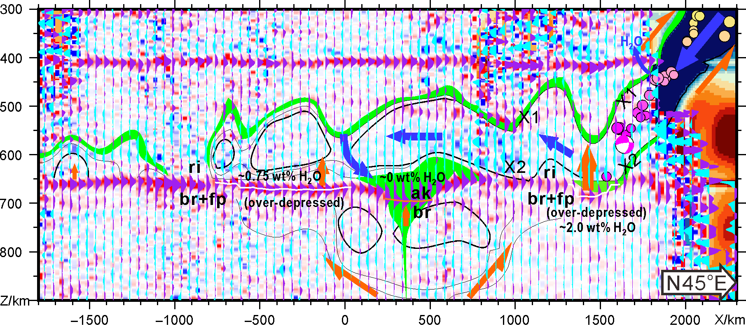

Extended data Fig. 9 | Inferred mantle processes for the stagnation of the slabs beneath the northeastern margin of Asia. The slab stagnation is attributed to the buoyancy resulting from the thermo-petrologically different phase changes of the slabs (~1000K mantle adiabatic temperature) and the pyrolitic surrounding mantle (~1560K mantle adiabatic temperature) between ~660 and ~720 km depths, and from the excess depressions of the post-spinel phase-change discontinuity (indicated by white lines; possibly induced by water) and the concentrated basalt crust trapped in the center of the stagnation zone, as well as mantle viscous resistance^{10,50}. The excess depressions provide significant additional resistant force and impede the subduction of the Pacific plate into the lower mantle, and make the plate turned to a sub-horizontal state and commence stagnation. Black lines show contours of high wave-speed anomalies in seismic tomograms^{17,49}, which are interpreted as the harzburgite parts of the slabs, whereas green shaded areas are the regions with relatively lower wave-speed anomalies (Fig. 2), which are interpreted as the basaltic parts of the slab assemblages. Blue arrows sketch the move of the slab materials. Brown arrows and semisagittates sketch the upward buoyancy and mantle viscous resistance, respectively.

Extended data Table S1. Endmember compositions⁴⁸ used in Perple X modeling (in mol%)
Component | Harzburgite  (basalt fraction f=0) | Basalt  (basalt fraction f=1)
SiO₂ | 36.04 | 51.75
MgO | 56.54 | 14.94
FeO | 5.97 | 7.06
CaO | 0.79 | 13.88
Al₂O₃ | 0.65 | 10.19
Na₂O | 0.00 | 2.18

Extended data Table S2. Mantle temperatures estimated from the MTZ structure observed along Profile A
x(km) | Depths of d410(km) |  | Depths of phase '2' (km) |  | MTZ thickness(km) |  | Temperature T(K, at phase '2') |  | ΔT (K, at phase '2') |  | Tadiabat(K)
x(km) | Not corrected | Corrected by TX2019 | Not corrected | Corrected by TX2019 | Not corrected | Corrected by TX2019 | Not corrected | Corrected by TX2019 | Not corrected | Corrected by TX2019 | Not corrected | Corrected by TX2019
237.5 | 411.25 | 408.25 | 688.25 | 690.75 | 277 | 282.5 | 1184.65 | 1175.68 | -6495.44 | -7274.15 | 1346.09 | 1304.33
262.5 | 411.75 | 408.25 | 690.75 | 691.75 | 279 | 283.5 | 1175.68 | 1172.09 | -7274.15 | -7585.64 | 1330.83 | 1296.81
287.5 | 412.25 | 408.25 | 692.25 | 693.25 | 280 | 285 | 1170.29 | 1166.7 | -7741.38 | -8052.86 | 1323.23 | 1285.57
312.5 | 411.75 | 407.75 | 693.25 | 694.25 | 281.5 | 286.5 | 1166.7 | 1163.11 | -8052.86 | -8364.35 | 1311.87 | 1274.38
337.5 | 411.75 | 407.25 | 693.75 | 695.25 | 282 | 288 | 1164.91 | 1159.52 | -8208.61 | -8675.83 | 1308.1 | 1263.24
362.5 | 412.25 | 407.75 | 694.25 | 695.75 | 282 | 288 | 1163.11 | 1157.73 | -8364.35 | -8831.57 | 1308.1 | 1263.24
387.5 | 412.25 | 407.75 | 693.75 | 695.25 | 281.5 | 287.5 | 1164.91 | 1159.52 | -8208.61 | -8675.83 | 1311.87 | 1266.95
412.5 | 412.25 | 408.75 | 693.75 | 695.25 | 281.5 | 286.5 | 1164.91 | 1159.52 | -8208.61 | -8675.83 | 1311.87 | 1274.38
437.5 | 415.25 | 410.25 | 693.75 | 695.75 | 278.5 | 285.5 | 1164.91 | 1157.73 | -8208.61 | -8831.57 | 1334.63 | 1281.83
462.5 | 415.75 | 411.25 | 693.75 | 695.25 | 278 | 284 | 1164.91 | 1159.52 | -8208.61 | -8675.83 | 1338.44 | 1293.06
487.5 | 416.25 | 409.75 | 692.25 | 694.25 | 276 | 284.5 | 1170.29 | 1163.11 | -7741.38 | -8364.35 | 1353.75 | 1289.31
512.5 | 409.25 | 406.75 | 690.75 | 692.75 | 281.5 | 286 | 1175.68 | 1168.5 | -7274.15 | -7897.12 | 1311.87 | 1278.1
x(km) | Depths of d410(km) |  | Depths of d660(km) |  | MTZ thickness(km) |  | Temperature T(K, at d660) |  | ΔT (K, at d660) |  | Tadiabat(K)
x(km) | Not corrected | Corrected by TX2019 | Not corrected | Corrected by TX2019 | Not corrected | Corrected by TX2019 | Not corrected | Corrected by TX2019 | Not corrected | Corrected by TX2019 | Not corrected | Corrected by TX2019
-2212.5 | 408.25 | 400.25
-2187.5 | 407.75 | 400.25 |  |  | Note:  1) Temperature T are estimated from the observed depths of phase '2' and the 660-km discontinuity (d660) and the Clapeyron slope curve for the akimotoite-to-bridgmanite transition⁴(see Extended data Fig.4c);  2) ΔT are estimated from the observed depths of phase '2' and d660 and the Clapeyron slope curve for the ringwoodite-to-bridgmanite transition⁴(see Extended data Fig.4d);  3) Tadiabat are estimated from the observed MTZ thicknesses and the theoretical relationship between the MTZ thickness and the adiabatic temperature³⁰(see Extended data Fig.4f).
-2162.5 | 406.75 | 399.75
-2137.5 | 409.75 | 401.75
-2112.5 | 409.75 | 400.75
-2087.5 | 403.75 | 398.25
-2062.5 | 401.25 | 394.75
-2037.5 | 400.75 | 394.25
-2012.5 | 400.75 | 394.25
-1987.5 | 399.25 | 393.25
-1962.5 | 399.25 | 393.25
-1937.5 | 398.75 | 393.25
-1912.5 | 399.25 | 416.25
-1887.5 | 420.25 | 416.75
-1862.5 | 418.25 | 412.75
-1837.5 | 416.75 | 411.25
-1812.5 | 415.25 | 410.25
-1787.5 | 414.75 | 409.75 | 664.25 | 667.25 | 249.5 | 257.5 | 1274.31 | 1262.63 | 265.08 | -4.8 | 1564.76 | 1499.44
-1762.5 | 413.75 | 408.75 | 663.25 | 657.75 | 249.5 | 249 | 1279.04 | 1304.96 | 313.8 | 580.65 | 1564.76 | 1568.89
-1737.5 | 411.25 | 407.25 | 663.25 | 658.25 | 252 | 251 | 1279.04 | 1302.85 | 313.8 | 555.38 | 1544.2 | 1552.41
-1712.5 | 407.75 | 404.25 | 663.25 | 659.75 | 255.5 | 255.5 | 1279.04 | 1295.85 | 313.8 | 480.15 | 1515.64 | 1515.64
-1687.5 | 406.25 | 406.25 | 662.75 | 660.75 | 256.5 | 254.5 | 1281.44 | 1291.05 | 338.04 | 431.43 | 1507.53 | 1523.78
-1662.5 | 421.75 | 407.75 | 661.75 | 659.75 | 240 | 252 | 1286.24 | 1295.85 | 384.55 | 480.15 | 1644.15 | 1544.2
-1637.5 | 418.75 | 414.25 | 661.25 | 660.25 | 242.5 | 246 | 1288.65 | 1293.45 | 409.03 | 455.94 | 1623.06 | 1593.78
-1612.5 | 409.75 | 413.25 | 662.25 | 661.25 | 252.5 | 248 | 1283.84 | 1288.65 | 360.28 | 409.03 | 1540.11 | 1577.17
-1587.5 | 412.25 | 412.75 | 661.75 | 661.75 | 249.5 | 249 | 1286.24 | 1286.24 | 384.55 | 384.55 | 1564.76 | 1568.89
-1562.5 | 412.25 | 410.75 | 661.75 | 660.75 | 249.5 | 250 | 1286.24 | 1291.05 | 384.55 | 431.43 | 1564.76 | 1560.64
-1537.5 | 412.25 | 408.75 | 661.25 | 660.25 | 249 | 251.5 | 1288.65 | 1293.45 | 409.03 | 455.94 | 1568.89 | 1548.3
-1512.5 | 411.25 | 408.75 | 660.75 | 659.75 | 249.5 | 251 | 1291.05 | 1295.85 | 431.43 | 480.15 | 1564.76 | 1552.41
-1487.5 | 410.25 | 408.75 | 658.75 | 657.75 | 248.5 | 249 | 1300.65 | 1304.96 | 530.12 | 580.65 | 1573.03 | 1568.89
-1462.5 | 410.25 | 408.75 | 656.75 | 656.75 | 246.5 | 248 | 1309.14 | 1309.14 | 631.18 | 631.18 | 1589.62 | 1577.17
-1437.5 | 410.75 | 408.75 | 657.75 | 656.75 | 247 | 248 | 1304.96 | 1309.14 | 580.65 | 631.18 | 1585.46 | 1577.17
-1412.5 | 411.25 | 408.75 | 657.75 | 656.25 | 246.5 | 247.5 | 1304.96 | 1311.22 | 580.65 | 656.44 | 1589.62 | 1581.31
-1387.5 | 411.25 | 409.25 | 657.25 | 656.25 | 246 | 247 | 1307.05 | 1311.22 | 605.91 | 656.44 | 1593.78 | 1585.46
-1362.5 | 411.25 | 410.25 | 655.75 | 655.75 | 244.5 | 245.5 | 1313.3 | 1313.3 | 681.7 | 681.7 | 1606.3 | 1597.95
-1337.5 | 410.75 | 410.25 | 655.25 | 655.25 | 244.5 | 245 | 1315.39 | 1315.39 | 706.97 | 706.97 | 1606.3 | 1602.12
-1312.5 | 410.75 | 410.25 | 653.25 | 655.25 | 242.5 | 245 | 1323.92 | 1315.39 | 808.02 | 706.97 | 1623.06 | 1602.12
-1287.5 | 412.75 | 410.75 | 651.25 | 654.75 | 238.5 | 244 | 1332.91 | 1317.49 | 909.07 | 732.23 | 1656.86 | 1610.48
-1262.5 | 413.75 | 411.75 | 652.25 | 654.75 | 238.5 | 243 | 1328.32 | 1317.49 | 858.55 | 732.23 | 1656.86 | 1618.86
-1237.5 | 413.75 | 412.25 | 654.75 | 654.75 | 241 | 242.5 | 1317.49 | 1317.49 | 732.23 | 732.23 | 1635.7 | 1623.06
-1212.5 | 416.25 | 413.75 | 655.75 | 654.75 | 239.5 | 241 | 1313.3 | 1317.49 | 681.7 | 732.23 | 1648.38 | 1635.7
-1187.5 | 418.25 | 414.25 | 656.75 | 654.25 | 238.5 | 240 | 1309.14 | 1319.61 | 631.18 | 757.49 | 1656.86 | 1644.15
-1162.5 | 417.75 | 413.25 | 656.75 | 656.75 | 239 | 243.5 | 1309.14 | 1309.14 | 631.18 | 631.18 | 1652.62 | 1614.67
-1137.5 | 413.75 | 408.25 | 655.25 | 656.75 | 241.5 | 248.5 | 1315.39 | 1309.14 | 706.97 | 631.18 | 1631.48 | 1573.03
-1112.5 | 411.25 | 407.25 | 656.25 | 656.25 | 245 | 249 | 1311.22 | 1311.22 | 656.44 | 656.44 | 1602.12 | 1568.89
-1087.5 | 409.25 | 406.75 | 656.75 | 656.25 | 247.5 | 249.5 | 1309.14 | 1311.22 | 631.18 | 656.44 | 1581.31 | 1564.76
-1062.5 | 412.25 | 406.75 | 657.25 | 656.75 | 245 | 250 | 1307.05 | 1309.14 | 605.91 | 631.18 | 1602.12 | 1560.64
-1037.5 | 412.25 | 406.25 | 657.25 | 661.75 | 245 | 255.5 | 1307.05 | 1286.24 | 605.91 | 384.55 | 1602.12 | 1515.64
-1012.5 |  | 406.25 |  | 663.25 |  | 257 |  | 1279.04 |  | 313.8 |  | 1503.49
-987.5 | 406.75 | 406.25 | 665.75 | 663.25 | 259 | 257 | 1268.47 | 1279.04 | 171.85 | 313.8 | 1487.35 | 1503.49
-962.5 | 407.25 | 410.75 | 664.25 | 662.25 | 257 | 251.5 | 1274.31 | 1283.84 | 265.08 | 360.28 | 1503.49 | 1548.3
-937.5 | 407.75 | 411.25 | 650.75 | 660.75 | 243 | 249.5 | 1335.28 | 1291.05 | 934.34 | 431.43 | 1618.86 | 1564.76
-912.5 | 406.25 | 407.25 | 648.75 | 660.75 | 242.5 | 253.5 | 1345.63 | 1291.05 | 1035.39 | 431.43 | 1623.06 | 1531.93
-887.5 | 403.75 | 406.25 | 650.75 | 661.75 | 247 | 255.5 | 1335.28 | 1286.24 | 934.34 | 384.55 | 1585.46 | 1515.64
-862.5 | 403.75 | 406.25 | 657.25 | 663.75 | 253.5 | 257.5 | 1307.05 | 1276.64 | 605.91 | 290.08 | 1531.93 | 1499.44
-837.5 | 403.75 | 406.75 | 657.75 | 663.75 | 254 | 257 | 1304.96 | 1276.64 | 580.65 | 290.08 | 1527.85 | 1503.49
-812.5 | 401.75 | 407.25 | 655.25 | 662.75 | 253.5 | 255.5 | 1315.39 | 1281.44 | 706.97 | 338.04 | 1531.93 | 1515.64
-787.5 | 400.75 | 407.75 | 653.75 | 659.25 | 253 | 251.5 | 1321.75 | 1298.25 | 782.76 | 504.86 | 1536.01 | 1548.3
-762.5 | 410.25 | 409.75 | 650.25 | 657.25 | 240 | 247.5 | 1337.72 | 1307.05 | 959.6 | 605.91 | 1644.15 | 1581.31
-737.5 | 410.25 | 411.75 | 673.75 | 657.75 | 263.5 | 246 | 1237.05 | 1304.96 | -1978.924 | 580.65 | 1451.37 | 1593.78
-712.5 | 409.75 | 412.25 | 673.75 | 658.75 | 264 | 246.5 | 1237.05 | 1300.65 | -1978.924 | 530.12 | 1447.4 | 1589.62
-687.5 | 406.75 | 406.75 | 659.25 | 660.25 | 252.5 | 253.5 | 1298.25 | 1293.45 | 504.86 | 455.94 | 1540.11 | 1531.93
-662.5 | 406.75 | 406.75 | 652.75 | 659.75 | 246 | 253 | 1326.1 | 1295.85 | 833.28 | 480.15 | 1593.78 | 1536.01
-637.5 | 408.25 | 410.25 | 651.25 | 659.75 | 243 | 249.5 | 1332.91 | 1295.85 | 909.07 | 480.15 | 1618.86 | 1564.76
-612.5 | 408.75 | 411.25 | 669.25 | 667.75 | 260.5 | 256.5 | 1254.85 | 1260.69 | -577.245 | -116.7 | 1475.31 | 1507.53
-587.5 | 409.25 | 411.25 | 662.75 | 667.75 | 253.5 | 256.5 | 1281.44 | 1260.69 | 338.04 | -116.7 | 1531.93 | 1507.53
-562.5 | 409.25 | 410.25 | 661.75 | 667.75 | 252.5 | 257.5 | 1286.24 | 1260.69 | 384.55 | -116.7 | 1540.11 | 1499.44
-537.5 | 409.25 | 409.25 | 661.25 | 667.25 | 252 | 258 | 1288.65 | 1262.63 | 409.03 | -4.8 | 1544.2 | 1495.41
-512.5 | 407.75 | 409.75 | 661.25 | 669.75 | 253.5 | 260 | 1288.65 | 1252.9 | 409.03 | -732.987 | 1531.93 | 1479.32
-487.5 | 407.75 | 410.25 | 662.75 | 669.75 | 255 | 259.5 | 1281.44 | 1252.9 | 338.04 | -732.987 | 1519.71 | 1483.33
-462.5 | 408.25 | 411.25 | 666.25 | 671.25 | 258 | 260 | 1266.53 | 1247.03 | 127.95 | -1200.213 | 1495.41 | 1479.32
-437.5 | 409.75 | 412.25 | 668.25 | 672.25 | 258.5 | 260 | 1258.74 | 1243.03 | -265.33 | -1511.697 | 1491.38 | 1479.32
-412.5 | 409.75 | 412.25 | 669.25 | 671.75 | 259.5 | 259.5 | 1254.85 | 1245.04 | -577.245 | -1355.955 | 1483.33 | 1483.33
-387.5 | 409.75 | 412.25 | 667.75 | 670.75 | 258 | 258.5 | 1260.69 | 1249 | -116.7 | -1044.471 | 1495.41 | 1491.38
-362.5 | 410.25 | 411.25 | 664.75 | 670.25 | 254.5 | 259 | 1272.37 | 1250.95 | 235.34 | -888.729 | 1523.78 | 1487.35
-337.5 | 412.25 | 413.25 | 669.75 | 670.25 | 257.5 | 257 | 1252.9 | 1250.95 | -732.987 | -888.729 | 1499.44 | 1503.49
-312.5 | 413.25 | 414.25 | 670.25 | 671.75 | 257 | 257.5 | 1250.95 | 1245.04 | -888.729 | -1355.955 | 1503.49 | 1499.44
-287.5 | 411.75 | 413.25 | 670.75 | 672.75 | 259 | 259.5 | 1249 | 1241.02 | -1044.471 | -1667.439 | 1487.35 | 1483.33
-262.5 | 411.25 | 411.75 | 670.75 | 672.25 | 259.5 | 260.5 | 1249 | 1243.03 | -1044.471 | -1511.697 | 1483.33 | 1475.31
-237.5 | 410.75 | 411.75 | 670.75 | 671.25 | 260 | 259.5 | 1249 | 1247.03 | -1044.471 | -1200.213 | 1479.32 | 1483.33
-212.5 | 410.75 | 410.75 | 670.75 | 671.25 | 260 | 260.5 | 1249 | 1247.03 | -1044.471 | -1200.213 | 1479.32 | 1475.31
-187.5 | 410.25 | 410.25 | 671.25 | 672.75 | 261 | 262.5 | 1247.03 | 1241.02 | -1200.213 | -1667.439 | 1471.31 | 1459.33
-162.5 | 410.25 | 410.25 | 670.75 | 671.75 | 260.5 | 261.5 | 1249 | 1245.04 | -1044.471 | -1355.955 | 1475.31 | 1467.31
-137.5 | 410.25 | 409.75 | 669.75 | 671.75 | 259.5 | 262 | 1252.9 | 1245.04 | -732.987 | -1355.955 | 1483.33 | 1463.32
-112.5 | 408.75 | 408.25 | 669.75 | 672.25 | 261 | 264 | 1252.9 | 1243.03 | -732.987 | -1511.697 | 1471.31 | 1447.4
-87.5 | 408.75 | 407.75 | 669.75 | 672.25 | 261 | 264.5 | 1252.9 | 1243.03 | -732.987 | -1511.697 | 1471.31 | 1443.44
-62.5 | 409.25 | 408.25 | 669.75 | 670.75 | 260.5 | 262.5 | 1252.9 | 1249 | -732.987 | -1044.471 | 1475.31 | 1459.33
-37.5 | 409.75 | 408.25 | 665.75 | 669.25 | 256 | 261 | 1268.47 | 1254.85 | 171.85 | -577.245 | 1511.59 | 1471.31
-12.5 | 410.25 | 408.25 | 665.25 | 667.75 | 255 | 259.5 | 1270.42 | 1260.69 | 206.18 | -116.7 | 1519.71 | 1483.33
12.5 | 409.25 | 407.75 | 664.25 | 666.75 | 255 | 259 | 1274.31 | 1264.58 | 265.08 | 72.03 | 1519.71 | 1487.35
37.5 | 408.75 | 407.25 | 664.25 | 666.75 | 255.5 | 259.5 | 1274.31 | 1264.58 | 265.08 | 72.03 | 1515.64 | 1483.33
62.5 | 409.25 | 407.75 | 665.75 | 667.75 | 256.5 | 260 | 1268.47 | 1260.69 | 171.85 | -116.7 | 1507.53 | 1479.32
87.5 | 410.75 | 407.75 | 668.25 | 669.75 | 257.5 | 262 | 1258.74 | 1252.9 | -265.33 | -732.987 | 1499.44 | 1463.32
112.5 | 410.75 | 407.75 | 669.75 | 671.75 | 259 | 264 | 1252.9 | 1245.04 | -732.987 | -1355.955 | 1487.35 | 1447.4
137.5 | 410.75 | 407.75 | 671.25 | 672.75 | 260.5 | 265 | 1247.03 | 1241.02 | -1200.213 | -1667.439 | 1475.31 | 1439.48
162.5 | 410.75 | 408.25 | 672.25 | 673.25 | 261.5 | 265 | 1243.03 | 1239.03 | -1511.697 | -1823.181 | 1467.31 | 1439.48
187.5 | 411.25 | 408.75 | 672.75 | 673.75 | 261.5 | 265 | 1241.02 | 1237.05 | -1667.439 | -1978.924 | 1467.31 | 1439.48
212.5 | 411.75 | 408.75 | 672.75 | 673.75 | 261 | 265 | 1241.02 | 1237.05 | -1667.439 | -1978.924 | 1471.31 | 1439.48
237.5 | 411.25 | 408.25 | 672.75 | 675.25 | 261.5 | 267 | 1241.02 | 1231.32 | -1667.439 | -2446.15 | 1467.31 | 1423.69
262.5 | 411.75 | 408.25 | 668.25 | 668.75 | 256.5 | 260.5 | 1258.74 | 1256.79 | -265.33 | -421.5 | 1507.53 | 1475.31
287.5 | 412.25 | 408.25 | 666.75 | 667.75 | 254.5 | 259.5 | 1264.58 | 1260.69 | 72.03 | -116.7 | 1523.78 | 1483.33
312.5 | 411.75 | 407.75 | 666.75 | 667.75 | 255 | 260 | 1264.58 | 1260.69 | 72.03 | -116.7 | 1519.71 | 1479.32
337.5 | 411.75 | 407.25 | 667.75 | 668.75 | 256 | 261.5 | 1260.69 | 1256.79 | -116.7 | -421.5 | 1511.59 | 1467.31
362.5 | 412.25 | 407.75 | 669.25 | 670.75 | 257 | 263 | 1254.85 | 1249 | -577.245 | -1044.471 | 1503.49 | 1455.35
387.5 | 412.25 | 407.75 | 667.25 | 670.75 | 255 | 263 | 1262.63 | 1249 | -4.8 | -1044.471 | 1519.71 | 1455.35
412.5 | 412.25 | 408.75 | 665.75 | 667.25 | 253.5 | 258.5 | 1268.47 | 1262.63 | 171.85 | -4.8 | 1531.93 | 1491.38
437.5 | 415.25 | 410.25 | 665.75 | 666.25 | 250.5 | 256 | 1268.47 | 1266.53 | 171.85 | 127.95 | 1556.52 | 1511.59
462.5 | 415.75 | 411.25 | 664.25 | 667.75 | 248.5 | 256.5 | 1274.31 | 1260.69 | 265.08 | -116.7 | 1573.03 | 1507.53
487.5 | 416.25 | 409.75 | 662.25 | 669.25 | 246 | 259.5 | 1283.84 | 1254.85 | 360.28 | -577.245 | 1593.78 | 1483.33
512.5 | 409.25 | 406.75 | 662.25 | 664.25 | 253 | 257.5 | 1283.84 | 1274.31 | 360.28 | 265.08 | 1536.01 | 1499.44
537.5 | 408.25 | 406.25 | 661.25 | 664.25 | 253 | 258 | 1288.65 | 1274.31 | 409.03 | 265.08 | 1536.01 | 1495.41
562.5 | 407.25 | 405.25 | 661.25 | 662.25 | 254 | 257 | 1288.65 | 1283.84 | 409.03 | 360.28 | 1527.85 | 1503.49
587.5 | 407.25 | 404.25 | 661.75 | 661.75 | 254.5 | 257.5 | 1286.24 | 1286.24 | 384.55 | 384.55 | 1523.78 | 1499.44
612.5 | 407.25 | 404.75 | 658.75 | 661.75 | 251.5 | 257 | 1300.65 | 1286.24 | 530.12 | 384.55 | 1548.3 | 1503.49
637.5 | 410.25 | 406.25 | 655.25 | 659.25 | 245 | 253 | 1315.39 | 1298.25 | 706.97 | 504.86 | 1602.12 | 1536.01
662.5 | 411.75 | 407.75 | 652.75 | 655.25 | 241 | 247.5 | 1326.1 | 1315.39 | 833.28 | 706.97 | 1635.7 | 1581.31
687.5 | 410.25 | 407.25 | 651.25 | 653.75 | 241 | 246.5 | 1332.91 | 1321.75 | 909.07 | 782.76 | 1635.7 | 1589.62
712.5 | 408.75 | 405.75 | 649.75 | 653.25 | 241 | 247.5 | 1340.23 | 1323.92 | 984.87 | 808.02 | 1635.7 | 1581.31
737.5 | 408.25 | 404.25 | 648.25 | 652.75 | 240 | 248.5 | 1348.43 | 1326.1 | 1060.66 | 833.28 | 1644.15 | 1573.03
762.5 | 414.75 | 408.25 | 648.25 | 652.25 | 233.5 | 244 | 1348.43 | 1328.32 | 1060.66 | 858.55 | 1699.59 | 1610.48
787.5 | 417.75 | 414.75 | 648.25 | 652.25 | 230.5 | 237.5 | 1348.43 | 1328.32 | 1060.66 | 858.55 | 1725.5 | 1665.36
812.5 | 416.25 | 416.25 | 650.25 | 652.25 | 234 | 236 | 1337.72 | 1328.32 | 959.6 | 858.55 | 1695.3 | 1678.16
837.5 | 416.25 | 409.75 | 648.25 | 651.25 | 232 | 241.5 | 1348.43 | 1332.91 | 1060.66 | 909.07 | 1712.52 | 1631.48
862.5 | 416.25 | 410.25 | 641.25 | 664.75 | 225 | 254.5 | 1390.91 | 1272.37 | 1414.35 | 235.34 | 1773.5 | 1523.78
887.5 | 414.25 | 410.75 | 661.75 | 665.25 | 247.5 | 254.5 | 1286.24 | 1270.42 | 384.55 | 206.18 | 1581.31 | 1523.78
912.5 | 415.25 | 413.25 | 660.25 | 662.25 | 245 | 249 | 1293.45 | 1283.84 | 455.94 | 360.28 | 1602.12 | 1568.89
937.5 | 415.75 | 414.75 | 659.25 | 661.25 | 243.5 | 246.5 | 1298.25 | 1288.65 | 504.86 | 409.03 | 1614.67 | 1589.62
962.5 | 416.25 | 416.25 | 658.25 | 660.75 | 242 | 244.5 | 1302.85 | 1291.05 | 555.38 | 431.43 | 1627.27 | 1606.3
987.5 | 416.25 | 416.25 | 658.25 | 659.25 | 242 | 243 | 1302.85 | 1298.25 | 555.38 | 504.86 | 1627.27 | 1618.86
1012.5 | 420.25 | 417.25 | 654.75 | 656.75 | 234.5 | 239.5 | 1317.49 | 1309.14 | 732.23 | 631.18 | 1691 | 1648.38
1037.5 | 420.25 | 416.25 | 654.25 | 655.25 | 234 | 239 | 1319.61 | 1315.39 | 757.49 | 706.97 | 1695.3 | 1652.62
1062.5 | 420.25 | 416.25 | 653.75 | 655.25 | 233.5 | 239 | 1321.75 | 1315.39 | 782.76 | 706.97 | 1699.59 | 1652.62
1087.5 | 419.75 | 416.25 | 654.75 | 655.75 | 235 | 239.5 | 1317.49 | 1313.3 | 732.23 | 681.7 | 1686.72 | 1648.38
1112.5 | 419.25 | 415.75 | 655.75 | 656.75 | 236.5 | 241 | 1313.3 | 1309.14 | 681.7 | 631.18 | 1673.89 | 1635.7
1137.5 | 415.25 | 412.75 | 656.75 | 656.75 | 241.5 | 244 | 1309.14 | 1309.14 | 631.18 | 631.18 | 1631.48 | 1610.48
1162.5 | 407.25 | 410.75 | 658.75 | 658.25 | 251.5 | 247.5 | 1300.65 | 1302.85 | 530.12 | 555.38 | 1548.3 | 1581.31
1187.5 | 407.25 | 407.25 | 663.25 | 668.25 | 256 | 261 | 1279.04 | 1258.74 | 313.8 | -265.33 | 1511.59 | 1471.31
1212.5 | 424.75 | 411.75 | 663.75 | 665.25 | 239 | 253.5 | 1276.64 | 1270.42 | 290.08 | 206.18 | 1652.62 | 1531.93
1237.5 | 420.75 | 416.25 | 663.25 | 663.25 | 242.5 | 247 | 1279.04 | 1279.04 | 313.8 | 313.8 | 1623.06 | 1585.46
1262.5 | 419.25 | 415.25 | 662.25 | 661.75 | 243 | 246.5 | 1283.84 | 1286.24 | 360.28 | 384.55 | 1618.86 | 1589.62
1287.5 | 418.25 | 415.25 | 661.75 | 661.25 | 243.5 | 246 | 1286.24 | 1288.65 | 384.55 | 409.03 | 1614.67 | 1593.78
1312.5 | 418.25 | 415.25 | 661.75 | 660.75 | 243.5 | 245.5 | 1286.24 | 1291.05 | 384.55 | 431.43 | 1614.67 | 1597.95
1337.5 | 419.25 | 416.25 | 662.25 | 662.25 | 243 | 246 | 1283.84 | 1283.84 | 360.28 | 360.28 | 1618.86 | 1593.78
1362.5 | 421.75 | 417.75 | 686.25 | 686.25 | 264.5 | 268.5 | 1191.83 | 1191.83 | -5872.48 | -5872.48 | 1443.44 | 1411.91
1387.5 | 424.25 | 418.75 | 686.25 | 685.75 | 262 | 267 | 1191.83 | 1193.63 | -5872.48 | -5716.73 | 1463.32 | 1423.69
1412.5 | 425.25 | 420.25 | 686.25 | 685.75 | 261 | 265.5 | 1191.83 | 1193.63 | -5872.48 | -5716.73 | 1471.31 | 1435.52
1437.5 | 425.25 | 418.75 | 686.75 | 686.25 | 261.5 | 267.5 | 1190.04 | 1191.83 | -6028.22 | -5872.48 | 1467.31 | 1419.76
1462.5 | 424.25 | 418.75 | 687.25 | 686.75 | 263 | 268 | 1188.24 | 1190.04 | -6183.96 | -6028.22 | 1455.35 | 1415.83
1487.5 | 421.75 | 418.25 | 684.25 | 684.25 | 262.5 | 266 | 1199.01 | 1199.01 | -5249.51 | -5249.51 | 1459.33 | 1431.57
1512.5 | 420.25 | 416.25 | 679.25 | 678.75 | 259 | 262.5 | 1216.96 | 1218.75 | -3692.09 | -3536.34 | 1487.35 | 1459.33
1537.5 | 417.75 | 413.75 | 678.75 | 677.75 | 261 | 264 | 1218.75 | 1222.34 | -3536.34 | -3224.86 | 1471.31 | 1447.4
1562.5 | 417.25 | 412.75 | 662.25 | 662.25 | 245 | 249.5 | 1283.84 | 1283.84 | 360.28 | 360.28 | 1602.12 | 1564.76
1587.5 | 414.75 | 410.75 | 662.25 | 662.25 | 247.5 | 251.5 | 1283.84 | 1283.84 | 360.28 | 360.28 | 1581.31 | 1548.3
1612.5 | 413.25 | 408.25 | 661.25 | 661.25 | 248 | 253 | 1288.65 | 1288.65 | 409.03 | 409.03 | 1577.17 | 1536.01
1637.5 | 412.75 | 407.25 | 657.25 | 656.75 | 244.5 | 249.5 | 1307.05 | 1309.14 | 605.91 | 631.18 | 1606.3 | 1564.76
1662.5 | 412.25 | 406.75 | 654.25 | 653.75 | 242 | 247 | 1319.61 | 1321.75 | 757.49 | 782.76 | 1627.27 | 1585.46
1687.5 | 411.75 | 405.75
1712.5 | 411.75 | 405.75 | 652.25 | 651.75 | 240.5 | 246 | 1328.32 | 1330.59 | 858.55 | 883.81 | 1639.92 | 1593.78
1737.5 | 411.75 | 405.25 | 651.75 | 650.75 | 240 | 245.5 | 1330.59 | 1335.28 | 883.81 | 934.34 | 1644.15 | 1597.95
1762.5 | 411.25 | 405.25 | 651.75 | 651.25 | 240.5 | 246 | 1330.59 | 1332.91 | 883.81 | 909.07 | 1639.92 | 1593.78
1787.5 | 411.25 | 404.75 | 654.25 | 651.25 | 243 | 246.5 | 1319.61 | 1332.91 | 757.49 | 909.07 | 1618.86 | 1589.62
1812.5 | 409.75 | 401.75 | 657.75 | 657.75 | 248 | 256 | 1304.96 | 1304.96 | 580.65 | 580.65 | 1577.17 | 1511.59
1837.5 | 412.75 | 406.75

