LncRNA PVT1-miR-148a-3p-MKL1 regulates the brain damage in children with congenital heart disease
Supplementary materials
Supplementary materials 1 Establishment and detection of animal models
- Establishment of a DHLF mouse model and Monitoring of regional cerebral blood flow (rCBF) in mice
C57BL/6 male mice (3-4 w) were intraperitoneally injected with 5% chloral hydrate (0.35-0.5 mg/kg). The mouse was fixed in a supine position on the operating table. Its neck was disinfected, and an incision was made in the median neck. Bilateral common carotid arteries and nerves and other tissues were separated. The mouse was placed on an ice bed, and the rectal temperature was measured by platinum resistance electronic temperature sensor. When the temperature dropped to 18℃-19℃, the bilateral common carotid arteries were clamped with non-invasive fiber artery clips for 120 min. The rectal temperature of the mouse was maintained at 18℃-19℃ throughout the procedure. Afterward, the bilateral common carotid arteries were opened, the neck incision was disinfected, and the incision was sutured. The mouse was placed in a neonatal incubator to rewarm. The body temperature was allowed to recover with a rate of ≤0.5℃/min to 32℃ within 30 min, after which the constant temperature of the warming box was maintained and the temperature was slowly increased until recovery. In the sham group, the operation was performed in the same manner except that the bilateral common carotid arteries were not blocked and the temperature was not lowered.
- Monitoring of regional cerebral blood flow (rCBF) in mice
C57BL/6 male mice (3-4 w) were randomly divided into DHLF (n=6) and sham groups (n=6). 5% chloral hydrate was injected intraperitoneally (0.35-0.5 mg/kg). The mouse was fixed in a prone position on the operating table. Parietal skin was prepared. Drill a hole with a diameter of 1 mm at 1 mm behind the skull anterior halogen and 2 mm to the left / right of the midline. A laser Doppler microfiber probe (0.5 mm in diameter) was placed in contact with the cerebral cortex through the above hole and fixed to the skull. The cerebral blood flow was monitored using Perisoft Version 2.50 Perimed software and recorded before and at 18±0.5°C, 0-5 min, 25-30 min, 55-60 min, 115-120 min, and 0-5 min after extracorporeal circulation at 18±0.5°C.
- Local cerebral blood flow in the DHLF mouse model
In the mouse model of DHLF, rCBF was monitored at 7 time points: before, 18-19℃, 0-5 min, 25-30 min, 55-60 min, 115-120 min during and 0-5 min after extracorporeal circulation (Table 1). Clinically, when the rectal temperature is 18-20°C, the perfusion flow rate in extracorporeal circulation should be reduced from 120 ml/kg/min to 20-25 ml/kg/min, letting the blood supply flow to the brain account for about 20% of the normal state. Therefore, to simulate the changes in cerebral blood flow during the surgery under extracorporeal circulation, the bilateral common carotid arteries were blocked to establish a low perfusion of brain tissue. The cerebral blood flow in the mouse during DHLF decreased to 15- 20% of the normal, similar to that in children receiving DHLF (Table 1). H&E staining showed that the cells in the sham group were densely arranged with obvious nuclei and without abnormal neurons (Figure 1, a&b). In the DHLF group, the neurons were sparse and edematous, with poorly defined nucleoplasm, inconspicuous nucleoli, and solid, dark-stained nuclei. Nisei staining showed that the cells in the sham group were densely packed with abundant Nisei vesicles, with obvious axons, and the cytoplasm was stained dark blue (Figure 1a, b). In the DHLF group, the neurons were sparse and edematous, with distorted and swollen cells, fewer Nisei vesicles, and inconspicuous axons. Apparent neuronal cell damage was observed. Therefore, the cerebral blood flow in the DHLF model could simulate that in children with DHLF.
Table 1 Changes in local cerebral blood flow of mice in DHLF model (%)
group | No cooling | 18±0.5℃ | time |  |  |  | After ischemia-reperfusion0-5 min
group | No cooling | 18±0.5℃ | 0-5 min | 25-30 min | 55-60 min | 115-120min | After ischemia-reperfusion0-5 min
sham | 97.5±1.2 | 97.6±1.3 | 97.1±1.4 | 97.8±2.1 | 98.2±1.2 | 97.5±1.2 | 97.6±0.9
DHLF | 97.9±0.6 | 45.8±1.2* | 21.5±2.3* | 19.2±2.6* | 17.8±3.2* | 17.5±2.0* | 42.1±2.0*
* p <0.005 vs sham，decreased cerebral blood flow，n= 6。
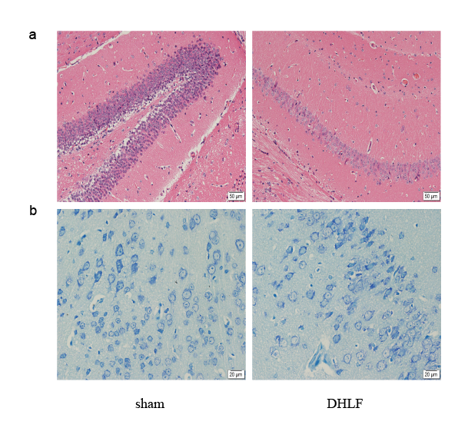
Supplementary materials 1 HE staining and Nissl staining of brain tissue in the DHLF mouse model. a: HE staining; b: Nissl staining. (DHLF: deep hypothermic low flow model group).

Supplementary materials 2 Establishment of Cell Model
Deep hypothermic oxygen glucose deprivation (hOGD) cell model
Cells were cultured to a confluence of 70%-75%. Serum-free medium was substituted with complete medium and placed in an incubator containing 5% CO2 and 95% air at 37°C for 2 h. The medium was gently aspirated with a pipette and 2 ml of PBS was added to each dish, which was repeated for three times. Then, 2 ml of fresh DMEM sugar-free medium was added. The cells were incubated in a triple-air incubator with 95% N2, 5% CO2 and 1% O2 for 24 h. The medium was gently aspirated with a pipette and 2 ml of PBS was added to each dish, which was repeated three times. Next, 2 ml of DMEM complete medium was added to each well, and the cells were incubated in an incubator with 5% CO2 and 95% air at 37°C for 24 h.

Supplementary materials 3
- Neurological deficit scoring
The mice were assessed for neurological function at 1 week after the establishment of the mouse DHLF model. A modified neurological deficit scale (total 14 points) was used:
(1) Tail-Hanging Test (THT)
The tail of the mouse was gently left above the ground by 10 cm. Each of forelimb flexion, hindlimb flexion or head rotation deviated from the central axis by more than 10 degrees was scored by 1 point.
(2) Flat movement test
The mouse was placed on a flat floor. Its movement scored 0 (walking normally); 1 (cannot walking in a straight line), 2 (walking in a circle), 3 (stumbling during walking).
(3) Sensory test
The auricle and cornea were stimulated. If the corneal reflex or auricular reflex disappeared, 1 point was given.
(4) Balance beam test
The mouse was gently placed on the balance beam and allowed to walk freely. Its performance scored 0 (normal walking), 1 (holding on to the balance beam), 2 (one foot falling down), 3 (two feet falling down or rotating in a circle), 4 (being able to maintain balance for more than 40 s), 5 (being able to maintain balance for more than 20 s), 6 (difficult to maintain balance and fall within 20 s).
(5) Total score=the sum of the four scores.
(6) Degree of neurological injury
Mild injury: 1-4 points; moderate injury: 5-9 points; severe injury: 10-14 points.
- Open field test
The DHLF mouse model was established. At day 28 or 29, every 12 mice were randomly taken as a group for open field test. The steps were as follows.
Parameters of the field box: 25 cm height, 50×40 cm bottom, black inner wall. A camera was placed 1 m above the box to ensure that its field of view can observe the internal area of the open field. The mouse was placed in the open field box, and the experimental personnel and equipment (such as computers) were placed in another room to reduce interference with animals (e.g., laboratory background noise below 65 dB).

Supplementary materials 4 Differentially expressed lncRNAs in brain tissue of deep hypothermic low-flow mouse model.
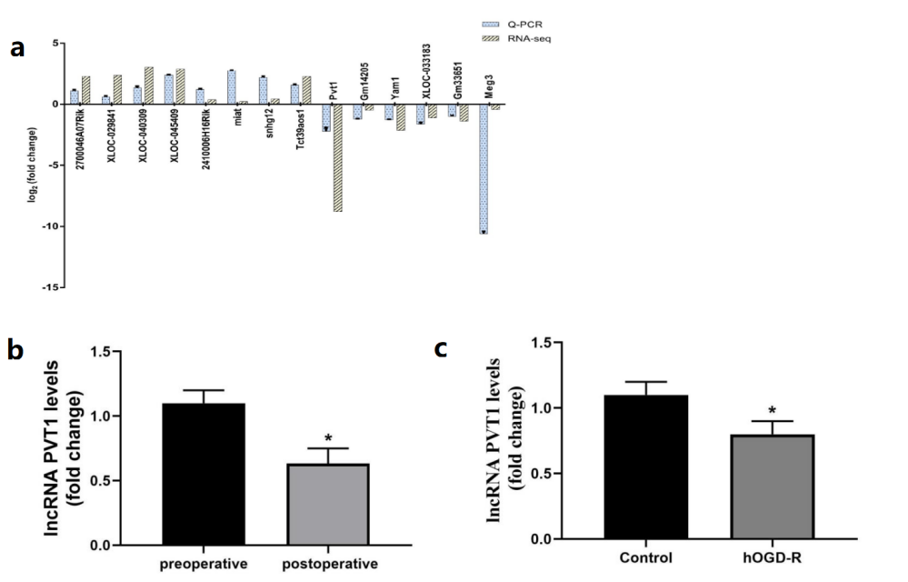
Supplementary materials 4 Differentially expressed lncRNAs in brain tissue of deep hypothermic low-flow mouse model. a:Validation of the changes of differentially expressed lncRNAs by real-time PCR (n=20); b:Expression of lncRNA PVT1 in the blood of children with congenital heart disease; c: Expression of lncRNA PVT1 in the deep hypothermic glucose oxygen deprivation cell model. (*p<0.05)

Table 2 Table of clinical and demographic characteristics of the children undergone DHLF.
category
age（day） | 30.00（12.00-75.00）
gender
male | 16（53.33%）
female | 14（46.67%）
weight（Kg） | 3.15（2.50-5.25）
extracorporeal circulation time（min） | 120.55（70.20-210.50）
aortic occlusion time（min） | 50.20（30.17-90.25）
Body temperature（℃） | 20.20（18-22）
ICU treatment time（day） | 12.3（7.00-35.00）
Total length of stay（day） | 48.20（45.20-72.30）
classification of congenital heart disease（case）
coarctation of aorta | 8
interrupted aortic arch | 4
total anomalous pulmonary  venous drainage | 10
double outlet of right ventricle | 6
complete transposition of great arteries | 2

Supplementary materials 5 Effect of lncRNA-PTV1 overexpression on apoptosis in a deep hypothermic glucose oxygen deprivation cell model.

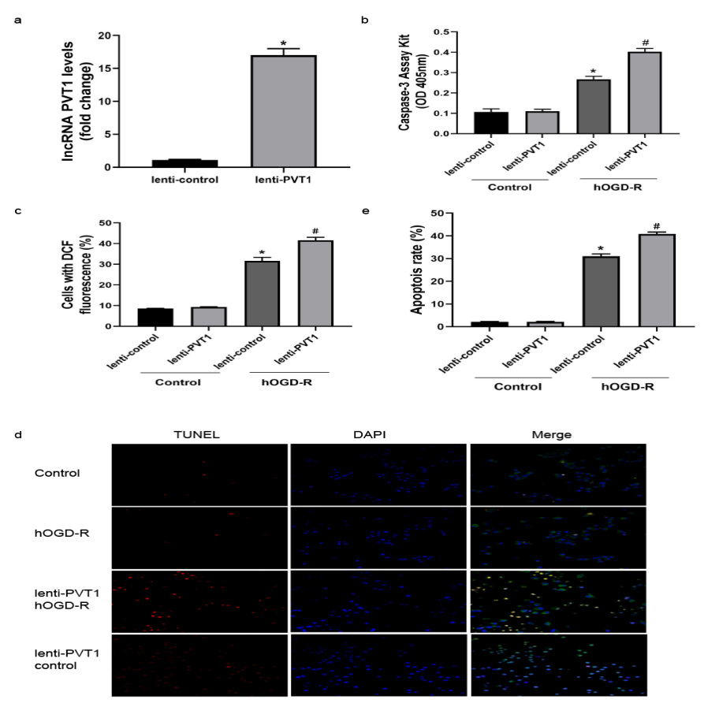
Supplementary materials 5 Effect of lncRNA-PTV1 overexpression on apoptosis in a deep hypothermic glucose oxygen deprivation cell model. a: the efficiency of lenti-PVT1 lentivirus vector transfection of N2a cells by real-time PCR (n= 6, *p< 0.05); b: the effect of lenti-PVT1 and lenti control on Caspase-3 activity in N2a cells by caspase-3 activity kit (n= 6, *p< 0.05, vs control group; n= 6, #p< 0.05, vs lncRNA PVT1 overexpression negative control in hOGD-R group); c: DCFH-DA probe to detect ROS production in cells of each group (n= 6, *p< 0.05, vs control group; n= 6, #p< 0.05, vs lncRNA PVT1 overexpression negative control in hOGD-R group); d&e. Immunofluorescence staining showing the effect of lenti-PVT1 and lenti-control lentivirus on apoptosis of N2a cells in control and hOGD-R groups (scale bar: 50 um) and analysis of apoptotic cells in selected regions by Image J software (n= 6, *p< 0.05, vs control group; n= 6, #p< 0.05, vs hOGD-R group in lncRNA PVT1 overexpression negative control group). (control: control group; hOGD-R: a deep hypothermic glucose oxygen deprivation cell model group; lenti-PVT1: lncRNA PVT1 overexpression model; lenti-control: lncRNA PVT1 overexpression model negative control)

Supplementary materials 6 lncRNA PVT1 interacts with miR-148a-3p.
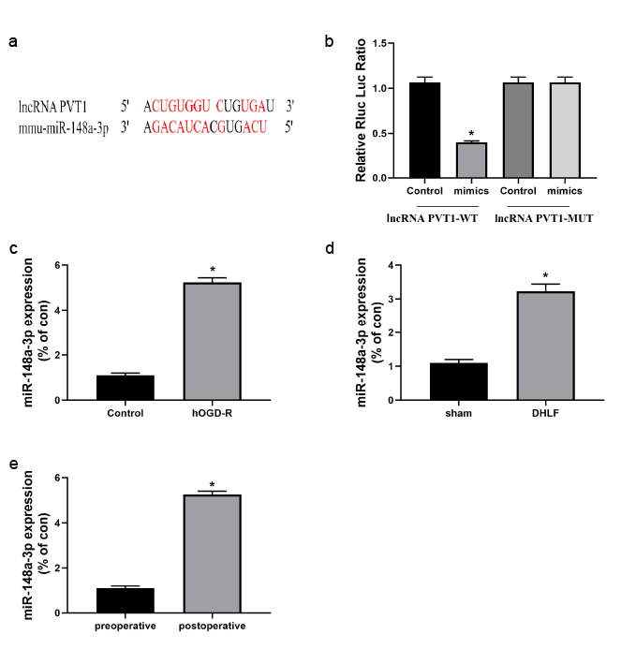
Supplementary materials 6 lncRNA PVT1 interacts with miR-148a-3p. a: bioinformatic analysis to predict the binding site of lncRNA PVT1 to miR-148a-3p; b: luciferase reporter gene assay to verify the binding of lncRNA PVT1 to miR-148a-3p (n= 6, p< 0.05); c: real-time PCR to detect the expression of miR-148a-3p in the N2a cell hOGD-R model (n= 6, *p< 0.05); d: real-time PCR to detect the expression of miR-148a-3p in the brain tissue of mouse DHLF model (n= 6, *p< 0.05); e: real-time PCR to detect the in vitro process on miR-148a-3p expression in the blood of the children (n= 6, *p< 0.05). (control: control group; hOGD-R: deep hypothermic glyoxylation deprivation-reoxygenation cell model group; DHLF: mouse deep hypothermic low-flow group; lenti-PVT1-WT: lncRNA PVT1 genotype as wild-type group; lncRNA PVT1-MUT: lncRNA PVT1 genotype as mutant group).

Supplementary materials 7 MKL1 as a downstream target molecule of lncRNA PVT1/miR-148a-3p axis

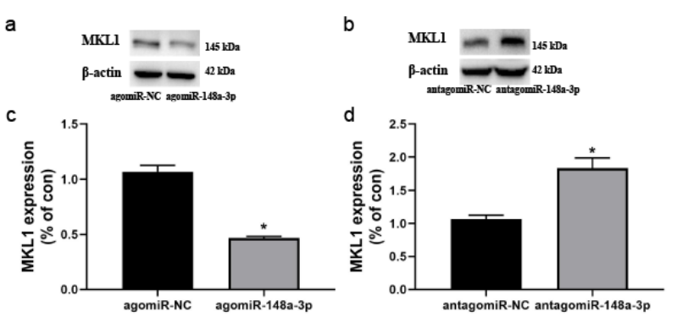
Supplementary materials 7A1 MKL1 as a downstream target molecule of lncRNA PVT1/miR-148a-3p axis. a&c: agomiR-NC, agomiR-148a-3p transfected N2a cells, established hOGD-R model, western blot to detect the protein expression level of MKL1 in cells (n= 6, *p<0.05); b&d. antagomiR-NC, antagomiR-148a-3p transfected N2a cells, hOGD-R model established, western blot to detect the protein expression level of MKL1 in the cells (n= 6, *p<0.05);

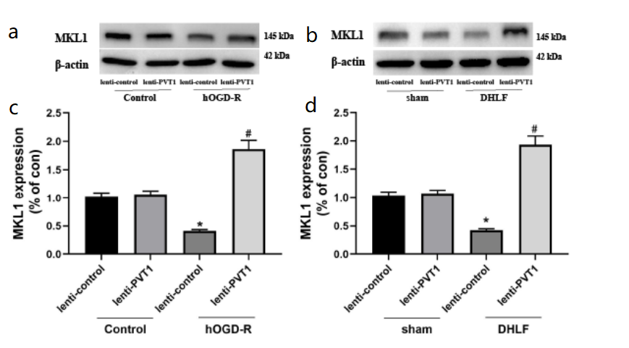
Supplementary materials 7A2 MKL1 as a downstream target molecule of lncRNA PVT1/miR-148a-3p axis.
a&c: western blot to detect the effect of lenti-PVT1 and lenti-control viral vectors on MKL1 protein expression in cells of control and hOGD-R groups (n= 6, *p< 0.05, vs control group; n= 6, #p<0.05, vs hOGD-R model in lncRNA PVT1 overexpression negative control group); b&d: western blot to detect the effect of lenti-PVT1 and lenti-control viral vectors on MKL1 protein expression in brain tissue of mice in sham and DHLF groups (n= 6, *p< 0.05, vs sham group; n= 6, #p<0.05, vs DHLF model in lncRNA PVT1 overexpression negative control group)
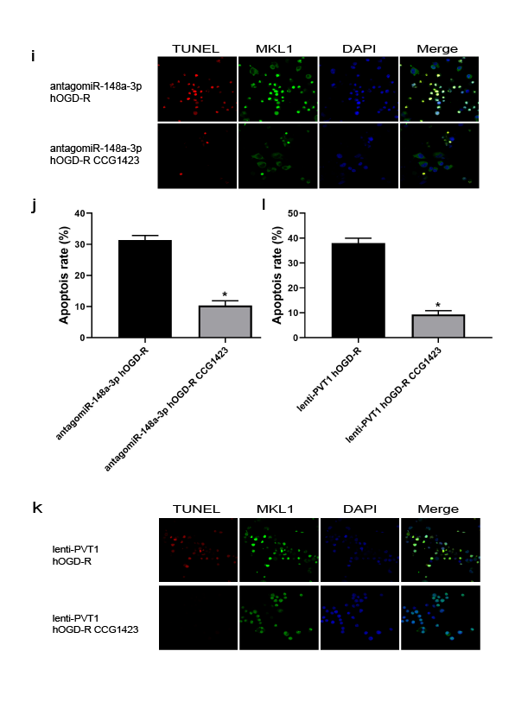
Supplementary materials 7B MKL1 as a downstream target molecule of lncRNA PVT1/miR-148a-3p axis. i&j: immunofluorescence analysis of apoptosis in antagomiR-148a-3p-transfected N2a cells hOGD-R model after MKL1 inhibitor blockade (n= 6, *p<0.05); k&l: immunofluorescence analysis of apoptosis in lncRNA PVT1 after MKL1 inhibitor blockade apoptosis in the overexpression group after MKL1 inhibitor blockade (n=6, *p<0.05)
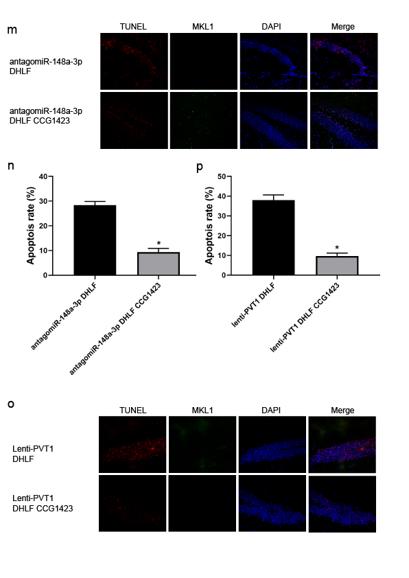
Supplementary materials 7C MKL1 as a downstream target molecule of lncRNA PVT1/miR-148a-3p axis. m&n: immunofluorescence analysis of apoptosis in the brain group of antagomiR-148a-3p lateral ventricle injected mouse DHLF model after MKL1 inhibitor blockade (n=6, *p<0.05); o&p: immunofluorescence analysis of apoptosis in the brain group of lenti-PVT1 slow apoptosis in the mouse DHLF model brain group after viral lateral ventricular injection (n=6, *p<0.05). (control: control group; hOGD-R: deep hypothermic glyoxylation deprivation-reoxygenation cell model group; lenti-PVT1: lncRNA PVT1 overexpression model group; lenti-control: lncRNA PVT1 overexpression model negative control group; agomiR-148a-3p: miR-148a-3p overexpression group. agomiR-NC: miR-148a-3p overexpression negative control; antagomiR-148a-3p: miR-148a-3p silent expression group; antagomiR-NC: miR-148a-3p silent expression negative control group).
Supplementary materials 8 The lncRNA PVT1/miR-148a-3p axis regulates apoptosis through MKL1.

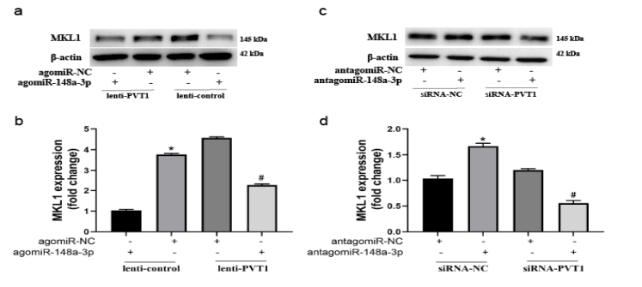
Supplementary materials 8A The lncRNA PVT1/miR-148a-3p axis regulates apoptosis through MKL1. a&b: western blot detection of MKL1 protein expression in N2a cells after co-transfection with lenti-PVT1 lentivirus and agomiR-148a-3p (n= 6, *p<0.05, vs agomiR-NC group. n= 6, #p<0.05, vs agomiR-148a-3p group); c&d: western blot detection of MKL1 expression in N2a cells after co-transfection with siRNA-PVT1 and antagomiR-148a-3p (n= 6, *p<0.05, vs antagomiR-NC group; n= 6, #p< 0.05, vs antagomiR-148a-3p group)(control: control group; hOGD: deep hypothermic glyoxylation deprivation/reoxygenation cell model group; lenti-PVT1: lncRNA PVT1 overexpression model; lenti-control: lncRNA PVT1 overexpression model negative control group; agomiR-148a-3p: miR-148a-3p overexpression group. agomiR-NC miR-148a-3p overexpression negative control; antagomiR-148a-3p: miR-148a-3p silent expression group; antagomiR-NC: miR-148a-3p silent expression negative control group; pcDNA3.1-vector: MKL1 overexpression negative control group. (pcDNA3.1-mkl1: MKL1 overexpression group; siRNA-NC: lncRNA PVT1 silent expression negative control group; siRNA-PVT1: lncRNA PVT1 silent expression group).
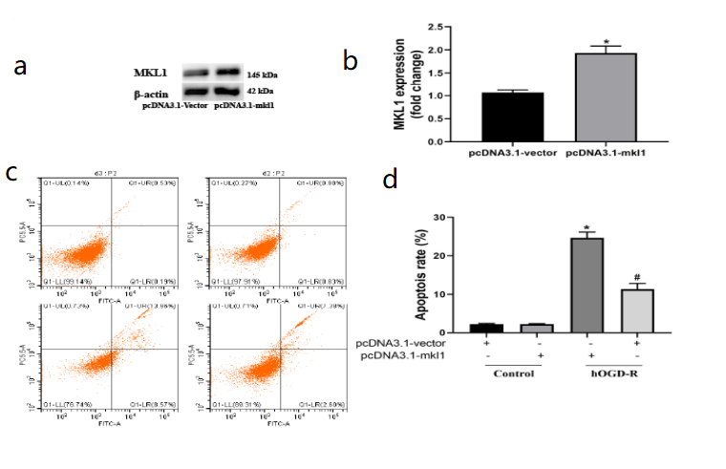

Supplementary materials 8B The lncRNA PVT1/miR-148a-3p axis regulates apoptosis through MKL1. a&b: Western blot detection of MKL1 protein expression after transfection with pcDNA3.1-MKL1; c&d: flow cytometry detection of the effect of N2a cells transfected with pcDNA3.1-MKL1 on apoptosis in hOGD model cells (n= 6, *p<0.05 vs pcDNA3.1-vector group; n= 6, #p<0.05, vs control group). (control: control group; hOGD: deep hypothermic glyoxylation deprivation/reoxygenation cell model group; lenti-PVT1: lncRNA PVT1 overexpression model; lenti-control: lncRNA PVT1 overexpression model negative control group; agomiR-148a-3p: miR-148a-3p overexpression group. agomiR-NC miR-148a-3p overexpression negative control; antagomiR-148a-3p: miR-148a-3p silent expression group; antagomiR-NC: miR-148a-3p silent expression negative control group; pcDNA3.1-vector: MKL1 overexpression negative control group. (pcDNA3.1-mkl1: MKL1 overexpression group; siRNA-NC: lncRNA PVT1 silent expression negative control group; siRNA-PVT1: lncRNA PVT1 silent expression group).

