Supplementary Information for
Electric double layer structure in concentrated aqueous solution

Minho M. Kim^{1,4}, Dong Hyun Kim^{2,4}, Junsic Cho^{2,4}, Seung-Jae Shin^{3,*}, Chang Hyuck Choi^{2,*}, and Hyungjun Kim^{1,*}

¹ Department of Chemistry, Korea Advanced Institute of Science and Technology (KAIST), Daejeon 34141, Republic of Korea
² Department of Chemistry, Pohang University of Science and Technology (POSTECH), Pohang 37673, Republic of Korea
³ School of Energy and Chemical Engineering, Ulsan National Institute of Science and Technology (UNIST), Ulsan 44919, Republic of Korea
⁴ These authors contributed equally: Minho M. Kim, Dong Hyun Kim, Junsic Cho

*Corresponding authors: (S.-J. Shin) seungjae.shin@unist.ac.kr; (C. H. Choi) chchoi@postech.ac.kr; (H. Kim) linus16@kaist.ac.kr

Supplementary Note 1. Computational details
In this study, we employed the density functional theory in classical explicit solvents (DFT-CES) method, which was developed by our group.^{1–3} DFT-CES is a mean-field quantum mechanics/molecular mechanics (QM/MM) simulation method used to accurately describe electrochemical interface systems. In this method, QM (mainly for the electrode) and MM (mainly for the electrolyte) simulations are performed iteratively until energy convergence is achieved. The ensemble-averaged electrostatic potential from the molecular dynamics (MD) trajectory was applied as an external potential in the DFT calculations. Conversely, the Hartree and nuclei potentials of the QM subsystem were used as external potentials in the MD simulations. DFT-CES was implemented by combining the Quantum Espresso software for DFT simulations and the large-scale atomic/molecular massive parallel simulator (LAMMPS) software package for MD simulations.^{4,5}
The Ag(100) and Ag(111) electrodes were interfaced with various bulk concentrations of the NaF electrolyte. Both electrodes were simulated at the QM level. The Ag(100) electrode was modelled using a four-layer slab with the lateral dimensions of 4.14 Å × 4.14 Å. The Ag(111) electrode was modelled using a four-layer slab with a ($\sqrt{3}$ × 2) correct surface unit cell with the dimensions of 5.08 Å × 5.86 Å. The projector-augmented wave (PAW) method was used together with the Perdew-Burke-Ernzerhof (PBE) exchange-correlation functional.^{6,7} A kinetic energy cutoff of 60 Ry and Gaussian smearing value of 0.0147 Ry were employed. (9 × 9 × 1)-and (8 × 8 × 1) Γ-centred k-point grids were used for Ag(100) and Ag(111), respectively. A dipole correction along the z-direction was applied to cancel the nonphysical interactions between the periodic images.
NaF electrolyte was simulated at the MM level using canonical-ensemble classical MD. 6000 TIP3P-EW water molecules⁸ were used, and Na⁺ and F⁻ ions were included in the simulation cell. Ion-ion and ion-water interactions were described using parameters reported in the literature.⁹ The interfacial van der Waals (vdW) interactions between the QM and MM subsystems were described using previously developed first-principles-based parameters that reproduced the experimental camel-shaped capacitance curve of the Ag(111)-NaF interface.¹⁰
For the dilute case, only the excess Na⁺ or F⁻ ions were added to compensate for the excess negative or positive charge of the electrode, respectively. For finite bulk concentration cases, the bulk concentration was maintained at specific values by applying the Chemostat method developed in this study. A detailed description of the Chemostat method is provided in Supplementary Note 2. For the Ag(100)-NaF interface, the simulations were performed for the dilute-limit, and 0.1 M and 0.2 M bulk concentrations, whereas for the Ag(111)-NaF interface, the simulations were only performed for the dilute limit and 0.1 M bulk concentrations.
(11 × 11) and (9 × 8) supercells of the small QM cell were employed for the MD simulations of the Ag(100)-NaF and Ag(111)-NaF interfaces, respectively, resulting in the MD cell sizes of 45.59 Å × 45.59 Å and 45.68 Å × 46.89 Å. The electrodes were polarised by varying the number of electrons, corresponding to the surface charge densities ranging from −27.76 to 18.50 μC cm⁻² for Ag(100) and from −23.94 to 29.92 μC cm⁻² for Ag(111). A Nosé-Hoover thermostat was used to maintain the temperature at 300 K with a damping constant of 100 fs,^{11,12} and periodic boundary conditions (PBCs) were applied along the x- and y-directions. The modified particle-particle particle-mesh (PPPM) method was employed to account for long-range electrostatic interactions in the slab geometry.¹³ Canonical ensemble simulations were performed for 12 ns, and the final 10 ns of the trajectory were used to compute the ensemble properties.
The electrode potential was calculated using the scheme proposed by Trasatti,¹⁴ in which the absolute potential of the standard hydrogen electrode (SHE) is set to 4.4 V.^{10,15} The electrode potential relative to the SHE is given by:
$$\begin{aligned}E \left(V_{SHE}\right)=E{}_{vac}-E_{F}-4.4 V\#\left(1\right)\end{aligned}$$
where $E{}_{vac}$ is the vacuum level and $E_{F}$ is the Fermi level.

Supplementary Note 2. Chemostat method
The microenvironment of the electric double layer (EDL) is different from that of the bulk electrolyte. For example, a previous experimental study showed that the interfacial concentration can differ by up to approximately 80 times compared to the bulk concentration.¹⁶ However, most EDL simulations typically include only counterions or a fixed number of cation-anion pairs based on the bulk concentration.^{17,18} Therefore, a simulation method that can investigate the interfacial properties under well-controlled bulk conditions is required to accurately compare simulation and experimental results.
To address this need, we developed a Chemostat method that efficiently and stably controls the bulk concentration of interfacial systems during MD simulations. To establish the Chemostat method, we first chose the bulk region, which must be sufficiently distant from the interface, such that the local concentrations of both cations and anions are equal and spatially uniform (Supplementary Note Fig. 1).
During MD simulation, the local ion concentration in the bulk region, $C\left(t\right)$, was calculated for each snapshot at time $t$. The Chemostat method determines the concentration adjustment rate as follows:
$$\begin{aligned}\frac{dC}{dt}=\frac{C^{0}-C}{τ} \#\left(2\right)\end{aligned}$$
where $C^{0}$ is the target concentration and τ is the Chemostat coupling constant, which determines the time scale of the adjustment. Eq. (2) is equivalent to the governing equation of the Berendsen thermostat¹⁹ used to control the temperature. In this study, $τ$ was set to 1 ps.
The Chemostat adjusts $C\left(t\right)$ by modifying the partial charges of a tagged ion pair located within the bulk region. Based on the computed $dC/dt$ value from Eqs. (2), the Chemostat determines the (de)growth rate of the tagged ion pair. To (de)grow ions while avoiding close contact with the existing molecules in the simulation cell, soft-core potentials were employed for the van der Waals ($u_{LJ}$) and Coulomb ($u_{Coul}$) interactions:²⁰
$$\begin{aligned}u_{LJ}\left(r,λ\right)=λ^{k}4ϵ\left\{\frac{1}{{\left[α_{LJ}{\left(1-λ\right)}^{2}+{\left(\frac{r}{σ}\right)}^{s}\right]}^{\frac{12}{s}}}-\frac{1}{{\left[α_{LJ}{\left(1-λ\right)}^{2}+{\left(\frac{r}{σ}\right)}^{s}\right]}^{\frac{6}{s}}}\right\}\#\left(3\right)\end{aligned}$$
$$\begin{aligned}u_{Coul}\left(r,λ\right)=λ^{k}\frac{q_{i}q_{j}}{4πϵ_{0}{\left[α_{Coul}{\left(1-λ\right)}^{2}+r^{p}\right]}^{\frac{1}{p}}}\#\left(4\right)\end{aligned}$$
where s = 2, p = 2, α_{LJ} = 6.25/σ², and α_{Coul} = 6.25. The activation parameter, λ gradually switches on the interaction as it changes from 0 to 1.
Using Eq. (2), the change in the concentration, defined as $∆C\left(t\right)≡C\left(t+∆t\right)-C\left(t\right)$, over an MD timestep, $∆t$, is expressed as:
$$\begin{aligned}∆C\left(t\right)=\frac{(C^{0}-C\left(t\right))∆t}{τ}\#\left(5\right)\end{aligned}$$
For monovalent ions, this change leads to
$$\begin{aligned}∆λ\left(t\right)=\frac{V_{bulk}∆C\left(t\right)}{N_{A}} \#\left(6\right)\end{aligned}$$
where $V_{bulk}$ is the volume of the bulk region and $N_{A}$ is Avogadro’s constant, as we used the molarity unit for concentration. Using Eq. (6), we (de)grow the tagged ion pairs. When $λ<0$, the originally tagged ion pair is deleted, and a new ion pair in the bulk region is selected, with its activation parameter set to $λ+1$. When $λ>0$, the tagged ion pair is fully grown (i.e., $λ=1$) and can then freely travel throughout the simulation cell without being confined to the bulk region. Then, a new ion pair in the bulk region is created, and its activation parameter is set to $λ-1$. We confirmed that the bulk concentration was well-maintained using the Chemostat method (Supplementary Fig. 2).

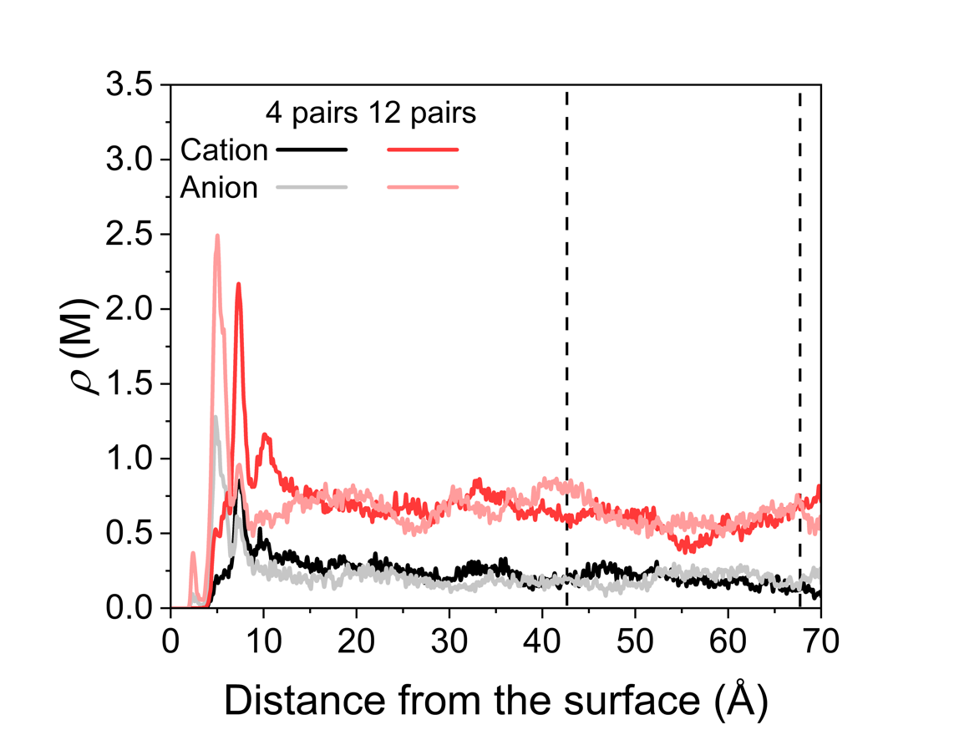
Supplementary Note Fig. 1. Local ion concentration (ρ) along the surface normal direction at different ion concentrations. Representative data are shown for the Ag(111)-NaF electrolyte interface systems under potential zero charge (PZC) conditions. The local ion concentrations near the electrode increased to approximately five times those in the bulk region, which was farther from the electrode and exhibited constant values (indicated by the black dashed lines).

Supplementary Note 3. Thermodynamic relation between the phase transition and capacitance peaks
Thermodynamically, the charging process of the EDL can be viewed as an entropy ($S$)-decreasing process at a given temperature ($T$), driven by the electric work, $δW$, done on the interfacial system. The change in the Helmholtz free energy $dF$ is given by
$$\begin{aligned}dF=-SdT+δW \#\left(7\right)\end{aligned}$$
$$\begin{aligned}δW=EdQ=EAdσ\#\left(8\right)\end{aligned}$$
where $E$ is the electrochemical potential, $Q$ is the total charge stored in the EDL, and $σ$ is the surface charge density (with $A$ denoting the interfacial area). Using per-area quantities (i.e. $f=F/A$ and $s=S/A$), Eq. (7) can be rewritten as
$$\begin{aligned}df=-sdT+Edσ\#\left(9\right)\end{aligned}$$
Under isothermal conditions ($dT=0)$, Eq. (9) yields the Helmholtz free energy per unit area (up to an additive constant):.
$$\begin{aligned}f=\int_{0}^{σ}{E\left(σ\right)dσ}\#\left(10\right)\end{aligned}$$
Upon applying an external bias potential, $E_{bias}$, using the Legendre transformation of Eq. (9), the interfacial Gibbs free energy can be defined as
$$\begin{aligned}g\left(σ\right)=f-Eσ=\int_{0}^{σ}{E\left(σ\right)dσ}-E_{bias}σ\#\left(11\right)\end{aligned}$$
At equilibrium, the condition for minimum $g$ leads to:
$$\begin{aligned}\frac{∂g}{∂σ}=E\left(σ\right)-E_{bias}=0\#\left(12\right)\end{aligned}$$
Consequently, in the S-shaped region of the $σ-E$ curve, Eq. (12) yields the following three mathematical roots. The middle root corresponds to a maximum of $g\left(σ\right)$, violating the thermodynamic stability condition, while the outer two correspond to local minima of $g\left(σ\right),$ resulting in a double-well free energy profile. If we define the bias potential at which both minima yield the same $g$ as $E_{0}$, then two thermodynamically stable phases, each characterised by a distinct value of $σ$, can coexist when $E_{bias}=E_{0}$. In addition, a phase transition occurred when $E_{bias}$ was swept across $E_{0}$ (Supplementary Note Fig. 2).
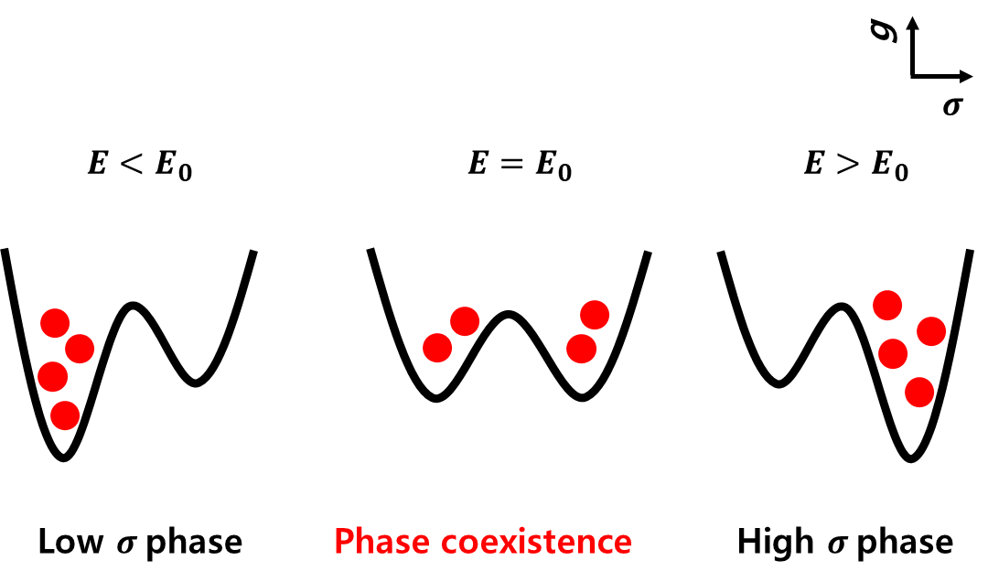
Supplementary Note Fig. 2. Free energy diagram of phase transition. Red circles indicate the probability distributions corresponding to the given double-well free energy curves. E₀ denotes the electrode potential at which the phase transition occurs.

A first-order phase transition typically produces a sharp peak in the second derivative of the free energy; or in this case, in the capacitance C. However, the experimentally observed capacitance peaks are quite broad, which is attributed to the finite size effect.²¹ According to the fluctuation-dissipation theorem, C can be expressed in terms of the fluctuation of σ:
$$\begin{aligned}C=A\frac{〈σ^{2}〉-{〈σ〉}^{2}}{k_{B}T}\#\left(13\right)\end{aligned}$$
where $〈⋯〉$ denotes the ensemble average, $k_{B}$ is the Boltzmann constant, T is the temperature, and A is the area of concurrent phase change. By varying A in the range of 10–50 Å², our additional Monte Carlo simulations reproduced reasonably broadened capacitance peaks that are comparable to those observed experimentally (Supplementary Note Fig. 3). This suggests that the correlation length associated with the phase transition spans only a few molecules.
Because the nature of the transition involves either reorientation within the disordered water structure or anion condensation into an intermediate-range ordered (i.e. liquid-like) phase, the correlation length is expected to be of the order of several molecular lengths, contributing to substantial peak broadening. We further note that the SPEIS (staircase potentioelectrochemical impedance spectroscopy) measurements based on an AC response intrinsically average the capacitance over an AC potential window (approximately ±10 mV), which also contributes to the experimentally observed peak broadening.
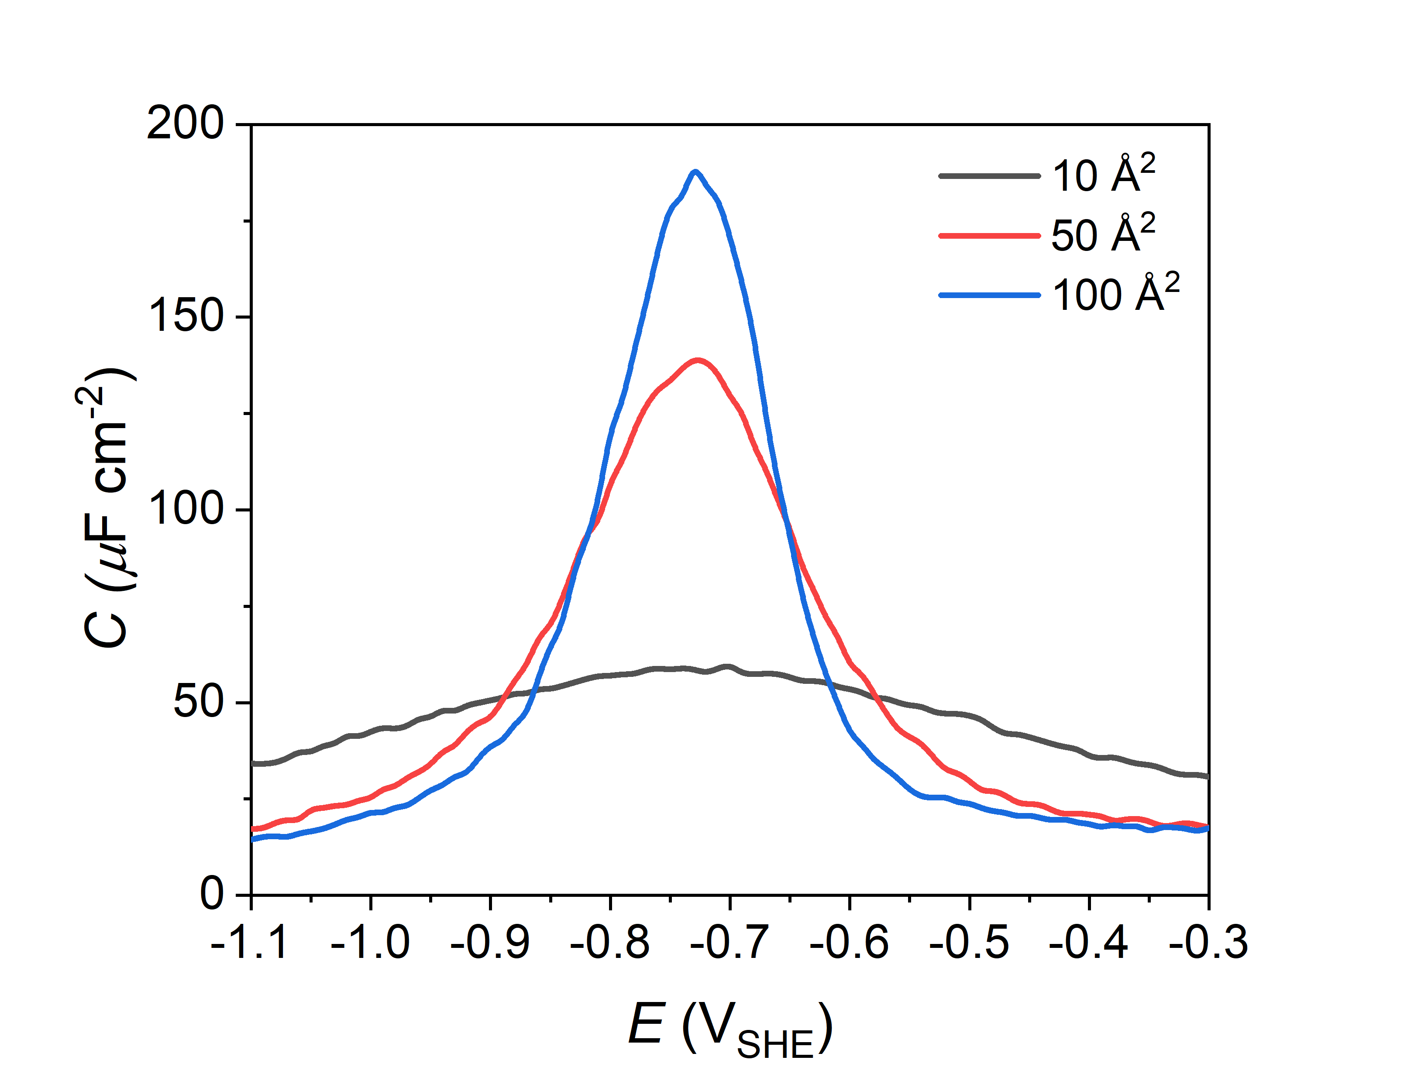
Supplementary Note Fig. 3. Calculated capacitance curve with Monte Carlo simulation. σ-E curve at the bulk concentration of 0.2 M is used.

Supplementary Note 4. Multi-layer capacitor models
To provide a general model for the EDL structure at different bulk concentrations, we developed multilayer capacitor models with parameters tuned to reproduce our atomic simulation results. Atomic simulations have revealed that more than one compact ion layer forms at the interface: two compact ion layers (outer Helmholtz layers) appear at the cathodically polarised electrode, whereas three compact ion layers, namely one inner Helmholtz layer and two outer Helmholtz layers, form at the anodically polarised electrode. Accordingly, we extended the original GCS model, which consisted of two capacitors (a Helmholtz capacitor and a GC capacitor), to include two and three ion layers at the cathodic and anodic interfaces, respectively (Supplementary Note Fig. 4).
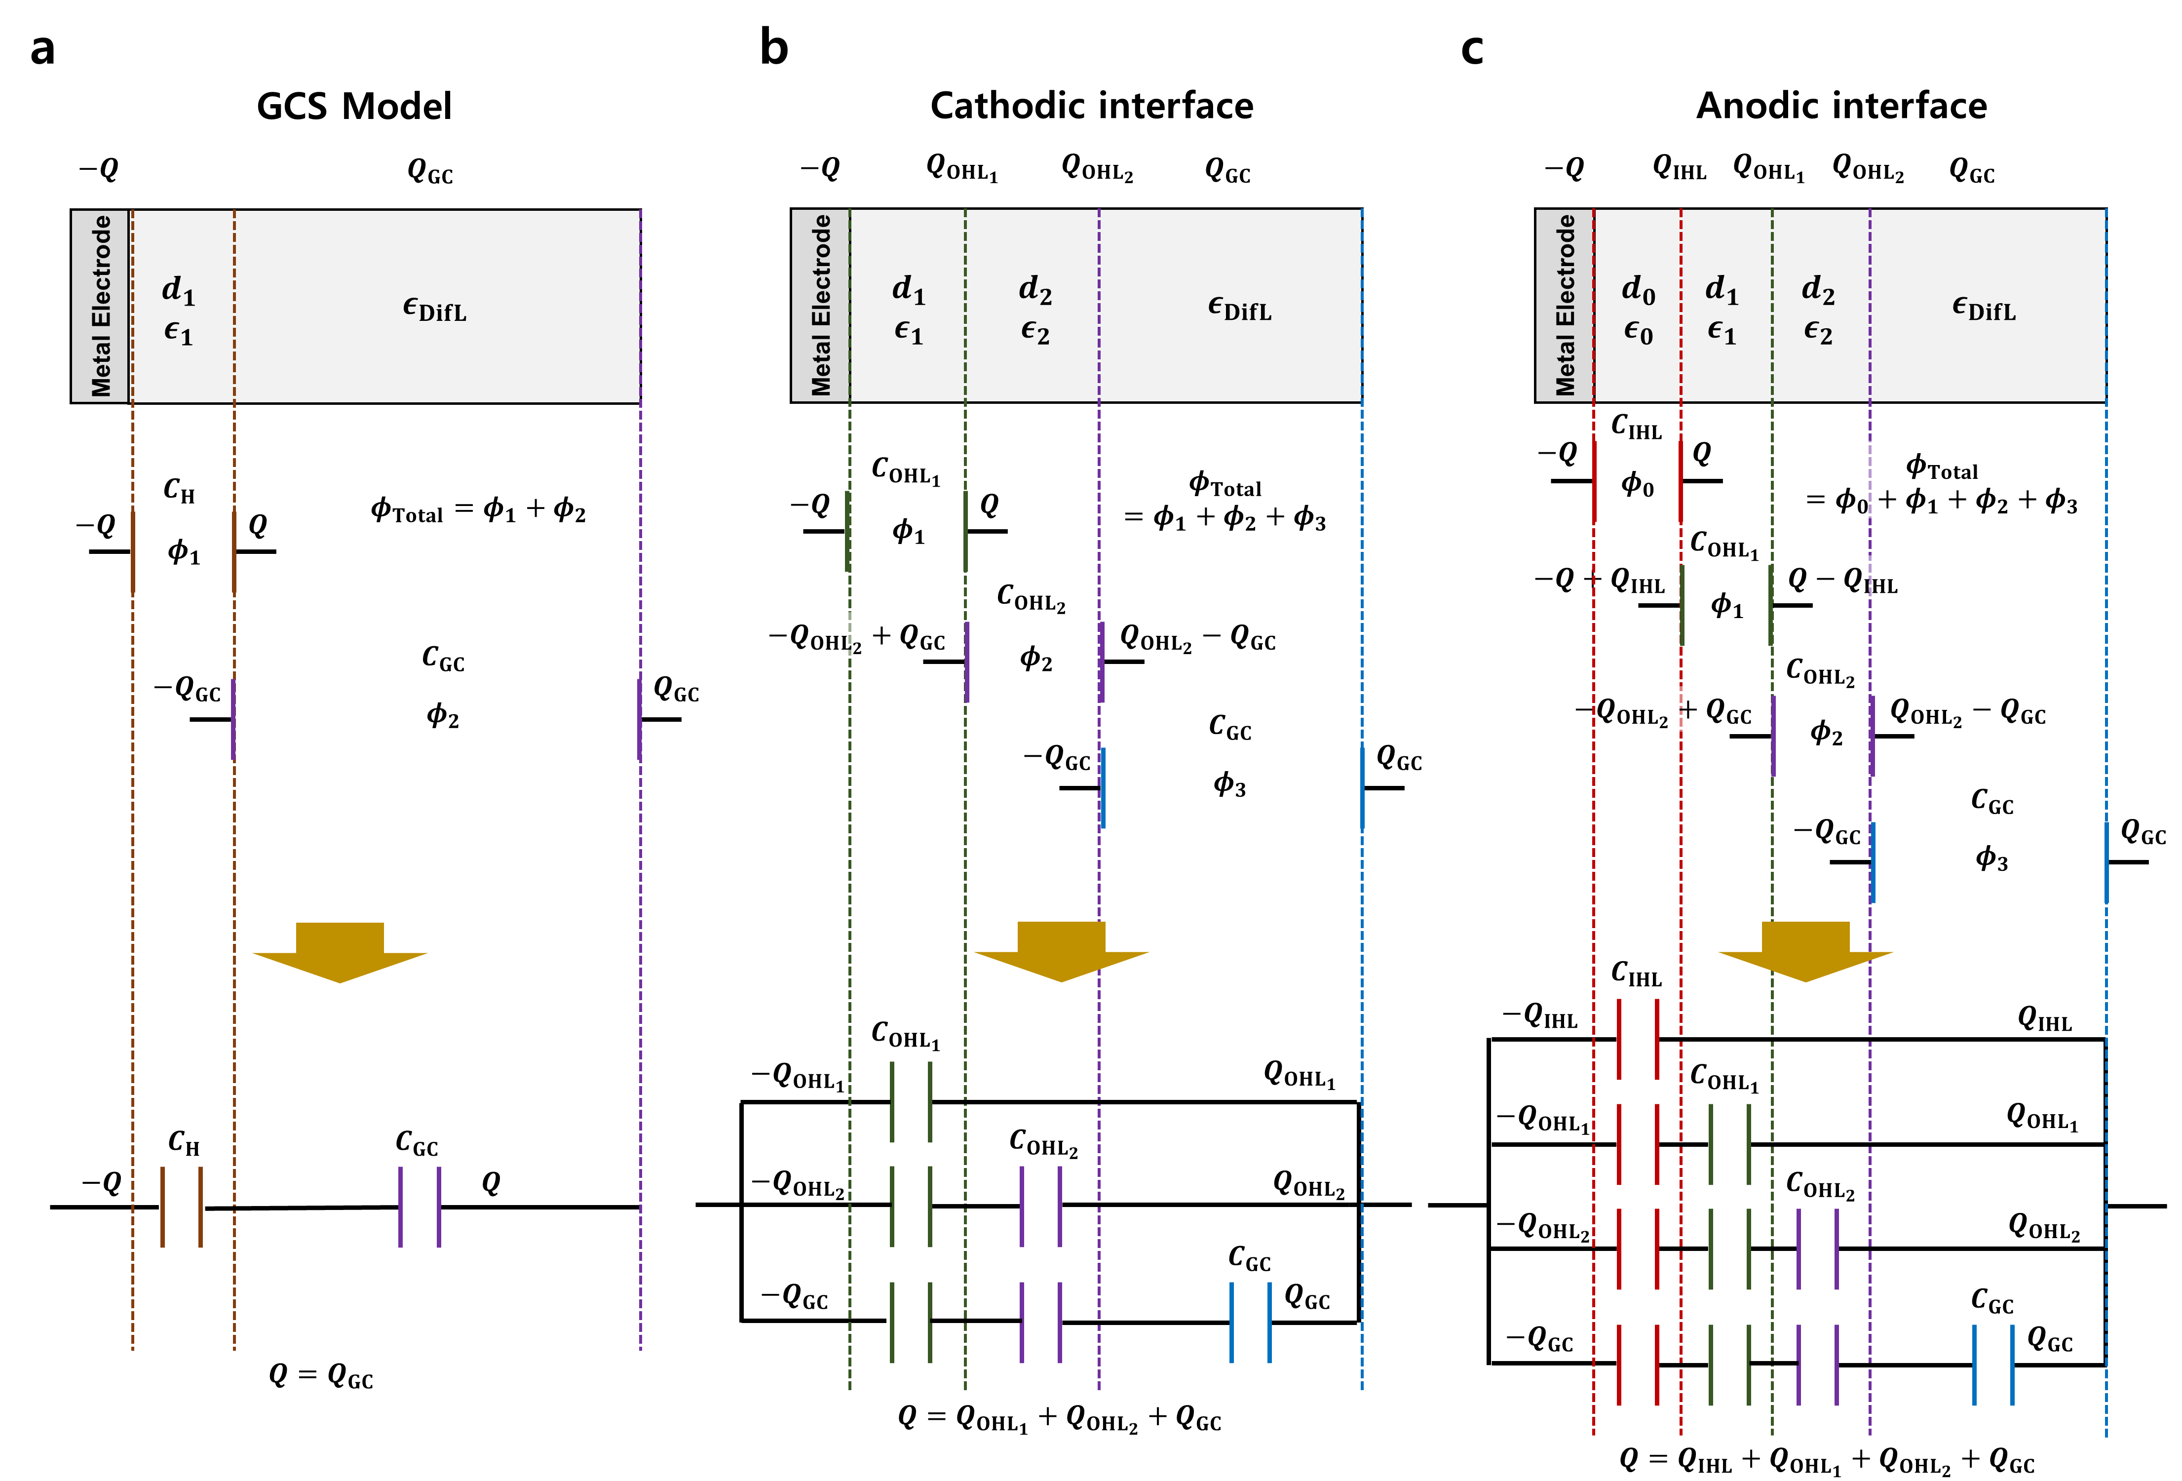
Supplementary Note Fig. 4. Multi-layer capacitor models. a, GCS model. b, Multilayer capacitor model for the cathodic interface. c, Multilayer capacitor model for the anodic interface. From the graphical representation of the EDL (top figures), total potential drop, $ϕ_{Total}$, is calculated as the sum of the potential drops across each layer (middle figures). These EDL structures are represented by the equivalent-circuit models shown in the figures at the bottom. C_{H} is the capacitance contribution of the region between the electrode and Helmholtz layer for the GCS model. C_{GC} represents the capacitance of the diffuse layer. C_{OHL1}, C_{OHL2}, C_{IHL} correspond to the capacitance contributions from OHL₁ (outer Helmholtz layer 1), OHL₂ (outer Helmholtz layer 2), and IHL (inner Helmholtz layer), respectively. Based on the DFT-CES results for the local ion distributions (Supplementary Figs. 3-5), OHL₁, OHL₂ and IHL are defined as the regions at the distances of 3.2–6.5 Å, 6.5–8.8 Å, and 0.0–3.2 Å from the surface, respectively. The remaining region is identified as the diffuse layer.
To compute the potential drop at a given σ, the following parameters must be defined: the amount of charge stored in each layer, the dielectric constant of each layer, and the Debye length of the diffuse layer. First, the amount of charge (i.e. ionic content) in each layer can be directly extracted from DFT-CES simulations. We found that the number of ions at the cathodic interface remained constant across different bulk concentrations (Supplementary Fig. 5).
Supplementary Note Fig. 5. Total amount of ions stored at each OHL for the cathodic interface. The DFT-CES simulation results show the total ion content in OHL₁ and OHL₂. The black dashed line indicates the surface charge density of the electrode (σ).

The fitted equations for the ion contents of the OHLs at the cathodic interface are as follows:
$$\begin{aligned}σ_{<{OHL}_{1}}=\frac{35.00\exp\left(-0.18σ-4.35\right)}{1+\exp\left(-0.18σ-4.35\right)} for σ<0\#\left(14\right)\end{aligned}$$
$$\begin{aligned}σ_{<{OHL}_{2}}=0.02σ^{2}-0.36σ for σ<0\#\left(15\right)\end{aligned}$$
where the unit of $σ$ is μC cm⁻². Note that $σ_{<{OHL}_{1}}$ has the form of Langmuir adsorption, and $σ_{<{OHL}_{2}}$ has the quadratic form, which was empirically chosen.
For the anodic interface, DFT-CES finds that the amount of ions at the interface depends strongly on the bulk concentration, c, and also linearly depends on the surface charge density of the electrode, σ (Supplementary Note Fig. 6). Thus, the fitted equations for the ion contents of the layers at the anodic interface are as follows:
$$\begin{aligned}σ_{<IHL}=σ\left(-14.59c^{2}-0.86c-0.99\right)\#\left(16\right)\end{aligned}$$
$$\begin{aligned}σ_{<OHL{}_{1}}=σ\left(-4.81c^{2}-1.88c-1.00\right)\#\left(17\right)\end{aligned}$$
$$\begin{aligned}σ_{<OHL{}_{2}}=σ\left(-0.55c^{2}-1.23c-1.00\right)\#\left(18\right)\end{aligned}$$
where the unit of c is M.
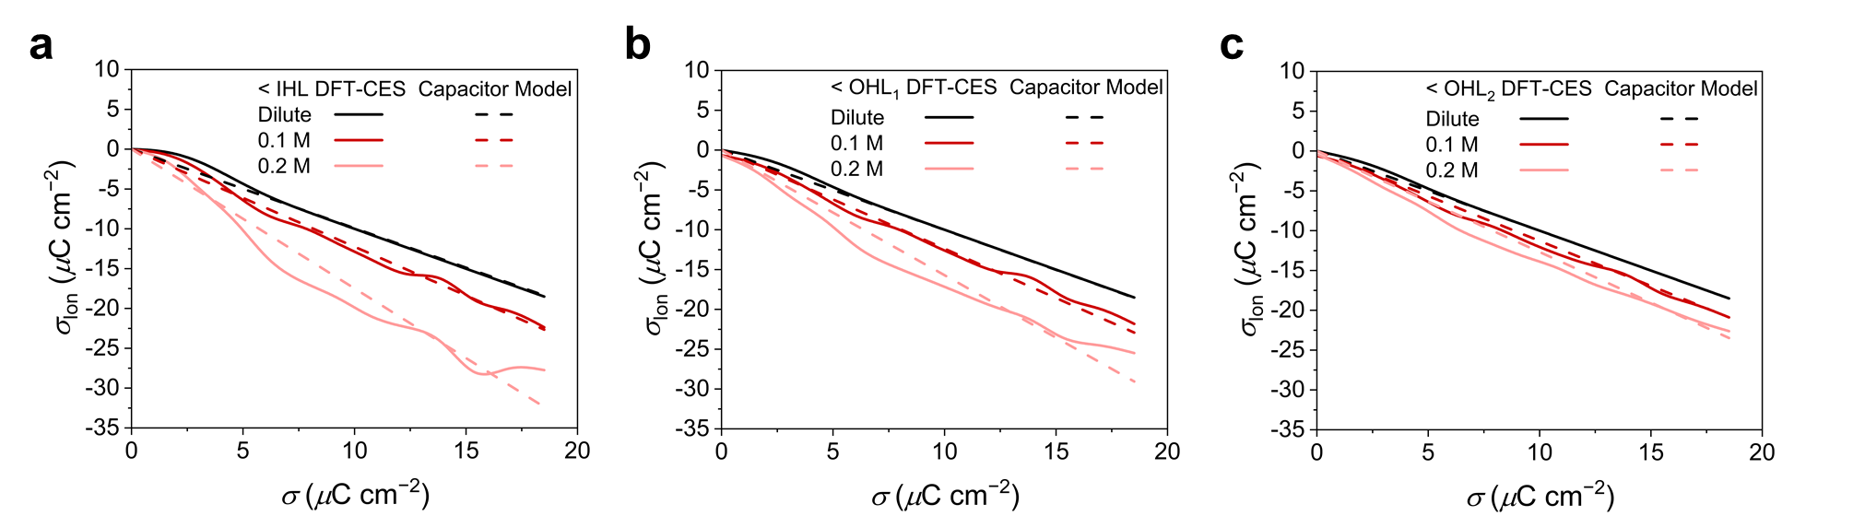
Supplementary Note Fig. 6. Total amount of ions stored at each layer for the anodic interface. DFT-CES simulation results show the total ion content in (a) IHL, (b) OHL₁, and (c) OHL₂.

For the diffuse layer, we used a Debye length of 5.6 Å, obtained by fitting the local ion concentration profiles in the diffuse region (Supplementary Fig. 8). In contrast to the conventional GCS model, we found that the Debye length was insensitive to bulk concentration. This behaviour is conceptually consistent with the results obtained by the Willard group who showed that water molecules can suppress the dependence of the Debye length on ionic strength.²²
Finally, we set the dielectric constant for C_{GC} as ε_{DifL}=78.4, considering the screening due to the bulk water. Then, we fitted ε₀ for C_{IHL}, ε₁ for C_{OHL1}, and ε₂ for C_{OHL2} to reproduce the DFT-CES simulation results. The fitted the dielectric constants accurately reproduce the σ-E curves obtained from the DFT-CES simulations, where ε_{DifL}=78.4 is employed (Supplementary Note Fig. 7).
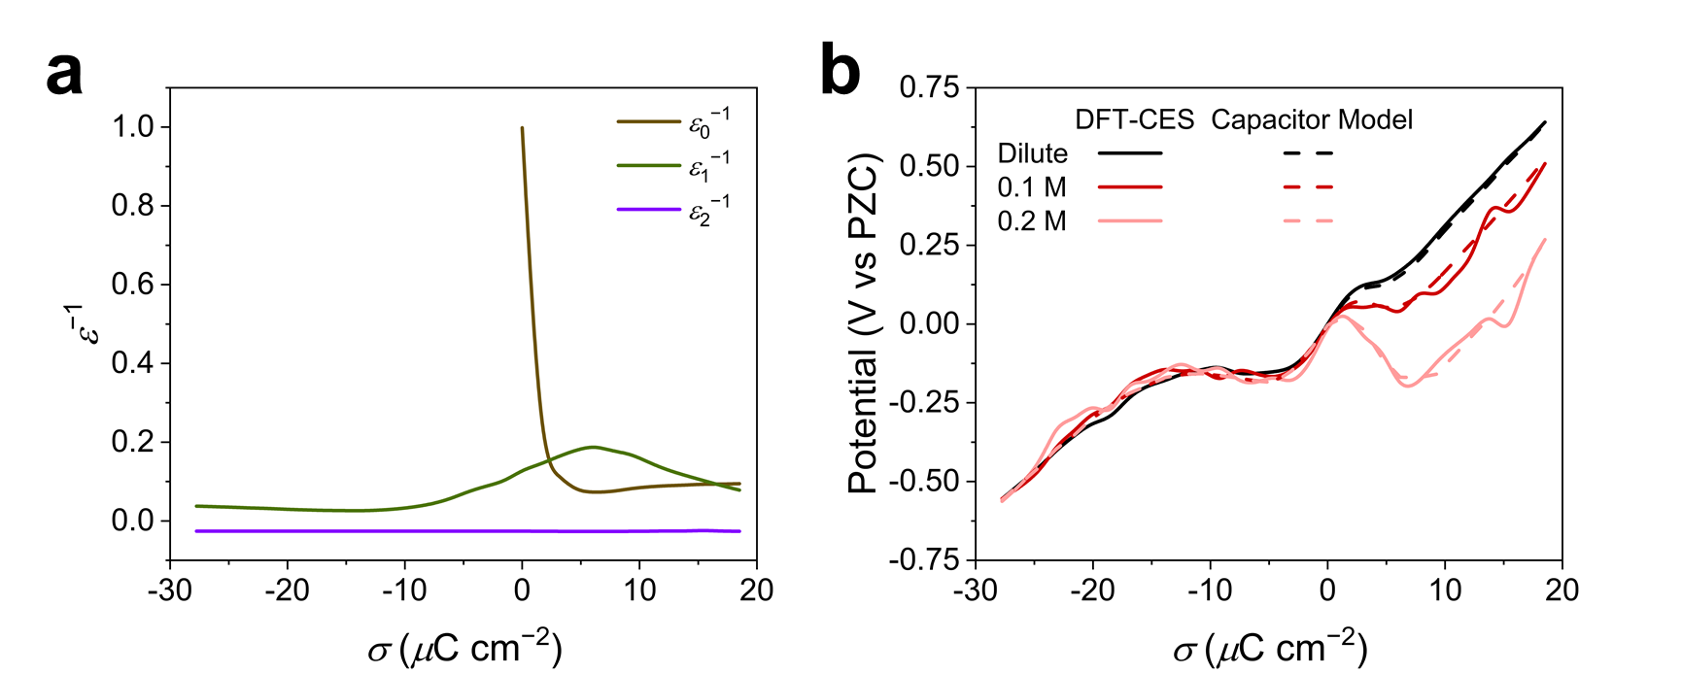Supplementary Note Fig. 7. Model dielectric constants and the σ-E curves compared with DFT-CES simulations.

Supplementary Note 5. Ising model of cathodic interface
To further understand the details of the phase transition at the cathodic interface, we used the following Ising model for water reorientation:
When the electrode was negatively charged, the water molecules at the interface began to rotate and screen the electric field. However, owing to the hydrogen-bonding network of the water molecules, their orientations are restricted. Therefore, we categorised the water molecules into three types depending on their orientation and hydrogen bonding (Supplementary Fig. 8).
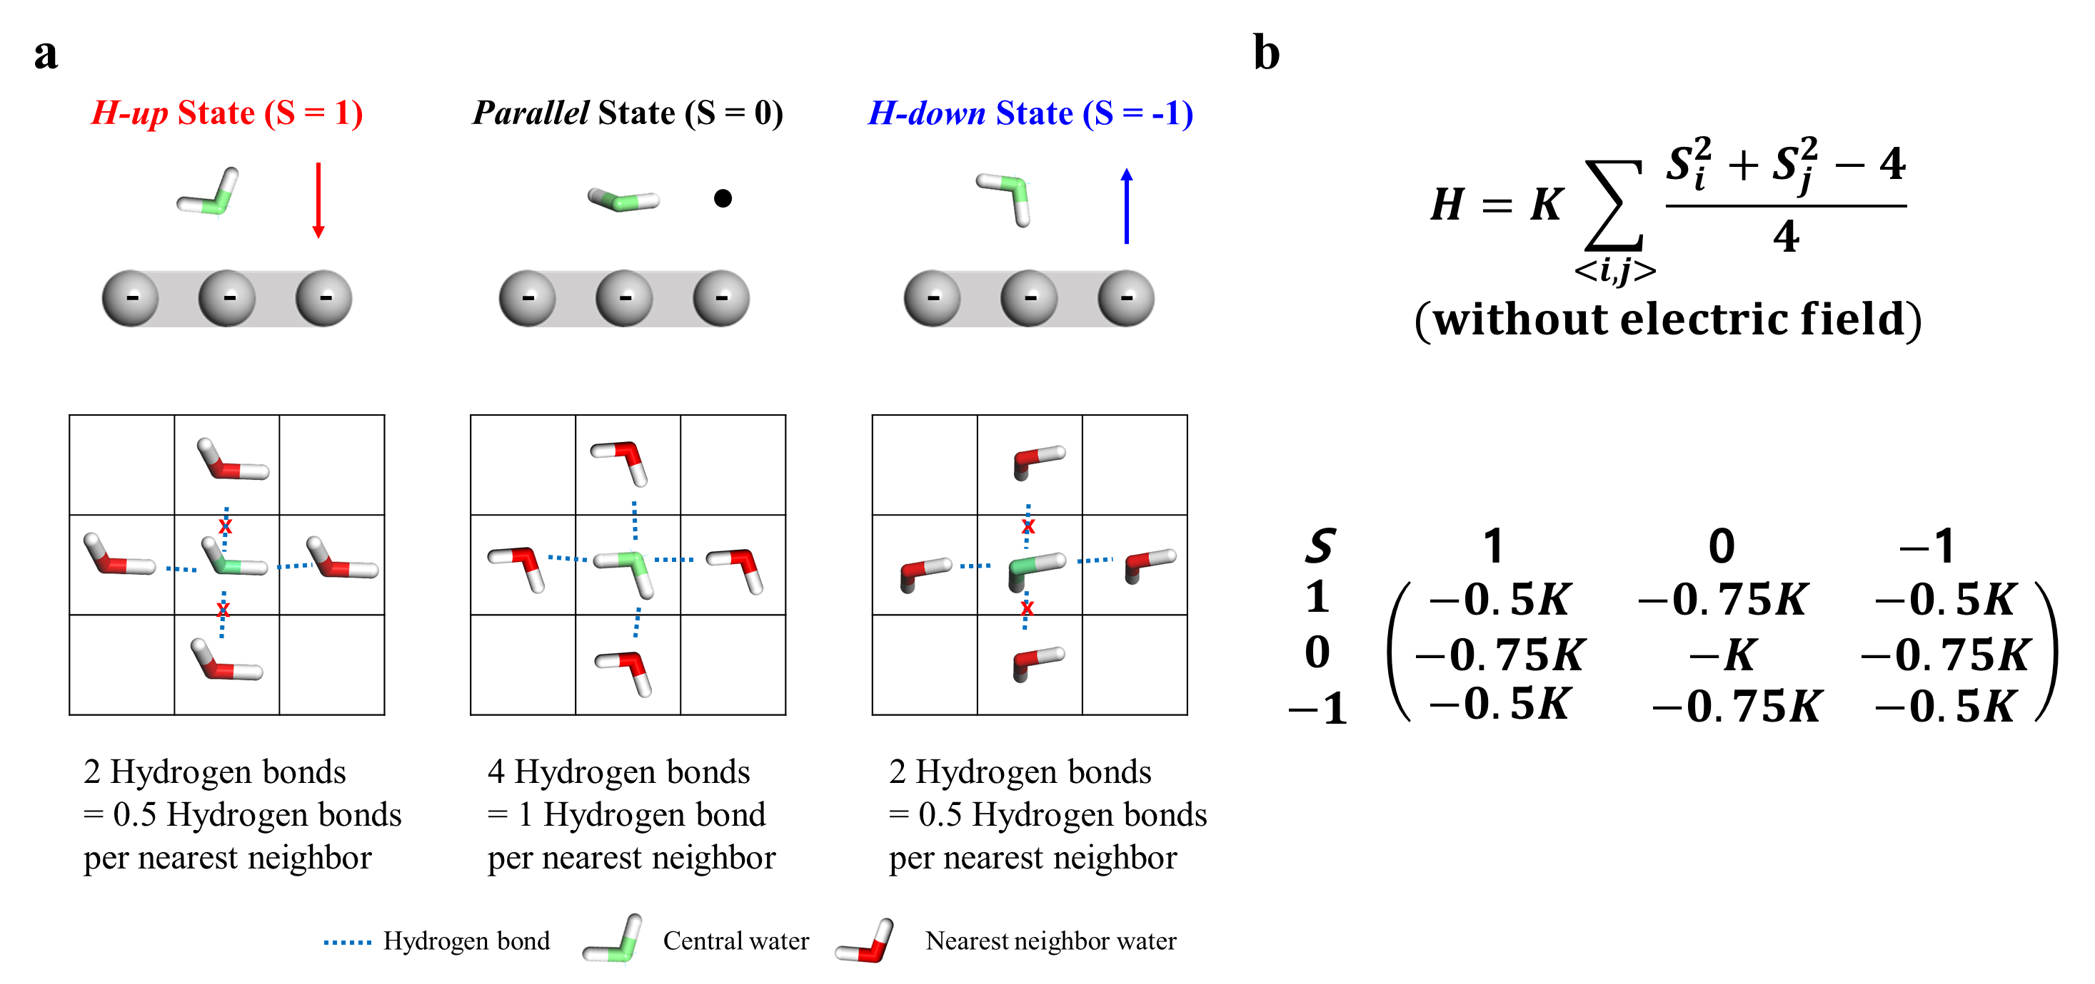
Supplementary Note Fig. 8. Three configurations of the water molecules at the cathodic interface and the corresponding Hamiltonian. a, Top figures show the side view, whereas the bottom figures show the top view of each configuration, assuming a square lattice for model convenience. b, Interaction Hamiltonian for hydrogen-bonding interactions without an electric field.

We employed the 2D spin-1 Ising model, in which each water configuration was modelled using different $S$ values, yielding the following Hamiltonian
$$\begin{aligned}H=K\sum_{〈i,j〉}{\frac{S_{i}^{2}+S_{j}^{2}-4}{4}}+dF_{ext}\sum_{i}{S_{i}}\#\left(19\right)\end{aligned}$$
where $〈i,j〉$ indicate the sum over all nearest neighbours, K is the nearest-neighbour interaction parameter, d is the dipole moment of the water molecule along the normal direction of the surface, and F_{ext} is the external electric field.
The first term describes hydrogen bonding interactions. K was set to 6.87 kcal/mol based on the hydrogen bond strength between the two TIP3P-EW water molecules. The parallel state can form four hydrogen bonds, whereas the H-up and H-down states can form two hydrogen bonds on average. A factor of 1/4 was included to account for the square lattice with the four nearest-neighbour sites. We further assumed the arithmetic mean of the hydrogen bonds between different states. This formulation effectively scales the hydrogen-bonding interactions between other water configurations.
The second term denotes the field-dipole interaction energy, where d is set to 0.57 e∙bohr, which is the dipole moment of the TIP3P-EW water molecule with H-up or H-down configurations.
We performed Monte Carlo simulations to compute the ensemble-averaged <S> as a function of surface charge density (σ). A clear transition was observed from <S> = 0 (parallel state) to <S> = −1 (H-down state) with decreasing σ (Supplementary Note Fig. 9a). This transition generated an additional electric potential owing to the collective reorientation of the interfacial water dipoles. Since this induced potential opposes the external potential from the electrode, an S-shaped region appears on the σ-E plane (Supplementary Note Fig. 9b).
We further confirmed that the dielectric constant defined as the degree of field screening of the external electric field exhibited a peak at −11 μC cm⁻² (Supplementary Note Fig. 9c). This behaviour is consistent with the dielectric response extracted from our DFT-CES simulation using the multi-layer capacitor model, which shows a peak at −13 μC cm⁻² (Fig. 2c). These results demonstrate that the statistical model for the cathodic interface successfully captures the key features of the phase transition driven by the collective reorientation of the interfacial water dipoles.
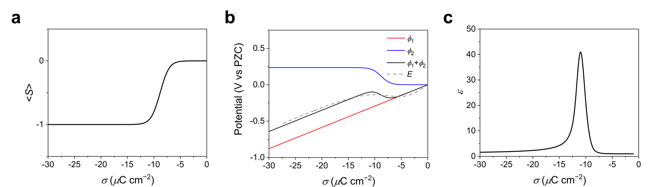
Supplementary Note Fig. 9. Ising model for the water reorientation at the cathodic interface. a, Ensemble-averaged <S> as a function of surface charge density (σ), showing a transition from the parallel to H-down state. b, Potential (E) predicted by the Ising model (black solid line) exhibiting an S-shaped region consistent with the DFT-CES simulation results (grey dashed line). $ϕ_{1}$ denotes the potential drop from the external electric field generated by the electrode, while $ϕ_{2}$ is the potential drop from the induced field generated by the water dipole reorientation. c, Dielectric constant predicted by the Ising model, showing a peak at −13 μC cm⁻².

Supplementary Note 6. Theoretical prediction of interfacial water IR spectra
To predict the infrared (IR) spectra of water, we computed the vibrational frequencies and IR intensities using DFT calculations with the B3LYP exchange-correlation functional with D3 van der Waals corrections and the 6-311G**+ basis set.^{23–25}
Approximately 2000 water molecules were randomly sampled from each of the simulation trajectories within 7.4 Å of the electrode surface, encompassing the first and second outer Helmholtz layers (OHL₁ and OHL₂). For each sampled water molecule, its first solvation shell was explicitly included in the DFT calculations, while molecules beyond the first solvation shell were treated as point charges up to a distance of 20 Å. This approach effectively incorporates the local EDL microenvironment into the IR calculations for each sampled molecule. The representativeness of the sampled molecules was verified by comparing the distributions of the local hydrogen-bonding structures for the ~2000 sampled molecules and for the full trajectory (Supplementary Table 2,3). Finally, Lorentzian broadening with a full width at half maximum (FWHM) of 30 cm⁻¹ was applied to predict the final spectra.
The same computational procedure was employed to predict the IR spectra of bulk water using the MD simulation trajectory of the bulk water system. By comparing the computed spectra with experimental data for the O–H stretching mode, we determined a scaling factor of 0.879 to empirically match the vibrational frequency of liquid-phase water (Supplementary Fig. 10).²⁵ This scaling factor was then applied to the interfacial water systems.

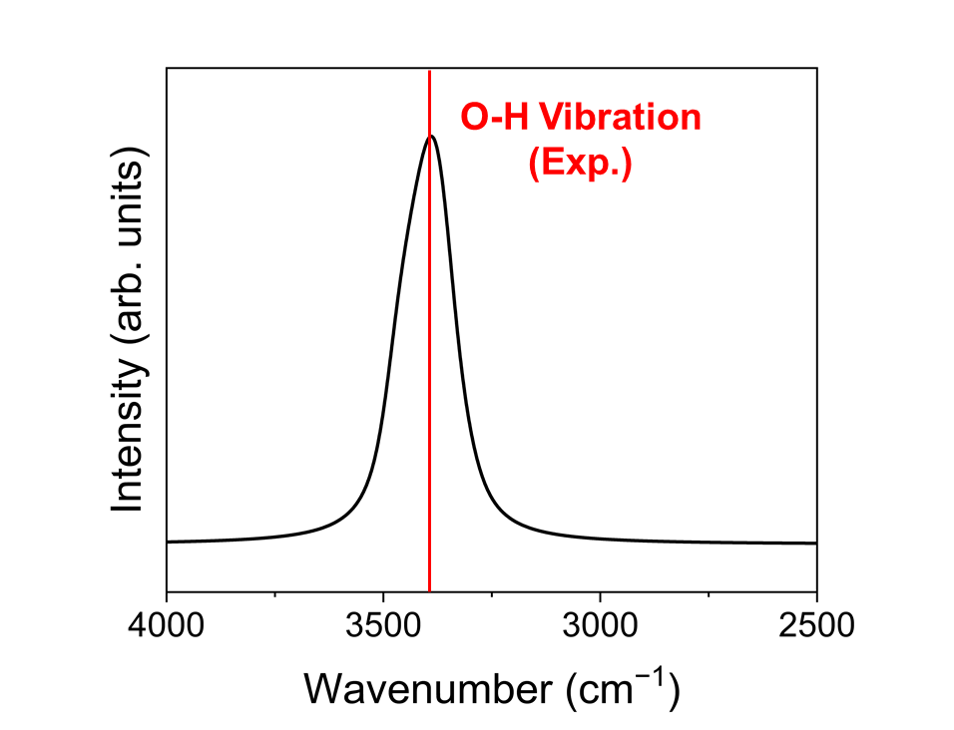
Supplementary Note Fig. 10. Calculated IR spectra of liquid-phase water. The experimental vibrational frequency is indicated by the red line.

Supplementary Figures and Tables
Supplementary Figure 1. Capacitance curves from the Helmholtz (C_{H}), Gouy-Chapman (C_{GC}), and Gouy-Chapman-Stern (C_{GCS}) models. The Helmholtz layer distance, dielectric constant and temperature are set to 11 Å, 78.4, and 300 K, respectively.

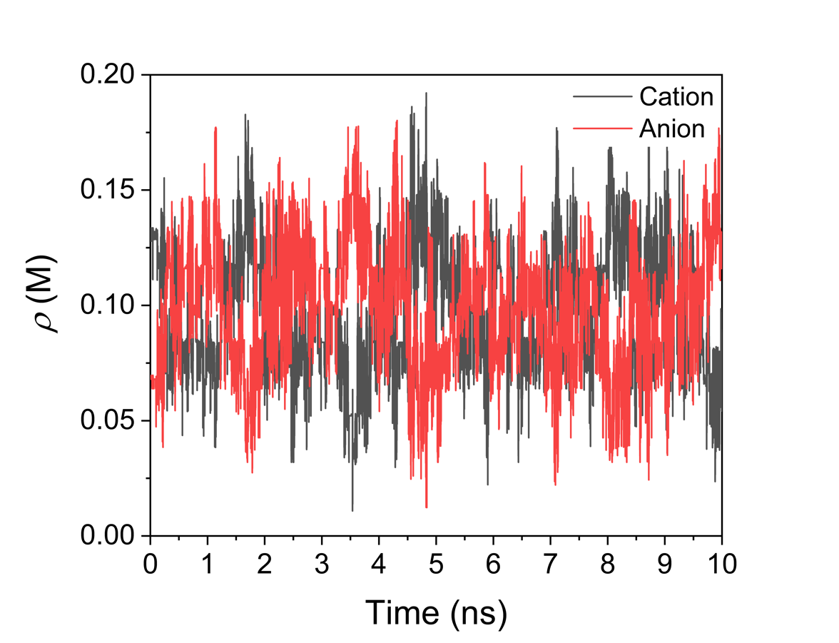
Supplementary Figure 2. Temporal evolution of the local ion concentration in the bulk region of the simulation cell. A representative case at 0.1 M bulk concentration under the PZC condition is shown.

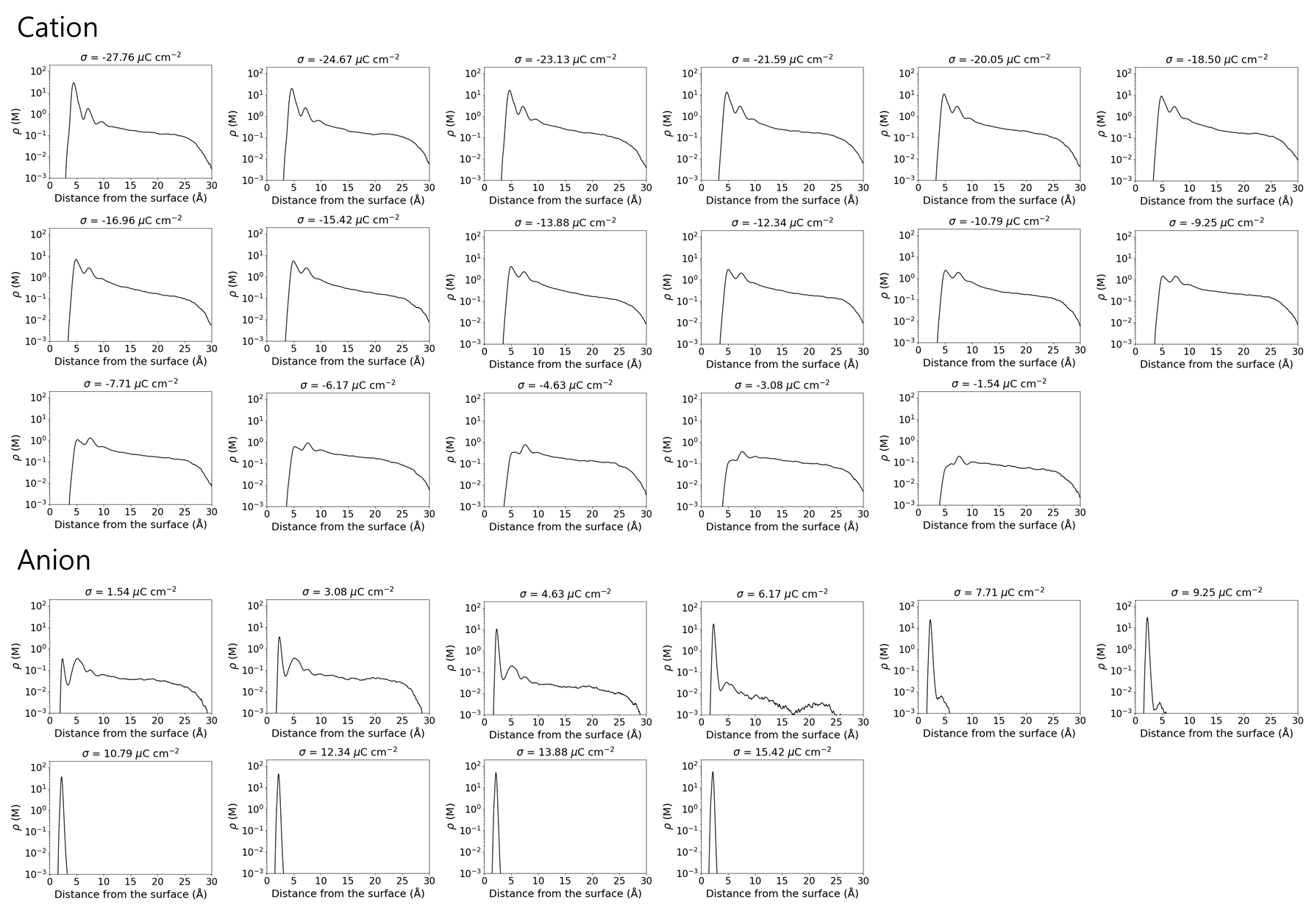
Supplementary Figure 3. Local ion distribution along the surface normal direction at various surface charge densities (σ) under dilute concentration. Only counterions are included in the simulations.

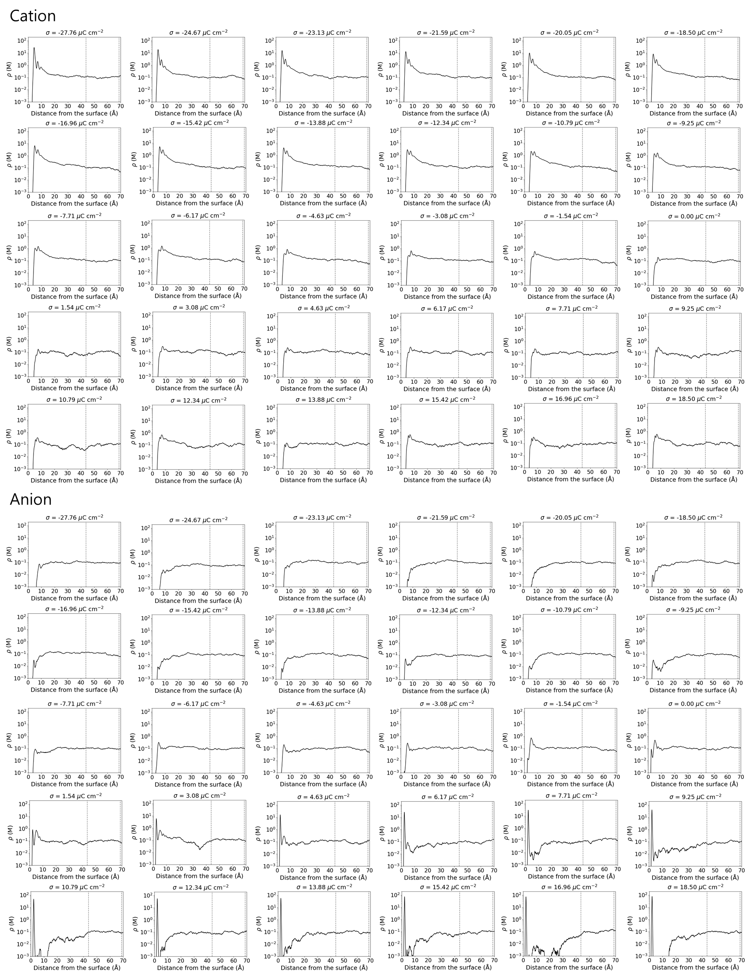
Supplementary Figure 4. Local ion distribution along the surface normal direction at various surface charge densities (σ) under 0.1 M concentration. Dashed lines indicate the bulk region.

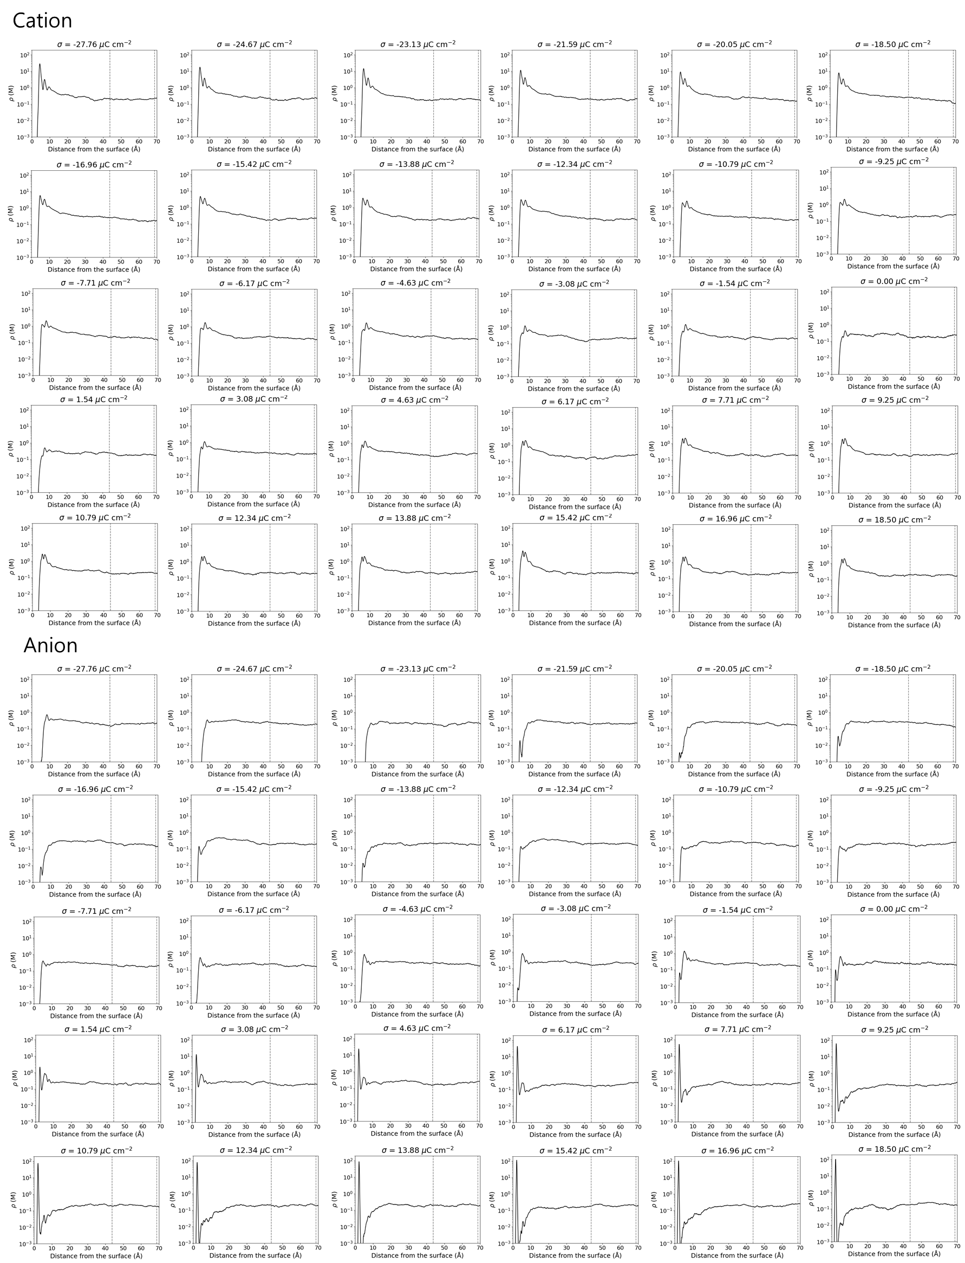
Supplementary Figure 5. Local ion distribution along the surface normal direction at various surface charge densities (σ) under 0.2 M concentration. Dashed lines indicate the bulk region.

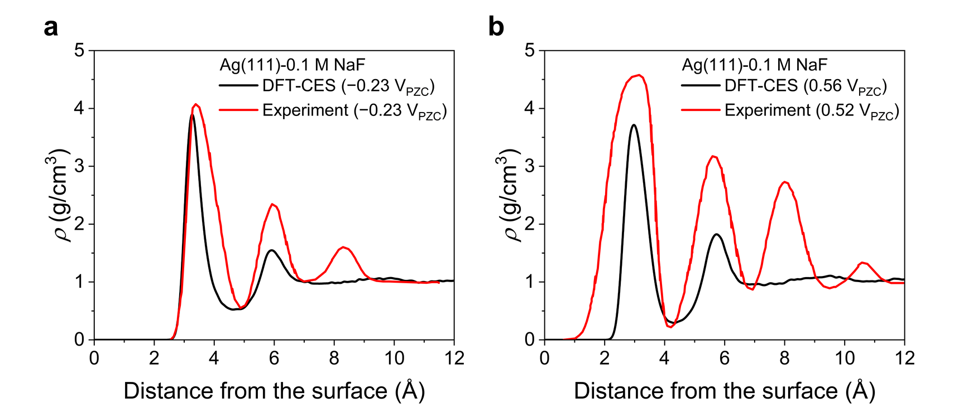
Supplementary Figure 6. Water density profile along the surface normal direction, compared with the X-ray scattering experimental data.²⁶ The Ag(111) electrode with 0.1 M NaF is analysed to match the experimental conditions. The peak positions show good agreement, while deviations in the peak heights may result from the absence of ion effects in the experimental measurements.

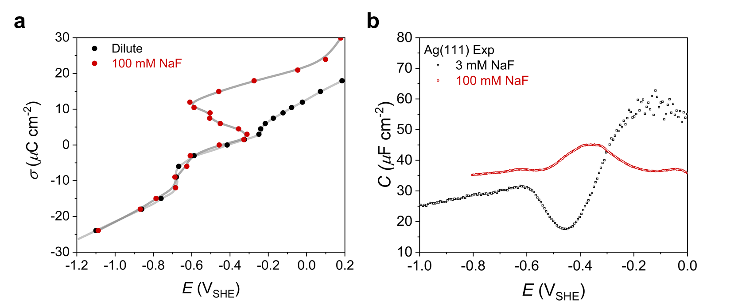
Supplementary Figure 7. Simulated σ-E curves and experimental capacitance curves for the Ag(111) electrode under different bulk concentrations. The trends observed for the Ag(111) electrodes are similar to those observed for the Ag(100) electrode, and the experimental peak positions align with the theoretical phase transition potentials (see Supplementary Table 1).

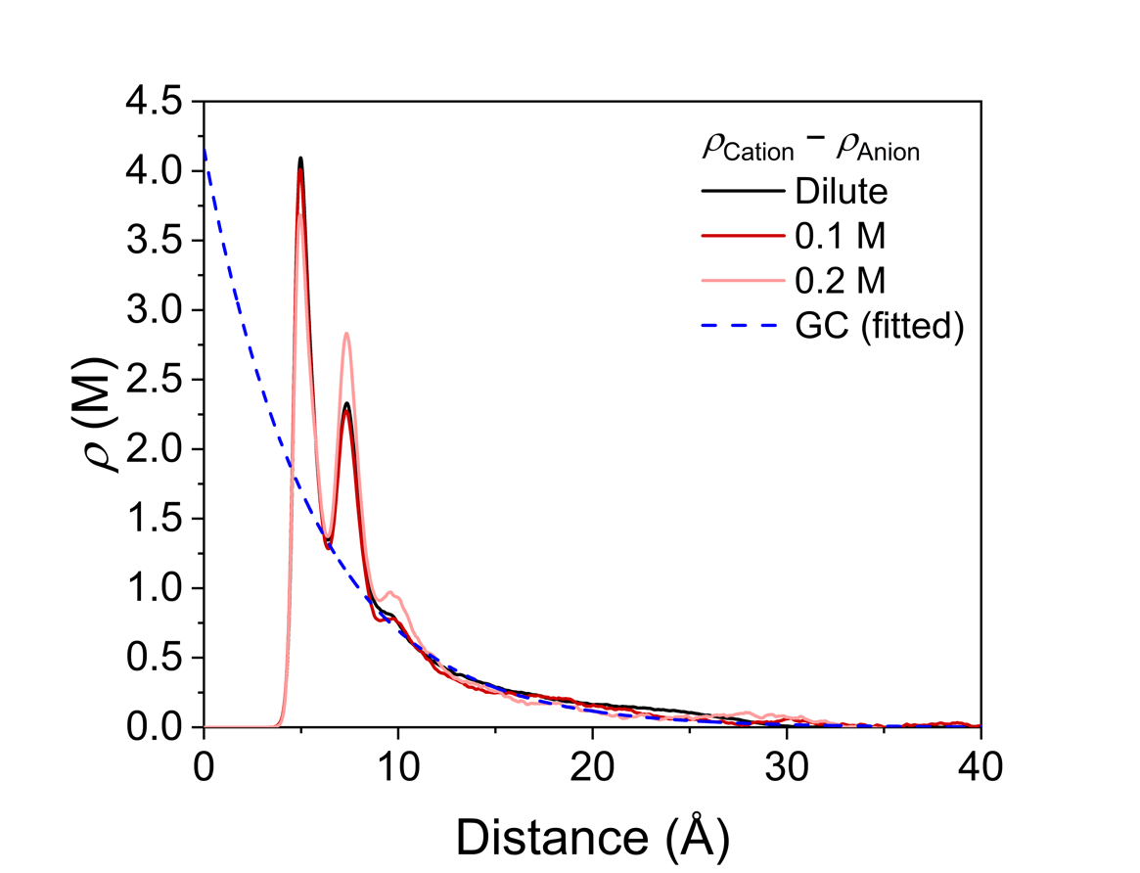
Supplementary Figure 8. Local ionic charge profiles along the surface normal direction at various bulk electrolyte concentration (σ = −13.9 μC cm⁻²). The blue dashed line represents the exponential decay predicted by the Gouy-Chapman (GC) model in the diffuse layer (> 8.8 Å), using a Debye length of 5.6 Å.

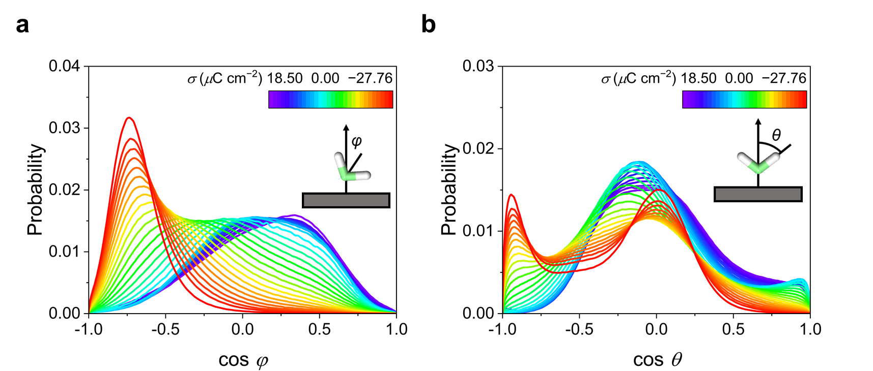
Supplementary Figure 9. Probability distributions of φ (the orientation of the water bisector) and θ (the orientation of the O−H bond), illustrating the orientation of water molecules in the IHP. A negative value of $\cos{φ}$ (or $\cos{θ}$) indicates that the bisector (or O−H vector) points toward the electrode. The dilute case is shown as a representative example.

Supplementary Figure 10. Number of hydrogen bonds per water molecule in the IHP at the cathodic interface. The number of hydrogen bond donors decreases due to water reorientation into the H-Down state. The dilute case is shown as a representative example.

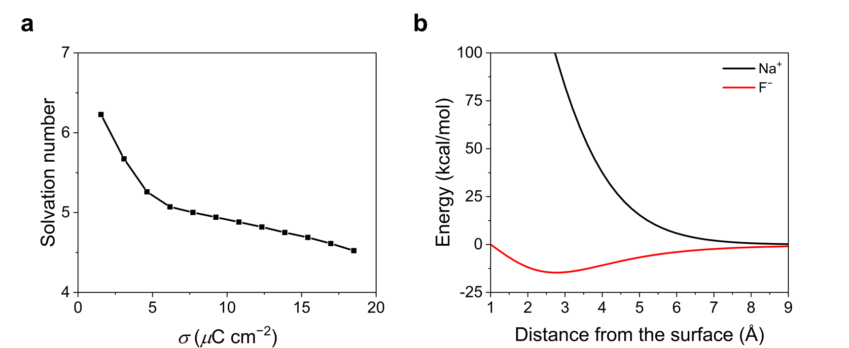
Supplementary Figure 11. F⁻ solvation number and vdW interaction energy between ions and the Ag(100) electrode. a, Solvation number results indicate the partial desolvation of F⁻ in the IHP. The dilute case is shown as a representative example. b, vdW interaction energies between ions and the Ag(100) electrode from DFT-CES simulations. A stronger dispersive interaction is observed for F⁻.

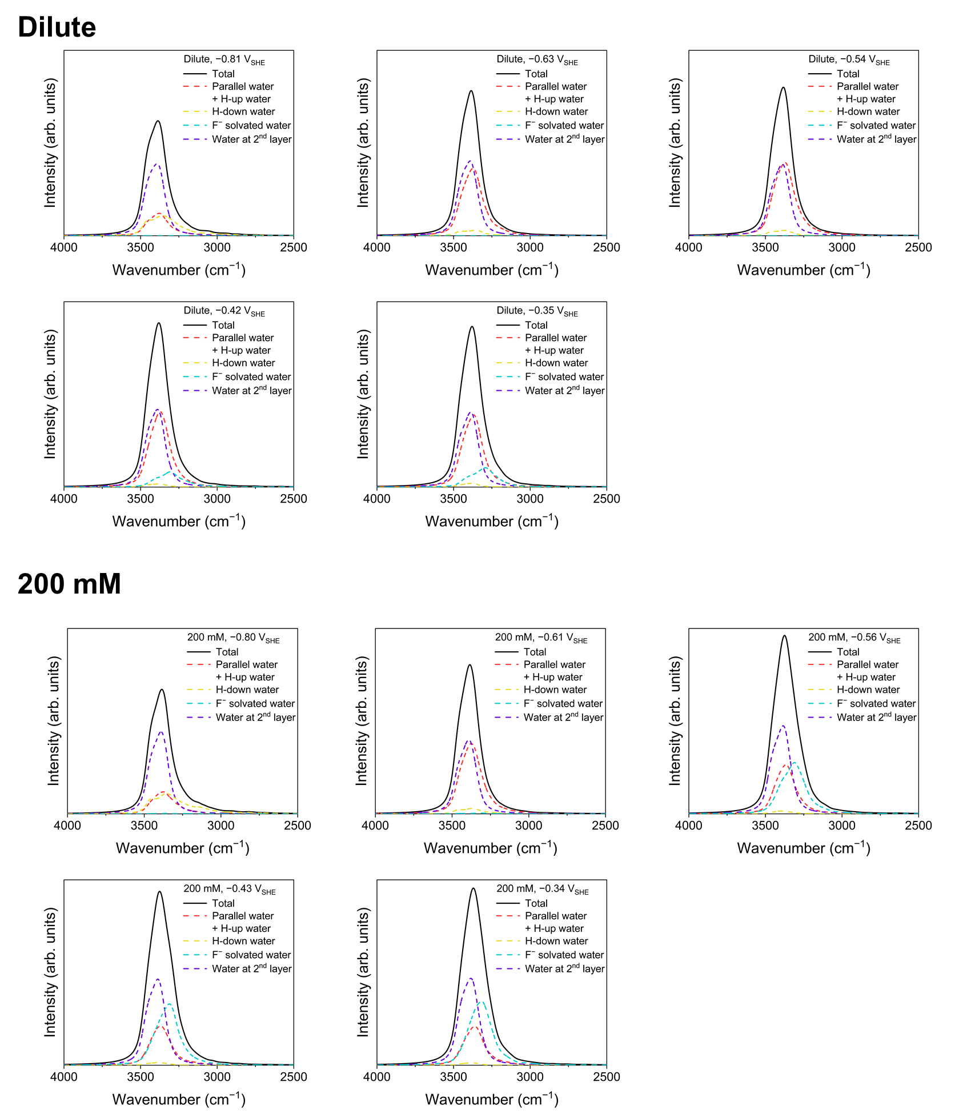
Supplementary Figure 12. Calculated total IR spectra (solid black lines), with contributions from individual water species shown by dashed lines.

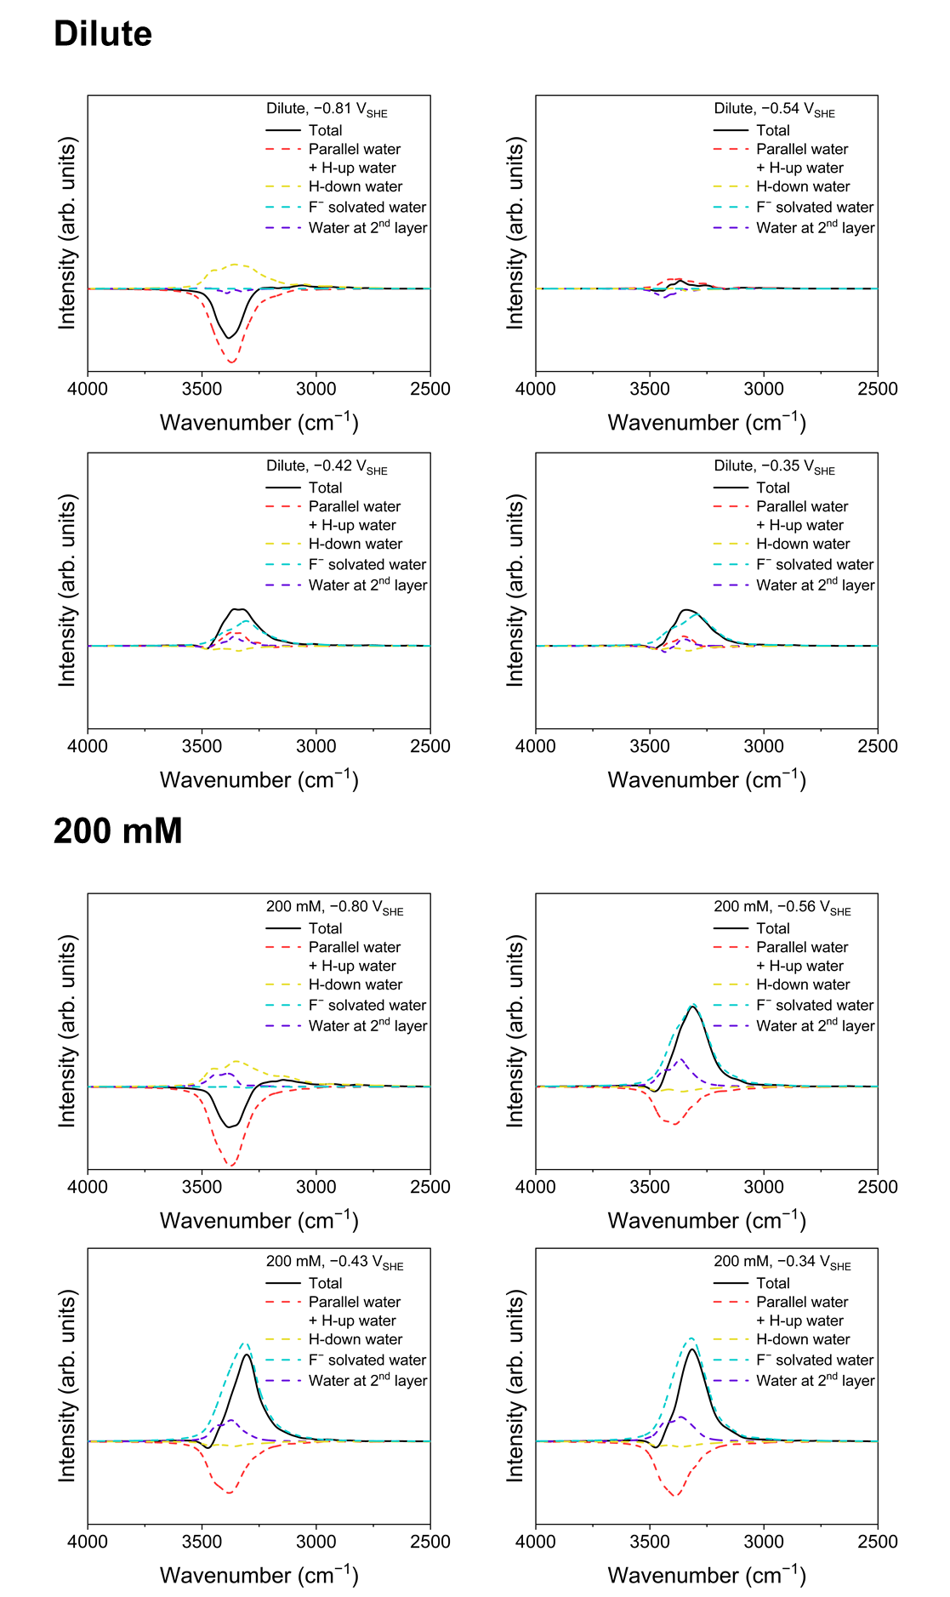
Supplementary Figure 13. Calculated differential IR spectra (solid black lines), with contributions from individual water species shown by dashed lines. All spectra are referenced to the IR spectra under the PZC condition.

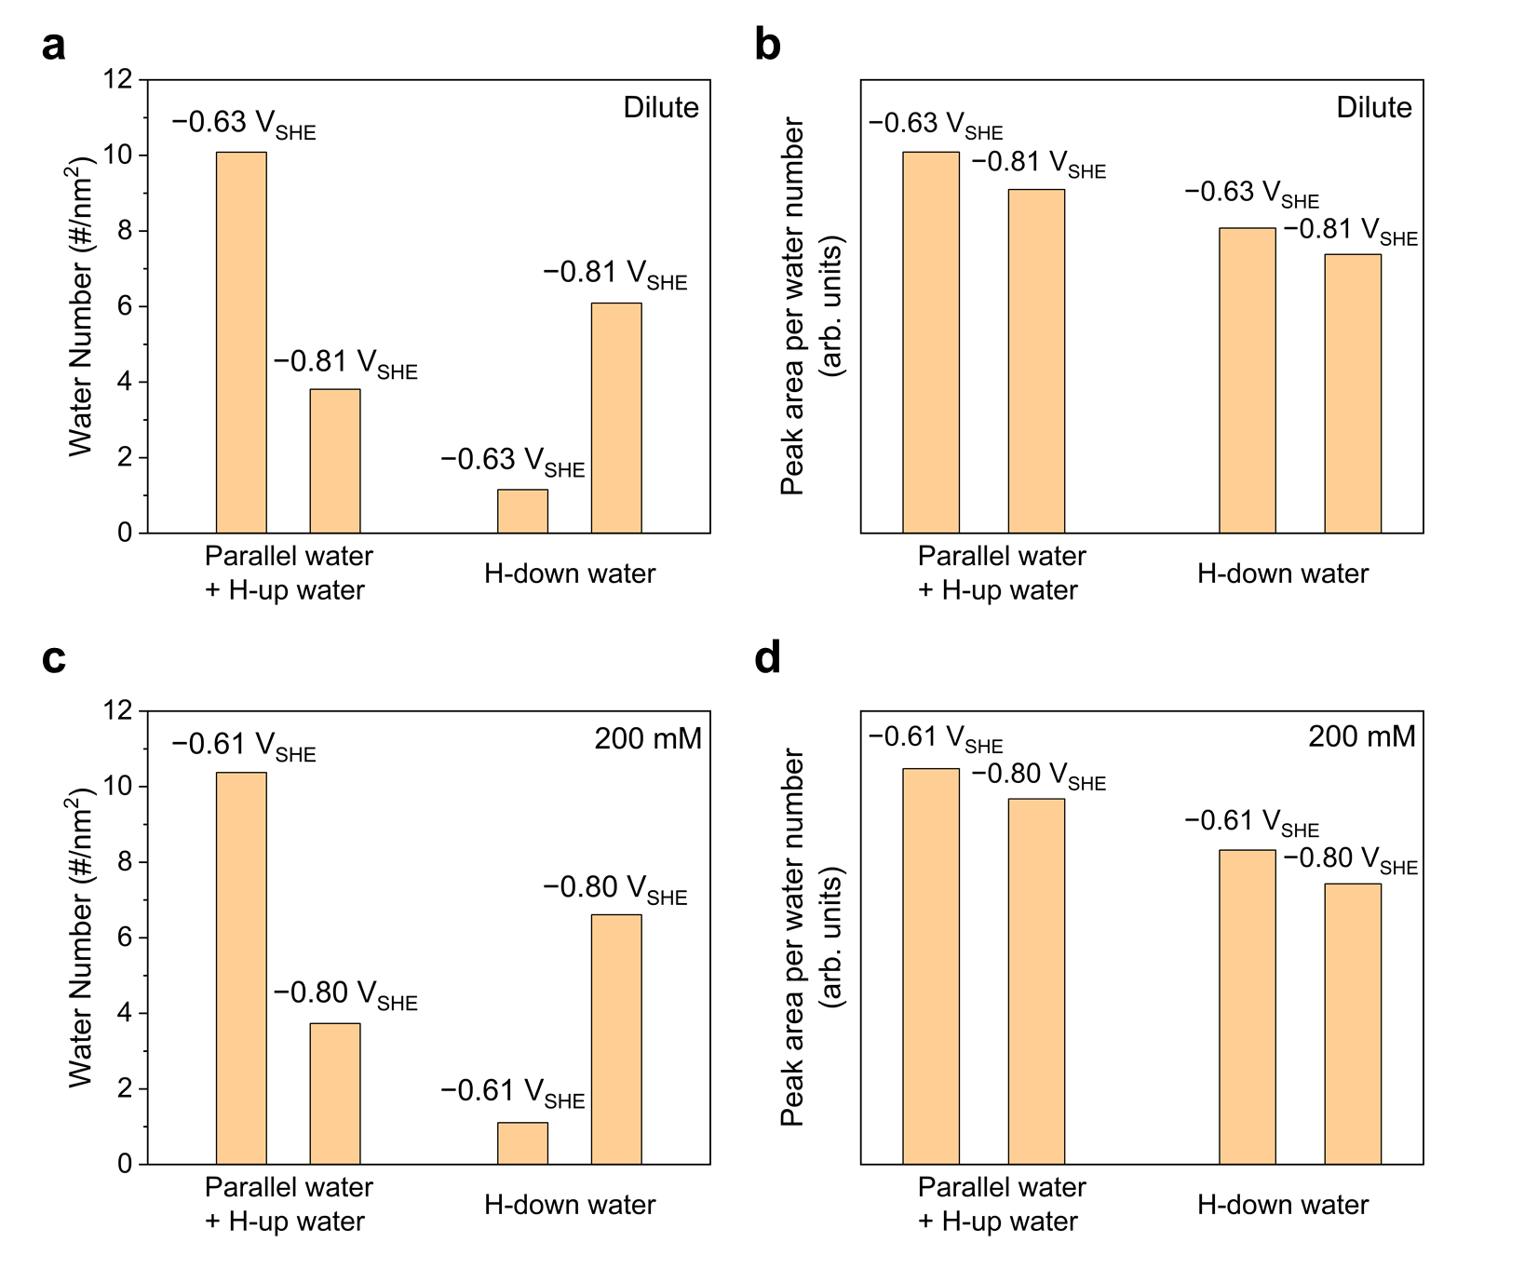
Supplementary Figure 14. Number of water molecules and their normalized IR peak areas at the PZC and cathodic interface. The number of water molecules are shown for a, dilute and c, 200 mM bulk electrolyte cases. The normalized peak areas are shown for b, dilute and d, 200 mM bulk electrolyte cases. These results imply that both the number of water molecules and their IR intensity contributions (mostly due to the different transition dipole moments) contribute to the total IR intensity with different species.

V_{SHE} | Cathodic peak |  | Anodic peak
V_{SHE} | Simulation | Experiment | Simulation | Experiment
3 mM  (Dilute in simulation) | −0.68 | −0.61 | −0.24 | −0.17
100 mM | −0.68 | −0.62 | −0.45 | −0.36
Supplementary Table 1. Comparison of phase transition potentials predicted from all-atom simulations with experimental capacitance peak positions for the Ag(111) electrode. The theoretical phase transition potentials were determined using Maxwell construction lines for the S-shaped curves in Supplementary Fig. 7a, whereas the experimental peak positions were extracted from the capacitance curves in Supplementary Fig. 7b.

V_{SHE} | Species | Average over the sampled trajectory (%) | Average over full trajectory (%)
−0.81 V | Parallel water + H-up water | 19.1 | 19.7
−0.81 V | H-down water | 30.5 | 29.7
−0.81 V | F⁻ solvated water | 0.0 | 0.0
−0.81 V | Water at 2nd layer | 47.5 | 46.6
−0.63 V  (PZC) | Parallel water + H-up water | 48.6 | 49.8
−0.63 V  (PZC) | H-down water | 5.6 | 5.7
−0.63 V  (PZC) | F⁻ solvated water | 0.0 | 0.0
−0.63 V  (PZC) | Water at 2nd layer | 45.8 | 44.6
−0.54 V | Parallel water + H-up water | 51.7 | 51.0
−0.54 V | H-down water | 4.6 | 4.3
−0.54 V | F⁻ solvated water | 0.0 | 0.5
−0.54 V | Water at 2nd layer | 43.8 | 44.3
−0.42 V | Parallel water + H-up water | 43.5 | 43.5
−0.42 V | H-down water | 2.1 | 2.1
−0.42 V | F⁻ solvated water | 9.31 | 9.32
−0.42 V | Water at 2nd layer | 45.1 | 45.0
−0.35 V | Parallel water + H-up water | 42.0 | 41.7
−0.35 V | H-down water | 2.0 | 1.9
−0.35 V | F⁻ solvated water | 11.1 | 11.2
−0.35 V | Water at 2nd layer | 44.9 | 45.2
Supplementary Table 2. Comparison of water species populations obtained from full simulation trajectories and from the sampled snapshots used in IR spectra calculations (dilute case).

V_{SHE} | Species | Average over the sampled trajectory (%) | Average over full trajectory (%)
−0.80 V | Parallel water + H-up water | 17.6 | 17.8
−0.80 V | H-down water | 31.1 | 29.8
−0.80 V | F⁻ solvated water | 0.4 | 0.3
−0.80 V | Water at 2nd layer | 47.7 | 47.7
−0.61 V  (PZC) | Parallel water + H-up water | 49.3 | 48.9
−0.61 V  (PZC) | H-down water | 5.3 | 5.3
−0.61 V  (PZC) | F⁻ solvated water | 0.5 | 0.7
−0.61 V  (PZC) | Water at 2nd layer | 44.7 | 45.0
−0.56 V | Parallel water + H-up water | 24.3 | 23.3
−0.56 V | H-down water | 1.3 | 1.7
−0.56 V | F⁻ solvated water | 25.2 | 25.7
−0.56 V | Water at 2nd layer | 47.9 | 48.2
−0.43 V | Parallel water + H-up water | 20.4 | 18.9
−0.43 V | H-down water | 1.4 | 1.4
−0.43 V | F⁻ solvated water | 28.8 | 29.8
−0.43 V | Water at 2nd layer | 47.7 | 48.3
−0.34 V | Parallel water + H-up water | 19.4 | 18.6
−0.34 V | H-down water | 1.1 | 1.3
−0.34 V | F⁻ solvated water | 30.1 | 30.5
−0.34 V | Water at 2nd layer | 48.4 | 48.2
Supplementary Table 3. Comparison of water species populations obtained from full simulation trajectories and from the sampled snapshots used in IR spectra calculations (0.2M case).

References
1. Lim, H. K., Lee, H. & Kim, H. A seamless grid-based interface for mean-field QM/MM coupled with efficient solvation free energy calculations. J. Chem. Theory Comput. 12, 5088–5099 (2016).
2. Jang, T., Paik, D., Shin, S. & Kim, H. Density functional theory in classical explicit solvents: mean‐field QM/MM method for simulating solid–liquid interfaces. Bull. Korean Chem. Soc. 43, 476–483 (2022).
3. Zhang, C. et al. 2023 roadmap on molecular modelling of electrochemical energy materials. J. Phys. Energy 5, 041501 (2023).
4. Giannozzi, P. et al. QUANTUM ESPRESSO: a modular and open-source software project for quantum simulations of materials. J. Phys. Condens. Matter 21, 395502 (2009).
5. Plimpton, S. Fast parallel algorithms for short-range molecular dynamics. J. Comput. Phys. 117, 1–19 (1995).
6. Blöchl, P. E. Projector augmented-wave method. Phys. Rev. B 50, 17953–17979 (1994).
7. Perdew, J. P., Burke, K. & Ernzerhof, M. Generalized gradient approximation made simple. Phys. Rev. Lett. 77, 3865–3868 (1996).
8. Price, D. J. & Brooks, C. L. A modified TIP3P water potential for simulation with Ewald summation. J. Chem. Phys. 121, 10096–10103 (2004).
9. Fyta, M. & Netz, R. R. Ionic force field optimization based on single-ion and ion-pair solvation properties: going beyond standard mixing rules. J. Chem. Phys. 136, 124103 (2012).
10. Shin, S.-J. et al. On the importance of the electric double layer structure in aqueous electrocatalysis. Nat. Commun. 13, 174 (2022).
11. Nosé, S. A unified formulation of the constant temperature molecular dynamics methods. J. Chem. Phys. 81, 511–519 (1984).
12. Hoover, W. G. Canonical dynamics: equilibrium phase-space distributions. Phys. Rev. A 31, 1695–1697 (1985).
13. Pollock, E. L. & Glosli, J. Comments on P³M, FMM, and the Ewald method for large periodic coulombic systems. Comput. Phys. Commun. 95, 93–110 (1996).
14. Trasatti, S. The absolute electrode potential: An explanatory note. Pure & Appl. Chem. 58, 955–966 (1986).
15. Le, J., Iannuzzi, M., Cuesta, A. & Cheng, J. Determining potentials of zero charge of metal electrodes versus the standard hydrogen electrode from density-functional-theory-based molecular dynamics. Phys. Rev. Lett. 119, 016801 (2017).
16. Garlyyev, B., Xue, S., Watzele, S., Scieszka, D. & Bandarenka, A. S. Influence of the nature of the alkali metal cations on the electrical double-layer capacitance of model Pt(111) and Au(111) electrodes. J. Phys. Chem. Lett. 9, 1927–1930 (2018).
17. Le, J.-B., Fan, Q.-Y., Li, J.-Q. & Cheng, J. Molecular origin of negative component of Helmholtz capacitance at electrified Pt(111)/water interface. Sci. Adv. 6, eabb1219 (2020).
18. Jiang, G., Cheng, C., Li, D. & Liu, J. Z. Molecular dynamics simulations of the electric double layer capacitance of graphene electrodes in mono-valent aqueous electrolytes. Nano Res. 9, 174–186 (2016).
19. Berendsen, H. J. C., Postma, J. P. M., van Gunsteren, W. F., DiNola, A. & Haak, J. R. Molecular dynamics with coupling to an external bath. J. Chem. Phys. 81, 3684–3690 (1984).
20. Moučka, F. et al. Molecular simulation of aqueous electrolyte solubility. 2. Osmotic ensemble Monte Carlo methodology for free energy and solubility calculations and application to NaCl. J. Phys. Chem. B 115, 7849–7861 (2011).
21. Binder, K. & Landau, D. P. Finite-size scaling at first-order phase transitions. Phys. Rev. B 30, 1477–1485 (1984).
22. Limaye, A., Suvlu, D. & Willard, A. P. Water molecules mute the dependence of the double-layer potential profile on ionic strength. Faraday Discuss. 249, 267–288 (2024).
23. Becke, A. D. Density-functional thermochemistry. III. The role of exact exchange. J. Chem. Phys. 98, 5648–5652 (1993).
24. Grimme, S., Antony, J., Ehrlich, S. & Krieg, H. A consistent and accurate ab initio parametrization of density functional dispersion correction (DFT-D) for the 94 elements H-Pu. J. Chem. Phys. 132, 154104 (2010).
25. Krishnan, R., Binkley, J. S., Seeger, R. & Pople, J. A. Self-consistent molecular orbital methods. XX. A basis set for correlated wave functions. J. Chem. Phys. 72, 650–654 (1980).
26. Toney, M. F. et al. Voltage-dependent ordering of water molecules at an electrode–electrolyte interface. Nature 368, 444–446 (1994).

