Supplementary information of
Focused groundwater recharge driven by landscape controls and climate
Stephen Lee et al.

Correspondence to: Stephen Lee (stephen.lee@cdu.edu.au)
1. Figures and tables
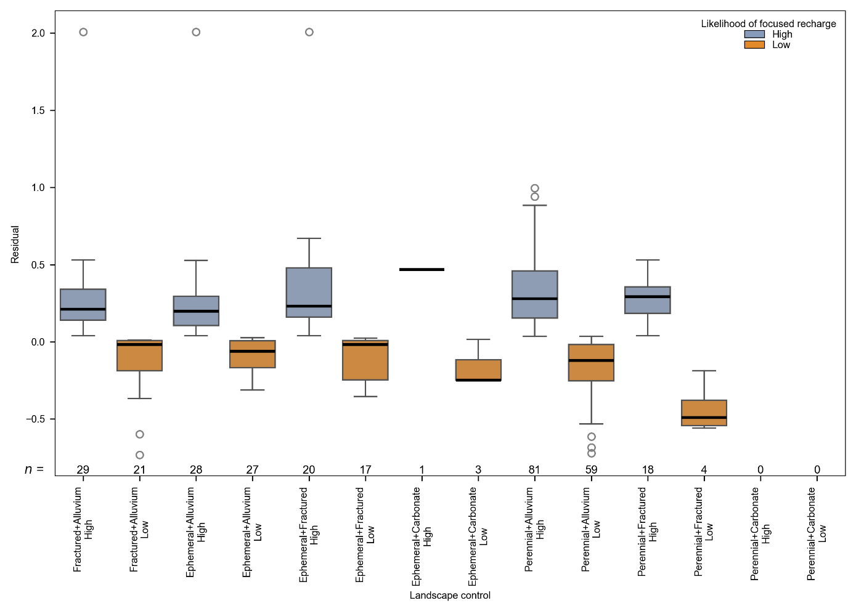
Figure S1. Box plots showing ³H_{G}/³H_{P5} residuals distribution for high- and low-likelihood focused recharge bores across different landscape controls. On box plots the black line denotes the median, the bottom and top of the boxes denote the 25th and 75th quartiles (i.e., the interquartile range, IQR), and the whiskers are ±1.5×IQR
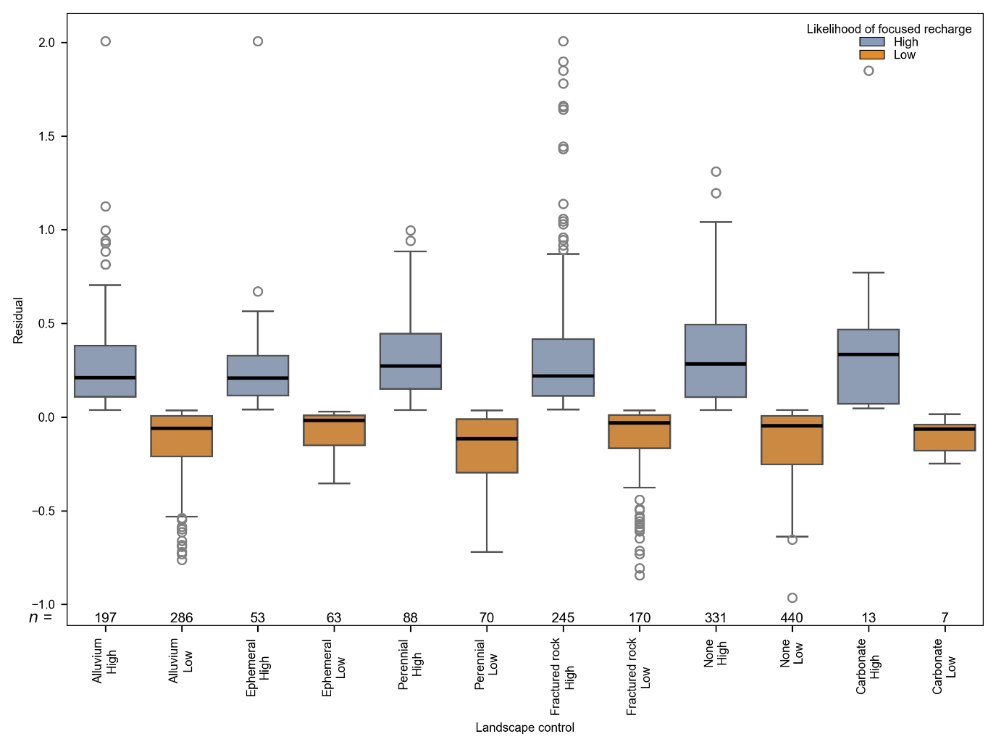
Figure S2. Box plots showing ³H_{G}/³H_{P5} residuals distribution for high- and low-likelihood focused recharge bores across different landscape controls combinations. On box plots the black line denotes the median, the bottom and top of the boxes denote the 25th and 75th quartiles (i.e., the interquartile range, IQR), and the whiskers are ±1.5×IQR
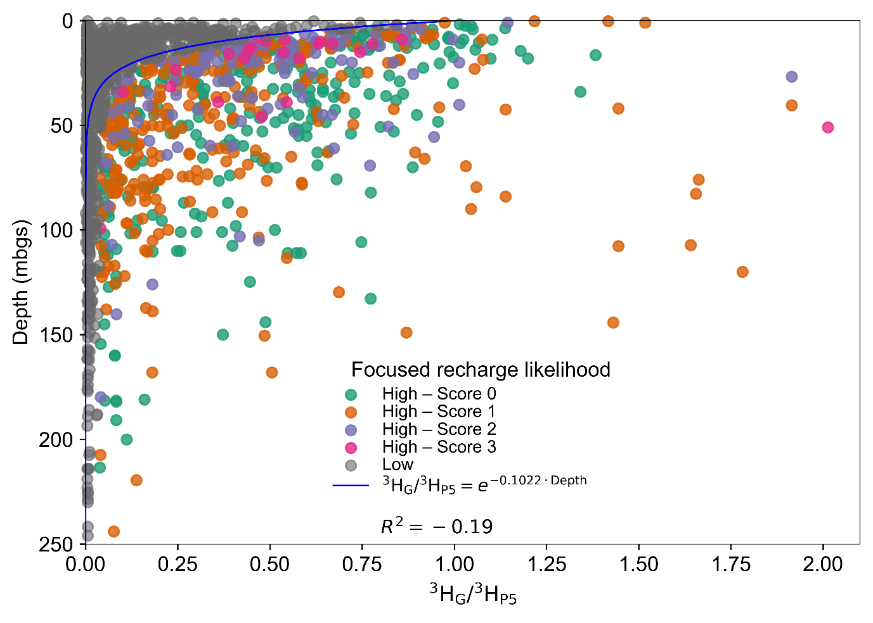
Figure S3. Relationship between groundwater depth (mbgs) and ³H_{G}/³H_{P5}. Points are coloured by the likelihood of focused recharge and landscape criteria score and fitted exponential decay curve.
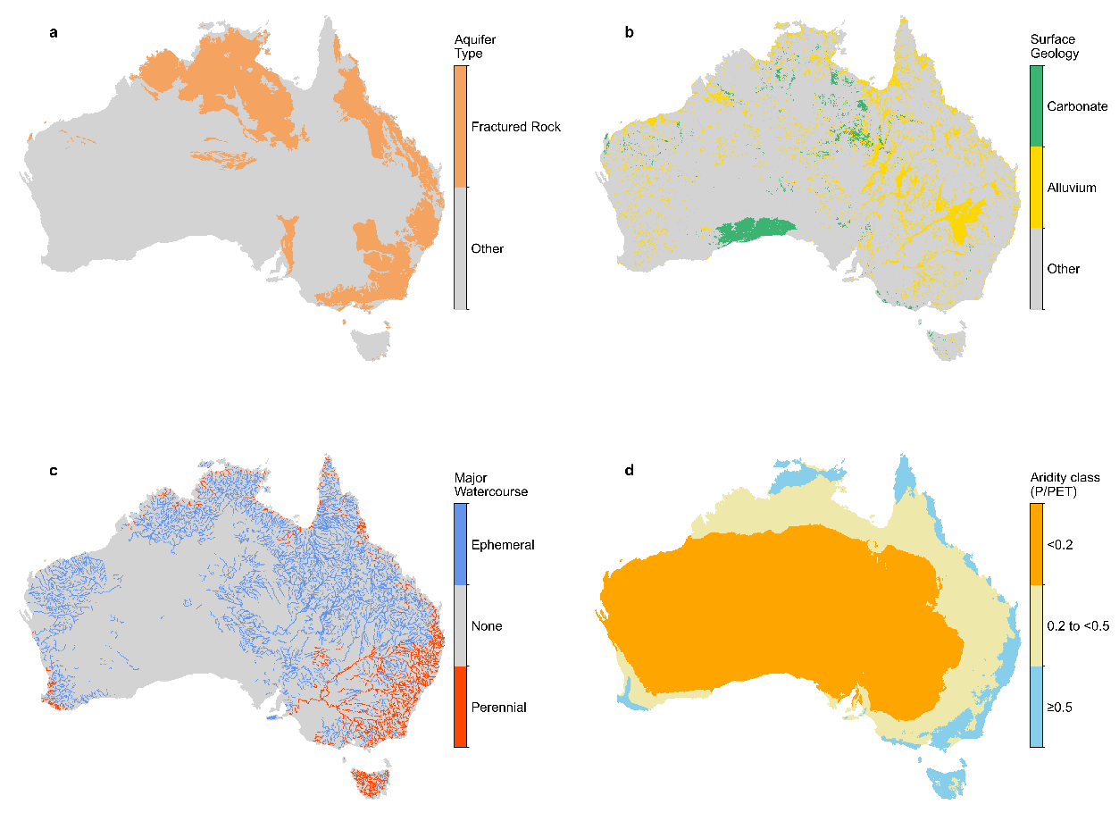
Figure S4. Spatial distribution of landscape features. (a) Fractured rock aquifers, (b) Carbonate and alluvium, (c) Major ephemeral and perennial watercourses, and (d) Aridity class based on P/PET.
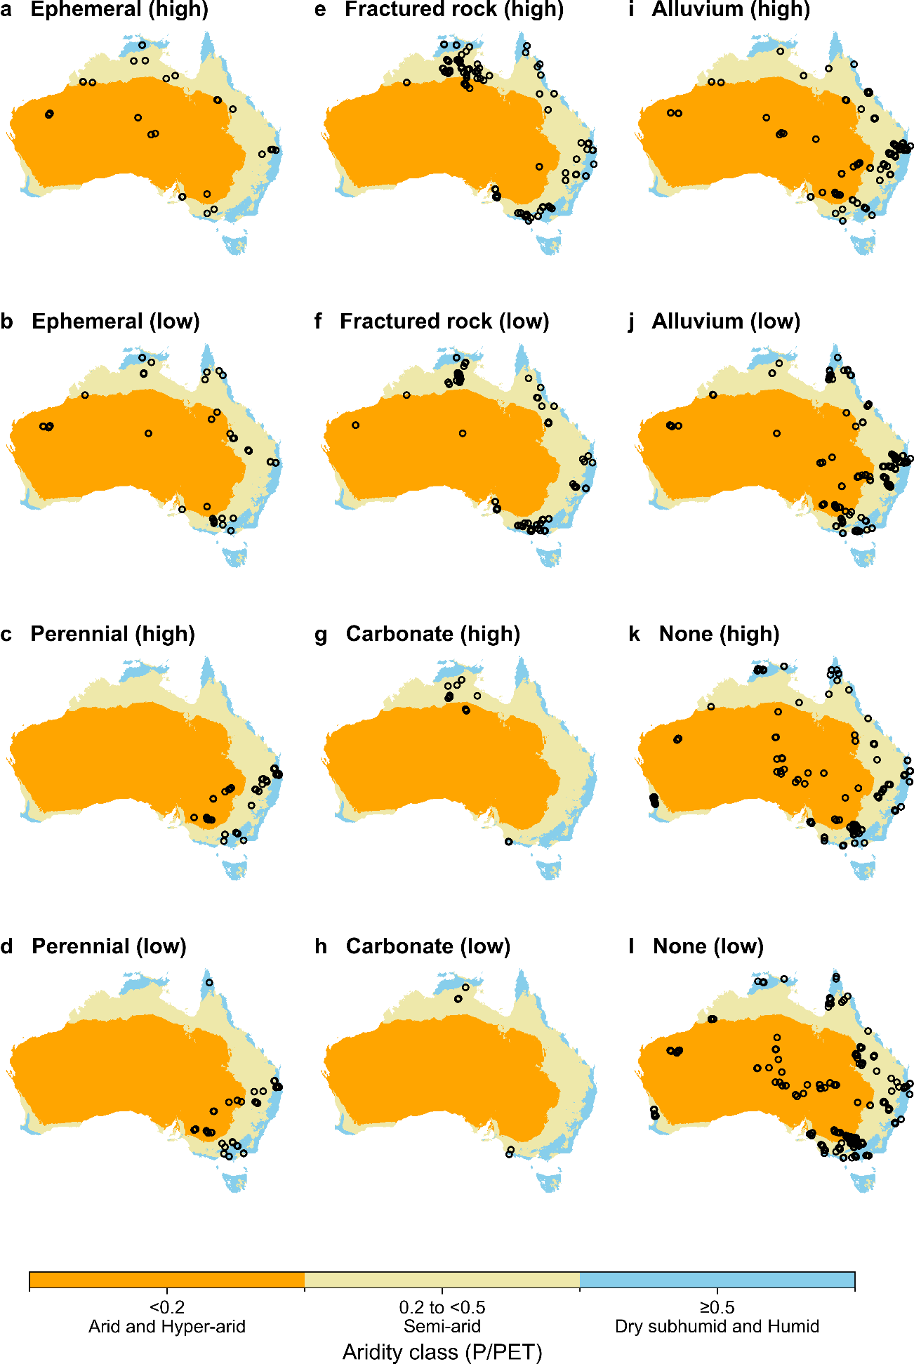
Figure S5. Locations of high- and low-likelihood focused recharge bores associated with landscape features and no landscape features (“None”) relative to aridity zones. High-likelihood focused recharge (a, c, e, g, i, k) and low-likelihood focused recharge (b, d, f, h, j, l). Aridity zones are grouped into three categories: (1) humid and dry subhumid (P/PET ≥0.5), (2) semi-arid (P/PET from 0.2 to <0.5), and (3) arid and hyper-arid (P/PET <0.2).
Table S1. Summary of data citations, source, state/territory, location and title of study. In the Source column, journal names are shortened to the following: IJoCG (International Journal of Coal Geology), AJES (Australian Journal of Earth Sciences), Appl. Chem (Applied Chemistry), Appl. Geochem (Applied Geochemistry), Aust. J. Earth Sci. (Australian Journal of Earth Sciences), Aust. J. Exp. Agri. (Australian Journal of Experimental Agriculture), Aust. J. Soil Res. (Australian Journal of Soil Research), HESS (Hydrology and Earth System Sciences), HJ (Hydrogeology Journal), Hydro. Processes (Hydrological Processes), J. Hydrol. Reg. Stud. (Journal of Hydrology: Regional Studies), JGR-Biogeochem (Journal of Geophysical Research: Biogeosciences), JoH (Journal of Hydrology), STOTEN (Science of the Total Environment), Water Res. (Water Research), and WRR (Water Resources Research). In the State/Territory and Location columns, states and territories are shortened to the following: South Australia (SA), Western Australia (WA), Northern Territory (NT), Queensland (Qld), New South Wales (NSW), Victoria (Vic), Tasmania (Tas).
No. | Citation | Source | State/  Territory | Location | Title
¹ | Allison and Hughes (1975) | JoH | SA | Naracoorte Range, SA | The use of environmental tritium to estimate recharge to a South-Australian aquifer
² | Allison and Hughes (1978) | Aust. J. Soil Res. | SA | Gambier Plain, SA | The use of environmental chloride and tritium to estimate total recharge to an unconfined aquifer
³ | Allison (1974) | Aust. J. Soil Res. | SA | Gambier Plain, SA | Estimation of groundwater accession to and evaporation from a South Australian lake using environmental tritium
⁴ | Appleyard (1995) | HJ | WA | Perth Basin, WA | The impact of urban development on recharge and groundwater quality in a coastal aquifer near Perth, Western Australia
⁵ | Atkinson et al. (2014) | HESS | Vic | Gellibrand River Catchment | Using 14C and 3H to understand groundwater flow and recharge in an aquifer window
⁶ | Banks et al. (2019) | JoH | NSW | Western Victoria | Multi-tracer and hydrogeophysical investigation of the hydraulic connectivity between coal seam gas formations, shallow groundwater and stream network in a faulted sedimentary basin
⁷ | Banks et al. (2021) | JoH | NT | Milingimbi Island | Fresh groundwater lens dynamics of a small bedrock island in the tropics, Northern Australia
⁸ | Barua et al. (2021) | HESS | Vic | Gatum, Vic | Using multiple methods to investigate the effects of land-use changes on groundwater recharge in a semi-arid area
⁹ | Barua et al. (2022) | JoH | Vic | Banool, Plantation and McGill streams, western Vic | Sources and mean transit times of intermittent streamflow in semi-arid headwater catchments
¹⁰ | Bennetts et al. (2006) | JoH | Vic | Willaura, western Victoria | Understanding the salinisation process for groundwater in an area of south-eastern Australia, using hydrochemical and isotopic evidence
¹¹ | Bryan et al. (2016) | JoH | WA | Rottnest Island | Island groundwater resources, impacts of abstraction and a drying climate: Rottnest Island, Western Australia
¹² | Broad (2020) | Thesis | SA | South Australia compilation | Using Groundwater Age to Inform Aquifer Sustainability (Honours Thesis)
¹³ | Cartwright and Morgenstern (2012) | JoH | Vic | Ovens catchment, Vic | Constraining groundwater recharge and the rate of geochemical processes using tritium and major ion geochemistry: Ovens catchment, southeast Australia
¹⁴ | Cartwright and Morgenstern (2016) | Appl. Geochem. | Vic | Deep Creek | Using tritium to document the mean transit time and sources of water contributing to a chain-of-ponds river system: Implications for resource protection
¹⁵ | Cook and Robinson (2002) | WRR | SA | Northern Mt Lofty Ranges, SA | Estimating groundwater recharge in fractured rock from environmental 3 H and 36Cl, Clare Valley, South Australia
¹⁶ | Calf (1978) | Aust. J. Soil Res. | NSW | Namoi River basin, NSW | An investigation of recharge to the Namoi Valley aquifers using environmental isotopes
¹⁷ | Calf et al. (1991) | Aust. J. Earth Sci. | NT | Ti-Tree Basin, NT | Recharge mechanism and groundwater age in the Ti‐Tree Basin, Northern Territory
¹⁸ | Cartwright et al. (2007) | JoH | Vic | Murray Basin (Riverine Plain) | Constraining modern and historical recharge from bore hydrographs, 3H, 14C, and chloride concentrations: Applications to dual-porosity aquifers in dryland salinity areas, Murray Basin, Australia
¹⁹ | Cartwright et al. (2010) | JoH | Vic | Murray Basin, Vic | Physical hydrogeology and environmental isotopes to constrain the age, origins, and stability of a low-salinity groundwater lens formed by periodic river recharge: Murray Basin, Australia
²⁰ | Cartwright et al. (2013) | Appl. Geochem. | Vic | Ovens catchment, Vic | Using 3H and 14C to constrain the degree of closed-system dissolution of calcite in groundwater
²¹ | Cartwright et al. (2019) | JoH | SA | Murray River Floodplain (Alluvials) | Using geochemistry to discern the patterns and timescales of groundwater recharge and mixing on floodplains in semi-arid regions
²² | Campbell et al. (2024) | JoH | Qld | Carmichael Mine area | Multiple isotope tracers reveal the sources of water sustaining ecologically and culturally significant springs, and their vulnerability to mining development
²³ | Campbell et al. (2025) | Appl. Chem. | Qld | Carmichael Mine area | Using geochemical and geophysical data to characterise inter-aquifer connectivity and impacts on shallow aquifers and groundwater dependent ecosystems
²⁴ | Cendón et al. (2014) | AJES | NSW | Sydney Basin | Groundwater residence time in a dissected and weathered sandstone plateau: Kulnura–Mangrove Mountain aquifer, NSW, Australia
²⁵ | Chmielarski et al. (2024) | JoH | WA | Eastern Pilbara, WA | Identifying the influence of episodic events on groundwater recharge in semi-arid environments using environmental tracers
²⁶ | Cook et al. (2017) | HJ | WA | Pilbara | Groundwater age, mixing and flow rates in the vicinity of large open pit mines, Pilbara region, northwestern Australia
²⁷ | Currell et al. (2013) | HJ | Vic | Western Port Basin | Analysis of environmental isotopes in groundwater to understand the response of a vulnerable coastal aquifer to pumping: Western Port Basin, south-eastern Australia
²⁸ | Dixon and Chiswell (1994) | Hydro. Processes | Qld | Lockyer Valley, Qld | Isotopic study of alluvial groundwaters, south-west lockyer valley, queensland, australia
²⁹ | Dean et al. (2014) | Biogeosciences | Vic | Grampians, Vic | Biomass uptake and fire as controls on groundwater solute evolution on a southeast Australian granite: aboriginal land management hypothesis
³⁰ | Dyring et al. (2025) | STOTEN | Qld | SE Qld | A hydrogeochemical approach to coastal groundwater-dependent ecosystem conservation: The case of Cooloola Sand Mass, Australia
³¹ | Duvert et al. (2015) | Appl. Geochem. | Qld | Teviot Brook alluvium/WCM | Hydrochemical processes in a shallow coal seam gas aquifer and its overlying stream–alluvial system: implications for recharge and inter-aquifer connectivity
³² | Duvert et al. (2020) | JGR-Biogeochem | NT | Howard catchment | Seasonal Shift From Biogenic to Geogenic Fluvial Carbon Caused by Changing Water Sources in the Wet-Dry Tropics
³³ | DWER (2023) | Report | WA | Kimbeley, WA | Fitzroy Valley groundwater investigations 2015–18 Kimberley, Western Australia
³⁴ | GA portal (2025) | Database | Aus | GA water portal | Geoscience Australia Portal
³⁵ | GBAP (2021a) | Report | NT | Mataranka | Environmental tracer data 2019
³⁶ | GBAP (2021b) | Report | Qld/SA | Cooper and Eromanga basins (GAB) | Hydrogeochemistry and environmental tracers of Cooper Basin, GAB and shallow groundwater
³⁷ | Hofmann and Cartwright (2013) | Appl. Geochem. | Vic | Gippsland Basin | Using hydrogeochemistry to understand inter-aquifer mixing in the on-shore part of the Gippsland Basin, southeast Australia
³⁸ | Hall et al. (2020) | JoH | Vic | Western Port Basin | Using multiple lines of evidence to map groundwater recharge in a rapidly urbanising catchment: Implications for future land and water management
³⁹ | Harris et al. (2022) | STOTEN | Qld | Nogoa River | Isotopic evidence for nitrate sources and controls on denitrification in groundwater beneath an irrigated agricultural district
⁴⁰ | Hepburn et al. (2020) | HJ | Vic | Yarra River estuary | Environmental isotopes as indicators of groundwater recharge, residence times and salinity in a coastal urban redevelopment precinct in Australia
⁴¹ | Howcroft et al. (2017) | Chemical Geology | Vic | Barwon River catchment, Vic | Differences in groundwater and chloride residence times in saline groundwater: The Barwon River Catchment of Southeast Australia
⁴² | Hofmann et al. (2020) | HESS | Qld | Stradbroke Island | Groundwater mean residence times of a subtropical barrier sand island
⁴³ | Hutley (2021) | Report | NT | Ranger Mine | Ecohydrology and sensitivity of riparian flora, Magela Creek, Ranger uranium mine
⁴⁴ | Irvine and Duvert (2022) | Report | NT | Cambrian Limestone Aquifer | Beetaloo Sub-basin SREBA Water Studies: Flora River groundwater and surface water interactions study
⁴⁵ | Iverach et al. (2015) | Scientific Reports | Qld | SE Qld CSG | Assessing Connectivity Between an Overlying Aquifer and a Coal Seam Gas Resource Using Methane Isotopes, Dissolved Organic Carbon and Tritium
⁴⁶ | Iverach et al. (2017) | HESS | NSW | Narrabri | A multi-tracer approach to constraining artesian groundwater discharge into an alluvial aquifer
⁴⁷ | JACOBS (2016) | Report | Vic | Barwon Downs, Vic | A multi-tracer approach to constraining artesian groundwater discharge into an alluvial aquifer Recharge Rate Assessment
⁴⁸ | King et al. (2015) | HESS | Qld | Near Brisbane | Identifying flood recharge and inter-aquifer connectivity using multiple isotopes in subtropical Australia
⁴⁹ | Lamontagne et al. (2015) | WRR | NSW | Namoi River basin, NSW | River infiltration to a subtropical alluvial aquifer inferred using multiple environmental tracers
⁵⁰ | Lamontagne et al. (2021) | Scientific Reports | NT | Cambrian Limestone Aquifer | Groundwater sources for the Mataranka Springs (Northern Territory, Australia)
⁵¹ | Martinez (2017) | Thesis | Qld | Condamine | Revealing groundwater-surface water exchanges and recharge processes with multiple tracers and hydrochemistry
⁵² | McCance et al. (2020) | Water Res. | Vic | Mornington Peninsula | Combining environmental isotopes with Contaminants of Emerging Concern (CECs) to characterise wastewater derived impacts on groundwater quality
⁵³ | McDonough et al. (2020) | Geochimica et Cosmochimica Acta | NSW | Various, NSW | Characterisation of shallow groundwater dissolved organic matter in aeolian, alluvial and fractured rock aquifers
⁵⁴ | Meredith et al. 2012 | STOTEN | WA | Perth Basin | Using 14C and 3H to delineate a recharge ‘window’ into the Perth Basin aquifers, North Gnangara groundwater system, Western Australia
⁵⁵ | Meredith et al. (2015) | JoH | NSW | Darling River catchment, NSW | Evaporation and concentration gradients created by episodic river recharge in a semi-arid zone aquifer: Insights from Cl−, δ18O, δ2H, and 3H
⁵⁶ | Owen et al. (2016) | Scientific Reports | Qld/SA | Condamine River, Qld | Thermodynamic and hydrochemical controls on CH4 in a coal seam gas and overlying alluvial aquifer: new insights into CH4 origins
⁵⁷ | Pearce et al. (2024) | IJoCG | Qld | GAB | Geochemical tracers associated with methane in aquifers overlying a coal seam gas reservoir
⁵⁸ | Raiber et al. (2015) | JoH | Vic | SW Victoria, eastern Hopkins | Environmental isotopes meet 3D geological modelling: Conceptualising recharge and structurally-controlled aquifer connectivity in the basalt plains of south-western Victoria, Australia
⁵⁹ | Raiber et al. (2022) | Report | Qld | Eromanga Basin (GAB) | Assessing recharge processes and flow dynamics using environmental tracers in the Great Artesian Basin
⁶⁰ | Santos et al. (2017) | STOTEN | NSW | Woodburn Sand Aquifer | Assessing the recharge of a coastal aquifer using physical observations, tritium, groundwater chemistry and modelling
⁶¹ | Schroder et al. (2020) | Report | NT/Qld | Northern Australia, NT and Qld | Northern Australia Hydrogeochemical Survey: Final Data Release and Hydrogeochemical Atlas for EFTF
⁶² | Shishaye et al. 2021 | STOTEN | Qld | Burdekin Delta | The legacy and drivers of groundwater nutrients and pesticides in an agriculturally impacted Quaternary aquifer system
⁶³ | Skrzypek et al. (2023) | J Hydrol Reg Stud | WA | Pilbara | Groundwater recharge through internally drained basins in a semiarid climate, Western Australia
⁶⁴ | Taylor et al. (2018) | JoH | Qld | Flinders River, Qld | Characterising alluvial aquifers in a remote ephemeral catchment (Flinders River, Queensland) using a direct push tracer approach
⁶⁵ | Taylor et al. (2023) | Report | NT | Roper Catchment NT | Hydrogeological assessment of the Cambrian Limestone Aquifer and Dook Creek Aquifer in the Roper catchment, Northern Territory
⁶⁶ | Taylor et al. (2024) | Report | NT | Victoria Catchment, NT | Characterising groundwater resources of the Montejinni Limestone and Skull Creek Formation in the Victoria catchment, Northern Territory. A technical report from the CSIRO Victoria River Water Resource Assessment for the National Water Grid.
⁶⁷ | Turnadge et al. (2018) | Report | NT | Mary-Wildman River region | Hydrogeological characterisation of the Mary–Wildman rivers area, Northern Territory. A technical report to the Australian Government from the CSIRO Northern Australia Water Resource Assessment, part of the National Water Infrastructure Development Fund: Water Resource Assessments
⁶⁸ | Tweed et al. (2011) | JoH | SA | Lake Eyre Basin, SA | Arid zone groundwater recharge and salinisation processes; an example from the Lake Eyre Basin, Australia
⁶⁹ | Unland et al. (2014) | HESS | Vic | Tambo River, Vic | Residence times and mixing of water in river banks: implications for recharge and groundwater–surface water exchange
⁷⁰ | Young et al. (2004) | Aust. J. Exp. Agri. | NSW | Liverpool Plains, NSW | If long fallow cropping is leaky then shallow groundwaters on the Liverpool Plains should be of recent origin
⁷¹ | Zhou and Cartwright (2021) | STOTEN | Vic | Upper Wimmera River, Vic | Using geochemistry to identify and quantify the sources, distribution, and fluxes of baseflow to an intermittent river impacted by climate change: The upper Wimmera River, southeast Australia
⁷² | Zhou et al. (2022) | HESS | Vic | Wimmera River region | Sources and mean transit times of stream water in an intermittent river system: the upper Wimmera River, southeast Australia
⁷³ | Zhou et al. (2024) | STOTEN | Vic | Avoca River | Integrating major ion geochemistry, stable isotopes (18O, 2H) and radioactive isotopes (222Rn, 14C, 36Cl, 3H) to understand the interaction between catchment waters and an intermittent river

Table S2. Locations and metadata for the 15 observation sites where composite monthly rainfall samples were collected from Bureau of Meteorology (BoM) stations to measure tritium concentrations. Data are adapted from Tadros et al.⁷⁴.
Location | Station (BoM number) | Latitude | Longitude | Altitude (m) | Temporal Coverage | Comments
Adelaide (SA) | Adelaide Airport (023034) | -34.95 | 138.52 | 2 | 1962–1991, 2005–2007
Alice Springs (NT) | Alice Springs Airport (015590) | -23.80 | 133.89 | 546 | 1964–1991, 2005–2012
Brisbane (Qld)* | Brisbane Aero (040223) | -27.42 | 153.11 | 4 | 1962–1982*, May 1994–2012 | *Data continuity maintained by Brisbane RFC (040214)
Brisbane (Qld)* | Brisbane RFC (040214) | -27.47 | 153.03 | 38 | 1983 - May 1994
Bundaberg (Qld) | Bundaberg Post Office (039015) | -24.87 | 152.35 | 14 | 1970-1982
Campbelltown (NSW)* | Campbelltown Swimming Centre (068081) | -34.08 | 150.82 | 75 | 1970–1984* | *Data continuity maintained by Campbelltown (Kentlyn, 068160)
Campbelltown (NSW)* | Campbelltown (Kentlyn, 068160) | -34.05 | 150.88 | 115 | 1985-1991
Charleville (Qld) | Charleville Aero (044021) | -26.41 | 146.26 | 302 | 1970–1982
Burdekin (Qld) | Burdekin Shire Council (033001) | -19.58 | 147.41 | 13 | 1970–1982
Darwin (NT) | Darwin Airport (014015) | -12.42 | 130.89 | 30 | 1963–2012
Longreach (Qld) | Longreach Aero (036031) | -23.44 | 144.28 | 192 | 1970-1991
Mackay (Qld) | Mackay M.O (033119) | -21.12 | 149.22 | 30 | 1970-1991
Melbourne (Vic)* | Melbourne Regional Office (086071) | -37.81 | 144.97 | 31 | 1960-1999* | *Data continuity maintained by Melbourne Airport (086282)
Melbourne (Vic)* | Melbourne Airport (086282) | -37.67 | 144.83 | 113 | 2005-2012
Narrabri (NSW) | Narrabri West Post Office (053030) | -30.34 | 149.76 | 212 | 1970–1987
Perth (WA) | Perth Airport (009021) | -31.93 | 115.98 | 15 | 1963–1991, 2006–2012
Ryde (NSW) | Concord Golf Club (066013) | -33.85 | 151.10 | 15 | 1970–1982
Toowoomba (Qld) | Toowoomba (041103) | -27.58 | 151.93 | 691 | 1970–1982
South Australia (SA), Western Australia (WA), Northern Territory (NT), Queensland (Qld), New South Wales (NSW), Victoria (Vic), Tasmania (Tas).

Table S3. Interpolated tritium rainfall station names, the state or territory in which they are located, and the latitude and longitude of stations
Station Name | State/Territory | Latitude | Longitude
Cape York Peninsula | Qld | -15.4774 | 143.4495
Cameron Corner | Qld | -28.9990 | 141.0002
Coober Pedy | SA | -29.0137 | 134.7543
Juna Downs | WA | -22.6688 | 118.7012
Mount Hardman | WA | -17.9405 | 124.7994
Sturt Plateau | NT | -15.6524 | 132.6229
South Australia (SA), Western Australia (WA), Northern Territory (NT), Queensland (Qld), New South Wales (NSW), Victoria (Vic), Tasmania (Tas).

References
1. Allison, G. B. & Hughes, M. W. The use of environmental tritium to estimate recharge to a South-Australian aquifer. J. Hydrol. 26, 245–254 (1975).
2. Allison, G. & Hughes, M. The use of environmental chloride and tritium to estimate total recharge to an unconfined aquifer. Soil Res. 16, 181 (1978).
3. Allison, G. B. Estimation of groundwater accession to and evaporation from a south australian lake using environmental tritium. Aust. J. Soil Res. 12, 119–131 (1974).
4. Appleyard, S. The Impact Of Urban Development On Recharge And Groundwater Quality In A Coastal Aquifer Near Perth, Western Australia. HYJO 3, 65–75 (1995).
5. Atkinson, A. P. et al. Using 14 C and 3 H to understand groundwater flow and recharge in an aquifer window. Hydrology and Earth System Sciences 18, 4951–4964 (2014).
6. Banks, E. W. et al. Multi-tracer and hydrogeophysical investigation of the hydraulic connectivity between coal seam gas formations, shallow groundwater and stream network in a faulted sedimentary basin. Journal of Hydrology 578, 124132 (2019).
7. Banks, E. W. et al. Fresh groundwater lens dynamics of a small bedrock island in the tropics, Northern Australia. Journal of Hydrology 595, 125942 (2021).
8. Barua, S., Cartwright, I., Evan Dresel, P. & Daly, E. Using multiple methods to investigate the effects of land-use changes on groundwater recharge in a semi-arid area. Hydrol. Earth Syst. Sci. 25, 89–104 (2021).
9. Barua, S. et al. Sources and mean transit times of intermittent streamflow in semi-arid headwater catchments. J. Hydrol. 604, (2022).
10. Bennetts, D. A., Webb, J. A., Stone, D. J. M. & Hill, D. M. Understanding the salinisation process for groundwater in an area of south-eastern Australia, using hydrochemical and isotopic evidence. Journal of Hydrology 323, 178–192 (2006).
11. Bryan, E., Meredith, K. T., Baker, A., Post, V. E. A. & Andersen, M. S. Island groundwater resources, impacts of abstraction and a drying climate: Rottnest Island, Western Australia. J. Hydrol. 542, 704–718 (2016).
12. Broad, M. Using Groundwater Age to Inform Aquifer Sustainability. (Flinders University, Adelaide, 2020).
13. Cartwright, I. & Morgenstern, U. Constraining groundwater recharge and the rate of geochemical processes using tritium and major ion geochemistry: Ovens catchment, southeast Australia. J. Hydrol. 475, 137–149 (2012).
14. Cartwright, I. & Morgenstern, U. Using tritium to document the mean transit time and sources of water contributing to a chain-of-ponds river system: Implications for resource protection. Appl. Geochem. 75, 9–19 (2016).
15. Cook, P. G. & Robinson, N. I. Estimating groundwater recharge in fractured rock from environmental 3H and 36Cl, Clare Valley, South Australia. Water Resour. Res. 38, 111–1113 (2002).
16. Calf, G. E. An investigation of recharge to the Namoi Valley aquifers using environmental isotopes. Soil Res. 16, 197–207 (1978).
17. Calf, G. E., McDonald, P. S. & Jacobson, G. Recharge mechanism and groundwater age in the Ti‐Tree Basin, Northern Territory. Australian Journal of Earth Sciences 38, 299–306 (1991).
18. Cartwright, I., Weaver, T. R., Stone, D. & Reid, M. Constraining modern and historical recharge from bore hydrographs, 3H, 14C, and chloride concentrations: Applications to dual-porosity aquifers in dryland salinity areas, Murray Basin, Australia. J. Hydrol. 332, 69–92 (2007).
19. Cartwright, I. et al. Physical hydrogeology and environmental isotopes to constrain the age, origins, and stability of a low-salinity groundwater lens formed by periodic river recharge: Murray Basin, Australia. Journal of Hydrology 380, 203–221 (2010).
20. Cartwright, I., Fifield, L. K. & Morgenstern, U. Using 3H and 14C to constrain the degree of closed-system dissolution of calcite in groundwater. Applied Geochemistry 32, 118–128 (2013).
21. Cartwright, I., Werner, A. D. & Woods, J. A. Using geochemistry to discern the patterns and timescales of groundwater recharge and mixing on floodplains in semi-arid regions. Journal of Hydrology 570, 612–622 (2019).
22. Campbell, A. G., Cartwright, I., Cendón, D. I. & Currell, M. J. Multiple isotope tracers reveal the sources of water sustaining ecologically and culturally significant springs, and their vulnerability to mining development. Journal of Hydrology 645, 132078 (2024).
23. Campbell, A. G., Cartwright, I., Webb, J. A., Cendón, D. I. & Currell, M. J. Using geochemical and geophysical data to characterise inter-aquifer connectivity and impacts on shallow aquifers and groundwater dependent ecosystems. Applied Geochemistry 178, 106217 (2025).
24. Cendón, D. I. et al. Groundwater residence time in a dissected and weathered sandstone plateau: Kulnura–Mangrove Mountain aquifer, NSW, Australia. Australian Journal of Earth Sciences 61, 475–499 (2014).
25. Chmielarski, M. et al. Identifying the influence of episodic events on groundwater recharge in semi-arid environments using environmental tracers. Journal of Hydrology 633, 130848 (2024).
26. Cook, P., Dogramaci, S., McCallum, J. & Hedley, J. Groundwater age, mixing and flow rates in the vicinity of large open pit mines, Pilbara region, northwestern Australia. Hydrogeol J 25, 39–53 (2017).
27. Currell, M., Cendón, D. I. & Cheng, X. Analysis of environmental isotopes in groundwater to understand the response of a vulnerable coastal aquifer to pumping. Hydrogeology Journal 21, 1413–1427 (2013).
28. Dixon, W. & Chiswell, B. Isotopic study of alluvial groundwaters, south-west lockyer valley, queensland, australia. Hydrological Processes 8, 359–367 (1994).
29. Dean, J. F., Webb, J. A., Jacobsen, G. E., Chisari, R. & Dresel, P. E. Biomass uptake and fire as controls on groundwater solute evolution on a southeast Australian granite: aboriginal land management hypothesis. Biogeosciences 11, 4099–4114 (2014).
30. Dyring, M. et al. A hydrogeochemical approach to coastal groundwater-dependent ecosystem conservation: The case of Cooloola Sand Mass, Australia. Science of The Total Environment 958, 177892 (2025).
31. Duvert, C. et al. Hydrochemical processes in a shallow coal seam gas aquifer and its overlying stream–alluvial system: implications for recharge and inter-aquifer connectivity. Applied Geochemistry 61, 146–159 (2015).
32. Duvert, C. et al. Seasonal Shift From Biogenic to Geogenic Fluvial Carbon Caused by Changing Water Sources in the Wet‐Dry Tropics. JGR Biogeosciences 125, e2019JG005384 (2020).
33. Department of Water and Environmental Regulation. Fitzroy Valley Groundwater Investigations 2015–2018, Kimberley, Western Australia. 236 https://www.wa.gov.au/system/files/2023-10/fitzroy-valley-groundwater-investigations-2015-2018.pdf (2023).
34. Geoscience Australia. Geoscience Australia. Geoscience Australia Portal https://portal.ga.gov.au/ (2022).
35. Geological and Bioregional Assessment Program. Environmental tracer data 2019. (2021).
36. Geological and Bioregional Assessment Program. Hydrogeochemistry and environmental tracers of Cooper Basin, GAB and shallow groundwater. (2021).
37. Hofmann, H. & Cartwright, I. Using hydrogeochemistry to understand inter-aquifer mixing in the on-shore part of the Gippsland Basin, southeast Australia. Applied Geochemistry 33, 84–103 (2013).
38. Hall, B., Currell, M. & Webb, J. Using multiple lines of evidence to map groundwater recharge in a rapidly urbanising catchment: Implications for future land and water management. J. Hydrol. 580, (2020).
39. Harris, S. J. et al. Isotopic evidence for nitrate sources and controls on denitrification in groundwater beneath an irrigated agricultural district. Sci. Total Environ. 817, (2022).
40. Hepburn, E., Cendón, D. I., Bekele, D. & Currell, M. Environmental isotopes as indicators of groundwater recharge, residence times and salinity in a coastal urban redevelopment precinct in Australia. Hydrogeol J 28, 503–520 (2020).
41. Howcroft, W., Cartwright, I., Fifield, L. K. & Cendón, D. I. Differences in groundwater and chloride residence times in saline groundwater: The Barwon River Catchment of Southeast Australia. Chemical Geology 451, 154–168 (2017).
42. Hofmann, H., Newborn, D., Cartwright, I., Cendón, D. I. & Raiber, M. Groundwater mean residence times of a subtropical barrier sand island. Hydrol. Earth Syst. Sci. 24, 1293–1318 (2020).
43. Hutley, L. B. et al. Ecohydrology and Sensitivity of Riparian Flora, Magela Creek, Ranger Uranium Mine. 68 https://nesplandscapes.edu.au/wp-content/uploads/2021/10/Ecohydrologyand-sensitivity-of-riparian-flora-final-report.pdf (2021).
44. Irvine, D. J. & Duvert, C. SREBA Water Studies: Flora River Groundwater & Surface Water Interactions Study. 31 https://territorystories.nt.gov.au/10070/900062/0/30 (2022).
45. Iverach, C. P. et al. Assessing Connectivity Between an Overlying Aquifer and a Coal Seam Gas Resource Using Methane Isotopes, Dissolved Organic Carbon and Tritium. Sci. Rep. 5, (2015).
46. Iverach, C. P. et al. A multi-tracer approach to constraining artesian groundwater discharge into an alluvial aquifer. Hydrology and Earth System Sciences 21, 5953–5969 (2017).
47. JACOBS. Barwon Downs Hydrogeological Studies 2015/16 Barwon Water Recharge Rate Assessment. 64 https://hdp-au-prod-app-barwonwater-yoursay-files.s3.ap-southeast-2.amazonaws.com/7816/7756/1213/06_-_Barwon_Downs_hydrogeological_studies_2015-2016_recharge_rate_assessment_2016.pdf (2016).
48. King, A. C., Raiber, M., Cendón, D. I., Cox, M. E. & Hollins, S. E. Identifying flood recharge and inter-aquifer connectivity using multiple isotopes in subtropical Australia. Hydrol. Earth Syst. Sci. 19, 2315–2335 (2015).
49. Lamontagne, S. et al. River infiltration to a subtropical alluvial aquifer inferred using multiple environmental tracers. Water Resources Research 51, 4532–4549 (2015).
50. Lamontagne, S. et al. Groundwater sources for the Mataranka Springs (Northern Territory, Australia). Sci Rep 11, 24288 (2021).
51. Martinez, J. L. Revealing groundwater-surface water exchanges and recharge processes with multiple tracers and hydrochemistry. (Queensland University of Technology, 2017).
52. McCance, W. et al. Combining environmental isotopes with Contaminants of Emerging Concern (CECs) to characterise wastewater derived impacts on groundwater quality. Water Research 182, 116036 (2020).
53. McDonough, L. K. et al. Characterisation of shallow groundwater dissolved organic matter in aeolian, alluvial and fractured rock aquifers. Geochimica et Cosmochimica Acta 273, 163–176 (2020).
54. Meredith, K., Cendón, D. I., Pigois, J.-P., Hollins, S. & Jacobsen, G. Using 14C and 3H to delineate a recharge ‘window’ into the Perth Basin aquifers, North Gnangara groundwater system, Western Australia. Science of The Total Environment 414, 456–469 (2012).
55. Meredith, K. T. et al. Evaporation and concentration gradients created by episodic river recharge in a semi-arid zone aquifer: Insights from Cl−, δ18O, δ2H, and 3H. Journal of Hydrology 529, 1070–1078 (2015).
56. Owen, D. D. R., Shouakar-Stash, O., Morgenstern, U. & Aravena, R. Thermodynamic and hydrochemical controls on CH4 in a coal seam gas and overlying alluvial aquifer: new insights into CH4 origins. Sci Rep 6, 32407 (2016).
57. Hofmann, H. et al. Multi-tracer approach to constrain groundwater flow and geochemical baseline assessments for CO2 sequestration in deep sedimentary basins. Int. J. Coal Geol. 282, (2024).
58. Raiber, M., Webb, J. A., Cendón, D. I., White, P. A. & Jacobsen, G. E. Environmental isotopes meet 3D geological modelling: Conceptualising recharge and structurally-controlled aquifer connectivity in the basalt plains of south-western Victoria, Australia. Journal of Hydrology 527, 262–280 (2015).
59. Raiber, M. et al. Assessing Recharge Processes and Flow Dynamics Using Environmental Tracers in the Great Artesian Basin. 59 https://publications.csiro.au/publications/publication/PIcsiro:EP2022-5860 (2022).
60. Santos, I. R. et al. Assessing the recharge of a coastal aquifer using physical observations, tritium, groundwater chemistry and modelling. Sci. Total Environ. 580, 367–379 (2017).
61. Schroder, I. et al. Northern Australia Hydrogeochemical Survey: Final Data Release and Hydrogeochemical Atlas for Exploring for the Future. http://pid.geoscience.gov.au/dataset/ga/133388 (2020) doi:10.11636/Record.2020.015.
62. Shishaye, H. A. et al. The legacy and drivers of groundwater nutrients and pesticides in an agriculturally impacted Quaternary aquifer system. Sci. Total Environ. 753, (2021).
63. Skrzypek, G., Siller, A., McCallum, J. L. & Dogramaci, S. Groundwater recharge through internally drained basins in a semiarid climate, Western Australia. Journal of Hydrology: Regional Studies 47, 101388 (2023).
64. Taylor, A. R., Smith, S. D., Lamontagne, S. & Suckow, A. Characterising alluvial aquifers in a remote ephemeral catchment (Flinders River, Queensland) using a direct push tracer approach. Journal of Hydrology 556, 600–610 (2018).
65. Taylor, A. et al. Hydrogeological Assessment of the Cambrian Limestone Aquifer and Dook Creek Aquifer in the Roper Catchment, Northern Territory. 338 https://publications.csiro.au/publications/publication/PIcsiro:EP2024-0699 (2023).
66. Taylor, A. et al. Characterising Groundwater Resources of the Montejinni Limestone and Skull Creek Formation in the Victoria Catchment, Northern Territory. 274 https://publications.csiro.au/publications/publication/PIcsiro:EP2024-5264 (2024).
67. Taylor, A. et al. Hydrogeological Characterisation of the Mary–Wildman Rivers Area, Northern Territory. 242 https://publications.csiro.au/publications/publication/PIcsiro:EP185984 (2018).
68. Tweed, S., Leblanc, M., Cartwright, I., Favreau, G. & Leduc, C. Arid zone groundwater recharge and salinisation processes; an example from the Lake Eyre Basin, Australia. Journal of Hydrology 408, 257–275 (2011).
69. Unland, N. P., Cartwright, I., Cendón, D. I. & Chisari, R. Residence times and mixing of water in river banks: implications for recharge and groundwater–surface water exchange. Hydrol. Earth Syst. Sci. 18, 5109–5124 (2014).
70. Young, R. R., Broughton, A., Bradd, J. M. & Holland, J. F. If long fallow cropping is leaky then shallow groundwaters on the Liverpool Plains should be of recent origin. Aust. J. Exp. Agric. 44, 1051–1056 (2004).
71. Zhou, Z. & Cartwright, I. Using geochemistry to identify and quantify the sources, distribution, and fluxes of baseflow to an intermittent river impacted by climate change: The upper Wimmera River, southeast Australia. Sci. Total Environ. 801, (2021).
72. Zhou, Z., Cartwright, I. & Morgenstern, U. Sources and mean transit times of stream water in an intermittent river system: the upper Wimmera River, southeast Australia. Hydrol. Earth Syst. Sci. 26, 4497–4513 (2022).
73. Zhou, Z., Cartwright, I., Morgenstern, U. & Fifield, L. K. Integrating major ion geochemistry, stable isotopes (18O, 2H) and radioactive isotopes (222Rn, 14C, 36Cl, 3H) to understand the interaction between catchment waters and an intermittent river. Sci. Total Environ. 908, (2024).
74. Tadros, C. V., Hughes, C. E., Crawford, J., Hollins, S. E. & Chisari, R. Tritium in Australian precipitation: A 50 year record. J. Hydrol. 513, 262–273 (2014).

