Extended Data
1. Extended Figure 1
2. Extended Figure 2
3. Extended Figure 3
4. Extended Figure 4
5. Extended Table 1
6. Extended Video 1

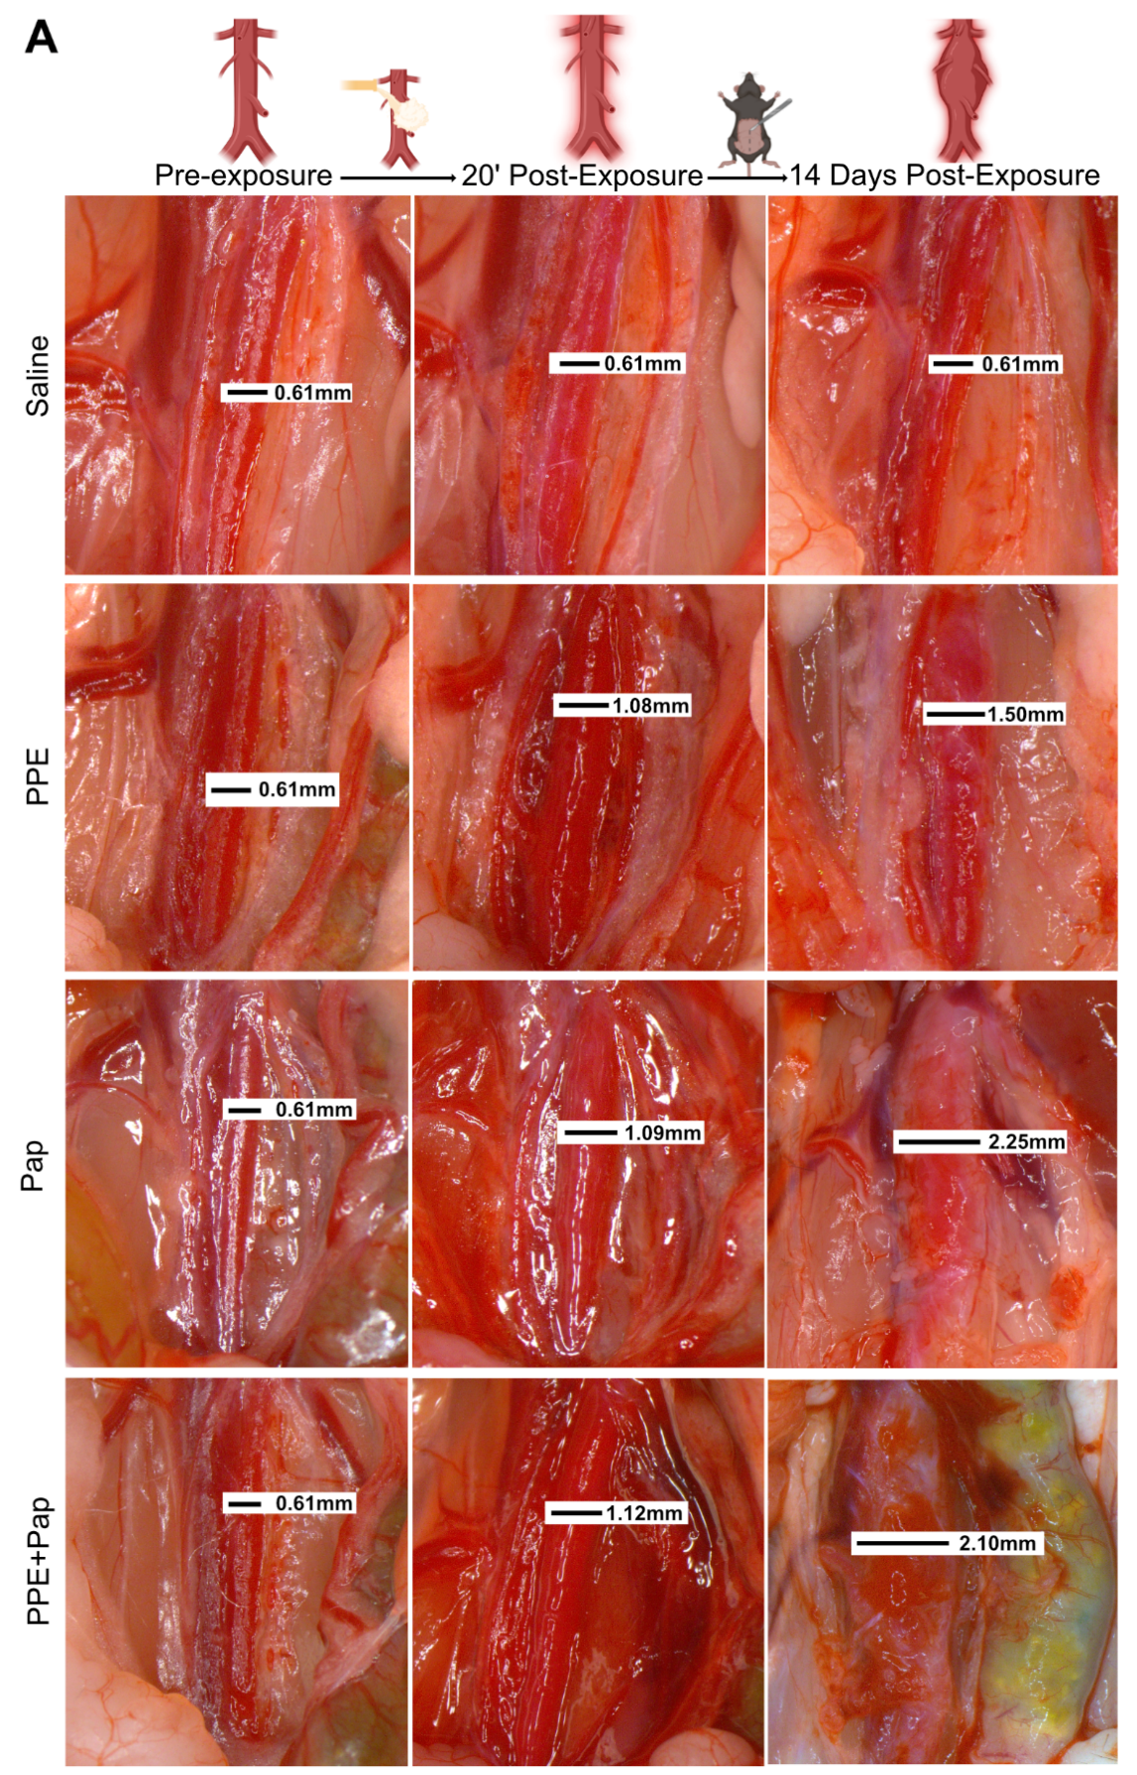
Extended Figure 1. Variable AAA development 20 minutes post-chemical exposure and at day 14 post-AAA formation.

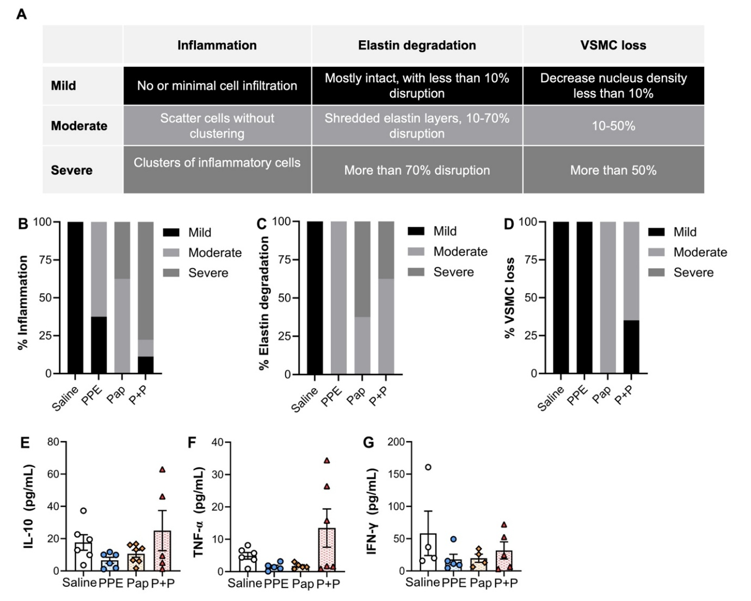
Extended Figure 2. Immunohistochemical categorical analysis. (A) Table with grading information. (B) Degree of inflammation, (C) elastin degradation and (D) percent of VSMC loss. Inflammatory markers (E) IL-10, (F) TNF-α and (G) IFN-γ content within the AAA tissue measured by ELISA.

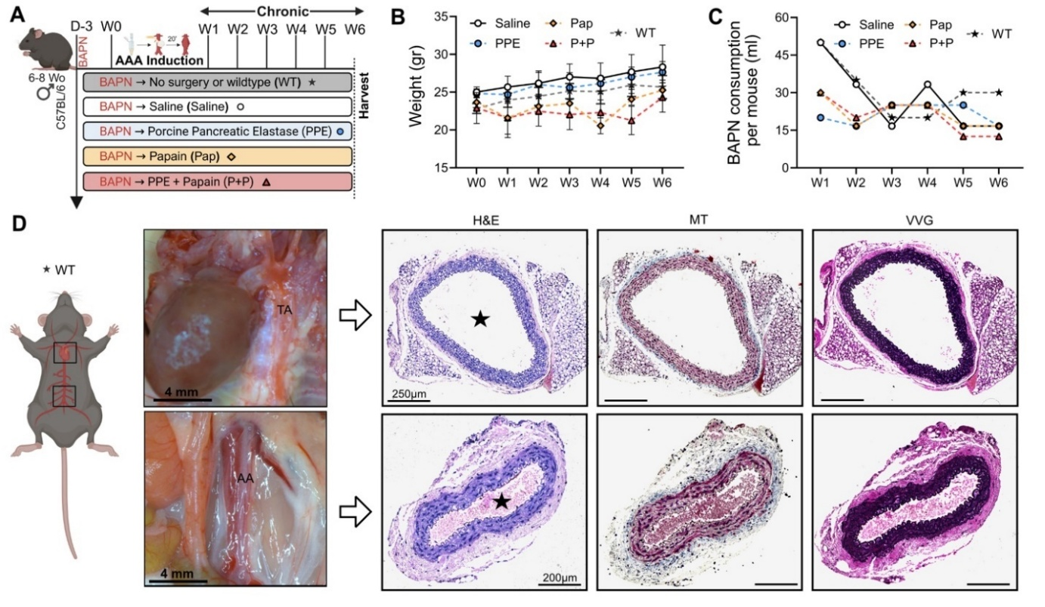
Extended Figure 3. Chronic model of AAA progression using daily BAPN administration over 6 weeks in wildtype (WT) mice. (A) WT mice (N = 3) received BAPN through drinking water starting 3 days prior to AAA induction and continuing until week 6. Mice were also exposed to either saline, Pap, PPE+Pap, PPE or no exposure (WT). (B) Body weight assessment over the 6-week period, measured in grams. (C) BAPN consumption assessment from weeks 1 to 6. (D) WT mouse harvest of the thoracic aorta (TA) and abdominal aorta (AA) and stained with H&E, Masson trichrome (MT) and VVG staining (cross-section of tissue slides) with 5x magnification. The star represents the lumen of the artery.

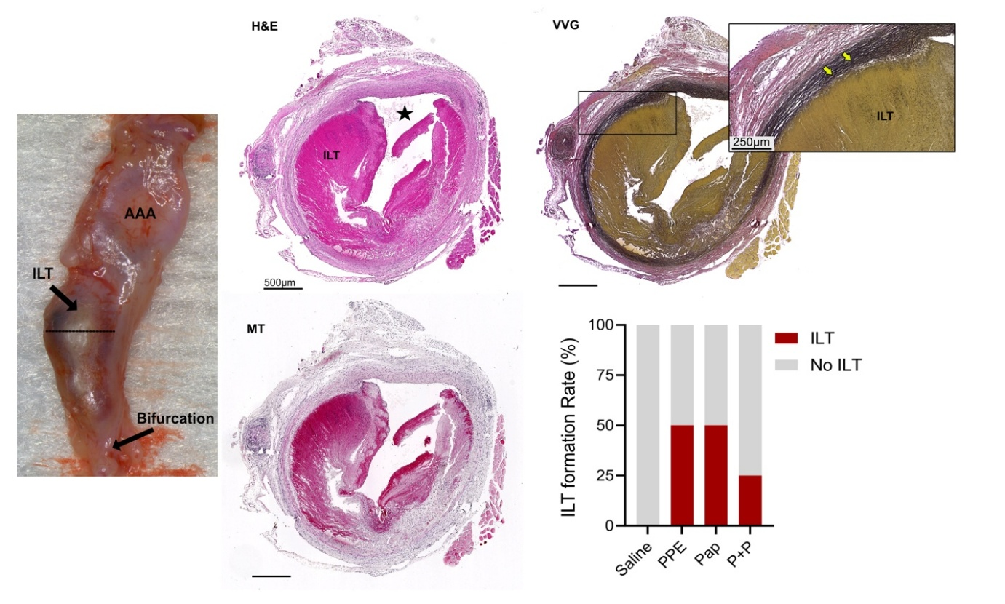
Extended Figure 4. Intraluminal thrombus (ILT) formation in a novel chronic model of AAA progression using daily BAPN administration over 6 weeks in chemically induced exposure. H&E, Masson trichrome (MT) and VVG staining of abdominal aortas (cross-section of tissue slides) with 5x and 10x magnification. Star = lumen.

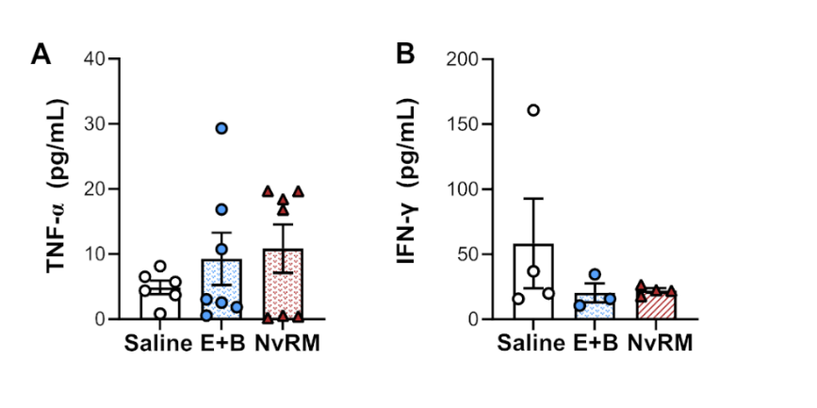
Extended Figure 5. Inflammatory markers at day 6. (A) TNF-α and (B) IFN-γ content within the AAA tissue measured by ELISA. Data are presented as mean ± standard deviation (SD). Ns>0.005, *p<0.05, **p<0.01, ***p<0.001 using either one-way ANOVA or student’s t-test when applicable.

Extended Table 1. Surgical Checklist divided by category
Category | Equipment | Uses
PPE | Surgical drapes, gauzes, gloves, gown and googles | Sterile technique and personal protection equipment
Setup | Small animal surgery board:  →Magnetic towers  →Self-retractors  →Hose holder  →3M tape | Standardized surgical technique and a comfortable setting for AAA creation surgery to ensure reproducibility
 | Heating pad | Thermoregulation and maintaining adequate body temperature to enhance recovery
Anesthesia | Nose cone, parafilm and hoods  Oxygen 100% | Minimizes the risk of anesthesia leakage and accidental user inhalation, ensures that the anesthesia is effectively delivered to the mouse
Anesthesia | Isoflurane | Halogenated, volatile anesthetic
Aseptic Skin Preparation | Nair | Hair removal for the surgical preparation
Aseptic Skin Preparation | Antiseptic swabs  →Chlorhexidine gluconate  →Isopropyl alcohol | Combination of skin antisepsis used in preoperative skin preparations and surgical procedures
AAA Creation | Pipet and cotton ball | 50µL pipet to drop chemical for aortic exposure to the retroperitoneal cavity through the cotton ball
AAA Creation | Porcine pancreatic elastase | PPE; 10.3mg protein/mL, 5.9 U/mg protein obtained from Sigma Aldrich
AAA Creation | Papain | Pap; 1.0 or 20mg/mL
AAA Creation | BAPN preparation | β-aminopropionitrile (BAPN) administration through drinking water (0.3% BAPN in water)
AAA Creation | Angiotensin II subcutaneous pump | Pump; Alzet 1004, Durect Corp, Cupertino, CA  ANG II; Sigma Aldrich Inc, St. Louis, MO
Syringes | 30 G (1 ½) 0.3mm x 13mm  (Insulin Syringe) | Blood draw  Buprenorphine administration
Analgesics | Buprenorphine SR | Pre-surgical procedure analgesia
Silks | 5.0 Vicryl | Uninterrupted suture closure of the rectus abdominis muscle (anterior abdominal wall)
Silks | 5.0 Monofilament Nylon | Interrupted suturing technique for skin wound closure
Hemostasis | Small Q-tips  Small Gauzes (2’’ x 2” → 5.1x5.1cm) | Rapid control of bleeding by applying pressure
Surgical Instruments | Atraumatic tissue forceps | Skin manipulation
 | Fine forceps | Retroperitoneal access and aortic and vena cava manipulation
 | Mayo scissors | Laparotomy
 | Fine scissors | Muscle incision, silk cut and tissue management
 | Needle holder | Skin and muscle suturing and closure

