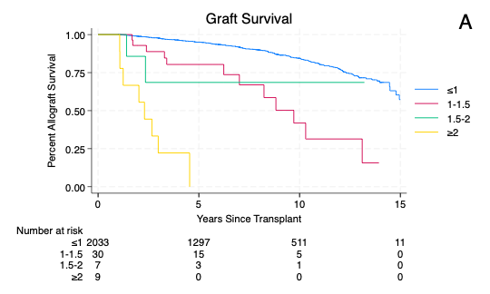
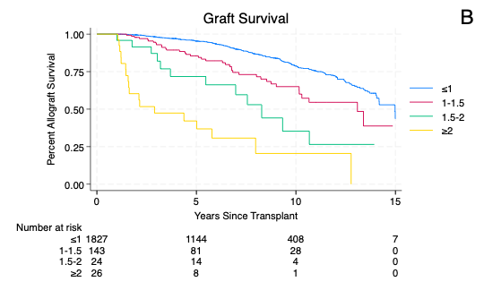
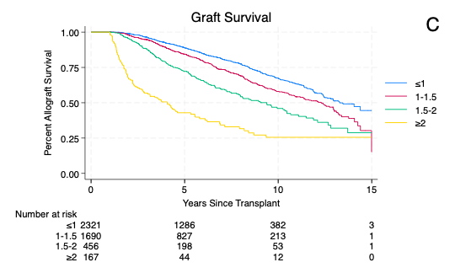

Supplementary Figure 1 Kaplan-Meier survival estimates comparing patients based on sCr one-year post-transplant in patients age <6 (A), age 6-11 (B), and age 12-17 (C). Blue line one-year sCr ≤1.0 mg/dL, red line one-year sCr 1.0-1.5 mg/dL, green line one-year sCr 1.5-2.0 mg/dL, yellow line one-year sCr ≥2.0 mg/dL. Number of patients at risk at each time point stratified by one-year sCr is presented underneath the graph

