Appendix A
Table 2: Means ± standard deviations separated by groups, as well as differences (Δ) between T0 and T2, levels of significance (sign.) and effect sizes (ES -Cohens D) of all measurements in body composition (BW, FFM, SMM, FM), muscle thickness (RF, BB, TB, BF), grip strength, 1-RM BBS, 1-RM DL. The significance was set at p< 0.05, time effects are market with #; time*group interaction to C with * and CP with $.
 | TP |  |  |  |  |  |  | T
 | T0 | T1 | T2 | Δ T0-T1 | Δ T1-T2 | D T0-T2 | D T1-T2 | T0 | T1 | T2 | Δ T0-T1 | Δ T1-T2 | D T0-T2 | D T1-T2
BW (kg) | 71.3 ± 11.2 | 74.2 ± 11.0 | 74.0 ± 11.1 | 2.3 ± 2.4* | 1.0 ± 2.4 | 0,3 | 0.1 | 68.9 ± 9.8 | 67.3 ± 6.1 | 67.8 ± 7.2 | -1.1 ± 3.5$ | -2.1 ± 4.2 | 0,1 | - 0.25
FFM (kg) | 46.2 ± 2.7 | 47.6 ± 2.3 | 47.7 ± 2.4 | 1.5 ± 0.8*$ | -0.3 ± 2.1 | 0,6 | - 0.1 | 45.7 ± 3.0 | 52.9 ± 2.1 | 44.8 ± 4.4 | -0.8 ± 2.8 | -0.9 ± 2.7 | 0,2 | - 0.25
SMM (kg) | 19.2 ± 1.1 | 20.1 ± 1.2 | 20.6 ± 1.6 | 1.4 ± 0.9$ | -0.5 ± 1.5 | 1 | - 0.4 | 19.5 ± 1.1 | 24.4 ± 1.4 | 22.2# ± 1.2 | 2.7 ± 0.5*$ | 1.6 ± 1.8 | 2,3 | 0.9
FM (kg) | 26.8 ± 10.4 | 26.6 ± 9.4 | 26.6 ± 10.3 | -0.2 ± 2.1$ | 2.2 ± 2.8 | 0 | 0.2 | 25.1 ± 11.4 | 14.5 ± 5.6 | 18.5# ± 10.5 | -6.6 ± 2.1*$ | -2.9 ± 2.9 | 0,6 | - 0.3
RF (cm) | 2.5 ± 0.7 | 2.6 ± 0.8 | 2.9 ± 0.6 | 0.4 ± 0.3* | 0.2 ± 0.9 | 0,6 | 0.3 | 2.0 ± 0.3 | 2.1 ± 0.4 | 2.0 ± 0.2 | 0.0 ± 0.1 | -0.1 ± 0.4 | 0,1 | - 0.3
BF (cm) | 1.9 ± 0.6 | 2.2 ± 0.3 | 2.7# ± 0.6 | 0.8 ± 0.5* | 0.5 ± 0.7 | 1,3 | 0.9 | 1.9 ± 0.3 | 2.3 ± 0.6 | 3.0 ± 0.6 | 1.1 ± 0.3* | 0.7 ± 1.0 | 2,4 | 1.0
BB (cm) | 2.2 ± 0.3 | 2.6 ± 0.3 | 2.5# ± 0.6 | 0.4 ± 0.5* | -0.0 ± 0.4 | 0,8 | - 0.1 | 2.2 ± 0.3 | 2.4 ± 2.2 | 2.4# ± 0.5 | 0.1 ± 0.5 | -0.1 ± 0.5 | 0,3 | - 0.3
TB (cm) | 3.2 ± 0.4 | 3.2 ± 0.6 | 3.3 ± 0.3 | 0.1 ± 0.4* | 0.1 ± 0.7 | 0,3 | 0.1 | 2.9 ± 1.1 | 3.2 ± 1.0 | 2.6# ± 1.0 | -0.3 ± 0.3 | -0.6 ± 0.4 | 0,3 | - 0.6
GS (kg) | 30.1 ± 2.1 | 34.3 ± 1.6 | 33.8 ± 3.9 | 3.7 ± 4.1* | -0.6 ± 3.0 | 1,2 | - 0.2 | 26.8 ± 3.5 | 31.1 ± 3.3 | 31.9 ± 4.8 | 5.3 ± 1.6*$ | 0.8 ± 2.5 | 1,2 | 0.2
1-RM BBS (kg) | 53.8 ± 14.0 | 97.5 ± 6..8 | 97.9 ± 23.5 | 44.0 ± 19.9*$ | 0.4 ± 21.9 | 2,3 | 0.0 | 36.5 ± 6.0 | 73.0 ± 8.7 | 63.5 ± 9.8 | 27.0 ± 7.4*$ | -9.5 ± 8.2 | 3,3 | - 0.9
1-RM DL (kg) | 59.3 ± 4.9 | 86.3 ± 6.1 | 81.7 ± 16.3 | 22.3 ± 20.5*$ | -4.6 ± 15.0 | 1,9 | - 0.4 | 41.0 ± 4.2 | 66.5 ± 7.5 | 61.0 ± 4.2 | 20.0 ± 3.5*$ | -5.5 ± 5.4 | 4,8 | - 0.8

C= control; CP= Control+Protein. D= Cohens’ D; T=Training; TP= Training + Protein; Significant time and time*group effects were set p<0.05. Time effects were marked with # and time*group effects to C with * and CP with $

 | CP |  |  |  |  |  |  | C
 | T0 | T1 | T2 | Δ T0-T1 | Δ T1-T2 | D T0-T2 | D T1-T2 | T0 | T1 | T2 | Δ T0-T1 | Δ T1-T2 | D T0-T2 | D T1-T2
BW (kg) | 70.2 ± 6.2 | 73.5 ± 5.0 | 73.2 ± 6.1 | 2.9 ± 2.2* | 0.4 ± 1.2 | 0,5 | 0.1 | 69.7 ± 13.4 | 64.4 ± 9.3 | 69.7 ± 13.1 | 0.0 ± 0.7 | -5.1 ± 8.4 | 0 | - 0.4
FFM (kg) | 48.2 ± 2.6 | 46.2 ± 4.3 | 46.2 ± 1.1 | -2.0 ± 2.2 | -3.4 ± 1.6 | 1 | - 2.4 | 46.3 ± 6.8 | 45.9 ± 4.3 | 45.9 ± 4.9 | -0.4 ± 3.0 | 1.7 ± 2.6 | 0,1 | 0.4
SMM (kg) | 21.0 ± 2.1 | 19.1 ± 1.2 | 19.1 ± 1.4 | -1.9 ± 1.7 | -2.8 ± 1.2 | 1,1 | - 2.0 | 19.8 ± 3.6 | 19.4 ± 2.6 | 19.4 ± 2.9 | -0.4 ± 1.1 | 1.8 ± 1.3 | 0,1 | 0.7
FM (kg) | 22.0 ± 5.1 | 27.3 ± 5.2 | 24.9 ± 5.0 | 2.9 ± 1.9* | 1.2 ± 3.9 | 0,6 | 0.24 | 22.9 ± 7.6 | 18.5 ± 6.5 | 20.5 ± 8.5 | -2.4 ± 3.4 | -1.6 ± 5.7 | 0,3 | - 0.2
RF (cm) | 1.6 ± 0.2 | 2.3 ± 0.5 | 1.9 ± 0.6 | 0.3 ± 0.8* | -0.4 ± 1.0 | 0,6 | - 0.7 | 2.0 ± 0.8 | 1.7 ± 0.5 | 1.92 ± 0.4 | -0.1 ± 0.9 | 0.1 ± 0.3 | 0,1 | 0.1
BF (cm) | 2.8 ± 0.1 | 2.8 ± 0.5 | 3.3# ± 0.7 | 0.5 ± 0.7 | 0.4 ± 1.0 | 1 | 0.7 | 2.3 ± 0.5 | 2.2 ± 0.5 | 2.21 ± 0.4 | -0.1 ± 0.6 | 0.0 ± 0.8 | 0,2 | 0.0
BB (cm) | 1.6 ± 0.2 | 2.4 ± 0.5 | 1.5*# ± 0.4 | -0.1 ± 0.6 | -0.2 ± 0.7 | 0,4 | - 0.4 | 2.2 ± 0.3 | 2.3 ± 0.4 | 2.04 ± 0.4 | -0.2 ± 0.6 | -0.2 ± 0.6 | 0,4 | - 0.6
TB (cm) | 1.6 ± 0.5 | 2.1 ± 0.8 | 1.5 ± 0.4 | -0.2 ± 0.3 | -0.7 ± 0.6 | 0,4 | - 0.9 | 2.5 ± 0.8 | 2.4 ± 0.3 | 2.29 ± 0.7 | -0.2 ± 0.3 | -0.1 ± 0.5 | 0,3 | -0.2
GS (kg) | 30.4 ± 3.7 | 30.2 ± 4.8 | 31.3 ± 2.9 | 0.8 ± 3.4 | 1.0 ± 3.6 | 0,3 | 0.2 | 28.9 ± 2.4 | 28.1 ± 2.2 | 28.8 ± 2.8 | -0.2 ± 1.4 | 0.7 ± 0.9 | 0,1 | 0.3
1-RM BBS (kg) | 68.3 ± 12.9 | 76.9 ± 16.9 | 73.1 ± 13.1 | 4.9 ± 5.2 | -3.8 ± 6.6 | 0,4 | - 0.2 | 44.5 ± 19.9 | 50.0 ± 13.0 | 52.0 ± 13.5 | 7.5 ± 11.2 | 2.0 ± 7.6 | 0,4 | 0.1
1-RM DL (kg) | 56.3 ± 11.8 | 66.8 ± 7.4 | 66.9 ± 6.3* | 10.6 ± 10.1* | 0.1 ± 7.2 | 1,1 | 0.0 | 46.5 ± 10.6 | 46.5 ± 12.5 | 46.0 ± 11.8 | -0.5 ± 5.4 | -0.5 ± 5.4 | 0 | - 0.0

Appendix B
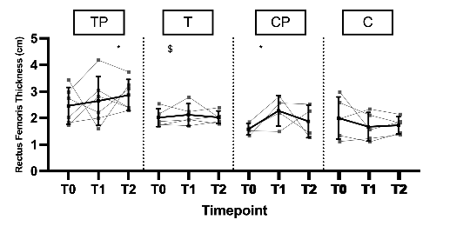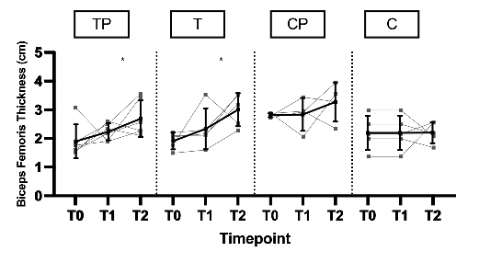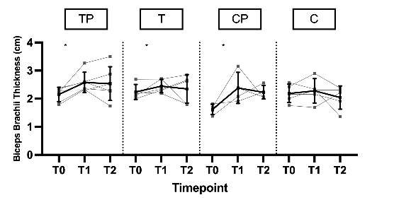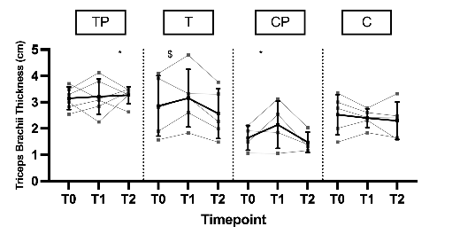
Fig. 2: Muscle thickness of (a) M. rectus femoris, (b) M. biceps femoris, (c) M. biceps brachii, (d) M. triceps brachii
TP= Training + Protein T=Training, CP= Control + Protein, C= control. Significant time effects were marked with # and time*group effects to C with * and to CP with $. Mean value with standard deviation are marked in black and individual curves in grey. Mean value with standard deviation are marked in black and individual curves in grey.

Appendix C
 |  | Did the study prompt  you to reflect on your  dietary habits for the  first time? | My willingness  to engage in  regular physical  activity has increased  since the intervention | Resistance Training  has now become an  integral part of my  routine | I feel more  confident in  my physical  performance  since the intervention | My overall physical  endurance has i  mproved since the  intervention and continues  to do so | I make sure to  consume enough  protein through  my diet on a daily  basis. | I have a better understanding of the role protein plays in my diet. | To what extent  has your emotional  well-being during menopause  improved as a result of the i  ntervention? | I feel energized  and capable in my  daily life. | I feel overall  fitter and  healthier. | I experience  more joy and  satisfaction in my  daily life | I am more  motivated to maintain healthy lifestyle habits
ID | GROUP | Q3 | Q8 | Q10 | Q14 | Q16 | Q24 | Q28 | Q31 | Q43 | Q47 | Q50 | Q57
VC10 | TP | 4 | 5 | 5 | 5 | 5 | 3 | 4 | 4 | 4 | 3 | 4 | 4
RB7 | TP | 4 | 5 | 5 | 5 | 5 | 4 | 5 | 5 | 4 | 4 | 4 | 4
RS50 | TP | 4 | 4 | 3 | 4 | 4 | 4 | 5 | 4 | 3 | 4 | 4 | 4
BM22 | TP | 4 | 5 | 5 | 4 | 4 | 3 | 5 | 5 | 4 | 4 | 4 | 5
KS18 | TP | 3 | 5 | 5 | 5 | 5 | 4 | 4 | 4 | 5 | 4 | 4 | 4
LAS56 | TP | 3 | 5 | 3 | 4 | 4 | 3 | 4 | 5 | 4 | 3 | 5 | 3
BA14 | T | 4 | 4 | 5 | 4 | 4 | 3 | 4 | 3 | 3 | 4 | 3 | 3
BM11 | T | 3 | 3 | 1 | 1 | 2 | 3 | 2 | 2 | 3 | 3 | 3 | 2
BM49 | T | 3 | 4 | 3 | 4 | 4 | 4 | 5 | 3 | 3 | 4 | 3 | 4
SB6 | T | 2 | 4 | 5 | 5 | 5 | 5 | 3 | 5 | 5 | 5 | 5 | 4
SG58 | T | 3 | 5 | 3 | 4 | 3 | 3 | 4 | 4 | 4 | 4 | 4 | 4
NR10 | CP | 3 | 3 | 4 | 3 | 3 | 3 | 3 | 3 | 3 | 4 | 3 | 4
SC6 | CP | 4 | 4 | 3 | 3 | 3 | 4 | 5 | 4 | 4 | 4 | 4 | 5
SJ8 | CP | 4 | 3 | 3 | 3 | 3 | 4 | 4 | 3 | 3 | 3 | 3 | 3
SA4 | CP | 3 | 4 | 3 | 3 | 3 | 2 | 3 | 1 | 1 | 2 | 3 | 2
BM45 | C | 3 | 3 | 2 | 2 | 3 | 3 | 3 | 3 | 3 | 3 | 4 | 4
PI34 | C | 1 | 4 | 5 | 4 | 3 | 5 | 5 | 1 | 3 | 3 | 3 | 3
PK2 | C | 4 | 2 | 4 | 4 | 3 | 2 | 4 | 1 | 5 | 4 | 4 | 4
SE38 | C | 2 | 3 | 3 | 3 | 3 | 3 | 4 | 2 | 3 | 4 | 2 | 3
SS28 | C | 4 | 2 | 1 | 3 | 5 | 4 | 4 | 1 | 4 | 3 | 4 | 3

 |  | Did you begin  strength training  after the intervention? | I have noticed long-term  changes in my lifestyle  since participating in the  intervention. | Has strength training  become a part of your daily  routine since the intervention?
ID | GROUP | Q2 | Q20 | Q38
VC10 | TP | 1 | 1 | 1
RB7 | TP | 1 | 1 | 1
RS50 | TP | 2 | 1 | 2
BM22 | TP | 1 | 1 | 1
KS18 | TP | 1 | 1 | 1
LAS56 | TP | 1 | 1 | 1
BA14 | T | 1 | 1 | 1
BM11 | T | 1 | 1 | 1
BM49 | T | 1 | 1 | 1
SB6 | T | 1 | 1 | 1
SG58 | T | 1 | 1 | 1
NR10 | CP | 2 | 2 | 1
SC6 | CP | 2 | 1 | 1
SJ8 | CP | 2 | 2 | 2
SA4 | CP | 2 | 2 | 2
BM45 | C | 2 | 1 | 2
PI34 | C | 2 | 2 | 1
PK2 | C | 2 | 2 | 1
SE38 | C | 2 | 2 | 1
SS28 | C | 2 | 2 | 2

