Supplementary Materials
VTA network dominance in depression confers distinct psychopathological states through blunted neural tracking of reward prediction errors
J. Beltrán^{1,2}*, M. Li¹*, Y. Jacob^{1,3}, G. Butler¹, M. Mehta⁵, J.W. Murrough^{1,2,6}, A. Radulescu^{1,2,4},
L.S. Morris^{1,7,8}
*equal contributions
- Department of Psychiatry, Icahn School of Medicine at Mount Sinai, New York, NY, USA
- Nash Family Department of Neuroscience & Friedman Brain Institute, Icahn School of Medicine at Mount Sinai, New York, NY, USA
- BioMedical Engineering and Imaging Institute, Department of Radiology, Icahn School of Medicine at Mount Sinai, New York, NY, USA
- Center for Computational Psychiatry, Icahn School of Medicine at Mount Sinai, New York, NY, USA
- The Laureate Institute for Brain Research, Tulsa, OK, USA
- VISN 2 Mental Illness Research, Education and Clinical Center (MIRECC), James J. Peters VA Medical Center, Bronx, NY, USA
- Nuffield Department of Clinical Neurosciences, University of Oxford, UK
- Department of Experimental Psychology, University of Oxford, UK

Contents
Supplementary methods 2
Multi-Echo Independent Components Analysis (ME-ICA) 3
Dependency network analysis (DEPNA) average correlation influence calculation 3
Computational Models 5
Free parameters and latent variable extraction 5
Parameter and model recovery 6
Supplementary results 6
Task-free fMRI 6
Group differences in VTA functional connectivity during task-free brain states 6
Relationships between anticipatory and consummatory anhedonia severity and VTA influence 8
Associations between anticipatory and consummatory anhedonia severity and VTA functional connectivity during task-free brain states 9
Associations between depressive and anxiety symptoms and VTA functional connectivity during task-free brain states 11
Task-based fMRI 12
Whole-brain results 12
Group differences in neural tracking of RPEs in the NAc and BLA 14
Association between mesocortical and mesolimbic functional connectivity and RPE encoding during task-based brain states 14
Association between anhedonia and RPE encoding within HC and MDD 15
Association between anxiety and RPE encoding 16
Sex hormones 17
Sex hormones associations with VTA functional connectivity and VTA influence during task-free brain states 17
Sex hormones associations with anticipatory and consummatory anhedonia 20
Testosterone associations with VTA functional connectivity and VTA influence during task-free brain states 20
Demographics 23
Supplementary figures 24

Supplementary methods

Multi-Echo Independent Components Analysis (ME-ICA)
Our study denoised functional data through Multi-Echo Independent Components Analysis (ME-ICA), which combines multi-echo acquisition and independent components analysis (ICA) to separate blood oxygen level–dependent (BOLD) signals from non-BOLD noise. Here, multi-echo acquisition exploits the dependence of BOLD signals on multiple echo times (TEs). Independent components analysis (ICA) decomposes the multi-echo data into statistically independent components, which are then classified based on their TE-dependent properties to isolate true neural activity from noise. Specifically, ME-ICA calculates the pseudo-F-statistic Kappa to determine components highly correlated with TE (BOLD signals), and Rho to identify non-BOLD components which remain constant across TEs (Kundu et al., 2012; Kundu et al., 2013; Morris et al., 2019). Components classified as noise are removed, while BOLD-related components are retained, to significantly improve the signal-to-noise ratio (SNR) and reduce the impact of motion and physiological noise.

Dependency network analysis (D_{EP}NA) average correlation influence calculation
Besides VTA influence degrees, we calculated the average correlation influence between the VTA and other regions within the VTA circuitry as identified by D_{EP}NA (Figure 1C). Multivariate linear regression models, controlling for age, sex, medication status and preprocessing variability, were then used to compare the VTA average correlation influence across different groups (MDD vs. HC) and varying levels of anticipatory/consummatory anhedonia, to capture distinct connectivity patterns. These distinctions in average correlation influence across groups and anhedonia levels were then used to construct directed graphs with weighted edges (see Figures 1E and S2).
It is important to note that TEPS, which was used to assess anhedonia, is a transdiagnostic tool for evaluating pleasure experience, designed for both clinical and non-clinical populations rather than being specific to MDD (Gard et al., 2006). Moreover, although anhedonia is a core symptom of MDD, it also serves as a symptom of other disorders (Dowd & Barch, 2010; Der-Avakian & Markou, 2012). Therefore, controlling group effects between MDD and HC may obscure the true effect of anhedonia itself. Thus, we constructed multivariate linear regression models of VTA average correlation influence across different anhedonia levels both without including group as a covariate and with controlling the group (Supplementary Table 1).

Node pairs | Predictor | Models without group |  |  |  | Models controlling for group
Node pairs | Predictor | β coefficient | p_{uncorr} | p_{FDR} | R² | β coefficient | p_{uncorr} | p_{FDR} | R²
NAc to VTA | MDD vs. HC | 0.035 | 0.071 | 0.099 | 0.112 | -- | -- | -- | --
vmPFC to VTA | MDD vs. HC | 0.038 | 0.176 | 0.224 | 0.034 | -- | -- | -- | --
dmPFC to VTA | MDD vs. HC | 0.036 | 0.057 | 0.099 | 0.064 | -- | -- | -- | --
sgACC to VTA |  | 0.037 | 0.066 | 0.099 | 0.138 | -- | -- | -- | --
plACC to VTA |  | 0.023 | 0.468 | 0.468 | 0.077 | -- | -- | -- | --
Hipp to VTA |  | 0.040 | 0.319 | 0.372 | 0.022 | -- | -- | -- | --
Amyg to VTA |  | 0.016 | 0.345 | 0.372 | 0.021 | -- | -- | -- | --
VTA to NAc |  | 0.036 | 0.036 | 0.093 | 0.101 | -- | -- | -- | --
VTA to vmPFC |  | 0.029 | 0.069 | 0.099 | 0.076 | -- | -- | -- | --
VTA to dmPFC |  | 0.036 | 0.040 | 0.093 | 0.080 | -- | -- | -- | --
VTA to sgACC |  | 0.028 | 0.012 | 0.082 | 0.183 | -- | -- | -- | --
VTA to plACC |  | 0.034 | 0.009 | 0.082 | 0.142 | -- | -- | -- | --
VTA to Hipp |  | 0.042 | 0.037 | 0.093 | 0.079 | -- | -- | -- | --
VTA to Amyg |  | 0.051 | 0.027 | 0.093 | 0.094 | -- | -- | -- | --
NAc to VTA | Anticipatory anhedonia | -0.002 | 0.024 | 0.113 | 0.134 | -0.001 | 0.090 | 0.420 | 0.147
vmPFC to VTA | Anticipatory anhedonia | -0.002 | 0.059 | 0.120 | 0.057 | -0.002 | 0.139 | 0.476 | 0.063
dmPFC to VTA |  | -0.002 | 0.013 | 0.113 | 0.095 | -0.002 | 0.059 | 0.412 | 0.110
sgACC to VTA |  | -0.002 | 0.060 | 0.120 | 0.140 | -0.001 | 0.202 | 0.476 | 0.158
plACC to VTA |  | -0.001 | 0.374 | 0.374 | 0.080 | -0.001 | 0.511 | 0.594 | 0.082
Hipp to VTA |  | -0.002 | 0.140 | 0.194 | 0.038 | -0.002 | 0.239 | 0.476 | 0.041
Amyg to VTA |  | -0.002 | 0.021 | 0.113 | 0.079 | -0.002 | 0.036 | 0.412 | 0.079
VTA to NAc |  | -0.001 | 0.114 | 0.177 | 0.077 | -0.001 | 0.394 | 0.549 | 0.11
VTA to vmPFC |  | -0.001 | 0.155 | 0.194 | 0.059 | -0.001 | 0.432 | 0.549 | 0.084
VTA to dmPFC |  | -0.001 | 0.219 | 0.236 | 0.045 | -0.000 | 0.629 | 0.629 | 0.083
VTA to sgACC |  | -0.001 | 0.058 | 0.120 | 0.151 | -0.000 | 0.302 | 0.476 | 0.195
VTA to plACC |  | -0.001 | 0.055 | 0.120 | 0.104 | -0.001 | 0.306 | 0.476 | 0.154
VTA to Hipp |  | -0.001 | 0.083 | 0.145 | 0.061 | -0.001 | 0.306 | 0.476 | 0.092
VTA to Amyg |  | -0.001 | 0.166 | 0.194 | 0.056 | -0.001 | 0.552 | 0.594 | 0.098
NAc to VTA | Consummatory anhedonia | -0.003 | 0.003 | 0.019 | 0.178 | -0.002 | 0.009 | 0.063 | 0.192
vmPFC to VTA | Consummatory anhedonia | -0.002 | 0.158 | 0.202 | 0.036 | -0.002 | 0.277 | 0.370 | 0.050
dmPFC to VTA |  | -0.003 | 0.004 | 0.019 | 0.122 | -0.002 | 0.013 | 0.063 | 0.141
sgACC to VTA |  | -0.001 | 0.216 | 0.252 | 0.116 | -0.001 | 0.436 | 0.470 | 0.145
plACC to VTA |  | -0.002 | 0.294 | 0.294 | 0.084 | -0.001 | 0.378 | 0.441 | 0.087
Hipp to VTA |  | -0.003 | 0.158 | 0.202 | 0.035 | -0.002 | 0.238 | 0.370 | 0.041
Amyg to VTA |  | -0.002 | 0.004 | 0.019 | 0.115 | -0.002 | 0.007 | 0.063 | 0.116
VTA to NAc |  | -0.002 | 0.044 | 0.117 | 0.097 | -0.001 | 0.126 | 0.352 | 0.130
VTA to vmPFC |  | -0.001 | 0.077 | 0.154 | 0.073 | -0.001 | 0.181 | 0.362 | 0.098
VTA to dmPFC |  | -0.001 | 0.113 | 0.176 | 0.058 | -0.001 | 0.276 | 0.370 | 0.095
VTA to sgACC |  | -0.001 | 0.258 | 0.278 | 0.124 | -0.000 | 0.623 | 0.623 | 0.186
VTA to plACC |  | -0.001 | 0.050 | 0.117 | 0.106 | -0.001 | 0.176 | 0.362 | 0.164
VTA to Hipp |  | -0.002 | 0.043 | 0.117 | 0.075 | -0.001 | 0.124 | 0.352 | 0.109
VTA to Amyg |  | -0.002 | 0.112 | 0.176 | 0.064 | -0.001 | 0.291 | 0.370 | 0.108
Table S1. Average correlation influence differences by group and anhedonia severity

Computational Models
Three computational models of learning were tested and fitted within a hierarchical Bayesian framework and compared using the WAIC metric for model comparison. α = learning rate, β = inverse temperature, αG = learning rate for gain trials, αL = learning rate for loss trials
Model # | Description | Free parameters
1 | One learning rate | α, β
2 | Two learning rates dependent on stimulus trial type | α_{G,}α_{L,} β
3 | Two learning rates dependent on stimulus trial type with 2 group-level hyperparameters | α_{G,,}α_{L,} β

Free parameters and latent variable extraction
Behavioral data were fitted to each model using R Stan (Carpenter et al., 2017). The mean and standard deviation of the population level learning rate were sampled from a cauchy distribution. The mean for the population level beta was sampled from a normal distribution while the standard deviation was sampled from a cauchy distribution. Subject level learning rates were sampled from a beta distribution, while subject level betas were sampled from a normal distribution.
For models 1 and 2, four chains were initialized with a 2500 sample warmup period, and each took 2500 samples from the posterior distribution (total of 5000 samples per chain). The 2500 samples per chain used for the warmup phase were removed from further analysis, leaving 10000 total samples from the posterior distribution for models 1 and 2. The winning model (model 3) consisted of four chains specified with a 3500 warmup period such that each chain took 3500 samples from the posterior distribution. The 3500 samples used for the warmup phase were removed from further analysis, leaving 14000 samples from the posterior distribution for model 3. There were no divergences within each chain with R hat ≤ 1.01 for each model and all parameters (Baribault and Collins, 2023). Median point estimates for α_{G}, α_{L}, and β were extracted from all iterations to assess for group differences. RPEs were extracted from a generated quantities block, and the median RPE on a given trial was computed for each subject for further analysis.

Parameter and model recovery
To ensure parameters were independently estimated, parameter recovery analysis was performed for competing model 1 and model 2 respectively by first taking the median of the population level parameter values estimated for the empirical dataset’s eta (mean and sd) and beta (mean and sd). The median mean and standard deviation for each parameter was then used to generate a posterior distribution from which 100 subject-level parameters (true values) were sampled to simulate behavioral data for 100 'participants'. The simulated behavioral data were then fitted to the same computational models used on the empirical data to determine if we could recover the true parameter values. Successful recovery was determined based on the correlation between the simulated parameters and the fitted parameters and further quantified as the proportion of true values that fall within the 95% credible intervals of the fitted parameters (Baribault and Collins, 2023).
Model recovery was performed to assess whether model 1 or model 2 provided the best fit to the data. The simulated datasets generated for 100 'participants' using model 1 and model 2 were fitted to their competing model to compare participant-level WAICs. The proportion of times the participant-level WAIC was the lowest for the true generative model against the competing model was determined and used to generate a confusion matrix.

Supplementary results

Task-free fMRI

Group differences in VTA functional connectivity during task-free brain states
To investigate group differences in functional connectivity of the ventral tegmental area (VTA) along the mesolimbic and mesocortical pathways, we first used analysis of covariance (ANCOVA) to examine the effect of group (MDD vs. HC) on functional connectivity in different brain regions, while controlling for potential covariates, including age, sex, medication status, and preprocessing variability. The results displayed a significant group difference in the sgACC region before FDR correction, but this did not survive FDR correction, indicating a trend towards enhanced functional connectivity in the mesocortical pathway in MDD individuals compared to HC (F(1) = 4.590, p_{uncorr} = 0.036, p_{FDR} = 0.178). Other brain regions exhibited similar trends of enhanced connectivity in MDD, though they did not reach significance after FDR correction (see Supplementary Table 2 for full results).
 | df | F | p_{uncorr} | p_{FDR}
plACC | 1 | 3.357 | 0.071 | 0.178
sgACC | 1 | 4.590 | 0.036 | 0.178
dmPFC | 1 | 2.752 | 0.102 | 0.178
vmPFC | 1 | 3.002 | 0.087 | 0.178
hippocampus | 1 | 2.181 | 0.144 | 0.202
BLA | 1 | 1.747 | 0.190 | 0.222
NAc | 1 | 1.355 | 0.248 | 0.248
Table S2. Group differences in VTA circuitry functional connectivity using ANCOVA

To further investigate the group differences in functional connectivity during task-free brain states along the mesolimbic and mesocortical pathways of the VTA, we constructed multivariate linear regression models with group (MDD vs. HC) as the primary predictor. Functional connectivity between the VTA and its target regions in both pathways was set as the dependent variable, while age, sex, medication status, and preprocessing differences were included as covariates.
We first assessed the normality of residuals for each region-specific regression model using both the Shapiro-Wilk and D’Agostino-Pearson tests (Shapiro & Wilk, 1965; D’Agostino & Pearson, 1973). For models with significant deviation from normality (p_{residual normality} < 0.05), robust regression (Huber loss) was applied to ensure reliable parameter estimation (Huber, 1964). For models with normally distributed residuals (p_{residual normality} > 0.05), ordinary least squares (OLS) regression was used for analysis (Supplementary Table 3).
Among the examined regions, vmPFC exhibited a statistically significant group effect before FDR correction (β = 0.073, p_{uncorr} = 0.044, p_{FDR} = 0.190). This finding aligns with the basal hyper-connectivity pattern observed in the ANCOVA analysis, further supporting the notion of mesocortical pathway hyperconnectivity in MDD.
 | p_{residual normality} | Model | β coefficient | p_{uncorr} | p_{FDR} | R²
plACC | 0.000 | Robust (Huber) | 0.048 | 0.182 | 0.190 | 0.096
sgACC | 0.021 | Robust (Huber) | 0.043 | 0.125 | 0.190 | 0.085
dmPFC | 0.540 | OLS | 0.048 | 0.102 | 0.190 | 0.045
hippocampus | 0.579 | OLS | 0.067 | 0.144 | 0.190 | 0.039
NAc | 0.006 | Robust (Huber) | 0.068 | 0.105 | 0.190 | 0.078
vmPFC | 0.000 | Robust (Huber) | 0.073 | 0.044 | 0.190 | 0.078
BLA | 0.211 | OLS | 0.050 | 0.190 | 0.190 | 0.041
Table S3. Group differences in VTA circuitry functional connectivity using multivariate linear regression

Relationships between anticipatory and consummatory anhedonia severity and VTA influence
In addition to functional connectivity, we also evaluated the relationships between anticipatory/ consummatory anhedonia severity and VTA influencing/influenced degrees in the VTA circuitry by multivariate linear regression models controlling for age, sex, medication status and preprocessing variability. As in previous analyses, we tested models both with and without controlling groups (MDD vs. HC). We reported the results from the models without controlling group as a covariate, because adjustment for diagnosis may obscure meaningful associations due to statistical suppression effects. Multiple comparison corrections were performed separately within each degree between two subtypes of anhedonia. Notably, we observed similar result patterns in the models both with and without group covariates (Supplementary Table 4).
Specifically, we found that the extent of VTA involvement was significantly associated with the severity of both anticipatory and consummatory anhedonia. In contrast, no significant association was observed between the severity of anhedonia and the extent of VTA involvement. These results further support the view that the role of VTA in modulating network activity (rather than being modulated by it) is particularly important in the context of anhedonia-related dysfunction.

Degree type | Predictor | Covariate | n | β | p | p_{FDR}
Influencing degree | Anticipatory anhedonia | Without group | 77 (n_{MDD} = 39) | -0.005 | 0.079 | 0.129
Influenced degree |  |  | 76 (n_{MDD} = 39) | -0.013 | 0.001 | 0.002
Influencing degree | Consummatory anhedonia |  | 77 (n_{MDD} = 39) | -0.005 | 0.129 | 0.129
Influenced degree |  |  | 76 (n_{MDD} = 39) | -0.013 | 0.006 | 0.006
Influencing degree | Anticipatory anhedonia | With group | 77 (n_{MDD} = 39) | -0.003 | 0.311 | 0.311
Influenced degree |  |  | 76 (n_{MDD} = 39) | -0.011 | 0.008 | 0.016
Influencing degree | Consummatory anhedonia |  | 77 (n_{MDD} =39) | -0.003 | 0.310 | 0.311
Influenced degree |  |  | 76 (n_{MDD} =39) | -0.011 | 0.018 | 0.018
Table S4. Relationships between anticipatory/consummatory anhedonia and VTA influence without/with controlling for group. Outliers beyond ±3 SD were excluded. Final sample sizes were 77 (influencing) and 76 (influenced) from an initial 78 participants.

Associations between anticipatory and consummatory anhedonia severity and VTA functional connectivity during task-free brain states
We assessed the partial correlations between the severity of anticipatory and consummatory anhedonia and functional connectivity within a VTA-centered brain network across the entire sample, controlling for covariates including sex, age, medication status and preprocessing variability (Supplementary Table 5). We found that greater severity of anticipatory anhedonia was associated with stronger functional connectivity within VTA-centered mesolimbic and mesocortical pathways. Similarly, greater severity of consummatory anhedonia was linked to increased connectivity in mesocortical pathway.
To test the robustness of these findings, we further constructed models that additionally controlled group distinctions between MDD and HC. Here, although some associations no longer survived FDR correction, key regional effects remained, particularly in the dmPFC (r = –0.285, p_{uncorr} = 0.015, p_{FDR} = 0.051) and hippocampus (r = –0.288, p_{uncorr} = 0.013, p_{FDR} = 0.051), where the association between anticipatory anhedonia and VTA functional connectivity within mesocortical and mesolimbic pathways persisted (see Supplementary Table 6 for full results). However, the effect of consummatory anhedonia in the dmPFC was no longer significant after controlling for group.
We argued that controlling for MDD group in this context may not be entirely appropriate. In earlier analyses, we found no significant group differences in functional connectivity within VTA circuitry (see Supplementary Tables 2 and 3). Moreover, given the nature of our partial correlation analysis and the fact that anhedonia, as a core symptom of MDD and other disorders (Lambert et al., 2018), theoretically and statistically overlaps with MDD diagnostic status, including group as a covariate may suppress the true relationship between anhedonia and functional connectivity. Controlling for group may inadvertently remove important variance in anhedonia that is meaningfully related to FC patterns. This statistical suppression effect could hide an important psychological factor that is closely related to changes in functional connectivity. Furthermore, the TEPS is a transdiagnostic measure of pleasure experience, originally designed for use in both clinical and non-clinical populations, not exclusively for MDD (Gard et al., 2006). Thus, adjusting for group may mask biologically meaningful associations between anhedonia and FC.
Based on these considerations, we prioritized analyses without controlling for group to better capture the continuity of anhedonia-related functional connectivity in both MDD and HC. However, to maintain transparency, we also reported results with group as a covariate. Interestingly, after controlling for group, we still observed significant associations between anticipatory anhedonia and VTA functional connectivity within mesolimbic and mesocortical pathways, which suggested while diagnostic status may account for some variance in the relationships between anhedonia and functional connectivity, VTA circuitry remain sensitive to the anhedonia severity.

 | Anhedonia subtypes | r | p_{uncorr} | p_{FDR}
plACC | Anticipatory | -0.241 | 0.038 | 0.045
sgACC |  | -0.247 | 0.034 | 0.045
dmPFC |  | -0.333 | 0.004 | 0.015
hippocampus |  | -0.327 | 0.004 | 0.015
NAc |  | -0.113 | 0.336 | 0.336
vmPFC |  | -0.261 | 0.025 | 0.044
BLA |  | -0.271 | 0.019 | 0.044
plACC | Consummatory | -0.243 | 0.037 | 0.087
sgACC |  | -0.153 | 0.193 | 0.193
dmPFC |  | -0.311 | 0.007 | 0.048
hippocampus |  | -0.218 | 0.063 | 0.088
NAc |  | -0.161 | 0.17 | 0.193
vmPFC |  | -0.251 | 0.031 | 0.087
BLA |  | -0.217 | 0.063 | 0.088
Table S5. Partial correlation between anticipatory/consummatory anhedonia and VTA circuitry functional connectivity controlling without group

 | Anhedonia subtypes | r | p_{uncorr} | p_{FDR}
plACC | Anticipatory | -0.176 | 0.137 | 0.182
sgACC |  | -0.168 | 0.156 | 0.182
dmPFC |  | -0.285 | 0.015 | 0.051
hippocampus |  | -0.288 | 0.013 | 0.051
NAc |  | -0.067 | 0.573 | 0.573
vmPFC |  | -0.203 | 0.085 | 0.149
BLA |  | -0.232 | 0.048 | 0.112
plACC | Consummatory | -0.196 | 0.096 | 0.177
sgACC |  | -0.091 | 0.442 | 0.442
dmPFC |  | -0.274 | 0.019 | 0.132
hippocampus |  | -0.181 | 0.126 | 0.177
NAc |  | -0.131 | 0.269 | 0.314
vmPFC |  | -0.208 | 0.077 | 0.177
BLA |  | -0.184 | 0.119 | 0.177
Table S6. Partial correlation between anticipatory/consummatory anhedonia and VTA circuitry functional connectivity controlling for group.

Associations between depressive and anxiety symptoms and VTA functional connectivity during task-free brain states
We examined the relationship between depressive symptoms measured by MADRS and VTA-centered functional connectivity, controlling for group, age, sex, medication status and preprocessing variability. We discovered that no associations survived FDR correction (Supplementary Table 7). Both mesolimbic and mesocortical pathways, including plACC, sgACC, hippocampus, NAc, vmPFC, and BLA, showed weak and non-significant correlations (all p_{FDR} > 0.99), which indicated no robust evidence of a connection between depressive symptom severity and VTA circuitry functional connectivity in these areas under current models.
We also evaluated the partial correlation between anxiety symptoms (STICSA scores) and VTA circuitry functional connectivity, controlling for group, age, sex, medication status and preprocessing variability. Although none of the associations remained statistically significant after FDR correction, several regions within the mesolimbic and mesocortical pathways exhibited negative trends (Supplementary Table 7). In particular, the connectivity between the VTA and sgACC exhibited a significant negative association prior to correction (r = -0.241, p_{uncorr} = 0.040, p_{FDR} = 0.279). These results demonstrated a potential inverse relationship between anxiety symptom severity and VTA circuitry functional connectivity, though the findings did not survive correction for multiple comparisons.

 | Clinical diagnosis | r | p_{uncorr} | p_{FDR}
plACC | Depression | 0.086 | 0.483 | 0.998
sgACC |  | -0.001 | 0.996 | 0.998
dmPFC |  | 0.224 | 0.064 | 0.449
hippocampus |  | -0.074 | 0.548 | 0.998
NAc |  | -0.035 | 0.778 | 0.998
vmPFC |  | 0.000 | 0.998 | 0.998
BLA |  | 0.004 | 0.975 | 0.998
plACC | Anxiety | -0.163 | 0.169 | 0.296
sgACC |  | -0.241 | 0.04 | 0.279
dmPFC |  | -0.144 | 0.224 | 0.314
hippocampus |  | -0.198 | 0.094 | 0.296
NAc |  | -0.049 | 0.683 | 0.683
vmPFC |  | -0.163 | 0.169 | 0.296
BLA |  | -0.102 | 0.390 | 0.455
Table S7. Partial correlation between depressive/anxiety symptoms and VTA circuitry functional connectivity

Task-based fMRI

Whole-brain results
Using GLM_{full-RPE,} significant bilateral activation in the nucleus accumbens and right postcentral gyrus was observed in HC. Additionally, significant deactivations were observed in the left supplementary motor area and the right superior frontal gyrus (see Supplementary Table 8 for full results). In participants with MDD, significant activations were observed in the right pre/postcentral gyrus and left temporal gyrus. Meanwhile significant deactivation was observed in the right superior frontal gyrus. There was no significant group difference in the encoding of RPEs that survived cluster correction.
In an exploratory analysis using GLM_{gain-loss-RPE}, during gain trials, HC demonstrated significant activation in the bilateral occipital gyri and left cerebellum. Significant deactivations were observed in the left SMA and left middle frontal gyrus. Meanwhile, participants with MDD also demonstrated significant activation in the bilateral occipital gyri. Interestingly, when compared to HC, there was higher activation in MDD observed in the left middle temporal gyrus (Supplementary Figure 5, see Supplementary Table 8 for full results). Meanwhile during loss trials, HC demonstrated significant deactivation in the bilateral occipital gyri. Significant activations were also observed in the lingual gyrus and postcentral gyrus. Participants with MDD demonstrated significant deactivation in the bilateral occipital gyri, and significant activation in the lingual gyrus and postcentral gyrus. There was no significant group difference in the encoding of RPEs that survived cluster correction. (Supplementary Figure 5, see Supplementary Table 7 for full results).

GLM | Group | Region | Z | corr | K | x | y | z
GLM_{full-RPE} | HC | Ventral Striatum/NAc | 4.24 | 0.05 | 460 | 16.5 | -0.5 | -15.5
 |  | Ventral Striatum/NAc | 4.07 | 0.05 | 429 | -13.5 | -0.5 | -15.5
 |  | Postcentral gyrus | 3.63 | 0.05 | 337 | -58.5 | 22.0 | 50.5
 |  | Superior frontal gyrus | -4.94 | 0.05 | 301 | -33.0 | -60.5 | 11.5
 |  | Left SMA | -3.71 | 0.05 | 300 | 1.5 | -12.5 | 61.0
 |  | Inferior frontal gyrus | -3.63 | 0.05 | 236 | -39 | -9.5 | 35.5
 |  | Temporal gyrus | -4.75 | 0.05 | 168 | -49.5 | 37 | -2
 |  | Left Cerebellum | -3.92 | 0.05 | 158 | 42.0 | 77.5 | -18.5
 |  | Right insula | -4.83 | 0.05 | 138 | -42.0 | -20.0 | -8.0
 |  | Right mid orbital gyrus/ACC | 4.58 | 0.05 | 129 | -10.5 | -39.5 | -8.0
 |  | Left superior temporal gyrus | 3.65 | 0.05 | 115 | 66.0 | 25.0 | 11.5
 | MDD | Right superior frontal gyrus |  | 0.05 | 226 | -31.5 | -60.5 | 14.5
 |  | Right pre/postcentral gyrus |  | 0.05 | 180 | -42.0 | 25.0 | 61.0
 |  | Left middle temporal gyrus |  | 0.05 | 178 | 69.0 | 32.5 | 7.0
GLM_{Gain-RPE} | HC | R middle occipital gyrus | 3.47 | 0.05 | 4416 | -34.5 | 97.0 | 5.5
 |  | L cerebellum | 5.82 | 0.05 | 1215 | 33.0 | 65.5 | -18.5
 |  | L middle occipital gyrus | 4.11 | 0.05 | 386 | 21.0 | 103.0 | 8.5
 |  | L SMA | -3.97 | 0.05 | 281 | 1.5 | -11.0 | 61.0
 |  | L middle frontal gyrus | -4.03 | 0.05 | 272 | 42.0 | -5.0 | 56.5
 |  | R inferior frontal gyrus | -3.49 | 0.05 | 191 | -61.5 | -21.5 | 20.5
 | MDD | R superior occipital gyrus | 4.76 | 0.05 | 4627 | -22.5 | 103.0 | 5.5
 |  | L fusiform gyrus | 3.67 | 0.05 | 1215 | 34.5 | 76.0 | -17.0
 |  | L middle occipital gyrus | 3.77 | 0.05 | 279 | 27.0 | 86.5 | 7.0
 |  | R middle frontal gyrus | -3.54 | 0.05 | 189 | -39.0 | -51.5 | 22.0
 | HC-MDD | Left middle temporal gyrus / occipital lobe / cerebellum |  | 0.05 | 276 | 70.5 | 43.0 | -5.0
GLM_{Loss-RPE} | HC | R occipital/cerebellum | -4.88 | 0.05 | 5794 | -43.5 | 80.5 | -20.0
 |  | L occipital/cerebellum | -5.42 | 0.05 | 3798 | 34.5 | 67.0 | -18.5
 |  | R lingual gyrus | 4.14 | 0.05 | 1310 | -13.5 | 47.5 | 1.0
 |  | R postcentral gyrus | 3.63 | 0.05 | 723 | -37.5 | 35.5 | 68.5
 |  | R superior temporal gyrus | 3.49 | 0.05 | 610 | -48.0 | 25.0 | 17.5
 |  | L Cuneus | 3.91 | 0.05 | 439 | 1.5 | 74.5 | 28.0
 |  | L heschis gyrus | 4.17 | 0.05 | 243 | 46.5 | 17.5 | 7.0
 |  | R middle occipital gyrus | -5.39 | 0.05 | 243 | -31.5 | 71.5 | 31.0
 |  | L superior temporal gyrus | 3.80 | 0.05 | 241 | 57.0 | 26.5 | 13.0
 |  | R calcarine gyrus | 3.47 | 0.05 | 238 | -9.0 | 56.5 | 13.0
 |  | R angular gyrus | -4.23 | 0.05 | 140 | -31.5 | 62.5 | 49.0
 | MDD | R cerebellum | -7.15 | 0.05 | 3403 | -31.5 | 74.5 | -18.5
 |  | L cerebellum | -5.30 | 0.05 | 1075 | 33.0 | 65.5 | -18.5
 |  | L cuneus | 3.43 | 0.05 | 946 | 3.0 | 88.0 | 38.5
 |  | L middle occipital gyrus / V1 | -3.64 | 0.05 | 538 | 13.5 | 106.0 | -8.0
 |  | R lingual gyrus | 3.57 | 0.05 | 292 | -16.5 | 62.5 | -8.0
 |  | L superior temporal gyrus | 4.30 | 0.05 | 239 | 49.5 | 35.5 | 17.5
 |  | R calcarine gyrus | 4.45 | 0.05 | 186 | -16.5 | 56.5 | 13.0
 |  | R postcentral gyrus | 3.47 | 0.05 | 173 | -42.0 | 25.0 | 56.5
 |  | L lingual gyrus | 3.76 | 0.05 | 143 | 12.0 | 65.5 | -6.5
Table S8. Whole brain results. K = cluster size, x/y/z = MNI peak coordinates

Group differences in neural tracking of RPEs in the NAc and BLA
Using unpaired two sample t-tests and GLM_{full-RPE}, a significant group difference in RPE encoding emerged in the NAc (W = 882, p= 0.033) whereby MDD demonstrated decrease neural tracking of RPEs in the NAc in comparison to HC. There were no significant group differences in neural tracking of RPEs in the BLA (W = 816, p = 0.158).
In an exploratory analysis using GLM_{gain/loss-RPE} to explore RPE encoding during gain trials, a significant group difference in the encoding of RPEs emerged in the BLA (W=858, p = 0.0475) suggesting there is a decrease in neural tracking of RPEs in the MDD group (See Supplementary Figure 4). There were no significant group differences in neural tracking of gain RPEs in the NAc (p’s > 0.05) (see Supplementary Figure 4) and no significant group differences in neural tracking of loss RPEs in the NAc (W = 771, p = 0.355) or BLA (t(72) = 0.285, p = 0.777).

ROI | Contrast | t/W | df | p
NAc | Full RPE | 882 |  | 0.0326
NAc | Gain RPE | 1.72 | 72 | 0.0906
NAc | Loss RPE | 771 |  | 0.355
BLA | Full RPE | 816 |  | 0.158
BLA | Gain RPE | 858 |  | 0.0475
BLA | Loss RPE | 0.285 | 72 | 0.777
Table S9. Group-wise comparisons in neural tracking of RPEs in the NAc and BLA.

Association between mesocortical and mesolimbic functional connectivity and RPE encoding during task-based brain states
VTA-to-ROI connectivity estimates were subjected to Spearman correlation (and Pearson correlation where appropriate) to determine the relationship between functional connectivity and neural tracking of RPEs across VTA, NAc and BLA. There was a positive association between VTA-vmPFC FC and RPE encoding in the NAc in the full cohort (R = -0.29 p=0.011) and in HCs (rho= -0.44 p=0.0062) whereby increased mesocortical connectivity during task-based brain states was associated with decreased neural tracking of RPEs.
FC | ROI | HC | MDD | HC + MDD
FC | ROI | R/rho/p | R/rho/p | R/rho/p
VTA-vmPFC | VTA | rho=0  p= 1 | rho=0.2 p=0.23 | R = 0.0670  p = 0.570
 | NAc | rho= -0.44 p=0.0062 | R= -0.138 p=0.416 | R = -0.29 p=0.011
 | BLA | rho= -0.21 p=0.22 | R= -0.0867 p=0.6097 | rho= -0.21 p=0.07
 | vmPFC | R= -0.047 p=0.781 | R =-0.0279 p=0.8698 | R= -0.0576 p=0.626
VTA-BLA | VTA | rho= 0.28 p=0.088 | rho= 0.098 p=0.56 | rho=0.19 p=0.11
 | NAc | rho= -0.25 p=0.13 | rho=0.073 p=0.67 | rho= -0.11 p=0.34
 | BLA | rho= -0.26 p=0.11 | rho= -0.13 p=0.45 | rho= -0.21 p=0.067
 | vmPFC | rho= -0.11 p=0.5 | R=0.273 p=0.102 | rho= 0.029 p=0.81
VTA-NAc | VTA | rho= -0.015 p=0.93 | rho=0.18 p=0.3 | rho= 0.084 p=0.47
 | NAc | rho= 0.073 p=0.67 | R= -0.00210 p=0.990 | rho= -0.078 p=0.51
 | BLA | rho= -0.17 p=0.32 | rho= -0.11 p=0.53 | rho= -0.17 p=0.14
 | vmPFC | rho= 0.16 p=0.33 | R=0.0152 p=0.929 | rho= 0.036 p=0.76
Table S10. Correlations between mesocortical and mesolimbic functional connectivity and RPE encoding across VTA, NAc, BLA and vmPFC during task-based brain states.

Association between anhedonia and RPE encoding within HC and MDD
Spearman correlation, and Pearson correlation where appropriate, was utilized to determine the relationship between neural tracking of RPEs across NAc and BLA and anhedonia symptoms as measured by the TEPS and SHAPS. In HC, there was a positive relationship between RPE encoding in the NAc during gain trials whereby increased neural tracking of RPEs were associated with worse symptoms of consummatory anhedonia (rho = 0.410, p=0.0116), but not anticipatory anhedonia or the SHAPS. There were no significant associations between anhedonia symptoms within MDD participants. There were also no significant associations between anhedonia symptoms and RPE encoding in the BLA within HC or MDD participants (p’s > 0.05).

NAc |  | Anticipatory  Anhedonia |  |  | Consummatory  Anhedonia
 |  | HC | MDD | HC + MDD | HC | MDD | HC + MDD
 |  | R/rho/p | R/rho/p | R/rho/p | R/rho/p | R/rho/p | R/rho/p
 | Full RPE | rho = 0.187  p=0.2682 | R = 0.2089  p=0.2147 | rho = 0.260  p=0.0253 | rho = 0.189  p=0.2624 | R=0.1785  p=0.2904 | rho = 0.257  p=0.027
 | Gain RPE | rho=0.237 p=0.157 | R= -0.031 p=0.853 | rho=0.187 p=0.110 | rho = 0.410 p=0.0116 | R= -0.062 p=0.714 | rho = 0.207  p=0.077
 | Loss RPE | rho = -0.125 p=0.462 | R= 0.248 p=0.139 | rho= 0.0529 p=0.654 | rho = 0.0310 p=0.855 | R=0.144 p=0.396 | rho = 0.0988 p = 0.402

BLA |  | Anticipatory  Anhedonia |  |  | Consummatory  Anhedonia
 |  | HC | MDD | HC + MDD | HC | MDD | HC + MDD
 |  | R/rho/p | R/rho/p | R/rho/p | R/rho/p | R/rho/p | R/rho/p
 | Full RPE | rho = -0.302  p=0.0693 | R = -0.0385  p=0.842 | rho = 0.042  p= 0.721 | rho = 0.064  p=0.705 | R= 0.111  p=0.515 | rho = 0.162  p=0.169
 | Gain RPE | rho= -0.225 p=0.186 | R= -0.0255 p=0.881 | rho=0.107 p=0.366 | rho = 0.0636 p=0.709 | R= -0.00309 p=0.9855 | rho = 0.144 p=0.221
 | Loss RPE | rho = -0.137 p=0.418 | R= 0.017 p=0.919 | rho = 0.00826  p=0.944 | rho = 0.206 p=0.222 | R= 0.0370 p=0.828 | rho = 0.0785 p=0.506
Table S11-12. Within group correlations of anhedonia measures and RPE signal for NAc and BLA across Full RPE (GLM_{full-RPE}) and Gain/Loss RPE (GLM_{gain-loss-RPE})

Association between anxiety and RPE encoding
Spearman correlation (and Pearson correlation where appropriate) was utilized to determine the relationship between neural tracking of RPEs across NAc and BLA and anxiety symptoms as measured by the STICSA. There was a negative relationship between RPE encoding in the BLA during gain trials whereby decreased neural tracking of RPEs were associated with worse symptoms of anxiety (rho = -0.245 p=0.0352).

ROI / RPE |  | Cognitive and Somatic Anxiety
 |  | HC | MDD | HC + MDD
 |  | R/rho/p | R/rho/p | R/rho/p
NAc | Full RPE | rho = 0.0576  p=0.735 | R= -0.0652 p=0.702 | rho = -0.184  p=0.116
 | Gain RPE | rho = 0.183 p=0.279 | R= -0.282 p=0.0903 | rho = -0.186 p=0.112
 | Loss RPE | rho = 0.181 p=0.284 | R= 0.0662 p=0.697 | rho = -0.00813  p= 0.9452
BLA | Full RPE | rho = 0.0143  p=0.933 | R = -0.1335  p=0.431 | rho = -0.153  p=0.192
 | Gain RPE | rho = -0.0129 p=0.9395 | R=-0.1905 p=0.259 | rho = -0.245 p=0.0352
 | Loss RPE | rho = 0.0196 p=0.908 | R= -0.0637, p=0.7081 | rho = -0.0141 p=0.9051

Table S13. Correlations of anxiety measures and RPE signal within NAc and BLA across Full RPE (GLM_{full-RPE}) and Gain/Loss RPE (GLM_{gain-loss-RPE}) in HC, participants with MDD, and the full cohort (HC + MDD).

Sex hormones

Sex hormones associations with VTA functional connectivity and VTA influence during task-free brain states
To explore the association between sex hormone levels and functional connectivity during task-free brain states from the VTA to mesocorticolimbic regions, we conducted partial correlation analyses controlling for age, sex, medication status, preprocessing variability, and group (MDD vs. HC) in the 51 participants for whom sex hormone data were available, including 28 MDD individuals. The same analyses were then performed within the MDD group to examine group-specific associations. In both the full sample and the MDD group, we did separate analyses for females and males to explore sex-specific patterns. Notably, the partial correlation coefficients were relatively high within each sex group, though not statistically significant, possibly due to limited sample sizes. Nonetheless, the elevated coefficients may still suggest a meaningful role of estradiol in VTA circuitry hyperconnectivity.
ROI | Group | Sex | n | r | p_{uncorr} | p_{FDR}
plACC | All participants | All | 51 | 0.279 | 0.060 | 0.140
sgACC |  |  |  | 0.183 | 0.222 | 0.259
dmPFC |  |  |  | 0.297 | 0.045 | 0.140
hippocampus |  |  |  | 0.185 | 0.218 | 0.259
NAc |  |  |  | 0.161 | 0.284 | 0.284
vmPFC |  |  |  | 0.388 | 0.008 | 0.054
BLA |  |  |  | 0.234 | 0.117 | 0.205
plACC | All participants | Female | 31 | 0.310 | 0.108 | 0.378
sgACC |  |  |  | 0.268 | 0.168 | 0.390
dmPFC |  |  |  | 0.238 | 0.223 | 0.390
hippocampus |  |  |  | 0.146 | 0.460 | 0.460
NAc |  |  |  | 0.149 | 0.448 | 0.460
vmPFC |  |  |  | 0.462 | 0.013 | 0.093
BLA |  |  |  | 0.165 | 0.403 | 0.460
plACC | All participants | Male | 20 | 0.148 | 0.571 | 0.571
sgACC |  |  |  | -0.302 | 0.239 | 0.409
dmPFC |  |  |  | 0.536 | 0.026 | 0.093
hippocampus |  |  |  | 0.371 | 0.142 | 0.332
NAc |  |  |  | 0.271 | 0.292 | 0.409
vmPFC |  |  |  | 0.166 | 0.524 | 0.571
BLA |  |  |  | 0.567 | 0.018 | 0.093
plACC | MDD | All | 28 | 0.394 | 0.051 | 0.089
sgACC |  |  |  | 0.329 | 0.108 | 0.126
dmPFC |  |  |  | 0.488 | 0.013 | 0.031
hippocampus |  |  |  | 0.521 | 0.008 | 0.027
NAc |  |  |  | 0.257 | 0.215 | 0.215
vmPFC |  |  |  | 0.329 | 0.108 | 0.126
BLA |  |  |  | 0.650 | 0.000 | 0.003
plACC | MDD | Female | 16 | 0.523 | 0.055 | 0.097
sgACC |  |  |  | 0.561 | 0.037 | 0.086
dmPFC |  |  |  | 0.413 | 0.143 | 0.166
hippocampus |  |  |  | 0.595 | 0.025 | 0.086
NAc |  |  |  | 0.187 | 0.522 | 0.522
vmPFC |  |  |  | 0.417 | 0.138 | 0.166
BLA |  |  |  | 0.682 | 0.007 | 0.050
plACC | MDD | Male | 12 | 0.143 | 0.694 | 0.694
sgACC |  |  |  | -0.507 | 0.135 | 0.314
dmPFC |  |  |  | 0.595 | 0.069 | 0.243
hippocampus |  |  |  | 0.411 | 0.238 | 0.417
NAc |  |  |  | 0.363 | 0.302 | 0.423
vmPFC |  |  |  | 0.190 | 0.600 | 0.694
BLA |  |  |  | 0.613 | 0.060 | 0.243
Table S14. Partial correlation between estradiol and endogenous functional connectivity
In the D_{EP}NA, we did partial correlation analyses between estradiol levels and the VTA influence degrees for all participants, as well as separately within the MDD group, females and males. These analyses controlled for group, age, sex, medication status and preprocessing variability. Our results exhibited significant correlations in either influencing or influenced degrees across all participants and within the MDD group, for both males and female, except for the VTA influencing degree in females across all participants, which showed only marginal significance (Supplementary Table 15). These findings suggest that estradiol levels are significantly associated with the VTA dominance in the mesocorticolimbic network, both in the general population and within the MDD group, for both males and females.
Group | Sex | Degree type | n | r | p
All participants | All | Influenced Degree | 49 | 0.380 | 0.011
 |  | Influencing Degree | 50 | 0.317 | 0.034
 | Female | Influenced Degree | 30 | 0.457 | 0.019
 |  | Influencing Degree | 31 | 0.352 | 0.071
 | Male | Influenced Degree | 19 | 0.671 | 0.004
 |  | Influencing Degree | 19 | 0.648 | 0.007
MDD | All | Influenced Degree | 27 | 0.556 | 0.005
 |  | Influencing Degree | 27 | 0.526 | 0.008
 | Female | Influenced Degree | 16 | 0.678 | 0.008
 |  | Influencing Degree | 16 | 0.627 | 0.016
 | Male | Influenced Degree | 11 | 0.794 | 0.011
 |  | Influencing Degree | 11 | 0.862 | 0.003
Table S15. Partial correlation between estradiol and VTA influence within the mesocorticolimbic network

Sex hormones associations with anticipatory and consummatory anhedonia
We uncovered the associations between sex hormones (estradiol and testosterone) and subtypes of anhedonia, controlling for group, age, sex, medication status and preprocessing variability (Supplementary Table 16). There are no partial correlations between estradiol levels and either anticipatory (r = -0.074, p_{uncorr} = 0.628, p_{FDR} = 0.985) or consummatory anhedonia (r = 0.003, p_{uncorr} = 0.985, p_{FDR} = 0.985). Correspondingly, we did not uncover the significant association between testosterone and anticipatory anhedonia (r = -0.041, p_{uncorr} = 0.793, p_{FDR} = 0.793). These results manifested that neither estradiol nor testosterone levels are robustly associated with anticipatory or consummatory anhedonia.
Hormone | Anhedonia subtypes | n | r | p_{uncorr} | p_{FDR}
Estradiol | Anticipatory | 51 | -0.072 | 0.636 | 0.636
Estradiol | Consummatory | 51 | -0.078 | 0.604 | 0.636
Testosterone | Anticipatory | 51 | -0.047 | 0.758 | 0.758
Testosterone | Consummatory | 51 | 0.230 | 0.123 | 0.247
Table S16. Estradiol and testosterone associations with anticipatory and consummatory anhedonia

Testosterone associations with VTA functional connectivity and VTA influence during task-free brain states
To dig into potential hormonal influences on VTA circuitry, we studied partial correlations between testosterone and VTA circuitry functional connectivity, controlling for group, age, sex, medication status and preprocessing variability (Supplementary Table 17). Here, we did not find any statistically meaningful associations (all p_{FDR} = 0.986). Our analyses provided no evidence for a significant relationship between testosterone and VTA circuitry functional connectivity, which reflected limited interaction between testosterone-specific hormonal mechanisms and VTA circuitry.
The association between testosterone and VTA circuitry functional connectivity was further assessed specifically within the MDD group (Supplementary Table 17). There were also no significant findings. To be specific, no regions within the mesolimbic or mesocortical pathways had a meaningful correlation with testosterone levels (all p_{FDR} > 0.727). All analyses were conducted in each sex group respectively, and no significant associations were found.
 | Group | Sex | n | r | p_{uncorr} | p_{FDR}
plACC | All participants | All | 51 | 0.052 | 0.731 | 0.986
sgACC |  |  |  | 0.007 | 0.962 | 0.986
dmPFC |  |  |  | -0.029 | 0.848 | 0.986
hippocampus |  |  |  | 0.003 | 0.986 | 0.986
NAc |  |  |  | -0.088 | 0.56 | 0.986
vmPFC |  |  |  | -0.042 | 0.783 | 0.986
BLA |  |  |  | 0.01 | 0.947 | 0.986
plACC | All participants | Female | 31 | 0.036 | 0.856 | 0.959
sgACC |  |  |  | 0.092 | 0.642 | 0.959
dmPFC |  |  |  | 0.01 | 0.959 | 0.959
hippocampus |  |  |  | 0.016 | 0.935 | 0.959
NAc |  |  |  | -0.168 | 0.392 | 0.959
vmPFC |  |  |  | -0.032 | 0.873 | 0.959
BLA |  |  |  | -0.026 | 0.895 | 0.959
plACC | All participants | Male | 20 | 0.032 | 0.902 | 0.995
sgACC |  |  |  | 0.022 | 0.934 | 0.995
dmPFC |  |  |  | 0.02 | 0.938 | 0.995
hippocampus |  |  |  | -0.002 | 0.995 | 0.995
NAc |  |  |  | -0.108 | 0.679 | 0.995
vmPFC |  |  |  | -0.035 | 0.895 | 0.995
BLA |  |  |  | 0.037 | 0.887 | 0.995
plACC | MDD | All | 28 | 0.136 | 0.515 | 0.727
sgACC |  |  |  | 0.143 | 0.496 | 0.727
dmPFC |  |  |  | 0.081 | 0.702 | 0.819
hippocampus |  |  |  | 0.135 | 0.519 | 0.727
NAc |  |  |  | -0.176 | 0.399 | 0.727
vmPFC |  |  |  | 0.042 | 0.841 | 0.841
BLA |  |  |  | 0.146 | 0.486 | 0.727
plACC | MDD | Female | 16 | 0.057 | 0.846 | 0.987
sgACC |  |  |  | 0.169 | 0.564 | 0.987
dmPFC |  |  |  | 0.000 | 0.999 | 0.999
hippocampus |  |  |  | 0.175 | 0.550 | 0.987
NAc |  |  |  | -0.316 | 0.271 | 0.987
vmPFC |  |  |  | -0.180 | 0.538 | 0.987
BLA |  |  |  | 0.090 | 0.761 | 0.987
plACC | MDD | Male | 12 | 0.205 | 0.569 | 0.772
sgACC |  |  |  | 0.271 | 0.448 | 0.772
dmPFC |  |  |  | 0.109 | 0.765 | 0.772
hippocampus |  |  |  | 0.105 | 0.772 | 0.772
NAc |  |  |  | -0.218 | 0.545 | 0.772
vmPFC |  |  |  | 0.12 | 0.741 | 0.772
BLA |  |  |  | 0.146 | 0.687 | 0.772
Table S17. Partial correlation between testosterone and VTA circuitry functional connectivity
We performed partial correlations between testosterone and VTA influenced/influencing degrees in D_{EP}NA across all participants and within the MDD group, females and males, controlling for group, age, sex, medication status and preprocessing variability. Our results revealed no significant correlations in either influenced or influencing degrees across all participants, or within the MDD group, females and males (Supplementary Table 18). These findings indicated that testosterone does not significantly correlate with VTA's dominance on network connectivity.

Group | Sex | Degree type | n | r | p
All participants | All | Influenced Degree | 49 | -0.059 | 0.702
 |  | Influencing Degree | 50 | 0.042 | 0.786
 | Female | Influenced Degree | 30 | -0.094 | 0.646
 |  | Influencing Degree | 31 | -0.055 | 0.786
 | Male | Influenced Degree | 19 | -0.039 | 0.887
 |  | Influencing Degree | 19 | -0.012 | 0.964
MDD | All | Influenced Degree | 27 | -0.058 | 0.789
 |  | Influencing Degree | 27 | 0.025 | 0.907
 | Female | Influenced Degree | 16 | -0.097 | 0.741
 |  | Influencing Degree | 16 | -0.006 | 0.985
 | Male | Influenced Degree | 11 | -0.053 | 0.893
 |  | Influencing Degree | 11 | -0.079 | 0.841
Table S18. Partial correlation between testosterone and VTA network dominance

Demographics

 | Task-free fMRI |  | Task-based fMRI
 | HC (N=38)  mean/count (SD/%/range) | MDD (N=40)  mean/count (SD/%/range) | HC (N=37)  mean/count (SD/%/range) | MDD (N=37)  mean/count  (SD/%/range)
Age (years) | 30.16 (8.58) | 28.20 (6.79) | 30.8 (7.87) | 28.3 (6.81)
Sex (female) | 20 (52.6%) | 24 (60.0%) | 19 (51.4%) | 23 (62.2%)
Age of onset (years) | -- | 16.3* (5 – 40) | -- | 15.9* (5 – 40)
Duration of current depressive episode  (months) | -- | 49.4* (1 – 300) | -- | 60.99* (1– 336)
Comorbid anxiety disorder | -- | 29 (72.5%) | -- | 22 (59.5%)
Medicated | -- | 19 (47.50%) | -- | 19 (51.4%)
MADRS | 0.7* (0 – 4) | 27.7* (10 – 41) | 0.71* (0 – 4) | 28.4* (10 – 41)
STICSA | 22.5 * (10 – 37) | 45.3 * (22 – 79) | 22.2 (10 – 37) | 45.1 (22 – 79)
Table S19. Demographics and clinical features. On average, participants with MDD were characterized by moderate depression based on the Montgomery-Asberg Depression Rating Scale (MADRS). HC = healthy control, MDD = major depressive disorder, *N=39 MDD and N=35 HC in task-free fMRI, N=36 for MDD and N=34 HC in task-based fMRI

Supplementary figures
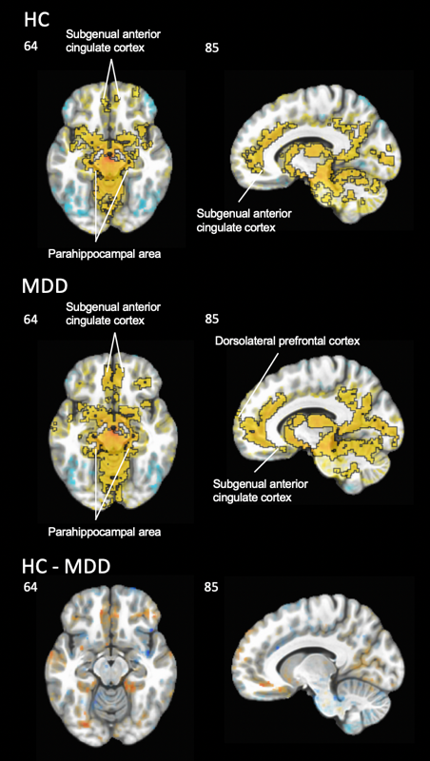
Figure S1. Whole brain functional connectivity during task-free brain states. Hyperconnectivity patterns were found in both the HC and MDD groups. However, the direct group comparison (HC – MDD) did not reveal any statistically significant differences. Regions outlined in black indicate areas of significant within-group connectivity. HC = healthy control, MDD = major depressive disorder, HC – MDD = group contrast.
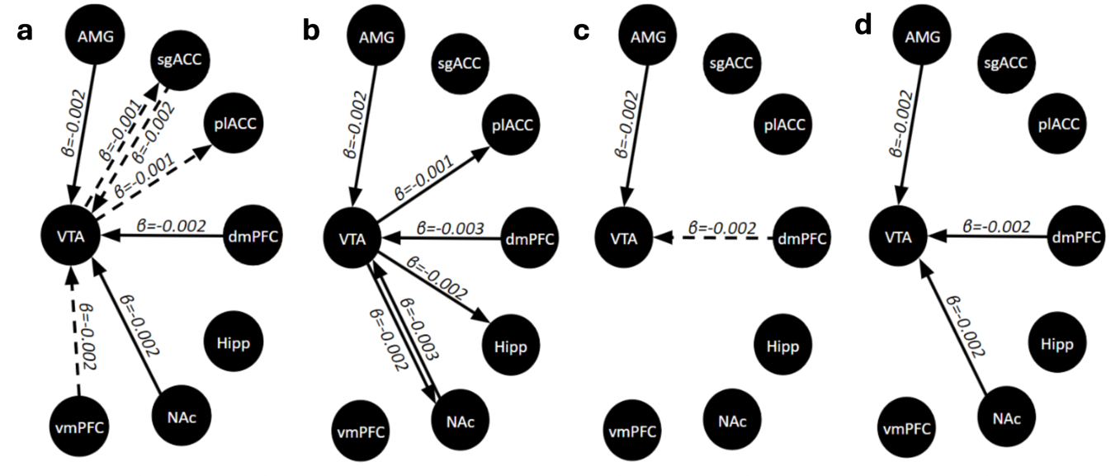
Figure S2. Directed graphs illustrate VTA influence across anhedonia levels. D_{EP}NA results described that VTA's influence on the network increases with greater severity of a anticipatory or b consummatory anhedonia in models without controlling for group. After controlling the group, VTA’s enhanced influence pattern persisted in more severe c anticipatory and d consummatory anhedonia. These findings suggested distinct underlying neural mechanisms within the VTA circuitry for the two types of anhedonia. Dashed lines indicate trends at p < 0.07.
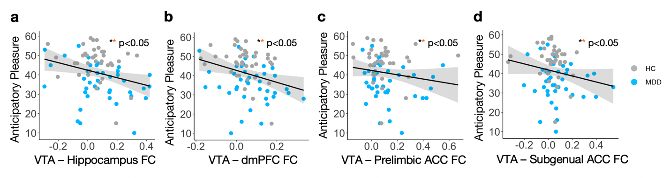Figure S3. Associations between functional connectivity (FC) and anticipatory pleasure during task-free brain states. VTA functional connectivity across hippocampus, dorsal medial prefrontal cortex (dmPFC), prelimbic anterior cingulate cortex (plACC) and subgenual anterior cingulate cortex (sgACC) were significantly correlated with anticipatory pleasure whereby increased connectivity was associated with worse anticipatory anhedonia. HC = healthy control, MDD = major depressive disorder. * FDR correction not required, ** survived FDR correction.

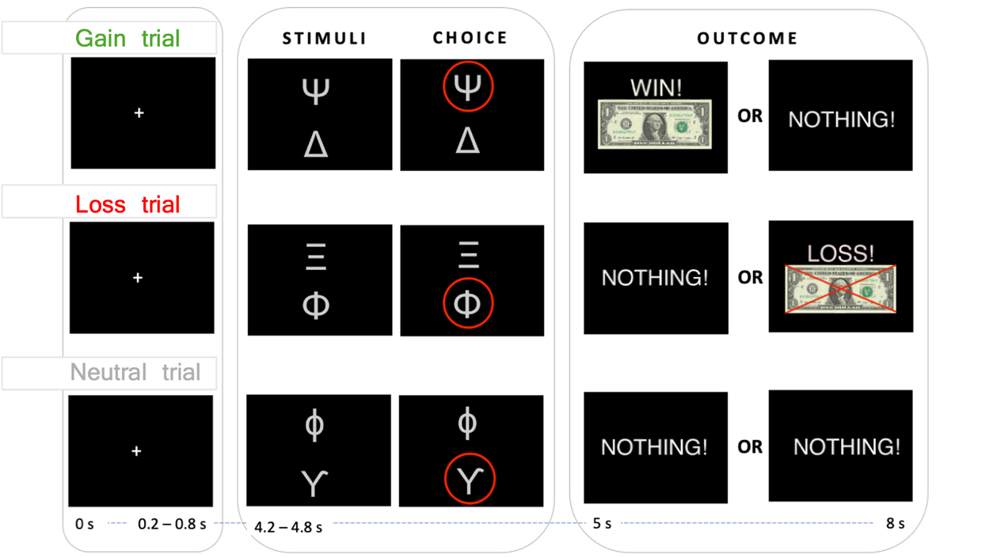
Figure S4. Reinforcement learning task. During the task, participants underwent three types of trials: gain, loss and neutral. During “gain trials”, outcomes consist of a reward (+$1) or nothing while during “loss trials” outcomes consist of a loss (-$1) or nothing. There are also “neutral trials” where regardless of choice there is no financial outcome. The position of stimuli was counterbalanced across all trials such that in half of the trials, the most rewarding stimulus was on the top of the screen and required participants to button-press to select it. To select the stimulus on the bottom of the screen, participants had to withhold a button-press. Counterbalancing the position of the stimuli in this way allows us to control for motor artifacts that may occur during button-pressing. Once participants made their choice, a red circle outlining the stimulus selected appeared followed by the outcome – either a gain ($1) or a loss (-$1).
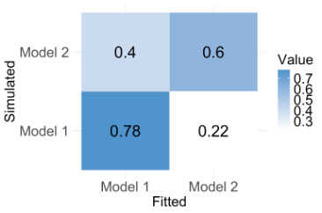
Figure S5. Model recovery results. Model recovery indicated that all models were uniquely identifiable.
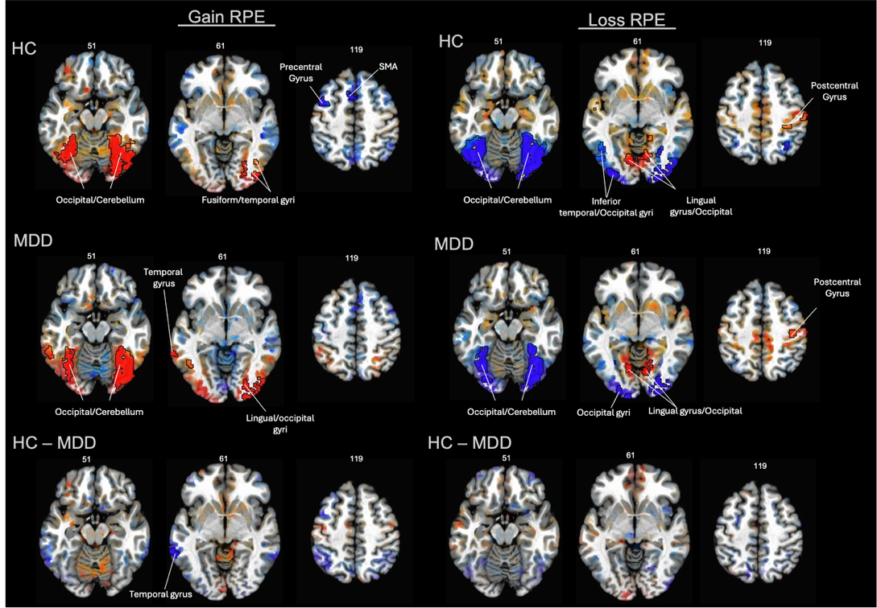
Figure S6. Whole brain encoding of gain/loss RPEs. HC = healthy control, MDD = major depressive disorder, HC – MDD = group contrast
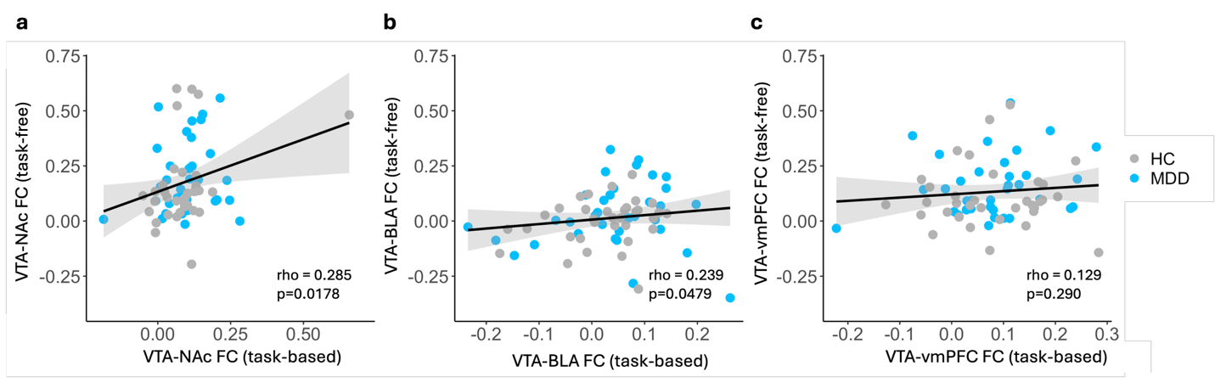Figure S7. Associations between functional connectivity across task-free and task-based brain states. HC = healthy control, MDD = major depressive disorder. *significant relationship between VTA-NAc FC holds even when excluding 2 outliers

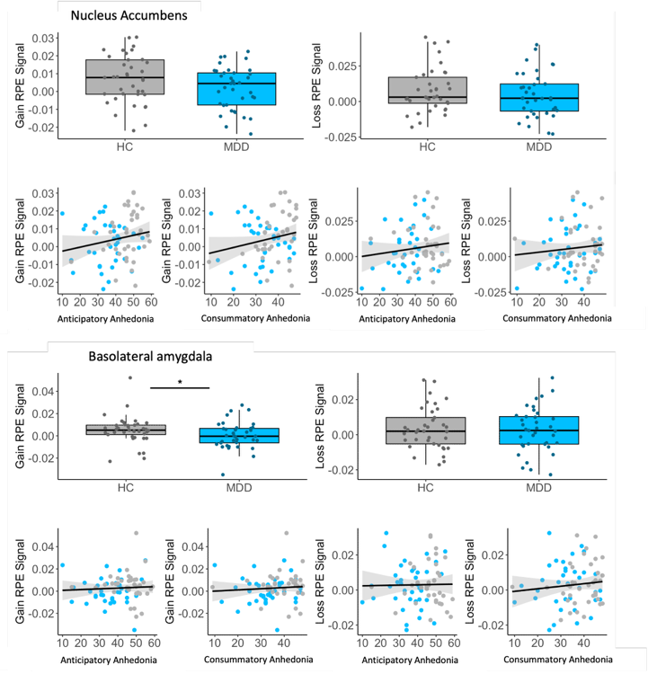
Figure S8. Assessing group differences in the encoding of gain/loss RPEs within the NAc and BLA in relation to anhedonia using GLM_{gain-loss-RPE}. During gain trials, a significant group difference in the encoding of RPEs emerged in the BLA (W=858, p = 0.0475) with no significant group differences observed in the NAc. There were no significant correlations between gain/loss RPE encoding and anhedonia.

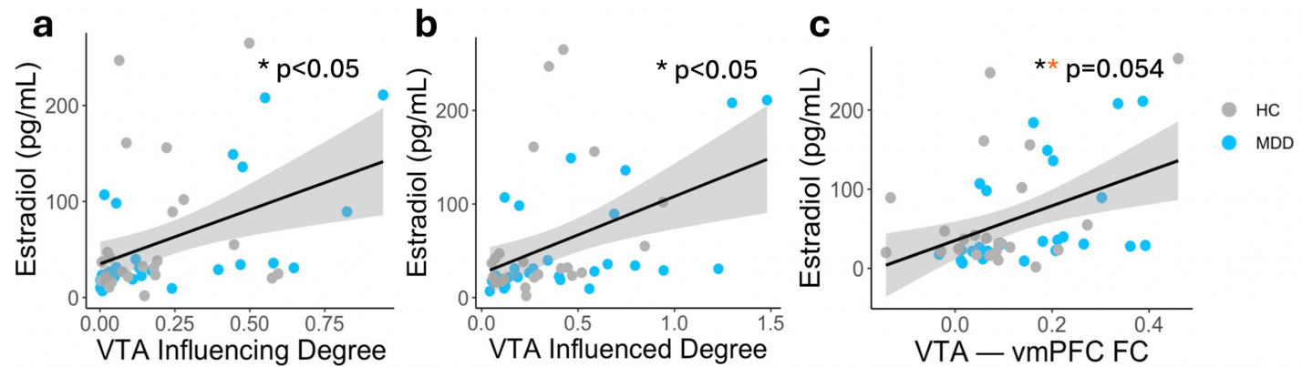Figure S9. Sex hormones across all participants. a-b VTA influencing and influenced degrees are positively associated with increased estradiol levels in the full group. Outliers beyond ±3 SD were excluded. Final sample sizes were 50 (influencing) and 49 (influenced) from an initial 51 participants with hormone data. c VTA to vmPFC hyper-connectivity is positively associated with high estradiol levels across all individuals. HC = healthy control, MDD = major depressive disorder. * FDR correction not required, ** survived FDR correction.

