Appendix 1
Cochrane:901
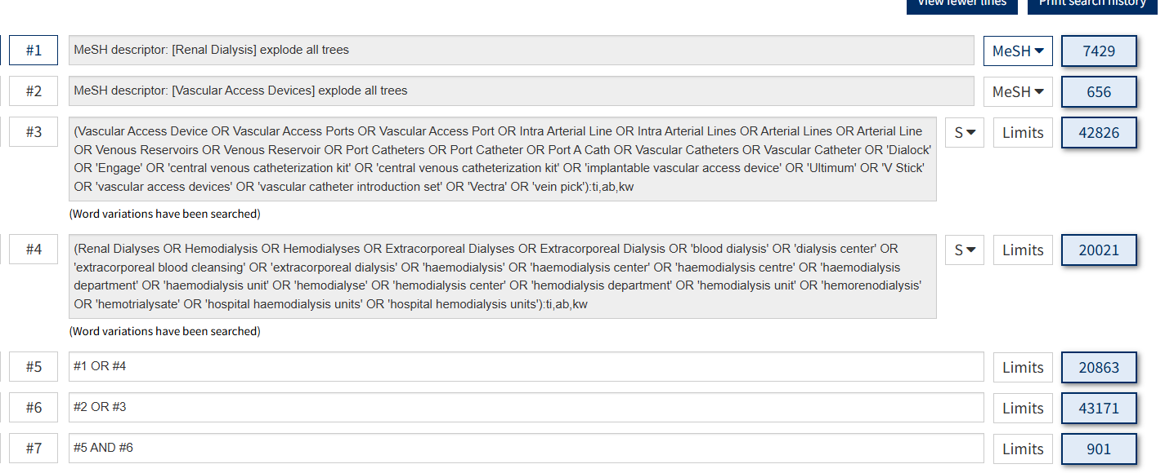
Pubmed:1821
((Vascular Access Devices[MeSH Terms]) OR (Vascular Access Device[Title/Abstract] OR Vascular Access Ports[Title/Abstract] OR Vascular Access Port[Title/Abstract] OR Intra Arterial Line[Title/Abstract] OR Intra Arterial Lines[Title/Abstract] OR Arterial Lines[Title/Abstract] OR Arterial Line[Title/Abstract] OR Venous Reservoirs[Title/Abstract] OR Venous Reservoir[Title/Abstract] OR Port Catheters[Title/Abstract] OR Port Catheter[Title/Abstract] OR Port A Cath[Title/Abstract] OR Vascular Catheters[Title/Abstract] OR Vascular Catheter[Title/Abstract] OR 'Dialock'[Title/Abstract] OR 'Engage'[Title/Abstract] OR 'central venous catheterization kit'[Title/Abstract] OR 'central venous catheterization kit'[Title/Abstract] OR 'implantable vascular access device'[Title/Abstract] OR 'Ultimum'[Title/Abstract] OR 'V Stick'[Title/Abstract] OR 'vascular access devices'[Title/Abstract] OR 'vascular catheter introduction set'[Title/Abstract] OR 'Vectra'[Title/Abstract] OR 'vein pick'[Title/Abstract])) AND ((Renal Dialysis[MeSH Terms]) OR (Renal Dialyses[Title/Abstract] OR Hemodialysis[Title/Abstract] OR Hemodialyses[Title/Abstract] OR Extracorporeal Dialyses[Title/Abstract] OR Extracorporeal Dialysis[Title/Abstract] OR 'blood dialysis'[Title/Abstract] OR 'dialysis center'[Title/Abstract] OR 'extracorporeal blood cleansing'[Title/Abstract] OR 'extracorporeal dialysis'[Title/Abstract] OR 'haemodialysis'[Title/Abstract] OR 'haemodialysis center'[Title/Abstract] OR 'haemodialysis centre'[Title/Abstract] OR 'haemodialysis department'[Title/Abstract] OR 'haemodialysis unit'[Title/Abstract] OR 'hemodialyse'[Title/Abstract] OR 'hemodialysis center'[Title/Abstract] OR 'hemodialysis department'[Title/Abstract] OR 'hemodialysis unit'[Title/Abstract] OR 'hemorenodialysis'[Title/Abstract] OR 'hemotrialysate'[Title/Abstract] OR 'hospital haemodialysis units'[Title/Abstract] OR 'hospital hemodialysis units'[Title/Abstract]))

Embase:2608
('hemodialysis'/exp OR 'renal dialyses':ab,ti OR hemodialysis:ab,ti OR hemodialyses:ab,ti OR 'extracorporeal dialyses':ab,ti OR 'blood dialysis':ab,ti OR 'dialysis center':ab,ti OR 'extracorporeal blood cleansing':ab,ti OR 'extracorporeal dialysis':ab,ti OR 'haemodialysis':ab,ti OR 'haemodialysis center':ab,ti OR 'haemodialysis centre':ab,ti OR 'haemodialysis department':ab,ti OR 'haemodialysis unit':ab,ti OR 'hemodialyse':ab,ti OR 'hemodialysis center':ab,ti OR 'hemodialysis department':ab,ti OR 'hemodialysis unit':ab,ti OR 'hemorenodialysis':ab,ti OR 'hemotrialysate':ab,ti OR 'hospital haemodialysis units':ab,ti OR 'hospital hemodialysis units':ab,ti) AND ('vascular access device'/exp OR 'vascular access device':ab,ti OR 'vascular access ports':ab,ti OR 'vascular access port':ab,ti OR 'intra-arterial lineintra arterial lines':ab,ti OR 'arterial lines':ab,ti OR 'arterial line':ab,ti OR 'venous reservoirs':ab,ti OR 'venous reservoir':ab,ti OR 'port catheters':ab,ti OR 'port catheter':ab,ti OR 'port a cath':ab,ti OR 'vascular catheters':ab,ti OR 'vascular catheter':ab,ti OR 'dialock':ab,ti OR 'engage':ab,ti OR 'haemodialysis/central venous catheterization kit':ab,ti OR 'hemodialysis/central venous catheterization kit':ab,ti OR 'implantable vascular access device':ab,ti OR 'ultimum':ab,ti OR 'v-stick':ab,ti OR 'vascular access devices':ab,ti OR 'vascular catheter introduction set':ab,ti OR 'vectra':ab,ti OR 'vein pick':ab,ti)

WOS:6905
"TS=(Vascular Access Device OR Vascular Access Ports OR Vascular Access Port OR Intra Arterial Line OR Intra Arterial Lines OR Arterial Lines OR Arterial Line OR Venous Reservoirs OR Venous Reservoir OR Port Catheters OR Port Catheter OR Port A Cath OR Vascular Catheters OR Vascular Catheter OR 'Dialock' OR 'Engage' OR 'central venous catheterization kit' OR 'central venous catheterization kit' OR 'implantable vascular access device' OR 'Ultimum' OR 'V Stick' OR 'vascular access devices' OR 'vascular catheter introduction set' OR 'Vectra' OR 'vein pick' OR Arteriovenous Fistula)" AND "TS=(Renal Dialyses OR Hemodialysis OR Hemodialyses OR Extracorporeal Dialyses OR Extracorporeal Dialysis OR 'blood dialysis' OR 'dialysis center' OR 'extracorporeal blood cleansing' OR 'extracorporeal dialysis' OR 'haemodialysis' OR 'haemodialysis center' OR 'haemodialysis centre' OR 'haemodialysis department' OR 'haemodialysis unit' OR 'hemodialyse' OR 'hemodialysis center' OR 'hemodialysis department' OR 'hemodialysis unit' OR 'hemorenodialysis' OR 'hemotrialysate' OR 'hospital haemodialysis units' OR 'hospital hemodialysis units' )"

Appendix 2
- all-cause mortality
publication bias
Catheters vs Fistula
Egger's test
------------------------------------------------------------------------------
Std_Eff | Coef. Std. Err. t P>|t| [95% Conf. Interval]
-------------+----------------------------------------------------------------
slope | .4236864 .0328168 12.91 0.000 .3533013 .4940715
bias | .9270163 1.2641 0.73 0.475 -1.784209 3.638242

Graft vs Fistula
Egger's test
------------------------------------------------------------------------------
Std_Eff | Coef. Std. Err. t P>|t| [95% Conf. Interval]
-------------+----------------------------------------------------------------
slope | .2403407 .0182768 13.15 0.000 .1989957 .2816856
bias | -.1100086 .8020989 -0.14 0.894 -1.924482 1.704465

Sensitivity analysis：
Catheters vs Fistula

Graft vs Fistula

