Table 1 Photolabile linker candidate and their performance in amination, acylation and photolysis

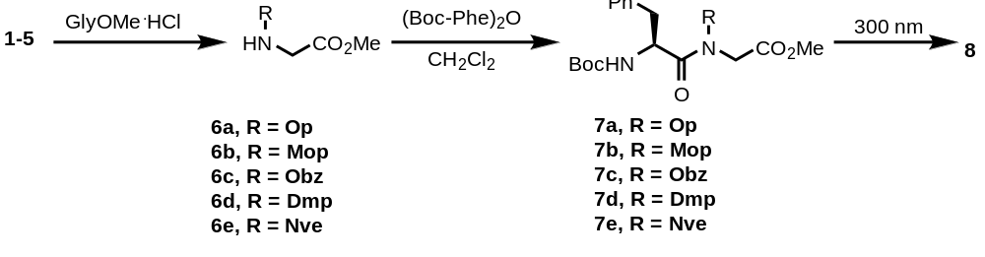

Starting materialª | Amination (yield, %) | Acylation (yield, %) | Photolysis (yield, %)
1 | 6a (63)^{b} | 7a (81) | 5^{c}
2 | 6b (78)^{b,d} | 7b (75) | 23^{c}
3 | 6c (74)^{c,e} | 7c (50) | 12^{f}
4 | 6d (85)^{g} | 7d (81) | 75^{f}
5 | 6e (82)^{h} | 7e (77) | 80^{c}

ª Details of the preparation of 1-5 are given in the Supporting Information. ^{b} CH₃CN used as solvent. ^{c} MeOH used as solvent. ^{d} Reaction run at 82 °C. ^{e} Reaction run at 65 °C. ^{f} CHCl₃ used as solvent. ^{g} Reaction run at 110 °C in PhCH₃. ^{h} NaBH₄ added to the reaction
Table 2 Solution phase synthesis of dipeptides using Hcna
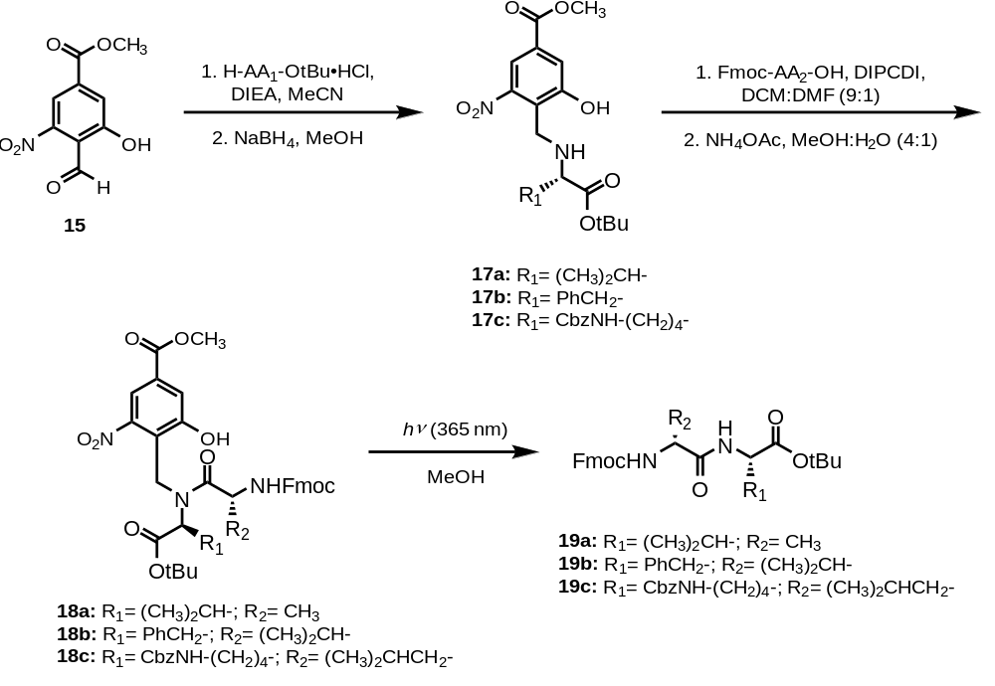

AA₁ | Amination, yield (%) | AA₂ | Acylation and Photocleavage, yield (%)
Val (17a) | 51 | Ala (18a & 19a) | 38 (over 2 steps)
Phe (17b) | 63 | Val (18b & 19b) | 35 (over 2 steps)
Lys(Z) (17c) | 69 | Leu (18c & 19c) | 54(over 2 steps)

Table 3 DKP formation during coupling of the third residue (27a-g)
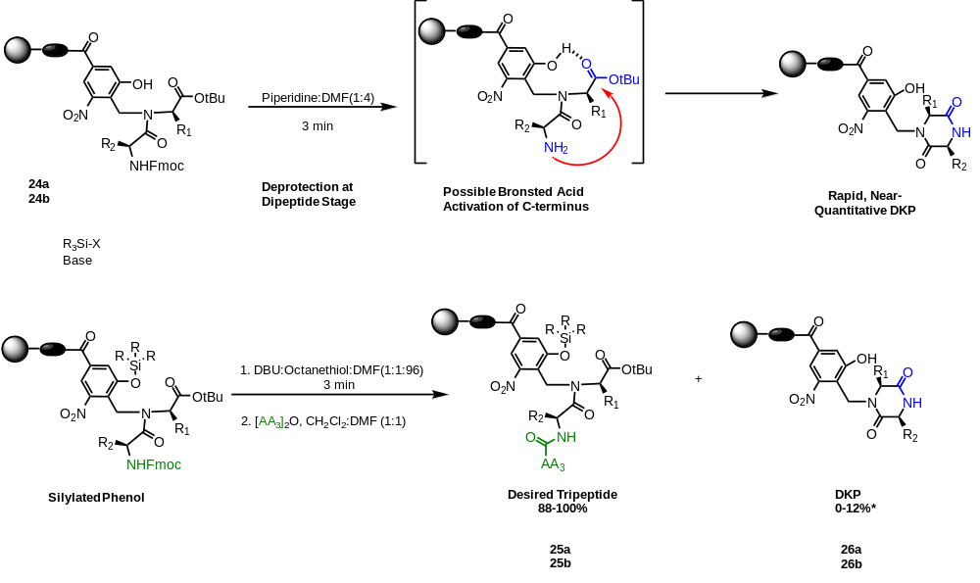
Dipeptide | Tripeptide | Tripeptide/ DKP
Fmoc-Ala-*Val-ODMA | Fmoc-Gly-Ala-*Val-ODMA (27a) | 100 / 0
Fmoc-Val-*Phe-ODMA | Fmoc-Phe-Val-*Phe-ODMA (27b) | 96 / 6
Fmoc-Phe-*Lys(Boc)-ODMA | Fmoc-Val-Phe-*Lys(Boc)-ODMA (27c) | 100 / 0
Fmoc-Ala-*Glu(tBu)-ODMA | Fmoc-Phe-Ala-*Glu(tBu)-ODMA (27d) | 98 / 2
Fmoc-Val-*Leu-OtBu | Fmoc-Gly-Val-*Leu-OtBu (27e) | 100 / 0
Fmoc-Ala-*Phe-OtBu | Fmoc-Phe-Ala-*Phe-OtBu (27f) | 100 / 0
Fmoc-Ala-*Ala-OtBu | Fmoc-Leu-Ala-*Ala-OtBu (27g) | 88 / 12
*residue anchored to Hcnb linker

