Supporting Information
Chlorine-Coordinated Iron Single-Atom Nanozymes for Amplified Ferroptosis in Triple-Negative Breast Cancer Therapy
Mingming Yin,^{a,#} Bing-Hao Wang,^{a,#} Huijuan Wang,ª Jie Ouyang,ª Xingsheng Hu,ª Xiong Wang,ª Yongping Liu,^{b} Fenghua Xu,^{c} Yi Chen,^{b,*} Shuang-Feng Yina,^{c,*}
ª Advanced Catalytic Engineering Research Center of the Ministry of Education, State Key Laboratory of Chemo and Biosensing, College of Chemistry and Chemical Engineering, Hunan University, Changsha 410082, P. R. China
^{b} School of Medicine, Hunan University of Chinese Medicine, Changsha, 410208, P. R. China
^{c} College of Chemistry and Chemical Engineering, Central South University of Forestry and Technology, Changsha 410004, P. R. China
# These authors contributed equally to this work.
* Corresponding authors: cscy1975@163.com; sf_yin@hnu.edu.cn.

Experimental Section
Synthesis of ZIF-8
Initially, 3.39 g of zinc nitrate hexahydrate was dissolved in 160 mL of methanol to prepare Solution A. Separately, 3.94 g of 2-methylimidazole (MeIM) was dissolved in another 160 mL of methanol to form Solution B. The two solutions were thoroughly mixed, transferred to a round-bottom flask, sealed, and stirred vigorously for 30 seconds. The reaction mixture was then left to stand in an oven at 60 °C for 12 hours. The resulting product was collected by centrifugation, washed thoroughly with methanol, and dried under vacuum at 70 °C overnight.
Characterization
Transmission electron microscopy (TEM) imaging and selected area electron diffraction (SAED) were performed using a JEOL JEM-2100F system (JEOL Ltd., Japan). Atomic-scale characterization, including high-angle annular dark-field scanning TEM (HAADF-STEM) and energy-dispersive X-ray spectroscopy (EDS) elemental mapping, was conducted on a FEI Themis Z 300 kV aberration-corrected STEM (Thermo Fisher Scientific, USA). X-ray absorption fine structure (XAFS) measurements were carried out at the 1W1B beamline of the Beijing Synchrotron Radiation Facility (BSRF), where atomic structure analysis was performed in transmission mode using a Si(111) double-crystal monochromator. X-ray diffraction (XRD) patterns were acquired with a Bruker D8 Advance diffractometer (Bruker AXS, Germany) using Cu Kα radiation (λ = 1.5406 Å) over a 2θ range of 10°–80°. X-ray photoelectron spectroscopy (XPS) data were collected on an ESCALAB 250Xi spectrometer (Thermo Fisher Scientific, USA) equipped with a monochromatic Al Kα X-ray source (1486.6 eV). Fluorescence imaging was performed using a Zeiss LSM 880 confocal microscope (Carl Zeiss AG, Germany) and a Leica DMi8 inverted microscope (Leica Microsystems, Germany). Quantitative analysis of fluorescence intensity and apoptosis rates was conducted with a MoFlo XDP flow cytometer (Beckman Coulter, USA). UV–vis absorption spectra were recorded on a Hitachi U-3900H spectrophotometer (Hitachi High-Tech, Japan). Hydrodynamic properties, including particle size distribution (DLS) and surface zeta potential, were measured using a Zetasizer Nano ZS system (Malvern Panalytical, UK).
DFT calculations
First-principles calculations were performed using the Vienna Ab initio Simulation Package (VASP) with the projector augmented wave (PAW) method[1, 2]. The exchange-correlation functional was treated using the Perdew–Burke–Ernzerhof (PBE) formulation[3], combined with the DFT-D dispersion correction[4]. All calculations were spin-polarized. The plane-wave basis set employed a cut-off energy of 520 eV. Brillouin-zone sampling was carried out using a (3 × 3 × 1) Monkhorst–Pack k-point mesh. Geometry optimizations were performed using the conjugate gradient algorithm. The convergence criteria were set to 1 × 10⁻⁵ eV for total energy and 0.02 eV/Å for the force on each atom.
The adsorption energy change (ΔE_{abs}) was determined as follows:
ΔE_{abs} = E_{total}- E_{slab}- E_{mol}
where E_{total} is the total energy for the adsorption state, E_{slab} is the energy of pure surface, E_{mol} is the energy of adsorption molecule.
The free energy change (ΔG) for adsorptions were determined as follows:
ΔG = E_{total}-E_{slab}- E_{mol} +ΔE_{ZPE}-TΔS
where E_{total} is the total energy for the adsorption state, E_{slab} is the energy of pure surface, E_{mol} is the energy of adsorption molecule, ΔE_{ZPE} is the zero-point energy change and ΔS is the entropy change.

Supplementary Figures
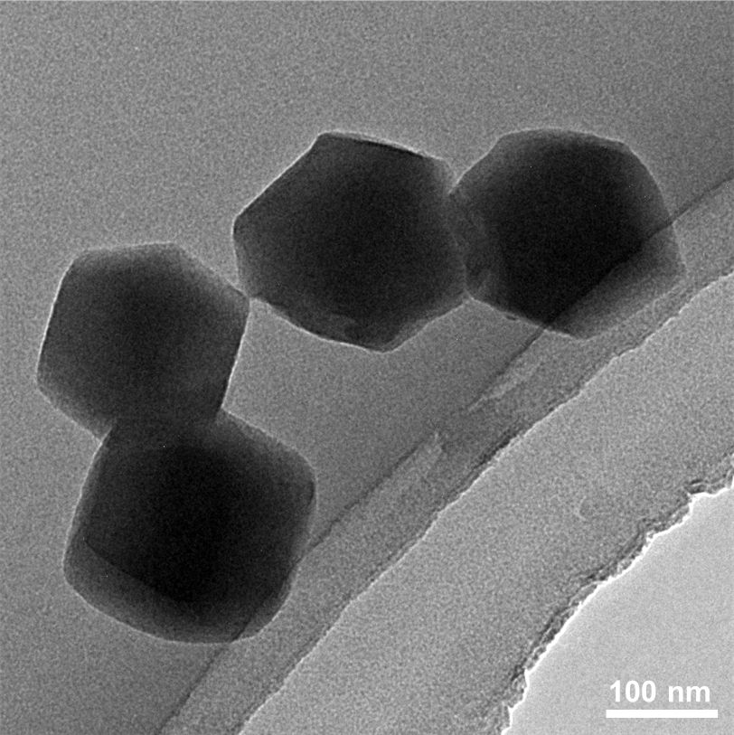
Figure S1. TEM image of the hemin-modified ZIF-8 precursor.

Figure S2. XRD patterns of ZIF-8, Fe(NO₃)₃/ZIF-8, and Hemin·Cl/ZIF-8

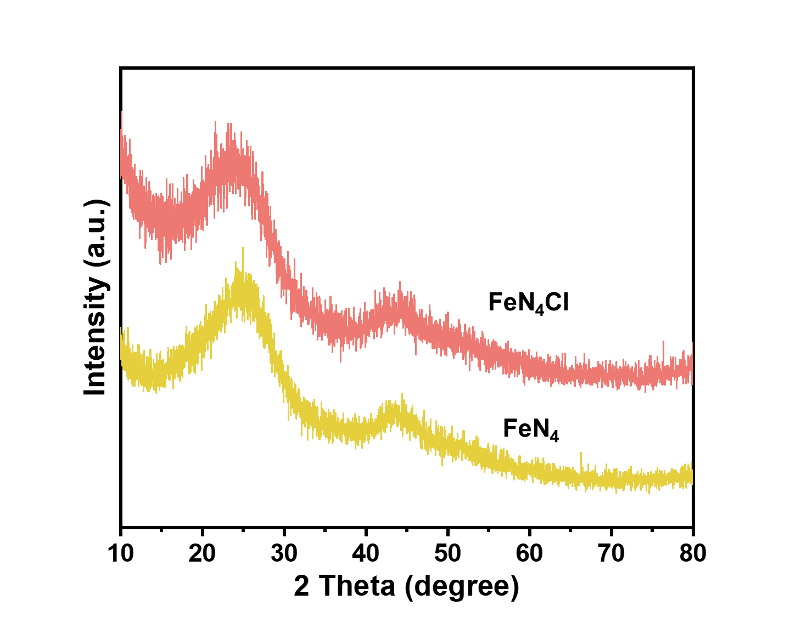
Figure S3. XRD patterns of FeN₄Cl SAC and FeN₄ SAC

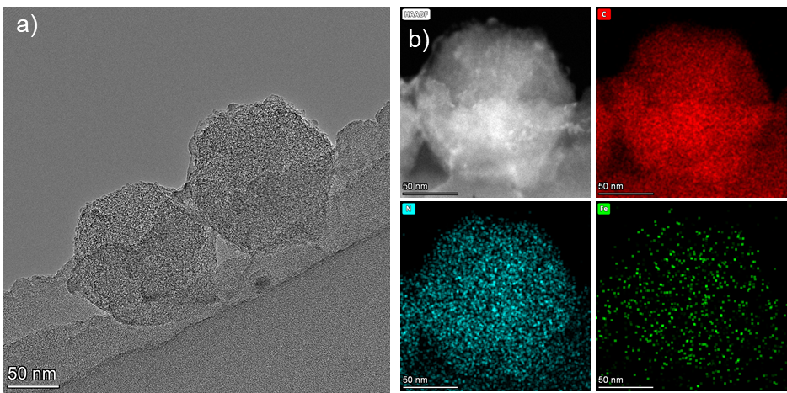
Figure S4. TEM image and EDS elemental mapping of FeN₄ SAC

Figure S5. High-resolution C 1s XPS spectra of FeN₄ (a) and FeN₄Cl (b).

Figure S6. High-resolution N 1s XPS spectra of FeN₄ (a) and FeN₄Cl (b).
All samples exhibit the presence of pyridinic N (398.3 eV), pyrrolic N (400.2 eV), graphitic N (401.4 eV), oxidized N (403.2 eV), and Fe–N coordination peaks (399.2 eV).[5].
Figure S7. High-resolution Cl 2p XPS spectrum of FeN₄Cl.
The Cl 2p spectrum of FeN₄Cl reveals the presence of Cl⁻ (198.0 eV), attributed to Fe–Cl species, and spin–orbit splitting peaks of C–Cl at 2p₃⁄₂ (200.4 eV) and 2p₁⁄₂ (202.0 eV), consistent with previous reports.[6]

Figure S8. High-resolution Fe 2p XPS spectra of FeN₄Cl and FeN₄.
The peaks at 709.18 and 711.71 eV correspond to the 2p₃⁄₂ orbitals of Fe(II) and Fe(III), respectively, while the peaks at 722.2 and 725.2 eV correspond to the 2p₁⁄₂ orbitals of Fe(II) and Fe(III), respectively[7]. The Fe species in both FeN₄ and FeN₄Cl exhibit an intermediate oxidation state between Fe(II) and Fe(III), with FeN₄Cl containing a higher Fe(III) content than FeN₄/NC (Table S4), consistent with the XAFS results.
Figure S9. Effect of (a) Hemin·Cl concentration and (b) temperature on the POD-like activity of FeN₄Cl.

Figure S10. Effect of pH on the POD-like activity of FeN₄Cl.

Figure S11. Fenton reaction catalytic activity of NC, FeN₄, and FeN₄Cl in the presence of varying concentrations of H₂O₂, evaluated using OPDA probes.
Figure S12. Time-dependent degradation of MB in the presence of NC, FeN₄, and FeN₄Cl at different concentrations of H₂O₂.

Figure S13. Charge density variation in FeN₄ and FeN₄Cl.

Figure S14. Schematic illustration of the proposed reaction mechanism on FeN₄.

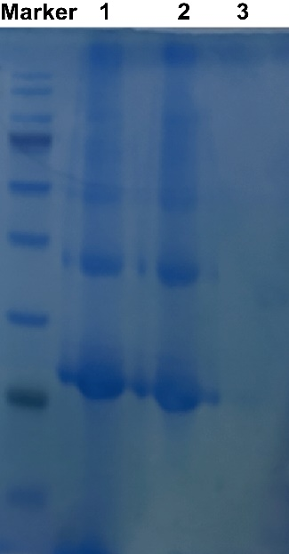
Figure S15. SDS-PAGE electrophoresis analysis of FeN₄Cl/RBC. The samples were loaded onto a 10% SDS-PAGE gel. M: Protein ladder marker (10–180 kDa); 1: RBC membrane; 2: FeN₄Cl/RBC; 3: FeN₄Cl SAC without RBC membrane coating.

Figure S16. Particle size distribution of different materials during the synthesis of FeN₄Cl/RBC.
Figure S17. Zeta potential changes of different materials during the synthesis of FeN₄Cl/RBC.

Figure S18. (a) Photograph of blood after centrifugation. (b) Hemolysis ratio of the nanozyme at various concentrations.
Figure S19. Cell viability of HEK-293 cells after treatment with different concentrations of FeN₄, FeN₄Cl, or FeN₄Cl/RBC.

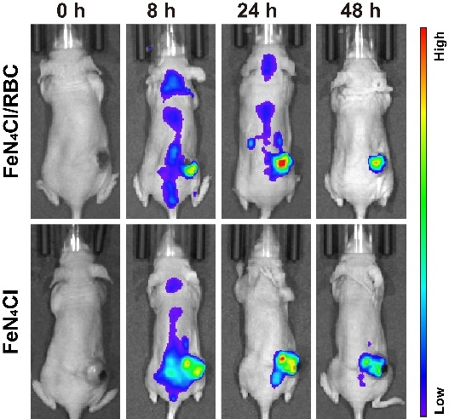
Figure S20. Biodistribution following intravenous (i.v.) injection.
Figure S21. Body weight of MDA-MB-231 tumor-bearing mice after different treatments over a 14-day period.
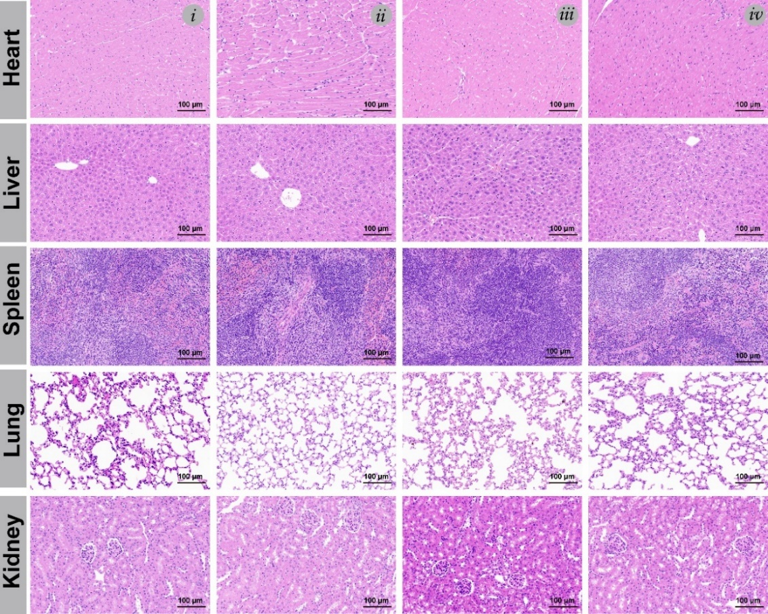
Figure S22. Hematoxylin and eosin (H&E)-stained images of major organs (heart, liver, spleen, lung, and kidney) from mice after different treatment protocols. (Scale bar: 100 μm)

Figure S23. Hematology and blood biochemistry indices of mice after 14 days of treatment.

Supplementary Tables
Table S1. XPS analysis of the nitrogen chemical environment in different samples.
Samples | Pyridinic N (%) | Pyrrolic N (%) | Graphitic N (%) | Oxidized N (%) | Fe-N (%)
FeN₄ | 23.03 | 22.98 | 22.3 | 12.29 | 19.4
FeN₄Cl | 24.14 | 21.12 | 24.4 | 10.44 | 19.9

Table S2. Oxidation states of Fe and the corresponding K-edge positions.
Sample | K-edge position of Fe (eV) ª | E (eV) | Oxidation state of Fe
FeN₄Cl | 7122.470 | 10.78 | +2.23
Fe₃O₄ | 7125.950 | 14.26 | +2.67
Fe₂O₃ | 7126.208 | 14.518 | +3
Fe foil | 7111.69 | 0 | 0
ªEdge position obtained from the half-height of the edge step. ªAssigned using calibration curve.

Table S3. The Michaelis-Menten constant (K_{m}) and maximum reaction rate (V_{max}) of different materials for POD-like activities.
Nanozymes | [E]  (M) | Substrates | K_{m}  (mM) | V_{max}  (M s⁻¹) | k_{cat}  (s⁻¹) | k_{cat}/ K_{m}  ₍mM⁻¹ s⁻¹) | Ref.
FeN₃P | 1.61⨯10⁻⁷ | TMB | 2.06 ⨯10⁻³ | 7.88 ⨯10⁻⁷ | 4.82 | 2.34 ⨯10³ | [8]
FeN₃P | 1.61⨯10⁻⁷ | H₂O₂ | 443 | 5.6 ⨯10⁻⁷ | 5.28 | 1.19⨯10⁻² | [8]
FeNC-edge | 1.43⨯10⁻⁶ | TMB | 0.57 | 1.24⨯10⁻⁶ | 0.866 | 1.52 | [9]
FeNC-edge | 1.43⨯10⁻⁶ | H₂O₂ | 0.374 | 4.22⨯10⁻² | 0.295 | 0.0789 | [9]
FeN₅ | 2.16⨯10⁻⁶ | TMB | 0.09 | 8.47⨯10⁻⁶ | 3.92 | 6.01 | [10]
FeN₅ | 2.16⨯10⁻⁶ | H₂O₂ | 166 | 2.96⨯10⁻⁶ | 1.37 | 0.122 | [10]
Fe-CDs | 1.52⨯10⁻⁶ | TMB | 0.33 | 1.7⨯10⁻⁷ | 0.113 | 1.256 | [11]
Fe-CDs | 1.52⨯10⁻⁶ | H₂O₂ | 8.16 | 4.9⨯10⁻⁷ | 0.32 | 0.019 | [11]
FeN₄Cl/CNCl | 1.92 ⨯10⁻⁷ | TMB | 0.56 | 7.88 ⨯10⁻⁷ | 4.11 | 7.34 | [12]
FeN₄Cl/CNCl | 1.92 ⨯10⁻⁷ | H₂O₂ | 5.68 | 3.53 ⨯10⁻⁷ | 1.84 | 0.32 | [12]
FeN₄-SO_{x} | 1.06⨯10⁻⁸ | TMB | 0.32 | 7.67⨯10⁻⁸ | 7.21 | 22.53 | [13]
FeN₄-SO_{x} | 1.06⨯10⁻⁸ | H₂O₂ | 39.55 | 4.65⨯10⁻⁸ | 4.37 | 0.11 | [13]
FeBNC | 3.45⨯10⁻⁶ | TMB | 2.22 | 1.81⨯10⁻⁶ | 0.52 | 0.23423 | [14]
FeBNC | 3.45⨯10⁻⁶ | H₂O₂ | 25.24 | 1.28⨯10⁻⁶ | 0.37 | 0.01465 | [14]
FeN₄ | 8.59 ⨯10⁻⁷ | TMB | 0.4 | 1.95⨯10⁻⁶ | 2.27 | 5.67 | This work
FeN₄ | 8.59 ⨯10⁻⁷ | H₂O₂ | 4.77 | 6.4 ⨯10⁻⁷ | 0.75 | 0.16 | This work
FeN₄Cl | 7.52 ⨯10⁻⁷ | TMB | 0.36 | 3.11⨯10⁻⁶ | 4.135 | 11.49 | This work
FeN₄Cl | 7.52 ⨯10⁻⁷ | H₂O₂ | 4.23 | 1.1⨯10⁻⁶ | 1.46 | 0.35 | This work
[E] is the molar concentration of Fe sites of nanozymes. K_{m} is the Michaelis-Menten constant, V_{max} is the maximal reaction velocity and kcat is the catalytic constant, where k_{cat} = V_{max}/[E] and the k_{cat} /K_{m} value represents the catalytic efficiency

Table S4. The content of Fe (%) in FeN₄Cl and FeN₄
Samples | 2p_{1/2} |  | 2p_{3/2}
Samples | Fe(Ⅱ) | Fe(Ⅲ) | Fe(Ⅱ) | Fe(Ⅲ)
FeN₄ | 19.05 | 15.05 | 36.81 | 29.09
FeN₄Cl | 18.47 | 15.63 | 35.69 | 30.21

References
[1] Y. Chen, P. Wang, H. Hao, J. Hong, H. Li, S. Ji, A. Li, R. Gao, J. Dong, X. Han, Thermal atomization of platinum nanoparticles into single atoms: An effective strategy for engineering high-performance nanozymes, J. Am. Chem. Soc. 143(44) (2021) 18643–18651.
[2] Y. Chen, B. Jiang, H. Hao, H. Li, C. Qiu, X. Liang, Q. Qu, Z. Zhang, R. Gao, D. Duan, Atomic‐Level Regulation of Cobalt Single‐Atom Nanozymes: Engineering High‐Efficiency Catalase Mimics, Angew. Chem., Int. Edit. 135(19) (2023) e202301879.
[3] S. Ding, J.A. Barr, Z. Lyu, F. Zhang, M. Wang, P. Tieu, X. Li, M.H. Engelhard, Z. Feng, S.P. Beckman, Effect of Phosphorus Modulation in Iron Single‐Atom Catalysts for Peroxidase Mimicking, Adv. Mater. 36(10) (2024) 2209633.
[4] Z. Li, Z. Tian, H. Cheng, T. Wang, W. Zhang, Y. Lu, Y. Lai, G. He, Engineering d-band center of FeN4 moieties for efficient oxygen reduction reaction electrocatalysts, Energy Storage Mater. 59 (2023) 102764.
[5] X.B. Zhang, X. Han, Z. Jiang, J. Xu, L.N. Chen, Y.K. Xue, A.M. Nie, Z.X. Xie, Q. Kuang, L.S. Zheng, Atomically dispersed hierarchically ordered porous Fe-N-C electrocatalyst for high performance electrocatalytic oxygen reduction in Zn-Air battery, Nano Energy 71 (2020)104547.
[6] Y.H. Han, Y.G. Wang, R.R. Xu, W.X. Chen, L.R. Zheng, A.J. Han, Y.Q. Zhu, J. Zhang, H.B. Zhang, J. Luo, C. Chen, Q. Peng, D.S. Wang, Y.D. Li, Electronic structure engineering to boost oxygen reduction activity by controlling the coordination of the central metal, Energ Environ. Sci. 11(9) (2018) 2348–2352.
[7] F.L. Meng, Z.L. Wang, H.X. Zhong, J. Wang, J.M. Yan, X.B. Zhang, Reactive Multifunctional Template-Induced Preparation of Fe-N-Doped Mesoporous Carbon Microspheres Towards Highly Efficient Electrocatalysts for Oxygen Reduction, Adv. Mater. 28(36) (2016) 7948–7955.
[8] S.F. Ji, B. Jiang, H.G. Hao, Y.J. Chen, J.C. Dong, Y. Mao, Z.D. Zhang, R. Gao, W.X. Chen, R.F. Zhang, Q. Liang, H.J. Li, S.H. Liu, Y. Wang, Q.H. Zhang, L. Gu, D.M. Duan, M.M. Liang, D.S. Wang, X.Y. Yan, Y.D. Li, Matching the kinetics of natural enzymes with a single-atom iron nanozyme, Nat. Catal. 4(5) (2021) 407–417.
[9] K. Kim, J. Lee, O.K. Park, J. Kim, J. Kim, D. Lee, V.K. Paidi, E. Jung, H.S. Lee, B. Lee, C.W. Lee, W. Ko, K. Lee, Y. Jung, C. Lee, N. Lee, S. Back, S.H. Choi, T. Hyeon, Geometric Tuning of Single-Atom FeN₄ Sites via Edge-Generation Enhances Multi-Enzymatic Properties, Adv. Mater. 35(19) (2023)2207666.
[10] B.L. Xu, S.S. Li, L.R. Zheng, Y.H. Liu, A.L. Han, J. Zhang, Z.J. Huang, H.J. Xie, K.L. Fan, L.Z. Gao, H.Y. Liu, A Bioinspired Five-Coordinated Single-Atom Iron Nanozyme for Tumor Catalytic Therapy, Adv. Mater. 34(15) (2022) 2107088.
[11] P. Muhammad, S. Hanif, J.Y. Li, A. Guller, F.U. Rehman, M. Ismail, D.Y. Zhang, X.Y. Yan, K.L. Fan, B.Y. Shi, Carbon dots supported single Fe atom nanozyme for drug-resistant glioblastoma therapy by activating autophagy-lysosome pathway, Nano Today 45 (2022)101530.
[12] S.J. Wei, M.M. Sun, J. Huang, Z.B. Chen, X.J. Wang, L.Z. Gao, J.J. Zhang, Axial Chlorination Engineering of Single-Atom Nanozyme: Fe-N₄Cl Catalytic Sites for Efficient Peroxidase-Mimicking, J. Am. Chem. Soc. 146(48) (2024) 33239–33248.
[13] G.M. Li, H. Liu, T.D. Hu, F. Pu, J.S. Ren, X.G. Qu, Dimensionality Engineering of Single-Atom Nanozyme for Efficient Peroxidase-Mimicking, J. Am. Chem. Soc. 145(30) (2023) 16835–16842.
[14] L. Jiao, W.Q. Xu, Y. Zhang, Y. Wu, W.L. Gu, X.X. Ge, B.B. Chen, C.Z. Zhu, S.J. Guo, Boron-doped Fe-N-C single-atom nanozymes specifically boost peroxidase-like activity, Nano Today 35 (2020)100971.

