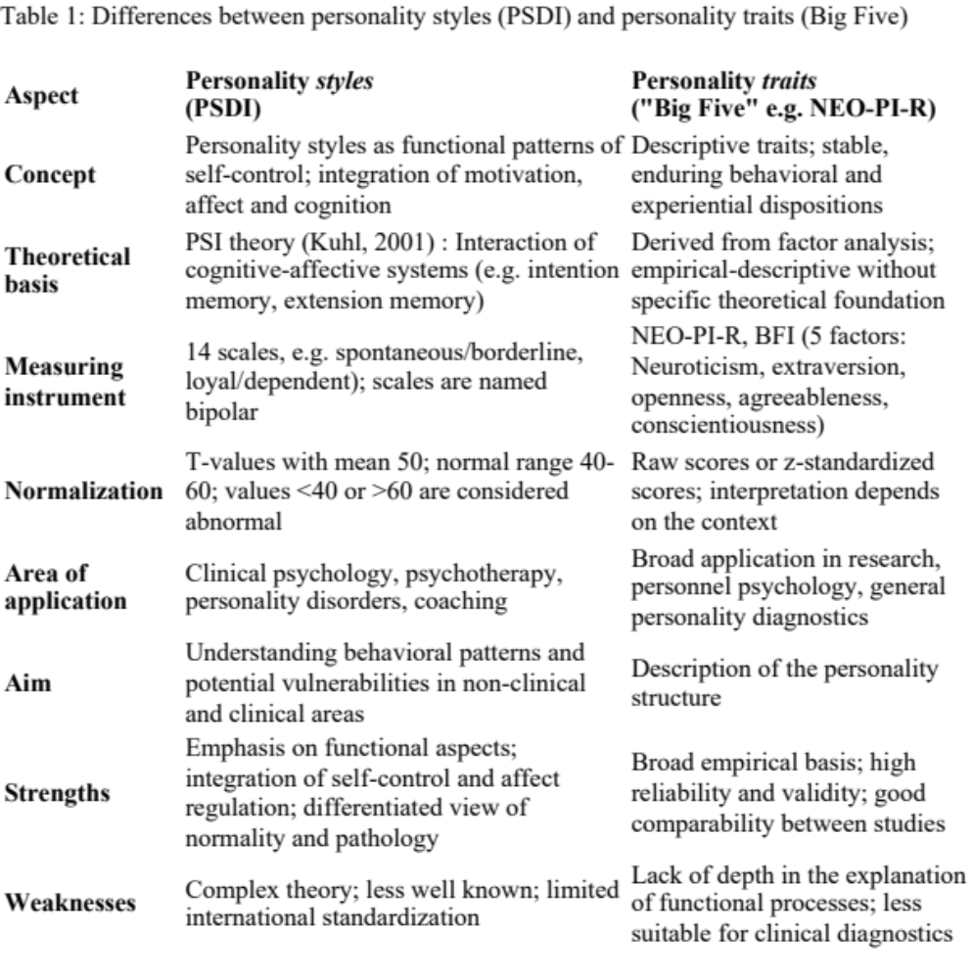
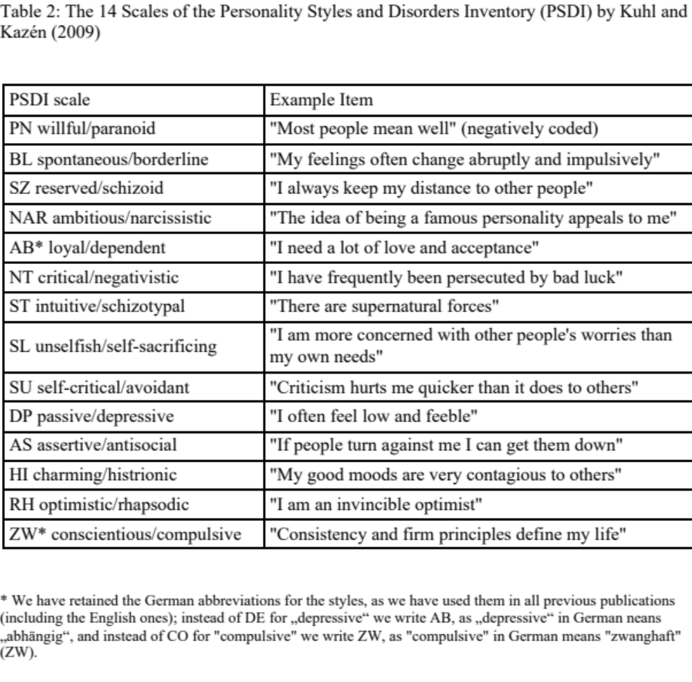
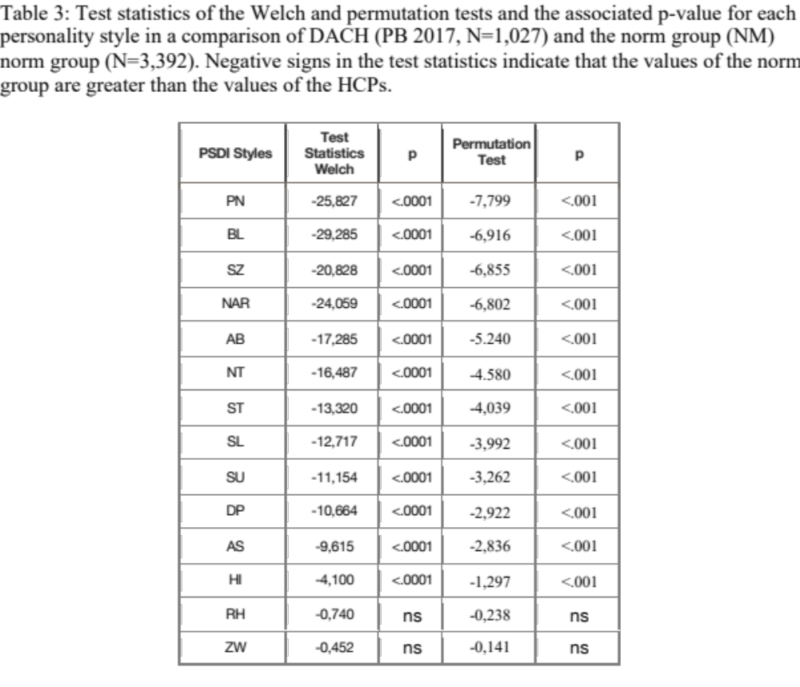
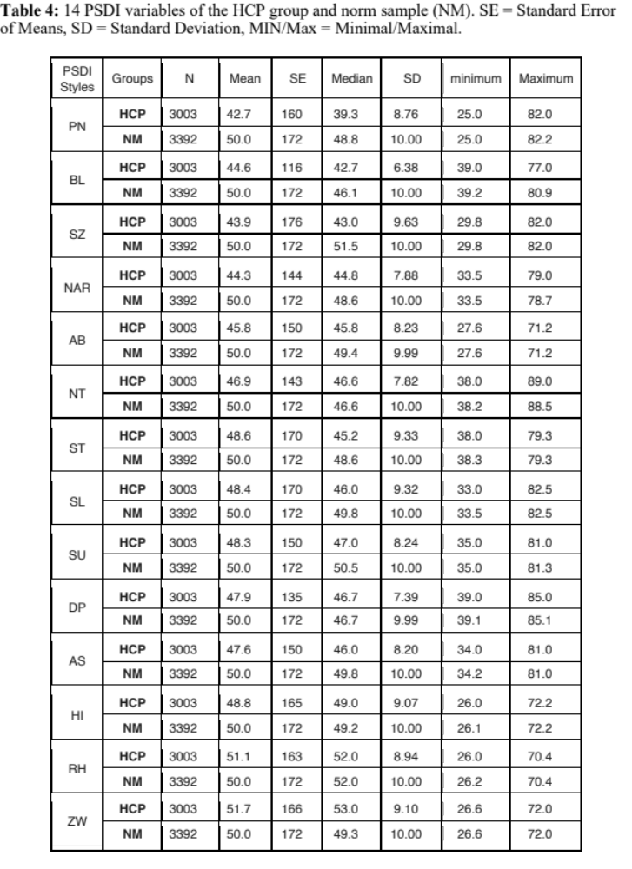
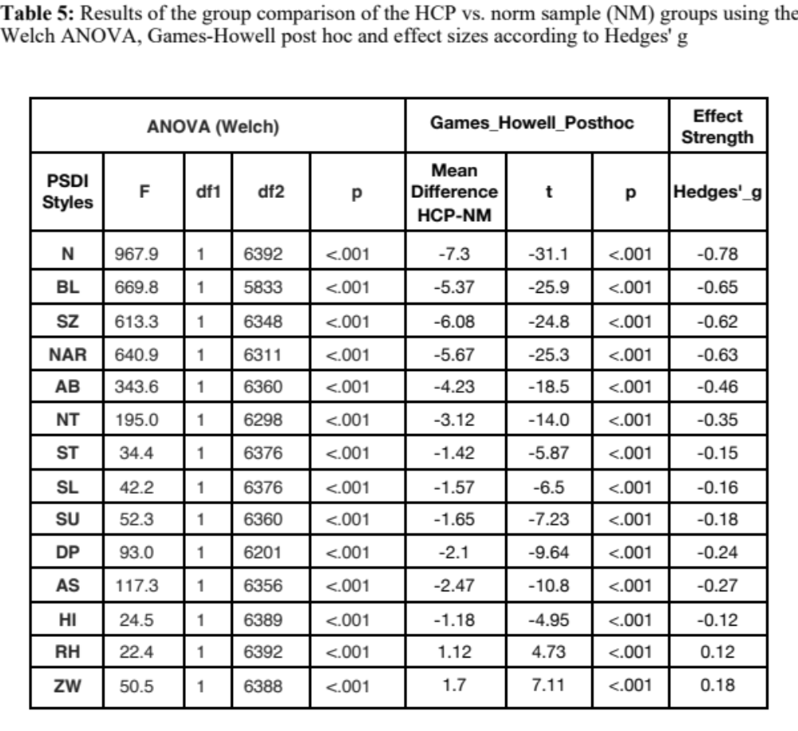
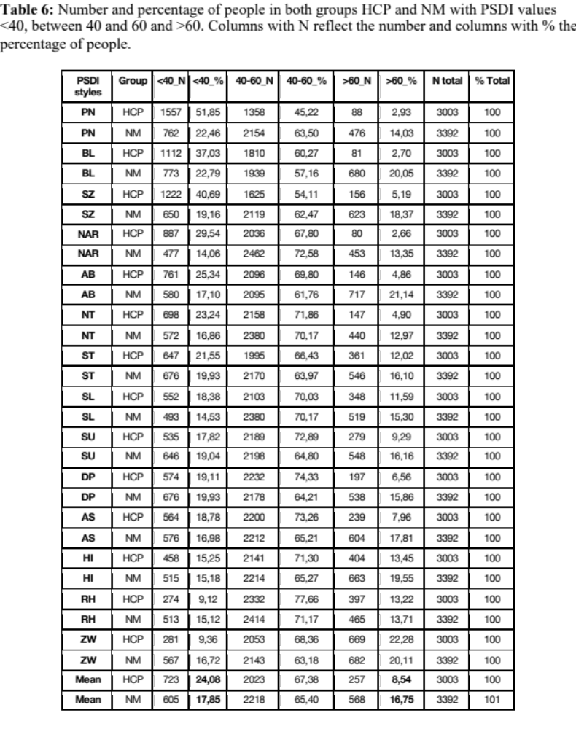
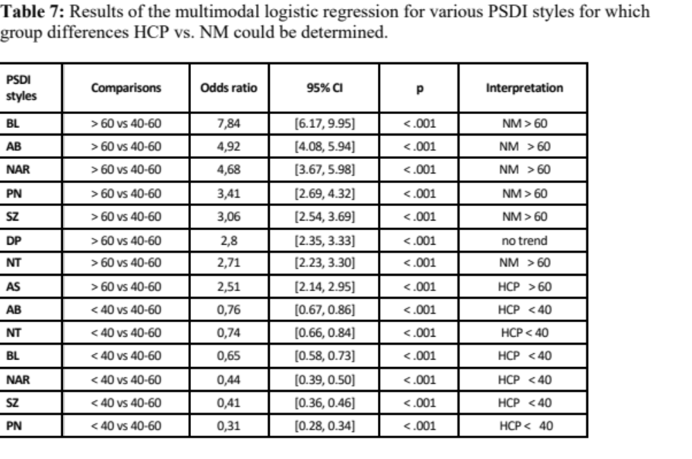
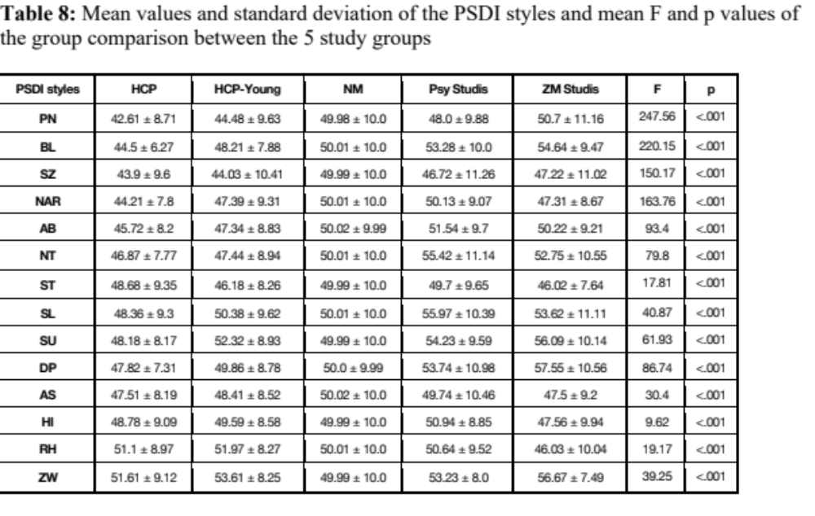
Table 9: Cohen's d effect sizes of the pairwise group comparisons for the individual styles.
Group Comparison | PSDI style | Cohen's d |  | PSDI style | Cohen's d
Studis-ZM vs. Y-HCP | PN | 0.58 |  | SL | 0.3
Studis-Psy vs. Y-HCP | PN | 0.36 |  | SL | 0.56
Y-HCP vs. HCP | PN | 0.21 |  | SL | 0.22
HCP_Y vs. NM | PN | -0.55 |  | SL | 0.04
Studis-ZM vs. Y-HCP | BL | 0.72 |  | SU | 0.39
Studis-Psy vs. Y-HCP | BL | 0.55 |  | SU | 0.21
Y-HCP vs. HCP | BL | 0.59 |  | SU | 0.51
Y-HCP vs. NM | BL | -0.18 |  | SU | 0.23
Studis-ZM vs. Y-HCP | SZ | 0.29 |  | DP | 0.77
Studis-Psy vs. Y-HCP | SZ | 0.25 |  | DP | 0.38
Y-HCP vs. HCP | SZ | 0.01 |  | DP | 0.28
Y-HCP vs. NM | SZ | -0.6 |  | DP | -0.01
Studis-ZM vs. Y-HCP | NAR | -0.01 |  | AS | -0.1
Studis-Psy vs. Y-HCP | NAR | 0.3 |  | AS | 0.14
Y-HCP vs. HCP | NAR | 0.4 |  | AS | 0.11
Y-HCP vs. NM | NAR | -0.26 |  | AS | -0.16
Studis-ZM vs. Y-HCP | AB | 0.32 |  | HI | -0.21
Studis-Psy vs. Y-HCP | AB | 0.45 |  | HI | 0.15
Y-HCP vs. HCP | AB | 0.2 |  | HI | 0.09
Y-HCP vs. NM | AB | -0.27 |  | HI | -0.04
Studis-ZM vs. Y-HCP | NT | 0.53 |  | RH | -0.62
Studis-Psy vs. Y-HCP | NT | 0.78 |  | RH | -0.15
Y-HCP vs. HCP | NT | 0.07 |  | RH | 0.1
Y-HCP vs. NM | NT | -0.26 |  | RH | 0.2
Studis-ZM vs. Y-HCP | ST | -0.02 |  | ZW | 0.4
Studis-Psy vs. Y-HCP | ST | 0.39 |  | ZW | -0.05
Y-HCP vs. HCP | ST | -0.27 |  | ZW | 0.22
Y-HCP vs. NM | ST | -0.38 |  | ZW | 0.36
Continued in next column 5 top right

