Supplementary Figure 1. The effect of FP003 addition on pluripotency preservation after 4 days of culture.
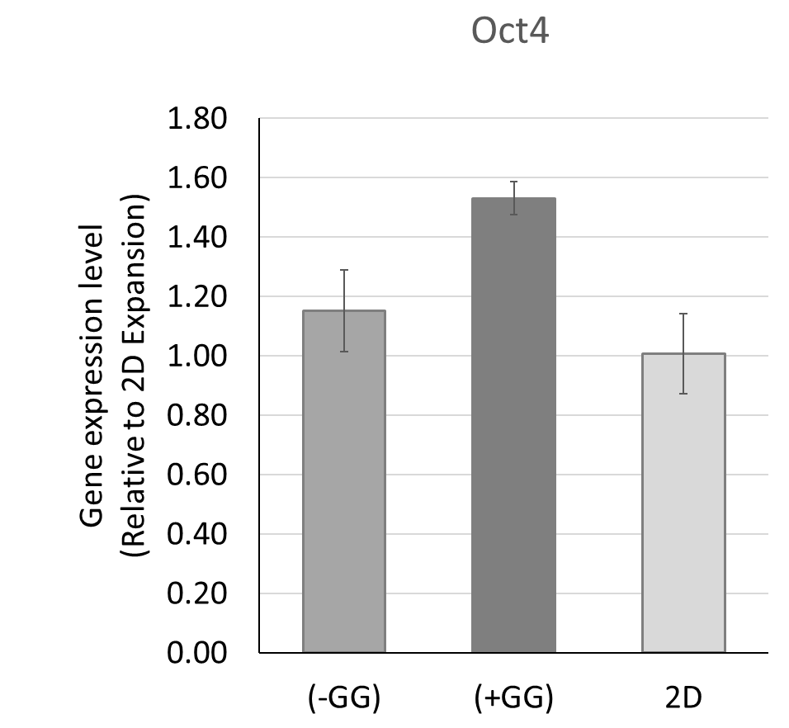

Supplementary Figure 2. The comparison of the main growth factors usage between the dialysis culture system (D/MR(-)) and conventional culture with medium replacement (C/MR(+)).
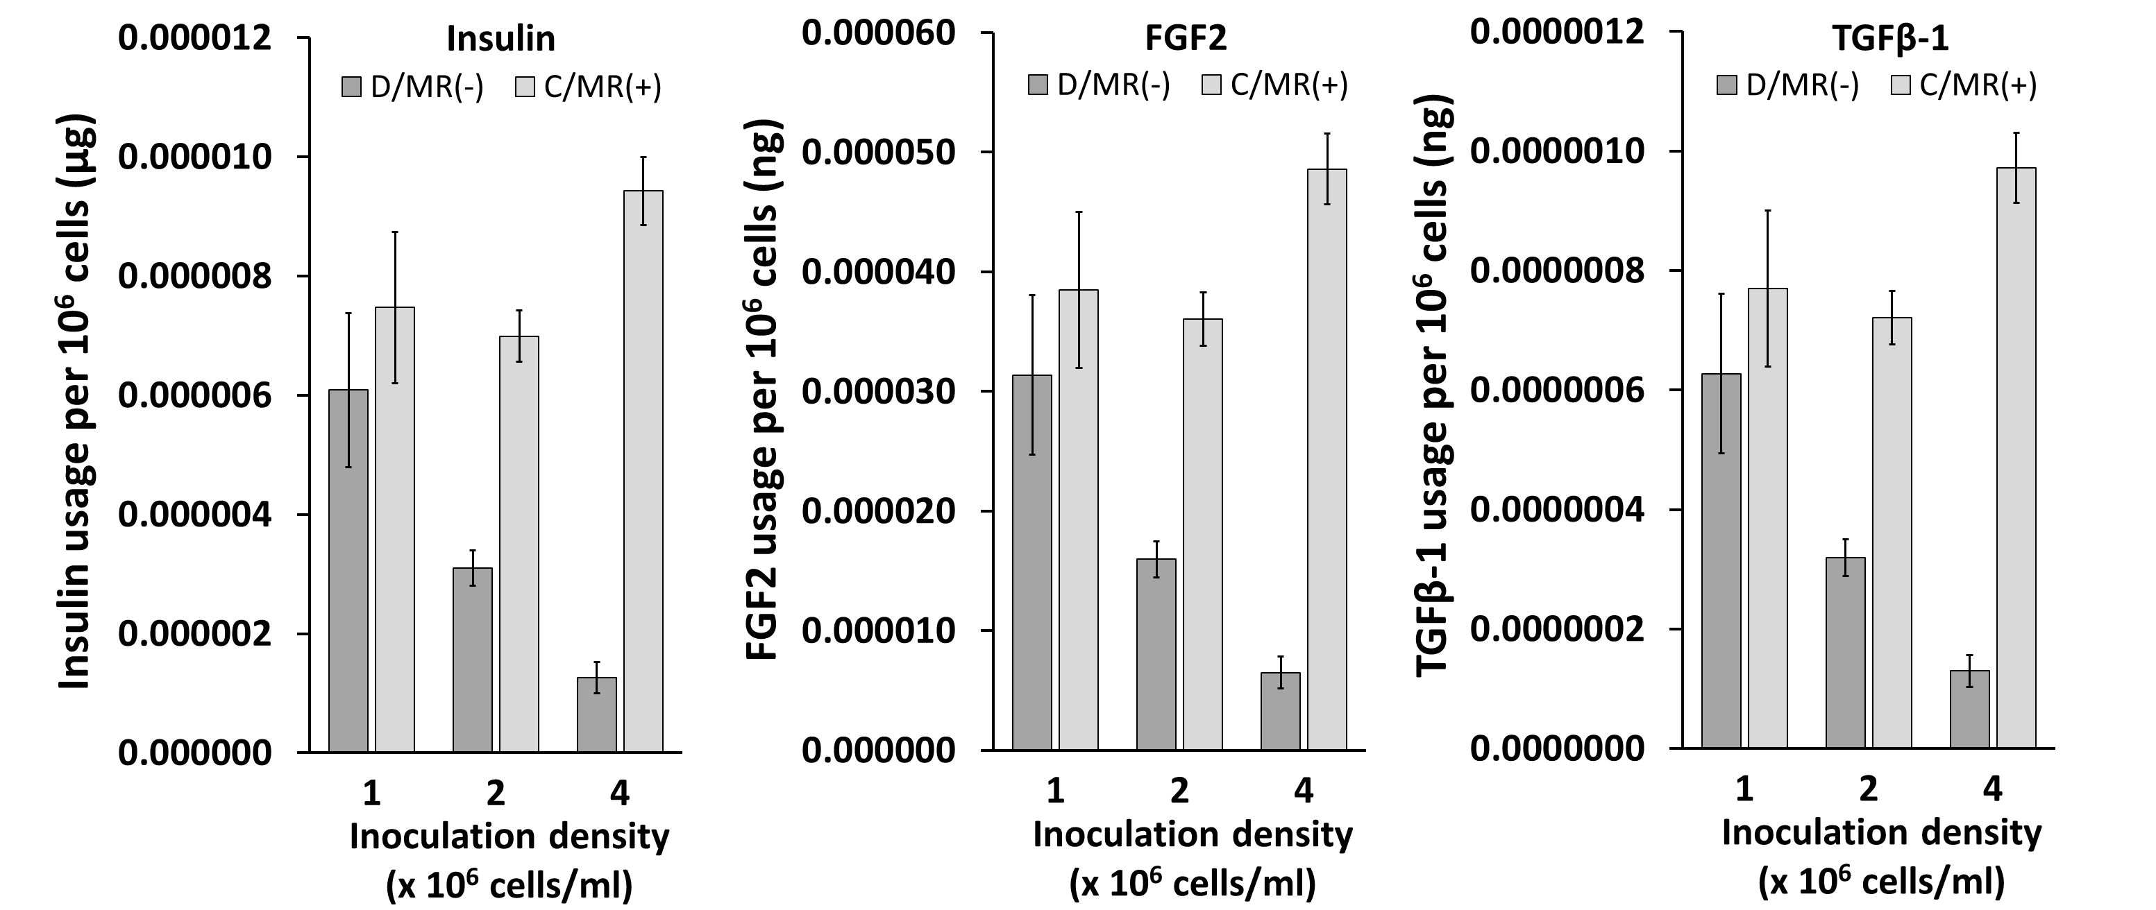

Supplementary Table 1. The list of antibody used in this study
No | Target Gene | Antibody / Kit Catalog no.
1 | FGF2 | MAB233-100
2 | Insulin | DY8056-05
3 | TGFβ-1 | BAF240
4 | Nodal | Human NODAL ELISA Kit (Sandwich ELISA) - LS-F12163
5 | OCT4, Nanog, SOX2 | Human Pluripotent Stem Cell 3-Color Immunocytochemistry Kit - SC021

Supplementary Table 2. The list of primer used in this study
No | Target Gene | Forward Primer | Reverse Primer
1 | Β-Actin | CCTCATGAAGATCCTCACCGA | TTGCCAATGGTGATGACCTGG
2 | OCT4 | AGTGGGTGGAGGAAGCTGACAAC | TCGGTTGTGCATAGTCGCTGCTTGA
3 | SOX 2 | GGCAGCTACAGCATGATGCAGGAGC | CTGGTCATGGAGTTGTACGCAGG
4 | Nanog | AGGACAGGTTTCAGAAGCAGAAGT | TCAGACCATTGCTAGTCTTCAACC
5 | OTX 2 | GGAGAGGACGACATTTACTAGG | TTCTGACCTCCATTCTGCTG
6 | Nestin | GCGTTGGAACAGAGGTTGGA | TGGGAGCAAAGATCCAAGAC
7 | Brachyury | ATCGTGGACAGCCAGTACGA | GCCAACTGCATCATCTCCAC
8 | RUNX1 | CCCTAGGGGATGTTCCAGAT | TGAAGCTTTTCCCTCTTCCA
9 | SOX17 | AGGAAATCCTCAGACTCCTGGGTT | CCCAAACTGTTCAAGTGGCAGACA
10 | CXCR4 | AGGGAACTGAACATTCCAGAGCGT | AAACGTTCCACGGGAATGGAGAGA
11 | GATA4 | AGCACACTGCATCTCTCCTGTG | CTCCGCTTGTTCTCAGATCCTC

