Supplementary information

Raw data in vivo

Table SI-1: Summary of the algesimetry measurements obtained by Hargreaves test in inflammatory carrageenan-induced pain model in rats. Results are presented as mean ± SEM .
Treatment | Basal | 0 min | 20 min | 40 min | 70 min | 100 min
Dextrose solution (n=10) | 10,5 ±0,2 | 4,8 ±0,1 | 5,2 ±0,1 | 5,4 ±0,2 | 5,0 ±0,2 | 4,9 ±0,1
LENK-SQ NPs (n=8) | 9,8 ± 0,1 | 4,2 ±0,1 | 7,3 ±0,6 | 7,5 ±0,4 | 6,6 ±0,6 | 4,6 ±0,1
STR (n=7) | 9,9 ±0,2 | 4,9 ±0,1 | 5,4 ±0,2 | 5,2 ±0,1 | 5,2 ±0,1 | 5,1 ±0,2
LENK-SQ NPs + STR (n=11) | 9,6 ±0,1 | 5,0 ±0.06 | 8,2 ±0,6 | 7,9 ±0,5 | 6,2 ±0,2 | 5,1 ±0,1
LENK-SQ NPs + STR-HM-SQ/SQ NPs (n=11) | 9,9 ±0,1 | 4,5 ±0.1 | 8,8 ±0,7 | 8,3 ±0,6 | 6,9 ±0,5 | 4,7 ±0,2

Experimental in vivo designs
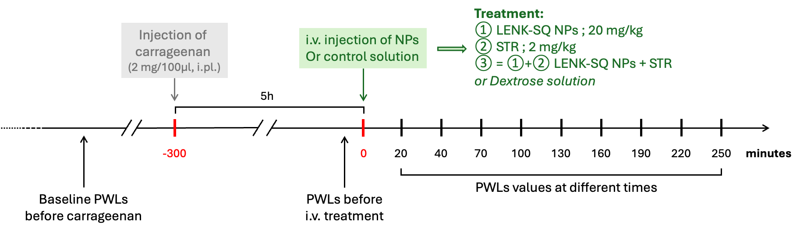
Fig. SI-1: Experimental design for algesimetry. The antinociceptive effect of LENK-SQ NPs, alone or in combination with STR-324, was evaluated in a pain model of inflammation, induced by intraplantar carrageenan injection (2% w/v in physiological saline, 100µl). The NPs suspension or control solution were injected intravenously at a dose volume of 5 mL/kg during several seconds. The Hargreaves test was performed 20 min after the treatment administration, then at 40 min, followed by measurements every 30 min for a total of 250 min.

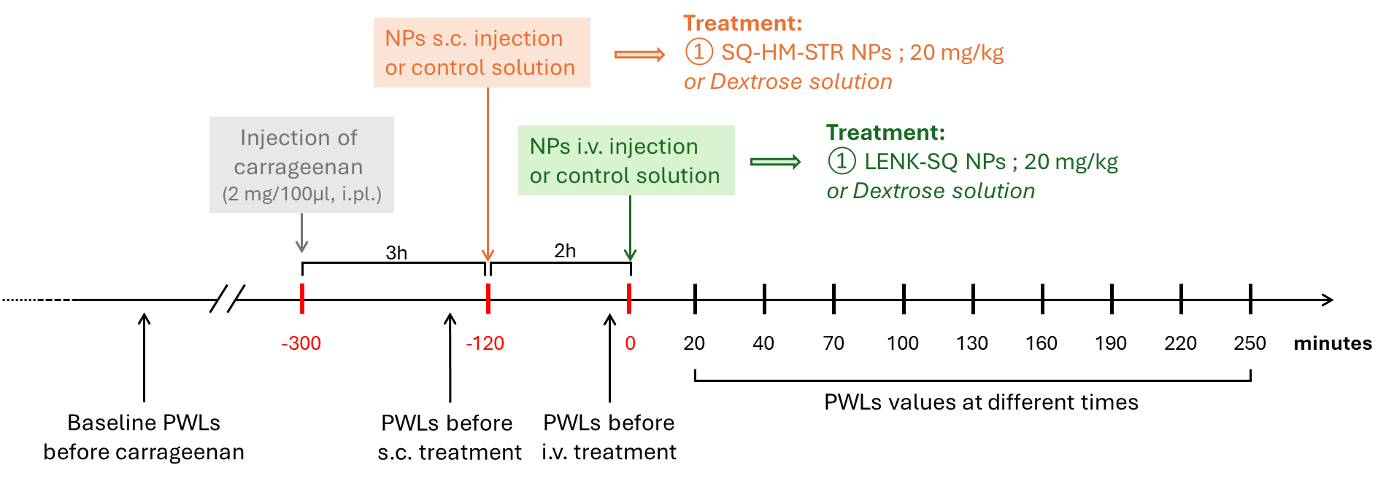
Fig. SI-2: Experimental design for algesimetry. The antinociceptive effect of 20 mg/kg STR-HM-SQ NPs combined with the same dose of LENK-SQ NPs was evaluated in a pain model of inflammation. Briefly, the inflammation was induced by intraplantar carrageenan injection (2% w/v in physiological saline, 100µl) in the left hind paw. STR-HM-SQ NPs were administered subcutaneously 3 h after carrageenan injection. LENK-SQ NPs suspension or control solution were injected intravenously (i.v.) with a dose volume of 5 mL/kg, 2h after subcutaneous injection (s.c.) of STR-HM-SQ NPs. Hargreaves test was performed just before the subcutaneous injection, and just before the intravenous injection, then 20 and 40 min after the intravenous administration, followed by measurements every 30 min for a total of 250 min.

Chemical syntheses
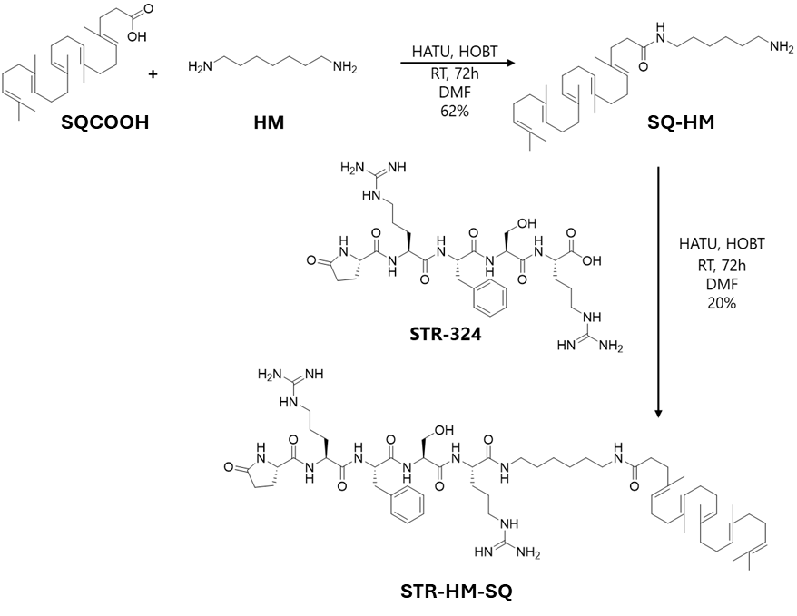
Fig. SI-3: Synthesis of STR-HM-SQ bioconjugate. RT = room temperature.

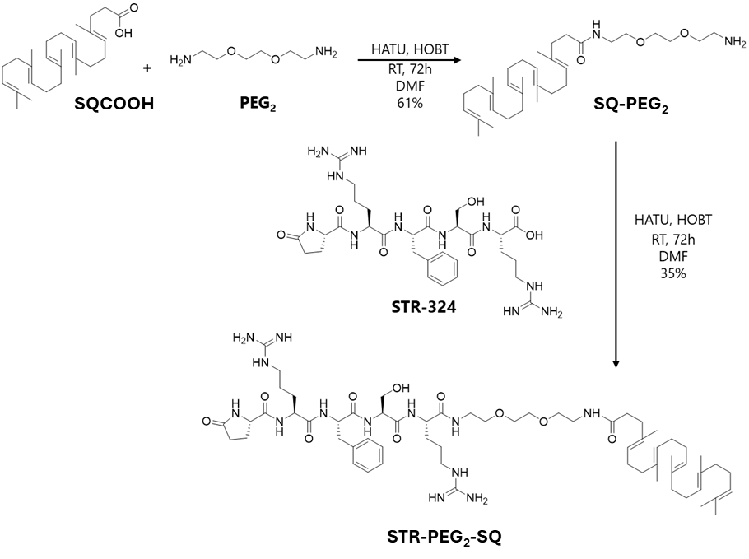Fig. SI-4: Synthesis of STR-PEG₂-SQ bioconjugate. RT = room temperature.
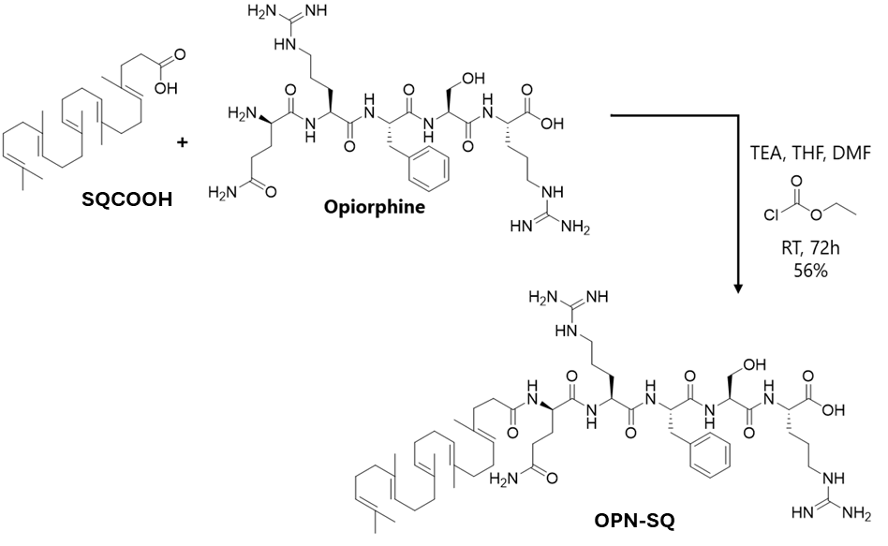
Fig. SI-5: Synthesis of OPN-SQ bioconjugate (12). RT = room temperature.

NMR and MS characterization of EEI-SQ bioconjugates
NMR spectra were recorded on a Bruker ARX 400 spectrometer (400 MHz for ¹H and 100 MHz for ¹³C) to characterize the STR-SQ and OPN-SQ bioconjugates, and on a Bruker Avance 300 spectrometer (300 MHz for ¹H and 75 MHz for ¹³C) to characterize the bioconjugate intermediates. Recognition of methyl, methylene, methine, and quaternary carbon nuclei in ¹³C NMR spectra rests on the J-modulated spin-echo sequence. Chemical shifts (ppm) are given relative to solvent: references for MeOD were 3.31 ppm (¹H-NMR) and 49.0 ppm (¹³C-NMR). ¹³C NMR spectra were acquired on a broad band decoupled mode. Multiplets were assigned as s (singlet), d (doublet), t (triplet), dd (doublet of doublet) and m (multiplet). Mass spectra were recorded on a Bruker Esquire-LC. High resolution Mass spectra (HR-MS) were achieved with an LTQ-Orbitrap Velos Pro (Thermo Fisher Scientific) operating in positive and negative electrospray ionization.
NMR characterization of STR-SQ bioconjugate intermediates:
NMR characterization of SQ-HM intermediate:
¹H NMR (300MHz, MeOD) δ: 5.22-5.03 (m, 5H, HC=C(CH₃) SQ), 3.15 (t, 2H, J = 7.1 Hz, CH₂-NH-CO linker), 2.92 (t, 2H, J = 7.2 Hz, CH₂-NH₂ linker), 2.26 (s, 4H, CH₂-CH₂-CO SQ), 2.14-1.89 (m, 16H, 8 CH₂ SQ), 1.70-1.55 (m, 18H, 6 CH₃ SQ), 1.55-1.29 (m, 8H, 4 CH₂ linker). ¹³C NMR (75 MHz, MeOD) δ: 175.7 (CONH), 135.9 (3 HC=C(CH₃) SQ), 135.7 (HC=C(CH₃) SQ), 134.7 (HC=C(CH₃) SQ), 126.1 (HC=C(CH₃)), 125.6 (HC=C(CH₃)), 125.5 (2 HC=C(CH₃)), 125.4 (2 HC=C(CH₃)), 40.8 (2 CH₂ SQ), 40.7 (CH₂ SQ), 40.6 (CH₂-N linker), 40.0 (CH₂-N linker), 36.8 (CH₂-CH₂-CO SQ), 36.1 (CH₂-CO SQ), 30.1 (CH₂ linker), 29.2 (2 CH₂ SQ), 28.3 (CH₂ linker), 27.7 (2 CH₂ SQ), 27.5 (CH₂ SQ), 27.2 ( CH₂ linker), 26.8 (CH₂ linker), 25.9 (CH₃ SQ), 17.8 (CH₃ SQ), 16.2 (2 CH₃ SQ), 16.1 (CH₃ SQ), 15.9 (CH₃ SQ).
NMR characterization of SQ-PEG₂ intermediate:
¹H NMR (300MHz, MeOD) δ: 5.24-5.00 (m, 5H, HC=C(CH₃) SQ), 3.74-3.58 (m, 6H, 3 CH₂-O linker), 3.53 (t, 2H, J = 5.9 Hz, CH₂-O linker), 3.35 (t, 2H, J = 5.9 Hz, CH₂-NH-CO linker), 3.12 (t, 2H, J = 5.3 Hz, CH₂-NH₂ linker), 2.26 (s, 4H, CH₂-CH₂-CO SQ), 2.14-1.88 (m, 16H, 8 CH₂ SQ), 1.70-1.50 (m, 18H, 6 CH₃ SQ). ¹³C NMR (75 MHz, MeOD) δ: 175.9 (CONH), 135.9 (3 HC=C(CH₃) SQ), 135.7 (HC=C(CH₃) SQ), 134.7 (HC=C(CH₃) SQ), 126.1 (HC=C(CH₃)), 125.4 (2 HC=C(CH₃)), 125.3 (2 HC=C(CH₃)), 71.1 (2 CH₂-O linker), 70.5 (CH₂-O linker), 67.7 (CH₂-O linker), 40.7 (2 CH₂ SQ), 40.6 (CH₂ SQ, CH₂-N linker), 40.0 (CH₂-N linker), 36.6 (CH₂-CH₂-CO SQ), 36.0 (CH₂-CO SQ), 29.1 (2 CH₂ SQ), 27.7 (2 CH₂ SQ), 27.5 (CH₂ SQ), 25.8 (CH₃ SQ), 17.7 (CH₃ SQ), 16.1 (3 CH₃ SQ), 15.9 (CH₃ SQ).

NMR and MS characterization of STR-SQ bioconjugates:
Characterization of STR-HM-SQ bioconjugate:
¹H NMR (400MHz, MeOD) δ: 7.30-7.16 (m, 5H_{Ar} Phe-Ala), 5.21-5.05 (m, 5H, HC=C(CH₃) SQ), 4.66 (dd, 1H, J = 9.6, 5.0 Hz, α-CH Phe-Ala), 4.41 (dd, 1H, J = 6.4, 5.4 Hz, α-CH Ser), 4.35 (dd, 1H, J = 8.7, 4.7 Hz, α-CH Arg), 4.27 (dd, 1H, J = 7.9, 6.4 Hz, α-CH Arg), 4.20 (dd, 1H, J = 8.4, 4.6 Hz, α-CH PyroGlu), 3.87 (dd, 1H, J = 10.7, 5.4 Hz, CH_{a}H_{b} Ser), 3.74 (dd, 1H, J = 10.7, 6.4 Hz, CH_{a}H_{b} Ser), 3.26-3.09 (m, 9H, 2 CH₂-NH linker, 2 δ-CH₂ Arg, CH_{a}H_{b} Phe-Ala), 2.97 (dd, 1H, J = 14.1, 9.6 Hz, CH_{a}H_{b} Phe-Ala), 2.46-2.26 (m, 3H, β-CH_{a}H_{b} PyroGlu, ɣ-CH₂ PyroGlu), 2.25 (s, 4H, CH₂-CH₂-CO SQ, CH₂-CH₂-CO SQ), 2.13-1.89 (m, 17H, 8 CH₂ SQ, β-CH_{a}H_{b} PyroGlu), 1.77-1.42 (m, 30H, 6 CH₃ SQ, 2 β-CH₂ Arg, 2 ɣ-CH₂ Arg, 2 CH₂-CH₂-NH linker), 1.38-1.26 (m, 4H, CH₂-CH₂ linker). ¹³C NMR (100 MHz, MeOD) δ: 181.4 (CO Pyroglu cycle), 175.8 (CO SQ), 175.2 (CO Pyroglu), 173.5 ( 2 COª), 173.4 (COª), 172.5 (CO Ser), 158.6 (2 C_{Guan} Arg), 138.3 (C_{Ar} Phe-Ala), 136.0 (HC=C(CH₃) SQ), 135.9 (2 HC=C(CH₃) SQ), 135.8 (HC=C(CH₃) SQ), 134.8 (HC=C(CH₃) SQ), 130.3 (2 o-CH_{Ar} Phe-Ala), 129.5 (2 m-CH_{Ar} Phe-Ala), 127.8 (p-CH_{Ar} Phe-Ala), 126.2 (HC=C(CH₃)), 125.6 (HC=C(CH₃)), 125.5 (HC=C(CH₃)), 125.4 (2 HC=C(CH₃)), 62.9 (CH₂-O Ser), 57.8 (α-CH Pyroglu), 56.7 (α-CH Ser), 55.9 (α-CH Phe-Ala), 54.6 (α-CH Arg), 54.3 (α-CH Arg), 41.9 (2 δ-CH₂ Arg), 40.8 (2 CH₂ SQ), 40.7 (CH₂ SQ), 40.4 (CH₂-NH linker), 40.2 (CH₂-NH linker), 38.3 (β-CH₂ Phe-Ala), 36.8 (CH₂-CH₂-CO SQ), 36.2 (CH₂-CO SQ), 30.4 (γ-CH₂ Pyroglu), 30.3 (CH₂ linker), 30.1 (CH₂ linker), 29.9 (2 β-CH₂ Arg), 29.2 (2 CH₂ SQ), 27.8 (CH₂ SQ), 27.7 (CH₂ SQ), 27.5 (2 CH₂ linker), 27.4 (CH₂ SQ), 26.5 (β-CH₂ Pyroglu), 26.4 (γ-CH₂ Arg), 26.1 (γ-CH₂ Arg), 25.8 (CH₃ SQ), 17.7 (CH₃ SQ), 16.2 (CH₃ SQ), 16.1 (2 CH₃ SQ), 16.0 (CH₃ SQ). HRMS (+ESI): m/z 1156.7999 ([M+H]⁺ calculated for C₆₂H₁₀₁N₁₃O₈ : 1156.79).

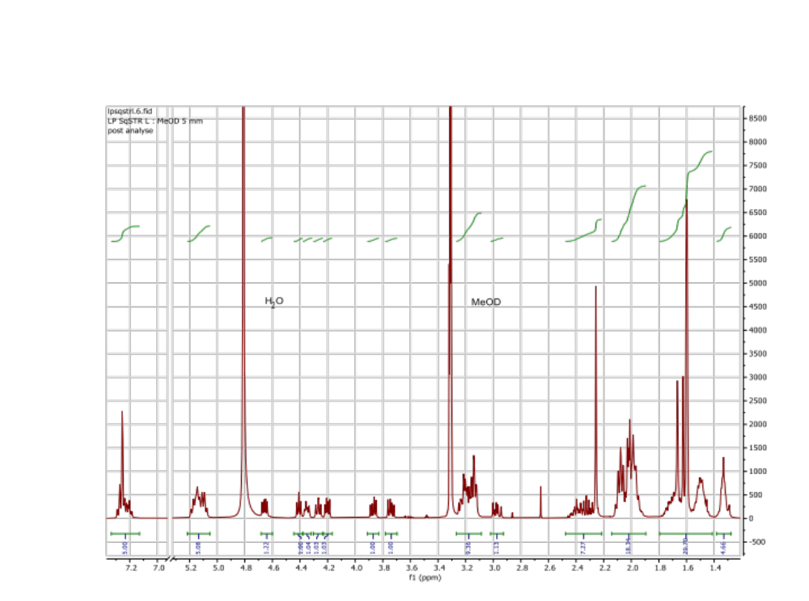
Fig. SI-6: ¹H NMR spectrum of STR-HM-SQ bioconjugate.
Characterization of STR-PEG₂-SQ bioconjugate:
¹H NMR (400 MHz, MeOD) δ 7.31–7.16 (m, 5H_{Ar} , Phe-Ala), 5.22–5.05 (m, 5H, HC=C(CH₃) , SQ), 4.66 (dd, 1H, J = 9.5, 5.0 Hz, α-CH Phe-Ala), 4.46–4.34 (m, 2H, α-CH Ser, α-CH Arg), 4.27 (dd, 1H, J = 7.2 Hz, α-CH Arg), 4.20 (dd, 1H, J = 8.3, 4.6 Hz, α-CH Pyroglu), 3.86 (dd, 1H, J = 10.7, 5.4 Hz, CH_{a}H_{b} Ser), 3.75 (dd, 1H, J = 10.7, 6.4 Hz, CH_{a}H_{b} Ser), 3.61 (s, 4H, O-CH₂-CH₂-O PEG linker), 3.54 (m, 4H, 2 NH-CH₂-CH₂-O PEG linker), 3.41–3.33 (m, 4H, 2 NH-CH₂-CH₂-O PEG linker), 3.27–3.19 (m, 3H, CH_{a}H_{b} Phe-Ala, 2 δ- CH_{a}H_{b} Arg), 3.14 (t, 2H, J = 7.1 Hz, 2 δ-CH_{a}H_{b} Arg), 2.97 (dd, 1H, J = 14.1, 9.6 Hz, CH_{a}H_{b} Phe-Ala), 2.52 – 2.22 (m, 7H, β-CH_{a}H_{b} Pyroglu, ɣ-CH₂ Pyroglu, CH₂-CH₂-CO SQ, CH₂-CH₂-CO SQ), 1.9-2.13 (m, 17H, β-CH_{a}H_{b} PyroGlu, 8 CH₂ SQ ), 1.81 – 1.41 (m, 26H, 6 CH₃ SQ, 2 ɣ-CH₂ Arg, 2 β-CH₂ Arg). ¹³C NMR (100 MHz, MeOD) δ: 181.4 (CO Pyroglu cycle), 176.0 (CO SQ), 175.1 (CO Pyroglu), 173.6 (COª), 173.5 (COª), 173.4 (COª), 172.4 (CO Ser), 158.6 (2 C_{Guan} Arg), 138.3 (C_{Ar} Phe-Ala), 136.0 (HC=C(CH₃) SQ), 135.9 (2 HC=C(CH₃) SQ), 135.8 (HC=C(CH₃) SQ), 134.8 (HC=C(CH₃) SQ), 130.3 (2 o-CH_{Ar} Phe-Ala), 129.5 (2 m-CH_{Ar} Phe-Ala), 127.8 (p-CH_{Ar} Phe-Ala), 126.2 (HC=C(CH₃)), 125.6 (HC=C(CH₃)), 125.5 (HC=C(CH₃)), 125.4 (2 HC=C(CH₃)), 71.3 (CH₂-O linker), 71.2 (CH₂-O linker), 70.6 (CH₂-O linker), 70.3 (CH₂-O linker), 63.0 (CH₂-O Ser), 57.8 (α-CH Pyroglu), 56.7 (α-CH Ser), 56.0 (α-CH Phe-Ala), 54.6 (α-CH Arg), 54.2 (α-CH Arg), 41.9 (2 δ-CH₂ Arg), 40.8 (2 CH₂ SQ), 40.7 (CH₂ SQ), 40.4 (CH₂-NH linker), 40.2 (CH₂-NH linker), 38.3 (CH₂ Phe-Ala), 36.8 (CH₂-CH₂-CO SQ), 36.1 (CH₂-CO SQ), 30.4 (γ-CH₂ Pyroglu), 30.0 (β-CH₂ Arg), 29.9 (β-CH₂ Arg), 29.2 (2 CH₂ SQ), 27.8 (2 CH₂ SQ), 27.5 (CH₂ SQ), 26.6 (β-CH₂ Pyroglu), 26.3 (γ-CH₂ Arg), 26.1 (γ-CH₂ Arg), 25.8 (CH₃ SQ), 17.7 (CH₃ SQ), 16.2 (CH₃ SQ), 16.1 (2 CH₃ SQ), 16.0 (CH₃ SQ). HRMS (+ESI): m/z 1188.7999 ([M+H]⁺ calculated for C₆₂H₁₀₁N₁₃O₁₀ : 1188.78).
ª : Phe-Ala or Arg1 or Arg2

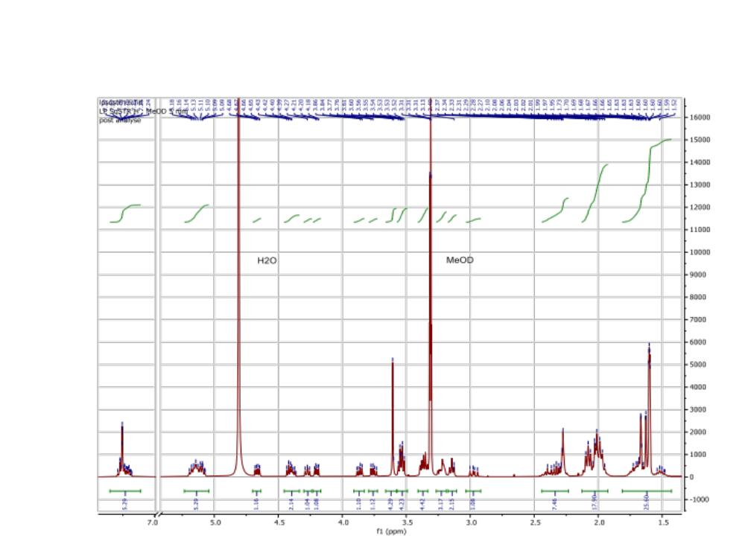
Fig. SI-7: ¹H NMR spectrum of STR-PEG₂-SQ bioconjugate.
NMR and MS characterization of OPN-SQ bioconjugate:
¹H NMR (400 MHz, MeOD) δ 7.27 (s, 2H, m-H_{ar} Phe-Ala), 7.25 (s, 2H, o-H_{ar} Phe-Ala), 7.20 (m, 1H, p-H_{ar} Phe-Ala), 5.24 – 5.04 (m, 5H, HC=C(CH₃), SQ), 4.68 (dd, 1H, J = 9.8, 4.9 Hz, α-CH Phe-Ala), 4.41 (dd, 1H, J = 5.4, 6.3 Hz, α-CH Ser), 4.37 (dd, 1H, J = 8.3, 4.9 Hz, α-CH Arg), 4.27 (dd, 1H, J = 8.1, 5.6 Hz, α-CH Arg), 4.21 (dd, 1H, J = 8.0, 6.3 Hz, α-CH Glu), 3.86 (dd, 1H, J = 11.3, 5.5 Hz, CH_{a}H_{b} Ser), 3.80 (dd, 1H, J = 11.3, 5.0 Hz, CH_{a}H_{b} Ser), 3.30-3.09 (m, 5H, J = 14.0, 7.0 Hz, CH_{a}H_{b} Phe-Ala, 2 δ-CH₂ Arg ), 2.98 (dd, 1H, J = 14.0, 9.7 Hz, CH_{a}H_{b} Phe-Ala), 2.44 – 2.19 (m, 6H, γ-CH₂ Glu, CH₂-CH₂-CO SQ, CH₂-CH₂-CO SQ), 2.14-1.86 (m, 18H, β-CH₂ Glu, 8 CH₂ SQ), 1.84-1.38 (m, 26H, 6 CH₃ SQ, 2 β-CH₂ Arg, 2 γ-CH₂ Arg ). ¹³C NMR (100 MHz, MeOD) δ: 177.6 (COOH Arg), 176.2 (COOH Glu), 176.0 (CO SQ), 174.4 (CO Glu), 173.7 (CO Arg), 173.5 (CO Phe-Ala), 171.9 (CO Ser), 158.6 (2 C_{guan} Arg), 138.5 (C_{arom} Phe-Ala), 136.0 (3 HC=C(CH₃) SQ), 135.8 (2 HC=C(CH₃) SQ), 134.8 (HC=C(CH₃) SQ), 130.3 (2 o-CH_{arom} Phe-Ala), 129.5 (2 m-CH_{arom} Phe-Ala), 127.8 (p-CH_{arom} Phe-Ala), 126.2 (HC=C(CH₃)), 125.6 (HC=C(CH₃)), 125.5 (HC=C(CH₃)), 125.4 (2 HC=C(CH₃)), 63.1 (CH₂ Ser), 57.0 (α-CH Ser), 56.1 (α-CH Phe-Ala), 54.8 (α-CH Arg), 54.2 (α-CH Arg), 41.9 (2 δ-CH₂ Arg), 40.8 (2 CH₂ SQ), 40.7 (CH₂ SQ), 38.4 (CH₂ Phe-Ala), 36.5 (CH₂-CH₂-CO SQ), 35.8 (CH₂-CO SQ), 32.4 (γ-CH₂ Glu), 30.1 (β-CH₂ Arg), 29.8 (β-CH₂ Arg), 29.2 (2 CH₂ SQ), 28.3 (β-CH₂ Glu), 27.8 (2 CH₂ SQ), 27.5 (CH₂ SQ), 26.1 (γ-CH₂ Arg), 26.0 (γ-CH₂ Arg), 25.8 (CH₃ SQ), 17.7 (CH₃ SQ), 16.2 (CH₃ SQ), 16.1 (2 CH₃ SQ), 16.0 (CH₃ SQ). HRMS (+ESI): m/z 1075.7060 ([M+H]⁺ calculated for C₅₆H₉₀N₁₂O₉ : 1075.70).

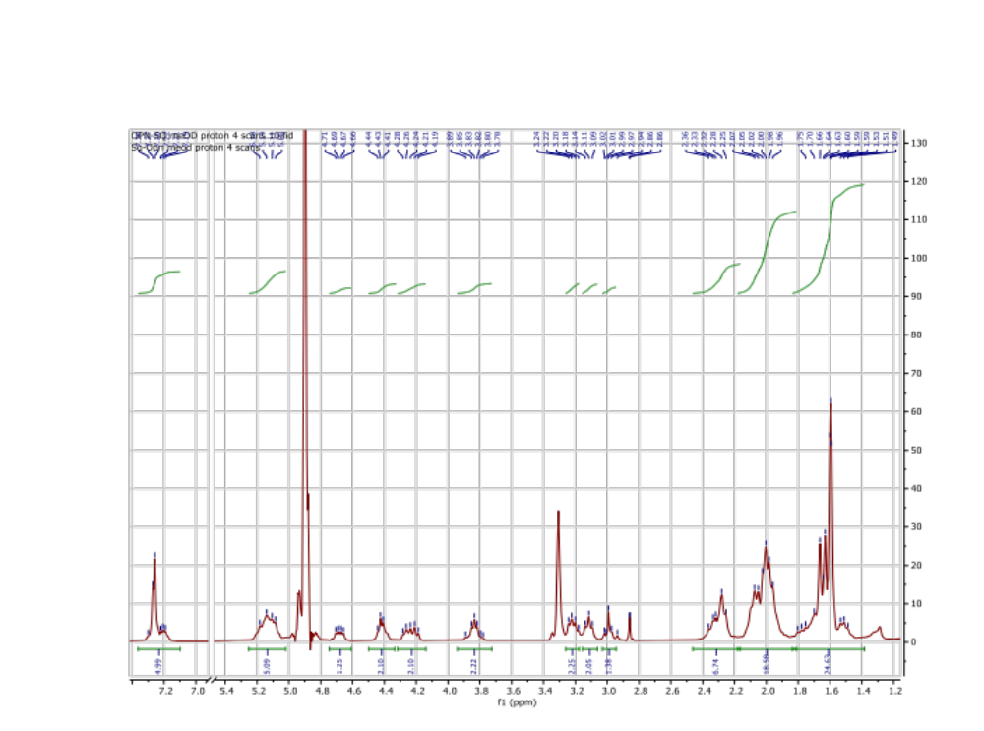
Fig. SI-8: ¹H NMR spectrum of OPN-SQ bioconjugate

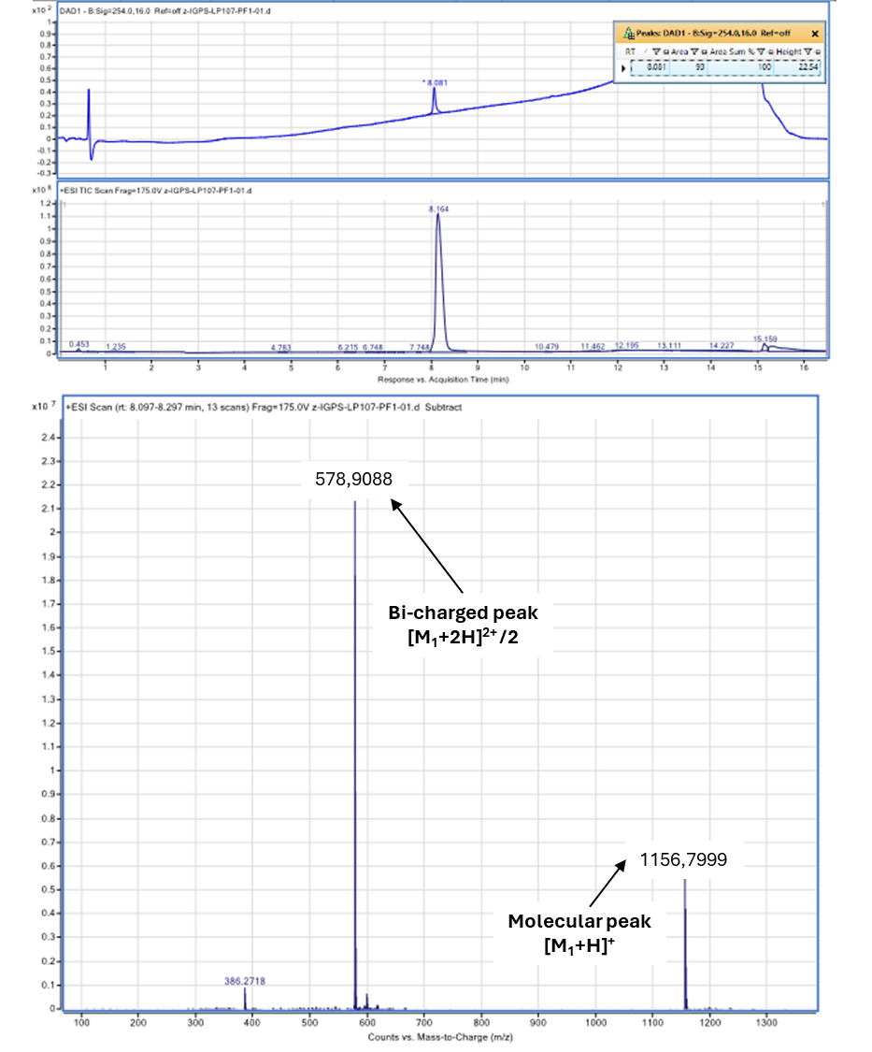
MS spectra
Fig. SI-9: MS spectrum of STR-HM-SQ.
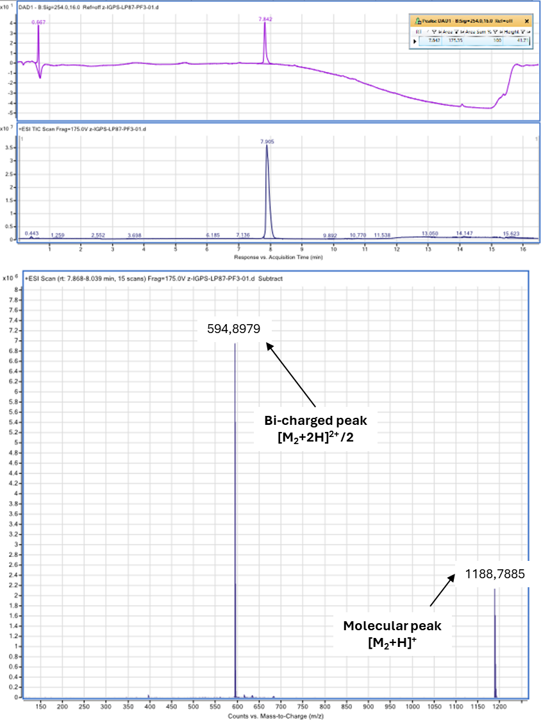
Fig. SI-10: MS spectrum of STR-PEG₂-SQ

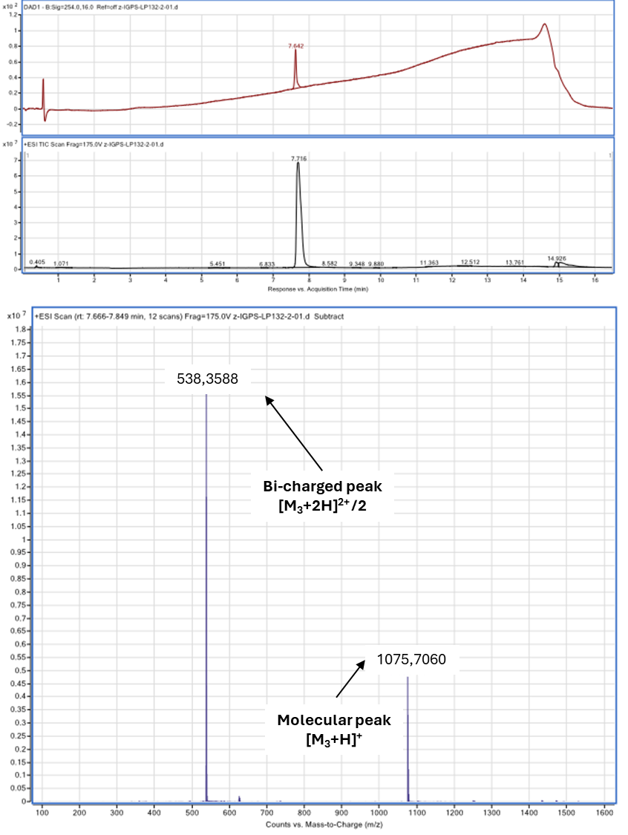
Fig. SI-11: MS spectrum of OPN-SQ

Comparative study of self-assembly properties
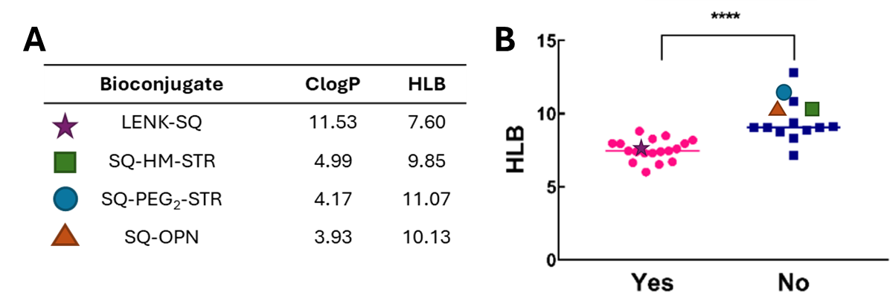
Fig. SI-12: Impact of ClogP and HLB on SQ bioconjugates self-assembly. (A) In silico CLogP and HLB values of various squalenoyl bioconjugates. (B) Comparison of HLB values for lipidic prodrugs that can (YES) or not (NO) self-assemble into nanoparticles in pure water using the nanopreciptation method (adapted from [1]; ****P>0.0001, Mann-Whitney’s test). ClogP values were calculated using ChemDraw; HLB values were calculated in silico using Griffin’s formula with MarvinSketch. Colored shapes represent the different SQ bioconjugates investigated in the present study. Our results are consistent with those of Coppens et al. (pink circles and blue squares).

Additional cryoTEM observations
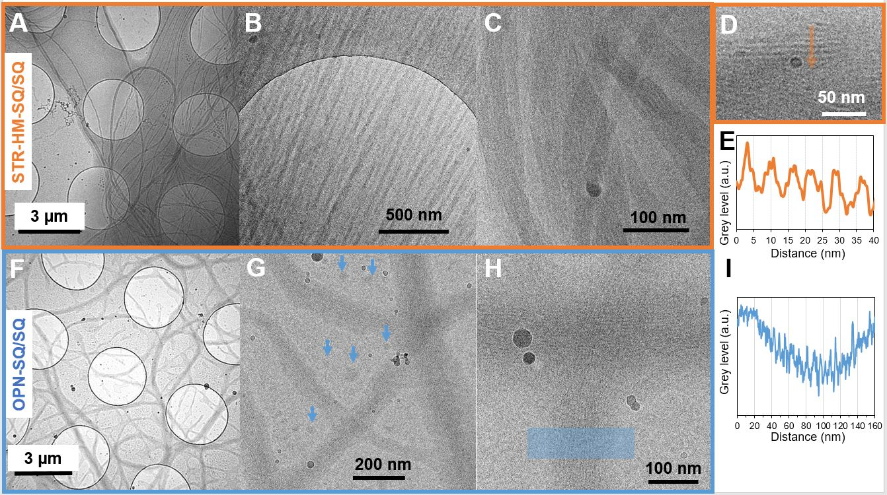
Fig. SI-13: Additional observations of the EEI-SQ NPs suspensions co-formulated with SQ leading to the formation of fibers. (A-E) STR-HM-SQ/SQ formulation; (F-I) OPN-SQ/SQ formulation. The blue arrows indicate non fibrillary structures. Intensity plot profiles of the inner structure of STR-HM-SQ/SQ fibers (E) and OPN-SQ/SQ fibers (I) display the grey level plots along the profiles indicated in panels (D) and (H) respectively. These profiles plots highlight a subfibrillar structure with 5-7 nm period (E and I).

Table SI-2: Measurements of the spherical nanoparticle diameter in different formulations (from cryoTEM images)
 | STR-HM-SQ/  SQ | STR-HM-SQ/  LENK-SQ | OPN-SQ/  SQ | OPN-SQ/  LENK-SQ | LENK-SQ | SQ
Average ± SD (nm) | 56±20 | 64±25 | 30±14 | 92±28 | 66±22 | 86±49
Median (nm) | 52 | 66 | 26 | 87 | 67 | 76
Number of  Measurements | 254 | 61 | 204 | 204 | 163 | 1064
Co-existence of fibrils | yes | no | yes | no | no | no

Table SI-3: Parameters obtained from the measurement of the position q_{max} and of the full width at half maximum (FWHM) of the WAXS peak. The peaks were fitted using a Gaussian function after subtraction of a splined baseline.
 | Morphology | d = 2π/q_{max} | ξ = 2π/fwhm
SQ | NPs | No peak | No peak
LENK-SQ | NPs | 3.9 nm | 13.8 nm
STR-HM-SQ/SQ* | NPs+Fibers | 5.0 nm | 19.9 nm
STR-HM-SQ/LENK-SQ | NPs | 5.0 nm | 13.5 nm
OPN-SQ/SQ | NPs+Fibers | 6.6 nm | 31.9 nm
OPN-SQ/LENK-SQ | NPs | No peak | No peak
* Note that this value is very close to that of 4.9 nm measured on the cryoTEM images of the STR-PEG₂-SQ/SQ formulation (see Fig. 3).

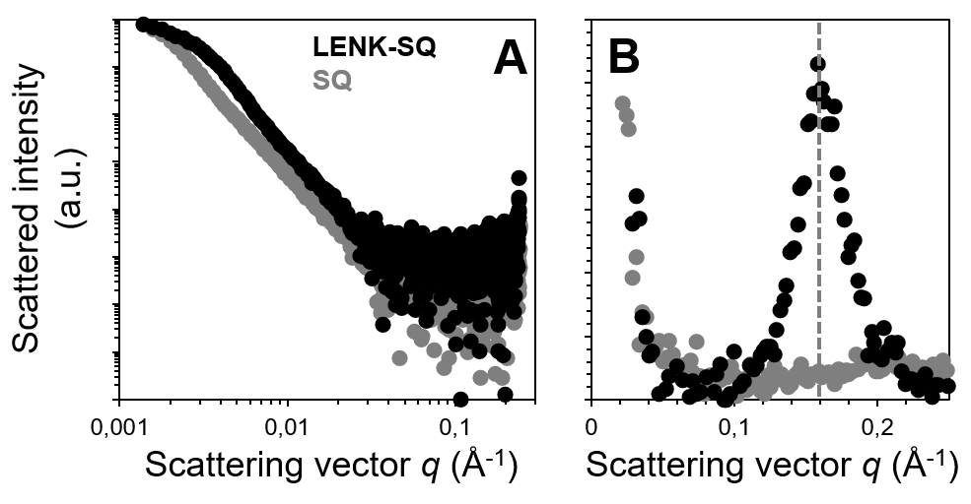
Fig. SI-14: SAXS (A) and WAXS (B) patterns of 2 mg/ml SQ-COOH (SQ) and LENK-SQ suspensions, the two adjuvants used to help STR-SQ and OPN-SQ forming nanoparticles.
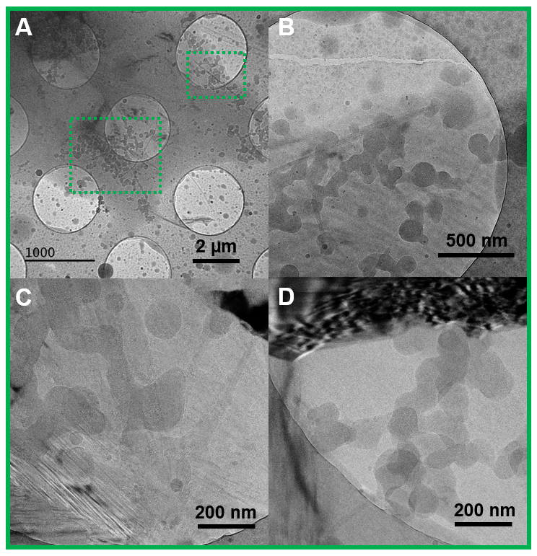
Fig. SI-15: (A-B) Four cryoTEM images of the flocculated suspension of OPN-SQ/LENK-SQ NPs at different magnifications. The images show that the nanoparticles not only tend to aggregate, but also appear to merge, forming continuous necklaces that contribute to the gelation of the solution.

In vivo mortality :

Fig. SI-16: Comparative effects of soluble STR-HM-SQ prodrug or STR-HM-SQ/SQ nanoparticles on hypoxia symptoms (orange) and mortality (blue) in animals, 10 min after administration. Severe hypoxia symptoms followed by significant mortality rate were observed. Specifically, 50% (N=2/4) of the rats treated with the STR-HM-SQ prodrug (20 mg/kg) and 25% (N=1/4) of the rats treated with STR-HM-SQ NPs (20 mg/kg) died in a 10-min period after i.v. injection. Additionally, 100% of the rats treated with any form of STR-HM-SQ exhibited severe symptoms (including hypoxia, respiratory distress, cardiac arrest and death); no mortality was observed in the group injected with dextrose solution. Formulations of OPN-SQ NPs and STR-PEG₂-SQ NPs induced the same toxicity.

In vitro tests for plasma gelation
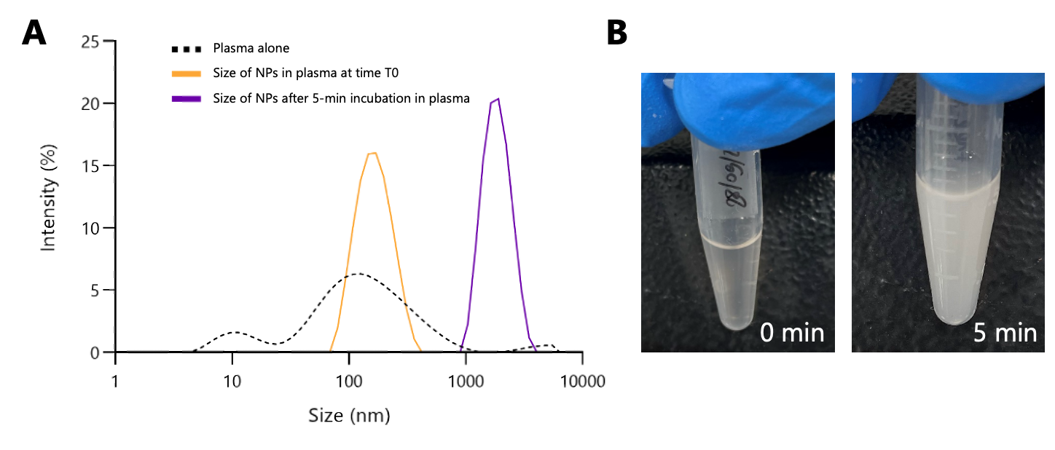Fig. SI-17: DLS measurements of in vitro incubation of plasma with STR-HM-SQ NPs. STR-HM-SQ NPs (300 µl, 4 mg/mL) were incubated in rat plasma at 37°C (ratio plasma/NPs 3:1). At 0 and 5 minutes, 50 µl of the mixture was sampled and diluted in water (450 µl), then analyzed by DLS. Images were captured at the time of measurement. (A) DLS measurements; a fast increase in the particles size was observed, indicating aggregation; (B) Pictures of the solution of plasma and NPs after 5 min of incubation. The particle size increased, and visible aggregates appeared in the solution. After 5 minutes, sampling was not possible due to the formation of excessively large aggregates.

In vivo cyst formation

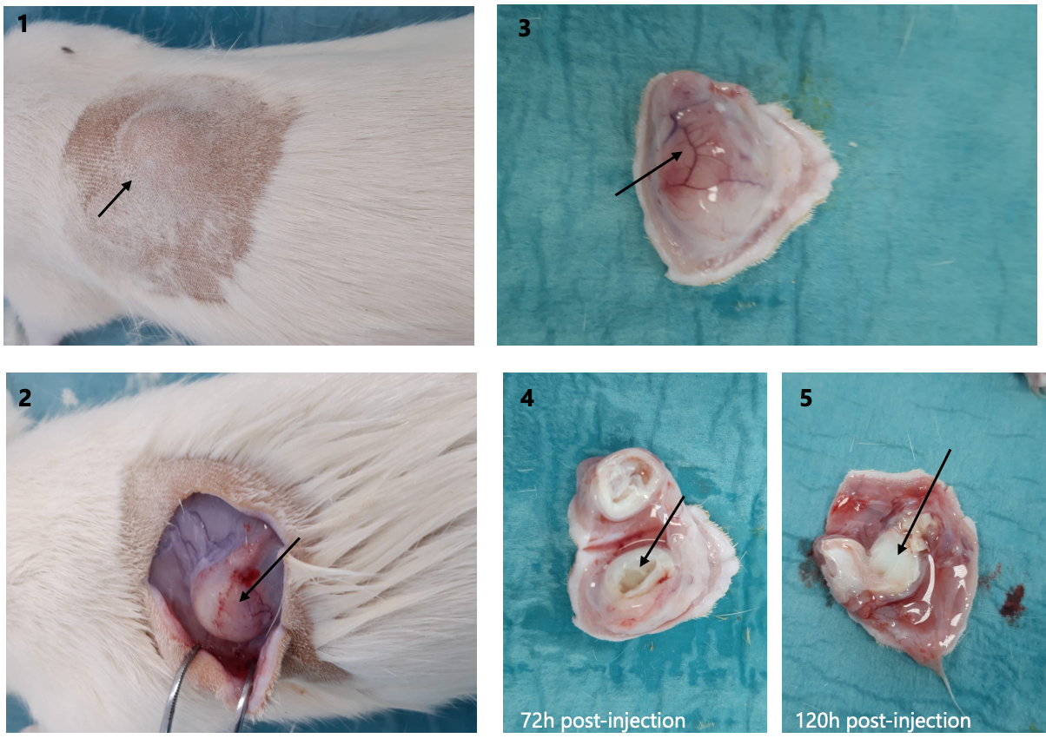
Fig. SI-18: Images of the cyst induced by STR-HM-SQ NPs at the injection site. (1) External appearance on shaved rat, 72h post-injection (2) Subcutaneous appearance after skin incision, 72h post-injection (3) Excised cyst with vascularized aspect (4) Interior of the cyst after longitudinal section, filled with fluid, 72h post-injection (5) Interior of the cyst after longitudinal section, appearing full, 120h post-injection.

