Supplementary Information
FAD-dependent hexenal isomerases in Lepidoptera evolved convergently with plant-derived hexenal isomerases
Yu-Hsien Lin^{1*}, Bulah Chia-hsiang Wu², Abdoallah Sharaf³, Sophie Maartje Elisabeth Heijblom¹, Ilias Prattis¹, Ching-Wen Tan^{4,5}, Rudolf J Schilder^{5,6}, Jared Gregory Ali⁵, Silke Allmann^{1*}
¹Green Life Sciences Research Cluster, Department of Plant Physiology, Swammerdam Institute for Life Sciences, University of Amsterdam, Amsterdam, Netherlands
²Biology Centre of the Czech Academy of Sciences, Institute of Entomology, Ceske Budejovice, Czechia
³SequAna Core Facility, Department of Biology, University of Konstanz, Konstanz, Germany
⁴Department of Entomology, National Chung Hsing University, Taichung Taiwan
⁵Department of Entomology, The Pennsylvania State University, University Park, PA, USA
⁶Department of Biology, The Pennsylvania State University, University Park, PA, USA
*Correspondence and requests for materials should be addressed to Y.H.L. (email: r99632012@gmail.com) and S.A. (email: S.Allmann@uva.nl)

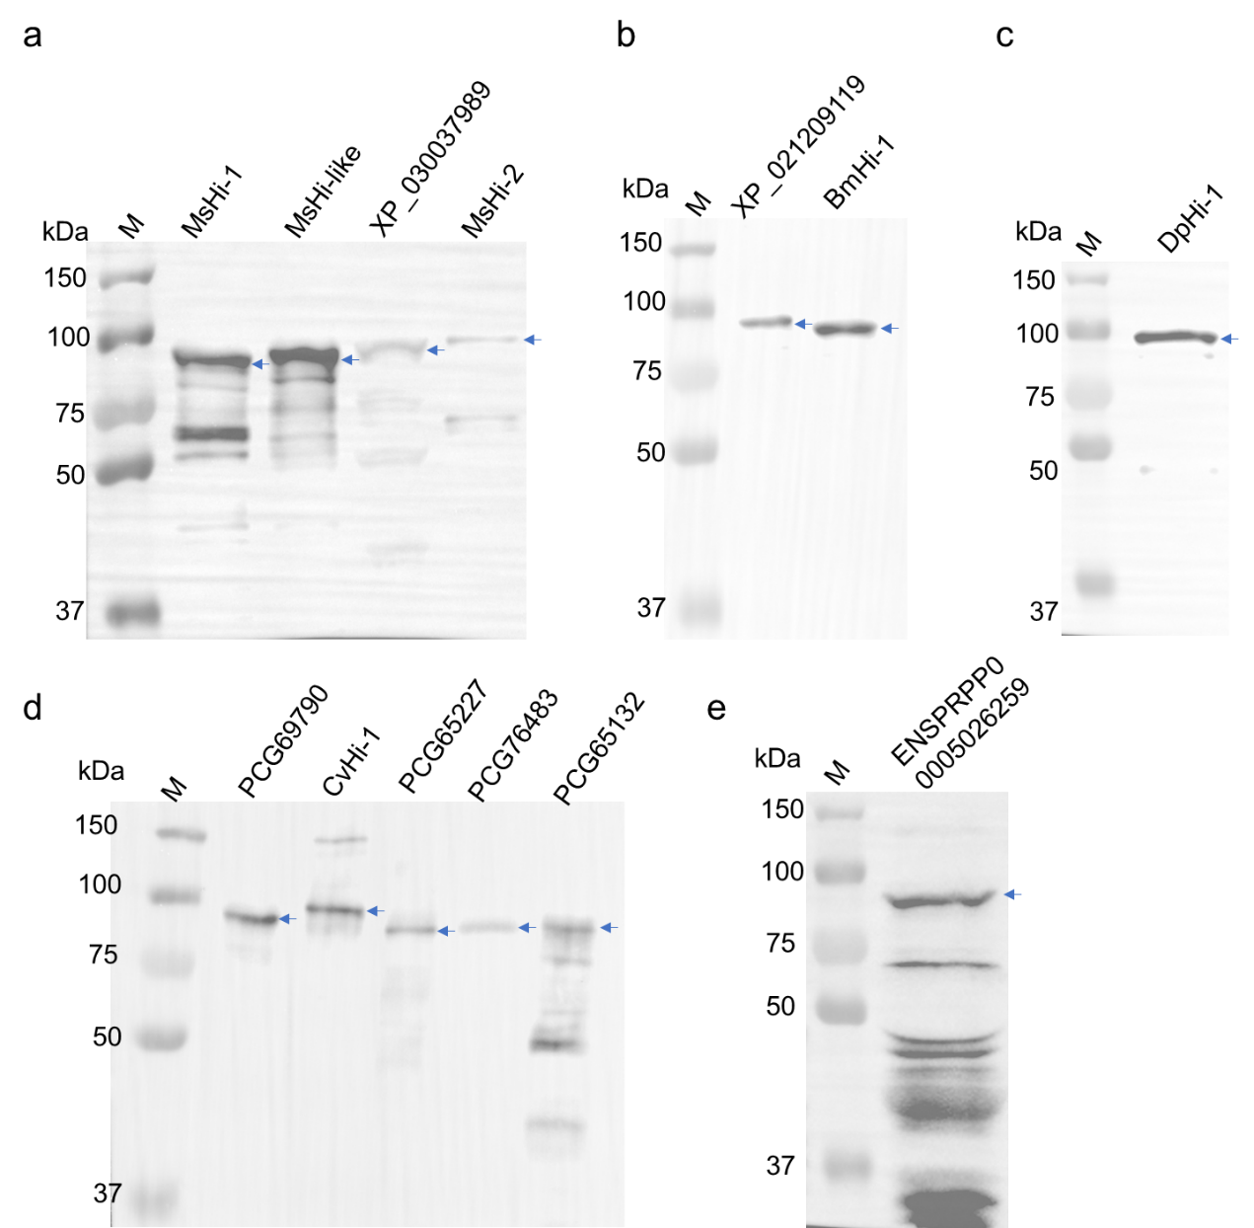

Supplementary Fig. 1. Western blot of recombinant putative Hi expressed in E. coli BL21. Genes encoding putative Hi were derived from (a) Manduca sexta, (b) Bombyx mori, (c) Danaus plexippus (d) Chloridea virescens and (e) Pieris rapae. Blue arrows indicate the position of recombinant Hi. M denotes protein marker.

Supplementary Fig. 2. Corresponding dot plot of Fig 3. Lognormal ordinary one-way ANOVA test was performed to assess significant differences between treatments, a, F_{2, 12} = 240, p < 0.001; b, F_{2, 13} = 87,26, p < 0.001; c, F_{2, 13} = 12,19, p = 0.001; d, F_{2, 13} = 8,477, p = 0.004. Different letters on the top of each bar indicate significant differences (p < 0.05) by Tukey post-hoc test. n = 5-6 biologically independent samples. The center line indicates median value. Host plants: (a-b; a'-b') Tomato; (c) Milkweed; (d) White mulberry.

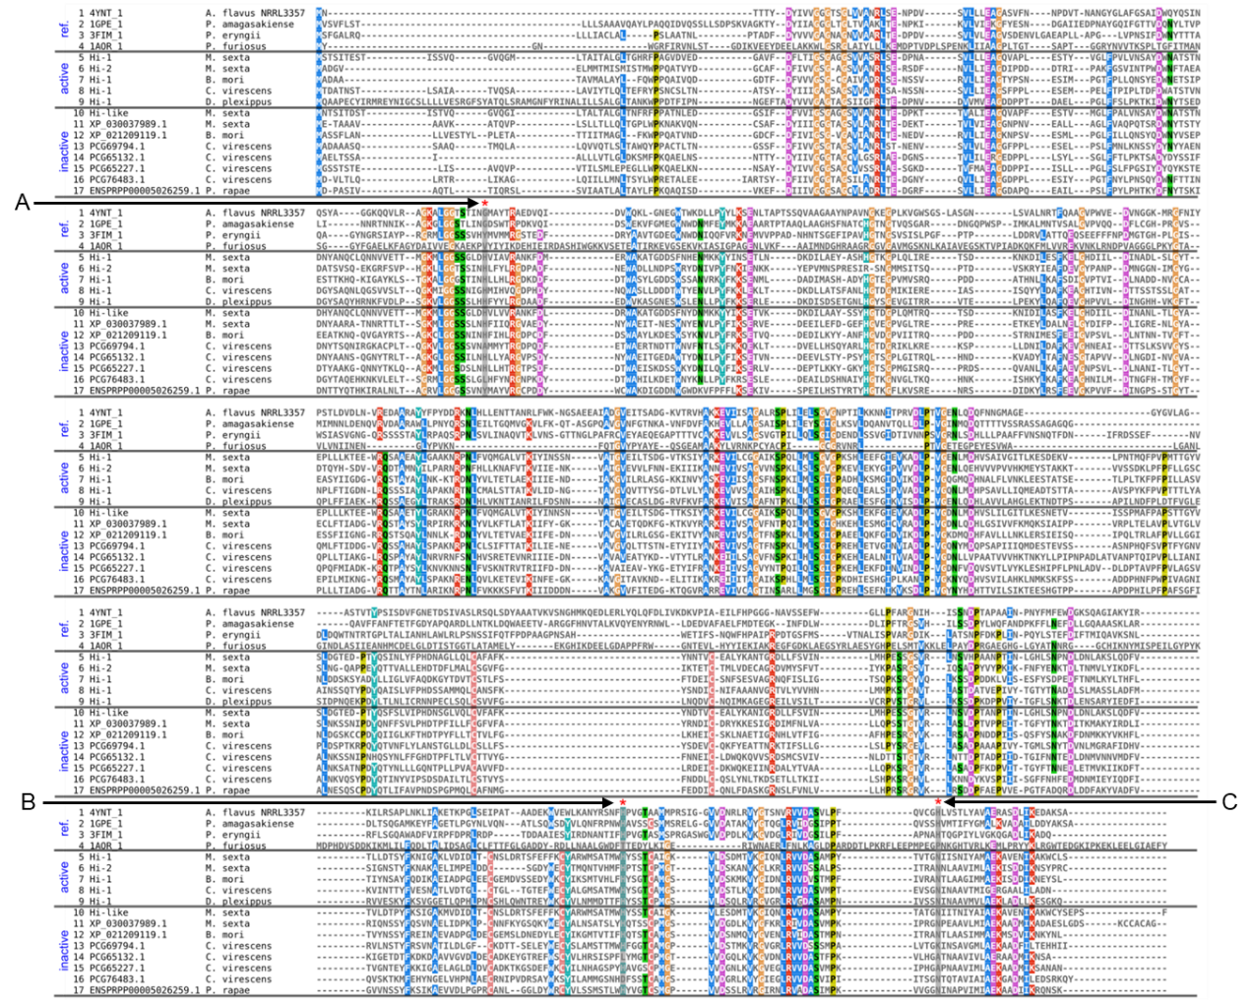

Supplementary Fig. 3: Alignment of Lepidopteran Hi homologs with four reference oxidoreductases. Label A (with a red asterisk) indicates a conserved histidine residue in Lepidopteran Hi proteins. Labels B and C (with red asterisks) denote the conserved catalytic histidine/histidine or histidine/asparagine pairs in GMC oxidoreductase family proteins. Rows 1–3 represent reference GMC oxidoreductases from fungi. Row 4 shows a non-GMC oxidoreductase protein (aldehyde ferredoxin oxidoreductase) from an archaeon. Rows 5–9 correspond to Lepidopteran Hi proteins that exhibit Hi activity, whereas rows 10–17 represent Lepidopteran Hi proteins that do not show Hi activity

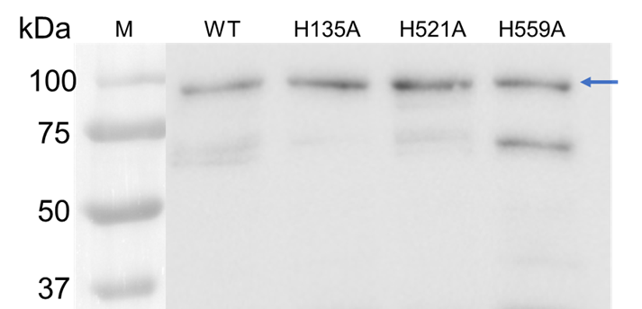

Supplementary Fig. 4. Western blot of recombinant wildtype MsHi-1 (WT) and three alanine-substitution MsHi-1 mutant proteins expressed in E. coli BL21. Blue arrow indicates the position of recombinant Hi. M denotes protein marker.

Supplementary Fig. 5: In planta assay for measuring Hi activity in wildtype and mutant MsHi-1 proteins. Leaf discs from tomato were mechanically wounded and treated with 10 µL of Milli-Q water (control), 0.1 µg of wildtype (WT) and three alanine-substitution MsHi-1 mutant proteins. Proportion of E-2-hexenal emitted from total aldehydes (Z-3-hexenal + E-2-hexenal) was calculated. Different letters indicate significant differences (p <0.05) between groups (ANOVA followed by Tukey HSD post-hoc analysis, F_{4,20}= 307.4, p <0.0001, n = 5).

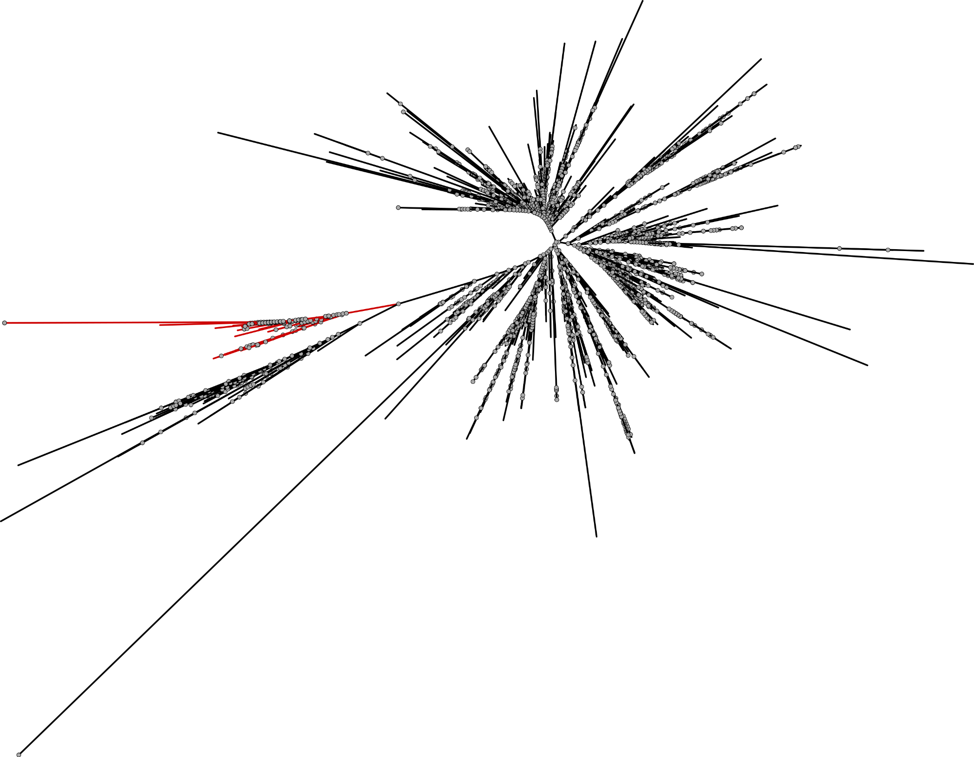

Supplementary Fig. 6: An un-rooted Maximum likelihood (ML) phylogenetic tree of the cupin superfamily. The ML tree was constructed using full-length protein sequences containing the cupin domain (Pfam: PF07883), combined with representative sequences from known cupin superfamily (Germin, Vicilin, Legumin, Globulin, and Hi). Branch support values are inferred using IQ-TREE/RAxML-NG. Previously characterized plant Hi (Kunishima et al., 2016; Spyropoulou et al., 2017) are clustered in a distinct subclade (highlighted in red).

Supplementary Fig. 7: Cladogram showing the diversity of putative Hi orthologs across the green lineage (Viridiplantae) representatives. Red lines highlight lineages that possess orthologs belonging to the Hi-potential clade. The numbers on branches indicate the number of species represented within each group.

References
Kunishima, M., Yamauchi, Y., Mizutani, M., Kuse, M., Takikawa, H., Sugimoto, Y., 2016. Identification of (Z)-3:(E)-2-Hexenal Isomerases Essential to the Production of the Leaf Aldehyde in Plants. J Biol Chem 291, 14023-14033.
Spyropoulou, E.A., Dekker, H.L., Steemers, L., van Maarseveen, J.H., de Koster, C.G., Haring, M.A., Schuurink, R.C., Allmann, S., 2017. Identification and Characterization of (3Z):(2E)-Hexenal Isomerases from Cucumber. Front Plant Sci 8, 1342.

