Supporting Information

Molecular Imaging of Pancreatic Duct Adenocarcinoma Using [¹⁸F]JR1004，a Cannabinoid Type 2 Receptor Targeted PET Probe

Can Jin ¹, Xinghai Cao ¹, Junwei Chen ¹, Dilong Mao ¹, Qinggang He ¹
¹School of Chemical Engineering and Biological Engineering, Zhejiang University, Hangzhou 310058, China;

- Chemical Synthesis
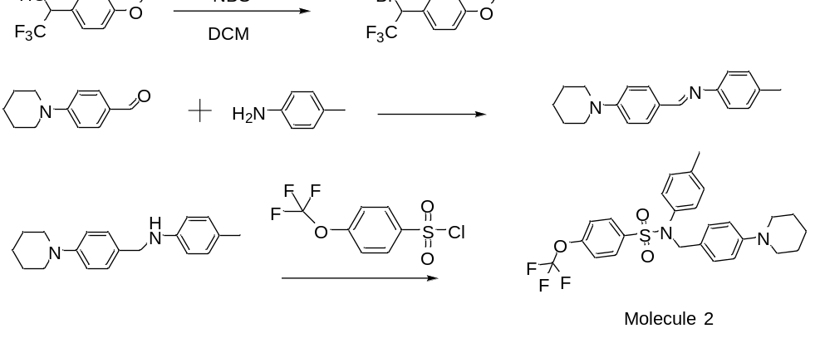

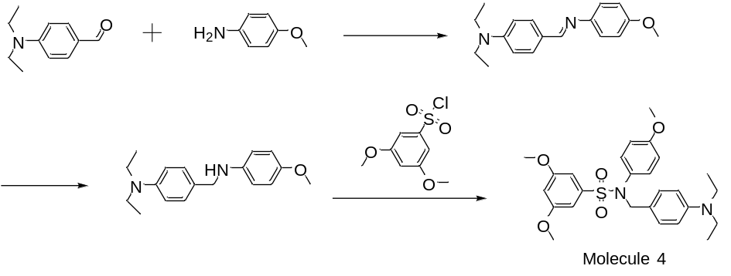
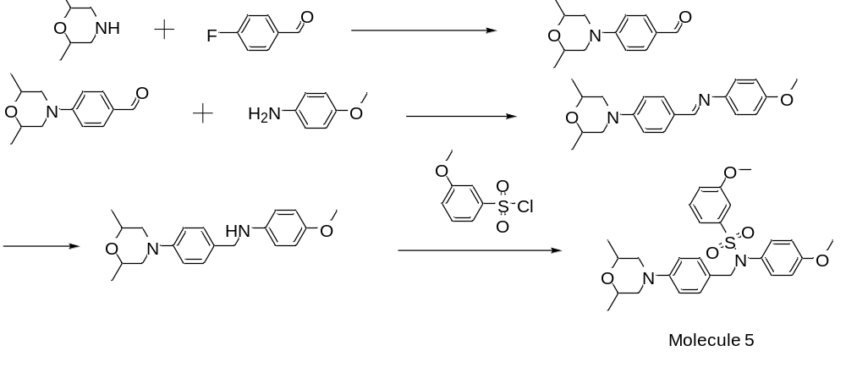
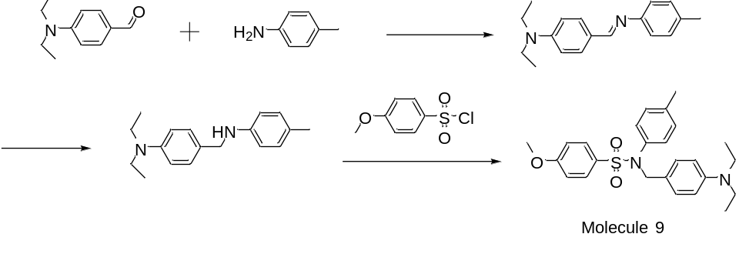

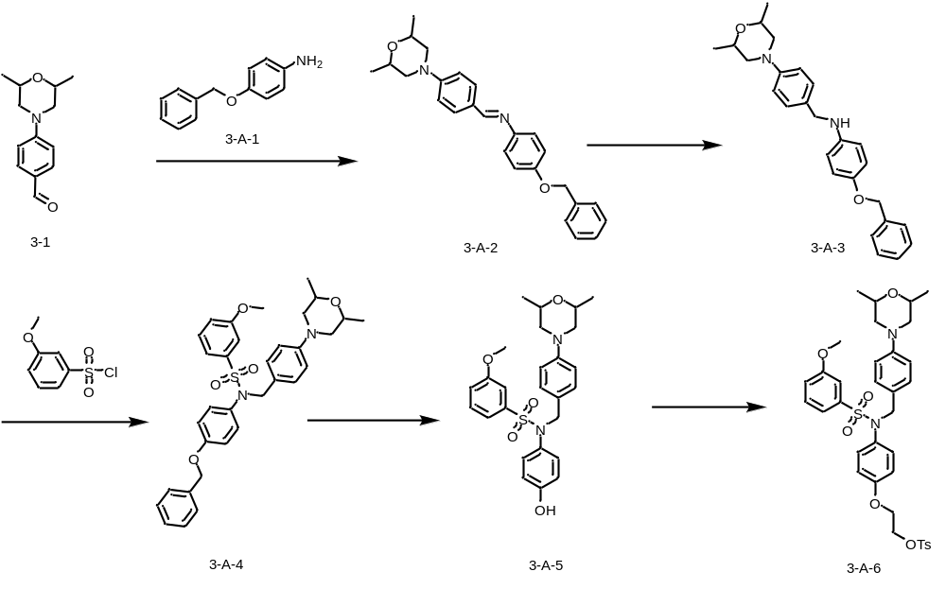
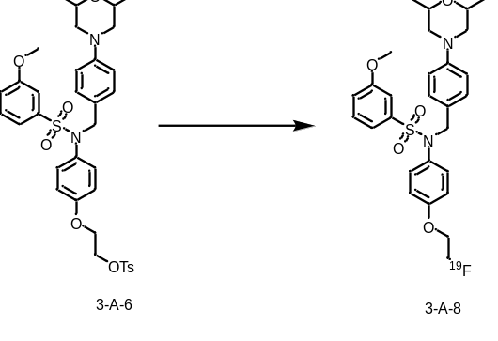
Figure S1: Design of synthetic routes for four lead compounds, along with preparation of the precursor compound and reference standard required for this probe.
3-A-3: A solution of 4-(2,6-dimethylmorpholinyl)benzaldehyde (1.27 g, 5.8 mmol) and 4-benzyl oxyaniline (1.156 g, 5.8 mmol) was prepared in methanol (40 ml). The addition of two drops of acetic acid was followed by stirring at room temperature for 2 hours. TLC monitoring (petroleum ether: ethyl acetate = 2:1) indicated formation of a new spot. The reaction mixture was cooled to 0°C and stirred in an ice bath. Sodium borohydride (438.8 mg, 11.6 mmol) was introduced and stirred in an ice bath for 30 minutes. The mixture was warmed to room temperature and stirred. Upon completion, the mixture was filtered and dried to yield 2.076 g of a gray-green solid product. 1H NMR: δ 7.28-7.41 (m, 5H), 7.19-7.21 (m, 2H), 7.02-7.04 (m, 1H), 6.87-6.89 (m, 2H), 6.74-6.76 (m, 2H), 6.50-6.53 (m, 2H), 4.93 (s, 2H), 4.07-4.09 (m, 2H), 3.64-3.71 (m, 2H), 3.51-3.54 (m, 2H), 2.17-2.23 (m, 2H), 1.13-1.15 (d, 2H).
3-A-4: 4-Benzyloxy-N-(4-(2,6-dimethylmorpholinyl)benzyl)aniline (2.076 g, 5.16 mmol) was dissolved in dichloromethane (40 ml), followed by the addition of N,N-diisopropylethylamine (1.334 g, 10.32 mmol). A dichloromethane solution (10 ml) containing m-methoxybenzenesulfonyl chloride(1.173 g, 5.676 mmol) was added dropwise to the solution at 0°C under ice bath conditions. After complete addition, the ice bath was removed, and the reaction mixture was stirred at room temperature for 16 hours. TLC monitoring (petroleum ether: ethyl acetate = 4: 1) revealed new spots. The mixture was diluted with water, extracted with DCM three times, washed twice with saturated sodium chloride solution, dried over anhydrous sodium sulfate, and filtered. Solvent evaporation under reduced pressure yielded the crude product, which underwent purification by silica gel column chromatography using gradient elution of PE/EA (15:1 to 3:1), affording 1.44 g of yellow solid product. 1H NMR: δ 7.35-7.40 (m, 5H), 7.26-7.29 (m, 2H), 7.07-7.11 (m, 4H), 6.84-6.86 (m, 2H), 6.74-6.79 (m, 4H), 4.97 (s, 2H), 4.60 (s, 2H), 3.73-3.80 (m, 5H), 3.38-3.41 (m, 2H), 2.33-2.39 (m, 2H), 1.23-1.24 (d, 6H).
3-A-5: Dissolve N-(4-(benzyloxy)phenyl) -N-(4-(2,6-dimethylmorpholinyl)benzyl) -3- methoxy benzenesulfonamide (1.44 g, 2.51 mmol) was dissolved in 120 ml of methanol and 40 ml of tetrahydrofuran. Palladium carbon (10%, 150 mg) was added, and the mixture was hydrogenated for 16 hours TLC monitoring (petroleum ether: ethyl acetate = 2:1) indicated the formation of a new spot. Vacuum rotary evaporation removed the solvent, yielding a crude product, which underwent purification by silica gel chromatography using a gradient elution of petroleum ether: ethyl acetate 10:1 to 2:1. The process yielded 640 mg of a light yellow oily product. 1H NMR: δ 7.19-7.25 (m, 2H), 6.99-7.07 (m, 4H), 6.65-6.71 (m, 4H), 6.51-6.54 (m, 2H), 4.52 (s, 2H), 3.66-3.73 (m, 5H), 3.30-3.33 (m, 2H), 2.26-2.31 (m, 2H), 1.15-1.17 (d, 6H).
3-A-6: N-(4-(2,6-dimethylmorpholinyl)benzyl) -N-(4-hydroxyphenyl)-3- methoxy benzenesulfona- mide (450 mg, 0.93 mmol) was dissolved in 15 mL of acetonitrile. Cesium carbonate (1215 mg, 3.73 mmol) was added to the solution and stirred for 15 minutes. Subsequently,1,2-bis(toluenesulfonyloxy) ethane (1382 mg, 3.73 mmol) was added and stirred at 45°C overnight. TLC monitoring (petroleum ether: ethyl acetate = 2:1) indicated the formation of new spots. Water was added, and the mixture was extracted with ethyl acetate three times, and the ethyl acetate phases were combined. The solution was washed with saturated sodium chloride solution twice, dried over anhydrous sodium sulfate, and filtered. The solvent was removed by vacuum rotary evaporation to obtain a crude product, which was purified by silica gel chromatography, using petroleum ether: ethyl acetate 8:1 to 2:1 for gradient elution to yielding 450 mg of a white oily product. 1H NMR: δ 7.77-7.79 (m, 2H), 7.23-7.41 (m, 4H), 7.10-7.12 (m, 2H), 7.04-7.06 (m, 2H), 6.80-6.83 (m, 2H), 6.73-6.75 (m, 2H), 6.59-6.61 (m, 2H), 4.59 (m, 2H), 4.30-4.32 (m, 2H), 4.06-4.14 (m, 4H), 3.37 (s, 3H), 3.37-3.40 (m, 2H), 2.44 (s, 3H), 2.31-2.37 (m, 2H), 1.22-1.26 (m, 6H), 3.79 (2H), 2.35 (3H), 1.29 (6H).
3-A-8: A mixture of 3-A-6 (100 mg, 0.15 mmol) and tetrabutylammonium fluoride (TBAF) (117.6 mg, 0.45 mmol) in anhydrous THF was placed in a sealed microwave vial. The reaction mixture was stirred at 70 ℃ in an oil bath for 2 h, and the progress was monitored by TLC (petroleum ether/ethyl acetate = 2:1, v/v), which indicated the formation of a new spot. The crude product was purified by preparative thin-layer chromatography (PTLC) to afford 3-A-8 (18 mg) as a pure compound. 1H NMR: δ7.30-7.34(m, 1H), 7.19-7.21(m, 3H), 6.99-7.06(m, 4H), 6.77-6.79(m, 2H), 6.65-6.68(m, 2H), 4.69-4.71(m, 1H), 4.57-4.59(m, 1H), 4.53(s, 2H), 4.02-4.11(m, 2H), 3.66-3.71(m, 5H), 3.30-3.33(m, 2H), 2.26-2.31(m, 2H), 1.15-1.18(m, 6H) .
2. Pancreatic Cancer Tissue Section
The microscopic examination of a pancreatic cancer section demonstrates significant pathological alterations during carcinogenesis, as illustrated in Figure S7. The analysis reveals a marked increase in cancer cell population and density, with cells exhibiting varying morphologies and pronounced atypia, characteristic of pancreatic cancer. The normal pancreatic architecture, including acinar and ductal structures, appears disrupted, with cells displaying disorganized arrangement. Furthermore, the pancreatic cancer tissue exhibits interstitial fibrosis, characterized by fibrous tissue proliferation, resulting in increased tissue density.
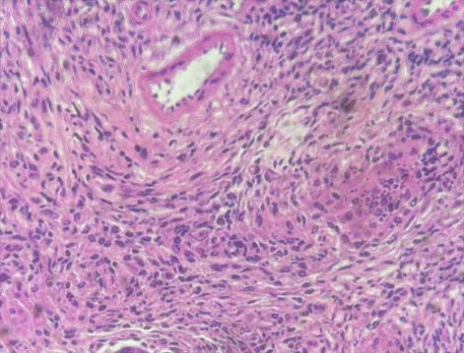 | 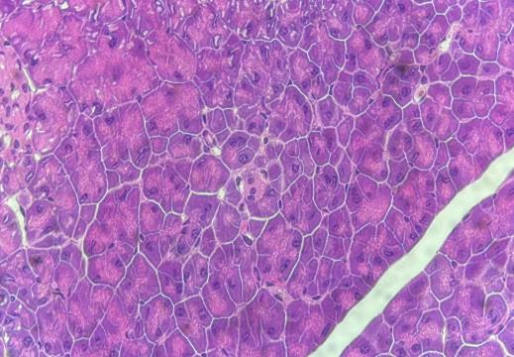
Tumor | Normal
Figure S2. Normal pancreatic tissue and pancreatic cancer tissue staining
3. Computer-Aided Drug Design (CADD) in Molecular Docking and Virtual Screening
CADD constitutes an innovative approach in contemporary pharmaceutical research, providing sophisticated tools for molecular-level drug discovery and development. Through the integration of computational chemistry, bioinformatics, and molecular modeling techniques, CADD enables detailed analysis of drug-target interactions and supports rational drug design. The methodology incorporates several essential computational approaches: virtual screening systematically identifies lead compounds from extensive molecular databases; molecular docking determines optimal binding conformations and affinity between ligands and their targets; QSAR analysis establishes quantitative relationships between chemical structures and biological activity; while molecular dynamics simulations elucidate the dynamic behavior of biomolecular systems.
Utilizing Discovery Studio software, we examined the common structural features of compounds demonstrating activity against the CB2 receptor, identifying critical pharmacophore elements including specific hydrogen bond donors, acceptor atoms, and hydrophobic group distribution. Following pharmacophore model construction, we employed it as a template for database screening, identifying compounds that aligned with the established pharmacophore features. These compounds theoretically present higher potential for desired activity against the CB2 receptor.
Following this, pharmacophore-based virtual screening was conducted on chemical databases to identify compounds showing high complementarity with the CB2R binding pocket. The screening outcomes underwent validation through molecular docking and binding free energy calculations, resulting in an election of compounds with predicted high binding affinity.
Through molecular modeling of reported CB2R antagonists (using Schrödinger AutoQSAR) and structure-activity relationship (SAR) analysis of known small-molecule ligands, we designed 54 novel compounds. Additionally, the induced-fit docking (IFD) module in MOE was employed to process the reported crystal structure (5ZTY) and generate optimized protein conformations suitable for ligand binding. All 54 molecules were then docked using Schrödinger Ligand Dock, prioritizing compounds with higher predicted binding affinities. These molecules were further required to exhibit reasonable binding modes, forming stable interactions (e.g., hydrogen bonds or hydrophobic contacts) with key active-site residues, while also complying with drug-like properties (e.g., Lipinski’s rule). This process yielded 14 candidate molecules.
A comprehensive SAR analysis incorporating QSAR and docking results was then conducted on these 14 candidates to evaluate their theoretical activity (e.g., inhibitory concentration (IC50), Ki values). Molecules showing low predicted activity or inconsistent activity patterns were eliminated, and quantitative relationships between structural features (e.g., substituents, functional groups, hydrophobicity) and activity were examined. Pharmacophore features (e.g., hydrogen bond donors/acceptors, hydrophobic centers, aromatic rings) were identified, and only molecules demonstrating full or high pharmacophore matching with significant activity contributions were retained. This refinement process identified nine final drug candidates.
ADMET properties were predicted using ADMETLab 2.0 (for reference only, not as exclusion criteria). Based on the CNS drug-like rules (MW, tPSA: 60-70 Å, LogP≤4, HBA≤7, HBD≤3) and synthetic feasibility, four compounds (2, 4, 5, 9) among these 9 final drug candidates were prioritized.
These four candidates, alongside our in-house lead compound and four commercial CB2R-targeting drugs, underwent cellular IC₅₀ assays. Combined with cytotoxicity assessments, compound 5 was selected as the lead for subsequent probe synthesis.
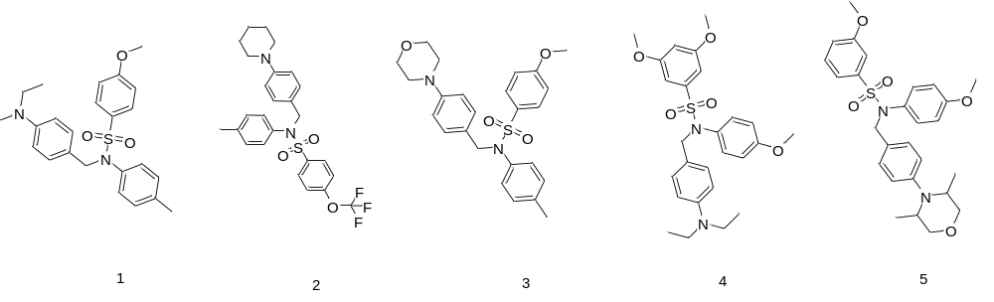
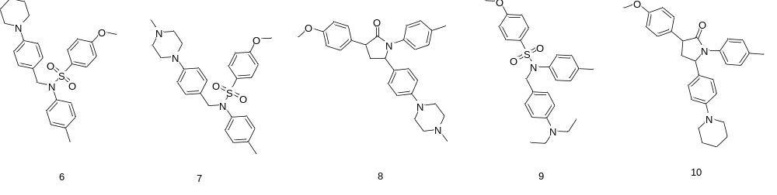
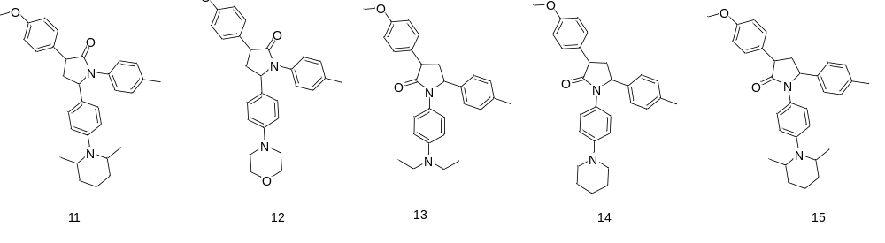
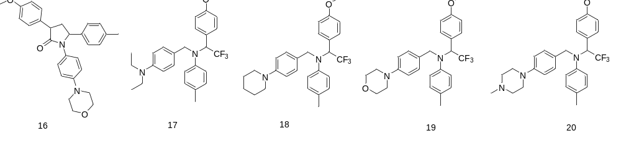
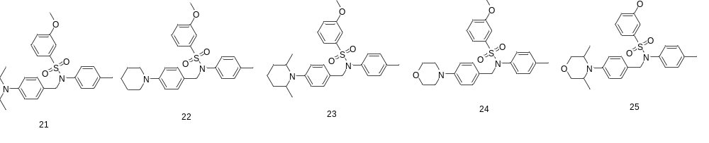
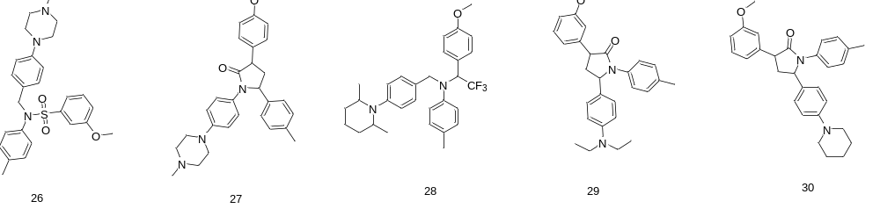
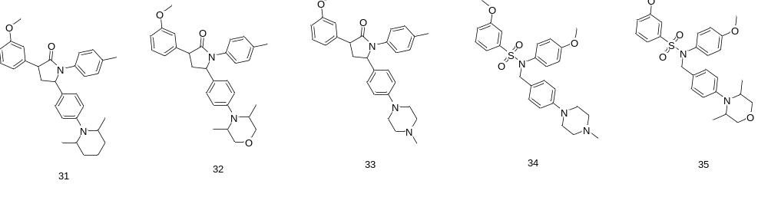
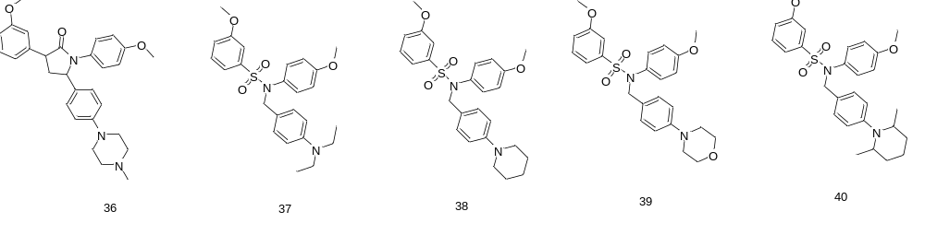
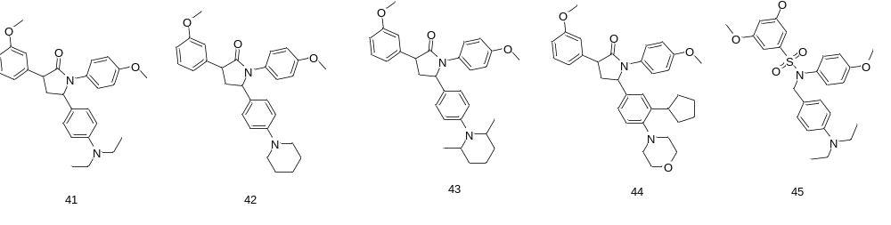
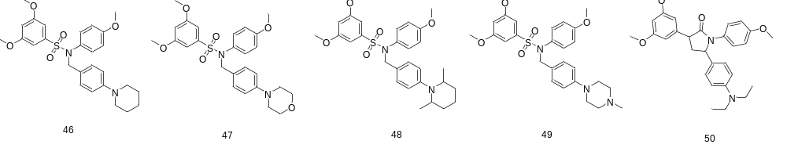
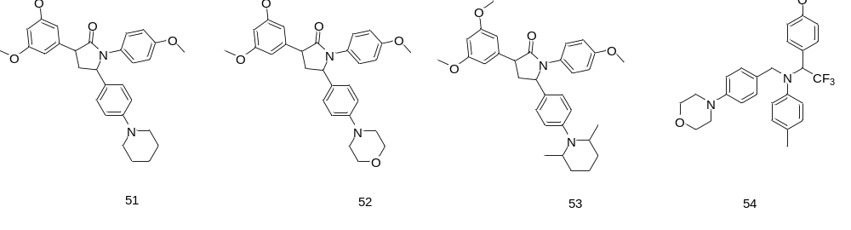

Figure S3. The molecular structures of the 54 compounds identified through CADD virtual screening are presented here. Due to research constraints, a selected subset of the compound structures is displayed.
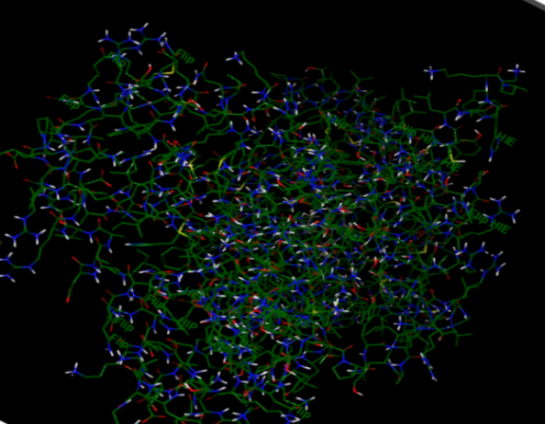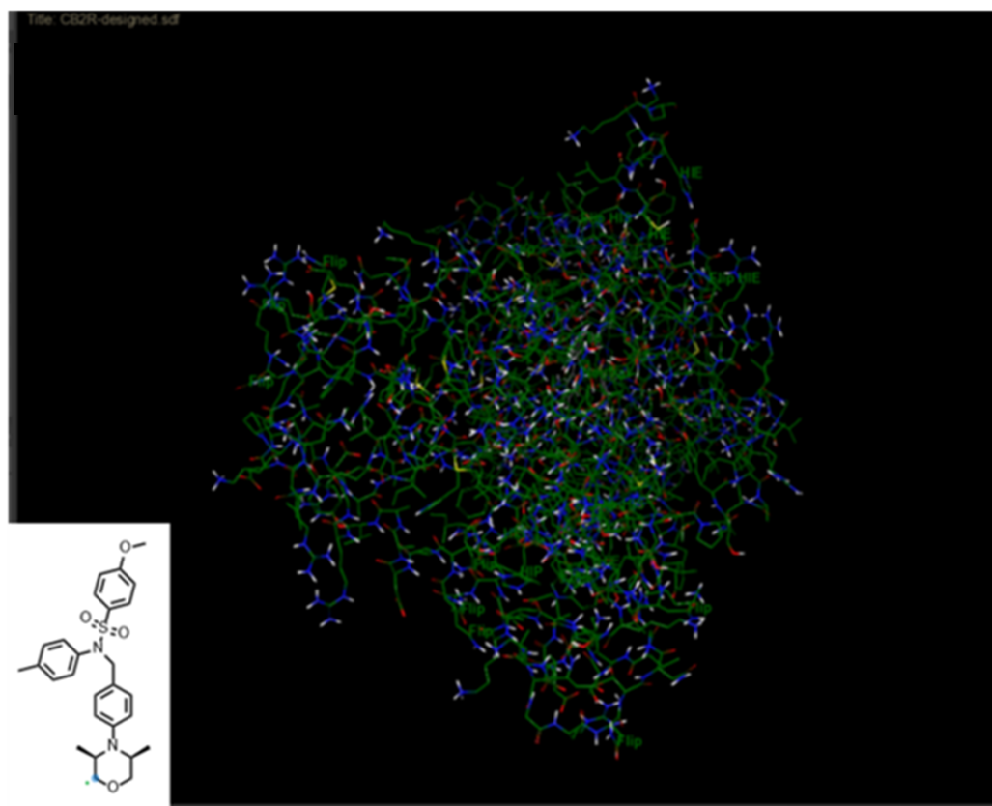
a b
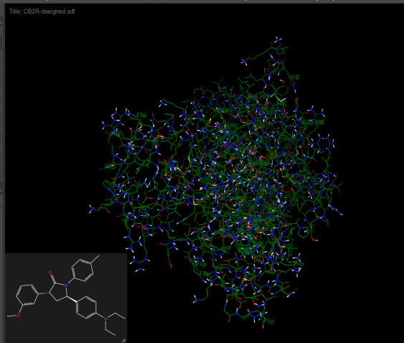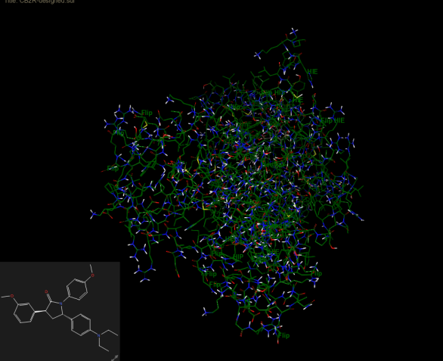
c d
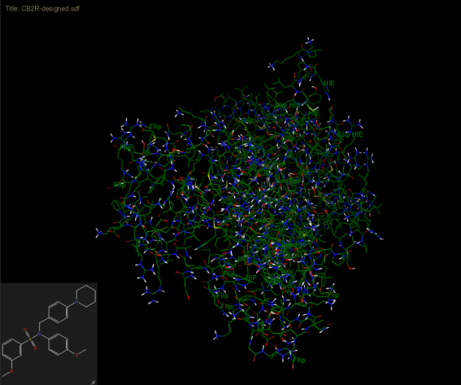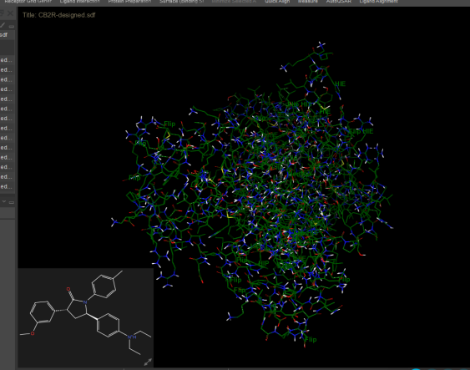
e f
Figure S4：Application of the CADD Screening Process in This Study. Panel (a) depicts the three-dimensional structure of CB2R protein, while panels (b)-(f) demonstrate the computationally determined molecular configurations at the CB2R binding site. Due to spatial limitations, only a subset of the content is shown.

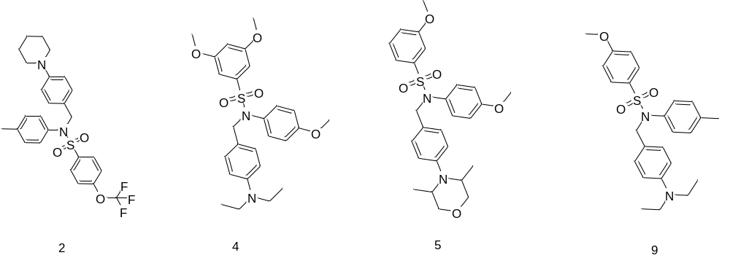
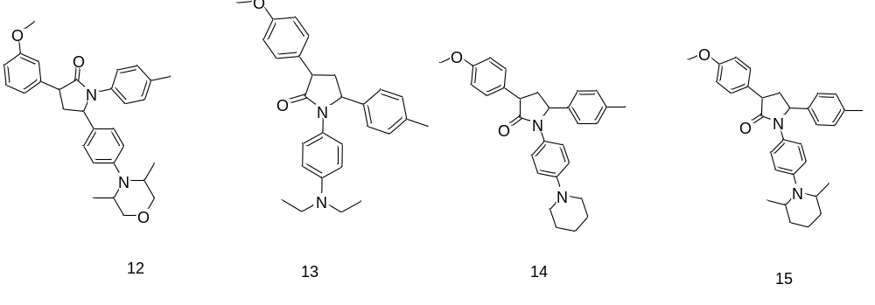
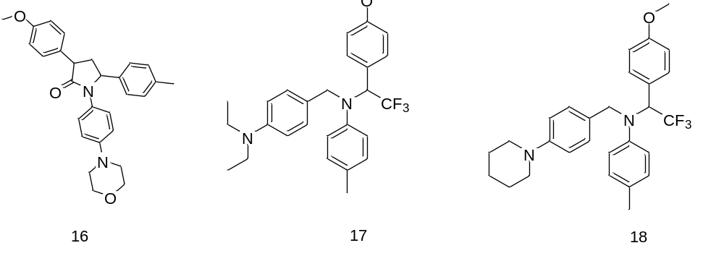
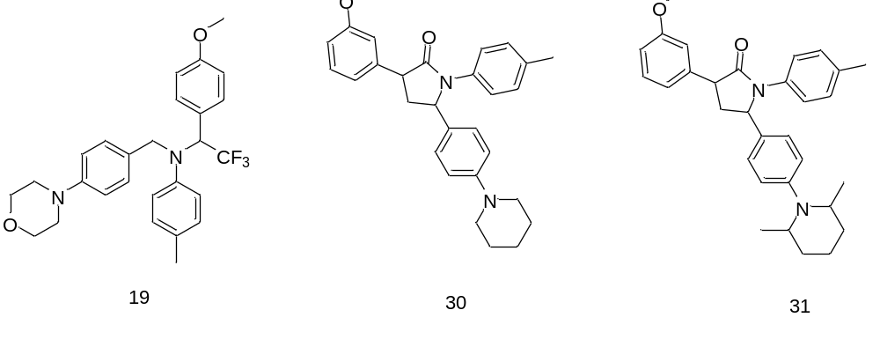

Figure S5. Chemical structures of the 14 highest-ranked bioactive compounds identified through virtual screening of 54 candidate molecules.

Molecule 2 | Molecule 4 | Molecule 5 Molecule 9 Molecule X
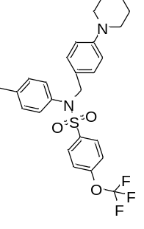 | 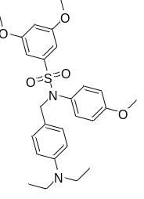 | 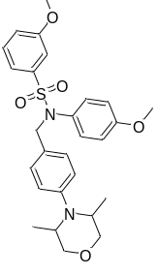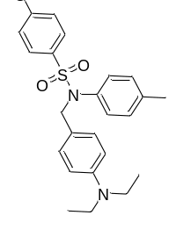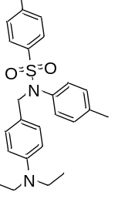
CB2 modulator 1 | PGN36 | CB2R antagonist 3 | CB1-IN-1
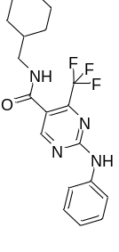 | 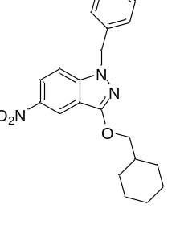 | 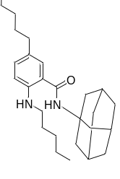 | 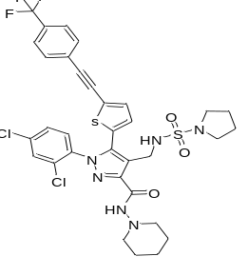
Figure S6：Structural characterization of four lead compounds identified through virtual screening of nine candidates and four CB2R-targeted drugs currently available on the market. Molecule X: represents lead compounds previously studied by our research group.
Molecule 2 | Molecule 4 | Molecule 5 | Molecule 9
CB2 modulator 1 | PGN36 | CB2R antagonist 3 | CB1-IN-1
Molecule X
Figure S7：IC₅₀ testing of four candidate molecules, our previously studied lead compound X, and four commercially available CB2R-targeting drugs in cellular assays.

4. Radiochemical Synthesis
The dried ¹⁸F fluoride was combined with the precursor compound in anhydrous acetonitrile and heated at 100°C for 5 minutes. Following reaction completion, the mixture was cooled to room temperature. A sample was extracted via pipette, and the crude product underwent analysis by radioactive HPLC, followed by purification using semi-preparative liquid chromatography. Radiolabeled components were monitored using a Bioscan FC3500A radio-thin layer chromatography detector. The chromatographic conditions were as follows: A Phenomenex Synergi Hydro-RP reversed-phase column served as the semi-preparative column. Mobile phase A consisted of a 1‰ trifluoroacetic acid aqueous solution. Mobile phase B comprised acetonitrile, with a flow rate of 5 mL/min, utilizing a gradient of 55% mobile phase B (0-15 min)→85% mobile phase B (20-30 min). Detection occurred at 254 nm, wavelength using the Bioscan FC3500A radioactive probe. The PET tracer was column-adsorbed, washed with physiological saline, and filtered through a 0.20 μm sterile filter membrane to obtain a sterile sample for subsequent use. A sample of the PET tracer was mixed with 1 mg of the standard [¹⁹F]-JR-1004 and identified via radio-HPLC.
- Cell-based binding assay
Cell experiments were performed using 24-well plates. hCB2R-CHO, hCB1R-CHO, and CHO cells were seeded at a density of 1×10⁴ cells/well. The experimental design incorporated 14 test groups for hCB2R-CHO cells and one control group each for hCB1R-CHO and CHO cells, with triplicate wells per condition. After 24 h incubation at 37°C with 5% CO₂, the assay commenced with culture medium replacement. Cells were then incubated for 15, 30, 60, or 90 min at designated time points. For hCB1R-CHO and CHO control groups, compound solutions (serially diluted in DMSO) were introduced and incubated for 60 min. Following treatment, cells underwent two PBS washes, and cell viability was evaluated according to the manufacturer's CCK-8 assay protocol. The half-maximal IC50 values were then calculated.
- Cell transfection
High CB1R-CHO cells (hCB1R-CHO) and high CB2R-CHO cells (hCB2R-CHO) were seeded into well plates for specific binding tests between the PET tracer and CB2R. The experimental conditions maintained 37 ℃ and 5% CO₂. The CHO cell line was maintained in complete medium comprising DMEM high glucose medium, 10% FBS, streptomycin (100 μg/ml) and penicillin (100 U/ml).
The hCB2R-CHO cell line with high expression of hCB2R was established through DNA plasmid transfection of CHO cells. Initially, 2.5μg of DNA plasmid was diluted in 125μL of Opti-MEM culture medium, while 12.5μL of EndoFectin Max transfection reagent was diluted in 112.5μL of culture medium. The diluted solutions were maintained at room temperature for 5 minutes. The solutions were then combined gently and incubated at room temperature for 20 minutes to facilitate complete DNA-Endofectin complex formation. The resulting complex was added dropwise to CHO cells in a six-well culture plate, with continuous agitation to ensure uniform distribution of the transfection reagent. Following incubation at 37°C and 5% CO₂ for 72 hours, cell selection was performed using puromycin (1μg/mL), and the selected cells were cultured for expansion. For [¹⁸F]JR-1004 uptake and binding studies, hCB2R-CHO (6 groups), hCB1R-CHO (1 group), and CHO (1 group) cells were plated in 24-well plates (1×10⁴cells/well, n=3 replicates/group) to assess temporal changes in [¹⁸F]JR-1004 cellar uptake and its binding specificity to hCB2R.
- Partition coefficient
The lipid-water partition coefficient of [^{18/19}F]JR-1004 was determined using the shake-flask method to assess the molecular structure’s lipophilicity. An ethanol solution of [¹⁸F]JR-1004 was combined with equal volumes of pre-saturated n-octanol and PBS. Following vortexing and centrifugation, equal volumes from both phases were collected for gamma counting.
The logD7.4 was determined by subtracting background gamma counts using the formula: $logD7.4=log[(CPM(tracer in n-octanol)-CPM (background))/( CPM (tracer in PBS)-CPM (background))]$. For [¹⁹F]JR-1004, the logD7.4 value was calculated based on the UV absorption peak area (AUC) of its corresponding [¹⁹F]JR-1004, utilizing the equation: $logD7.4=log[AUC()]JR-1004 in n-octanol)/AU([]JR-1004 in PBS)$ .
The measured logD7.4 values were 4.42 (n=3) for [¹⁸F]JR-1004 and 4.43 (n=3) for [¹⁹F]JR-1004.

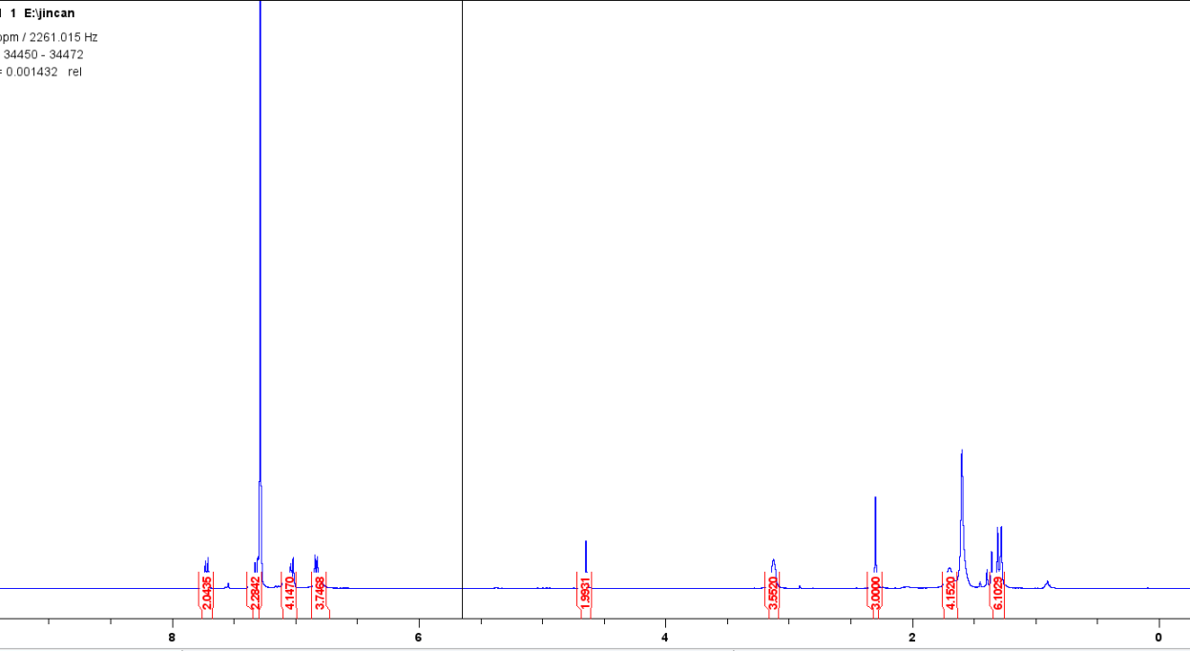
Figure S8 Molecule 2

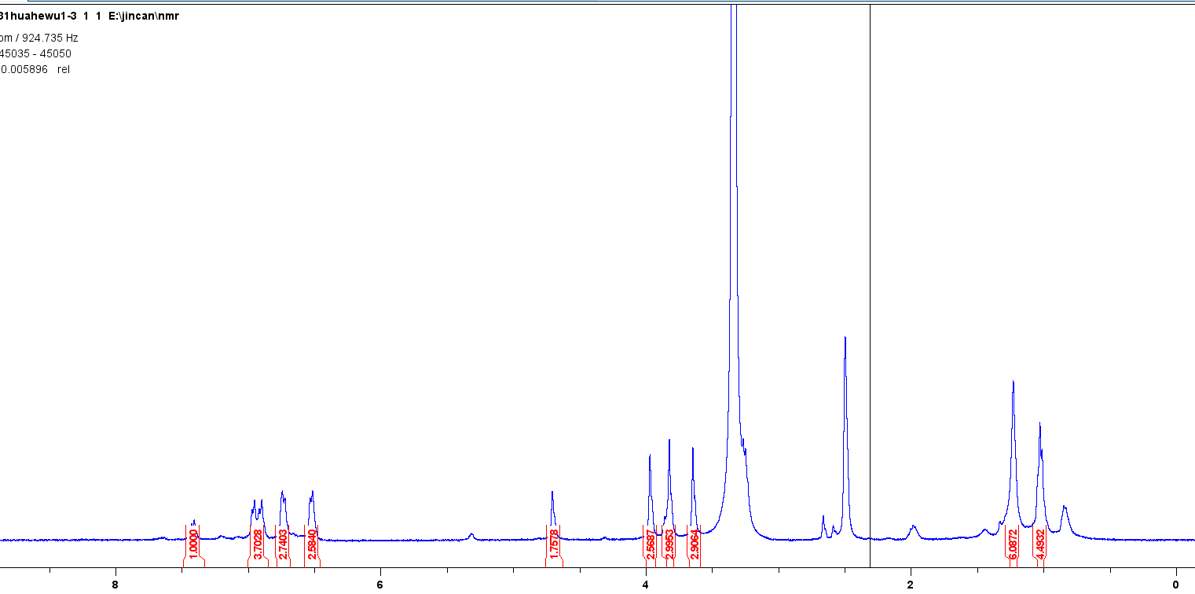
Figure S9 Molecule 4
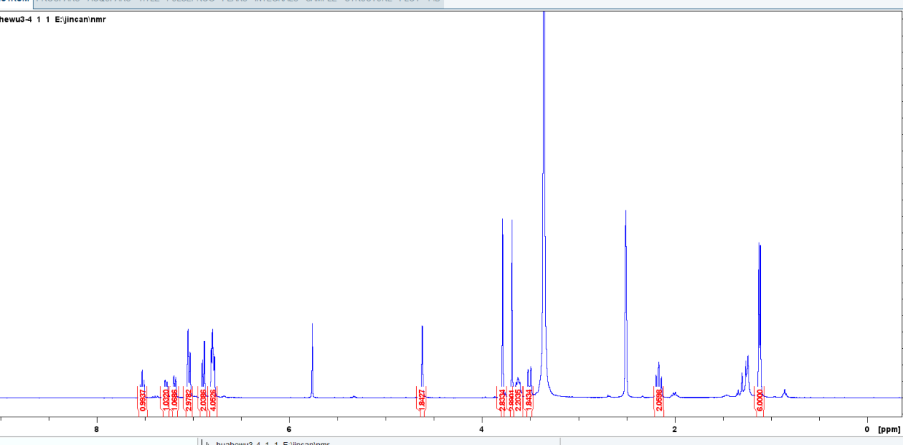
Figure S10 Molecule 5

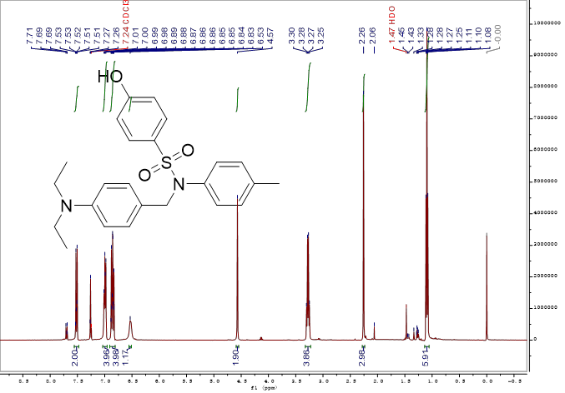
Figure S11 Molecule X

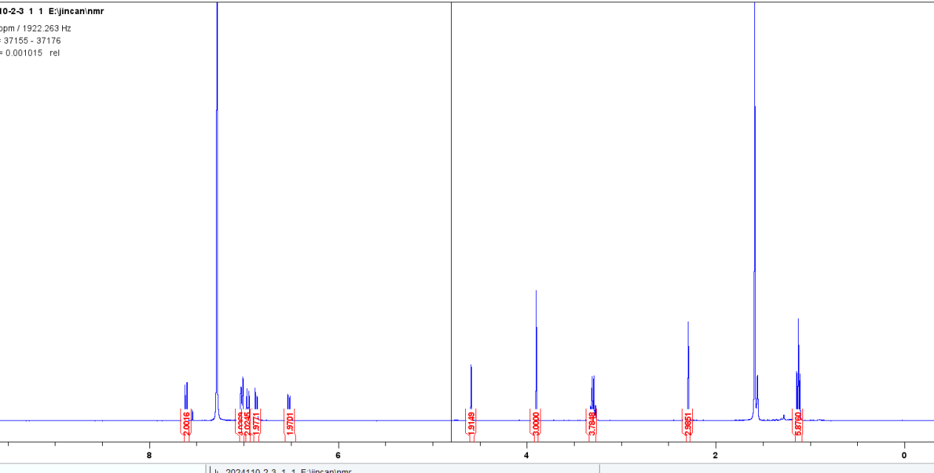
Figure S12 Molecule 9
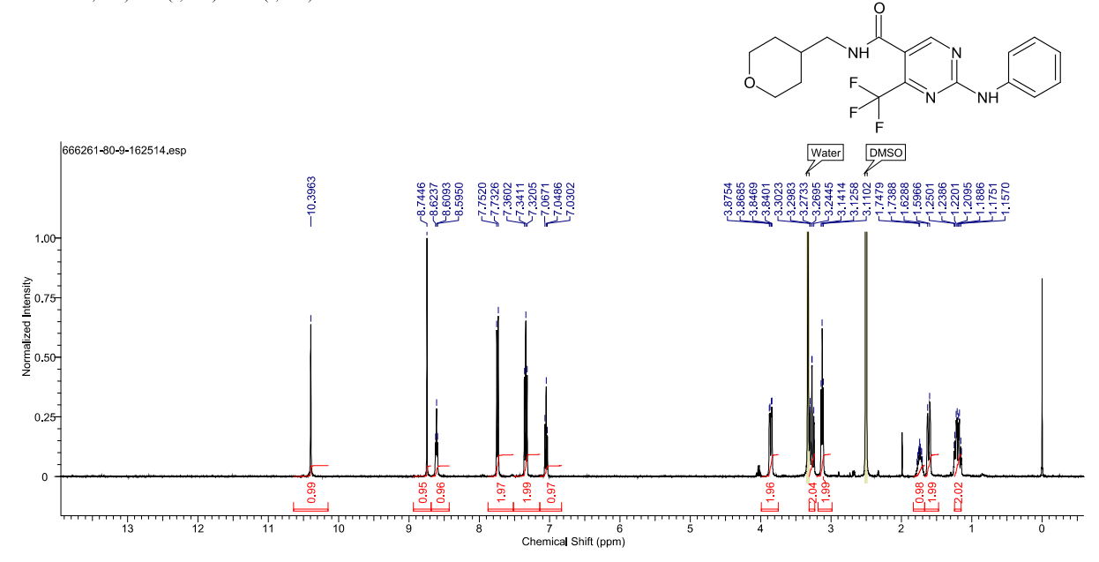
Figure S13 CB2 modulator 1

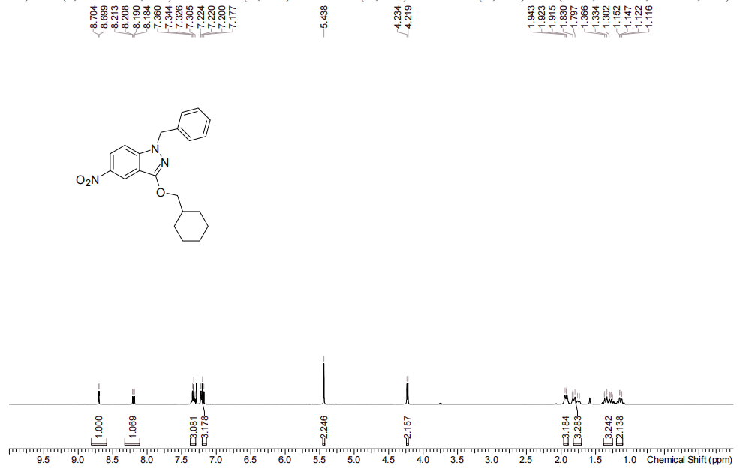
Figure S14 PGN36

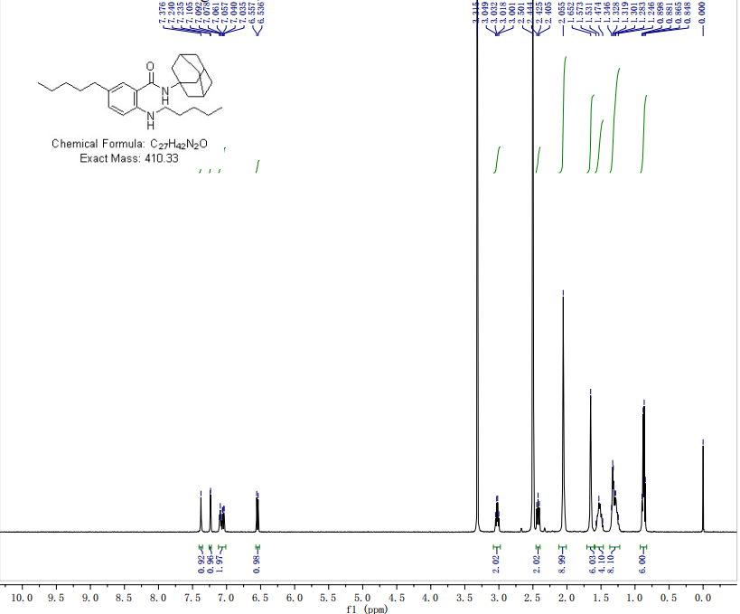
Figure S15 CB2R antagonist 3

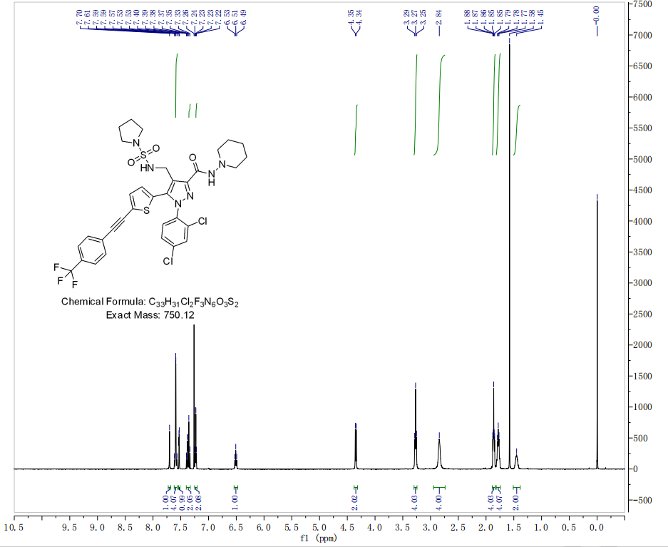
Figure S16 CB1-IN-1
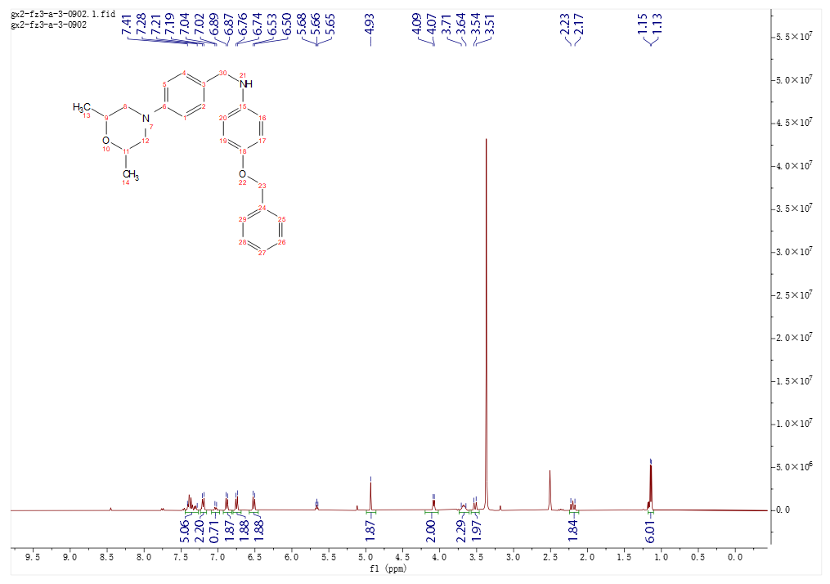
Figure S17 3-A-3
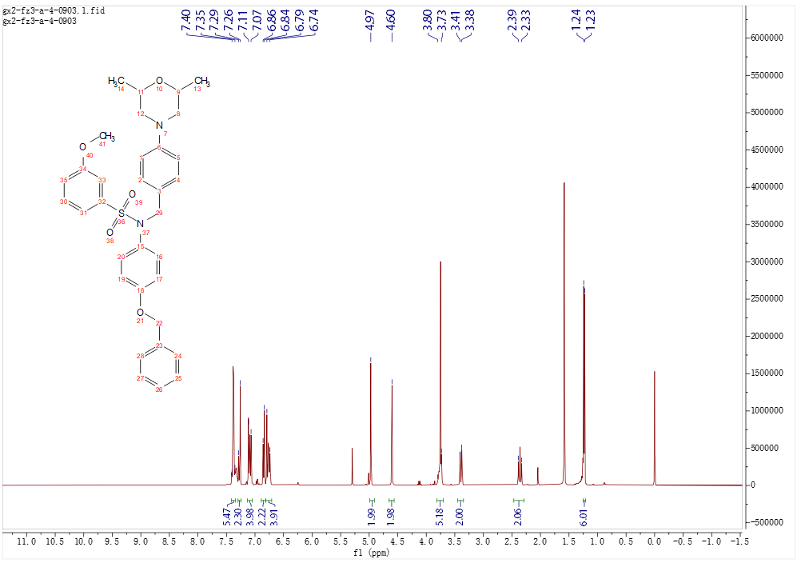
Figure S18 3-A-4
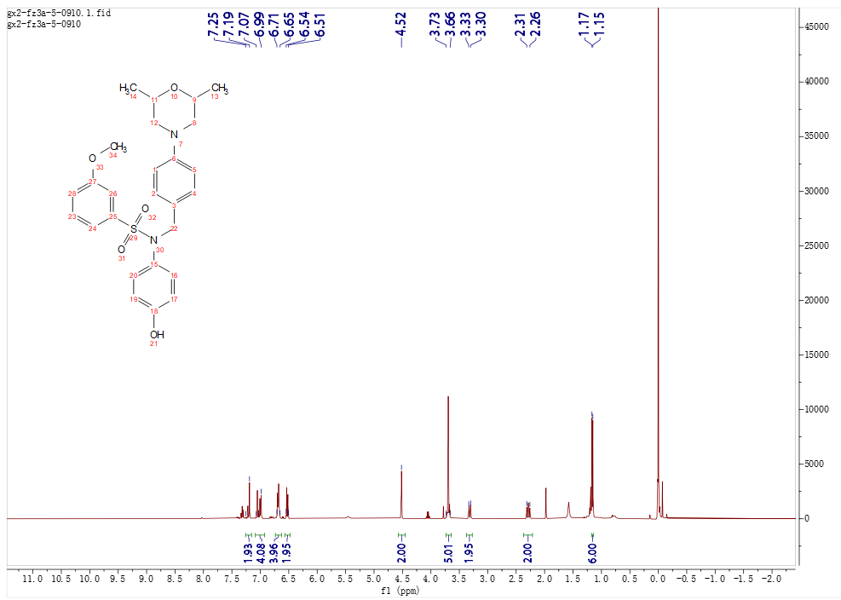
Figure S19 3-A-5
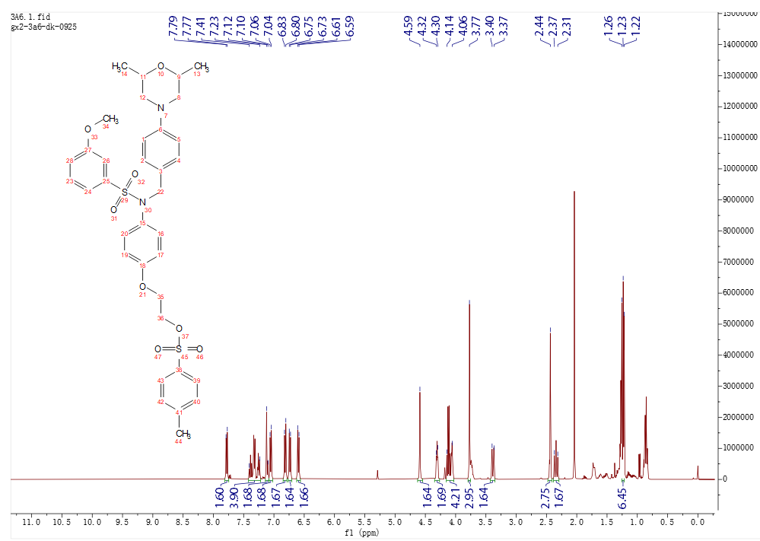
Figure S20 3-A-6

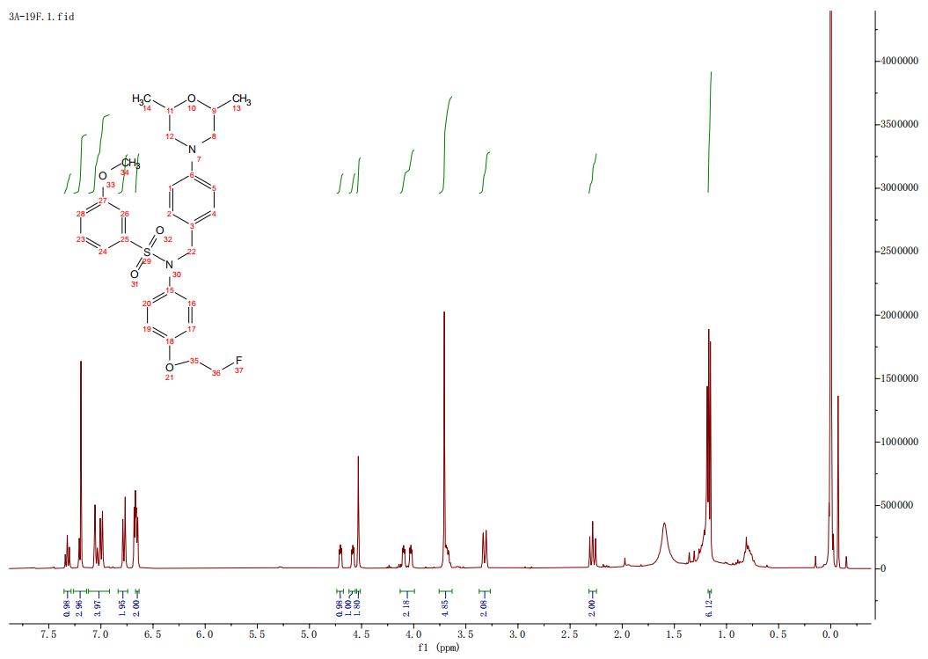
Figure S21 3-A-F

.
Table S1 9 virtual screening-derived bioactive compound structures from 14 candidates
Number | 2D Structure | MWg/mol | PSA/Å | LogP | HBA | HBD | RotB
2 | 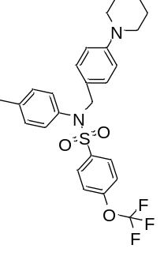 | 504.17 | 15.71 | 6.939 | 3 | 0 | 8
4 | 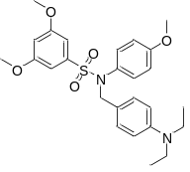 | 484.2 | 68.31 | 5.45 | 7 | 0 | 11
5 | 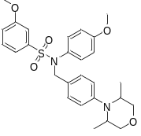 | 496.2 | 68.31 | 4.493 | 7 | 0 | 8
9 | 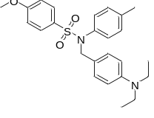 | 438.2 | 49.85 | 5.795 | 5 | 0 | 9
13 | 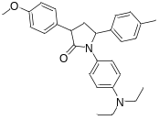 | 428.25 | 32.78 | 6.177 | 4 | 0 | 7
15 | 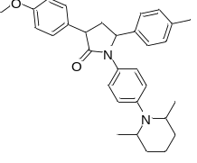 | 468.28 | 32.78 | 6.253 | 4 | 0 | 5
17 | 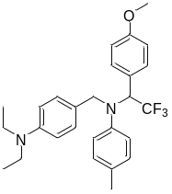 | 456.24 | 15.71 | 6.795 | 3 | 0 | 10
30 | 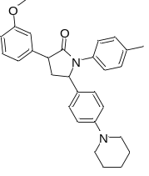 | 440.25 | 32.78 | 6.303 | 4 | 0 | 5
31 | 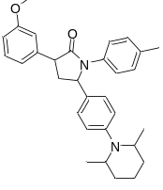 | 468.25 | 32.78 | 6.225 | 4 | 0 | 5

