Supporting Information for Original article

Deep Learning-Enhanced QSAR Modeling for Predicting Developmental Neurotoxicity Based on Molecular Initiating Events from Adverse Outcome Pathways

Eufrásia de Sousa Pereira ^{1*}, Vinícius Alexandre Fiaia Costa,¹ Eder Soares de Almeida Santos,¹ Bruno Junior Neves ^{1,}*
¹ Laboratory of Cheminformatics, Faculty of Pharmacy, Federal University of Goiás, Goiânia, Brazil

*Author for correspondence: E-mail addresses: brunoneves@ufg.br (Bruno Junior Neves), efrsousa@gmail.com (Eufrásia de Sousa Pereira)

Journal: Molecular Diversity

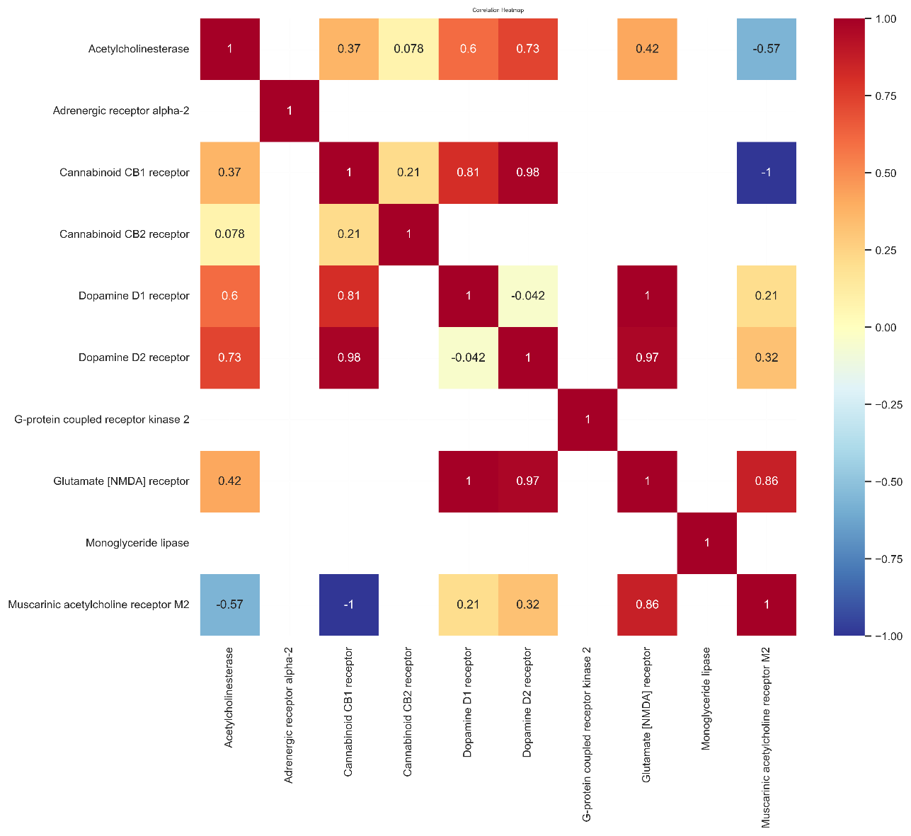

Fig. S1 Heat maps showing the correlation among the pIC₅₀ values of the ten tasks.

Fig. S2 Schematic workflow of the Deep Learning-Enhanced QSAR modeling framework for predicting developmental neurotoxicity, integrating AOP concepts, data curation, model development, and interpretability analysis.
Table S1 Summarized statistical characteristics of multitask and single-task models developed using random split.
Assay | FNN |  |  | RF |  |  | LightGBM |  |  | MT-FNN |  |  | SVM
Assay | r | MAE | RMSE | r | MAE | RMSE | r | MAE | RMSE | r | MAE | RMSE | r | MAE | RMSE
CB1 | 0.881 ± 0.008 | 0.415 ± 0.015 | 0.529  ±  0.035 | 0.711 ± 0.009 | 0.958 ± 0.051 | 1.239  ±  0.198 | 0.691 ± 0.308 | 1.06  ± 0.036 | 1.317  ±  0.118 | 0.804 ± 0.018 | 0.524 ± 0.034 | 0.648  ± 0.042 | 0.581 ± 0.03 | 0.79  ± 0.013 | 1.016  ± 0.007
CB2 | 0.869 ± 0.082 | 0.605 ± 0.031 | 0.736 ± 0.126 | 0.802 ± 0.38 | 1.096 ± 0.015 | 1.579 ± 0.345 | 0.96 ± 0.376 | 1.168 ± 0.057 | 1.735 ± 0.515 | 0.778 ± 0.022 | 0.534 ± 0.015 | 0.662 ± 0.027 | 0.578 ± 0.029 | 0.744 ± 0.019 | 0.95 ± 0.024
MAGL | 0.836 ± 0.053 | 0.693 ± 0.079 | 0.825 ± 0.077 | 0.789 ± 0.234 | 0.88 ± 0.051 | 1.164 ± 0.174 | 0.804 ± 0.286 | 1.164 ± 0.076 | 1.472 ± 0.17 | 0.872 ± 0.046 | 0.564 ± 0.08 | 0.71 ± 0.096 | 0.733 ± 0.022 | 0.897 ± 0.061 | 1.197 ± 0.073
AchE | 0.829 ± 0.035 | 0.75 ± 0.052 | 0.898 ± 0.097 | 0.777 ± 0.193 | 0.879 ± 0.039 | 1.09 ± 0.094 | 0.706 ± 0.323 | 1.062 ± 0.169 | 1.306 ± 0.197 | 0.876 ± 0.02 | 0.566 ± 0.035 | 0.724 ± 0.053 | 0.738 ± 0.035 | 0.747 ± 0.041 | 1.14 ± 0.071
D₁ | 0.813 ± 0.026 | 0.603 ± 0.054 | 0.727 ± 0.093 | 0.762 ± 0.138 | 0.782 ± 0.024 | 0.967 ± 0.043 | 0.752 ± 0.278 | 0.944 ± 0.046 | 1.214 ± 0.199 | 0.792 ± 0.033 | 0.53 ± 0.038 | 0.654 ± 0.052 | 0.721 ± 0.047 | 0.704 ± 0.037 | 0.891 ± 0.048
D₂ | 0.788 ± 0.074 | 0.526 ± 0.016 | 0.595 ± 0.092 | 0.646 ± 0.22 | 0.805 ± 0.01 | 1.007 ± 0.046 | 0.591 ± 0.269 | 0.952 ± 0.025 | 1.134 ± 0.028 | 0.82 ± 0.015 | 0.448 ± 0.016 | 0.554 ± 0.016 | 0.563 ± 0.03 | 0.698 ± 0.022 | 0.936 ± 0.028
α₂ | 0.799 ± 0.054 | 0.556 ± 0.007 | 0.632 ± 0.075 | 0.676 ± 0.187 | 0.827 ± 0.036 | 1.023 ± 0.032 | 0.651 ± 0.311 | 1.011 ± 0.018 | 1.239 ± 0.113 | 0.862 ± 0.046 | 0.556 ± 0.061 | 0.716 ± 0.07 | 0.697 ± 0.066 | 1.393 ± 0.191 | 0.978 ± 0.162
M₂ | 0.747 ± 0.072 | 0.47 ± 0.011 | 0.545 ± 0.092 | 0.646 ± 0.17 | 0.74 ± 0.019 | 0.931 ± 0.028 | 0.546 ± 0.294 | 0.858 ± 0.018 | 1.089 ± 0.034 | 0.842 ± 0.041 | 0.634 ± 0.068 | 0.78 ± 0.086 | 0.712 ± 0.043 | 0.967 ± 0.068 | 1.205 ± 0.072
NMDA | 0.844 ± 0.076 | 0.787 ± 0.047 | 0.96 ± 0.045 | 0.756 ± 0.191 | 0.975 ± 0.035 | 1.194 ± 0.03 | 0.788 ± 0.384 | 1.266 ± 0.043 | 1.649 ± 0.295 | 0.792 ± 0.021 | 0.616 ± 0.036 | 0.766 ± 0.045 | 0.583 ± 0.051 | 0.925 ± 0.043 | 1.161 ± 0.037
GRK2 | 0.838 ± 0.009 | 0.633 ± 0.02 | 0.787 ± 0.059 | 0.758 ± 0.362 | 1.02 ± 0.028 | 1.506 ± 0.284 | 0.73 ± 0.533 | 1.27 ± 0.054 | 1.89 ± 0.539 | 0.702 ± 0.055 | 0.67 ± 0.063 | 0.878 ± 0.061 | 0.744 ± 0.038 | 0.978 ± 0.016 | 1.194 ± 0.028

Table S2 Summarized statistical characteristics of multitask and single-task regression models developed using scaffold-split
Assay | DNN |  |  | RF |  |  | LightGBM |  |  | MT-DNN |  |  | SVM
Assay | r | MAE | RMSE | r | MAE | RMSE | r | MAE | RMSE | r | MAE | RMSE | r | MAE | RMSE
CB1 | 0.099 ± 0.014 | 1.135 ± 0.03 | 1.402 ± 0.042 | 0.076 ± 0.031 | 1.374 ± 0.04 | 1.768 ± 0.066 | 0.091 ± 0.029 | 1.558 ± 0.042 | 1.925 ± 0.07 | 0.762 ± 0.03 | 0.584 ± 0.008 | 0.712 ± 0.014 | 0.215 ± 0.047 | 1.041 ± 0.039 | 1.267 ± 0.04
CB2 | 0.012 ± 0.033 | 1.236 ± 0.044 | 1.515 ± 0.053 | -0.104 ± 0.039 | 1.595 ± 0.044 | 1.965 ± 0.07 | 0.02 ± 0.013 | 1.627 ± 0.041 | 1.995 ± 0.07 | 0.726 ± 0.027 | 0.56 ± 0.02 | 0.684 ± 0.025 | -0.006 ± 0.091 | 1.247 ± 0.073 | 1.494 ± 0.065
MAGL | 0.297 ± 0.025 | 1.19 ± 0.015 | 1.478 ± 0.021 | 0.127 ± 0.034 | 1.255 ± 0.035 | 1.641 ± 0.056 | 0.047 ± 0.038 | 1.298 ± 0.041 | 1.675 ± 0.064 | 0.71 ± 0.096 | 0.656 ± 0.058 | 0.804 ± 0.053 | 0.271 ± 0.05 | 1.021 ± 0.043 | 1.244 ± 0.042
AchE | 0.925 ± 0.011 | 0.421 ± 0.017 | 0.56 ± 0.039 | 0.608 ± 0.034 | 1.008 ± 0.025 | 1.364 ± 0.062 | 0.742 ± 0.011 | 1.269 ± 0.038 | 1.65 ± 0.061 | 0.83 ± 0.035 | 0.658 ± 0.066 | 0.856 ± 0.104 | 0.208 ± 0.031 | 1.206 ± 0.054 | 1.525 ± 0.043
D₁ | 0.009 ± 0.041 | 1.148 ± 0.046 | 1.4 ± 0.064 | 0.067 ± 0.024 | 1.356 ± 0.039 | 1.753 ± 0.065 | 0.004 ± 0.046 | 1.477 ± 0.042 | 1.851 ± 0.069 | 0.794 ± 0.051 | 0.582 ± 0.114 | 0.716 ± 0.135 | 0.314 ± 0.02 | 1.05 ± 0.039 | 1.254 ± 0.045
D₂ | 0.112 ± 0.023 | 1.177 ± 0.052 | 1.421 ± 0.063 | 0.235 ± 0.011 | 1.389 ± 0.044 | 1.777 ± 0.07 | 0.041 ± 0.042 | 1.472 ± 0.043 | 1.847 ± 0.07 | 0.748 ± 0.021 | 0.502 ± 0.039 | 0.622 ± 0.047 | 0.264 ± 0.033 | 1.037 ± 0.045 | 1.246 ± 0.046
α₂ | 0.354 ± 0.035 | 1.133 ± 0.025 | 1.402 ± 0.042 | 0.232 ± 0.023 | 1.23 ± 0.032 | 1.636 ± 0.057 | -0.075 ± 0.042 | 1.242 ± 0.035 | 1.682 ± 0.055 | 0.856 ± 0.064 | 0.57 ± 0.13 | 0.71 ± 0.143 | 0.29 ± 0.029 | 1.051 ± 0.052 | 1.33 ± 0.056
M₂ | 0.052 ± 0.015 | 1.246 ± 0.025 | 1.545 ± 0.044 | -0.022 ± 0.003 | 1.415 ± 0.045 | 1.805 ± 0.069 | 0.03 ± 0.05 | 1.56 ± 0.042 | 1.927 ± 0.07 | 0.792 ± 0.031 | 0.684 ± 0.059 | 0.828 ± 0.085 | 0.157 ± 0.046 | 1.128 ± 0.058 | 1.351 ± 0.057
NMDA | 0.836 ± 0.014 | 0.629 ± 0.017 | 0.818 ± 0.02 | 0.126 ± 0.014 | 1.242 ± 0.035 | 1.656 ± 0.056 | 0.103 ± 0.031 | 1.253 ± 0.035 | 1.657 ± 0.056 | 0.694 ± 0.075 | 0.72 ± 0.094 | 0.884 ± 0.111 | 0.742 ± 0.034 | 0.666 ± 0.02 | 0.873 ± 0.035
GRK2 | 0.117 ± 0.062 | 1.144 ± 0.042 | 1.425 ± 0.062 | 0.261 ± 0.023 | 1.256 ± 0.04 | 1.634 ± 0.063 | 0.26 ± 0.025 | 1.292 ± 0.041 | 1.668 ± 0.065 | 0.752 ± 0.088 | 0.664 ± 0.075 | 0.788 ± 0.09 | 0.272 ± 0.062 | 1.022 ± 0.052 | 1.293 ± 0.046

Table S3 Summarizes statistical characteristics of the validation set multitasking and single-task regression models developed using random split
Assay | DNN |  |  | RF |  |  | LightGBM |  |  | MT-DNN |  |  | SVM
Assay | r | MAE | RMSE | r | MAE | RMSE | r | MAE | RMSE | r | MAE | RMSE | r | MAE | RMSE
CB1 | 0.888 ± 0.052 | 0.457 ± 0.063 | 0.57 ± 0.074 | 0.586 ± 0.061 | 0.973 ± 0.054 | 1.174 ± 0.069 | 0.551 ± 0.031 | 1.054 ± 0.034 | 1.259 ± 0.031 | 0.804 ± 0.027 | 0.55 ± 0.042 | 0.67 ± 0.051 | 0.599 ± 0.021 | 0.79 ± 0.013 | 1.016 ± 0.007
CB2 | 0.889 ± 0.041 | 0.636 ± 0.064 | 0.831 ± 0.102 | 0.6 ± 0.03 | 1.101 ± 0.018 | 1.436 ± 0.028 | 0.708 ± 0.075 | 1.193 ± 0.074 | 1.531 ± 0.082 | 0.808 ± 0.023 | 0.5 ± 0.027 | 0.62 ± 0.037 | 0.562 ± 0.03 | 0.744 ± 0.019 | 0.95 ± 0.024
MAGL | 0.832 ± 0.029 | 0.669 ± 0.075 | 0.812 ± 0.077 | 0.69 ± 0.049 | 0.899 ± 0.061 | 1.114 ± 0.079 | 0.664 ± 0.035 | 1.154 ± 0.069 | 1.39 ± 0.109 | 0.872 ± 0.021 | 0.572 ± 0.06 | 0.702 ± 0.069 | 0.716 ± 0.007 | 0.949 ± 0.01 | 1.22 ± 0.019
AchE | 0.615 ± 0.13 | 0.877 ± 0.098 | 1.049 ± 0.09 | 0.68 ± 0.058 | 0.882 ± 0.035 | 1.064 ± 0.046 | 0.694 ± 0.137 | 1.055 ± 0.147 | 1.248 ± 0.156 | 0.868 ± 0.01 | 0.58 ± 0.018 | 0.76 ± 0.028 | 0.737 ± 0.021 | 0.747 ± 0.041 | 1.14 ± 0.071
D₁ | 0.786 ± 0.04 | 0.649 ± 0.023 | 0.804 ± 0.029 | 0.698 ± 0.02 | 0.781 ± 0.021 | 0.966 ± 0.042 | 0.641 ± 0.033 | 0.961 ± 0.053 | 1.152 ± 0.07 | 0.812 ± 0.038 | 0.508 ± 0.054 | 0.626 ± 0.053 | 0.694 ± 0.03 | 0.704 ± 0.037 | 0.891 ± 0.048
D₂ | 0.799 ± 0.032 | 0.516 ± 0.025 | 0.629 ± 0.029 | 0.556 ± 0.017 | 0.812 ± 0.017 | 0.998 ± 0.03 | 0.469 ± 0.048 | 0.94 ± 0.034 | 1.119 ± 0.038 | 0.822 ± 0.013 | 0.454 ± 0.021 | 0.566 ± 0.025 | 0.546 ± 0.02 | 0.698 ± 0.022 | 0.936 ± 0.028
α₂ | 0.828 ± 0.02 | 0.531 ± 0.026 | 0.635 ± 0.024 | 0.586 ± 0.019 | 0.823 ± 0.033 | 1.021 ± 0.033 | 0.467 ± 0.042 | 1.016 ± 0.019 | 1.191 ± 0.016 | 0.882 ± 0.038 | 0.52 ± 0.077 | 0.656 ± 0.111 | 0.685 ± 0.029 | 0.978 ± 0.162 | 1.393 ± 0.191
M₂ | 0.778 ± 0.023 | 0.476 ± 0.014 | 0.586 ± 0.013 | 0.566 ± 0.013 | 0.74 ± 0.016 | 0.94 ± 0.024 | 0.415 ± 0.037 | 0.86 ± 0.017 | 1.074 ± 0.013 | 0.816 ± 0.011 | 0.67 ± 0.022 | 0.814 ± 0.041 | 0.677 ± 0.034 | 0.967 ± 0.068 | 1.205 ± 0.072
NMDA | 0.794 ± 0.023 | 0.769 ± 0.065 | 0.935 ± 0.072 | 0.672 ± 0.011 | 0.955 ± 0.053 | 1.175 ± 0.057 | 0.629 ± 0.049 | 1.258 ± 0.041 | 1.509 ± 0.034 | 0.806 ± 0.035 | 0.59 ± 0.065 | 0.734 ± 0.074 | 0.6 ± 0.035 | 0.925 ± 0.043 | 1.161 ± 0.037
GRK2 | 0.815 ± 0.025 | 0.662 ± 0.03 | 0.845 ± 0.033 | 0.586 ± 0.02 | 1.021 ± 0.024 | 1.392 ± 0.107 | 0.545 ± 0.036 | 1.274 ± 0.048 | 1.659 ± 0.098 | 0.79 ± 0.051 | 0.618 ± 0.038 | 0.802 ± 0.056 | 0.537 ± 0.138 | 0.978 ± 0.016 | 1.194 ± 0.028

Table S4 Summarizes statistical characteristics of the train set multitasking and single-task regression models developed using random split
Assay | DNN |  |  | RF |  |  | LightGBM |  |  | MT-DNN |  |  | SVM
Assay | r | MAE | RMSE | r | MAE | RMSE | r | MAE | RMSE | r | MAE | RMSE | r | MAE | RMSE
CB1 | 0.914 ± 0.014 | 0.416 ± 0.033 | 0.518 ± 0.046 | 0.588 ± 0.011 | 0.94 ± 0.016 | 1.145 ± 0.021 | 0.535 ± 0.018 | 1.086 ± 0.009 | 1.297 ± 0.009 | 0.946 ± 0.016 | 0.3 ± 0.048 | 0.368 ± 0.056 | 0.594 ± 0.008 | 0.769 ± 0.004 | 0.98 ± 0.003
CB2 | 0.92 ± 0.045 | 0.466 ± 0.149 | 0.609 ± 0.206 | 0.636 ± 0.007 | 1.122 ± 0.03 | 1.435 ± 0.033 | 0.793 ± 0.014 | 1.181 ± 0.014 | 1.546 ± 0.021 | 0.944 ± 0.013 | 0.286 ± 0.042 | 0.35 ± 0.052 | 0.582 ± 0.011 | 0.944 ± 0.008 | 0.739 ± 0.006
MAGL | 0.859 ± 0.009 | 0.662 ± 0.022 | 0.825 ± 0.024 | 0.682 ± 0.011 | 0.949 ± 0.012 | 1.189 ± 0.017 | 0.669 ± 0.015 | 1.184 ± 0.013 | 1.436 ± 0.018 | 0.968 ± 0.01 | 0.278 ± 0.045 | 0.338 ± 0.055 | 0.61 ± 0.019 | 0.84 ± 0.013 | 1.069 ± 0.014
AchE | 0.798 ± 0.024 | 0.775 ± 0.038 | 0.962 ± 0.041 | 0.642 ± 0.029 | 0.915 ± 0.011 | 1.111 ± 0.013 | 0.726 ± 0.018 | 1.037 ± 0.035 | 1.25 ± 0.042 | 0.964 ± 0.009 | 0.298 ± 0.035 | 0.388 ± 0.038 | 0.739 ± 0.008 | 0.727 ± 0.012 | 1.126 ± 0.023
D₁ | 0.797 ± 0.014 | 0.618 ± 0.007 | 0.765 ± 0.006 | 0.694 ± 0.008 | 0.729 ± 0.005 | 0.901 ± 0.009 | 0.656 ± 0.011 | 0.976 ± 0.016 | 1.174 ± 0.016 | 0.942 ± 0.019 | 0.298 ± 0.039 | 0.366 ± 0.041 | 0.72 ± 0.009 | 0.755 ± 0.013 | 0.956 ± 0.012
D₂ | 0.816 ± 0.01 | 0.514 ± 0.007 | 0.626 ± 0.009 | 0.569 ± 0.005 | 0.796 ± 0.006 | 0.983 ± 0.008 | 0.46 ± 0.016 | 0.951 ± 0.006 | 1.131 ± 0.007 | 0.934 ± 0.022 | 0.282 ± 0.032 | 0.354 ± 0.036 | 0.57 ± 0.01 | 0.672 ± 0.006 | 0.905 ± 0.009
α₂ | 0.837 ± 0.009 | 0.504 ± 0.008 | 0.61 ± 0.01 | 0.587 ± 0.005 | 0.8 ± 0.008 | 1.003 ± 0.01 | 0.529 ± 0.012 | 1.022 ± 0.003 | 1.201 ± 0.001 | 0.976 ± 0.016 | 0.254 ± 0.028 | 0.32 ± 0.032 | 0.669 ± 0.011 | 1.023 ± 0.042 | 1.433 ± 0.051
M₂ | 0.787 ± 0.008 | 0.471 ± 0.005 | 0.584 ± 0.005 | 0.578 ± 0.005 | 0.741 ± 0.003 | 0.946 ± 0.005 | 0.416 ± 0.009 | 0.864 ± 0.004 | 1.078 ± 0.005 | 0.964 ± 0.011 | 0.312 ± 0.031 | 0.392 ± 0.037 | 0.701 ± 0.012 | 0.983 ± 0.019 | 1.23 ± 0.016
NMDA | 0.82 ± 0.004 | 0.79 ± 0.009 | 0.955 ± 0.009 | 0.681 ± 0.01 | 0.961 ± 0.01 | 1.183 ± 0.007 | 0.611 ± 0.015 | 1.255 ± 0.018 | 1.494 ± 0.017 | 0.962 ± 0.013 | 0.28 ± 0.041 | 0.344 ± 0.047 | 0.608 ± 0.01 | 0.931 ± 0.009 | 1.159 ± 0.006
GRK2 | 0.835 ± 0.008 | 0.638 ± 0.01 | 0.811 ± 0.01 | 0.61 ± 0.004 | 1.005 ± 0.009 | 1.344 ± 0.026 | 0.546 ± 0.004 | 1.264 ± 0.012 | 1.648 ± 0.029 | 0.938 ± 0.027 | 0.32 ± 0.066 | 0.398 ± 0.09 | 0.61 ± 0.019 | 0.84 ± 0.013 | 1.069 ± 0.014

Table S5 Summarizes statistical characteristics of the validation set multitasking and single-task regression models developed using scafold split
Assay | DNN |  |  | RF |  |  | LightGBM |  |  | MT-DNN |  |  | SVM
Assay | r | MAE | RMSE | r | MAE | RMSE | r | MAE | RMSE | r | MAE | RMSE | r | MAE | RMSE
CB1 | 0.84 ± 0.026 | 0.628 ± 0.042 | 0.813 ± 0.057 | 0.128 ± 0.038 | 1.242 ± 0.035 | 1.656 ± 0.056 | 0.104 ± 0.019 | 1.253 ± 0.035 | 1.657 ± 0.056 | 0.764 ± 0.059 | 0.59 ± 0.033 | 0.72 ± 0.046 | 0.23 ± 0.036 | 1.041 ± 0.039 | 1.267 ± 0.04
CB2 | 0.376 ± 0.035 | 1.131 ± 0.06 | 1.39 ± 0.079 | 0.266 ± 0.048 | 1.23 ± 0.032 | 1.636 ± 0.057 | -0.097 ± 0.05 | 1.242 ± 0.035 | 1.682 ± 0.055 | 0.76 ± 0.015 | 0.598 ± 0.039 | 0.728 ± 0.043 | -0.029 ± 0.088 | 1.247 ± 0.073 | 1.494 ± 0.065
MAGL | 0.31 ± 0.032 | 1.2 ± 0.067 | 1.476 ± 0.08 | 0.114 ± 0.022 | 1.255 ± 0.035 | 1.641 ± 0.056 | 0.054 ± 0.021 | 1.298 ± 0.041 | 1.675 ± 0.064 | 0.796 ± 0.115 | 0.634 ± 0.112 | 0.768 ± 0.134 | 0.317 ± 0.045 | 1.021 ± 0.043 | 1.244 ± 0.042
AchE | 0.07 ± 0.044 | 1.157 ± 0.058 | 1.444 ± 0.081 | 0.253 ± 0.039 | 1.256 ± 0.04 | 1.634 ± 0.063 | 0.251 ± 0.027 | 1.292 ± 0.041 | 1.668 ± 0.065 | 0.788 ± 0.032 | 0.672 ± 0.054 | 0.846 ± 0.074 | 0.22 ± 0.045 | 1.206 ± 0.054 | 1.525 ± 0.043
D₁ | 0.005 ± 0.029 | 1.127 ± 0.052 | 1.374 ± 0.07 | 0.079 ± 0.031 | 1.356 ± 0.039 | 1.753 ± 0.065 | 0.014 ± 0.012 | 1.477 ± 0.042 | 1.851 ± 0.069 | 0.746 ± 0.122 | 0.56 ± 0.064 | 0.692 ± 0.075 | 0.365 ± 0.031 | 1.05 ± 0.039 | 1.254 ± 0.045
D₂ | 0.044 ± 0.041 | 1.199 ± 0.059 | 1.473 ± 0.069 | -0.121 ± 0.031 | 1.595 ± 0.044 | 1.965 ± 0.07 | 0.006 ± 0.046 | 1.627 ± 0.041 | 1.995 ± 0.07 | 0.786 ± 0.011 | 0.502 ± 0.023 | 0.624 ± 0.026 | 0.284 ± 0.03 | 1.037 ± 0.045 | 1.246 ± 0.046
α₂ | 0.085 ± 0.031 | 1.129 ± 0.057 | 1.397 ± 0.07 | 0.073 ± 0.052 | 1.374 ± 0.04 | 1.768 ± 0.066 | 0.142 ± 0.032 | 1.558 ± 0.042 | 1.925 ± 0.07 | 0.766 ± 0.103 | 0.562 ± 0.09 | 0.706 ± 0.136 | 0.232 ± 0.03 | 1.051 ± 0.052 | 1.33 ± 0.056
M₂ | 0.139 ± 0.022 | 1.159 ± 0.036 | 1.413 ± 0.056 | 0.239 ± 0.033 | 1.389 ± 0.044 | 1.777 ± 0.07 | 0.025 ± 0.04 | 1.472 ± 0.043 | 1.847 ± 0.07 | 0.804 ± 0.031 | 0.716 ± 0.064 | 0.886 ± 0.083 | 0.137 ± 0.024 | 1.128 ± 0.058 | 1.351 ± 0.057
NMDA | 0.081 ± 0.049 | 1.212 ± 0.057 | 1.496 ± 0.073 | -0.036 ± 0.031 | 1.415 ± 0.045 | 1.805 ± 0.069 | 0.015 ± 0.023 | 1.56 ± 0.042 | 1.927 ± 0.07 | 0.656 ± 0.1 | 0.79 ± 0.084 | 0.98 ± 0.135 | 0.774 ± 0.025 | 0.666 ± 0.02 | 0.873 ± 0.035
GRK2 | 0.923 ± 0.008 | 0.437 ± 0.022 | 0.578 ± 0.036 | 0.628 ± 0.031 | 1.008 ± 0.025 | 1.364 ± 0.062 | 0.759 ± 0.022 | 1.269 ± 0.038 | 1.65 ± 0.061 | 0.602 ± 0.265 | 0.818 ± 0.335 | 1.022 ± 0.477 | 0.268 ± 0.091 | 1.022 ± 0.052 | 1.293 ± 0.046

Table S5 Summarizes statistical characteristics of the train set multitasking and single-task regression models developed using scafold split
Assay | DNN |  |  | RF |  |  | LightGBM |  |  | MT-DNN |  |  | SVM
Assay | r | MAE | RMSE | r | MAE | RMSE | r | MAE | RMSE | r | MAE | RMSE | r | MAE | RMSE
CB1 | 0.831 ± 0.003 | 0.638 ± 0.008 | 0.829 ± 0.012 | 0.125 ± 0.009 | 1.241 ± 0.01 | 1.66 ± 0.023 | 0.101 ± 0.004 | 1.25 ± 0.009 | 1.661 ± 0.023 | 0.938 ± 0.013 | 0.334 ± 0.028 | 0.406 ± 0.035 | 1.046 ± 0.006 | 1.046 ± 0.006 | 1.268 ± 0.006
CB2 | 0.347 ± 0.008 | 1.155 ± 0.01 | 1.42 ± 0.012 | 0.251 ± 0.011 | 1.226 ± 0.009 | 1.637 ± 0.023 | -0.075 ± 0.011 | 1.241 ± 0.01 | 1.687 ± 0.023 | 0.938 ± 0.01 | 0.314 ± 0.023 | 0.386 ± 0.027 | 1.263 ± 0.014 | 1.263 ± 0.014 | 1.526 ± 0.011
MAGL | 0.284 ± 0.004 | 1.203 ± 0.011 | 1.484 ± 0.015 | 0.136 ± 0.006 | 1.251 ± 0.008 | 1.641 ± 0.023 | 0.073 ± 0.004 | 1.289 ± 0.01 | 1.673 ± 0.024 | 0.964 ± 0.008 | 0.296 ± 0.031 | 0.364 ± 0.045 | 1.023 ± 0.01 | 1.023 ± 0.01 | 1.239 ± 0.008
AchE | 0.107 ± 0.011 | 1.149 ± 0.013 | 1.434 ± 0.019 | 0.236 ± 0.009 | 1.253 ± 0.01 | 1.637 ± 0.024 | 0.24 ± 0.007 | 1.285 ± 0.01 | 1.668 ± 0.024 | 0.964 ± 0.005 | 0.312 ± 0.017 | 0.402 ± 0.021 | 1.199 ± 0.016 | 1.199 ± 0.016 | 1.512 ± 0.018
D₁ | 0.007 ± 0.009 | 1.142 ± 0.011 | 1.397 ± 0.017 | 0.042 ± 0.005 | 1.347 ± 0.01 | 1.752 ± 0.024 | -0.019 ± 0.008 | 1.461 ± 0.011 | 1.846 ± 0.023 | 0.94 ± 0.009 | 0.294 ± 0.013 | 0.362 ± 0.019 | 1.042 ± 0.007 | 1.042 ± 0.007 | 1.256 ± 0.008
D₂ | 0.018 ± 0.01 | 1.22 ± 0.015 | 1.502 ± 0.016 | -0.084 ± 0.008 | 1.574 ± 0.011 | 1.956 ± 0.023 | 0.019 ± 0.007 | 1.607 ± 0.011 | 1.987 ± 0.023 | 0.928 ± 0.008 | 0.298 ± 0.013 | 0.368 ± 0.013 | 1.036 ± 0.01 | 1.036 ± 0.01 | 1.245 ± 0.008
α₂ | 0.115 ± 0.008 | 1.129 ± 0.006 | 1.391 ± 0.008 | 0.072 ± 0.006 | 1.364 ± 0.011 | 1.766 ± 0.023 | 0.114 ± 0.007 | 1.539 ± 0.011 | 1.918 ± 0.023 | 0.974 ± 0.005 | 0.276 ± 0.027 | 0.346 ± 0.032 | 1.119 ± 0.009 | 1.119 ± 0.009 | 1.41 ± 0.007
M₂ | 0.121 ± 0.007 | 1.173 ± 0.011 | 1.423 ± 0.015 | 0.234 ± 0.006 | 1.374 ± 0.011 | 1.772 ± 0.024 | 0.048 ± 0.002 | 1.456 ± 0.011 | 1.841 ± 0.023 | 0.958 ± 0.01 | 0.332 ± 0.034 | 0.418 ± 0.044 | 1.163 ± 0.01 | 1.163 ± 0.01 | 1.391 ± 0.009
NMDA | 0.082 ± 0.009 | 1.228 ± 0.011 | 1.519 ± 0.015 | -0.009 ± 0.006 | 1.402 ± 0.011 | 1.798 ± 0.023 | 0.026 ± 0.014 | 1.542 ± 0.011 | 1.92 ± 0.023 | 0.954 ± 0.005 | 0.308 ± 0.016 | 0.384 ± 0.02 | 0.656 ± 0.002 | 0.656 ± 0.002 | 0.86 ± 0.003
GRK2 | 0.926 ± 0.002 | 0.422 ± 0.004 | 0.553 ± 0.009 | 0.612 ± 0.005 | 1.005 ± 0.009 | 1.364 ± 0.025 | 0.763 ± 0.004 | 1.264 ± 0.009 | 1.652 ± 0.024 | 0.914 ± 0.037 | 0.364 ± 0.056 | 0.456 ± 0.068 | 1.038 ± 0.008 | 1.038 ± 0.008 | 1.296 ± 0.007

Table S6 Hyperparameter Configuration for FNN, Random Forest, and LightGBM Models in a Single-Task Approach
Model | Hyperparameter | Values
Feedforward Neural Network  (FNN) | hidden_layers | 2
Feedforward Neural Network  (FNN) | neurons_per_layer | Input: 50, hidden_layers: 50
Feedforward Neural Network  (FNN) | activation_function | relu, selu, selu, linear
Feedforward Neural Network  (FNN) | learning_rate | 0.01
Feedforward Neural Network  (FNN) | optimizer | RMSprop
Feedforward Neural Network  (FNN) | batch_size | 48
Feedforward Neural Network  (FNN) | epochs | 1000
Random Forest  (RF) | max_depth | 9
Random Forest  (RF) | max_features | sqrt
Random Forest  (RF) | min_samples_leaf | 19
Random Forest  (RF) | min_samples_split | 8
Random Forest  (RF) | n_estimators | 68
Light Gradient-Boosting Machine  (LGBM) | learning_rate | 0.07756
Light Gradient-Boosting Machine  (LGBM) | max_depth | 9
Light Gradient-Boosting Machine  (LGBM) | n_estimators | 12
Light Gradient-Boosting Machine  (LGBM) | num_leaves | 49
Light Gradient-Boosting Machine  (LGBM) | scale_pos_weight | 189
Light Gradient-Boosting Machine  (LGBM) | subsample | 0.6721
Support Vector Machines  (SVM) | C | 0.01
Support Vector Machines  (SVM) | Kernel | Linear e rbf
Support Vector Machines  (SVM) | Gamma | 0.1
The hyperparameter values presented in this table were applied in the random split method

Table S7 Distribution of data points across the training, validation, and test sets for each task. Each set corresponds to a specific phase of model development and evaluation.
Tasks | Train (80%) | Validation (10%) | Test (10%)
Number of Data Points
CB1 | 2063 | 258 | 258
CB2 | 2736 | 342 | 342
MAGL | 529 | 66 | 66
AchE | 3754 | 469 | 469
D1 | 784 | 98 | 98
D2 | 4906 | 613 | 613
α2 | 361 | 45 | 45
M2 | 947 | 118 | 118
NMDA | 1113 | 139 | 139
GRK2 | 238 | 30 | 30
Multitasking approach | 17,430 | 2,179 | 2,178

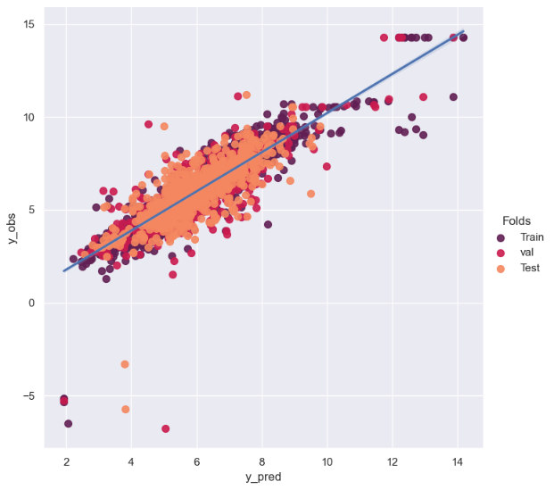
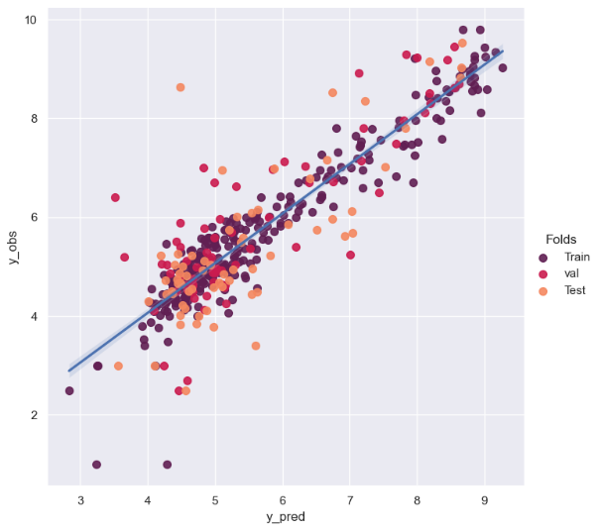
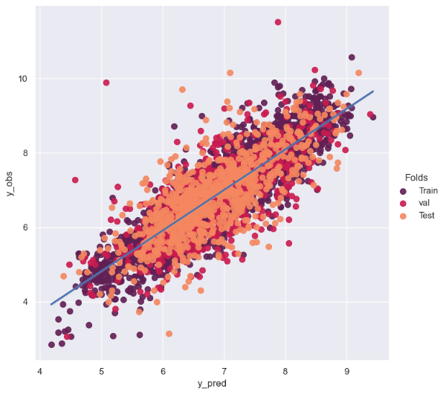
ach
α 2
CB1
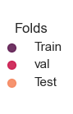

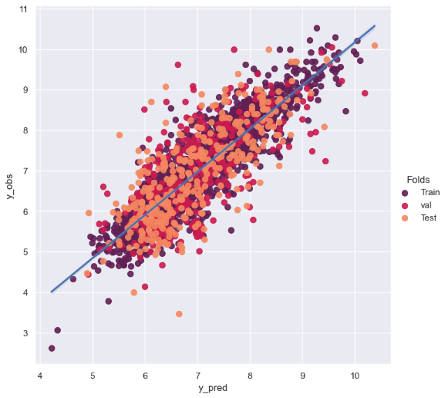
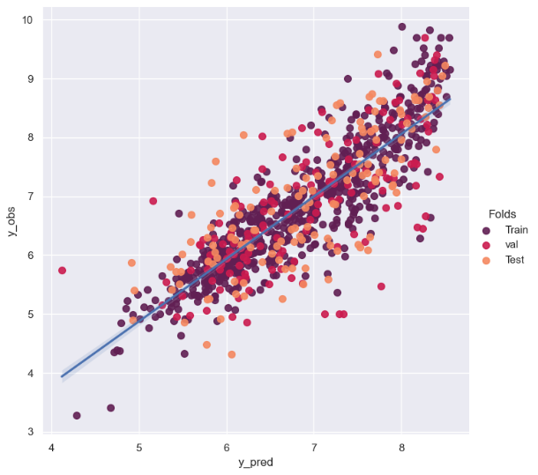
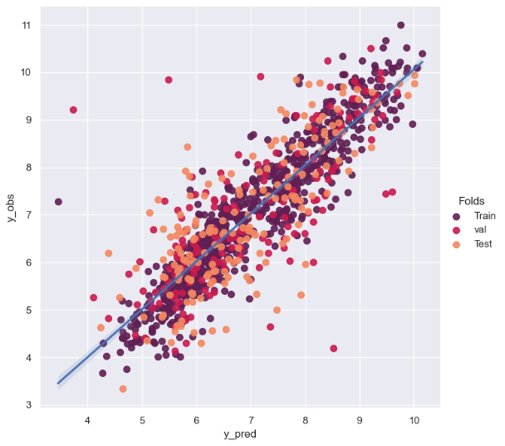
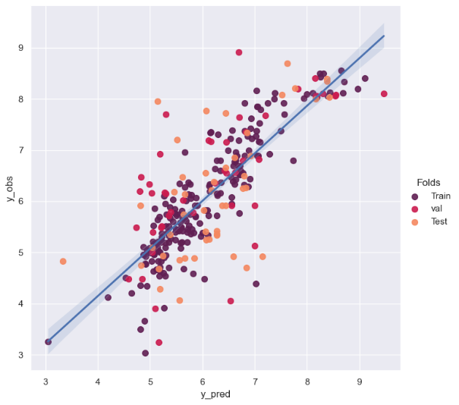
CB2
D1
D2
G2
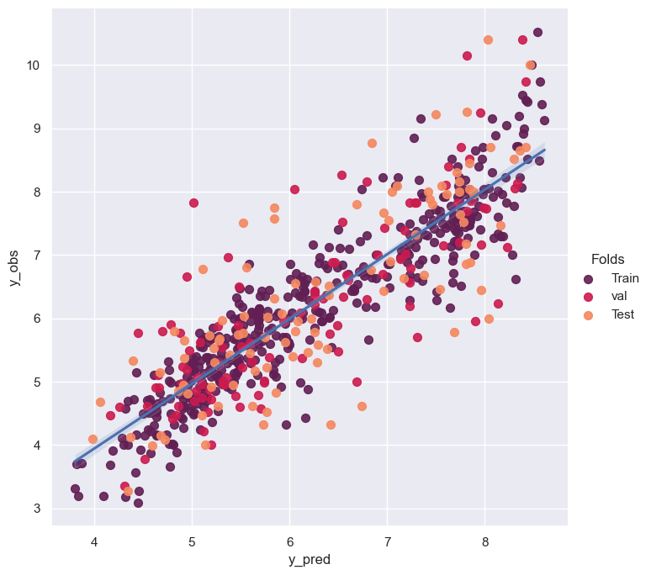
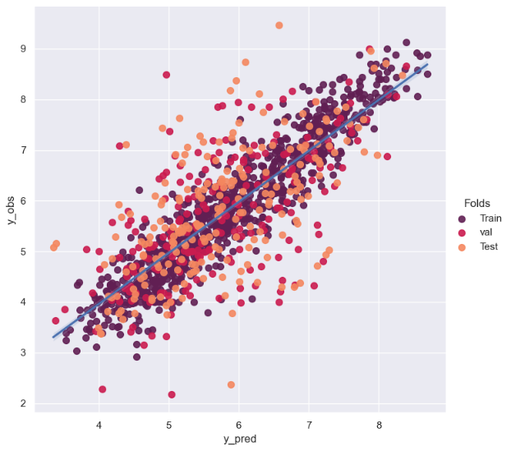
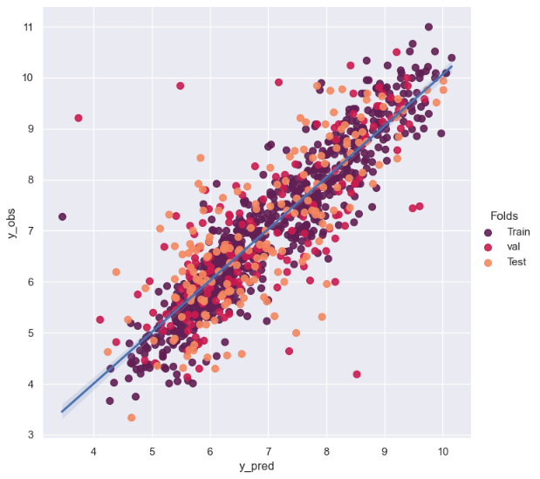
NMDA
MAGL
M2

Fig. S3. Scatter plot illustrating the correlation between predicted and experimental pIC₅₀ values for the selected tasks MIE1, KE1, and KE2. CB1: cannabinoid receptor 1; CB2: cannabinoid receptor 2; MAGL: Monoacylglycerol lipase; AchE: acetylcholinesterase; D₁: dopamine 1 receptor; D₂: dopamine 2 receptor; α₂: adrenergic receptor alpha-2; M₂: muscarinic acetylcholine receptor M2; NMDA: N-methyl-D-aspartate glutamate receptor; GRK2: G-protein coupled receptor kinase 2.

