Supplementary materials

Supplementary
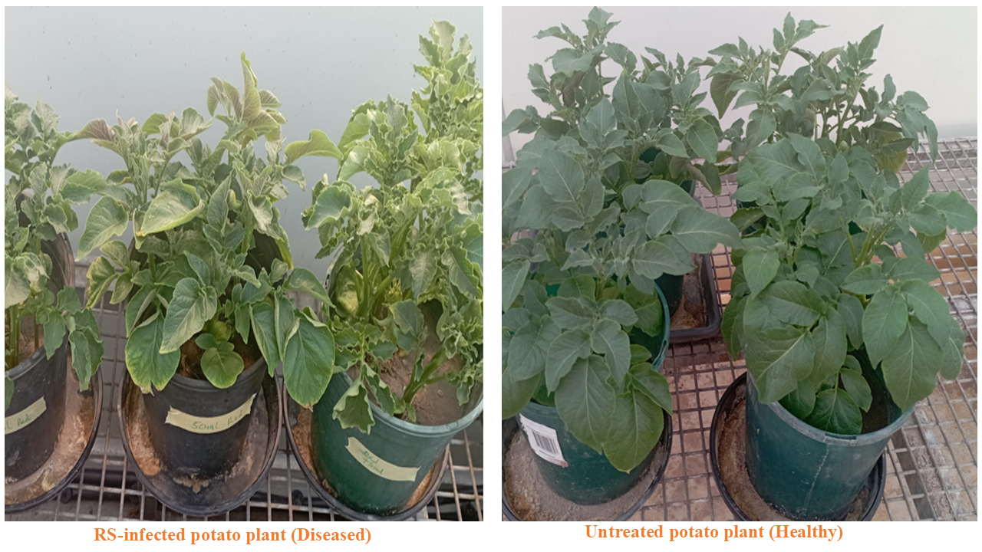
Figure S1: Representative picture of a RS-diseased and healthy potato plant

Figure S2. Comparison of Alpha Diversity Indices of (A) Bacteria and (B) Fungi across diseased and healthy rhizosphere of potato plants. This figure presents boxplots illustrating four commonly used alpha diversity metrics—Chao1, Observed richness, Shannon index, and Simpson index—in diseased and healthy rhizosphere microbial communities of potato plants across different developmental stages. ED: Diseased (RS-infected) potato plants at vegetative stage (Green boxes); EH: Healthy Potato plant at vegetative stage (Orange boxes); PD: Diseased (RS-infected) potato plants at tuber bulking (Purple boxes); PH: Healthy potato plant at tuber bulking (Pink boxes).
Figure S3: Rhizosphere microbial compositions at the genus level (A) bacteria and (B) fungi across diseased and healthy potato plants under different developmental stages. ED: Diseased (RS-infected) potato plants at vegetative stage; EH: Healthy Potato plant at vegetative stage; PD: Diseased (RS-infected) potato plants at tuber bulking; PH: Healthy potato plant at tuber bulking

Figure S4. LEFse cladogram of (A) Bacteria and (B) Fungi across diseased and healthy rhizosphere of potato plants. ED: Diseased (RS-infected) potato plants at vegetative stage; EH: Healthy Potato plant at vegetative stage; PD: Diseased (RS-infected) potato plants at tuber bulking; PH: Healthy potato plant at tuber bulking.

Figure S5: Functional Shifts in Bacterial and Fungal Communities Across Plant Health and Developmental Stage. To assess how microbial functions vary with plant health status and developmental stage, Z-score heatmaps were constructed based on predicted bacterial and fungal functions across four sample groups: ED (RS-infected vegetative stage), EH (healthy vegetative stage), PD (RS-infected tuber bulking stage), and PH (healthy tuber bulking stage).
Figure S6. Comparison of functional alpha diversity indices of (A) Bacteria and (B) Fungi across diseased and healthy rhizosphere of potato plants. This figure presents boxplots illustrating four commonly used alpha diversity metrics—Chao1, Observed richness, Shannon index, and Simpson index—in functions of diseased and healthy rhizosphere microbial communities of potato plants across different developmental stages. ED: Diseased (RS-infected) potato plants at vegetative stage (Green boxes); EH: Healthy Potato plant at vegetative stage (Orange boxes); PD: Diseased (RS-infected) potato plants at tuber bulking (Purple boxes); PH: Healthy potato plant at tuber bulking (Pink boxes).

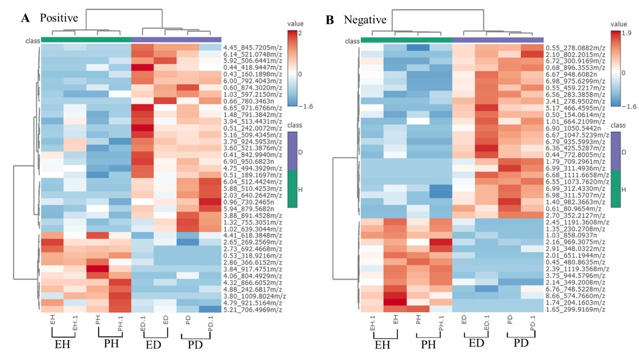
Figure S7: Heatmaps showing the hierarchical clustering of significantly differentially abundant metabolites (rows) detected in (A) positive and (B) negative ionization modes of diseased and healthy potato plants across two different developmental stages: ED: Diseased (RS-infected) potato plants at vegetative stage; EH: Healthy Potato plant at vegetative stage; PD: Diseased (RS-infected) potato plants at tuber bulking; PH: Healthy potato plant at tuber bulking. Color scale represents Z-score normalized abundance levels. Sample groups are annotated below the heatmap, and hierarchical clustering indicates metabolite similarity across conditions. Metabolites are labelled by retention time and m/z values.
Figure S8: Partial least squares discriminant analysis (PLS-DA) plot of root exudate metabolites between Diseased (D) and Healthy (H) potatoes. (A) positive mode ionization; (B) negative mode ionization.
Figure S9: Volcano plot of differential metabolites in positive (A) and negative(B) ion modes in the healthy and diseased potato plant. The red dots represent up-regulated metabolites, the blue/purple dots represent down-regulated metabolites, and the grey/black dots represent metabolites with no significant differences.
Figure S10: Variable Importance in Projection (VIP) scores of PLS-DA analyses for each treatment (diseased and healthy potato plants), reflecting the relative importance of each of the 15 most important features in the variation of component 1 (Upper row) and component 2 (lower row). The coloured boxes indicate features of high importance (red) and low importance (blue) in explaining the data separation between groups. D=Diseased potato plants H= Healthy potato plants.

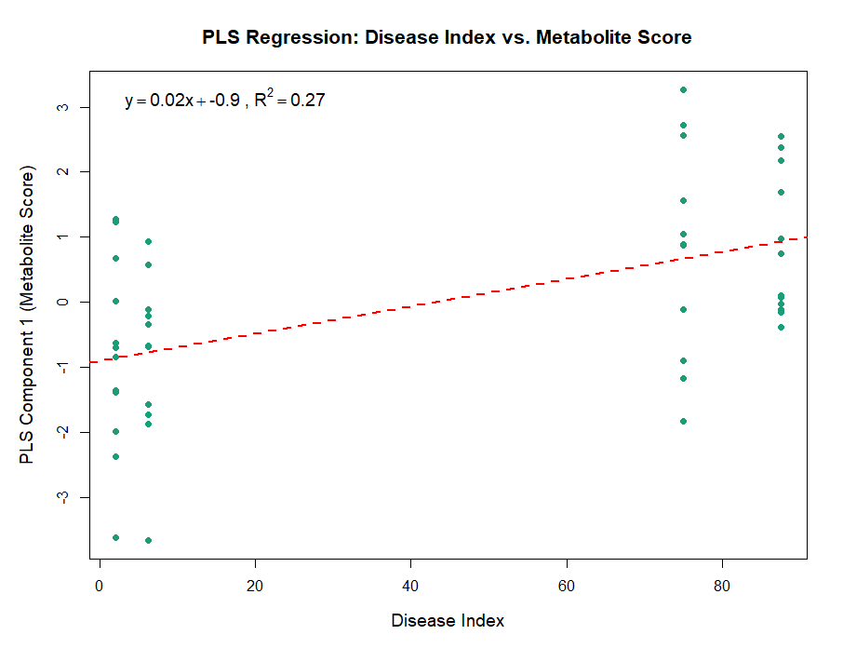
Figure S11: Partial Least Squares (PLS) Regression Reveals Association Between Disease Index and Metabolite-Based Component Scores. The scatterplot shows the relationship between the observed disease index and the PLS Component 1 scores derived from metabolite profiles. The red dashed line indicates the linear regression fit (y = 0.02x + -0.9, R² = 0.27), suggesting that metabolite composition partially explains disease severity patterns.

Table S1: Disease index (%) in potato groups
Group | Disease Index (%)
ED | 75
EH | 2.08
PD | 87.5
PH | 6.25

Table S2: Combined list of UP and DOWN-regulated molecular features in diseased and healthy and groups with putative identification, corresponding formula, confidence score and trends in predictions of the interaction model, including significance results, trend of results (up-/down regulated)
Metabolic features | Putative pathways | Putative identification | Formula | Confidence score | Significance | Trend of Up (U) and Down (D) regulated
Positive Nodes
3.41_278.9502m/z | Phosphate derivative | 5-(methylsulfanyl)-2,3-dioxopentyl phosphate | C6H11O6PS | 39.4 | Sig | U
4.45_845.7205m/z | - | Unidentified | - | - | Sig | U
6.00_792.4043m/z | - | Not identified | - | - | Sig | U
4.01_938.5473m/z | Triterpenoid saponin | Rotundifolioside I | C47H76O16 | 37 | Sig | U
6.70_1113.6928m/z | Triterpenoid derivative | Globostellatic Acid B | C33H48O7 | 41.8 | Sig | U
1.43_722.2076m/z | Streptomyces derivative | lucensimycin E | C34H41NO12S | 31.6 | Sig | U
3.78_865.4382m/z | Polyketide derivative | Inflexin | C24H32O7 | 37 | Sig | U
6.13_806.3928m/z | Indole derivative | Tryprostatin A | C22H27N3O3 | 38.8 | Sig | U
0.65_752.4125m/z | Acetylsalicylic acid | Martefragin A | C20H25N3O3 | 38.3 | Sig | U
1.78_767.3004m/z | Azaphilone derivative | azanigerone D | C19H23NO6 | 36.7 | Sig | U
6.90_1050.5442n | - | Acrophiarin | C49H78N8O17 | 38.9 | Sig | U
6.79_935.5993m/z | Diterpenoid derivative | Kansuiphorin B | C54H90O10 | 35.1 | Sig | U
0.55_459.2217m/z | Monoterpenoid derivative | Lactinolide | C10H16O4 | 37.7 | Sig | U
1.02_547.1835m/z | Flavonoid derivative | abacopterin A | C26H30O10 | 36.8 | Sig | U
0.64_116.0714m/z | Amino acid derivative | Valine | C5H11NO2 | 38.9 | Sig | U
5.17_950.4928m/z | Polyketide derivatives | Tylosin | C46H77NO17 | 45.1 | Sig | U
3.78_865.4382m/z | Polyketide derivatives | Michaolide E | C24H32O7 | 37 | Sig | U
3.67_381.1717m/z | Polyketide derivatives | Rotiorinol A | C23H26O5 | 37
6.19_862.4216n | Diterpenoid derivative | Nicotianoside I | C41H66O19 | 36.5 | Sig | U
2.17_1047.3272m/z | Siderophore derivative | ferrirubin | C41H64FeN9O17 | 22.4 | Sig | D
1.03_858.0937n | - | Not identified | - | - | Sig | D
1.35_230.2708m/z | Polyamine derivative | Caldopentamine (4+) | C12H35N5 | 36.6 | Sig | D
2.16_969.3075m/z | Monoterpenoid derivative | Lactiflorin | C23H26O10 | 37.3 | Sig | D
0.45_480.8635m/z | - | Not identified | - | - | Sig | D
2.72_965.2748m/z | Alkaloid derivative | hyponine D | C47H50N2O18 | 44.3 | Sig | D
7.55_796.5467m/z | Alkaloid derivative | Karakoline | C22H35NO4 | 39.1 | Sig | U
4.26_915.4783m/z | Indole derivative | Paxilline | C27H33NO4 | 40.1 | Sig | U
5.92_880.4558m/z | Indole derivative | Ancistrotanzanine B | C26H29NO4 | 41.5 | Sig | U
0.43_160.1898m/z | - | Not identified | - | - | Sig | U
4.88_242.6817m/z | - | Not identified | - | - | Sig | U
2.86_366.6152m/z | - | Not identified | - | - | Sig | U
5.16_509.4345m/z | - | Not identified | -- | - | Sig | U
3.88_891.4528m/z | Diterpenoid derivative | clerodin | C24H34O7 | 37.6 | Sig | U
0.68_765.2341m/z | Nitrogen & oxygen containing heterocycle derivate | Acalyphin | C14H20N2O9 | 40.3 | Sig | U
0.96_819.2915m/z | Alkaloid derivative | Jaconine | C18H26ClNO6 | 43.4 | Sig | U
2.05_508.1746m/z | Alkaloid derivative | Scutebarbatine G | C26H33NO7 | 36.3 | Sig | U
2.70_352.2127m/z | Alkaloid derivative | Dihydrocapsaicin | C18H29NO3 | 38,9 | Sig | U
2.04_1112.4357m/z | Fatty Acid | 3-Oxotetracosanoyl-CoA | C45H80N7O18P3S | 34 | Sig | U
3.84_917.4751m/z | - | iso-precytochalasin | C28H33NO4 | 40.1 | Sig | D

Table S3: Enriched metabolites and their function in plant disease resistance
Putative identification | Functions | Reference
5-(methylsulfanyl)-2,3-dioxopentyl phosphate | Plant defense and microbial modulation | (Bigeard et al., 2015)  (Raaijmakers and Mazzola, 2012)
Rotundifolioside I | -Modulation of phytohormone pathways and defense-related transcription factors  -Support localized and systemic acquired resistance (SAR) | (Saracoglu et al., 2003),  (Fuji et al., 2024)
Globostellatic Acid B | -Disruption of microbial cell membranes (especially fungi and Gram-positive bacteria)  -Inhibition of key microbial enzyme  -Induction of fungal hyphal deformation  Triterpenoid acids  It also function as elicitors | (Shakeel et al., 2025),  (Aharoni et al., 2003)
lucensimycin E | Promotion of plant growth and induced systemic resistance (ISR)  Suppression of plant pathogens via secretion of antibiotics like lucensimycin, streptomycin, and actinomycin | (Khan et al., 2023)
Inflexin | Suppress phytopathogens in the rhizosphere or endosphere  Contribute to natural disease resistance in the host plant  Be a candidate for biocontrol applications via microbial inoculants | (Jha et al., 2023)
Tryprostatin A | Inhibit fungal pathogens by disrupting protein synthesis or mitochondrial function  Act as a competitive metabolite in the rhizosphere to suppress the growth of pathogens like Fusarium and Phytophthora  Reduce pathogen colonization when produced by beneficial endophytes | (Martins and Carvalho, 2007)
Martefragin A | Accumulate at infection sites in response to pathogen attack  May be involved in systemic acquired resistance (SAR) | (Blasey et al., 2023)
azanigerone D | Disrupts cell membrane integrity or cell wall biosynthesis  Inhibits fungal spore germination and hyphal growth | (Pang et al., 2020)
Acrophiarin | Suppression of competing pathogenic microbes  Protection of host plant tissues when produced by beneficial endophytes  Induce localized cell death (HR-like response) that prevents further pathogen invasion | (Daroodi and Taheri, 2023)
Kansuiphorin B | Induce oxidative bursts and localized cell death (hypersensitive response)  Modulate jasmonic acid (JA) and salicylic acid (SA) signaling cascades involved in plant immunity  Trigger expression of pathogenesis-related (PR) genes | (Hossain et al., 2018)
Lactinolide | Priming jasmonic acid (JA)-dependent responses  Inducing expression of pathogenesis-related (PR) genes  Stimulating ROS (reactive oxygen species) burst or programmed cell death to contain infection | (Tholl, 2015)
abacopterin A | Inhibit the growth of fungal and bacterial phytopathogens by interacting with microbial membranes and enzymes  Interfere with spore germination and mycelial development | (Balasundram et al., 2006)
Valine | While primarily known for its role in protein synthesis, valine has critical functions in plant defense responses, particularly in: Serving as a precursor for antimicrobial compounds  Participating in signaling pathways | (Walters, 2003)
Tylosin | While it is primarily used in veterinary medicine for its antibacterial properties, tylosin and structurally related macrolides have emerging relevance in plant protection, particularly through biocontrol mechanisms, modulation of microbial communities, and direct suppression of phytopathogens. | (Arseneault and Filion, 2017)
Michaolide E | Michaolide E are known for their broad-spectrum antimicrobial activity and complex roles in plant–microbe interactions. | (Grove et al., 2007)
Rotiorinol A | Though not extensively characterised in the context of plant–pathogen resistance, structural analogs and its known bioactivities suggest a likely role in fungal antagonism, microbial competition, and indirect enhancement of plant defense | (Zhong and Xiao, 2009)
Nicotianoside I | These compounds are increasingly recognized for their roles in plant defense against pathogens and herbivores, particularly as phytoanticipins and elicitor-triggered immune molecules. | (Jassbi et al., 2017)
ferrirubin | In the context of plant–microbe–pathogen interactions, ferrirubin plays a dual role: it can support beneficial microbes in suppressing pathogens or be exploited by pathogens themselves. | (Aznar and Dellagi, 2015)
Caldopentamine(4+) | Caldopentamine(4+) specifically has limited literature, we can infer its potential functions in plant–pathogen resistance based on the broader role of polyamines in plant immunity and stress tolerance. | (Hussain et al., 2011)
Lactiflorin | It is part of the broader group of plant-derived terpenoids, which are well-documented for their bioactive roles in plant defense. Its structural class and known biological activities suggest it likely contributes to defense signaling and pathogen inhibition. | (Toffolatti et al., 2021)
hyponine D | Disrupt pathogen cell membranes, particularly in fungi and Gram-positive bacteria  Interfere with membrane sterols, leading to leakage and cell death | (Friedman, 2006)
Karakoline | Inhibit growth of fungal and bacterial pathogens by disrupting membranes and metabolic enzymes  Exhibit antibiotic-like activity, especially against Gram-positive bacteria and some fungal strains | (Alhilal et al., 2021)
Paxilline | Inhibit competing phytopathogenic fungi or bacteria in the rhizosphere  Suppress pathogens like Fusarium spp., Alternaria, or Phytophthora through metabolic interference | (Hou et al., 2022)
Ancistrotanzanine B | Disrupt microbial membranes and interfere with enzyme systems  Exhibit potent antibacterial and antifungal activity, especially against Gram-positive bacteria and filamentous fungi | (Qing et al., 2017)
clerodin | Clerodin and related clerodane diterpenoids:  Inhibit fungal and bacterial growth through membrane disruption and interference with metabolic enzymes  They are active against pathogens such as Fusarium spp., Botrytis cinerea, Pseudomonas syringae, and Ralstonia solanacearum | (Waliullah et al., 2014)
Acalyphin | While acalyphin itself has not been as extensively studied as other cyanogenic glycosides (like linamarin or dhurrin), its functional class suggests a clear role in plant pathogen resistance and broader defensive ecology | (Vetter, 2000)
Jaconine | Inhibit fungal and bacterial growth through DNA intercalation or by interfering with nucleic acid synthesis  Suppress phytopathogens such as Botrytis cinerea, Fusarium oxysporum, and Ralstonia solanacearum | (Hartmann and Ober, 2000)
Scutebarbatine G | Inhibiting the growth of bacterial and fungal phytopathogens, including Fusarium spp., Ralstonia solanacearum, and Botrytis cinerea  Acting on cell membrane integrity and protein or DNA synthesis pathways in pathogens | (Sripathi and Ravi, 2017)
Dihydrocapsaicin | Inhibits the growth of plant pathogens such as Fusarium oxysporum, Botrytis cinerea, Phytophthora spp., and Ralstonia solanacearum  Disrupts cell membranes, interferes with ATP production, and impairs microbial enzyme systems | (Careaga et al., 2003)
iso-precytochalasin | Suppress plant pathogens through chemical antagonism  Compete in the rhizosphere, reducing colonization by soil-borne pathogens  Contribute to biocontrol strategies in agriculture | (Nishad et al., 2019)

Methods S1
Mass spectrometry instrument setup 190 191 2 µL of sample metabolite extract was injected onto the same column (ACQUITY UPLC HSS 192 T3 1.8 µm 100 × 2.1 mm Column at 35 °C) from 96-well 1mL sample collection plates kept at 4 193 °C, alongside pooled biological quality control sample (created by combining small aliquots 194 from several samples across all treatment types). Injection was eluted at a flow rate of 0.5 195 mL/min with a 9 min gradient, with mobile phase A held at 99% for 1 min, decreased to 85% 196 over 1 min, decreased to 50% over 2 min, decreased to 5% over 2 min and increased to 99% over 197 2 min. The mobile phases consisted of: Mobile phase A containing (Water + 0.1% Formic Acid), 198 and mobile phase B containing (Acetonitrile + 0.1% Formic Acid). Mass spectral data from 50- 199 1200 m/z were collected in the positive and negative electrospray ionization mode. Data 200 acquisition was performed using HDMSe with ion mobility separation followed by mass 201 fragmentation and Resolution mode mass analysis. The scan time was 0.2 s, and the elevated 202 energy transfer collision voltage was 20–50 eV. For this experiment, the instrument was run in 203 positive ionisation mode with the following settings: Capillary: 0.5 kV, source temperature: 120 204 °C, sampling cone: 30 V, source offset: 80 V, desolvation temperature: 500 °C, desolvation gas 205 flow: 800 L/h, cone gas flow: 20 L/h. Leucine Enkephalin solution (Waters, 200 pg/mL) was 206 used for lockspray.

References
Aharoni, A., Giri, A. P., Deuerlein, S., Griepink, F., de Kogel, W.-J., Verstappen, F. W., Verhoeven, H. A., Jongsma, M. A., Schwab, W. & Bouwmeester, H. J. 2003. Terpenoid metabolism in wild-type and transgenic Arabidopsis plants. The Plant Cell15, 2866-2884.
Alhilal, M., Sulaiman, Y. A., Alhilal, S., Gomha, S. M. & Ouf, S. A. 2021. Antifungal activity of new diterpenoid alkaloids isolated by different chromatographic methods from Delphinium peregrinum L. var. eriocarpum Boiss. Molecules 26, 1375.
Arseneault, T. & Filion, M. 2017. Biocontrol through antibiosis: exploring the role played by subinhibitory concentrations of antibiotics in soil and their impact on plant pathogens. Canadian Journal Of Plant Pathology 39, 267-274.
Aznar, A. & Dellagi, A. 2015. New insights into the role of siderophores as triggers of plant immunity: what can we learn from animals? Journal of Experimental Botany 66, 3001-3010.
Balasundram, N., Sundram, K. & Samman, S. 2006. Phenolic compounds in plants and agri-industrial by-products: Antioxidant activity, occurrence, and potential uses. Food Chemistry 99, 191-203.
Bigeard, J., Colcombet, J. & Hirt, H. 2015. Signaling mechanisms in pattern-triggered immunity (PTI). Molecular Plant 8, 521-539.
Blasey, N., Rehrmann, D., Riebisch, A. K. & Mühlen, S. 2023. Targeting bacterial pathogenesis by inhibiting virulence-associated Type III and Type IV secretion systems. Frontiers in Cellular and Infection Microbiology, 12, 1065561.
Careaga, M., Fernández, E., Dorantes, L., Mota, L., Jaramillo, M. E. & Hernandez-Sanchez, H. 2003. Antibacterial activity of Capsicum extract against Salmonella typhimurium and Pseudomonas aeruginosa inoculated in raw beef meat. International Journal of Food Microbiology, 83, 331-335.
Daroodi, Z. & Taheri, P. 2023. Function of the endophytic fungus Acrophialophora jodhpurensis, methionine, and nitric oxide in wheat resistance induction against Fusarium graminearum via interplay of reactive oxygen species and iron. Physiological and Molecular Plant Pathology 128, 102132.
Friedman, M. 2006. Potato glycoalkaloids and metabolites: roles in the plant and in the diet. Journal of Agricultural and Food Chemistry 54, 8655-8681.
Fuji, Y., Matsufuji, H. & Hirai, M. Y. 2024. Distribution, biosynthesis, and synthetic biology of phenylethanoid glycosides in the order Lamiales. Plant Biotechnology Journal, 41, 231-241.
Grove, J., Reimann, E., Roy, S. & Grovey, J. 2007. The trichothecenes and their biosynthesis. In: Herz, W., Falk, H., Kirby, G.W. (eds) Progress in the chemistry of organic natural products. Fortschritte der Chemie organischer Naturstoffe / Progress in the Chemistry of Organic Natural Products, vol 88. pp63-130. Springer, Vienna.
Hartmann, T. & Ober, D. 2000. Biosynthesis and metabolism of pyrrolizidine alkaloids in plants and specialized insect herbivores. In: Leeper, F.J., Vederas, J.C. (eds) Biosynthesis. Topics in Current Chemistry, vol 209. pp 207-243. Springer, Berlin, Heidelberg. https://doi.org/10.1007/3-540-48146-X_5.
Hossain, M. Z., Ishiga, Y., Yamanaka, N., Ogiso-Tanaka, E. & Yamaoka, Y. 2018. Soybean leaves transcriptomic data dissects the phenylpropanoid pathway genes as a defence response against Phakopsora pachyrhizi. Plant Physiology, 132, 424-433.
Hou, Y., Chen, M., Sun, Z., Ma, G., Chen, D., Wu, H., Yang, J., Li, Y. & Xu, X. 2022. The biosynthesis related enzyme, structure diversity and bioactivity abundance of indole-diterpenes: A review. Molecules 27, 6870.
Hussain, S. S., Ali, M., Ahmad, M. & Siddique, K. H. 2011. Polyamines: natural and engineered abiotic and biotic stress tolerance in plants. Biotechnology Advances 29, 300-311.
Jassbi, A. R., Zare, S., Asadollahi, M. & Schuman, M. C. 2017. Ecological roles and biological activities of specialized metabolites from the genus Nicotiana. Chemical Reviews 117, 12227-12280.
Jha, P., Kaur, T., Chhabra, I., Panja, A., Paul, S., Kumar, V. & Malik, T. 2023. Endophytic fungi: hidden treasure chest of antimicrobial metabolites interrelationship of endophytes and metabolites. Frontiers in Microbiology 14, 1227830.
Khan, S., Srivastava, S., Karnwal, A. & Malik, T. 2023. Streptomyces as a promising biological control agents for plant pathogens. Frontiers in Microbiology 14, 1285543.
Martins, M. B. & Carvalho, I. 2007. Diketopiperazines: biological activity and synthesis. Tetrahedron 63, 9923-9932.
Nishad, J. H., Singh, A., Gautam, V. S., Kumar, D., Kumar, J. & Kharwar, R. 2019. Endophytic Fungi: A cryptic fountainhead for biodiversity, functional metabolites, host stress tolerance, and myco-mediated nanoparticles (Nps) synthesis. In: Jha, S. (eds) Endophytes and Secondary Metabolites. Reference Series in Phytochemistry. Springer, Cham. https://doi.org/10.1007/978-3-319-90484-9_18.
Pang, G., Sun, T., Yu, Z., Yuan, T., Liu, W., Zhu, H., Gao, Q., Yang, D., Kubicek, C. P. & Zhang, J. 2020. Azaphilones biosynthesis complements the defence mechanism of Trichoderma guizhouense against oxidative stress. Environmental Microbiology, 22, 4808-4824.
Qing, Z.-X., Yang, P., Tang, Q., Cheng, P., Liu, X.-B., Zheng, Y.-j., Liu, Y.-S. & Zeng, J.-G. 2017. Isoquinoline alkaloids and their antiviral, antibacterial, and antifungal activities and structure-activity relationship. Current Organic Chemistry 21, 1920-1934.
Raaijmakers, J. M. & Mazzola, M. 2012. Diversity and natural functions of antibiotics produced by beneficial and plant pathogenic bacteria. Annual Review of Phytopathology 50, 403-424.
Saracoglu, I., Varel, M., Hada, J., Hada, N., Takeda, T., Donmez, A. A. & Calisa, I. 2003. Phenylethanoid glycosides from Phlomis integrifolia hub.-mor. Zeitschrift für Naturforschung C, 58, 820-825.
Shakeel, A., Noor, J. J., Jan, U., Gul, A., Handoo, Z. & Ashraf, N. 2025. Saponins, the unexplored secondary metabolites in plant defense: Opportunities in integrated pest management. Plants 14, 861.
Sripathi, R. & Ravi, S. 2017. Ethnopharmacology, phytoconstituents, essential oil composition and biological activities of the genus Scutellaria. Journal of Pharmaceutical Sciences Research 9, 275.
Tholl, D. 2015. Biosynthesis and biological functions of terpenoids in plants. Biotechnology of isoprenoids, 63, 63-106.

Toffolatti, S. L., Maddalena, G., Passera, A., Casati, P., Bianco, P. A. & Quaglino, F. 2021. Role of terpenes in plant defense to biotic stress. In Jogaiah, S (eds) Biocontrol and secondary metabolites: applications and immunization for plant growth and protection. Elsevier, pp 401-417. https://doi.org/10.1016/C2019-0-03577-7
Vetter, J. 2000. Plant cyanogenic glycosides. Toxicon, 38, 11-36.

Waliullah, T. M., Yeasmin, A. M., Wahedul, I. M. & Parvez, H. 2014. Evaluation of antimicrobial study in in vitro application of Clerodendrum infortunatum Linn. Asian Pacific Journal of Tropical Disease 4, 484-488.
Walters, D. 2003. Resistance to plant pathogens: possible roles for free polyamines and polyamine catabolism. New Phytologist 159, 109-115.
Zhong, J.-J. & Xiao, J.-H. 2009. Secondary metabolites from higher fungi: discovery, bioactivity, and bioproduction. In: Zhong, JJ., Bai, FW., Zhang, W. (eds) Biotechnology in China I. Advances in Biochemical Engineering / Biotechnology, vol 113.pp 79-150. Springer, Berlin, Heidelberg. https://doi.org/10.1007/10_2008_26.

