Additional File 1. ROC comparison among each model
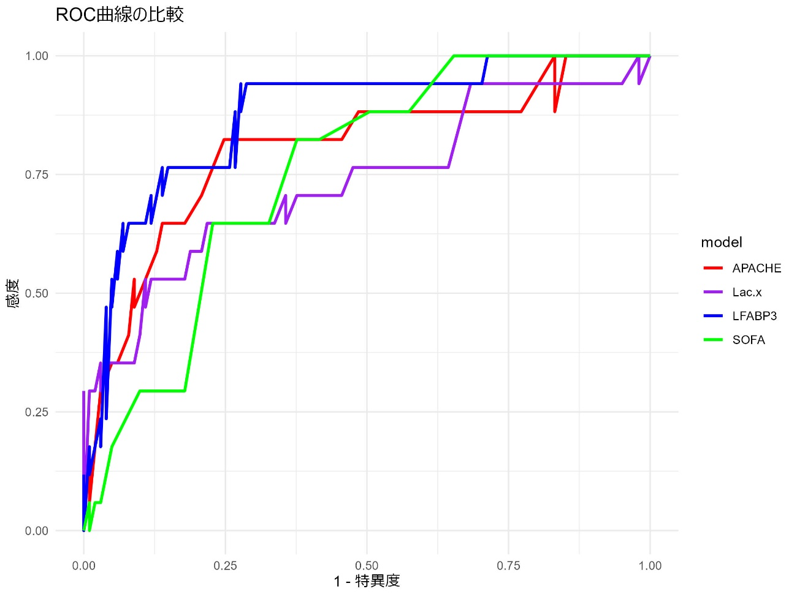
L-FABP(T3)
APACHEⅡ
SOFA
Lac
Sensitivity
Specificity

