Additional File

Table of contents | Page
- Methods | 2
- Tables and Figures
Low vs. moderate-high doses of corticosteroids (Tables S3-4, Figure S1)
Table S3. Baseline characteristics of patients who received early low or moderate-high doses of corticosteroids | 5
Table S4. Outcomes according to the use of early low or moderate-high doses of corticosteroids | 6
Figure S1. Kaplan-Meier estimates of mortality according to the use of early low or moderate-high doses of corticosteroids | 7
Early vs. never corticosteroids (Tables S5-6, Figure S2)
Table S5. Baseline characteristics of patients who received Early or Never corticosteroids | 8
Table S6. Outcomes according to the use of Early or Never corticosteroids. | 9
Figure S2. Kaplan-Meier estimates of mortality according to the use of Early or Never corticosteroids | 10
Ever (early + delayed) vs. never corticosteroids (Tables S7-8, Figure S3)
Table S7. Baseline characteristics of patients who Ever or Never received corticosteroids | 11
Table S8. Outcomes depending on whether patients received corticosteroids (Ever or Never) | 12
Figure S3. Kaplan-Meier estimates of mortality according to the use of corticosteroids (Ever or Never) | 13
- References | 14

- Methods

A total of 882 patients were included in the present study. Out of them, 191 (21.7%) did not receive corticosteroids during total ICU stay, and 691 (78.3%) received corticosteroids during total ICU stay. Considering only the first 48 hours of ICU stay, 485 (55.0%) patients received corticosteroids during this period and 397 (45.0%) patients did not. Out of the 397 patients who were not treated with corticosteroids during the first 48 hours of ICU stay, 206 received corticosteroids afterwards. All patients treated with corticosteroids before ICU admission (n=120) were also treated during ICU stay except for 4 patients.

For some patients, information about type of corticosteroids and dose administered during the first 48 hours is not available (n=23). Out of 485 patients treated within the first 48 hours (462 with dose information) 131(28.4%) patients received low doses and 331 (71.6%) received moderate-high doses.

For the analyses of type of corticosteroids, 11 patients with both dexamethasone and methylprednisolone were excluded. Out of the remaining 871 patients, 23 had no information on the type of drug and 6 were treated with prednisone and were also excluded. Out of 842 patients, 397 were not treated with corticosteroids during the first 48 hours of ICU stay, 106 were treated exclusively with dexamethasone, and 339 were treated exclusively with methylprednisolone.

Outcome definitions

Medical and infectious complications followed a standard definition.
-Medical complications:

1. Acute respiratory distress syndrome. According to Berlin definition [1]
Mild: PaO₂/FiO₂ between 200-300
Moderate: PaO₂/FiO₂ between 100-200
Severe: PaO₂/FiO₂ < 100

2. Pulmonary hypertension [2]
clinical signs + (imaging or invasive hemodynamic monitor.)
- Ultrasound Right ventricle failure
-Swan Ganz: mean pulmonary artery pressure ≥ 25 mmHg, Pulmonary Artery Wedge Pressure ≤ 15 mmHg, Right Ventricular Pressure > 3 UW.

3. Shock. [3]
Shock is best defined as a life-threatening, generalized form of acute circulatory failure associated with inadequate oxygen utilization by the cells. It is a state in which the circulation is unable to deliver sufficient oxygen to meet the demands of the tissues, resulting in cellular dysfunction. The result is cellular dysoxia, i.e. the loss of the physiological independence between oxygen delivery and oxygen consumption, associated with increased lactate levels. Some clinical symptoms suggest an impaired microcirculation, including mottled skin, acrocyanosis, slow capillary refill time, and an increased central-to-toe temperature gradient.

4. Bleeding [4]
Any sign of hemorrhage plus hemoglobin drop > 3 g/dL or any transfusion with overt bleeding.

5. Pulmonary embolism.[5]
Clinical probability + imaging + laboratory variables.

6. Cardiac arrest.
Pulseless electrical activity or ventricular fibrillation /pulseless ventricular tachycardia

7. Heart failure. [6]
Clinical signs and symptoms with or without preserved left ventricular ejection fraction.
Abnormality of cardiac structure or function leading to failure of the heart to deliver oxygen at a rate commensurate with the requirements of the metabolizing tissues, despite normal filling pressures

8. Arrhythmias.
Alteration from basal electrocardiography or new onset:
- Atrial fibrillation, atrial flutter.
- other supraventricular tachycardia
- Ventricular tachycardia/ Torsade de Pointes
- Atrioventricular block>2 degree.

9. Stroke.[7]
Neurological dysfunction caused by focal cerebral, spinal or retinal infarction ± imaging (caused by ischemia or hemorrhage)

10. Acute kidney injury. According to Kidney Disease Improving Global Outcomes definitions [8]

Stage 2: one of the following
- Serum creatinine increase 2.0–2.9 times baseline
- Urinary output <0.5 ml/kg/h during two 6 hours blocks
Stage 3: one of the following:
- Serum creatinine increase >3 times baseline
- Serum creatinine increases to >4.0 mg/dl (353 µmol/l)
- Initiation of renal replacement therapy
- Urinary output <0.3ml/kg/h for more than 24 hours
- Anuria for more than 12 hours

11. Transaminitis
Defined by elevation x2 times normal values of bilirubin and/or AST/ALT

- Infectious complications

1. Respiratory super-infection. [9]
Defined by the presence of a new lung infiltrate plus clinical evidence that the infiltrate is of an infectious origin, which includes the new onset of fever, purulent sputum, leucocytosis, and decline in oxygenation.

2. Pneumonia. [9]
> 5 points CPIS criteria. Temperature, blood leukocytes, tracheal secretions, oxygenation index, and chest X-ray.

3. Bloodstream infection. [10]
Paired quantitative blood cultures (ratio >=3:1) or paired blood cultures for differential time to positivity (>=120min)

4. Urinary infection [11]
Positive urologic culture and infectious signs/symptoms (Fever, leukocytes, acute phase reactants)

5. Septic shock. [12]
Sepsis with vasopressors required to maintain a mean arterial pressure ≥65 mmHg and serum lactate level > 2 mmol l⁻¹ in the absence of hypovolemia. [12]

- Tables and Figures

Table S3. Baseline Characteristics of Patients Receiving early low or moderate-high doses of Corticosteroids.
 | Non-early steroids | Low-early dose | Moderate-high-early-dose | p-value
Patients demographics and comorbidities
N (%) | 397 (46.22%) | 131 (15.25%) | 331 (38.53%)
Age, years | 61.6 (12.4)/394 | 61.3 (10.9)/130 | 63.6 (10.6)/330 | 0.05
Female (%) | 138/395 (34.94%) | 41/131 (31.30%) | 107/331 (32.33%) | 0.66
Body mass index (kg/m2) | 29.17 (5.40)/258 | 29.38 (5.26)/66 | 29.20 (5.42)/215 | 0.96
Arterial Hypertension | 180/397 (45.34%) | 65/131 (49.62%) | 165/331 (49.85%) | 0.43
Diabetes Mellitus | 90/397 (22.67%) | 28/131 (21.37%) | 76/331 (22.96%) | 0.95
Chronic heart failure | 6/397 (1.51%) | 2/131 (1.53%) | 5/331 (1.51%) | 1.00
Chronic renal failure | 24/397 (6.05%) | 9/131 (6.87%) | 19/331 (5.74%) | 0.87
Asthma | 8/397 (2.02%) | 6/131 (4.58%) | 10/331 (3.02%) | 0.24
COPD | 16/397 (4.03%) | 5/131 (3.82%) | 17/331 (5.14%) | 0.71
Obese | 141/357 (39.50%) | 52/119 (43.70%) | 99/298 (33.22%) | 0.08
Dyslipidemia | 56/397 (14.11%) | 20/131 (15.27%) | 55/331 (16.62%) | 0.62
Cancer | 19/397 (4.79%) | 2/131 (1.53%) | 6/331 (1.81%) | 0.05
Laboratory findings
Hematocrit (%) | 38.99 (5.89)/289 | 39.51 (5.61)/68 | 39.39 (5.70)/228 | 0.54
Platelets, 1000/mm³ | 227 (108)/305 | 229 (98)/82 | 246 (111)/266 | 0.06
Leukocytes, 10³/μL | 8.62 (5.37)/303 | 9.50 (6.13)/81 | 9.43 (6.25)/261 | 0.10
Lymphocytes, μL | 0.79 (0.47)/297 | 0.96 (1.25)/82 | 0.78 (0.54)/261 | 0.63
CRP, mg/dL | 81.51 (105.40)/274 | 69.94 (85.10)/74 | 64.28 (92.98)/257 | 0.02
Lactate, mmol/L | 0.43 (1.01)/230 | 0.34 (0.56)/58 | 0.42 (0.58)/180 | 0.06
Ferritin, ng/mL | 1561 (1641)/106 | 2344 (2291)/25 | 1630 (1543)/147 | 0.07
D- Dimer, ng/mL | 1825 (2094)/230 | 1857 (2265)/66 | 2285 (2585)/215 | 0.24
CRP/lymphocyte ratio | 156 (295)/273 | 107 (174)/74 | 106 (164)/253 | 0.05
IL-6, pg/mL | 163 (290)/25 | 225 (368)/13 | 321 (612)/44 | 0.77
LDH, U/L | 485 (267)/265 | 509 (230)/69 | 479 (213)/244 | 0.39
Procalcitonin, ng/mL | 1.64 (6.30)/194 | 0.94 (2.16)/55 | 1.22 (4.40)/200 | 0.43
Bilirubin, mg/dL | 0.88 (1.62)/245 | 0.78 (0.61)/70 | 0.77 (0.62)/240 | 0.76
AST, U/L | 59.72 (111.01)/291 | 57.26 (48.76)/80 | 57.14 (64.61)/261 | 0.83
Creatinine, mg/dL | 1.07 (0.71)/297 | 1.15 (1.08)/80 | 0.98 (0.48)/262 | 0.59
Urea, mg/dL | 46.26 (28.69)/197 | 44.19 (25.65)/66 | 47.41 (28.18)/193 | 0.72
NTProBNP, pg/mL | 2068 (6380)/46 | 1151 (1109)/7 | 1797 (4054)/43 | 0.24
Vital signs
Temperature, ºC | 37.08 (1.10)/309 | 36.87 (1.17)/75 | 36.66 (1.02)/251 | <0.001
Mean arterial pressure, mmHg | 86.57 (14.70)/303 | 88.33 (15.62)/75 | 85.80 (15.10)/246 | 0.61
Heart rate, bpm | 86.40 (18.60)/312 | 84.68 (21.09)/74 | 82.75 (18.23)/253 | 0.08
SpO₂, % | 87.74 (10.52)/299 | 88.23 (7.35)/75 | 88.89 (7.38)/251 | 0.65
Respiratory rate, bpm | 26.66 (7.96)/283 | 24.85 (6.55)/72 | 25.03 (6.53)/233 | 0.03
PaO₂/FiO₂ | 149.44 (77.09)/254 | 148.50 (68.47)/68 | 153.2 (81.5)/226 | 0.92
Severity scores
APACHE II | 13.14 (5.87)/252 | 14.14 (7.28)/86 | 13.64 (6.51)/254 | 0.80
CURB65 | 1.80 (1.20)/138 | 1.94 (1.01)/32 | 1.96 (1.28)/115 | 0.50
SOFA | 5.70 (2.88)/208 | 6.02 (3.36)/51 | 5.44 (2.89)/209 | 0.38

COPD: Chronic Obstructive Pulmonary Disease; CRP: C- Reactive Protein; LDH: Lactate dehydrogenase; AST: Aspartate Aminotransferase; NTProBNP: N-terminal pro-brain natriuretic peptide; APACHE: Acute Physiology and Chronic Health Evaluation; CURB65: Confusion, uremia, elevated respiratory rate, hypotension, and aged 65 years or older; SOFA: Sequential Organ Failure Assessment

Table S4. Outcomes according to the use of early low or moderate-high doses of corticosteroids. IPW sample, n=386

 | Non early steroids | Low-early dose | p-value | Moderate-high-early dose | p-value
n (%) | 397 (46.2%) | 131 (15.2%) |  | 331 (38.5%)
ICU mortality, cases/person-days | 161/24441 | 43/8705 |  | 89/23570
ICU mortality (hazard ratio) | 1 (Ref.) | 0.74 (0.51, 1.03) | 0.07 | 0.58 (0.45, 0.75) | <0.001
ICU mortality (hazard ratio) IPW sample, non-weighted* | 1 (Ref.) | 0.69 (0.35, 1.35) | 0.28 | 0.55 (0.36, 0.85) | 0.008
ICU mortality (hazard ratio) IP-weighted* | 1 (Ref.) | 0.54 (0.21, 1.12) | 0.11 | 0.54 (0.34, 0.80) | 0.007
7-day mortality, cases/person-days | 37/1873.97 | 9/634 |  | 19/1616
7-day mortality (hazard ratio) | 1 (Ref.) | 0.64 (0.31, 1.31) | 0.22 | 0.53 (0.31, 0.91) | 0.02
7-day mortality (hazard ratio) IPW sample, non-weighted* | 1 (Ref.) | 0.26 (0.03, 2.010) | 0.19 | 0.52 (0.23, 1.24) | 0.14
7-day mortality (hazard ratio) IP-weighted* | 1 (Ref.) | 0.17 (0, 0.683) | 0.09 | 0.62 (0.13, 1.44) | 0.30
ICU length of stay, days | 19.67 (15.92) | 18.6 (13.2) |  | 15.7 (12.2)
ICU length of stay (mean difference) | 0 (Ref.) | -0.59 (-3.37, 2.18) | 0.67 | -3.54 (-5.58, -1.50) | 0.001
ICU length of stay (mean difference) IPW sample, non-weighted* | 0 (Ref.) | -4.21 (-9.24, 0.81) | 0.10 | -4.91 (-8.08, -1.75) | 0.002
ICU length of stay (mean difference) IP-weighted* | 0 (Ref.) | -5.05 (-9.29, -0.93) | 0.01 | -5.38 (-8.64, -2.11) | 0.002
ICU length of stay among survivors, days | 20.18 (16.56) | 19.92 (14.5) |  | 15.3 (12.5)
ICU length of stay among survivors (mean difference) | 0 (Ref.) | -0.08 (-3.65, 3.47) | 0.96 | -4.62 (-7.21, -2.02) | 0.001
ICU length of stay among survivors (mean difference) IPW sample, non-weighted* | 0 (Ref.) | -4.9 (-10.81, 0.90) | 0.09 | -5.63 (-9.34, -1.93) | 0.003
ICU length of stay among survivors (mean difference) IP-weighted* | 0 (Ref.) | -5.7 (-10.24, -1.16) | 0.02 | -5.73 (-9.79, -1.98) | 0.005
Ventilator-free days | 7.0 (9.1) | 7.6 (8.7) |  | 10.6 (9.5)
Ventilator-free days (mean difference) | 0 (Ref.) | 0.72 (-1.08, 2.53) | 0.43 | 3.74 (2.41, 5.08) | <0.001
Ventilator-free days (mean difference) IPW sample, non-weighted* | 0 (Ref.) | 1.44 (-1.68, 4.56) | 0.36 | 3.90 (1.93, 5.86) | <0.001
Ventilator-free days (mean difference) IP-weighted* | 0 (Ref.) | 2.6 (-0.78, 5.64) | 0.12 | 4.00 (2.05, 5.87) | <0.001
Medical complications, n (%) | 383 (96.4%) | 127 (96.9%) |  | 327 (98.7%)
Medical complications (odds ratio) | 1 (Ref.) | 1.09 (0.35, 3.38) | 0.87 | 2.81 (0.91, 8.64) | 0.07
Medical complications (odds ratio) IPW sample, non-weighted* | 1 (Ref.) | 1.48 (0.17, 12.64) | 0.71 | 2.00 (0.49, 8.12) | 0.33
Medical complications (odds ratio) IP-weighted* | 1 (Ref.) | 0.62 (0.10, 1.19) | 0.66 | 1.86 (0.41, 8.57) | 0.39
Infectious complications, n (%) | 236 (59.4%) | 81 (61.8%) |  | 183 (55.2%)
Infectious complications (odds ratio) | 1 (Ref.) | 1.15 (0.74, 1.73) | 0.47 | 0.88 (0.66, 1.18) | 0.40
Infectious complications (odds ratio) IPW sample, non-weighted* | 1 (Ref.) | 1.16 (0.58, 2.32) | 0.65 | 0.75 (0.49, 1.14) | 0.18
Infectious complications (odds ratio) IP-weighted* | 1 (Ref.) | 1.03 (0.48, 2.34) | 0.92 | 0.78 (0.51, 1.21) | 0.29
*N=386

Figure S1. Kaplan-Meier estimates of mortality according to the use of early low or moderate-high doses of corticosteroids. The upper graphs are the crude estimates. The middle graphs are crude estimates in the IP-non-weighted sample (N=386). The lower graphs are IP-weighted estimates (N=386).

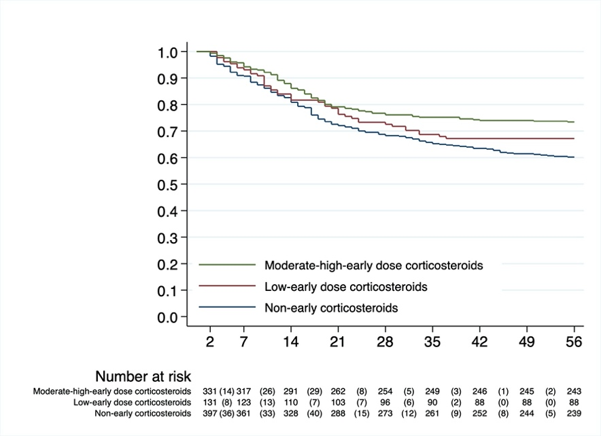
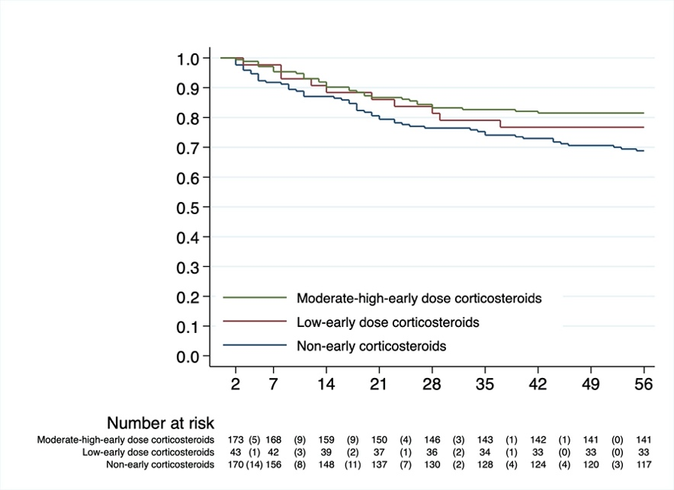
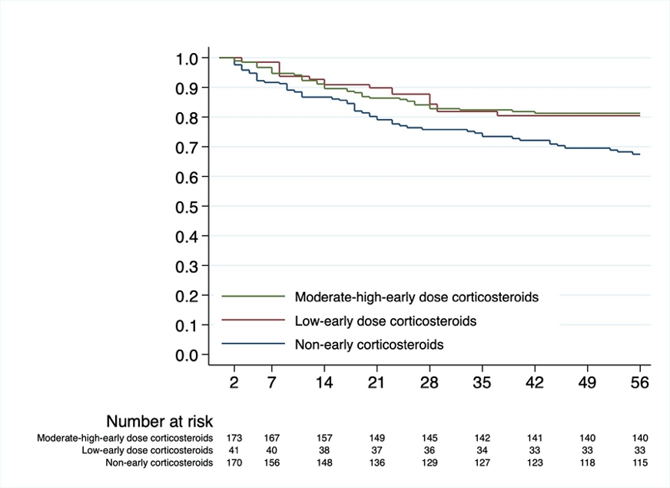

Table S5. Baseline Characteristics of Patients who never received or received early corticosteroids.
 | Never corticosteroids | Early corticosteroids | p-value
Patients demographics and comorbidities
N (%) | 191 (21.7%) | 485 (55.0%)
Age, years | 60.1 (13.9)/189 | 62.9 (10.6)/483 | 0.02
Female (%) | 66/191 (34.6%) | 153/485 (31.6%) | 0.46
Body mass index (kg/m2) | 28.7 (5.48)/114 | 29.25 (5.35)/292 | 0.35
Arterial Hypertension | 79/191 (41.36%) | 240/485 (49.48%) | 0.06
Diabetes Mellitus | 43/191 (22.51%) | 111/485 (22.89%) | 0.99
Chronic heart failure | 1/191 (0.52%) | 7/485 (1.44%) | 0.45
Chronic renal failure | 11/191 (5.76%) | 28/485 (5.77%) | 0.99
Asthma | 5/191 (2.62%) | 16/485 (3.30%) | 0.80
COPD | 5/191 (2.62%) | 24/485 (4.95%) | 0.21
Obese | 66/170 (38.82%) | 158/435 (36.32%) | 0.57
Dyslipidemia | 21/191 (10.99%) | 76/485 (15.67%) | 0.14
Cancer | 3/191 (1.57%) | 8/485 (1.65%) | 0.99
Laboratory findings
Hematocrit (%) | 39.13 (6.03)/122 | 39.4 (5.6)/313 | 0.61
Platelets, 1000/mm³ | 232.42 (106.60)/130 | 243 (109)/367 | 0.37
Leukocytes, 10³/μL | 8.63 (5.20)/129 | 9.45 (6.14)/360 | 0.08
Lymphocytes, μL | 0.82 (0.45)/126 | 0.84 (0.87)/361 | 0.10
CRP, mg/dL | 85.41 (110.95)/119 | 69.0 (93.3)/349 | 0.09
Lactate, mmol/L | 0.39 (0.53)/99 | 0.44 (0.88)/245 | 0.44
Ferritin, ng/mL | 1744.85 (2191.54)/38 | 1726 (1669)/179 | 0.47
D- Dimer, ng/mL | 1586.78 (1957.73)/96 | 2185 (2507)/292 | 0.02
CRP/lymphocyte ratio | 158.09 (342.22)/118 | 111 (169)/344 | 0.29
IL-6, pg/mL | 269.25 (154.34)/4 | 289 (544)/62 | 0.12
LDH, U/L | 453.41 (268.91)/114 | 484 (215)/330 | 0.02
Procalcitonin, ng/mL | 0.91 (2.46)/83 | 1.15 (3.99)/260 | 0.71
Bilirrubin, mg/dL | 0.91 (1.46)/98 | 0.76 (0.61)/322 | 0.97
AST, U/L | 68.55 (148.72)/122 | 57.2 (60.1)/359 | 0.98
Creatinine, mg/dL | 1.07 (0.76)/124 | 1.03 (0.66)/361 | 0.64
Urea, mg/dL | 43.73 (35.38)/80 | 46.6 (27.5)/265 | 0.06
NTProBNP, pg/mL | 4505.73 (10334.04)/16 | 1707 (3780)/50 | 0.43
Vital signs
Temperature, ºC | 37.04 (1.06)/137 | 36.7 (1.0)/345 | 0.001
Mean arterial pressure, mmHg | 86.88 (14.77)/134 | 86.8 (15.8)/341 | 0.84
Heart rate, bpm | 88.18 (19.30)/142 | 84.1 (18.9)/346 | 0.06
SpO₂, % | 87.66 (10.64)/136 | 88.5 (7.8)/342 | 0.61
Respiratory rate, bpm | 26.69 (8.71)/126 | 24.9 (6.6)/321 | 0.07
PaO₂/FiO₂ | 153.67 (78.12)/107 | 151 (78)/305 | 0.78
Severity scores
Apache II | 12.45 (5.85)/121 | 13.77 (6.67)/348 | 0.11
CURB65 | 1.67 (1.26)/60 | 1.93 (1.23)/150 | 0.14
SOFA | 5.85 (3.18)/86 | 5.58 (2.99)/266 | 0.40

Table S6. Outcomes according to early or never use of corticosteroids.
 | Never corticosteroids | Early corticosteroids | p-value
n (%) | 191 | 485
ICU mortality, cases/person-days | 70 /11894 | 147 /33148
ICU mortality (hazard ratio) | 1 (Ref.) | 0.753 (0.566, 1.000) | 0.05
ICU mortality (hazard ratio) IP-weighted* | 1 (Ref.) | 0.545 (0.345, 0.931) | 0.02
7-day mortality, cases/person-days | 29 /865 | 35 /2356
7-day mortality (hazard ratio) | 1 (Ref.) | 0.449 (0.275, 0.735) | 0.001
7-day mortality (hazard ratio) IP-weighted* | 1 (Ref.) | 0.233 (0.091, 0.607) | 0.0009
ICU length of stay, days | 14.19 (13.01) | 16.37 (12.48)
ICU length of stay (mean difference) | 0 (Ref.) | 2.179 (0.060, 4.297) | 0.04
ICU length of stay (mean difference) IP-weighted* | 0 (Ref.) | 2.726 (-0.867, 6.296) | 0.14
ICU length of stay among survivors, days | 14.96 (12.98) | 16.56 (13.14)
ICU length of stay among survivors (mean difference) | 0 (Ref.) | 1.600 (-1.126, 4.327) | 0.24
ICU length of stay among survivors (mean difference) IP-weighted* | 0 (Ref.) | 2.068 (-1.552, 5.537) | 0.27
Ventilatory-free days | 9.58 (10.14) | 9.58 (9.45)
Ventilatory-free days (mean difference) | 0 (Ref.) | -0.004 (-1.622, 1.614) | 0.99
Ventilatory-free days (mean difference) IP-weighted* | 0 (Ref.) | 0.180 (-2.088, 2.274) | 0.89
Medical complications, n (%) | 179 (93.72%) | 477 (98.35%)
Medical complications (odds ratio) | 1 (Ref.) | 3.997 (1.607, 9.940) | 0.002
Medical complications (odds ratio) IP-weighted* | 1 (Ref.) | 3.843 (0.862, 18.936) | 0.04
Infectious complications, n (%) | 92 (48.17%) | 273 (56.29%)
Infectious complications (odds ratio) | 1 (Ref.) | 1.386 (0.990, 1.939) | 0.06
Infectious complications (odds ratio) IP-weighted* | 1 (Ref.) | 1.541 (0.905, 2.619) | 0.12
N=343

Figure S2. Kaplan-Meier estimates of mortality according to early use of corticosteroids or never use. The upper graphs are the crude estimates. The lower graphs are IP-weighted estimates (N=343).
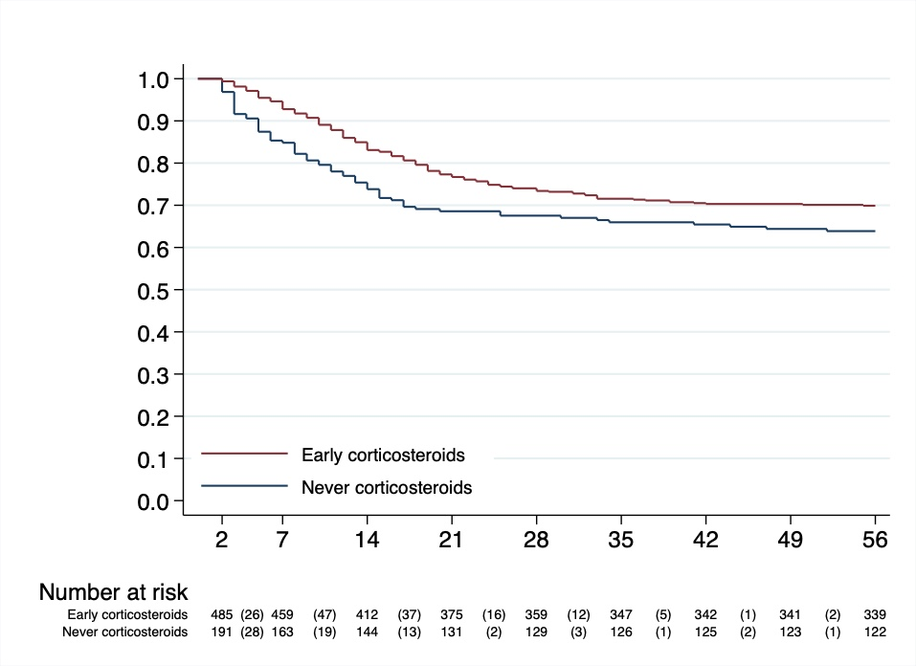
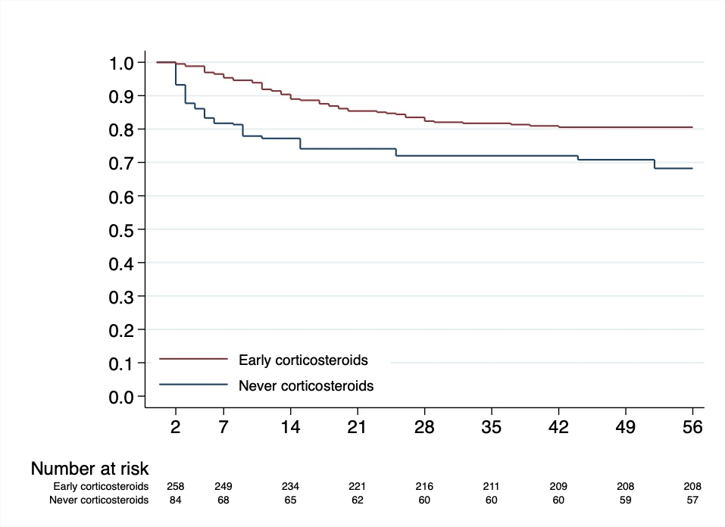

Table S7. Baseline Characteristics of Patients who have Ever or Never Received Corticosteroids during hospital stay.

 | Never steroids | Ever corticosteroids | p-value
Patients demographics and comorbidities
N (%) | 191 (21.66%) | 691 (78.34%)
Age, years | 60.0 (13.9)/189 | 62.9 (10.6)/688 | 0.01
Female (%) | 66/191 (34.5%) | 225/689 (32.6%) | 0.66
Body mass index (kg/m2) | 28.71 (5.48)/114 | 29.34 (5.34)/436 | 0.23
Arterial Hypertension | 79/191 (41.36%) | 341/691 (49.35%) | 0.06
Diabetes Mellitus | 43/191 (22.51%) | 158/691 (22.87%) | 1.00
Chronic heart failure | 1/191 (0.52%) | 12/691 (1.74%) | 0.31
Chronic renal failure | 11/191 (5.76%) | 41/691 (5.93%) | 1.00
Asthma | 5/191 (2.62%) | 19/691 (2.75%) | 1.00
COPD | 5/191 (2.62%) | 35/691 (5.07%) | 0.17
Obese | 66/170 (38.82%) | 233/622 (37.46%) | 0.78
Dyslipidemia | 21/191 (10.99%) | 111/691 (16.06%) | 0.08
Cancer | 3/191 (1.57%) | 24/691 (3.47%) | 0.23
Laboratory findings
Hematocrit (%) | 39.13 (6.03)/122 | 39.21 (5.68)/480 | 0.80
Platelets, 1000/mm³ | 232.42 (106.60)/130 | 236.25 (108.96)/542 | 0.76
Leukocytes, 10³/μL | 8.63 (5.20)/129 | 9.18 (5.95)/534 | 0.20
Lymphocytes, μL | 0.82 (0.45)/126 | 0.82 (0.77)/532 | 0.06
CRP, mg/dL | 85.41 (110.95)/119 | 71.92 (95.77)/504 | 0.25
Lactate, mmol/L | 0.39 (0.53)/99 | 0.44 (1.02)/376 | 0.72
Ferritin, ng/mL | 1744.85 (2191.54)/38 | 1652.27 (1565.18)/247 | 0.61
D- Dimer, ng/mL | 1586.78 (1957.73)/96 | 2125.38 (2407.53)/426 | 0.02
CRP/lymphocyte ratio | 158.09 (342.22)/118 | 124.22 (200.24)/499 | 0.63
IL-6, pg/mL | 269.25 (154.34)/4 | 252.47 (496.98)/83 | 0.08
LDH, U/L | 453.41 (268.91)/114 | 491.48 (231.86)/481 | 0.02
Procalcitonin, ng/mL | 0.91 (2.46)/83 | 1.46 (5.53)/371 | 0.96
Bilirubin, mg/dL | 0.91 (1.46)/98 | 0.80 (1.09)/469 | 0.91
AST, U/L | 68.55 (148.72)/122 | 55.97 (64.22)/528 | 0.72
Creatinine, mg/dL | 1.07 (0.76)/124 | 1.04 (0.66)/534 | 0.67
Urea, mg/dL | 43.73 (35.38)/80 | 47.04 (26.16)/382 | 0.02
NTProBNP, pg/mL | 4505.73 (10334.04)/16 | 1354.94 (3184.04)/80 | 0.22
Vital signs
Temperature, ºC | 37.04 (1.06)/137 | 36.85 (1.09)/517 | 0.02
Mean arterial pressure, mmHg | 86.88 (14.77)/134 | 86.67 (15.43)/510 | 0.87
Heart rate, bpm | 88.18 (19.30)/142 | 84.34 (18.58)/516 | 0.07
SpO₂, % | 87.66 (10.64)/136 | 88.27 (8.74)/505 | 0.68
Respiratory rate, bpm | 26.69 (8.71)/126 | 25.47 (6.88)/478 | 0.26
PaO₂/FiO₂ | 153.67 (78.12)/107 | 149.67 (77.39)/452 | 0.62
Severity scores
APACHE II | 12.45 (5.85)/121 | 13.78 (6.44)/479 | 0.07
CURB65 | 1.67 (1.26)/60 | 1.92 (1.20)/228 | 0.13
SOFA | 5.85 (3.18)/86 | 5.59 (2.88)/388 | 0.43

COPD: Chronic Obstructive Pulmonary Disease; CRP: C- Reactive Protein; LDH: Lactate dehydrogenase; AST: Aspartate Aminotransferase; NTProBNP: N-terminal pro-brain natriuretic peptide; APACHE: Acute Physiology and Chronic Health Evaluation; CURB65: Confusion, uremia, elevated respiratory rate, hypotension, and aged 65 years or older; SOFA: Sequential Organ Failure Assessment.

Table S8. Outcomes according to the use of corticosteroids ever or never during total hospital stay.

 | Whole cohort | Never steroids | Corticosteroids | p-value
n (%) | 882 | 191 (21.66%) | 691 (78.34%)
ICU mortality, cases/person-days | 308/59344 | 70/12274 | 238/47070
ICU mortality (hazard ratio) |  | 1 (Ref.) | 0.85 (0.65, 1.11) | 0.25
ICU mortality (hazard ratio) IPW sample, non-weighted* |  | 1 (Ref.) | 0.92 (0.55, 1.53) | 0.75
ICU mortality (hazard ratio) IP-weighted* |  | 1 (Ref.) | 0.69 (0.41, 1.27) | 0.20
7-day mortality, cases/person-days | 72/5985 | 29/1245 | 43/4740
7-day mortality (hazard ratio) |  | 1 (Ref.) | 0.38 (0.24, 0.62) | <0.001
7-day mortality (hazard ratio) IPW sample, non-weighted* |  | 1 (Ref.) | 0.28 (0.12, 0.64) | 0.003
7-day mortality (hazard ratio) IP-weighted* |  | 1 (Ref.) | 0.23 (0.09, 0.63) | 0.001
ICU length of stay, days | 17.8 (14.2) | 14.2 (13.01) | 18.9 (14.38)
ICU length of stay (mean difference) |  | 0 (Ref.) | 4.67 (2.41, 6.94) | <0.001
ICU length of stay (mean difference) IPW sample, non-weighted* |  | 0 (Ref.) | 5.65 (1.77, 9.53) | 0.004
ICU length of stay (mean difference) IP-weighted* |  | 0 (Ref.) | 5.28 (1.32, 9.46) | 0.02
ICU length of stay among survivors, days | 18.0 (14.7) | 15.0 (13.0) | 18.9 (15.1)
ICU length of stay among survivors (mean difference) |  | 0 (Ref.) | 3.91 (0.96, 6.86) | 0.009
ICU length of stay among survivors (mean difference) IPW sample, non-weighted* |  | 0 (Ref.) | 4.27 (-0.28, 8.83) | 0.06
ICU length of stay among survivors (mean difference) IP-weighted* |  | 0 (Ref.) | 4.48 (0.26, 8.40) | 0.04
Ventilator-free days | 8.4 (9.4) | 9.6 (10.1) | 8.1 (9.1)
Ventilator-free days (mean difference) |  | 0 (Ref.) | -1.46 (-2.96, 0.04) | 0.06
Ventilator-free days (mean difference) IPW sample, non-weighted* |  | 0 (Ref.) | -2.58 (-5.02, -0.14) | 0.04
Ventilator-free days (mean difference) IP-weighted* |  | 0 (Ref.) | -1.56 (-4.24, 0.96) | 0.28
Medical complications, n (%) | 860 (97.5%) | 179 (93.7%) | 681 (98.55%)
Medical complications (odds ratio) |  | 1 (Ref.) | 4.56 (1.94, 10.73) | <0.001
Medical complications (odds ratio) IPW sample, non-weighted* |  | 1 (Ref.) | 3.13 (0.86, 11.41) | 0.08
Medical complications (odds ratio) IP-weighted* |  | 1 (Ref.) | 2.36 (0.51, 10.36) | 0.20
Infectious complications, n (%) | 509 (57.7%) | 92 (48.2%) | 417 (60.35%)
Infectious complications (odds ratio) |  | 1 (Ref.) | 1.63 (1.18, 2.26) | 0.003
Infectious complications (odds ratio) IPW sample, non-weighted* |  | 1 (Ref.) | 2.31 (1.37, 3.91) | 0.002
Infectious complications (odds ratio) IP-weighted* |  | 1 (Ref.) | 2.38 (1.38, 4.28) | 0.004
*N=392. We used as predictor of treatment covariables measured at ICU admission. For the analysis of early corticosteroids treatment (48 hours) we used as predictor the last available measure of the covariables in the first 48 hours. Therefore, sample size for IPW approach is smaller in this case compare with the early treatment analysis.

Figure S3. Kaplan-Meier estimates of mortality according to corticosteroids use during total hospital stay (ever or never treatment). The upper graphs are the crude estimates. The middle graphs are crude estimates in the IP-non-weighted sample (N=392). The lower graphs are IP-weighted estimates (N=392).

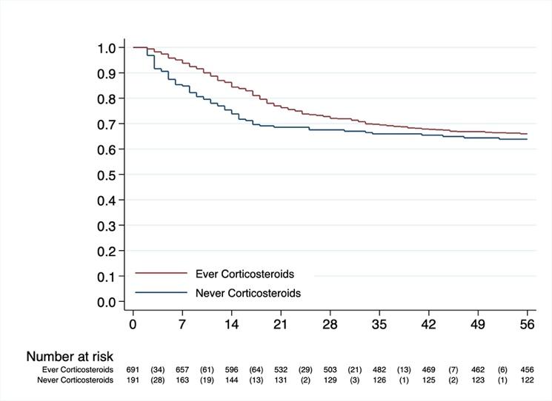
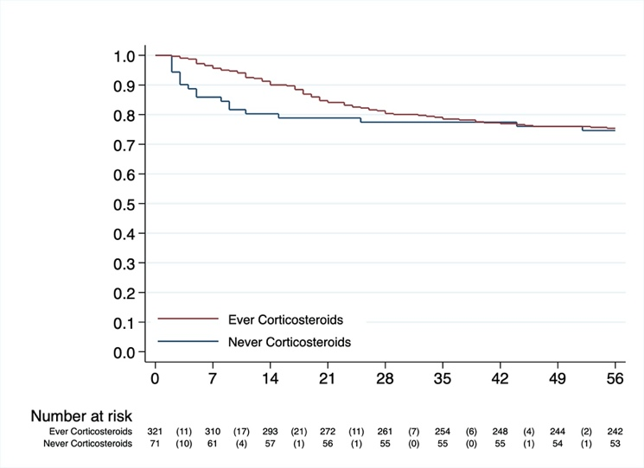
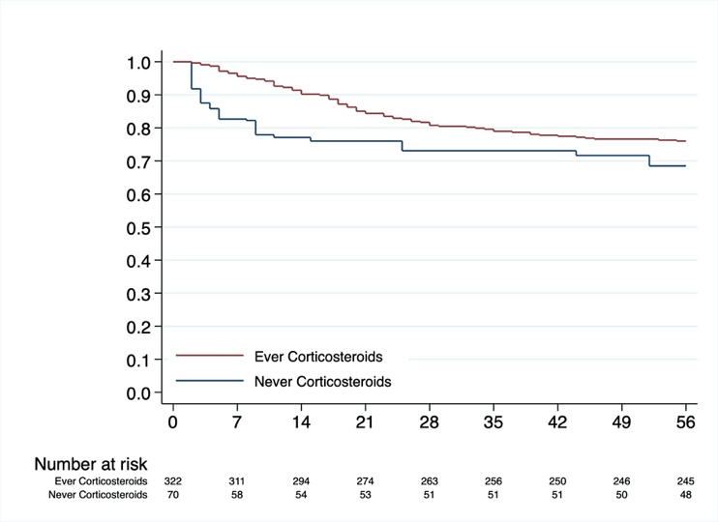

- References

- Ranieri VM, Rubenfeld GD, Thompson BT, et al. Acute respiratory distress syndrome: The Berlin Definition. JAMA 2012; 307:2526-33.
- Barberà JA, Román A, Gómez-Sánchez MA, et al. Guidelines on the Diagnosis and Treatment of Pulmonary Hypertension: Summary of Recommendations. Arch Bronconeumol. 2017.
- Cecconi M, De Backer D, Antonelli M, et al. Consensus on circulatory shock and hemodynamic monitoring. Task force of the European society of intensive care medicine. Intensive Care Med 2014; 40:1795-815.
- Mehran R, Rao S, Bhatt D, et al. Standardized bleeding definitions for cardiovascular clinical trials. A consensus report from the bleeding academic research consortium. Circulation 2011; 123:2736-47.
- Konstantinides S, Meyer G, Becattini C, et al. 2019 ESC guidelines for the diagnosis and management of acute pulmonary embolism developed in collaboration with the European respiratory society (ERS). E Respir J 2019, 1901647.
- McMurray J, Adamopoulos S, Anker S, et al. ESC guidelines for the diagnosis and treatment of acute and chronic heart failure 2012. The task force for the diagnosis and treatment of acute and chronic heart failure 2012 of the European society of cardiology. Developed in collaboration with the heart failure association (HFA) of the ESC. Eur J Heart Fail 2012; 14:803-69.
- An update definition of the stroke for the 21st century: a statement for healthcare professionals from the American heart association/American stroke. Stroke 2013; 44:2064-89.
- A European renal best practice (ERBP= position on the kidney disease improving global outcomes (KDIGO) clinical practice guidelines on acute kidney injury: part 1: definitions, conservative management and contrast-induced nephropathy. Nephrol Dial Transplant 2012; 27:4263-72.
- Singh N, Rogers P, Atwood C, et al. Short-course empiric antibiotic therapy for patients with pulmonary infiltrates in the intensive care unit. Am J Respir Crit Care Med 2000; 162: 505-11.
- Raad I, Hanna H, Maki D. Intravascular catheter-related infections: advances in diagnosis, prevention and management. Lancet Infect Dis 2007; 7:645-657.
- Hooton TN, Bradley SF, Cardenas DD, et al. Diagnosis, prevention, and treatment of catheter-associated urinary tract infection in adults: 2009 international clinical practice guidelines from the infectious disease of America. Clin Infect Dis 2010; 50:625-663.
- Singer M, Deutschman CS, Seymour CW, et al. The third consensus definitions for sepsis and septic shock (sepsis-3). JAMA 2016; 23:801-10.

