Supplemental material
Supplementary Figure 1
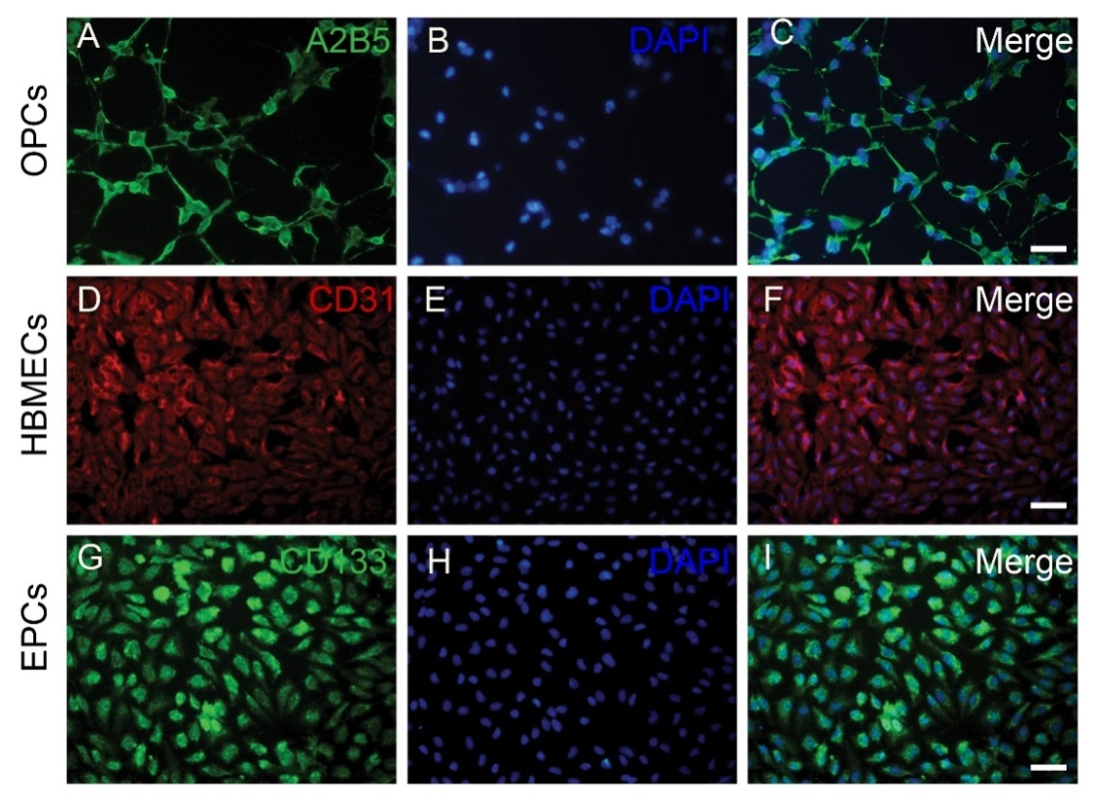
Figure1. OPCs, HBMECs and human EPCs were identified by A2B5 (A-C), CD31(D-F) and CD133 (G-I) immunofluorescent staining. Scale bars: 20μm.
Supplementary Figure 2
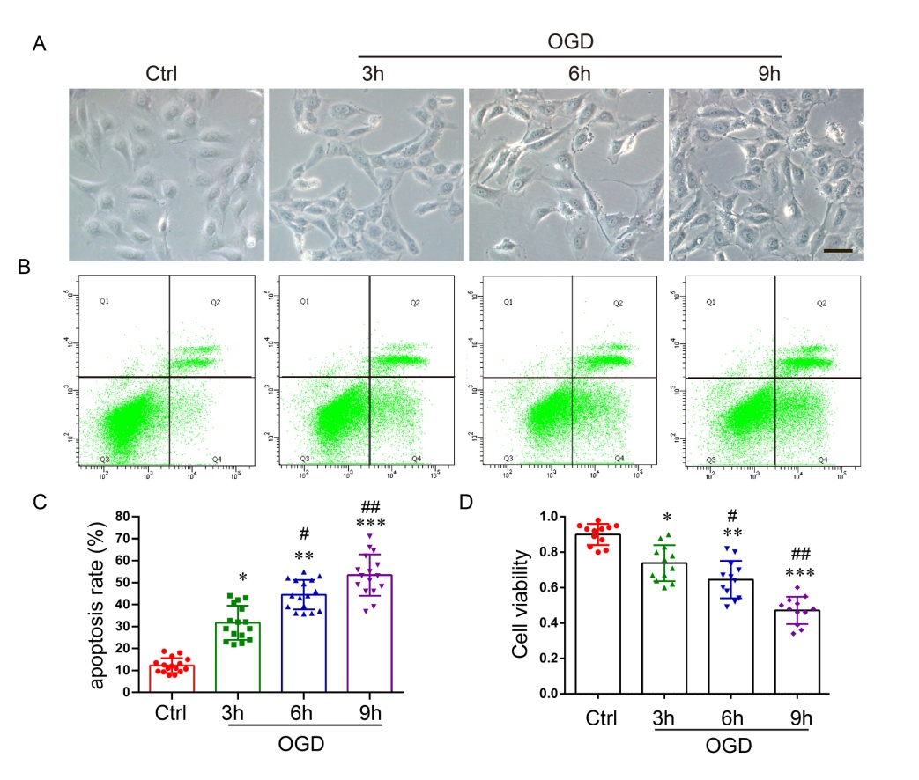

Figure 2.Oxygen-glucose deprivation (OGD) caused morphological changes and apoptosisof ECs. A,OGD caused morphological changes of ECs.Scale bar=50μm. B-C, ODG induced ECs apoptosis was detected by FACS and quantitative analyzed at different time points (n =4, triplicates per group).D, OGD resulted in significant reduction of ECs viability by CCK-8 analysis (n =6, triplicates per group). Data were analyzed using one-way ANOVA and shown as mean ± SD. *P< 0.05, **P< 0.01, **P< 0.001 vs. Ctrl group; #P< 0.05, ##P< 0.01 vs. OGD 3 h group.
Supplementary Figure 3
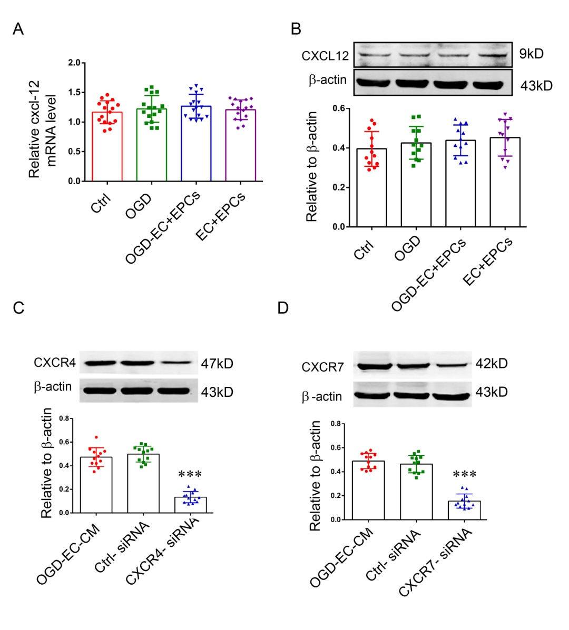
Figure 3. The mRNA and protein of CXCL12 of ECs were detected by RT-qPCR and western blotting. A, There was no statistically differencesin the CXCL12 mRNA among the groups.B,Quantification of CXCL12protein levels from immunoblots, and no statistically significant differences among the four groups. C-D, The expression of CXCR4 and CXCR7 were obviously down-regulated by cxcr4 and cxcr7 silence. Compared the mean ± SD by one-way ANOVA (n =4, triplicates per group).
Supplementary Figure 4
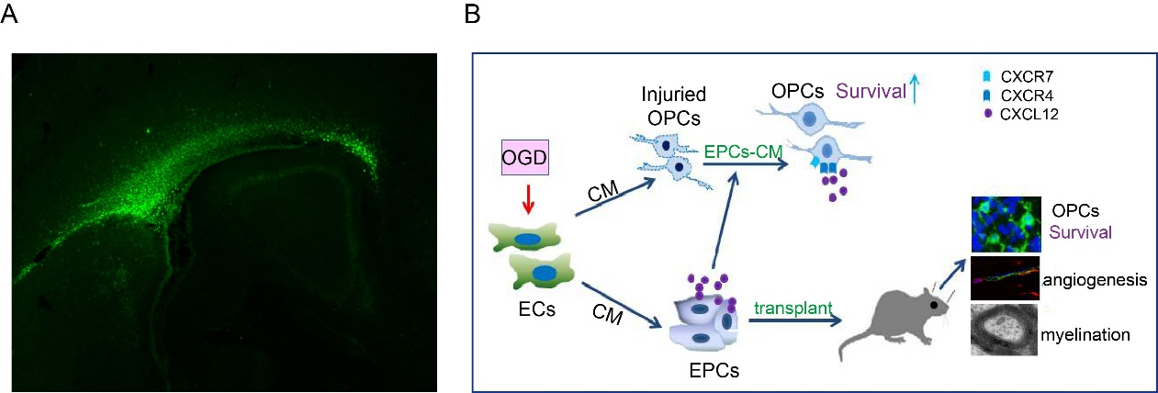
Figure 4. A, The transplanted EC-pEPCs (conditioned medium from hypoxic endothelial cells preconditioned EPCs) were observed by immunofluorescent stainingwiththe antibody that specifically binds to human CD133. EC-pEPCs distributed along corpus callosum. B, A schematic diagram was used to illustrate the effects and mechanism of EC-pEPCs on OPCs and oligovascular remodeling in vitro and in vivo.

