Supplementary material
Online Methods
The study was approved by the Institutional Review Boards of Mass General Brigham (MGB) and the Icahn School of Medicine at Mount Sinai and was conducted per the Declaration of Helsinki.
Study population: We used data from two hospital-based biobanks, Mass General Brigham Biobank (MGBB) and Mount Sinai BioMe Biobank.
Mass General Brigham Biobank: The MGB Biobank (MGBB) consists of over 135,000 participants from the MGB healthcare system in the greater Boston area (Boutin, 2022). A total of 36,217 participants were genotyped using the Illumina Multi-Ethnic Genotyping Array (MEGA) as previously described (Tran et al., 2024).
Mount Sinai BioMe Biobank: The Mount Sinai BioMe Biobank includes over 54,000 participants from the Mount Sinai Health System in New York City and the greater metropolitan area. All participants were genotyped using the Illumina Global Screening Array and Illumina Global Diversity Array as previously described (Chen et al., 2025).
Genotype quality control: Best practice genotype quality control (QC) filtering process was applied using PLINK 1.9/PLINK 2 on directly genotyped and imputed variants at both the sample and variant levels within each biobank. Quality control for each biobank was as follows:
MGBB: Samples were removed with call rates <98%, missingness rate >2%, and mismatched genotype-inferred and self-reported sex and ancestry. Duplicate samples were also removed. At the variant level, variants were removed with low imputation quality with a cutoff INFO < 0.6, and a missingness rate > 2%. Heterozygous sites on the non-pseudoautosomal region (PAR) of chromosome X in males were set as missing. Furthermore, shared single nucleotide polymorphisms (SNPs) were removed based on the following criteria: Minor Allele frequency (MAF) < 0.01, failed allele frequency association tests across batches (P < 0.05/(8* number of shared SNPs), monomorphic sites, and SNPs with Hardy Weinberg Equilibrium (HWE) p < 1×10⁻⁸ in any of the population groups tested. A total of 36,217 samples and 8,109,830 variants remained after QC.
Mount Sinai BioMe Biobank: Samples with call rates <95%, unresolved differences between genotype-inferred and self-reported sex, heterozygosity rate beyond three standard deviations (SD) per ancestry, and duplicate samples were removed. At the variant level, those with a missingness rate >5%, HWE for autosomes with p<1×10⁻⁸, and an imputation score of Rsq < 0.7 were removed. A total of 53,982 samples and ~9.4 million variants remained after QC.
For both biobanks, Principal Component Analysis was applied to linkage disequilibrium-pruned (r²<0.2 in 200kb windows) genetic markers with MAF >0.05 and the k-nearest neighbors algorithm to predict the ancestral background of participants using informative markers from the 1000 Genomes Project Phase 3 reference panel.
PRS Construction: We computed a genome-wide POAG polygenic risk score (PRS) based on summary statistics from a large cross-ancestry genome-wide association study (GWAS) meta-analysis after the exclusion of the UK Biobank (UKBB) cohort (summary statistics available at https://segrelab.meei.harvard.edu/data/) (Gharahkhani, 2021). The PRS was first trained with imputed genotype data from the UKBB population using a Lassosum penalized regression framework (Mak, 2017) as previously described (Sekimitsu, 2023). The array curation process for UKBB is described in detail elsewhere (Bycroft, 2017). The model included 10,238,000 directly genotyped and imputed variants for 449,186 UKBB samples (14,171 POAG cases and 394,292 controls). The reference panels 1000 Genomes Project Phase 3 merged with UK10K, and the Haplotype Reference Consortium (HRC) were used for imputation. A total of 144,009 SNPs with non-zero beta values remained across the autosomes plus selected (non-PAR) X chromosome variants after the Lassosum regression. The calculated weights for these SNPs were used to compute a PRS for 36,217 participants in the MGBB and 53,449 participants in the BioMe Biobank using the --score function in PLINK. We normalized our PRS to a mean of 0 and a standard deviation of 1 within each genotype-inferred ancestral group to reduce bias due to the higher frequency of certain alleles within an ancestry.
This PRS has been validated and used in other studies with area under the curve (AUC) values for glaucoma case discrimination as high as 0.82 in European Caucasians (de Vries, 2025) and 0.7 in African ancestries (Singh, 2024).
Clinical exam: Using standard protocols the study visit included 1) LogMAR and Sellen visual acuity; 2) Autorefraction; 3) Intraocular pressure measurement (IOP) with Goldmann applanation tonometry (mean of 2 or 3 masked measures); 4) Ocular Response Analyzer IOP and corneal hysteresis; 5) Visual field assessment using the Humphrey visual field (HVF), SITA 24-2 standard testing; 6) Spectral domain optical coherence tomography (OCT) of the macula, circumpapillary retina, optic nerve, and retinal vessels (Heidelberg); 7) Optic nerve centered fundus photography; 8) Slit lamp biomicroscopy; 9) Gonioscopy; 10) Fundus examination; 11) Central corneal thickness measured with ultrasound, and; 12) Ocular biometry.

Glaucoma definitions:
Definite POAG: circumpapillary retinal nerve fiber layer (cpRNFL) with a classification of outside normal limits (ONL) (p<0.01) confirmed with minimal rim width analysis (MRWA) with correlating visual field loss and/or optic nerve photo consistent with glaucoma per two independent graders.
Probable POAG: either the cpRNFL or MRWA report provides a classification of ONL with suggestive visual field loss and probable glaucoma when viewing the optic nerve, per two independent graders.
Possible POAG (Glaucoma suspect): either the cpRNFL or MRWA report provides a classification of borderline (p<0.05), or the optic nerve appears possibly glaucomatous by two independent graders based on optic nerve photos.
Not Glaucoma: The cpRNFL and the MRWA reports reveal a classification of within normal limits (p>0.05), and the optic nerve appears healthy, determined by two independent graders reviewing optic nerve photos.
Censored: Unable to grade because OCT and optic nerve photo findings could be due to secondary conditions, and insufficient past ocular history is available to rule out secondary glaucoma or non-glaucomatous optic nerve disease. When the OCT was not useful, we graded glaucoma status based on available fundus photographs and HVF data.

Supplemental Figure 1. Selection of study participants for recall and glaucoma assessment
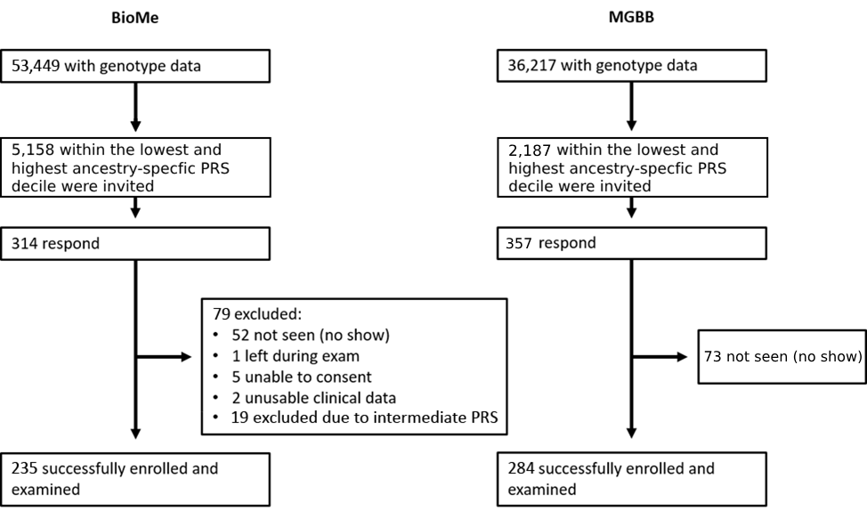

Figure 1. For BioMe, of 53,449 individuals with genotype data to calculate a polygenic risk score (PRS), 5,158 individuals with either low or high PRS deciles were invited to participate in the clinical recall study using letters of invitation. Of these, 314 (6.1%) responded to the invitation. 79 of these individuals were excluded, and 254 individuals were successfully enrolled and examined. For MGBB of the 36,217 individuals with genotype data, 2,150 individuals in the top or bottom decile were invited to participate. 357 individuals responded, and of these 73 were excluded. 284 subjects were successfully enrolled and examined.

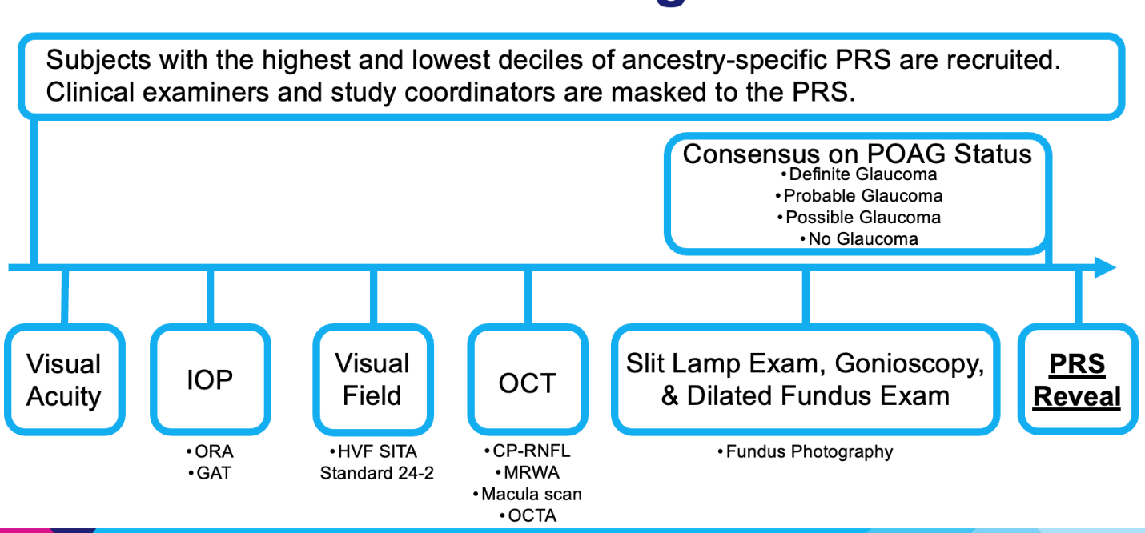
Supplementary Figure 2. Workflow for the clinical exam. Subjects with either the highest or lowest polygenic risk score (PRS) decile were examined by a board-certified, fellowship-trained glaucoma specialist. The study personnel were masked to the PRS score. The exam included measurement of visual acuity; corneal-compensated and Goldmann applanation tonometric intraocular pressure (IOP) (the former measured with the Ocular Response Analyzer (ORA)); visual field (Humphrey SITA standard 24-2 tests); optical coherence tomography (OCT) measurements of the circumpapillary retinal nerve fiber layer (CP-RNFL) thickness, neuroretinal rim thickness (assessed with minimum rim width analysis (MWRA)) software, macula volume and retinal vessel density (measured with OCT-angiography (OCTA); slit lamp exam including gonioscopy; and dilated fundus exam with acquisition of fundus photography. After the examination, the glaucoma specialist designates the glaucoma status. A second fellowship-trained glaucoma specialist reviews the exam findings and determines a glaucoma diagnosis for the patient without knowing the grade of the in-person examiner. If the initial two examiners did not agree, a third ophthalmologist with glaucoma fellowship training adjudicated the final status.

Supplementary Table 1a. Demographic features of BioMe and Mass General Brigham Biobank patients invited for comprehensive examination stratified by PRS (N=519)
 |  | Highest PRS decile | Lowest PRS decile
N |  | 273 | 246
Mean PRS (Min, Max) |  | 2.07 (1.28, 4.34) | -2.08 (-3.79, -1.23)
Ancestral Normalized PRS percentile (Min, Max) |  | 90, 100 | 0, 10
Mean Age, years (SD) |  | 65.0 (10.3) | 64.7 (10.1)
Sex (% Male) |  | 39.6% | 45.5%
Genetically inferred ancestries
European | N (%) | 175 (64.1%) | 150 (61.0%)
European | Mean PRS (Min, Max) | 2.13 (1.43, 4.34) | -2.11 (-3.72, -1.25)
European | Mean Age, years (SD) | 66.3 (10.9) | 65.7 (10.2)
African | N (%) | 62 (22.7%) | 44 (17.9%)
African | Mean PRS (Min, Max) | 2.02 (1.30, 2.83) | -2.02 (-3.79, -1.28)
African | Mean Age, years (SD) | 63.4 (8.2) | 63.7 (11.7)
Mixed American | N (%) | 31 (11.4%) | 39 (15.9%)
Mixed American | Mean PRS (Min, Max) | 1.85 (1.28, 3.34) | -2.05 (-3.62, -1.25)
Mixed American | Mean Age, years (SD) | 60.5 (8.5) | 61.8 (8.1)
Asian | N (%) | 5 (1.8%) | 13 (5.3%)
Asian | Mean PRS (Min, Max) | 2.21 (1.87, 2.49) | -2.08 (-3.03, -1.23)
Asian | Mean Age, years (SD) | 63.6 (12.7) | 64.5 (6.9)
Abbreviations: PRS=polygenic risk score; Min=Minimum; Max=Maximum; SD=Standard Deviation

Supplementary Table 1b. Site-specific demographic features of participants invited for comprehensive examination (N=519)
 |  | BioMe | MGBB
N |  | 235 | 284
Mean PRS (Min, Max) |  | 0.04 (-3.62, 3.43) | 0.16 (-3.79, 4.34)
Ancestral Normalized PRS percentile (Min, Max) |  | 0, 99 | 1, 100
Mean Age (SD) |  | 65.1 (7.4) | 64.6 (12.0)
Sex (% Male) |  | 38.7% | 45.4%
Genetically inferred ancestries
European | N (%) | 86 (36.6%) | 239 (84.2%)
European | Mean PRS (Min, Max) | -0.04 (-3.11, 3.43) | 0.25 (-3.72, 4.34)
European | Mean Age, years (SD) | 66.6 (7.4) | 65.9 (11.5)
African | N (%) | 81 (34.5%) | 25 (8.8%)
African | Mean PRS (Min, Max) | 0.45 (-3.27, 2.83) | 0.005 (-3.79, 2.68)
African | Mean Age, years (SD) | 65.7 (7.2) | 56.6 (13.2)
Mixed American | N (%) | 58 (24.7%) | 12 (4.2%)
Mixed American | Mean PRS (Min, Max) | -0.30 (-3.62, 3.15) | -0.43 (-2.82, 3.34)
Mixed American | Mean Age, years (SD) | 62.0 (6.9) | 57.6 (12.7)
Asian | N (%) | 10 (4.3%) | 8 (2.8%)
Asian | Mean PRS (Min, Max) | -0.67 (-2.58, 2.49) | -1.16 (-3.03, 2.44)
Asian | Mean Age, years (SD) | 66.4 (7.2) | 61.5 (9.6)
Abbreviations: PRS=polygenic risk score; Min=Minimum; Max=Maximum; SD=Standard Deviation

Supplemental Table 1c. Demographic features of BioMe patients invited for comprehensive examination stratified by PRS (N=235)

 |  | High PRS | Low PRS
N |  | 119 | 116
Mean PRS (Min, Max) |  | 1.97 (1.28, 3.43) | -1.94 (-3.62, -1.23)
Ancestral Normalized PRS percentile (Min, Max) |  | 90, 99 | 0, 10
Mean Age (SD) |  | 65.4 (7.5) | 64.9 (7.3)
Sex (%Male) |  | 36.10% | 41.40%
Genetically inferred ancestries
European | N (%) | 42 (35.3%) | 44 (37.9%)
European | Mean PRS (Min, Max) | 2.04 (1.43, 3.43) | -2.01 (-3.11, -1.25)
European | Mean Age, years (SD) | 68.3 (7.1) | 65.0 (7.3)
African | N (%) | 48 (40.3%) | 33 (28.4%)
African | Mean PRS (Min, Max) | 2.01 (1.30, 2.83) | -1.82 (-3.27, -1.28)
African | Mean Age, years (SD) | 64.8 (6.9) | 67.0 (7.7)
Mixed American | N (%) | 26 (21.8%) | 32 (27.6%)
Mixed American | Mean PRS (Min, Max) | 1.76 (1.28, 3.15) | -1.97 (-3.62, -1.25)
Mixed American | Mean Age, years (SD) | 61.7 (7.6) | 62.2 (6.5)
Asian | N (%) | 3 (2.5%) | 7 (6.0%)
Asian | Mean PRS (Min, Max) | 2.22 (1.87, 2.49) | -1.9 (-2.58, -1.23)
Asian | Mean Age, years (SD) | 65.3 (10.8) | 66.9 (6.2)
Abbreviations: PRS=polygenic risk score; Min=Minimum; Max=Maximum; SD=Standard Deviation

Supplemental Table 1d. Demographic features of MGBB patients invited for comprehensive examination stratified by PRS (N=284)

 |  | High PRS | Low PRS
N |  | 154 | 130
Mean PRS (Min, Max) |  | 2.16 (1.67, 4.34) | -2.21 (-3.79, -1.75)
Ancestral Normalized PRS percentile (Min, Max) |  | 96, 100 | 1, 5
Mean Age (SD) |  | 64.6 (12.0) | 64.6 (12.1)
Sex (%Male) |  | 42.20% | 49.20%
Genetically inferred ancestries
European | N (%) | 133 (85.4%) | 106 (81.5%)
European | Mean PRS (Min, Max) | 2.16 (1.75, 4.34) | -2.15 (-3.72, -1.75)
European | Mean Age, years (SD) | 65.7 (11.8) | 66.0 (11.2)
African | N (%) | 14 (9.1%) | 11 (8.5%)
African | Mean PRS (Min, Max) | 2.05 (1.67, 2.68) | -2.60 (-3.79, -1.91)
African | Mean Age, years (SD) | 58.6 (10.5) | 54.0 (16.1)
Mixed American | N (%) | 5 (3.3%) | 7 (5.4%)
Mixed American | Mean PRS (Min, Max) | 2.35 (1.80, 3.34) | -2.41 (-2.82, -2.02)
Mixed American | Mean Age, years (SD) | 53.8 (10.8) | 60.3 (14.0)
Asian | N (%) | 2 (1.3%) | 6 (4.6%)
Asian | Mean PRS (Min, Max) | 2.20 (1.96, 2.44) | -2.28 (-3.03, -1.89)
Asian | Mean Age, years (SD) | 61.0 (19.8) | 61.7 (7.1)
Abbreviations: Min=Minimum; Max=Maximum; SD=Standard Deviation
Supplementary Table 2. Previously undiagnosed glaucoma in the highest and lowest polygenic risk score (PRS) decile groups in two biobanks.

 | Highest PRS decile | Lowest PRS decile
 | Previously Undiagnosed / Glaucoma Cases (%), N=51 | Previously Undiagnosed / Glaucoma Cases (%), N=10
BioMe | 13/27 (48.1%) | 2/4 (50%)
MGBB | 11/24 (45.8%) | 4/6 (66.7%)
BioMe & MGBB | 24/51 (47.1%) | 6/10 (60%)
European | 13/29 (44.8%) | 3/3 (100%)
African | 7/15 (46.7%) | 3/4 (75%)
Mixed American | 4/6 (66.7%) | 0/3 (0%)
Asian | 0/1 (0%) | 0/0
Abbreviations: MGBB, Mass General Brigham Biobank
References
Boutin NT, Schecter SB, Perez EF, et al. The Evolution of a Large Biobank at Mass General Brigham. J Pers Med. 2022;12(8):1323.

Bycroft C, Freeman C, Petkova D, et al. Genome-wide genetic data on ~500,000 UK Biobank participants. Published online in 2017.

Chen R, Petrazzini BO, Duffy Á, Rocheleau G, Jordan D, Bansal M, Do R. Trans-ancestral rare variant association study with machine learning-based phenotyping for metabolic dysfunction-associated steatotic liver disease. Genome Biol. 2025 Mar 10;26(1):50.

Gharahkhani P, Jorgenson E, Hysi P, et al. Genome-wide meta-analysis identifies 127 open-angle glaucoma loci with consistent effect across ancestries. Nat Commun. 2021;12(1):1258.

Mak TSH, Porsch RM, Choi SW, Zhou X, Sham PC. Polygenic scores via penalized regression on summary statistics. Genet Epidemiol. 2017;41(6):469-480.

Sekimitsu S, Xiang D, Smith SL, et al. Deep Ocular Phenotyping Across Primary Open-Angle Glaucoma Genetic Burden. JAMA Ophthalmol. 2023;141(9):891-899.

Tran JH, Kang J, Han E, Gupta U, Seresirikachorn K, Vy HMT, Zhao Y, Rocheleau G, Luo Y, Lee R, Do R, Friedman DS, Kang JH, Wiggs JL, Pasquale LR, Segrè AV, Zebardast N. Use of Diagnostic Codes for Primary Open-Angle Glaucoma Polygenic Risk Score Construction in Electronic Health Record-Linked Biobanks. Am J Ophthalmol. 2024 Nov;267:204-212.

de Vries VA, Hanyuda A, Vergroesen JE, Do R, Friedman DS, Kraft P, Turman C, Luo YL, Tran JH, Liefers B, Wong SH, Lee RH, Zebardast N, Klaver CCW, Segrè AV, Pasquale LR, Wiggs JL, Kang JH, Ramdas WD. The Clinical Usefulness of a Glaucoma Polygenic Risk Score in 4 Population-Based European Ancestry Cohorts. Ophthalmology. 2025 Feb;132(2):228-237.

Singh RK, Zhao Y, Elze T, Fingert J, Gordon M, Kass MA, Luo Y, Pasquale LR, Scheetz T, Segrè AV, Wiggs JL, Zebardast N. Polygenic Risk Scores for Glaucoma Onset in the Ocular Hypertension Treatment Study. JAMA Ophthalmol. 2024 Apr 1;142(4):356-363.

