Supporting information

«Beyond Intensity Imaging: Dissipative Equilibrium of NADH/NAD⁺ as a Metabolic Sensor for Ischemic Response in Cardiac Tissue»

M.M. Slotvitsky^{1,2,3,*}, M.S. Medvedev^{1,2}, G.S. Pashintsev^{1,2}, V.S. Kachan^{1,2}, S.A. Romanova^{2,3},
K.I. Agladze^{2,3}, V.A. Tsvelaya^{1,2,3,*}

¹ITMO University, 197101 St. Petersburg, Russia
²Laboratory of Experimental and Cellular Medicine, Moscow Center for Advanced Studies, 123592, Moscow, Russia
³M. F. Vladimirsky Moscow Regional Research Clinical Institute, 129110 Moscow, Russia

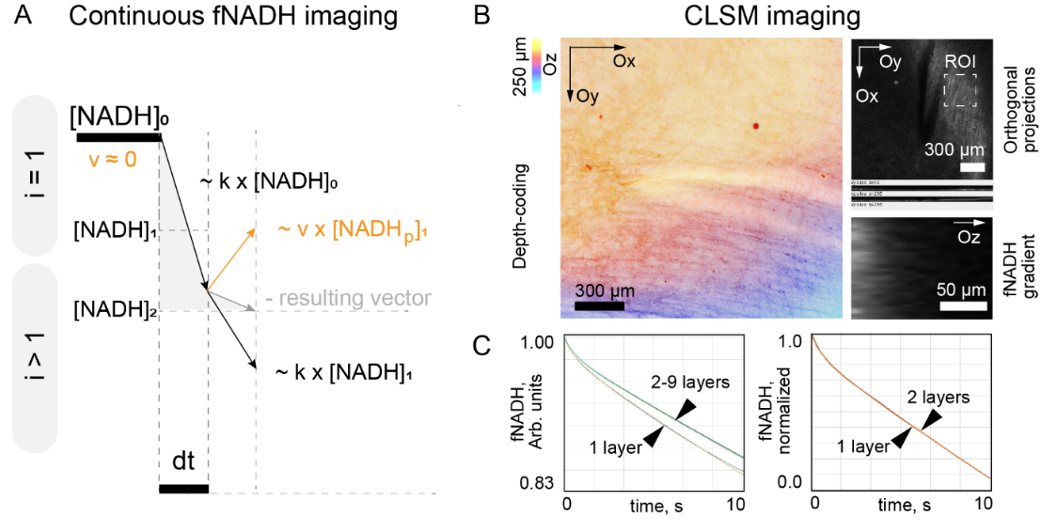
Figure S1. A. The computational scheme for Equations 1–3, the time step is denoted by dt, the subscript [NADH] denotes the time step number (i), [NADHp] denotes the equivalent concentration of photobleached [NADH], which in the case of α = 1 is equivalent to the sum of all d[NADH]. In solving Equation 9, the final signal was summed by integrating several f_{NADH}(t) trajectories with decreasing k values ​​as estimated in panel B. Panel B shows a confocal depth-coding image of the epicardium according to Protocol B. The orthogonal projections show the decay of the fluorescence signal in the tissue thickness. The white dotted line highlights the ROI for the orthogonal projection in the bottom panel. The signal was recorded in the range of 480±20 nm. Panel C shows the numerical solutions of Equation 9 for the original system of Equations 1–3, where the tissue thickness was divided into 1–9 tissue layers: changing the number of layers from 2 to 9 does not yield significant changes in f_{NADH}(t).

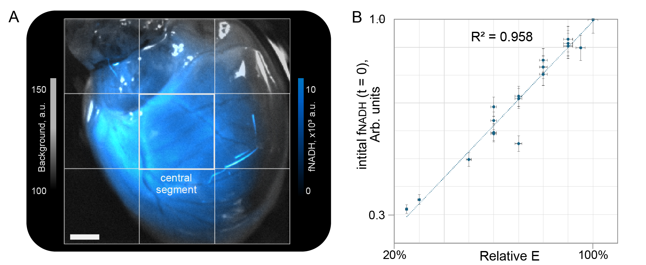
Figure S2. Dependence of the initial fluorescence f_{NADH}(0) on relative illumination E. A. Scheme of segmentation of the central part of the epicardium for averaging f_{NADH}(0). Scale bar – 0.5 mm. B. Linear dependence of the initial fluorescence f_{NADH}(0) on relative E, R²=0.958, n = 22 from 5 experiments. The error of the initial fluorescence f_{NADH}(0) was estimated from the SD of the spread of f_{NADH}(0) within the central segment, and the error of E from the differences Δk/k and the resulting Δf_{NADH}(0)/f_{NADH}(0) in the experiments according to Protocol C.

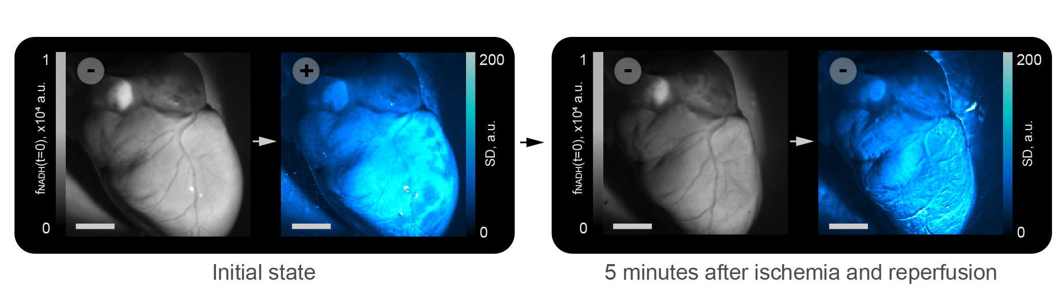
Figure S3. Illustration of the disappearance of dissipative spots during 5-minute ischemia (Protocol C). The scales indicate the values ​​of f_{NADH}(t=0) (black and white scale) and SD (cyan hot pseudo colors). The left half shows the state of the heart in the first recording of Protocol C, and the right half in the second recording. The scale bar is 3 mm. The presence of dissipative spots is marked with the “+” sign.

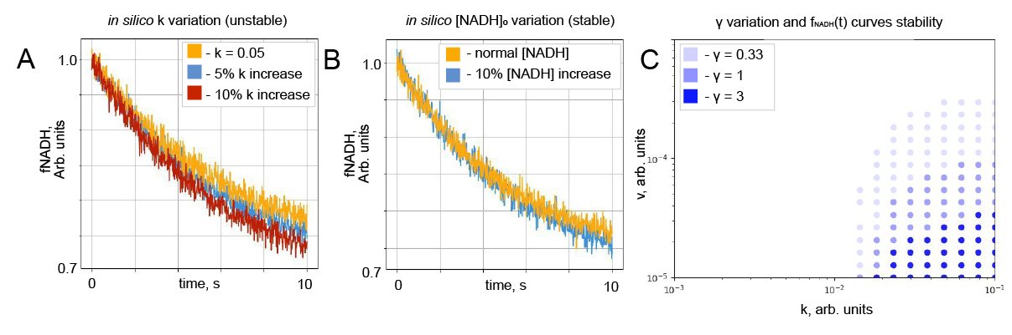
Figure S4. Numerical solution of the system of Equations 1–3 with added Gaussian [4] noise (corresponds to the noise level in the experimental data) for v = 8×10-5, k = 0.05, γ = 7.5. A. Change in solution with increasing k within 10% - the discrepancy between the curves exceeds the noise. B. Divergence of the curves by increasing [NADH] by 10% - the change does not exceed the noise level. C. Parametric diagram: the k and v values ​​for which the discrepancy between the curves with increasing k by 10% exceeds that for increasing [NADH] by 10% (as in the examples from panels A and B) are marked in color.

