Appendix 1

Guideline Implementation Success Assessment Tool (A-GIST) revised - English Ver.
Section 1: Health professional items
Introduction:
The questionnaire is to investigate the implementation effects of clinical practice guidelines (CPGs) in your healthcare institution. The questionnaire is for ______ (name of the target CPG).
The questionnaire will take 3-5 minutes to complete. Your personal information will be kept confidential and your responses will only be used to evaluate the success of implementation of the target CPG.

*Success of CPGs Implementation: The whole process of CPGs implemented through specific channels to Reach the healthcare institutions, professionals and patients, be Adopted, then be Implemented in accordance with the recommendations, producing certain clinical effects on patients (Effectiveness), and be Maintained for a sufficient period of time. Information on the Barriers and facilitators of CPGs implementation was also included.

Part 1 Basic Information
1. Your Age ________
2. Your sex
○ Male ○ Female ○ Prefer not to say
3. Highest Level of Education
○ High school diploma or below ○ Bachelor’s Degree ○ Master’s Degree
○ Doctorate (PhD) ○ Other (please specify) ________
4.Occupation
○ Doctor ○ Nurse ○ Pharmacist ○ Therapist ○ Other (please specify) _______
5. Professional Title
○ Assistant ○ junior ○ senior
6. Primary Area of Practice ______ (e.g. general medicine, pediatrics, oncology, etc.)
7. Years of Experience in the Medical Field
○＜1 year ○ 1-5 years ○ 6-10 years ○＞10 years
8. Name of Your Institution _______________
9. Nature of Your Institution ○ Public ○ Private
10. Level of Your Institution
○ Township ○ County ○ City
○ Provincial ○ National ○ Other (please specify)_______
11. Declaration of Interest (multi-choices are allowed)
☐ Have been involved in the development or review of the target CPG or similar ones  ☐ Relevant studies have been carried out before  ☐Has received funding from relevant companies | ☐ Has acted as a consultant to relevant companies  ☐ Holding of stocks in related companies  ☐ Other (please specify) ________  ☐ None of the above
*Please notice: Relevant companies are those that manufacture or supply the drugs, instruments or equipment covered in the recommendations of the target CPG.

Part 2 Evaluation Items
*Please attention: The following questions are only for ______ (name of the target CPG).
Dimensions | Questions
Reach | Q1 Did you know this CPG?  ○ Yes ○ No (→Please skip to Q16)
Reach | Q2 When did you know this CPG? (Specify the year and month) ______
Reach | Q3 Through which channels did you know this CPG? (Multiple choice)
Reach | ☐ Literature database  ☐ Academic conference  ☐ Institutions’ websites  ☐ Journals  ☐ Books  ☐ Other (please specify) ________ | ☐ Internet  ☐ Social media  ☐ Email  ☐ Lectures or seminars  ☐ Recommended by colleague
Adoption | Q4 Has this CPG been adopted in practice in your institution? (e.g., promoted or presented it hospital-wide/department-wide, used it as a daily reference for diagnosis and treatment, or adopted it as part of regulations or evaluation criteria, etc.)  ○ Yes ○ No
Adoption | Q5 To what extent do you agree with this CPG’s recommendations? (Referring to its professionalism, authority, and evidence reliability) (*Please mark the corresponding positions on the lower axis with a distinctive dot ● according to the actual extent)  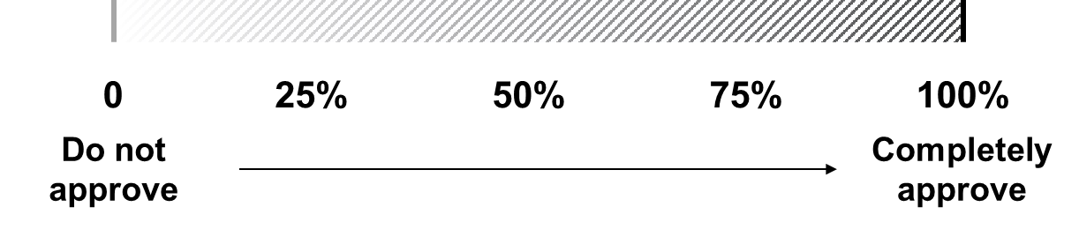
Adoption | Q6 Have you adopted this CPG in practice?  ○ Yes ○ No (→Please skip to Q16)
Adoption | Q7 When did you start adopting this CPG in practice? (Specify the year and month) _____
Implementation | Q8 To what extent did you follow the recommendations of this CPG in practice when treating applicable patients? (Please mark the corresponding positions on the lower axis with a distinctive dot ● according to the actual extent)  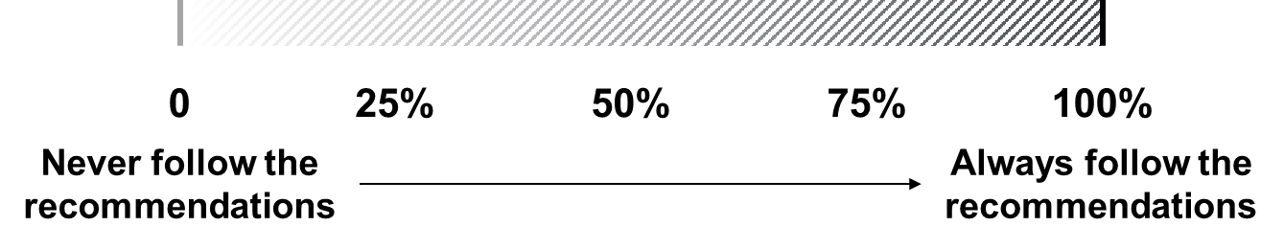
Implementation | Q9 What percentage of eligible patients have been treated according to this CPG since adopted? (Please mark the corresponding positions on the lower axis with a distinctive dot ● according to the actual extent)  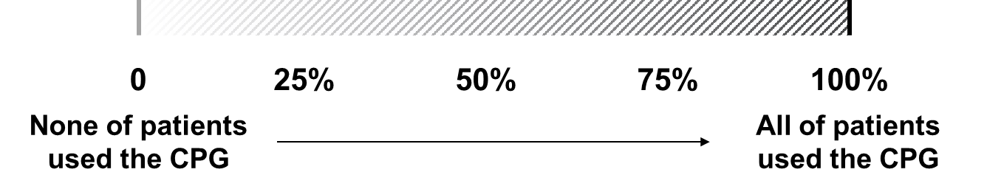
Effectiveness | Q10 To what extent have clinical outcomes improved, compared to previous practice since implementing this CPG?  ○Strongly agree ○Agree ○Neutral ○Disagree ○Strongly disagree
Effectiveness | Q11 To what extent have adverse reactions or complications reduced, compared to previous practice since implementing this CPG?  ○Strongly agree ○Agree ○Neutral ○Disagree ○Strongly disagree
Effectiveness | Q12 To what extent has medical expenditure reduced, compared to previous practice since implementing this CPG?  ○Strongly agree ○Agree ○Neutral ○Disagree ○Strongly disagree
Maintenance | Q13a Did your institution make specific actions to maintain the implementation of this CPG?  ○ Yes, there are some specific actions. ○ No (→Please skip to Q14)  Q13b If so, what were they? (Multiple choice)  ☐ Transformed into standardizations or clinical norms  ☐ Included as a basis for off-label drug using  ☐ Included in the prescription database  ☐ Included in patient education in the department  ☐ Used as a basis for prescription review  ☐ Induction education for new employees  ☐ Continuing education for old employees  ☐ Considered in ward rounds  ☐ Included in clinical pathway management  ☐ As a reference for the discussion of difficult cases  ☐ Medical quality assessment  ☐ Others (please specify) _______
Maintenance | Q14 How long have you consistently adhered to this CPG? _______ months
Maintenance | Q15a Have you ever discontinued or stopped using this guideline?  ○ Yes, I had ever stopped using it.  ○ No, I never stopped using it. (→Please skip to Q16)  Q15b If so, when? (Specify the year and month) _________  Q15c And why? (Multiple choice)  ☐ The CPG was updated or similar but new CPG appeared.  ☐ New clinical evidence was generated.  ☐ The clinical effect was proved to be dissatisfactory.  ☐ Others (please specify) _______
Barriers and facilitators | Q16a Did you encounter any barriers when implementing this CPG in your institution or in practice?  ○ Yes, there are some barriers to its implementation.  ○ No, I don’t think there are any barriers to its implementation (→Please skip to Q17)  Q16b If so, what were they? (Multiple choice)  1）Guideline factors  ☐ Convenience of acquisition channels to the CPG  ☐ Clarity of the recommendations of the CPG  ☐ Scientificity and reliability of the evidence in the CPG  ☐ Applicability of the CPG  ☐ Impact of the CPG on clinicians’ autonomy  ☐ Influence of the CPG on patients’ treatment choices  ☐ Whether there are implementation plan or strategies to promote the implementation of the guidelines (e.g. network-wide release, academic conference presentations, leader promotion, etc.)  ☐ Others (please specify) _______  2）Environmental factors  ☐ Policies and systems (e.g., centralized procurement) of national, local, and medical institutions  ☐ Impact of medical insurance  ☐ Overall climate of the institution to support the implementation of CPG into practice  ☐ Attitude of the leader in the department or team towards the CPG  ☐ Cooperation from relevant departments in implementing the CPG  ☐ Hardware conditions for implementing the CPG (e.g., information system, equipment, technology, drugs (including biological preparations, vaccines, etc.))  ☐ Others (please specify) _______  3）Professional factors  ☐ Evidence-based medical literacy and skills of clinicians (e.g., proposing clinical questions, searching, decision-making, and effect evaluation)  ☐ Time cost of clinicians in retrieving and learning the CPG  ☐ Awareness and familiarity of clinicians with the CPG  ☐ Trustiness and implementation willingness of clinicians towards the CPG  ☐ Consistency between the views of clinicians and the recommendations of the CPG  ☐ Others (please specify) _______  4）Patient factors  ☐ Patients’ understanding and attitude towards the concept of evidence-based medicine  ☐ Patients’ health literacy  ☐ Patients’ education level  ☐ Patients’ compliance  ☐ Patients’ economic status and family support situation  ☐ Others (please specify) _______  5）Other factors (please specify) ______________________
Overall evaluation | Q17 How would you rate the overall implementation of this CPG from your personal perspective, and based on the aspects mentioned above?  ○1 ○2 ○3 ○4 ○5 ○6 ○7 ○8 ○9 ○10
Overall evaluation | Q18 Any suggestions for improving the implementation of this CPG?  _______________________________________________________________

Date (Year/Month): /
Section 2: Patient items
Introduction:
This questionnaire is designed to find out how well you have been treated for your current illness and your quality of life in the recent past. We hope you will read the following questions carefully and if you are not sure how to answer a question, please choose the one that is closest to how you really feel. This questionnaire will take between 5-8 minutes to complete. Your personal information will be kept confidential and your responses will only be used to evaluate the implementation effects of the clinical practice guidelines. We sincerely hope to obtain your true and complete answers as a reference and thank you for your participation and cooperation!

Part 1 Basic Information
1. Your Age ________
2. Your Gender ○ Male ○ Female ○ Prefer not to say
3. Highest Level of Education
○ High school diploma or below ○ Bachelor’s Degree ○ Master’s Degree
○ Doctorate (PhD) ○ Other (please specify) ________
4. Name of the hospital you attended _______________
5. Name of the department you attended _____________
6. Type of the visit ○ Inpatient ○ Outpatient
7. Type of the medical insurance
○ Public ○ Private ○ Other (please specify) ______________

Part 2 Evaluation of Patient Outcomes (Q1’)
This part of the question is intended to give you an idea of the effects, side effects and cost of the treatment you have received at this hospital for your current condition.
q1. How well did you get treated for this condition at this hospital?
○ Very good ○ Good ○ Fair ○ Not so good ○ Quite bad
q2. How were the side effects or adverse events that occurred during the treatment for this condition at this hospital?
○ Very mild or none ○ Mild ○ Fair ○ Severe ○ Very severe
q3. How was the total cost of treating this condition at this hospital?
○ Very low ○ Low ○ Medium ○ High ○ Very high

Part 3 Patient Health Related Quality of Life (EQ-5D-5L)

Appendix 2

Reliability and validity of A-GIST revised
Internal consistency reliability analysis revealed a Cronbach's α coefficient of 0.975 for healthcare provider items and 0.725 for patient items, indicating high overall reliability. All subscales demonstrated Cronbach's α coefficients exceeding 0.7, confirming satisfactory internal consistency within each dimension. Split-half reliability coefficients calculated using the Spearman-Brown formula were 0.967 (providers) and 0.726 (patients), reflecting robust split-half reliability.

A multidimensional structural equation model (SEM) was constructed in AMOS 28 using the five dimensions (Reach-Adoption-Implementation-Effectiveness-Maintenance) as latent variables, with quantifiable items under each dimension serving as observed variables. Items that could not be scored (e.g., time-point surveys) were excluded. For multiple-response items, values were assigned based on the number of options selected. Based on the instrument's conceptual framework and internal logic, Items 1, 3–6, 8–12, 15, and 17 were retained for model construction. Model fit indices indicated acceptable factor loadings for all items except Item 1 (which exhibited high loading). The model demonstrated acceptable fit: χ²/df = 4.840; absolute fit indices RMR = 0.402, RMSEA = 0.121, GFI = 0.844; relative fit indices AGFI = 0.742, NFI = 0.512, CFI = 0.548; parsimonious fit index PNFI = 0.361. These results support the theoretical plausibility of the model structure.

A second-order SEM was specified with patient items (Treatment Effectiveness, Quality of Life) as second-order latent variables. Subdomains under Quality of Life served as first-order latent variables, with specific questions as observed variables. Model estimation employed maximum likelihood estimation. Patient items Q1–3 and Q′1–5 were included. All questions exhibited acceptable factor loadings, indicating effective reflection of latent constructs. The model demonstrated good fit: χ²/df = 4.111; absolute fit indices RMR and RMSEA ≤ 0.10 (or approximating 0.10); GFI, NFI, and CFI ≥ 0.90 (or approaching 0.90); parsimonious fit index PNFI > 0.50. This confirms excellent model fit and theoretically sound structure for the patient-item SEM.

Appendix 3
Guideline Implementation Success Assessment Tool (A-GIST)
Handbook for Users
Introduction
The target users of the tool are clinicians and patients applicable in healthcare facilities.
The tool contains 6 dimensions including Reach (S1 Q1-3), Adoption (S1 Q4-7), Implementation (S1 Q8-9), Effectiveness (S1 Q10-12; S2), Maintenance (S1 Q13-15) and Barriers and facilitators of CPGs implementation (S1 Q16), with 2 items of Overall evaluation (S1 Q17-18).
The survey of clinicians provides an indication of the overall level of implementation of CPGs in the medical institution, allowing cross-sectional comparisons to be made; the survey of patient outcomes and quality of life reflects the effectiveness of guideline implementation in clinical practice on the patient side.

1. Calculation of Standardized Scores of Each Dimension
$$Dimension X=\frac{Average score of items-Minimum possible score}{Maximum possible score-Minimum possible score}×100$$
The scores for each dimension ranged from 0 to 100. Q10~Q12 were assigned 100%, 75%, 50%, 25%, and 0 in the order of the indicators, respectively. 100% was assigned to the option "yes" for Q1, Q4, Q6, and Q13, and 0 was assigned to the option "no". The "No" option for Q15 was assigned a value of 100% and the "Yes" option was assigned a value of 0.
$$①Reach=Q1×100$$
$$②Adoption=\frac{（Q4+Q5+Q6）}{3}×100$$
$$③Implementation=\frac{（Q8+Q9）}{2}×100$$
$$④Effectiveness=\frac{\left[Q10+Q11+Q12+\frac{（Q1'+Q2'）}{100}\right]}{5}×100$$
$$⑤Maintenance=\frac{Q15+Q17}{2}×100$$
2. Calculation of Section 2: Patients Evaluation
2.1 Evaluation of Patient Outcomes (Q1’)
$$Q1'=\frac{（Q'1+Q'2+Q'3）-3}{12}×100$$
2.2 WHOQOL-BREF (Q2’)
The WHOQOL-BREF scale is capable of generating scores on four dimensions, and consists of two independently analyzed question entries (question 1 asks about an individual's total subjective feelings about their quality of life, and question 2 asks about an individual's total subjective feelings about their health) which are not included in the scoring. Dimension scores were recorded positively (in order from 1-5, i.e., the higher the score, the better the quality of life). The dimensions and total scores range from 0 to 100.
$$①PHYS=\frac{\left[\left(6-Q3\right)+\left(6-Q4\right)+Q10+Q15+Q16+Q17+Q18-7\right]}{28}×100$$
$$②PSYCH=\frac{\left[Q5+Q6+Q7+Q11+Q19+\left(6-Q26\right)-6\right]}{24}×100$$
$$③SOCIL=\frac{\left[\left(Q20+Q21+Q22\right)-3\right]}{12}×100$$
$$④ENVIR=\frac{\left[\left(Q8+Q9+Q12+Q13+Q14+Q23+Q24+Q25\right)-8\right]}{32}×100$$
$$TOTAL（Q2'）=\frac{（\sum_{5}^{25}{Qn}-Q3-Q4-Q26-6）}{96}×100$$
3. Calculation of the Final Score
$$Final Score=\frac{\left[Q1+\sum_{4}^{6}{Qn}+\sum_{8}^{12}{Qn}+\frac{\left(Q1^{'}+Q2'\right)}{100}+Q15+Q17+Q19\right]}{14}×100$$
4. Handling of the Missing Date
When 20% of the data in a questionnaire were missing, the questionnaire was invalidated. If ≤2 question entries in a dimension were missing, the average score of the other entries in the dimension was substituted for the score of the missing entry. If there are ＞2 missing entries in a dimension, the score for that dimension is not calculated (except for the social relations dimension in Q2’, where no more than one question is allowed to be missing).

Appendix 4
Table 1 Implementation success score of the 2020 Chinese guideline for the prevention and treatment of type 2 diabetes mellitus using A-GIST
Dimension | Mean（SD）
Total score | 76.86 (30.25)
Reach | 84.38 (36.35)
Adoption | 79.81 (35.99)
Implementation | 70.11 (37.17)
Effectiveness | 83.33 (15.68)
-Health professionals | 77.12 (21.88)
-Patients | 89.54 (10.16)
Maintenance | 75.89 (40.36)
GIST: Guideline Implementation Success Assessment Tool

Appendix 5
Table 2 Multivariate linear regression analysis of factors associated with dimensional score of A-GIST
 | Reach |  |  |  |  |  | Adoption |  |  |  |  |  | Implementation |  |  |  |  |  | Effectiveness |  |  |  |  |  | Maintenance
Variable | OR | (95% | CI) |  |  | OR |  | (95% | CI) |  |  | OR |  | (95% | CI) |  |  | OR |  | (95% | CI) |  |  | OR |  | (95% | CI)
Region
East | Comparison
Middle | 0.29 | 0.10 | 0.78* |  |  | -15.48 |  | -25.74 | -5.21* |  |  | -21.84 |  | -32.26 | -11.41* |  |  | -12.98 |  | -19.28 | -6.68* |  |  | -18.60 |  | -30.11 | -7.10*
West | 0.40 | 0.15 | 1.10 |  |  | -7.69 |  | -17.43 | 2.05 |  |  | -11.40 |  | -21.29 | -1.51* |  |  | -6.01 |  | -11.98 | -0.03* |  |  | -9.33 |  | -20.25 | 1.58
Age
~30 | comparison
30~40 | 0.69 | 0.25 | 1.88 |  |  | -3.71 |  | -16.47 | 9.05 |  |  | -7.84 |  | -20.81 | 5.12 |  |  | -4.72 |  | -12.55 | 3.11 |  |  | -5.84 |  | -20.14 | 8.46
40~50 | 1.61 | 0.26 | 10.11 |  |  | 0.32 |  | -18.30 | 18.93 |  |  | -5.50 |  | -24.41 | 13.41 |  |  | -3.43 |  | -14.86 | 7.99 |  |  | -4.98 |  | -25.84 | 15.88
50~ | 1.03 | 0.07 | 14.29 |  |  | -3.75 |  | -29.92 | 22.41 |  |  | -9.00 |  | -35.58 | 17.58 |  |  | -7.45 |  | -23.51 | 8.60 |  |  | -10.75 |  | -40.07 | 18.57
Degree
High school | comparison
College | 2.64 | 0.37 | 18.73 |  |  | 21.00 |  | -4.48 | 46.49 |  |  | 19.64 |  | -6.25 | 45.52 |  |  | 12.88 |  | -2.76 | 28.51 |  |  | 25.52 |  | -3.04 | 54.08
Bachelor | 0.76 | 0.11 | 5.16 |  |  | 6.55 |  | -18.81 | 31.90 |  |  | 6.65 |  | -19.10 | 32.41 |  |  | 4.67 |  | -10.88 | 20.23 |  |  | 6.89 |  | -21.52 | 35.30
Master | 2.01 | 0.17 | 23.26 |  |  | 10.71 |  | -17.01 | 38.44 |  |  | 10.84 |  | -17.32 | 39.01 |  |  | 4.89 |  | -12.12 | 21.90 |  |  | 9.40 |  | -21.67 | 40.47
Doctorate | 1.00 |  |  |  |  | 14.93 |  | -17.67 | 47.52 |  |  | 15.41 |  | -17.70 | 48.53 |  |  | 3.53 |  | -16.48 | 23.53 |  |  | 15.81 |  | -20.72 | 52.34
Profession
Physician | comparison
Nurse | 0.24 | 0.10 | 0.54* |  |  | -18.37 |  | -27.73 | -9.02* |  |  | -20.37 |  | -29.88 | -10.87* |  |  | -10.12 |  | -15.86 | -4.38* |  |  | -21.97 |  | -32.45 | -11.48*
Pharmacist | 0.76 | 0.26 | 2.17 |  |  | -2.51 |  | -13.08 | 8.07 |  |  | -8.08 |  | -18.82 | 2.67 |  |  | -2.53 |  | -9.02 | 3.96 |  |  | -9.82 |  | -21.67 | 2.04
Professional Title
None | comparison
Junior | 0.80 | 0.22 | 2.93 |  |  | -7.21 |  | -22.98 | 8.57 |  |  | -13.99 |  | -30.01 | 2.03 |  |  | -5.99 |  | -15.67 | 3.69 |  |  | -9.14 |  | -26.82 | 8.53
Moderate | 1.01 | 0.24 | 4.16 |  |  | 0.21 |  | -17.46 | 17.87 |  |  | -1.03 |  | -18.97 | 16.92 |  |  | 1.26 |  | -9.58 | 12.10 |  |  | 4.18 |  | -15.61 | 23.98
Senior | 2.19 | 0.31 | 15.41 |  |  | 5.62 |  | -15.88 | 27.12 |  |  | 3.03 |  | -18.81 | 24.87 |  |  | 3.57 |  | -9.62 | 16.76 |  |  | 7.75 |  | -16.35 | 31.84
Work year
<6 | comparison
6~10 | 0.96 | 0.37 | 2.49 |  |  | -3.50 |  | -15.86 | 8.86 |  |  | 2.14 |  | -10.42 | 14.69 |  |  | 0.34 |  | -7.25 | 7.92 |  |  | -1.13 |  | -14.98 | 12.72
10~15 | 1.87 | 0.57 | 6.13 |  |  | 1.32 |  | -12.38 | 15.01 |  |  | 0.38 |  | -13.53 | 14.29 |  |  | -0.10 |  | -8.50 | 8.31 |  |  | -4.57 |  | -19.91 | 10.78
15~25 | 1.39 | 0.32 | 6.08 |  |  | -0.85 |  | -17.69 | 15.99 |  |  | 0.21 |  | -16.90 | 17.32 |  |  | -1.70 |  | -12.03 | 8.64 |  |  | 0.96 |  | -17.91 | 19.84
≥25 | 0.50 | 0.06 | 4.53 |  |  | -3.72 |  | -25.85 | 18.41 |  |  | -3.22 |  | -25.70 | 19.26 |  |  | -1.95 |  | -15.53 | 11.63 |  |  | -0.51 |  | -25.31 | 24.28
Hospital level
Tertiary | comparison
Secondary | 0.76 | 0.37 | 1.53 |  |  | -5.39 |  | -13.86 | 3.07 |  |  | -7.17 |  | -15.77 | 1.42 |  |  | -2.75 |  | -7.94 | 2.45 |  |  | -6.82 |  | -16.30 | 2.66
A-GIST: Guideline Implementation Success Assessment Tool, OR: odds ratio, CI: confidence interval

Appendix 6
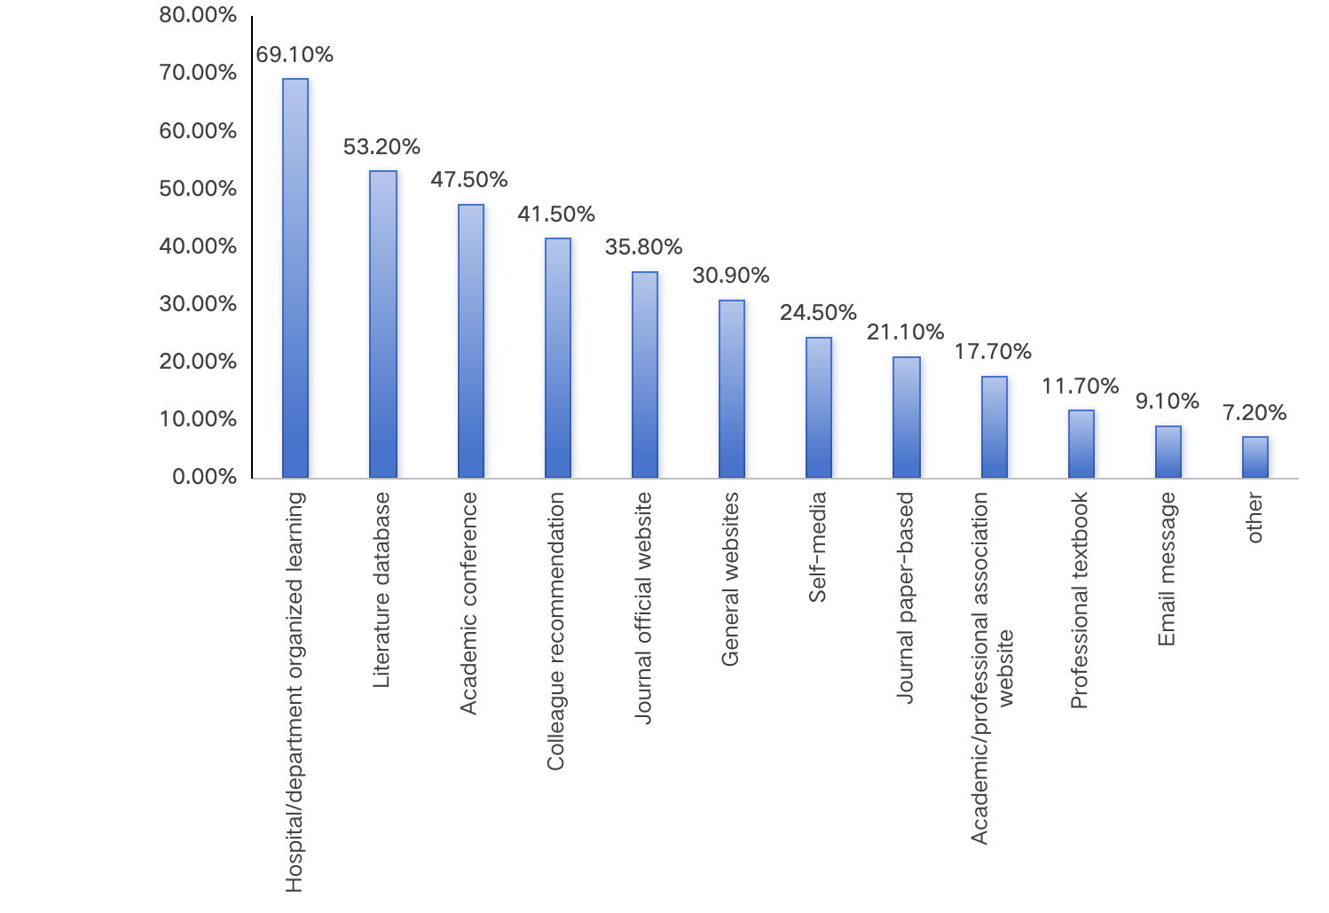
Figure 1 Acquisition channels of the guidelines

Appendix 7
Table 3 Barriers of guideline implementation
 |  | N |  | Percentage%
No. of participants reported barriers of guideline implementation |  | 43 | 11.8%
Guideline dimension | Influence on patient treatment choices | 19 | 5.20%
Guideline dimension | Impact on physician autonomy | 18 | 4.90%
Guideline dimension | Convenience of accessing guideline | 17 | 4.70%
Guideline dimension | Applicability of the guidelines | 15 | 4.10%
Guideline dimension | Clarity or complexity of the guidelines | 13 | 3.60%
Guideline dimension | Scientific basis of guideline evidence | 12 | 3.30%
Guideline dimension | Presence of plans/actions promoting guideline implementation (such as online releases, presentations at academic conferences, endorsements by industry leaders, etc.) | 8 | 2.20%
Guideline dimension | Other guideline-related factors | 0 | 0.00%
Environmental dimension | Impact of medical insurance | 23 | 6.30%
Environmental dimension | Impact of national, local, and institutional management policies (e.g., centralized procurement, management methods) | 13 | 3.60%
Environmental dimension | Availability of necessary hardware conditions in the institution for using the guidelines (information systems, facilities, equipment, technology, medications including biologics and vaccines, etc.) | 11 | 3.00%
Environmental dimension | Attitude of department leaders (or team leaders) toward the guidelines | 9 | 2.50%
Environmental dimension | Overall institutional climate supporting medical practices according to the guidelines | 8 | 2.20%
Environmental dimension | Collaboration and coordination from other relevant departments for implementing the guidelines | 8 | 2.20%
Environmental dimension | Other environment-related factors | 0 | 0.00%
Healthcare Professional dimension | Awareness and familiarity with the guidelines | 15 | 4.10%
Healthcare Professional dimension | Time cost for retrieving and learning guidelines | 13 | 3.60%
Healthcare Professional dimension | Consistency between healthcare professionals' views and guideline recommendations | 13 | 3.60%
Healthcare Professional dimension | Trust in and willingness to implement the guidelines | 7 | 1.90%
Healthcare Professional dimension | Evidence-based medicine literacy and skills of healthcare professionals (including formulating clinical questions, evaluation, decision-making, and outcome assessment) | 3 | 0.80%
Healthcare Professional dimension | Other healthcare professional-related factors | 1 | 0.30%
Patient dimension | Patients’ compliance | 30 | 8.20%
Patient dimension | Patients’ education level | 27 | 7.40%
Patient dimension | Patients’ economic status and family support | 27 | 7.40%
Patient dimension | Patients’ health literacy | 20 | 5.50%
Patient dimension | Other patient-related factors | 7 | 1.90%
Patient dimension | Patients’ understanding and attitudes toward evidence-based medicine concepts | 4 | 1.10%
Other factors |  | 2 | 0.5%

