Electrochemical CO₂-reduction to Formate over Activated Carbon-Supported
Transition Metals (M = Cu, Fe, Zn, Ni, Co)-based High-Entropy Oxide
Naveen Kumar Verma^{a,b}, Basker Sundararaju^{c}, and Nishith Verma^{a,d,*}
ªDepartment of Chemical Engineering, Indian Institute of Technology Kanpur, Kanpur- 208016, India.
^{b}Department of Petroleum Engineering, Rajasthan Technical University Kota, Kota-324010, India.
^{c}Department of Chemistry, Indian Institute of Technology Kanpur, Kanpur-208016, India.
^{d}Center for Environmental Science and Engineering, Indian Institute of Technology Kanpur, Kanpur-208016, India.

*Corresponding author:
Prof. Nishith Verma (Email id: vermanishith@gmail.com)

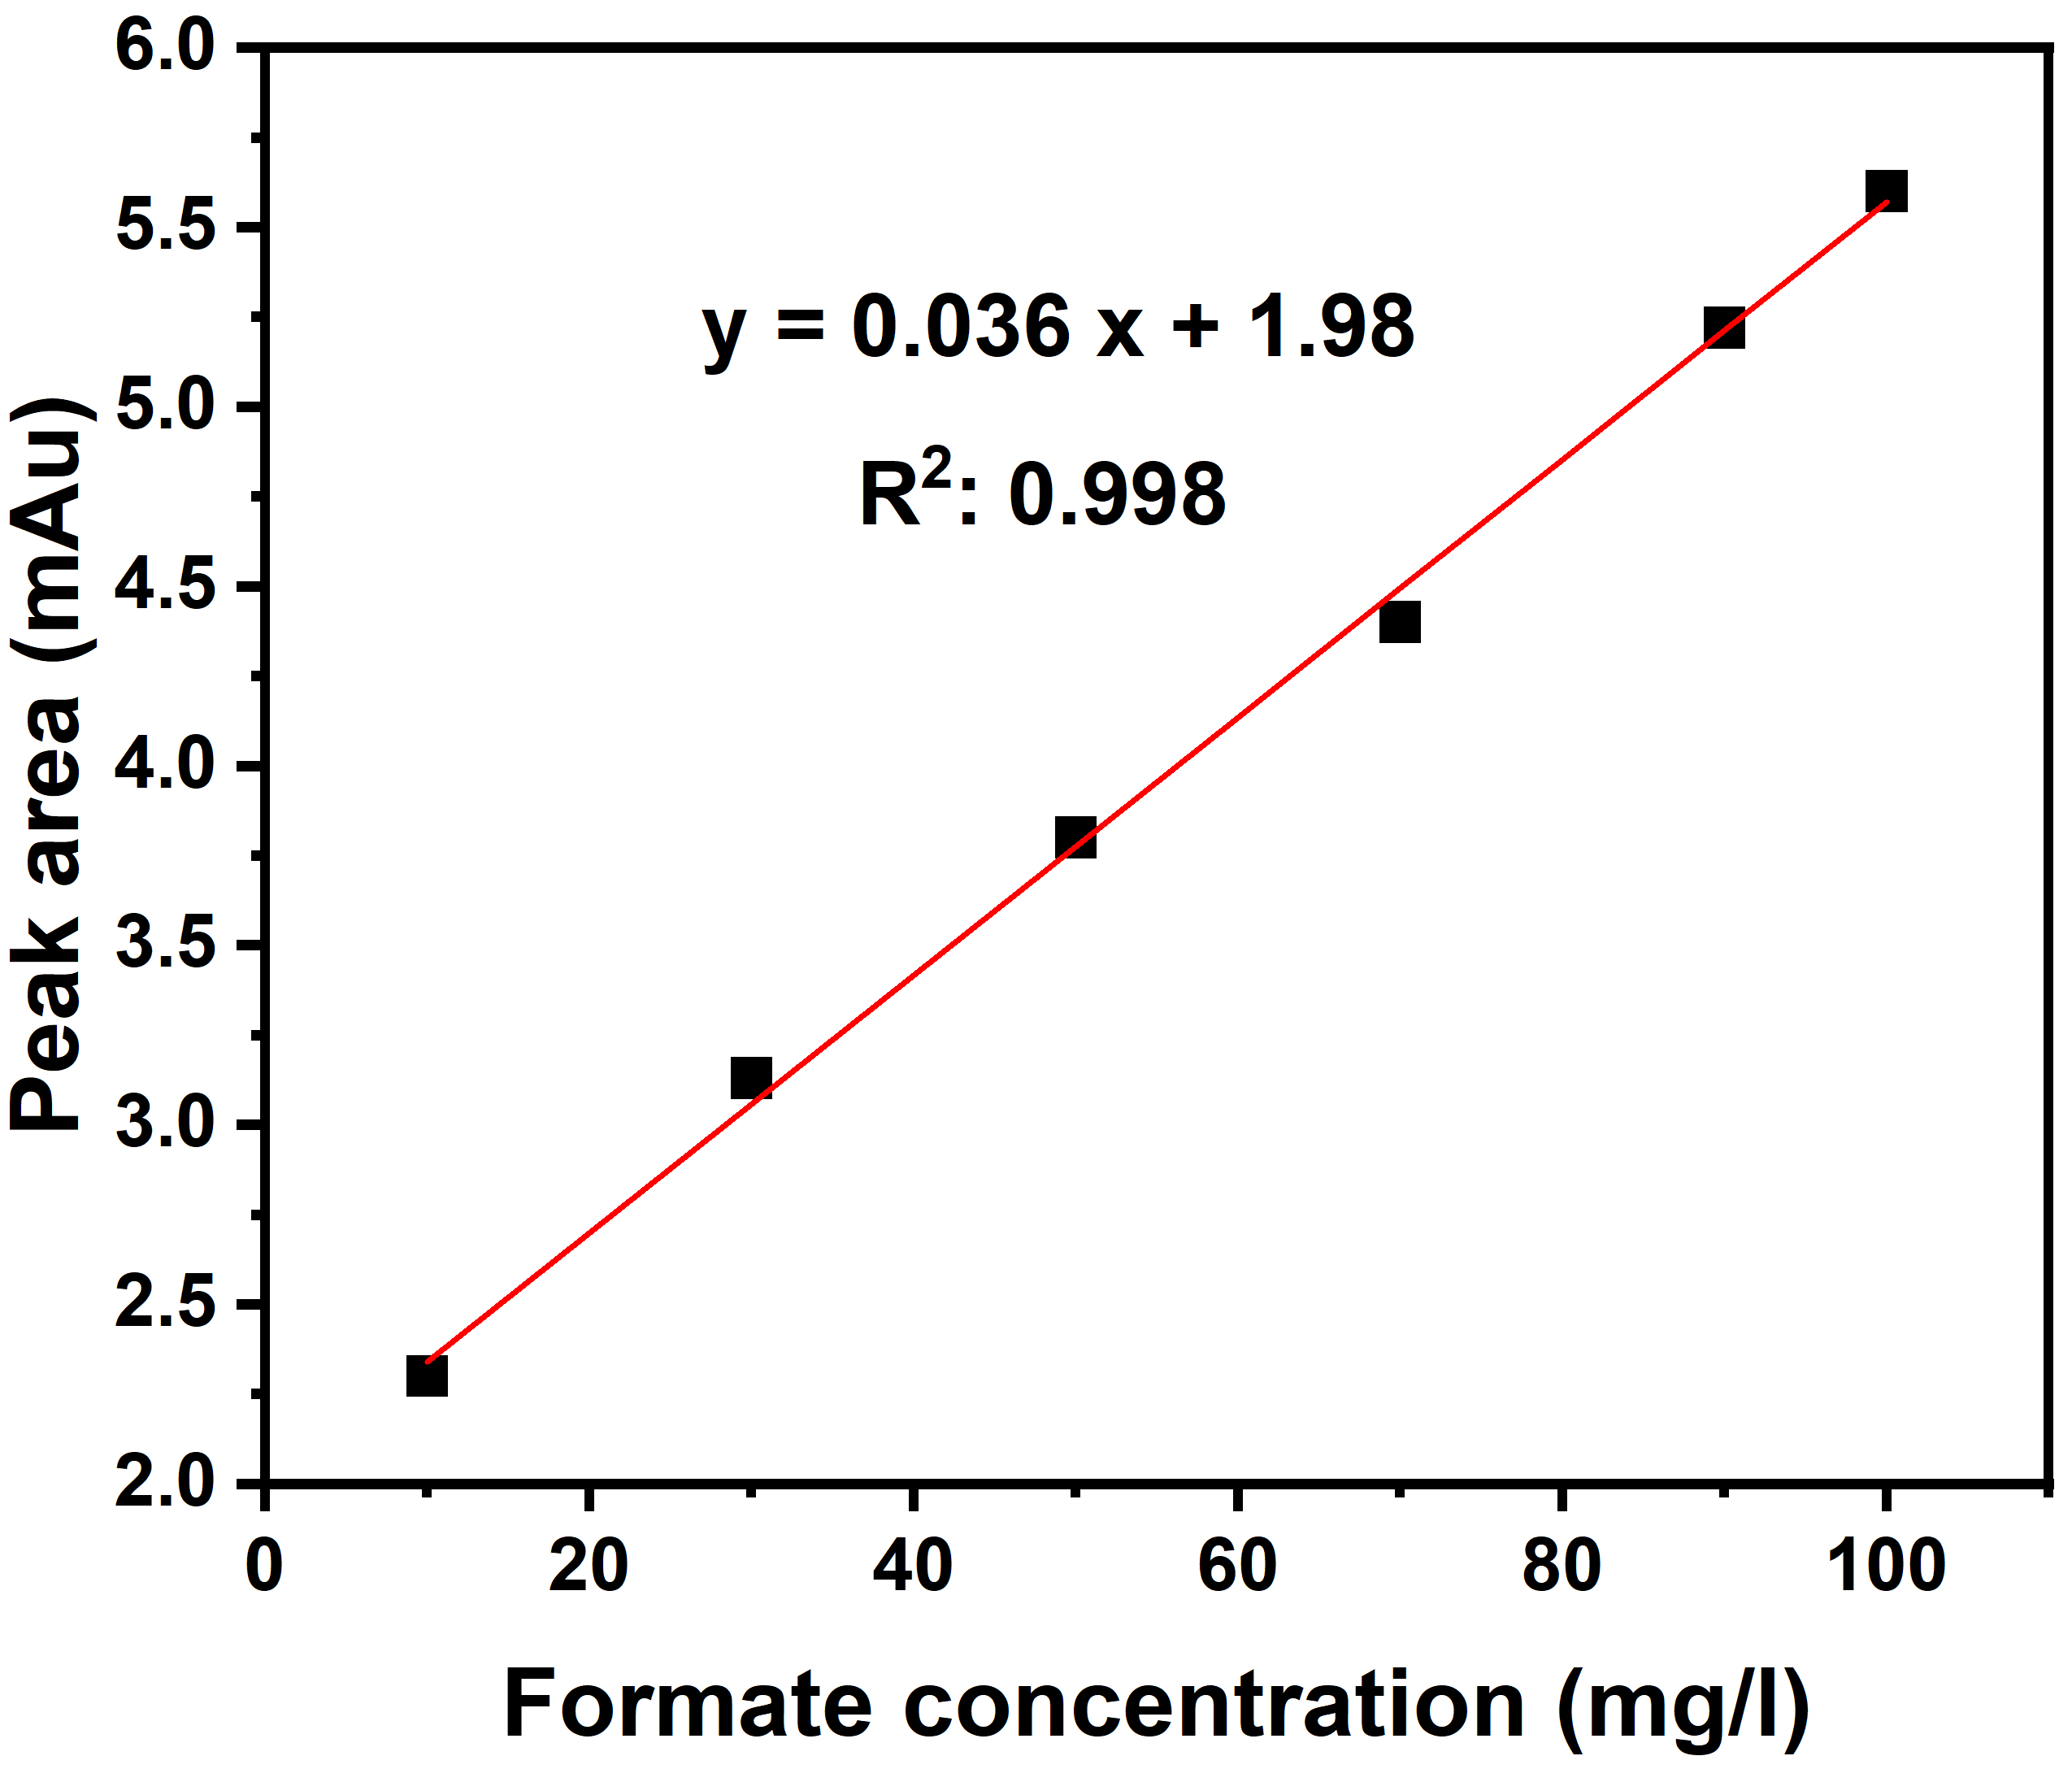
Fig. S1 Calibration data for formate using HPLC.

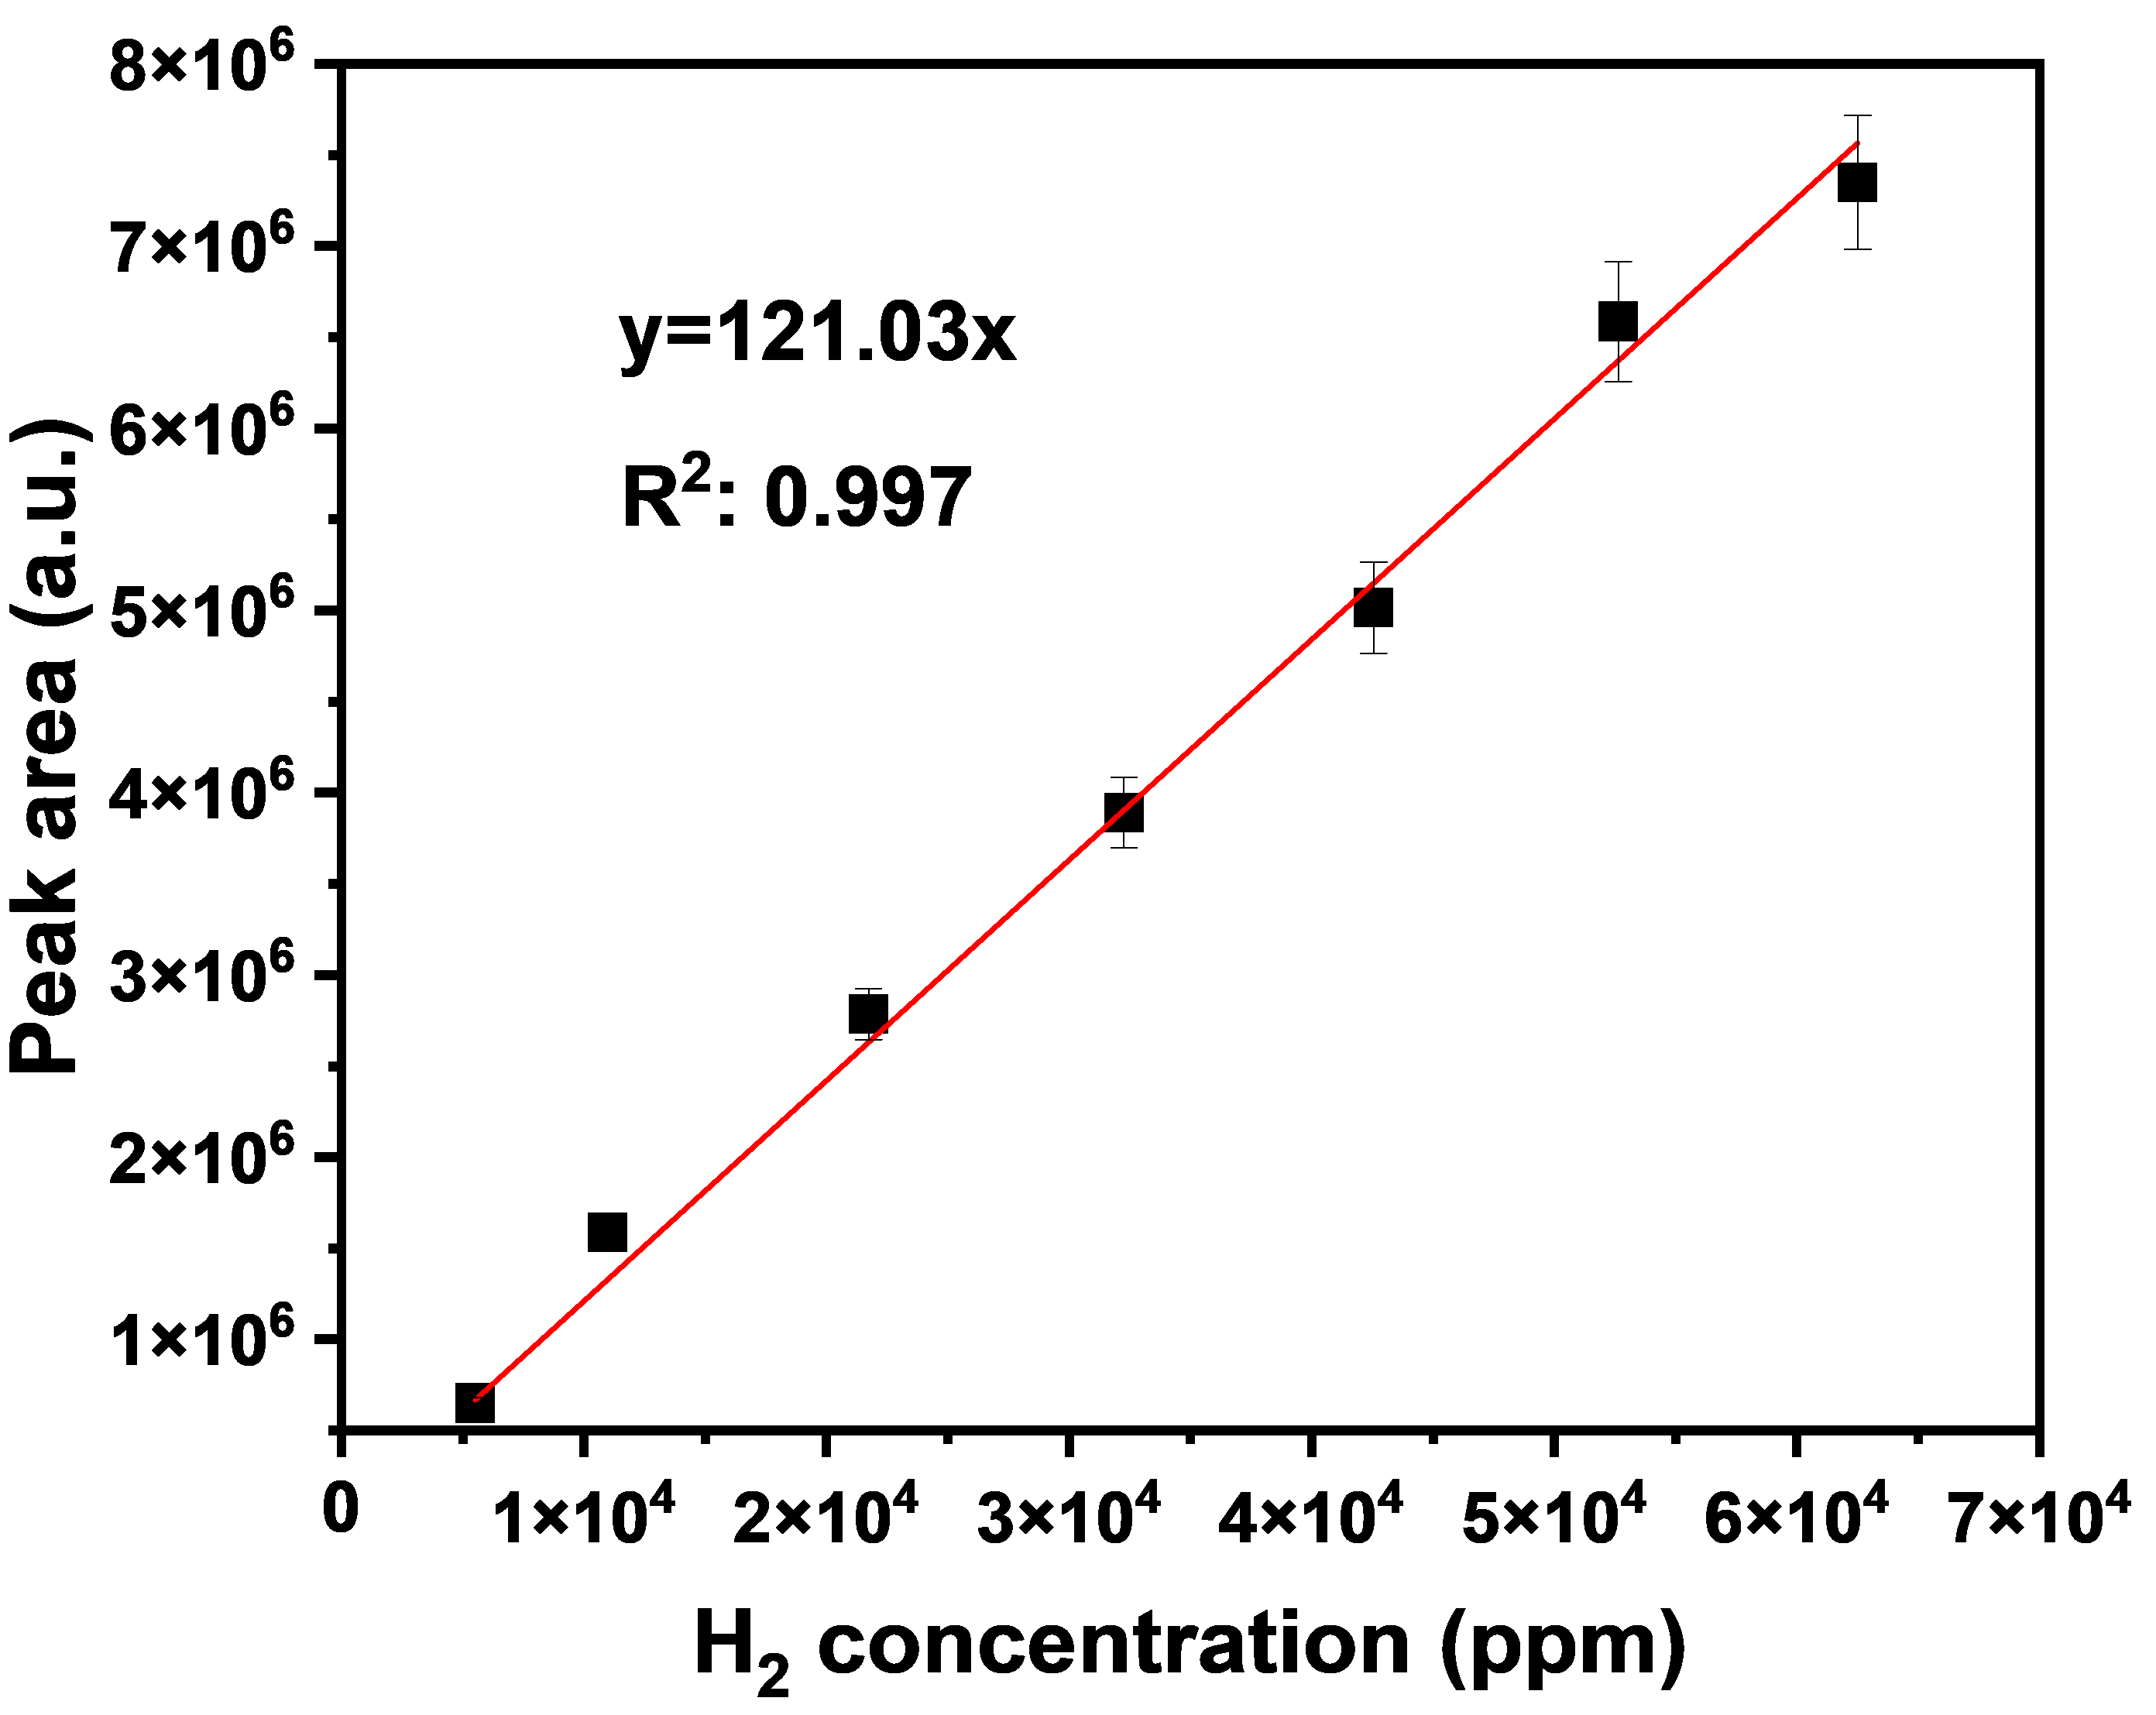
Fig. S2 Calibration data for hydrogen gas using gas chromatography.

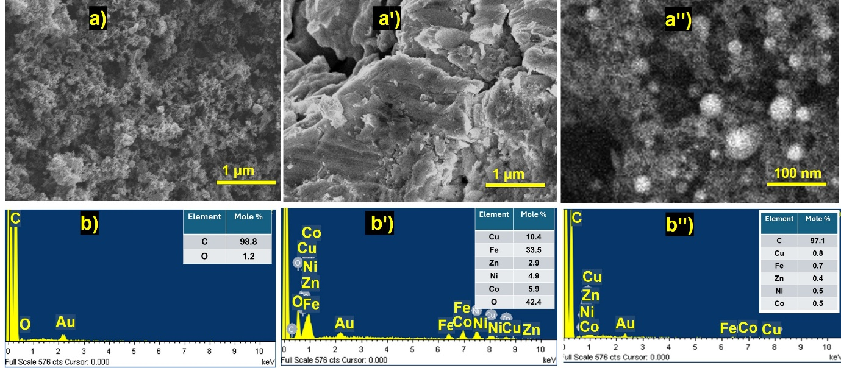
Fig. S3 (a, aꞌ, and aꞌꞌ) SEM images and (b, bꞌ, and bꞌꞌ) EDS spectra of ACP, CFZN-O, and CFZNC-HEA/ACP, respectively.

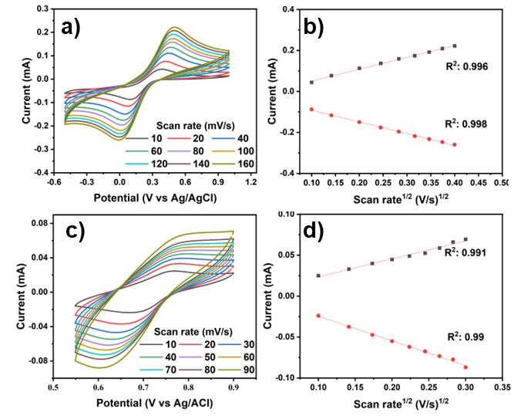
Fig. S4: CV and RS equation (line) for ECSA calculations: (a-b) CFZNC-O and c-d) ACP.

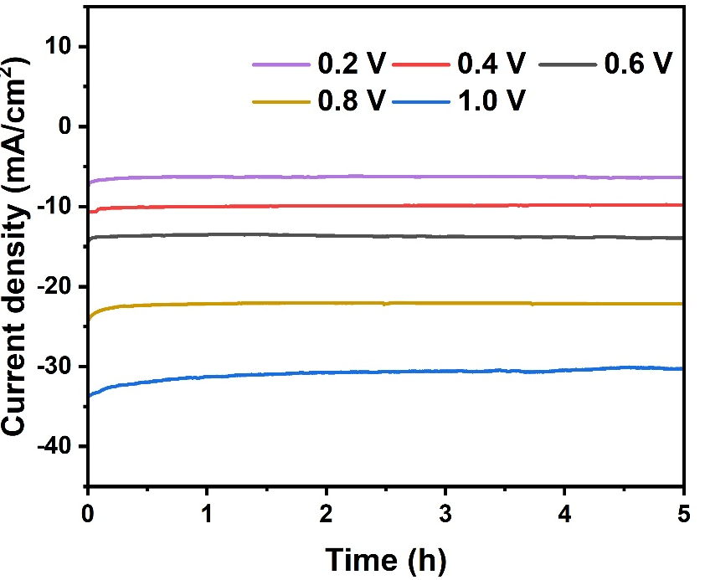
Fig. S5: Chronoamperometry test for CFZNC-HEO/ACP at different applied potentials.

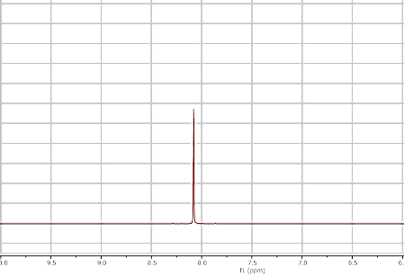
Fig. S6 ¹H-NMR spectra of eCRR liquid product (formate).

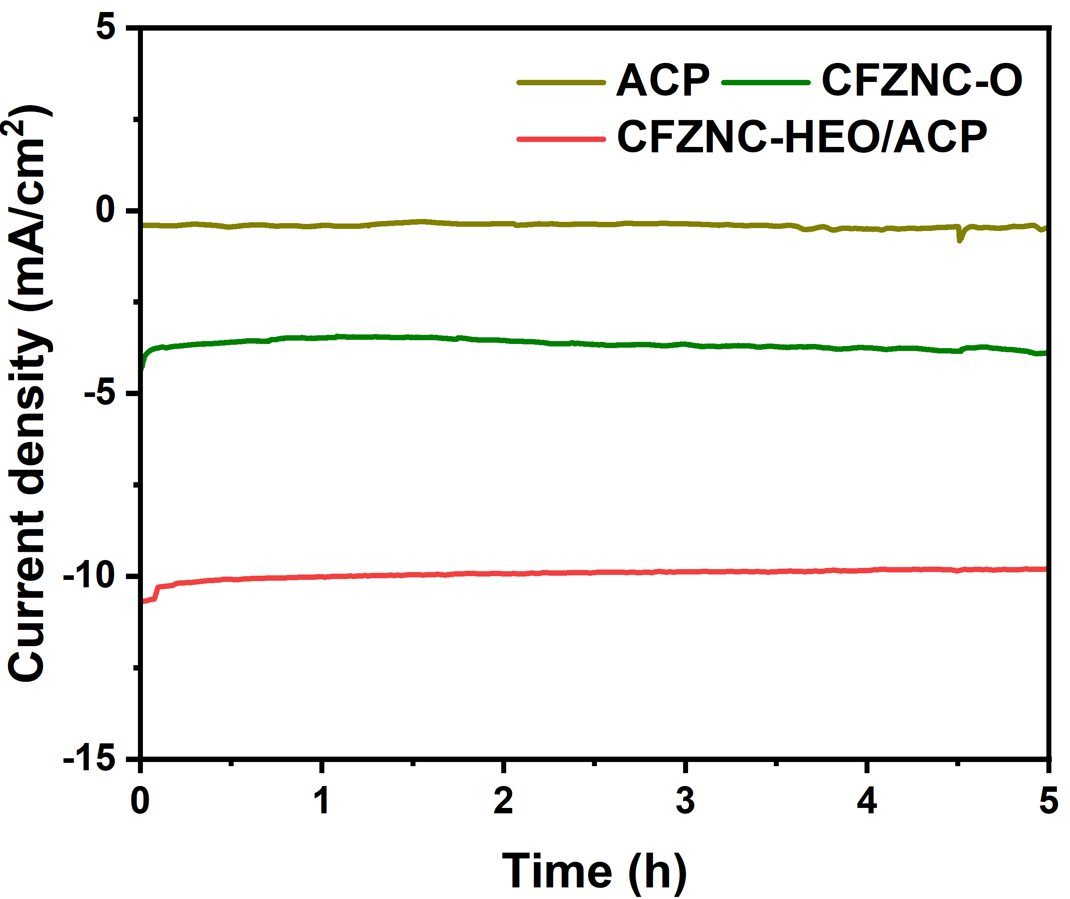
Fig. S7: Chronoamperometry test for different catalysts at -0.4 V.

Table S1 Amount of the metal nitrate salts used to prepare multi-metal salt solution.
Metal salt | Amount (g)
Cu(NO₃)₂.3H₂O | 1.26
Fe(NO₃)₃.9H₂O | 2.10
Zn(NO₃)₂.6H₂O | 1.54
Ni(NO₃)₂.6H₂O | 1.52
Co(NO₃)₂.6H₂O | 1.52
Total | 7.94

Table S2 Elemental composition of the constituent metals and the calculated configurational entropies of CFZNC-O, using ICP-MS analysis.
Element | CFZNC-O |  | CFZNC-HEA/ACP
Element | Mole% | ∆S/R | Mole% | ∆S/R
Cu | 12.74 | 0.26 | 27.58 | 0.36
Fe | 60.57 | 0.30 | 24.14 | 0.34
Zn | 5.62 | 0.16 | 13.79 | 0.27
Ni | 7.57 | 0.20 | 17.24 | 0.30
Co | 13.50 | 0.27 | 17.25 | 0.30
Total |  | 1.19 |  | 1.58

Table S3 Specific surface area and pore volume of the materials.
Surface area (m²/g) | Total pore volume (cc/g) | Micro pore volume (cc/g) | Macro pore volume (cc/g)
Metal salts-impregnated polymeric powder
0 | 0 | 0 | 0
Metal salts-impregnated polymeric powder post-carbonization
356 | 0.33 | 0.10 | 0.23
CFZNC-HEA/ACP
678 | 0.47 | 0.38 | 0.09

Table S4 EIS data for the different electrodes.
 | Working electrode | Solution resistance (Rs, Ω) | Charge transfer resistance (Rct, Ω) | Warburg Diffusion resistance (Rw, Ω)
 | CFZNC-HEO/ACP | 31.2 | 101 | 13.93
 | CFZNC-O | 30.9 | 118 | 84.03
ACP |  | 30.6 | 206 | 14.66
CFZNC-HEA/ACP |  | 29.2 | 92 | 13.15

Table S5 Comparison of CO₂ electroreduction to HCOO⁻ over different catalysts in aqueous electrolytes.
Catalyst | Electrolyte | Applied potential | Current density (mA.cm⁻²) | FE_{HCOO}⁻ (%) | Reference
CFZNC-HEO/ACP | 0.5 M K₂SO₄ | -0.4 V vs RHE | 10.75 | 98 | This study
Partially oxidized Co 4 atom-thick layers | 0.1 M Na₂SO₄ | -0.85 V vs SCE | 10.59 | 90.1 | 12
Cu₃NiOCs | 0.1 M KHCO₃ | -0.57 V vs RHE | 10.90 | 95.9 | 13
Zn₂SnO₄/SnO₂ | 0.1 M KHCO₃ | -1.08 V vs RHE | 5.72 | 77 | 14
SnO₂ NPs | 0.5 M NaOH | -0.8 V vs RHE | 3.00 | 67.6 | 38
Bi/In bimetallic oxide NPs/carbon networks | 0.5 M KHCO₃ | −0.9 V vs RHE | 8.27 | 91 | 39
SnOx/AgOx | 0.1 M KHCO₃ | -0.8 V vs RHE | ~9.0 | 47 | 40
CeO₂/Bi₃NbO₇ | 0.1 M KHCO₃ | -1.4 V vs RHE | 14.29 | 83.13 | 41
PdCuAuAgBiIn HEA Aerogel | 0.1 M KHCO₃ | -1.1 V vs RHE | 8.60 | 98.1 | 42

References
- S. Gao, Y. Lin, X. Jiao, Y. Sun, Q. Luo, W. Zhang, D. Li, J. Yang, Y. Xie, Nature 529, 68 (2016). https://doi.org/10.1038/nature16455
- D. Yang, Q. Zhu, X. Sun, C. Chen, L. Lu, W. Guo, Z. Liu, B. Han, Green Chem. 20, 3705 (2018). https://doi.org/10.1039/C8GC01552J
- K. Wang, D. Liu, P. Deng, L. Liu, S. Lu, Z. Sun, Y. Ma, Y. Wang, M. Li, B. Y. Xia, C. Xiao, S. Ding, Nano Energy 64, 103954 (2019). https://doi.org/10.1016/j.nanoen.2019.103954
- S. Lee, J. D. Ocon, Y. Son, J. Lee, J. Phys. Chem. C 119, 4884 (2015). https://doi.org/10.1021/jp512436w
- Q. Wang, X. Yang, H. Zang, F. Chen, C. Wang, N. Yu, B. Geng, Inorg. Chem. 61, 12003 (2022). https://doi.org/10.1021/acs.inorgchem.2c01961
- Y.W. Choi, F. Scholten, I. Sinev, B. Roldan Cuenya, J. Am. Chem. Soc. 141, 5261 (2019). https://doi.org/10.1021/jacs.8b12766
- L. Song, Z. Liang, M. Sun, B. Huang, Y. Du, Energy Environ. Sci. 15, 3494 (2022). https://doi.org/10.1039/D2EE01710E
- H. Li, H. Huang, Y. Chen, F. Lai, H. Fu, L. Zhang, N. Zhang, S. Bai, T. Liu, Adv. Mater. 35, (2023). https://doi.org/10.1002/adma.202209242

