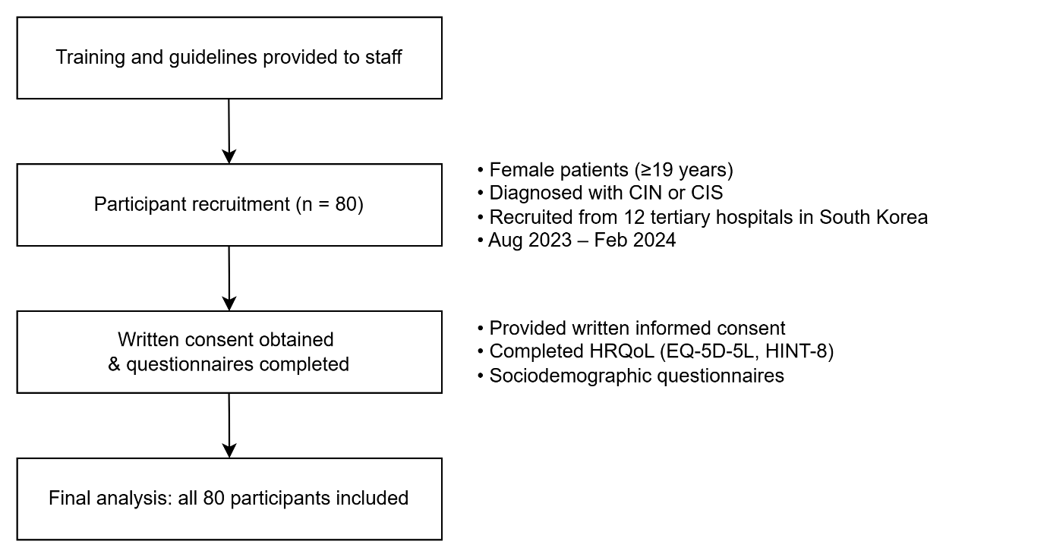
Additional file 1. Participant recruitment and inclusion flowchart

