Global, Regional, and National Burden of Tuberculosis Among Individuals Aged 60 and Above from 1990 to 2021: A Systematic Analysis Based on the 2021 Global Burden of Disease

Appendix Figure 1: EAPC for Global, 5 SDI Regions, and 21 GBD Regions
Appendix Figure 2: AAPC
Appendix Figure 3: EAPC of ASR
Appendix Figure 4: Gender-Time Trend Analysis
Appendix Figure 5: Age-Time Trend Analysis
Appendix Figure 6: Age-Period-Cohort Analysis Results
Appendix Figure 7: Correlation Between ASR and SDI for 204 Countries
Appendix Figure 8: Temporal Trend of Risk Factors
Appendix Table 1: ASRs and EAPCs for 204 Countries
Appendix Table 2: Decomposition Analysis
Appendix Table 3: Predictive Analysis
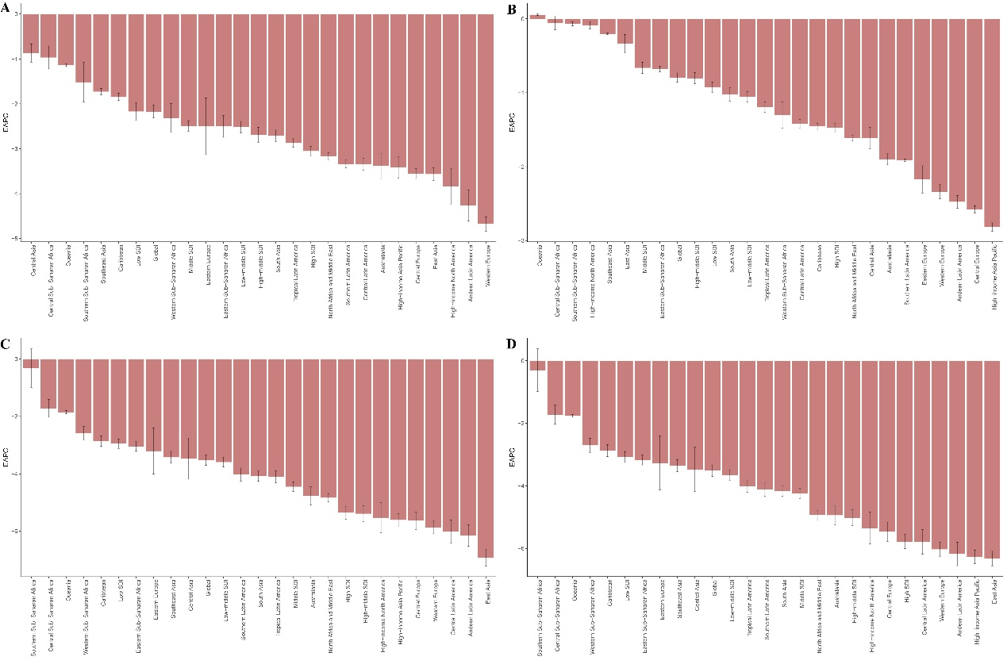
Appendix Figure 1: EAPC for Global, 5 SDI Regions, and 21 GBD Regions

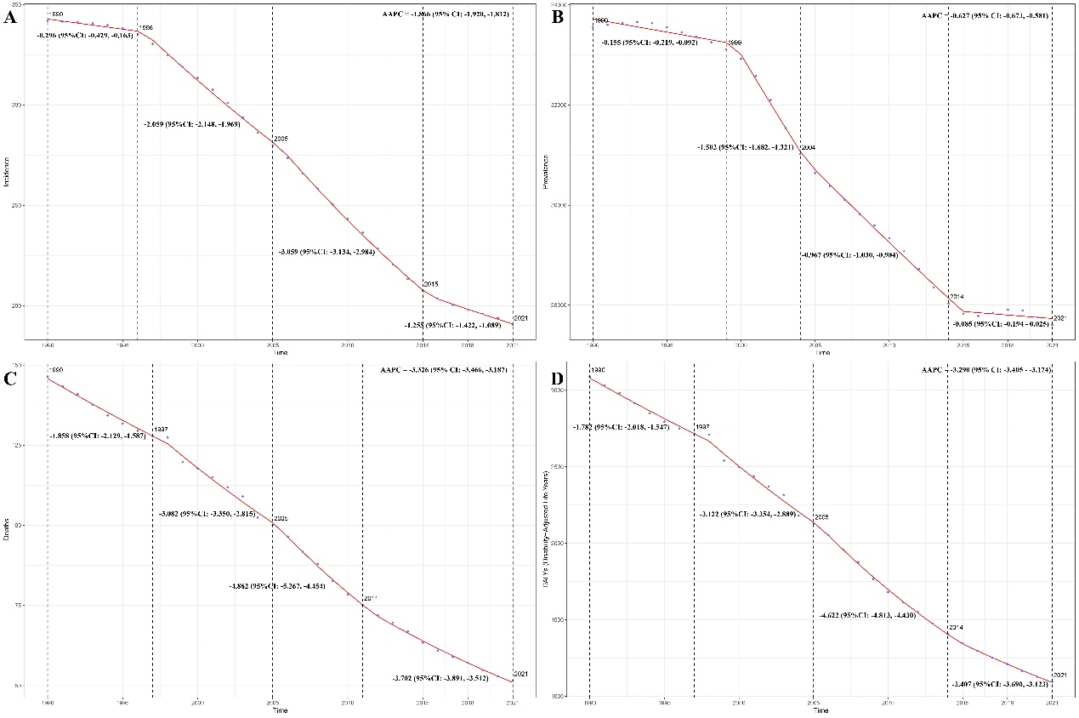
Appendix Figure 2: AAPC

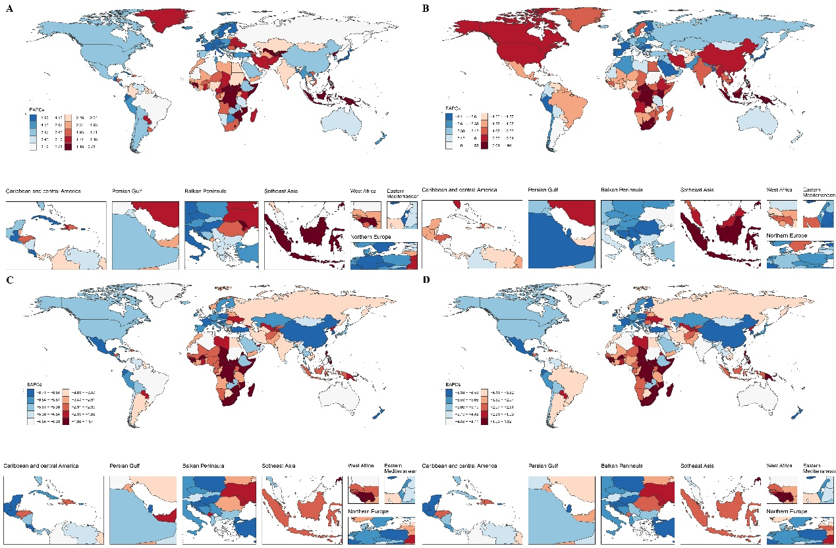
Appendix Figure 3: EAPC of ASR

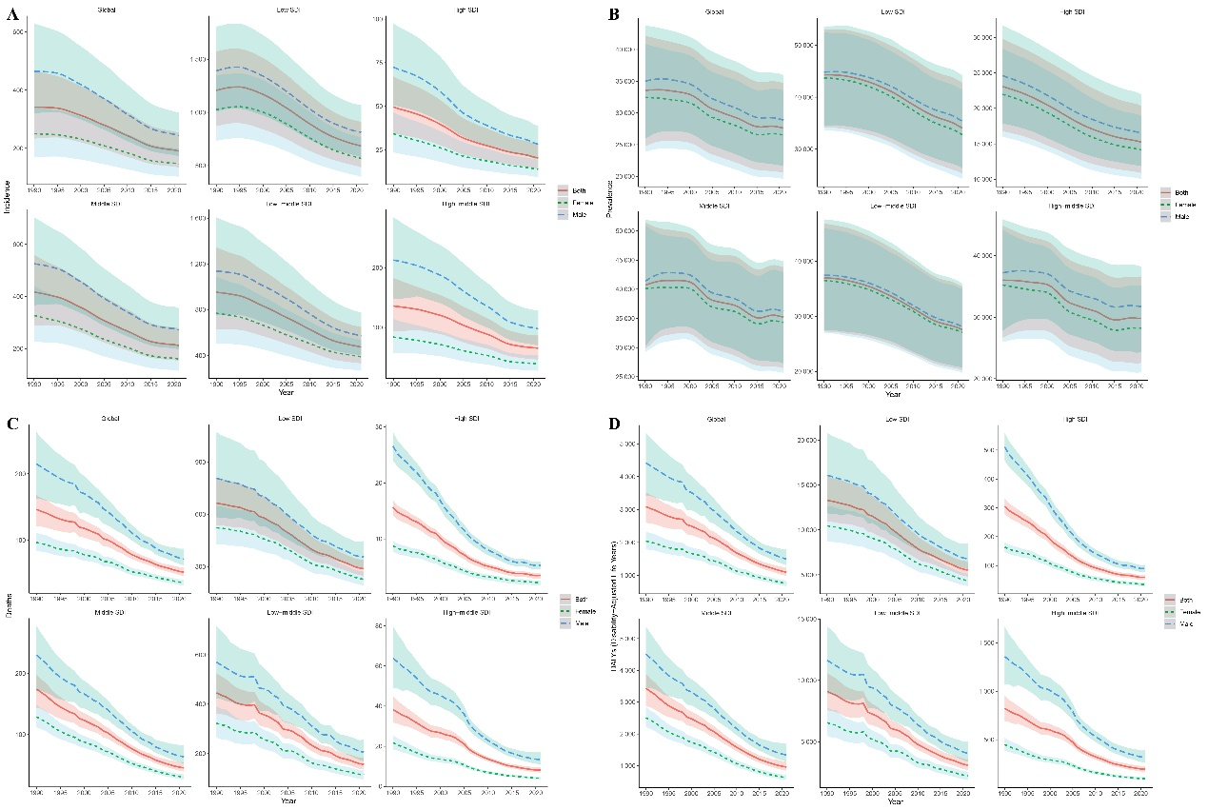
Appendix Figure 4: Gender-Time Trend Analysis

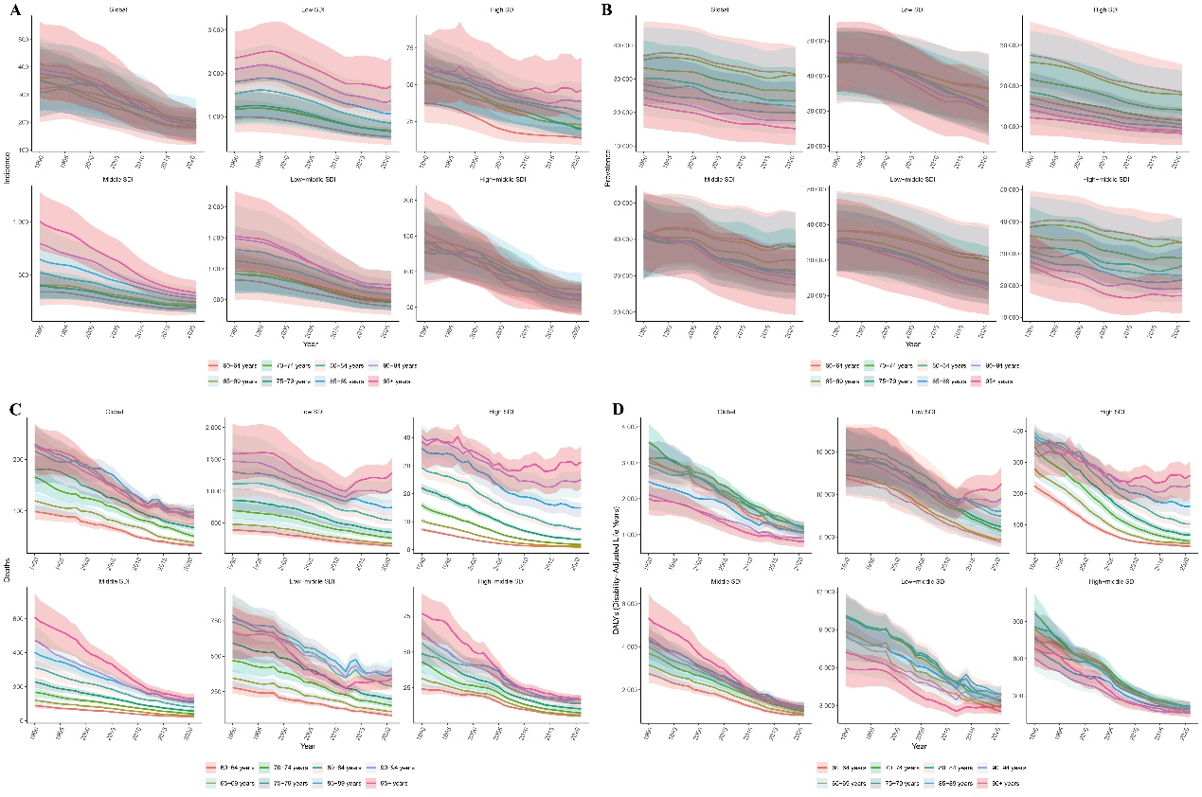
Appendix Figure 5: Age-Time Trend Analysis

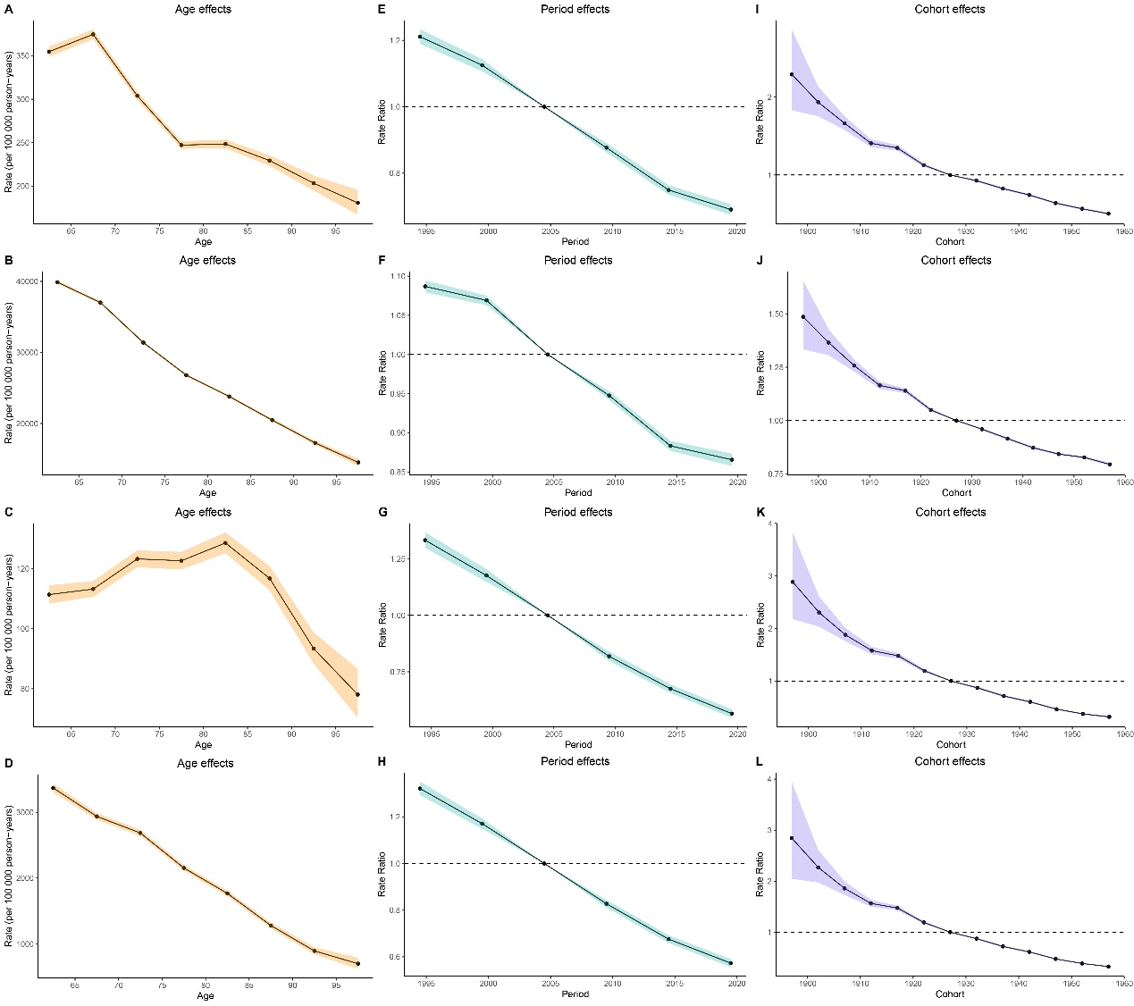
Appendix Figure 6: Age-Period-Cohort Analysis Results

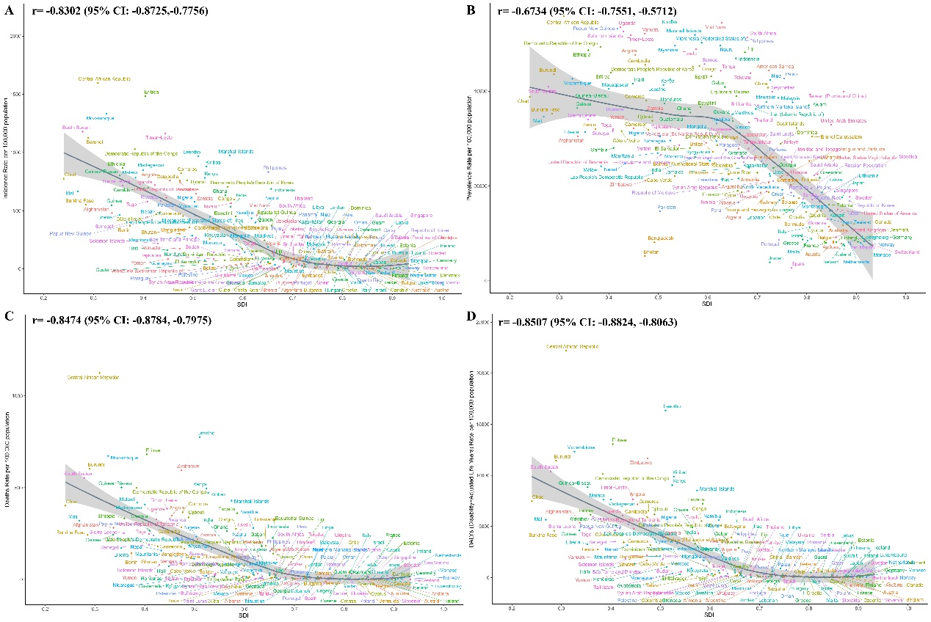
Appendix Figure 7: Correlation Between ASR and SDI for 204 Countries

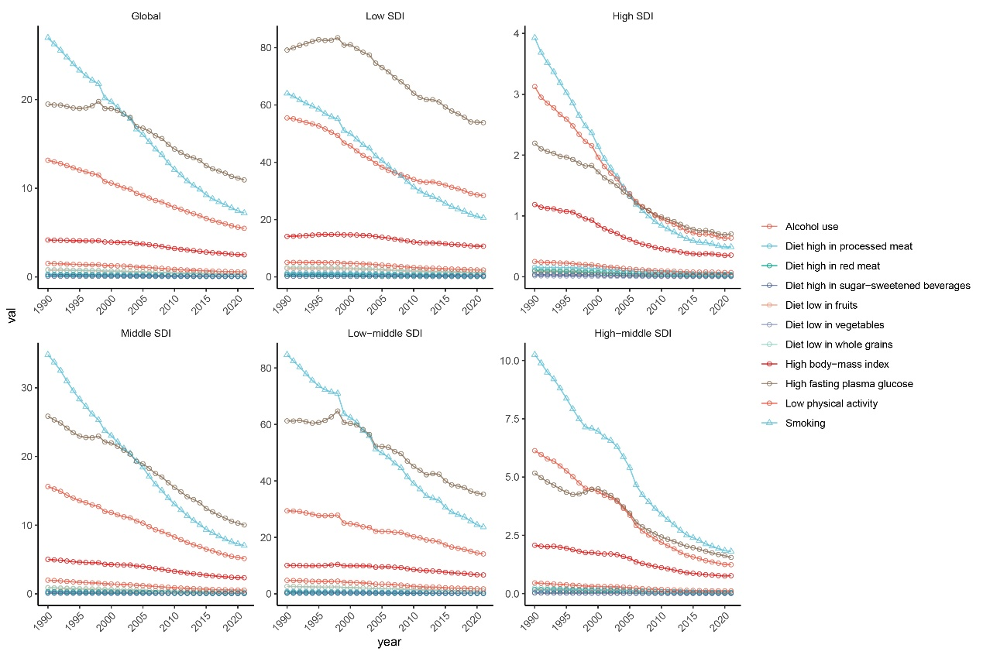
Appendix Figure 8: Temporal Trend of Risk Factors

Appendix Table 1: ASRs and EAPCs for 204 Countries
location | ASIR |  |  | ASPR |  |  | ASMR |  |  | ASDR
location | 1990 (per 100,000 population, 95% UI) | 2021 (per 100,000 population, 95% UI) | EAPCs (95% CI) | 1990 (per 100,000 population, 95% UI) | 2021 (per 100,000 population, 95% UI) | EAPCs (95% CI) | 1990 (per 100,000 population, 95% UI) | 2021 (per 100,000 population, 95% UI) | EAPCs (95% CI) | 1990 (per 100,000 population, 95% UI) | 2021 (per 100,000 population, 95% UI) | EAPCs (95% CI)
American Samoa | 67.26(47.19,90.94) | 35.71(25.33,47.20) | -2.34(-2.43,-2.24) | 43571.33(32290.55,54773.20) | 44350.15(33133.41,54817.19) | 0.11(0.09,0.14) | 30.16(20.39,43.02) | 12.13(8.66,16.80) | -3.60(-3.94,-3.27) | 685.09(492.38,929.23) | 291.57(220.36,382.66) | -3.39(-3.67,-3.10)
Antigua and Barbuda | 37.55(23.67,55.19) | 16.64(10.03,25.39) | -2.64(-2.69,-2.59) | 37002.55(26560.55,48069.92) | 22163.25(15463.15,30262.89) | -1.67(-1.75,-1.60) | 7.27(6.11,8.49) | 1.47(1.23,1.75) | -4.96(-5.36,-4.56) | 150.88(126.79,177.33) | 31.60(25.48,39.11) | -4.96(-5.34,-4.58)
Arab Republic of Egypt | 66.72(53.94,80.57) | 25.61(18.45,33.85) | -2.50(-2.71,-2.28) | 55696.73(48549.82,59224.97) | 43117.30(32551.54,53032.63) | -0.75(-0.82,-0.69) | 30.56(22.52,41.24) | 7.95(5.68,11.02) | -3.76(-4.00,-3.52) | 571.53(433.41,757.20) | 153.68(113.60,205.74) | -3.72(-3.91,-3.52)
Argentine Republic | 42.92(28.31,60.53) | 14.80(8.26,23.06) | -3.53(-3.61,-3.45) | 36090.04(26145.99,46013.83) | 20763.76(14491.57,28562.16) | -1.72(-1.74,-1.69) | 18.56(16.13,21.04) | 5.99(5.14,6.86) | -3.79(-4.15,-3.43) | 386.78(338.92,437.70) | 126.31(108.58,145.49) | -3.77(-4.09,-3.44)
Australia | 14.42(9.55,20.87) | 5.81(3.88,8.30) | -3.22(-3.49,-2.95) | 20907.92(14534.94,28495.46) | 11436.56(7913.76,15793.83) | -1.90(-1.98,-1.81) | 3.41(2.95,3.88) | 1.03(0.85,1.18) | -4.18(-4.55,-3.80) | 63.98(54.95,73.24) | 18.55(15.52,21.79) | -4.33(-4.71,-3.94)
Barbados | 17.42(11.42,24.88) | 7.09(4.40,10.57) | -3.05(-3.19,-2.90) | 36228.83(25842.88,47307.01) | 21805.89(14998.71,29963.63) | -1.61(-1.67,-1.55) | 5.67(4.88,6.52) | 1.60(1.21,2.06) | -4.62(-5.08,-4.15) | 113.63(97.68,131.18) | 32.51(24.26,41.82) | -4.54(-4.98,-4.09)
Belize | 90.41(58.88,125.42) | 47.13(30.46,68.51) | -2.21(-2.41,-2.01) | 42226.43(30851.50,53284.75) | 27202.97(18931.23,36562.33) | -1.48(-1.60,-1.35) | 48.49(41.46,56.14) | 13.88(11.28,16.78) | -4.48(-4.94,-4.01) | 940.43(810.92,1084.99) | 282.95(232.40,341.26) | -4.36(-4.82,-3.90)
Bermuda | 29.14(17.01,44.86) | 14.44(8.16,22.62) | -2.15(-2.29,-2.01) | 31065.21(21871.54,41484.35) | 14694.54(10115.88,20140.99) | -2.39(-2.41,-2.36) | 1.44(1.23,1.67) | 0.14(0.11,0.18) | -7.55(-7.84,-7.26) | 31.96(25.35,40.07) | 6.22(3.20,10.79) | -5.33(-5.64,-5.01)
Bolivarian Republic of Venezuela | 110.67(77.29,149.16) | 43.91(29.09,61.07) | -3.22(-3.35,-3.09) | 45281.60(34080.34,55537.06) | 29097.01(20545.01,38574.94) | -1.48(-1.57,-1.39) | 49.33(42.52,56.11) | 14.00(10.12,18.75) | -4.71(-5.23,-4.17) | 961.54(833.67,1089.00) | 280.96(205.47,370.93) | -4.64(-5.13,-4.14)
Bosnia and Herzegovina | 128.61(90.47,173.30) | 47.89(32.33,67.20) | -3.50(-3.70,-3.30) | 39821.91(28904.10,50855.39) | 18654.35(12954.05,25253.35) | -2.70(-2.82,-2.59) | 51.04(40.13,62.88) | 10.18(7.38,13.71) | -5.69(-6.12,-5.26) | 1023.66(819.44,1251.02) | 197.81(146.25,262.57) | -5.79(-6.17,-5.40)
Brunei Darussalam | 506.06(385.07,637.57) | 227.11(154.80,314.03) | -2.91(-3.08,-2.74) | 53100.02(44250.93,58748.81) | 30422.50(21436.04,40369.33) | -1.81(-1.87,-1.76) | 123.97(85.56,172.29) | 38.42(27.58,51.83) | -3.53(-3.87,-3.20) | 2420.12(1720.30,3290.71) | 640.22(475.87,841.01) | -4.17(-4.44,-3.89)
Burkina Faso | 941.55(682.26,1193.56) | 550.47(376.46,758.82) | -1.87(-2.12,-1.63) | 51755.71(40065.50,60345.52) | 35272.33(25169.47,46283.24) | -1.18(-1.30,-1.07) | 412.61(302.34,548.61) | 242.58(169.42,339.52) | -1.56(-1.69,-1.44) | 7843.39(5887.34,10247.09) | 4561.78(3249.25,6276.82) | -1.55(-1.67,-1.43)
Canada | 18.33(12.50,25.75) | 7.61(5.12,10.67) | -3.58(-3.90,-3.26) | 12631.07(8783.05,17229.11) | 11729.23(8152.30,16020.05) | -0.27(-0.30,-0.24) | 4.17(3.59,4.73) | 0.91(0.76,1.05) | -5.44(-5.88,-4.99) | 75.94(65.91,86.46) | 16.49(13.56,19.71) | -5.46(-5.90,-5.02)
Central African Republic | 1936.10(1437.31,2438.59) | 1597.46(1210.50,1945.74) | -0.71(-0.82,-0.59) | 54398.25(42994.85,62611.79) | 55761.64(45236.08,62387.19) | 0.11(0.08,0.13) | 1396.69(791.55,1966.64) | 1125.63(709.54,1588.62) | -0.82(-0.94,-0.70) | 28763.82(16789.02,39823.30) | 22225.07(14316.43,30966.06) | -0.92(-1.05,-0.79)
Commonwealth of Dominica | 72.89(50.69,98.05) | 33.23(22.36,46.05) | -2.39(-2.66,-2.11) | 42163.23(31052.60,53200.98) | 28862.01(20259.68,38473.24) | -1.19(-1.23,-1.16) | 48.51(36.09,63.62) | 15.15(10.05,21.92) | -3.64(-4.09,-3.18) | 910.36(683.56,1189.38) | 280.86(189.29,402.14) | -3.61(-4.13,-3.09)
Commonwealth of the Bahamas | 46.01(30.64,63.89) | 17.94(11.26,26.63) | -3.22(-3.33,-3.10) | 39964.94(29028.95,51375.08) | 25273.58(17657.68,34527.03) | -1.51(-1.57,-1.46) | 20.92(17.74,24.46) | 5.12(4.02,6.41) | -4.85(-5.16,-4.54) | 435.28(370.67,507.24) | 102.76(81.27,128.55) | -4.92(-5.23,-4.61)
Cook Islands | 65.37(44.29,89.92) | 30.28(20.48,42.78) | -2.57(-2.63,-2.50) | 39371.49(28351.25,51100.73) | 32241.92(22879.66,43059.11) | -0.62(-0.67,-0.56) | 26.35(17.44,37.24) | 5.87(3.86,8.57) | -4.69(-4.85,-4.53) | 603.84(424.41,811.02) | 158.83(113.17,214.66) | -4.19(-4.35,-4.04)
Czech Republic | 33.89(22.66,47.79) | 6.48(4.32,9.19) | -5.84(-6.13,-5.56) | 33599.51(24041.54,44420.88) | 14855.15(10248.10,20224.89) | -2.56(-2.63,-2.49) | 6.73(5.91,7.59) | 0.82(0.68,0.97) | -6.31(-6.58,-6.03) | 140.38(123.50,159.51) | 17.41(14.32,21.30) | -6.23(-6.48,-5.97)
Democratic People's Republic of Korea | 935.34(690.92,1185.54) | 705.45(498.88,925.14) | -0.97(-1.15,-0.79) | 51418.58(40645.11,58946.59) | 45100.51(33838.11,55069.93) | -0.36(-0.49,-0.23) | 299.40(192.16,440.80) | 160.69(103.16,239.53) | -2.15(-2.41,-1.88) | 6034.88(3964.52,8750.31) | 3301.91(2169.48,4858.99) | -2.05(-2.32,-1.78)
Democratic Republic of Sao Tome and Principe | 531.19(386.58,687.91) | 268.23(179.85,380.52) | -2.15(-2.40,-1.89) | 47631.88(35929.83,57949.00) | 26540.38(18610.02,35883.69) | -1.80(-2.00,-1.59) | 218.18(157.05,291.52) | 90.09(54.98,155.57) | -3.02(-3.41,-2.64) | 4467.49(3288.80,5859.50) | 1793.25(1175.55,2950.59) | -3.14(-3.48,-2.79)
Democratic Republic of the Congo | 1303.88(930.05,1716.02) | 1028.86(737.75,1339.05) | -0.69(-0.97,-0.40) | 50450.64(38055.06,60684.22) | 49357.17(37390.17,59658.41) | 0.00(-0.09,0.10) | 777.11(444.40,1214.62) | 498.46(299.71,810.71) | -1.38(-1.73,-1.02) | 15880.47(9719.98,23956.46) | 10128.89(6438.67,15842.28) | -1.37(-1.72,-1.01)
Democratic Republic of Timor-Leste | 1456.44(1097.82,1815.26) | 1163.85(887.09,1440.53) | -0.91(-0.98,-0.84) | 53701.28(42987.95,60635.79) | 51845.71(41029.22,59609.32) | -0.16(-0.19,-0.13) | 712.42(437.60,1082.70) | 385.30(241.25,623.27) | -2.16(-2.31,-2.02) | 14128.73(8923.95,21289.92) | 7652.30(4985.55,12075.35) | -2.17(-2.32,-2.02)
Democratic Socialist Republic of Sri Lanka | 187.43(126.20,264.83) | 120.86(82.03,166.79) | -1.72(-1.88,-1.56) | 21003.84(14720.97,28413.89) | 37007.67(26295.69,48482.11) | 1.92(1.84,1.99) | 97.10(69.04,128.50) | 19.17(12.01,29.03) | -5.06(-5.27,-4.85) | 1908.03(1388.31,2490.29) | 461.87(315.81,654.46) | -4.62(-4.84,-4.41)
Dominican Republic | 155.59(112.35,203.43) | 85.30(57.35,120.87) | -1.89(-2.04,-1.75) | 46151.58(34922.14,56076.58) | 28584.48(20025.34,38173.84) | -1.45(-1.51,-1.40) | 68.88(51.58,90.18) | 23.94(14.53,39.94) | -2.59(-2.95,-2.22) | 1261.44(954.93,1633.72) | 465.63(293.35,758.53) | -2.55(-2.90,-2.21)
Eastern Republic of Uruguay | 51.43(33.75,72.85) | 27.35(17.88,39.31) | -1.88(-2.12,-1.64) | 32625.70(23390.05,42926.73) | 18859.88(13110.39,25934.08) | -1.76(-1.78,-1.73) | 14.32(12.34,16.43) | 4.69(4.00,5.45) | -3.64(-4.06,-3.21) | 301.53(261.73,346.65) | 101.83(86.98,119.96) | -3.52(-3.94,-3.10)
Federal Democratic Republic of Ethiopia | 2369.07(1716.22,3025.89) | 865.36(639.14,1085.02) | -3.71(-3.87,-3.55) | 50748.13(39230.76,59715.66) | 48626.25(37491.45,57493.74) | -0.17(-0.20,-0.15) | 1518.48(1080.87,1931.81) | 333.46(259.83,413.82) | -5.42(-5.66,-5.17) | 29750.13(21737.05,37295.83) | 6152.49(4886.18,7554.63) | -5.64(-5.89,-5.39)
Federal Democratic Republic of Nepal | 1340.15(1009.57,1664.56) | 480.38(323.52,674.72) | -3.33(-3.37,-3.29) | 54152.20(43265.96,61415.89) | 24720.02(17208.45,33879.96) | -2.52(-2.60,-2.43) | 658.44(418.59,954.28) | 157.61(97.49,237.32) | -4.62(-4.77,-4.48) | 13520.05(8906.39,19000.20) | 3169.02(2041.62,4633.88) | -4.66(-4.82,-4.51)
Federal Republic of Germany | 16.92(11.51,24.02) | 4.01(2.67,5.68) | -4.76(-5.06,-4.45) | 18004.24(12529.95,24677.08) | 8245.15(5705.97,11440.18) | -2.36(-2.50,-2.22) | 8.22(7.08,9.36) | 1.34(1.11,1.56) | -6.21(-6.78,-5.63) | 159.88(139.22,182.42) | 24.51(20.08,29.40) | -6.32(-6.88,-5.76)
Federal Republic of Nigeria | 1221.33(893.73,1573.27) | 576.48(392.88,799.78) | -2.74(-3.16,-2.32) | 48290.20(37322.25,57231.82) | 30478.36(21864.83,39857.44) | -1.39(-1.58,-1.19) | 512.53(387.70,703.33) | 233.62(174.97,300.27) | -2.80(-3.12,-2.47) | 9847.75(7514.22,13284.17) | 4214.32(3193.53,5359.23) | -3.00(-3.33,-2.67)
Federal Republic of Somalia | 2050.35(1457.13,2736.49) | 2164.90(1477.63,2957.69) | 0.14(0.02,0.25) | 46047.97(33792.42,57732.32) | 36656.27(25932.54,48088.14) | -0.72(-0.88,-0.57) | 1361.14(739.59,2420.02) | 1370.83(769.60,2438.10) | -0.06(-0.21,0.08) | 26208.35(14790.18,45879.27) | 24493.34(14089.54,42821.43) | -0.32(-0.46,-0.17)
Federated States of Micronesia | 372.80(278.49,467.94) | 209.84(157.04,262.40) | -1.88(-1.97,-1.80) | 52362.66(41980.40,59304.77) | 50209.76(39351.92,58444.50) | -0.15(-0.17,-0.14) | 171.54(100.74,270.90) | 71.84(45.97,106.69) | -2.90(-2.98,-2.82) | 3885.16(2388.62,5873.35) | 1652.84(1127.57,2362.21) | -2.86(-2.95,-2.77)
Federative Republic of Brazil | 106.33(72.28,145.90) | 45.00(28.50,65.63) | -2.91(-3.00,-2.81) | 43616.45(32456.89,53670.24) | 29976.23(21597.02,38995.52) | -1.19(-1.26,-1.12) | 26.16(24.16,27.83) | 7.92(7.15,8.53) | -4.18(-4.40,-3.96) | 544.15(506.71,578.93) | 170.10(155.50,183.73) | -4.07(-4.27,-3.87)
French Republic | 28.99(19.57,40.43) | 6.23(4.20,8.82) | -5.54(-5.82,-5.27) | 17855.39(12493.57,24484.99) | 8034.58(5575.64,11127.82) | -2.63(-2.71,-2.56) | 18.14(15.59,20.70) | 2.63(2.10,3.07) | -7.15(-7.56,-6.73) | 294.03(255.61,334.92) | 39.40(31.68,46.75) | -7.34(-7.73,-6.95)
Gabonese Republic | 625.45(429.52,841.48) | 406.09(260.04,568.71) | -1.74(-2.14,-1.33) | 45492.37(33668.59,56598.87) | 40887.90(29765.78,52538.30) | -0.27(-0.36,-0.19) | 397.48(209.25,627.91) | 181.76(102.70,277.33) | -2.55(-2.83,-2.28) | 8479.87(4680.45,12897.53) | 3688.77(2192.63,5474.32) | -2.70(-2.95,-2.45)
Georgia | 64.20(43.72,89.32) | 55.22(36.74,76.30) | -0.07(-0.31,0.17) | 36580.23(26373.32,47396.51) | 23794.70(16649.02,32343.82) | -1.19(-1.28,-1.09) | 12.37(10.61,14.39) | 6.91(5.67,8.20) | -1.86(-2.61,-1.10) | 306.76(265.38,354.45) | 160.85(132.69,191.12) | -1.96(-2.66,-1.25)
Grand Duchy of Luxembourg | 18.23(12.26,26.00) | 4.64(2.95,6.83) | -4.56(-4.64,-4.49) | 18163.86(12663.73,24790.76) | 8111.90(5609.13,11294.91) | -2.60(-2.71,-2.49) | 4.43(3.80,5.09) | 0.86(0.70,1.02) | -5.75(-6.00,-5.51) | 81.51(69.72,94.69) | 15.12(12.35,18.22) | -5.83(-6.03,-5.62)
Greenland | 293.75(195.34,424.52) | 202.51(132.60,292.15) | -1.29(-1.52,-1.06) | 25135.86(17529.68,33645.91) | 21731.88(15164.02,29716.38) | -0.55(-0.61,-0.48) | 116.74(85.01,153.58) | 34.28(24.41,46.69) | -4.35(-4.84,-3.85) | 1919.42(1416.02,2508.83) | 561.12(410.12,753.37) | -4.41(-4.92,-3.90)
Grenada | 25.55(16.82,35.85) | 9.94(5.99,15.14) | -3.03(-3.09,-2.97) | 43357.97(31976.73,53892.90) | 26231.32(18259.48,35631.03) | -1.51(-1.57,-1.44) | 8.21(6.94,9.58) | 1.74(1.42,2.07) | -4.85(-5.18,-4.52) | 168.95(144.04,197.46) | 34.43(27.32,42.28) | -5.05(-5.35,-4.75)
Guam | 123.59(83.73,172.12) | 78.97(54.26,108.40) | -1.78(-2.06,-1.50) | 35255.36(25132.25,46942.76) | 37004.27(26342.32,48351.20) | 0.11(-0.03,0.26) | 50.40(37.83,66.32) | 20.00(14.81,26.58) | -3.70(-4.23,-3.16) | 1098.04(854.19,1405.70) | 486.80(375.84,618.51) | -3.27(-3.78,-2.76)
Hashemite Kingdom of Jordan | 47.22(31.36,67.52) | 18.99(12.48,27.12) | -3.20(-3.34,-3.05) | 8846.64(6093.80,12135.03) | 3918.84(2655.39,5486.61) | -2.85(-2.97,-2.73) | 16.09(10.65,22.45) | 4.01(2.72,5.76) | -4.97(-5.20,-4.74) | 305.72(205.97,421.75) | 73.51(51.80,102.82) | -5.12(-5.36,-4.87)
Hellenic Republic | 15.73(10.67,22.30) | 5.08(3.44,7.16) | -3.39(-3.79,-2.99) | 15719.78(10916.13,21577.21) | 8723.38(5970.90,12006.79) | -1.84(-1.94,-1.74) | 10.11(8.65,11.66) | 2.42(1.99,2.82) | -4.18(-4.98,-3.37) | 174.21(149.72,201.64) | 43.44(35.98,51.30) | -4.18(-4.83,-3.53)
Hungary | 52.18(35.07,73.06) | 9.71(6.46,13.74) | -5.52(-5.68,-5.35) | 36561.98(26248.94,47548.01) | 16497.74(11387.16,22776.70) | -2.53(-2.56,-2.50) | 22.85(20.01,25.93) | 1.64(1.38,1.94) | -8.62(-8.85,-8.39) | 456.79(398.57,519.88) | 37.15(30.77,44.55) | -8.26(-8.49,-8.03)
Independent State of Papua New Guinea | 611.66(465.20,754.79) | 421.85(326.99,509.99) | -1.17(-1.20,-1.14) | 52322.41(41446.57,59951.41) | 53179.07(42571.33,59991.21) | 0.08(0.06,0.09) | 442.09(291.91,663.34) | 240.49(166.79,345.48) | -1.92(-1.99,-1.85) | 8519.06(5791.88,12569.77) | 4800.99(3469.96,6723.02) | -1.78(-1.85,-1.71)
Independent State of Samoa | 189.51(135.47,246.97) | 126.72(91.55,164.26) | -1.34(-1.38,-1.29) | 47475.97(35647.26,57494.77) | 45717.49(34017.22,56123.18) | -0.08(-0.10,-0.05) | 107.60(68.83,163.36) | 49.06(32.90,73.59) | -2.41(-2.56,-2.26) | 2338.15(1578.33,3449.68) | 1115.12(792.00,1574.76) | -2.29(-2.44,-2.14)
Ireland | 20.15(13.53,28.49) | 4.84(3.16,6.94) | -4.79(-4.92,-4.65) | 17647.02(12248.32,24211.66) | 7730.10(5335.19,10789.05) | -2.80(-2.89,-2.72) | 11.98(10.33,13.66) | 1.84(1.47,2.16) | -6.41(-6.63,-6.19) | 216.01(187.76,244.87) | 31.70(25.47,37.72) | -6.59(-6.81,-6.38)
Islamic Republic of Afghanistan | 725.31(519.33,948.62) | 480.17(321.84,675.12) | -1.60(-1.92,-1.28) | 48500.39(37314.50,57275.37) | 30501.97(21423.32,40749.93) | -1.51(-1.69,-1.33) | 525.10(300.02,1137.86) | 281.81(167.90,601.19) | -2.54(-2.96,-2.11) | 9962.81(5830.93,20618.14) | 5335.44(3256.66,11295.96) | -2.57(-2.98,-2.15)
Islamic Republic of Iran | 60.92(43.06,81.09) | 38.74(26.90,52.65) | -1.37(-1.45,-1.28) | 42163.23(32243.49,51255.91) | 36251.42(26999.22,45535.96) | -0.50(-0.56,-0.44) | 20.25(14.74,26.06) | 6.23(5.03,7.83) | -3.57(-3.83,-3.30) | 379.69(281.23,483.73) | 115.50(96.12,141.67) | -3.59(-3.84,-3.34)
Islamic Republic of Mauritania | 709.80(529.39,893.40) | 284.64(192.88,402.08) | -2.85(-2.89,-2.81) | 50858.10(39474.39,59424.80) | 26960.65(18935.18,36532.51) | -1.90(-2.10,-1.70) | 426.20(297.29,591.92) | 113.01(68.05,200.15) | -4.32(-4.41,-4.22) | 8143.62(5821.39,11120.26) | 2079.55(1318.47,3509.38) | -4.39(-4.49,-4.30)
Islamic Republic of Pakistan | 1068.72(726.11,1486.69) | 458.90(311.83,636.34) | -2.94(-3.15,-2.73) | 32255.76(22737.69,42942.26) | 14673.26(10233.41,19959.33) | -2.55(-2.64,-2.45) | 514.21(288.12,737.43) | 205.59(138.02,277.12) | -3.22(-3.46,-2.97) | 9732.83(5610.49,13745.48) | 4020.29(2760.56,5358.79) | -3.11(-3.40,-2.82)
Jamaica | 17.99(11.88,25.40) | 6.24(3.80,9.37) | -3.62(-3.69,-3.55) | 37258.16(26883.23,48573.75) | 23876.04(16691.92,32610.24) | -1.44(-1.48,-1.39) | 7.46(6.30,8.68) | 1.96(1.45,2.55) | -4.16(-4.53,-3.78) | 152.06(128.90,177.65) | 39.70(29.26,51.51) | -4.22(-4.57,-3.87)
Japan | 92.86(61.85,129.70) | 21.37(14.46,30.21) | -4.80(-4.96,-4.64) | 38820.47(28359.46,48973.55) | 17572.70(12282.71,24199.23) | -2.63(-2.68,-2.59) | 21.53(19.79,22.66) | 5.06(4.07,5.64) | -5.23(-5.49,-4.97) | 412.03(380.17,440.37) | 73.86(61.46,83.37) | -6.17(-6.44,-5.89)
Kingdom of Bahrain | 125.67(87.79,171.81) | 44.45(30.34,62.32) | -3.79(-4.13,-3.44) | 37237.77(26918.93,48257.19) | 17534.80(12184.76,24143.30) | -2.57(-2.63,-2.51) | 60.55(44.48,79.90) | 12.85(8.92,18.46) | -5.44(-5.73,-5.16) | 1067.70(795.95,1384.99) | 208.27(148.15,294.09) | -5.93(-6.23,-5.63)
Kingdom of Belgium | 15.00(10.10,21.07) | 4.35(2.81,6.29) | -4.23(-4.38,-4.09) | 16834.67(11730.31,22783.78) | 8268.40(5743.78,11449.06) | -2.27(-2.32,-2.23) | 6.53(5.60,7.47) | 1.50(1.23,1.76) | -5.07(-5.31,-4.83) | 122.91(106.05,140.79) | 28.21(23.11,33.67) | -5.11(-5.33,-4.89)
Kingdom of Bhutan | 726.01(474.93,1030.28) | 301.76(195.77,429.06) | -2.84(-2.96,-2.71) | 14675.58(10130.20,20243.34) | 5234.89(3556.20,7244.01) | -3.33(-3.38,-3.29) | 376.44(175.60,680.61) | 85.49(41.21,166.31) | -4.94(-5.05,-4.83) | 7435.85(3629.28,13192.56) | 1663.03(845.51,3152.63) | -4.97(-5.08,-4.86)
Kingdom of Cambodia | 1831.27(1475.88,2196.73) | 760.18(539.16,1009.88) | -2.95(-3.14,-2.76) | 58660.63(50240.86,63669.42) | 45552.87(33735.54,57325.37) | -0.84(-0.91,-0.76) | 756.00(452.44,1053.68) | 284.88(167.56,432.37) | -3.47(-3.75,-3.19) | 15900.90(10080.17,21542.27) | 5887.89(3707.86,8601.73) | -3.55(-3.82,-3.28)
Kingdom of Denmark | 10.36(6.91,14.85) | 2.99(1.94,4.33) | -4.29(-4.44,-4.15) | 17903.90(12400.78,24636.57) | 8456.44(5828.63,11741.71) | -2.52(-2.58,-2.45) | 4.72(4.11,5.38) | 1.01(0.85,1.17) | -5.48(-5.76,-5.20) | 91.52(79.16,104.91) | 19.38(16.03,23.11) | -5.52(-5.77,-5.27)
Kingdom of Eswatini | 950.82(670.64,1268.01) | 452.16(183.80,929.23) | -2.06(-2.47,-1.64) | 47397.52(35932.37,57678.55) | 36609.37(26470.01,47356.10) | -0.75(-0.87,-0.62) | 468.93(281.91,738.37) | 361.55(222.67,542.03) | -0.53(-1.27,0.21) | 10282.34(6316.62,15921.70) | 7232.13(4484.58,10758.75) | -0.79(-1.54,-0.03)
Kingdom of Lesotho | 976.34(652.52,1323.42) | 969.25(477.62,1734.56) | 0.47(0.09,0.85) | 48619.64(36576.26,58623.54) | 41295.17(30229.27,52054.90) | -0.42(-0.51,-0.33) | 630.88(374.06,976.73) | 775.53(513.28,1083.67) | 1.30(0.77,1.83) | 14028.37(8462.70,21196.00) | 16349.42(10891.85,22650.24) | 1.09(0.59,1.59)
Kingdom of Morocco | 416.74(292.62,558.66) | 204.37(136.07,286.10) | -2.23(-2.32,-2.14) | 45010.46(33951.67,55153.65) | 25886.45(18007.17,35000.30) | -1.74(-1.83,-1.65) | 162.85(90.40,498.24) | 52.11(28.67,124.77) | -3.34(-3.59,-3.10) | 3079.28(1798.21,8712.49) | 908.88(515.47,2102.97) | -3.75(-3.93,-3.57)
Kingdom of Norway | 20.22(13.42,28.88) | 5.60(3.83,7.82) | -4.25(-4.50,-4.00) | 17952.63(12523.24,24715.63) | 8328.48(5794.72,11543.92) | -2.48(-2.60,-2.37) | 7.49(6.78,8.04) | 2.75(2.33,3.03) | -3.36(-3.76,-2.96) | 134.60(122.89,145.61) | 43.17(37.52,47.81) | -3.80(-4.15,-3.45)
Kingdom of Saudi Arabia | 364.05(273.58,455.76) | 121.16(80.69,171.37) | -3.72(-3.96,-3.49) | 51778.01(42547.94,58337.06) | 22244.80(15326.65,30301.51) | -2.81(-2.92,-2.70) | 162.26(102.43,237.99) | 32.16(21.42,50.07) | -5.47(-5.71,-5.23) | 2782.73(1777.00,4051.64) | 541.40(376.30,823.37) | -5.46(-5.69,-5.22)
Kingdom of Spain | 20.38(13.05,29.64) | 5.51(3.39,8.18) | -3.79(-3.94,-3.64) | 9718.61(6699.64,13576.99) | 2711.98(1815.68,3849.24) | -4.07(-4.22,-3.92) | 10.71(9.10,12.25) | 1.75(1.42,2.05) | -5.96(-6.15,-5.78) | 200.35(171.67,229.33) | 30.24(24.56,35.68) | -6.20(-6.39,-6.00)
Kingdom of Sweden | 17.13(11.66,23.91) | 4.72(3.11,6.75) | -4.72(-4.95,-4.49) | 24907.25(17274.09,33852.01) | 17725.83(12294.57,24411.80) | -1.03(-1.09,-0.96) | 8.08(6.97,9.09) | 1.54(1.25,1.80) | -5.73(-6.12,-5.34) | 132.12(115.05,148.78) | 24.11(19.56,28.82) | -5.89(-6.23,-5.55)
Kingdom of Thailand | 638.55(437.94,874.61) | 311.74(210.81,434.24) | -2.59(-2.74,-2.44) | 41197.91(29716.33,53124.19) | 33378.08(23711.03,44377.44) | -0.71(-0.77,-0.65) | 265.50(185.19,360.23) | 54.91(37.62,77.54) | -5.16(-5.29,-5.04) | 4962.26(3564.94,6593.33) | 1088.31(786.02,1485.70) | -4.99(-5.12,-4.87)
Kingdom of the Netherlands | 11.26(7.56,15.99) | 3.36(2.20,4.88) | -4.17(-4.30,-4.04) | 15458.37(10732.87,21234.88) | 7638.72(5335.13,10574.51) | -2.38(-2.46,-2.30) | 6.26(5.34,7.19) | 1.40(1.13,1.64) | -5.61(-5.91,-5.30) | 111.86(95.77,129.12) | 23.46(18.97,28.22) | -5.71(-5.98,-5.45)
Kingdom of Tonga | 133.99(93.49,178.47) | 93.81(66.62,123.10) | -1.20(-1.23,-1.17) | 45006.86(33469.08,56004.84) | 44302.98(32865.99,55185.55) | -0.01(-0.03,0.01) | 63.48(40.11,106.04) | 31.79(21.27,47.85) | -2.02(-2.19,-1.85) | 1435.87(964.00,2296.84) | 746.06(530.59,1074.01) | -1.94(-2.08,-1.79)
Kyrgyz Republic | 126.69(89.10,170.05) | 142.95(94.91,198.65) | 0.75(0.59,0.91) | 43637.40(32567.27,54249.05) | 25320.80(17568.97,34195.95) | -1.76(-1.92,-1.60) | 23.08(19.95,26.60) | 14.34(11.48,17.84) | -2.79(-3.80,-1.77) | 566.92(493.90,648.94) | 355.64(287.25,435.07) | -2.67(-3.63,-1.70)
Lao People's Democratic Republic | 1277.75(864.75,1797.03) | 401.85(271.21,561.11) | -3.97(-4.12,-3.82) | 36339.58(25575.68,48255.51) | 22696.32(15901.47,31030.93) | -1.63(-1.69,-1.56) | 639.98(349.13,935.04) | 182.86(103.93,273.86) | -4.36(-4.58,-4.14) | 13241.76(7545.32,19141.25) | 3743.68(2237.71,5450.38) | -4.38(-4.60,-4.16)
Lebanese Republic | 90.61(60.80,126.04) | 37.97(25.69,53.64) | -2.79(-2.85,-2.74) | 36186.66(25956.47,47193.79) | 17018.90(11917.49,23526.84) | -2.54(-2.59,-2.49) | 27.38(15.08,42.15) | 4.24(3.04,5.82) | -6.24(-6.36,-6.11) | 518.07(306.21,782.36) | 88.14(65.67,116.29) | -5.86(-5.95,-5.78)
Malaysia | 374.91(262.65,500.49) | 171.25(117.95,232.68) | -2.82(-2.94,-2.70) | 44396.83(32629.74,55638.30) | 38581.85(27725.99,49933.12) | -0.49(-0.56,-0.43) | 144.68(99.31,197.66) | 40.79(28.75,56.82) | -4.49(-4.67,-4.30) | 3051.74(2193.22,4043.61) | 877.38(655.99,1172.55) | -4.41(-4.58,-4.24)
Mongolia | 282.01(208.86,354.56) | 120.49(81.35,167.85) | -2.77(-3.08,-2.46) | 50831.60(40267.62,57978.53) | 29453.26(20581.77,39020.46) | -1.87(-2.01,-1.72) | 104.92(61.47,162.69) | 29.54(20.65,41.92) | -4.54(-5.00,-4.09) | 2456.99(1457.39,3757.01) | 678.05(479.53,958.60) | -4.59(-5.04,-4.14)
Montenegro | 33.56(22.30,47.63) | 19.14(12.85,27.35) | -1.94(-2.17,-1.71) | 29719.38(20866.54,39588.03) | 16375.94(11441.68,22329.69) | -2.18(-2.35,-2.01) | 6.26(4.48,8.81) | 3.82(2.72,5.28) | -2.28(-2.81,-1.75) | 130.80(94.51,181.19) | 73.49(53.31,101.20) | -2.51(-3.06,-1.95)
New Zealand | 19.24(12.35,28.06) | 5.18(3.19,7.73) | -4.16(-4.52,-3.79) | 23341.02(16323.92,31455.17) | 12919.31(8972.29,17950.45) | -1.91(-1.95,-1.87) | 5.34(4.63,6.05) | 0.40(0.33,0.46) | -8.10(-8.97,-7.22) | 107.78(93.44,122.91) | 8.82(7.04,10.92) | -7.90(-8.62,-7.17)
North Macedonia | 80.21(56.72,107.96) | 35.06(23.79,49.49) | -3.11(-3.32,-2.89) | 40620.46(29921.96,51209.74) | 19201.58(13358.53,26275.18) | -2.60(-2.68,-2.53) | 29.46(22.24,39.40) | 7.57(5.24,10.42) | -4.82(-5.24,-4.40) | 606.99(467.08,797.02) | 134.93(96.85,183.70) | -5.19(-5.56,-4.82)
Northern Mariana Islands | 402.53(272.56,561.75) | 227.38(157.73,312.30) | -1.93(-2.02,-1.84) | 36996.29(26465.83,48560.06) | 37633.02(27035.58,49081.10) | 0.26(0.16,0.35) | 151.68(102.07,217.59) | 57.55(37.13,84.54) | -3.42(-3.71,-3.13) | 3069.15(2111.25,4319.55) | 1215.68(811.27,1736.84) | -3.26(-3.56,-2.95)
Palestine | 85.06(58.30,117.53) | 34.16(23.05,47.85) | -2.89(-3.07,-2.71) | 39361.32(28415.74,49966.49) | 21458.34(14909.98,29293.20) | -1.93(-2.01,-1.85) | 31.45(19.44,49.50) | 7.29(4.59,11.41) | -4.41(-4.84,-3.98) | 576.57(371.24,881.11) | 136.93(89.31,207.63) | -4.41(-4.77,-4.05)
People's Democratic Republic of Algeria | 328.05(220.80,458.72) | 136.66(92.62,194.21) | -2.83(-2.87,-2.79) | 30827.81(21786.01,41055.22) | 14330.88(9947.11,19579.81) | -2.48(-2.49,-2.47) | 99.66(57.02,169.96) | 30.00(18.55,47.28) | -4.03(-4.15,-3.91) | 1648.05(977.85,2759.37) | 463.46(296.06,711.57) | -4.24(-4.33,-4.14)
People's Republic of Bangladesh | 1276.03(865.46,1814.42) | 354.98(236.14,505.25) | -4.12(-4.23,-4.01) | 24873.92(17464.20,34215.35) | 8139.11(5625.84,11269.34) | -3.58(-3.63,-3.53) | 543.44(356.34,749.71) | 116.56(77.30,165.49) | -5.27(-5.70,-4.84) | 10845.79(7415.83,14552.45) | 2096.56(1437.25,2915.72) | -5.47(-5.80,-5.13)
People's Republic of China | 290.30(190.87,400.44) | 95.93(68.63,126.13) | -3.75(-3.87,-3.62) | 41085.44(29034.92,52577.17) | 40740.18(30990.98,49355.74) | -0.34(-0.47,-0.21) | 97.31(79.33,117.22) | 10.16(7.85,13.39) | -7.46(-7.78,-7.14) | 1962.30(1625.12,2344.51) | 253.07(199.76,320.32) | -6.73(-6.97,-6.48)
Plurinational State of Bolivia | 520.19(373.94,683.62) | 170.76(117.10,238.65) | -3.74(-3.84,-3.65) | 46110.55(34832.71,55710.94) | 24685.65(17373.33,33213.37) | -2.01(-2.10,-1.92) | 375.21(242.54,524.75) | 73.94(46.68,109.81) | -5.43(-5.63,-5.24) | 7446.12(4906.88,10315.91) | 1428.36(922.43,2104.00) | -5.50(-5.69,-5.31)
Portuguese Republic | 36.71(23.90,52.76) | 12.09(7.88,17.55) | -3.39(-3.62,-3.16) | 21242.29(14620.79,29291.51) | 8645.45(6019.92,12037.48) | -2.88(-2.98,-2.78) | 20.28(17.50,23.05) | 4.75(3.92,5.57) | -5.13(-5.48,-4.79) | 377.56(327.31,430.20) | 86.06(71.71,101.26) | -5.21(-5.55,-4.87)
Principality of Andorra | 24.07(15.12,35.68) | 9.47(6.00,13.94) | -2.83(-3.01,-2.66) | 15619.14(10839.55,21468.78) | 7850.42(5418.71,10944.89) | -2.16(-2.27,-2.05) | 1.19(0.71,1.97) | 0.42(0.26,0.63) | -3.21(-3.63,-2.79) | 22.15(13.86,35.18) | 7.41(4.78,10.90) | -3.46(-3.86,-3.05)
Principality of Monaco | 19.63(13.20,27.74) | 8.81(5.94,12.56) | -2.61(-2.85,-2.37) | 15093.29(10471.93,20778.95) | 8060.45(5609.00,11219.01) | -2.03(-2.08,-1.98) | 11.25(7.49,16.00) | 3.29(2.25,4.67) | -4.04(-4.38,-3.71) | 199.60(135.89,279.16) | 58.19(41.02,80.98) | -4.06(-4.39,-3.74)
Puerto Rico | 21.12(13.97,30.12) | 4.42(2.74,6.55) | -5.38(-5.54,-5.22) | 31948.54(22561.96,42868.49) | 16673.37(11556.32,22756.91) | -2.20(-2.26,-2.14) | 10.81(9.35,12.31) | 1.07(0.84,1.31) | -7.39(-7.62,-7.15) | 205.69(178.53,234.92) | 22.46(17.71,27.70) | -7.14(-7.34,-6.93)
Republic of Albania | 61.86(43.51,83.20) | 23.81(16.12,33.83) | -3.29(-3.46,-3.12) | 42634.84(31871.12,52842.36) | 18611.86(12863.83,25642.52) | -2.86(-2.94,-2.77) | 22.98(16.92,30.40) | 4.58(2.94,7.44) | -5.35(-5.78,-4.92) | 447.44(332.23,586.93) | 79.12(51.64,127.40) | -5.66(-6.06,-5.26)
Republic of Angola | 1219.95(894.20,1564.64) | 758.59(535.92,988.97) | -1.72(-1.88,-1.57) | 51612.29(39940.50,60664.21) | 47665.19(35559.40,58265.82) | -0.21(-0.29,-0.14) | 795.53(439.17,1250.58) | 348.45(217.73,519.23) | -2.94(-3.16,-2.72) | 16488.38(9443.10,25307.03) | 7165.39(4684.73,10298.88) | -2.93(-3.14,-2.72)
Republic of Armenia | 59.31(40.76,82.33) | 30.16(20.10,42.70) | -1.81(-2.08,-1.55) | 38637.74(27926.40,49986.61) | 21188.42(14808.47,29163.68) | -2.00(-2.08,-1.92) | 7.57(6.69,8.44) | 2.75(2.35,3.21) | -3.56(-4.73,-2.37) | 191.88(169.49,215.07) | 67.39(56.65,80.03) | -3.59(-4.70,-2.47)
Republic of Austria | 17.05(11.44,24.18) | 4.94(3.33,6.96) | -4.06(-4.13,-3.99) | 17059.89(11898.70,23254.67) | 8085.21(5557.65,11196.50) | -2.35(-2.45,-2.25) | 8.71(7.53,9.94) | 1.80(1.49,2.09) | -4.97(-5.38,-4.57) | 163.29(141.01,186.14) | 32.89(27.31,39.03) | -5.00(-5.40,-4.59)
Republic of Azerbaijan | 96.13(66.47,129.46) | 57.62(38.63,81.02) | -1.89(-2.20,-1.58) | 44215.93(32943.65,54644.70) | 25519.39(17846.98,34423.82) | -1.81(-1.99,-1.64) | 27.64(21.93,34.56) | 9.36(6.41,14.57) | -3.74(-4.43,-3.05) | 656.27(529.44,811.14) | 216.75(152.46,326.18) | -3.88(-4.57,-3.19)
Republic of Belarus | 42.49(27.96,60.39) | 23.69(15.72,33.21) | -1.56(-1.98,-1.15) | 36309.68(26151.88,46911.43) | 17432.68(12037.26,23634.68) | -2.50(-2.69,-2.32) | 8.54(7.42,9.75) | 3.78(2.95,4.68) | -3.21(-4.18,-2.23) | 207.13(178.69,238.01) | 95.84(74.57,118.36) | -3.10(-4.09,-2.10)
Republic of Benin | 712.78(531.50,896.30) | 368.96(249.19,517.73) | -2.31(-2.61,-2.00) | 50861.34(39374.25,59716.02) | 32039.99(22789.94,42587.24) | -1.38(-1.54,-1.23) | 392.97(283.21,547.74) | 143.74(95.18,222.98) | -3.29(-3.41,-3.16) | 7643.53(5682.41,10393.66) | 2759.49(1875.31,4190.32) | -3.30(-3.42,-3.17)
Republic of Botswana | 711.00(427.66,1076.24) | 244.00(89.46,526.45) | -4.28(-4.97,-3.59) | 31810.79(22244.60,42801.67) | 22493.53(15560.32,30789.00) | -1.20(-1.36,-1.04) | 558.47(328.08,849.52) | 184.65(114.87,279.30) | -3.72(-4.09,-3.35) | 11710.53(6989.38,17578.70) | 3899.65(2480.75,5826.45) | -3.67(-4.10,-3.25)
Republic of Bulgaria | 51.77(34.84,72.79) | 19.66(13.39,27.56) | -3.30(-3.56,-3.04) | 37647.61(27191.91,48475.77) | 20254.61(14107.76,27464.91) | -2.04(-2.19,-1.90) | 11.72(10.28,13.34) | 3.02(2.51,3.58) | -5.57(-6.11,-5.02) | 241.52(211.00,275.98) | 66.20(54.12,78.84) | -5.21(-5.78,-4.65)
Republic of Burundi | 1958.68(1510.29,2396.87) | 1126.16(793.25,1493.97) | -2.49(-2.79,-2.18) | 56157.57(45308.14,63307.25) | 43575.22(32095.19,54849.25) | -0.86(-0.92,-0.79) | 1244.70(867.12,1700.65) | 603.44(393.08,876.95) | -2.89(-3.10,-2.68) | 24254.87(17370.68,32792.78) | 11431.61(7660.31,16356.65) | -2.98(-3.19,-2.77)
Republic of Cabo Verde | 522.59(361.17,705.60) | 257.77(171.82,368.41) | -2.44(-2.52,-2.36) | 42687.08(30827.56,54401.13) | 22076.79(15349.51,30091.69) | -2.19(-2.35,-2.03) | 168.99(115.56,248.13) | 70.94(43.06,126.60) | -3.52(-3.97,-3.08) | 3285.07(2363.21,4690.27) | 1346.85(876.74,2300.12) | -3.56(-3.96,-3.16)
Republic of Cameroon | 673.80(501.19,853.54) | 454.04(298.82,639.38) | -1.59(-2.22,-0.95) | 50371.82(38873.26,59449.38) | 31820.74(22351.37,42181.58) | -1.35(-1.57,-1.13) | 407.89(273.01,566.28) | 168.52(93.13,272.17) | -2.85(-3.17,-2.52) | 7775.70(5406.86,10560.59) | 3160.93(1826.24,5007.34) | -2.86(-3.20,-2.53)
Republic of Chad | 1194.89(902.27,1482.23) | 775.31(537.75,1052.32) | -1.51(-1.72,-1.29) | 53644.34(42175.72,61466.00) | 38797.99(28045.48,50030.96) | -0.96(-1.12,-0.80) | 619.45(410.92,887.90) | 401.92(259.04,575.60) | -1.70(-2.02,-1.39) | 11979.41(8215.08,16714.34) | 7479.01(4962.02,10584.91) | -1.77(-2.08,-1.45)
Republic of Chile | 73.18(50.25,99.13) | 23.89(16.09,33.46) | -3.74(-3.84,-3.64) | 34447.39(24835.15,44664.62) | 16472.56(11401.79,22604.06) | -2.44(-2.47,-2.41) | 42.11(36.75,47.74) | 8.74(7.36,10.11) | -4.93(-5.17,-4.69) | 866.47(763.58,976.35) | 167.22(142.82,192.50) | -5.21(-5.41,-5.01)
Republic of Colombia | 105.00(72.75,142.44) | 45.90(30.97,64.54) | -2.48(-2.55,-2.40) | 44984.95(33254.72,55338.70) | 24791.73(17253.89,33580.26) | -1.91(-2.00,-1.82) | 35.43(30.63,40.59) | 9.61(7.66,11.93) | -4.46(-4.76,-4.15) | 724.89(634.77,822.51) | 198.55(159.88,245.28) | -4.43(-4.73,-4.12)
Republic of Costa Rica | 64.03(43.51,89.13) | 18.47(12.32,26.11) | -4.58(-4.79,-4.36) | 36174.41(25719.06,47442.93) | 22794.79(15896.67,31110.32) | -1.55(-1.65,-1.44) | 29.72(25.50,34.28) | 4.70(3.83,5.61) | -6.54(-6.99,-6.08) | 580.93(502.34,667.61) | 98.21(81.34,117.20) | -6.38(-6.84,-5.91)
Republic of Cote d'Ivoire | 974.66(711.17,1251.67) | 468.19(312.58,659.94) | -2.31(-2.57,-2.04) | 50898.32(38928.12,60052.73) | 31583.69(22302.58,41973.23) | -1.42(-1.62,-1.22) | 443.34(312.36,605.27) | 181.44(117.38,278.29) | -2.97(-3.25,-2.69) | 8607.86(6222.85,11583.54) | 3425.15(2281.19,5154.72) | -3.05(-3.34,-2.76)
Republic of Croatia | 72.38(48.45,101.67) | 16.74(11.43,23.50) | -5.09(-5.28,-4.90) | 31009.04(21885.70,41252.14) | 14504.72(10059.27,19789.07) | -2.56(-2.62,-2.50) | 30.87(26.93,35.17) | 3.40(2.78,4.02) | -7.00(-7.25,-6.74) | 609.69(535.36,693.63) | 65.66(53.61,78.72) | -7.07(-7.31,-6.82)
Republic of Cuba | 23.18(15.45,32.90) | 6.32(4.12,9.09) | -4.52(-4.73,-4.30) | 32612.32(23018.38,43511.97) | 18699.33(13097.31,25506.26) | -1.76(-1.83,-1.70) | 4.20(3.64,4.83) | 0.78(0.64,0.95) | -5.71(-6.12,-5.31) | 85.49(72.96,99.95) | 18.61(14.77,23.16) | -5.22(-5.57,-4.87)
Republic of Cyprus | 37.26(25.09,53.21) | 8.29(5.58,11.67) | -4.77(-5.11,-4.43) | 20374.77(14094.31,28163.92) | 8256.38(5687.53,11475.98) | -3.09(-3.23,-2.95) | 22.60(13.25,34.25) | 2.75(1.90,3.81) | -6.69(-7.20,-6.18) | 300.55(181.39,448.33) | 41.09(29.02,56.69) | -6.53(-6.94,-6.13)
Republic of Djibouti | 1231.13(968.03,1515.52) | 761.36(515.76,1072.41) | -1.58(-1.79,-1.37) | 55744.27(46267.83,61679.70) | 33756.00(24019.25,44484.17) | -1.53(-1.73,-1.32) | 593.25(388.28,839.16) | 337.91(190.28,518.80) | -2.09(-2.44,-1.74) | 11565.01(7714.61,16239.83) | 6174.94(3622.16,9401.78) | -2.27(-2.63,-1.92)
Republic of Ecuador | 259.31(182.44,350.38) | 77.14(51.36,108.77) | -4.70(-4.96,-4.44) | 38638.49(27851.90,49694.58) | 18970.52(13166.12,25924.44) | -2.21(-2.28,-2.13) | 118.80(104.72,133.34) | 11.93(9.22,15.10) | -7.13(-7.38,-6.88) | 2376.36(2107.92,2656.17) | 231.28(180.82,292.71) | -7.18(-7.42,-6.95)
Republic of El Salvador | 243.68(178.86,310.36) | 75.01(49.75,106.03) | -4.03(-4.27,-3.78) | 48551.43(37474.43,57275.30) | 27987.11(19615.77,37740.92) | -1.78(-1.83,-1.74) | 84.68(65.17,106.69) | 14.01(9.85,19.52) | -6.10(-6.69,-5.49) | 1663.56(1294.84,2078.75) | 276.41(197.63,383.73) | -6.09(-6.70,-5.48)
Republic of Equatorial Guinea | 1477.63(1089.24,1863.68) | 371.43(243.46,522.26) | -5.00(-5.28,-4.71) | 52651.43(40623.22,61008.05) | 38966.27(28031.81,50686.05) | -1.07(-1.13,-1.01) | 1020.07(623.79,1486.96) | 141.24(84.17,221.01) | -7.16(-7.70,-6.62) | 21012.05(13140.12,30054.44) | 2887.19(1802.93,4371.60) | -7.14(-7.68,-6.60)
Republic of Estonia | 35.31(22.82,50.38) | 14.73(9.62,21.30) | -3.38(-3.79,-2.97) | 35314.09(25272.38,46198.82) | 16070.64(11125.37,21949.17) | -2.75(-2.88,-2.62) | 8.33(7.20,9.63) | 2.66(2.19,3.18) | -4.23(-5.21,-3.24) | 212.93(182.82,245.06) | 64.29(53.12,76.61) | -4.45(-5.41,-3.48)
Republic of Fiji | 178.30(128.29,230.58) | 88.70(66.25,111.51) | -2.42(-2.57,-2.27) | 47831.19(36451.06,57338.42) | 48198.94(36932.68,57080.53) | 0.06(0.04,0.09) | 65.01(44.79,93.41) | 31.44(21.14,44.92) | -2.54(-2.73,-2.35) | 1465.57(1056.18,2041.75) | 724.25(521.27,985.77) | -2.42(-2.58,-2.27)
Republic of Finland | 23.30(15.86,32.51) | 5.28(3.64,7.40) | -5.23(-5.46,-4.99) | 18123.72(12553.38,25004.29) | 8139.55(5690.37,11242.97) | -2.61(-2.71,-2.51) | 13.63(11.63,15.62) | 2.16(1.73,2.52) | -6.30(-6.56,-6.03) | 246.48(212.96,280.62) | 36.79(29.90,43.46) | -6.53(-6.78,-6.28)
Republic of Ghana | 1017.35(776.37,1260.44) | 631.35(435.36,866.91) | -1.34(-1.51,-1.18) | 53503.35(42920.57,60653.23) | 35498.58(25627.76,46062.57) | -1.16(-1.33,-0.98) | 519.54(366.06,727.78) | 264.27(173.55,389.27) | -1.90(-2.01,-1.80) | 10006.31(7191.76,13835.25) | 4895.41(3305.13,7064.67) | -1.98(-2.10,-1.86)
Republic of Guatemala | 183.37(141.37,225.96) | 42.01(29.08,56.87) | -4.74(-5.06,-4.42) | 52104.82(42043.65,58522.50) | 34980.59(25011.04,45172.25) | -1.29(-1.35,-1.24) | 143.58(126.68,161.04) | 15.80(12.94,19.15) | -7.45(-8.25,-6.64) | 2775.58(2456.97,3109.92) | 319.10(263.53,386.59) | -7.33(-8.17,-6.48)
Republic of Guinea | 710.24(540.25,877.37) | 548.00(374.21,750.90) | -0.64(-1.04,-0.23) | 52706.74(41770.49,60384.58) | 36429.56(26031.22,47073.15) | -1.05(-1.20,-0.89) | 420.48(294.04,579.91) | 243.07(160.02,366.39) | -1.64(-1.87,-1.41) | 8172.66(5945.44,11011.04) | 4609.24(3131.21,6792.92) | -1.66(-1.89,-1.43)
Republic of Guinea-Bissau | 1403.03(1093.40,1705.83) | 801.73(543.10,1103.08) | -1.77(-1.87,-1.66) | 54802.55(44487.90,61526.49) | 38187.64(27448.73,49250.72) | -1.05(-1.21,-0.89) | 938.13(636.11,1296.42) | 501.27(326.52,696.21) | -1.99(-2.09,-1.90) | 18016.30(12418.36,24755.65) | 8847.71(5873.16,12118.43) | -2.21(-2.32,-2.09)
Republic of Guyana | 145.06(104.66,187.33) | 58.43(37.26,83.67) | -2.69(-2.82,-2.57) | 49392.19(38625.98,57517.63) | 33692.82(24000.81,43816.81) | -1.13(-1.22,-1.05) | 101.28(82.33,123.68) | 23.46(17.05,31.48) | -4.01(-4.26,-3.76) | 2036.04(1672.11,2475.68) | 489.24(359.30,651.89) | -3.88(-4.13,-3.64)
Republic of Haiti | 256.86(194.61,323.94) | 162.07(110.38,222.37) | -1.49(-1.54,-1.44) | 53661.69(45090.33,58875.07) | 41572.65(31148.94,51225.04) | -0.82(-0.89,-0.75) | 162.57(79.27,710.21) | 70.89(33.12,277.53) | -2.70(-2.83,-2.57) | 3200.21(1588.65,13604.25) | 1342.30(649.22,5118.65) | -2.78(-2.92,-2.65)
Republic of Honduras | 198.02(149.20,246.17) | 114.43(79.57,154.81) | -1.74(-1.82,-1.66) | 51194.25(40865.49,58130.93) | 37410.81(27005.98,47505.70) | -1.01(-1.08,-0.93) | 125.02(79.47,190.44) | 52.68(34.74,75.97) | -2.60(-2.83,-2.37) | 2406.34(1577.31,3608.00) | 1044.13(701.49,1491.15) | -2.53(-2.76,-2.30)
Republic of Iceland | 13.49(9.08,18.94) | 4.08(2.71,5.82) | -4.21(-4.38,-4.04) | 14972.50(10374.01,20592.18) | 7392.34(5102.71,10293.80) | -2.22(-2.33,-2.11) | 7.13(5.99,8.29) | 1.73(1.36,2.07) | -5.10(-5.35,-4.85) | 126.77(107.78,147.29) | 29.40(23.56,35.50) | -5.20(-5.44,-4.95)
Republic of India | 1011.99(594.33,1545.13) | 531.89(365.14,741.71) | -2.52(-2.65,-2.38) | 29709.06(18852.07,42488.64) | 26089.40(18388.21,34758.52) | -0.70(-0.80,-0.60) | 475.52(395.78,561.05) | 151.01(126.40,188.87) | -3.98(-4.15,-3.81) | 9972.15(8410.57,11577.86) | 3003.04(2540.43,3694.94) | -4.11(-4.27,-3.94)
Republic of Indonesia | 935.59(678.04,1213.36) | 687.01(510.90,869.60) | -1.09(-1.25,-0.93) | 46576.10(35689.66,55397.51) | 46923.89(35734.61,56513.74) | 0.03(0.01,0.06) | 499.52(332.54,624.63) | 226.25(178.04,276.82) | -2.39(-2.65,-2.13) | 9771.10(6762.99,12002.99) | 4271.94(3418.06,5191.95) | -2.51(-2.78,-2.24)
Republic of Iraq | 185.66(128.86,250.80) | 83.70(56.49,118.39) | -2.81(-2.93,-2.69) | 41149.13(30391.88,51819.00) | 21569.49(14987.78,29743.82) | -2.21(-2.35,-2.08) | 66.89(42.87,103.60) | 21.84(14.31,32.17) | -4.49(-4.79,-4.18) | 1365.49(898.93,2059.71) | 405.31(272.16,582.37) | -4.69(-4.98,-4.40)
Republic of Italy | 17.12(11.24,24.62) | 3.95(2.55,5.72) | -5.30(-5.71,-4.89) | 20822.81(14551.61,28605.50) | 11331.66(7875.82,15627.67) | -1.89(-1.99,-1.79) | 5.74(5.22,6.12) | 1.05(0.90,1.16) | -5.69(-5.98,-5.41) | 116.68(106.90,126.26) | 18.95(16.34,21.43) | -6.11(-6.41,-5.81)
Republic of Kazakhstan | 142.67(96.11,196.70) | 74.89(50.80,104.89) | -2.39(-2.70,-2.07) | 41240.02(30136.45,52499.50) | 22541.11(15807.81,30965.45) | -2.13(-2.39,-1.86) | 26.63(22.89,30.50) | 7.68(6.40,9.18) | -6.23(-7.32,-5.13) | 658.11(569.91,750.08) | 177.43(148.01,209.69) | -6.39(-7.49,-5.28)
Republic of Kenya | 1187.02(822.39,1603.63) | 781.83(549.00,1037.44) | -1.58(-1.91,-1.26) | 41650.71(30452.71,52780.83) | 42491.51(31620.15,52840.24) | 0.11(0.05,0.16) | 725.22(397.67,1206.40) | 496.24(287.48,724.86) | -0.99(-1.24,-0.74) | 13224.63(7492.41,21462.08) | 9040.24(5344.15,12677.81) | -0.92(-1.24,-0.60)
Republic of Kiribati | 1152.87(911.85,1393.76) | 879.40(707.84,1039.85) | -0.95(-1.02,-0.89) | 55480.46(45751.47,61004.85) | 54859.74(45252.42,60553.81) | -0.02(-0.03,-0.02) | 774.19(563.52,1021.91) | 472.00(330.20,662.72) | -1.55(-1.64,-1.45) | 16506.51(12261.47,21399.45) | 9887.21(7068.15,13706.03) | -1.61(-1.70,-1.52)
Republic of Korea | 472.08(352.36,594.62) | 140.95(96.62,193.85) | -3.42(-3.69,-3.14) | 50437.35(40002.62,57813.69) | 16852.15(11692.79,23179.46) | -3.76(-3.86,-3.65) | 178.63(136.62,230.14) | 20.29(14.96,26.66) | -7.00(-7.23,-6.78) | 3095.72(2409.91,3948.30) | 306.53(232.81,395.97) | -7.39(-7.61,-7.18)
Republic of Latvia | 52.67(35.53,73.27) | 21.33(13.79,31.49) | -3.36(-3.65,-3.07) | 35917.79(25802.98,46603.06) | 18640.71(12842.98,25516.81) | -2.12(-2.25,-1.99) | 10.99(9.53,12.69) | 4.13(3.40,4.87) | -3.55(-4.42,-2.68) | 275.01(240.18,316.26) | 102.01(84.47,119.95) | -3.64(-4.49,-2.78)
Republic of Liberia | 1059.65(796.41,1320.57) | 464.72(314.63,652.02) | -3.22(-3.45,-2.98) | 52479.35(41314.11,60394.21) | 31372.61(21906.43,41539.66) | -1.62(-1.77,-1.47) | 412.07(296.13,554.34) | 171.94(99.92,336.41) | -3.32(-3.55,-3.08) | 7935.54(5835.16,10501.68) | 3233.16(2023.02,5993.67) | -3.36(-3.59,-3.13)
Republic of Lithuania | 63.59(42.57,89.89) | 33.49(22.29,47.48) | -2.21(-2.55,-1.86) | 34809.09(24847.99,45362.05) | 18864.27(12981.74,25830.57) | -1.91(-1.99,-1.82) | 13.13(11.42,15.01) | 5.36(4.43,6.35) | -2.92(-3.81,-2.03) | 323.03(279.99,370.23) | 130.88(108.19,155.38) | -2.95(-3.82,-2.06)
Republic of Madagascar | 1431.71(1083.71,1781.13) | 847.47(600.48,1144.97) | -1.52(-1.62,-1.42) | 53493.88(42371.98,61301.46) | 40473.32(29511.98,51817.95) | -0.88(-0.95,-0.81) | 692.03(478.83,950.44) | 408.50(265.28,623.69) | -1.83(-1.96,-1.70) | 13219.06(9387.10,17728.75) | 7620.85(5119.69,11349.41) | -1.87(-2.00,-1.73)
Republic of Malawi | 1381.96(909.67,1924.76) | 783.23(449.33,1209.08) | -3.00(-3.80,-2.19) | 44263.24(32063.50,56668.66) | 24176.44(16777.67,32988.80) | -1.98(-2.05,-1.90) | 803.91(526.01,1194.77) | 418.38(256.97,625.39) | -2.46(-2.71,-2.21) | 15687.77(10758.24,22583.81) | 7635.19(4856.35,11306.68) | -2.68(-2.95,-2.40)
Republic of Maldives | 495.77(356.49,648.29) | 185.35(127.85,254.38) | -3.62(-3.83,-3.42) | 48904.17(37320.59,58574.63) | 35171.17(24945.53,46259.86) | -1.23(-1.38,-1.08) | 297.51(157.94,496.12) | 34.70(23.87,49.53) | -7.09(-7.37,-6.81) | 6097.52(3540.86,9499.89) | 746.06(547.45,1006.72) | -7.08(-7.40,-6.76)
Republic of Mali | 1225.71(938.50,1511.13) | 664.51(458.84,915.58) | -2.00(-2.10,-1.91) | 53045.70(42322.96,61116.13) | 34626.86(24614.66,45375.13) | -1.27(-1.40,-1.13) | 715.50(526.60,924.51) | 320.33(202.29,488.23) | -2.80(-2.91,-2.68) | 13574.30(10199.62,17327.20) | 5657.94(3771.18,8392.12) | -2.97(-3.05,-2.89)
Republic of Malta | 32.12(21.18,46.03) | 8.36(5.28,12.24) | -4.35(-4.43,-4.28) | 18235.32(12668.24,24901.32) | 8442.49(5857.64,11702.50) | -2.45(-2.52,-2.39) | 3.33(2.84,3.86) | 0.51(0.41,0.60) | -6.30(-6.51,-6.09) | 64.27(54.04,75.29) | 10.28(8.04,13.07) | -6.09(-6.27,-5.92)
Republic of Mauritius | 56.61(37.87,78.59) | 26.05(17.57,36.43) | -2.92(-3.08,-2.77) | 39193.31(27883.66,50809.92) | 37695.21(26905.32,48945.32) | 0.03(-0.06,0.13) | 17.05(14.72,19.63) | 3.26(2.77,3.78) | -4.77(-5.16,-4.39) | 405.90(347.45,470.51) | 92.83(75.32,113.72) | -4.39(-4.69,-4.08)
Republic of Moldova | 58.55(40.89,80.39) | 46.44(30.48,66.25) | -0.03(-0.35,0.28) | 40587.53(29872.04,51247.79) | 21052.64(14592.44,28806.83) | -2.07(-2.25,-1.89) | 10.03(8.66,11.58) | 5.84(4.88,6.92) | -2.06(-3.10,-1.02) | 252.49(219.22,292.99) | 150.16(124.99,178.52) | -1.90(-2.92,-0.87)
Republic of Mozambique | 1821.01(1386.37,2268.06) | 1331.82(896.43,1823.33) | -0.81(-0.91,-0.71) | 54672.19(43882.48,61889.17) | 42606.65(31190.86,53737.38) | -0.73(-0.80,-0.66) | 997.01(673.49,1483.84) | 672.82(436.07,952.30) | -0.78(-0.99,-0.56) | 18765.15(13094.21,27508.83) | 12322.62(8157.59,17213.58) | -0.84(-1.07,-0.62)
Republic of Namibia | 1087.62(747.93,1458.54) | 434.35(230.90,722.02) | -3.11(-3.50,-2.71) | 48310.84(35872.56,58520.32) | 33172.82(23458.33,43466.88) | -1.18(-1.29,-1.07) | 624.48(383.91,899.48) | 279.37(175.84,442.03) | -2.89(-3.42,-2.35) | 13016.06(8311.75,18298.78) | 5614.37(3560.37,8806.17) | -2.96(-3.47,-2.45)
Republic of Nauru | 606.98(446.23,768.26) | 397.48(295.07,496.95) | -1.42(-1.74,-1.10) | 50426.06(39375.99,58739.29) | 49655.42(38472.13,58188.54) | -0.02(-0.10,0.05) | 242.29(122.91,428.51) | 90.36(51.94,158.92) | -3.41(-3.82,-3.01) | 4884.96(2665.71,8453.72) | 2152.96(1345.25,3462.56) | -2.83(-3.25,-2.42)
Republic of Nicaragua | 195.40(142.04,252.70) | 74.01(50.66,102.79) | -3.40(-3.51,-3.28) | 46945.69(35366.37,56339.85) | 29586.18(20776.98,39477.52) | -1.54(-1.65,-1.44) | 93.89(72.04,120.23) | 19.43(13.75,27.54) | -5.39(-5.53,-5.25) | 1842.28(1427.58,2338.24) | 392.04(285.91,544.41) | -5.29(-5.42,-5.16)
Republic of Niue | 129.41(90.14,173.26) | 79.36(56.06,105.18) | -1.74(-1.79,-1.68) | 45137.66(33328.53,56000.35) | 42352.85(31300.17,53536.18) | -0.20(-0.21,-0.19) | 61.41(39.85,90.19) | 26.52(17.82,37.02) | -2.84(-2.93,-2.76) | 1390.03(955.59,1976.42) | 618.84(441.82,830.99) | -2.77(-2.85,-2.68)
Republic of Palau | 137.93(94.71,185.42) | 92.27(65.49,122.46) | -1.32(-1.35,-1.29) | 43831.46(32187.78,54888.60) | 42705.27(31576.39,54048.24) | -0.04(-0.07,-0.01) | 69.59(44.75,103.04) | 32.46(22.25,46.35) | -2.16(-2.31,-2.01) | 1556.72(1045.27,2220.51) | 751.45(540.52,1027.87) | -2.13(-2.26,-2.00)
Republic of Panama | 137.38(94.16,188.03) | 57.70(38.92,81.67) | -2.76(-2.81,-2.71) | 41469.66(30148.90,52932.22) | 25224.08(17659.60,34056.57) | -1.50(-1.61,-1.40) | 74.82(64.19,85.32) | 14.96(11.23,18.73) | -5.08(-5.32,-4.84) | 1430.74(1240.91,1624.08) | 307.04(233.90,381.37) | -4.86(-5.08,-4.64)
Republic of Paraguay | 87.67(61.29,118.70) | 54.76(36.52,76.90) | -1.57(-1.72,-1.43) | 42687.89(31548.88,53557.49) | 27605.32(19204.28,37221.05) | -1.39(-1.49,-1.28) | 37.29(28.28,48.19) | 17.35(11.78,24.50) | -2.23(-2.36,-2.09) | 756.25(584.07,965.15) | 354.72(247.72,497.42) | -2.26(-2.40,-2.13)
Republic of Peru | 399.91(276.65,540.19) | 120.86(81.09,171.89) | -4.32(-4.88,-3.76) | 38617.55(27951.23,49956.03) | 16552.49(11434.33,22519.77) | -2.80(-2.91,-2.70) | 169.27(127.25,222.80) | 28.69(18.64,42.36) | -6.29(-6.94,-5.63) | 3426.36(2627.11,4445.67) | 570.18(385.48,826.71) | -6.31(-6.96,-5.66)
Republic of Poland | 87.34(58.82,122.11) | 23.70(15.34,34.66) | -4.44(-4.60,-4.28) | 39689.44(29325.73,50202.71) | 18329.04(12742.75,24968.54) | -2.57(-2.60,-2.53) | 22.13(20.83,23.25) | 2.77(2.45,3.05) | -7.22(-7.69,-6.74) | 460.73(435.04,487.61) | 61.21(54.40,68.25) | -6.92(-7.38,-6.47)
Republic of Rwanda | 1612.47(1245.86,1985.68) | 585.21(391.11,821.17) | -3.92(-4.18,-3.66) | 55047.52(45038.78,61298.26) | 36716.09(26503.25,47762.28) | -1.39(-1.52,-1.26) | 1086.91(698.85,1541.34) | 286.25(173.82,430.92) | -5.36(-5.81,-4.90) | 20673.63(13610.35,29031.52) | 5189.98(3274.35,7671.27) | -5.50(-5.97,-5.02)
Republic of San Marino | 7.90(5.24,11.22) | 3.61(2.41,5.12) | -2.78(-3.03,-2.53) | 14499.17(10078.99,19790.15) | 7946.46(5498.63,11051.22) | -1.90(-1.98,-1.81) | 3.08(2.15,4.26) | 0.90(0.52,1.35) | -4.42(-4.85,-4.00) | 55.14(39.95,74.29) | 16.84(10.34,24.60) | -4.20(-4.58,-3.83)
Republic of Senegal | 765.09(569.30,963.91) | 445.15(302.63,617.47) | -1.97(-2.16,-1.78) | 50743.70(39139.30,59672.01) | 31617.25(22331.98,42182.29) | -1.37(-1.51,-1.24) | 421.74(309.02,554.52) | 188.96(123.18,277.18) | -2.59(-2.67,-2.51) | 8125.49(6130.34,10502.20) | 3521.89(2406.17,5030.89) | -2.65(-2.73,-2.58)
Republic of Serbia | 49.77(34.63,67.96) | 20.67(13.86,29.14) | -3.18(-3.42,-2.93) | 38291.81(27815.18,49217.42) | 17272.08(11962.76,23759.96) | -2.75(-2.86,-2.64) | 16.27(10.88,22.96) | 3.82(2.80,5.11) | -5.61(-6.18,-5.04) | 326.02(221.65,454.67) | 78.45(58.69,102.90) | -5.44(-5.95,-4.92)
Republic of Seychelles | 130.96(90.63,176.25) | 76.01(52.65,103.94) | -1.96(-2.07,-1.84) | 42733.47(31319.07,54294.16) | 39915.68(28726.86,51393.18) | -0.19(-0.26,-0.12) | 41.05(30.56,53.33) | 16.25(12.05,21.68) | -3.40(-3.64,-3.16) | 945.27(728.30,1191.01) | 377.85(294.24,489.09) | -3.36(-3.59,-3.14)
Republic of Sierra Leone | 1214.85(913.57,1521.50) | 717.68(492.30,991.62) | -1.82(-2.25,-1.38) | 52120.77(40630.53,60828.48) | 33996.35(24062.51,44730.14) | -1.23(-1.42,-1.03) | 485.79(340.00,672.29) | 252.70(166.11,378.47) | -1.81(-2.18,-1.44) | 9342.79(6742.55,12603.19) | 4772.98(3244.68,7012.03) | -1.86(-2.24,-1.48)
Republic of Singapore | 295.90(212.42,387.58) | 83.47(56.21,117.09) | -4.24(-4.49,-4.00) | 45931.08(35033.26,55048.35) | 17338.37(11990.76,24005.82) | -3.31(-3.38,-3.23) | 45.31(39.05,51.99) | 4.53(3.74,5.27) | -7.40(-7.70,-7.10) | 865.42(752.56,988.60) | 84.06(69.08,100.32) | -7.48(-7.74,-7.22)
Republic of Slovenia | 39.11(26.15,55.36) | 9.89(6.60,14.06) | -4.93(-5.17,-4.69) | 30068.44(21165.04,40278.04) | 12962.96(8981.09,17876.24) | -2.93(-3.02,-2.84) | 7.51(6.49,8.62) | 1.00(0.81,1.19) | -6.54(-6.96,-6.12) | 158.03(136.79,181.54) | 20.59(16.32,25.43) | -6.63(-7.04,-6.22)
Republic of South Africa | 630.48(462.32,801.42) | 331.06(206.04,474.63) | -1.72(-2.15,-1.28) | 51587.12(41400.92,58583.89) | 51287.09(41143.05,58140.89) | -0.02(-0.04,-0.01) | 205.00(161.50,269.69) | 184.72(158.36,216.47) | -0.42(-1.18,0.35) | 4373.93(3516.19,5564.02) | 3921.62(3406.12,4566.59) | -0.35(-1.12,0.44)
Republic of South Sudan | 1466.76(1083.57,1860.60) | 1178.64(827.15,1594.91) | -0.82(-0.87,-0.77) | 53160.61(41906.00,61158.64) | 40911.11(29765.49,52362.64) | -0.85(-0.91,-0.79) | 695.85(413.28,1149.17) | 553.38(341.77,915.77) | -1.00(-1.15,-0.85) | 13395.67(8210.62,21881.93) | 10397.56(6620.80,16819.46) | -1.08(-1.22,-0.94)
Republic of Sudan | 316.21(227.19,411.28) | 143.52(96.98,199.60) | -2.57(-2.65,-2.50) | 48228.54(37468.33,56847.38) | 28637.80(19979.51,38369.24) | -1.62(-1.71,-1.54) | 113.41(59.89,193.07) | 30.76(17.07,50.06) | -4.14(-4.24,-4.04) | 2133.87(1170.35,3560.43) | 565.85(330.04,895.58) | -4.21(-4.30,-4.11)
Republic of Suriname | 48.29(32.62,65.25) | 22.68(15.09,32.02) | -2.69(-2.79,-2.59) | 45791.19(34296.84,55790.12) | 30371.50(21541.55,40104.26) | -1.35(-1.43,-1.27) | 20.13(14.73,26.78) | 6.00(3.84,8.86) | -4.21(-4.48,-3.94) | 402.12(301.38,527.65) | 123.73(82.36,178.00) | -4.14(-4.39,-3.89)
Republic of Tajikistan | 129.39(92.35,171.11) | 85.15(58.38,116.67) | -1.15(-1.52,-0.78) | 46382.50(35392.23,56132.34) | 31975.89(22640.72,42146.47) | -1.11(-1.22,-1.00) | 45.75(35.80,58.31) | 23.78(15.41,33.89) | -2.17(-2.80,-1.53) | 1056.75(835.55,1332.18) | 540.52(359.10,759.35) | -2.27(-2.89,-1.64)
Republic of the Congo | 1045.59(742.57,1365.84) | 597.45(410.62,805.83) | -1.98(-2.17,-1.78) | 49256.84(37406.55,59435.97) | 45305.68(33679.60,56490.22) | -0.24(-0.31,-0.16) | 675.97(403.23,977.55) | 276.04(174.67,408.68) | -3.15(-3.39,-2.90) | 13744.83(8558.86,19427.41) | 5535.42(3610.69,8025.09) | -3.17(-3.41,-2.93)
Republic of the Gambia | 1240.66(865.09,1665.21) | 698.26(463.71,988.78) | -1.71(-1.84,-1.58) | 46445.21(34093.90,58638.27) | 28033.17(19521.13,38164.06) | -1.53(-1.70,-1.36) | 468.15(309.72,691.81) | 265.72(161.84,421.38) | -2.02(-2.15,-1.89) | 9487.05(6579.76,13692.10) | 5111.56(3289.11,7836.00) | -2.11(-2.24,-1.99)
Republic of the Marshall Islands | 1379.04(1025.67,1726.69) | 973.24(732.58,1195.52) | -1.27(-1.41,-1.14) | 51988.04(41507.62,59146.34) | 51874.30(41169.44,58836.47) | -0.02(-0.05,0.01) | 798.81(463.83,1129.86) | 429.40(256.84,655.31) | -1.81(-1.98,-1.65) | 16274.11(9484.95,22846.19) | 8517.05(5199.91,12887.47) | -1.89(-2.04,-1.74)
Republic of the Niger | 1190.80(897.01,1484.11) | 717.82(501.45,980.53) | -1.78(-1.88,-1.68) | 54069.41(43093.43,61754.93) | 37090.61(26735.47,47874.19) | -1.19(-1.31,-1.06) | 667.61(433.76,1005.81) | 321.30(190.99,530.66) | -2.65(-2.82,-2.48) | 12901.23(8687.23,18976.05) | 5954.10(3702.12,9599.32) | -2.74(-2.91,-2.58)
Republic of the Philippines | 686.19(497.67,888.00) | 832.47(616.72,1063.39) | 0.50(-0.11,1.11) | 49489.38(38366.99,57883.47) | 50880.89(40124.26,58470.98) | -0.01(-0.05,0.02) | 256.00(197.65,322.57) | 154.30(126.13,184.05) | -1.39(-1.60,-1.17) | 5233.53(4159.84,6495.02) | 3438.97(2865.55,4053.31) | -1.20(-1.42,-0.99)
Republic of the Union of Myanmar | 1627.33(1237.96,2001.51) | 447.77(328.26,562.65) | -4.19(-4.37,-4.02) | 54600.85(44136.62,61312.73) | 49598.18(38228.24,58399.64) | -0.33(-0.36,-0.30) | 660.80(454.34,904.87) | 165.53(105.87,243.04) | -4.91(-5.23,-4.60) | 13303.37(9314.63,17992.20) | 3327.50(2256.06,4737.97) | -4.91(-5.22,-4.60)
Republic of Trinidad and Tobago | 38.55(26.48,52.75) | 14.85(9.52,21.93) | -3.03(-3.07,-2.98) | 42168.48(30942.49,53081.49) | 25021.76(17505.73,33911.61) | -1.80(-1.90,-1.70) | 16.35(14.16,18.88) | 3.22(2.37,4.21) | -5.68(-6.05,-5.31) | 323.09(280.10,373.36) | 70.34(52.14,91.21) | -5.39(-5.74,-5.04)
Republic of Tunisia | 216.92(147.80,297.94) | 66.23(44.65,93.76) | -4.05(-4.19,-3.91) | 36585.02(26196.83,47609.89) | 18919.10(13162.32,26199.62) | -2.16(-2.19,-2.13) | 44.10(27.95,68.66) | 11.21(6.62,19.49) | -4.36(-4.46,-4.26) | 776.08(503.04,1186.12) | 191.83(116.30,327.39) | -4.48(-4.57,-4.40)
Republic of Turkey | 125.69(89.77,162.15) | 36.21(23.05,52.75) | -4.36(-4.54,-4.18) | 49189.59(37730.36,57242.93) | 24761.82(16138.04,35407.64) | -2.37(-2.47,-2.28) | 55.24(32.72,87.95) | 6.07(4.24,8.47) | -7.41(-7.98,-6.84) | 1072.46(661.65,1635.32) | 115.53(83.45,156.42) | -7.54(-8.03,-7.05)
Republic of Uganda | 1240.07(970.78,1524.92) | 719.47(535.57,901.39) | -2.05(-2.33,-1.77) | 58583.06(52050.27,61905.89) | 53507.55(43740.94,59816.99) | -0.29(-0.33,-0.25) | 643.87(385.74,1115.39) | 328.84(221.28,484.90) | -2.64(-3.07,-2.21) | 12175.28(7579.48,20743.00) | 6059.29(4144.83,8784.42) | -2.76(-3.19,-2.32)
Republic of Uzbekistan | 116.18(79.82,159.88) | 112.47(76.53,155.92) | 0.46(0.18,0.74) | 43305.68(32075.77,53853.10) | 27842.76(19548.62,37427.76) | -1.46(-1.59,-1.32) | 27.13(23.82,30.60) | 12.51(10.16,15.22) | -2.38(-3.05,-1.71) | 666.92(590.49,747.70) | 313.39(257.18,376.70) | -2.29(-2.94,-1.64)
Republic of Vanuatu | 259.41(191.87,329.55) | 174.20(134.02,213.03) | -1.24(-1.29,-1.20) | 51308.49(40466.25,58918.22) | 52132.84(41756.99,58850.20) | 0.05(0.04,0.07) | 172.75(91.13,315.87) | 103.44(57.75,167.50) | -1.52(-1.66,-1.37) | 3542.26(1954.43,6325.05) | 2176.73(1295.92,3391.81) | -1.45(-1.57,-1.34)
Republic of Yemen | 167.24(119.97,219.79) | 84.24(57.27,116.69) | -2.11(-2.29,-1.94) | 48206.92(37351.64,56776.83) | 32119.44(22656.01,42414.04) | -1.41(-1.46,-1.36) | 76.38(38.98,133.11) | 30.88(17.00,50.28) | -3.24(-3.49,-3.00) | 1503.03(793.84,2573.81) | 592.99(345.26,933.94) | -3.31(-3.54,-3.08)
Republic of Zambia | 1319.99(946.03,1680.12) | 647.35(351.67,1003.38) | -3.57(-4.34,-2.80) | 54773.86(43767.81,62181.82) | 35548.56(25299.61,46704.51) | -1.41(-1.57,-1.24) | 815.58(546.07,1105.94) | 218.31(126.94,334.40) | -5.38(-6.19,-4.56) | 15931.28(10948.85,21281.04) | 3921.54(2384.65,5862.08) | -5.63(-6.47,-4.79)
Republic of Zimbabwe | 851.21(425.72,1388.86) | 744.26(352.41,1364.19) | 0.04(-0.42,0.49) | 32819.71(22949.33,44266.90) | 21109.80(14604.22,29114.01) | -1.00(-1.20,-0.81) | 481.43(346.39,644.66) | 595.17(359.17,834.77) | 1.55(0.92,2.19) | 10061.69(7354.14,13281.55) | 11667.85(7199.36,16269.03) | 1.31(0.66,1.97)
Romania | 89.68(63.72,120.93) | 49.80(33.49,70.25) | -1.85(-2.13,-1.57) | 41516.16(30891.27,51711.34) | 18619.54(12894.74,25354.45) | -2.71(-2.77,-2.65) | 14.85(12.94,16.91) | 8.00(6.66,9.44) | -2.95(-3.59,-2.30) | 325.70(283.90,372.11) | 183.98(155.05,217.47) | -2.80(-3.46,-2.14)
Russian Federation | 92.32(61.02,130.22) | 45.45(28.57,67.13) | -3.02(-3.74,-2.30) | 38126.97(27959.15,48553.24) | 19476.96(13600.47,26418.47) | -2.31(-2.53,-2.09) | 14.31(13.81,14.74) | 5.57(5.00,6.09) | -3.52(-4.38,-2.65) | 352.72(337.24,369.69) | 131.83(118.94,145.45) | -3.65(-4.58,-2.72)
Saint Kitts and Nevis | 50.06(36.11,64.53) | 16.21(10.66,23.14) | -3.90(-4.08,-3.72) | 46092.87(34822.17,55741.52) | 25526.42(17834.07,34811.23) | -1.92(-1.94,-1.90) | 26.63(22.97,30.65) | 6.06(4.84,7.52) | -5.01(-5.48,-4.55) | 520.02(450.46,597.14) | 124.09(98.89,154.26) | -4.98(-5.50,-4.45)
Saint Lucia | 62.46(43.18,85.15) | 19.18(12.57,27.49) | -4.08(-4.30,-3.86) | 42769.16(31533.82,53544.00) | 25073.06(17609.68,34239.86) | -1.70(-1.71,-1.68) | 38.08(33.19,43.53) | 6.24(4.91,7.79) | -6.23(-6.64,-5.82) | 711.87(620.00,813.09) | 124.84(98.53,154.44) | -5.88(-6.30,-5.46)
Saint Vincent and the Grenadines | 55.16(37.22,75.88) | 20.63(13.16,30.31) | -3.22(-3.29,-3.15) | 42384.88(31457.05,53226.57) | 27584.12(19359.86,36988.43) | -1.38(-1.45,-1.31) | 28.85(24.47,33.64) | 5.49(4.50,6.64) | -5.34(-5.65,-5.03) | 556.80(472.74,649.10) | 109.44(89.87,132.60) | -5.32(-5.62,-5.02)
Slovak Republic | 28.75(19.79,39.68) | 10.08(6.84,14.27) | -3.60(-3.67,-3.52) | 35796.08(25793.39,46744.09) | 17115.36(11858.62,23365.71) | -2.47(-2.52,-2.41) | 8.85(6.79,11.25) | 1.71(1.25,2.27) | -5.35(-5.51,-5.20) | 187.45(146.54,235.45) | 36.88(27.44,48.14) | -5.29(-5.43,-5.15)
Socialist Republic of Viet Nam | 783.25(635.22,941.79) | 460.11(367.13,554.50) | -1.76(-1.83,-1.70) | 56980.81(49798.65,60999.70) | 54405.78(45286.34,59794.80) | -0.15(-0.16,-0.14) | 450.84(299.83,632.29) | 127.95(87.29,184.24) | -3.99(-4.07,-3.91) | 8179.45(5590.21,11340.55) | 2377.54(1706.31,3310.19) | -3.92(-3.98,-3.86)
Solomon Islands | 281.61(214.21,350.92) | 218.13(169.22,264.34) | -0.80(-0.82,-0.77) | 53034.35(43020.78,59556.79) | 52618.13(42215.81,59400.71) | -0.01(-0.02,-0.00) | 162.56(103.89,241.45) | 78.77(54.58,112.90) | -2.14(-2.23,-2.04) | 3492.62(2348.13,5053.38) | 1796.41(1327.14,2456.67) | -1.97(-2.06,-1.88)
State of Eritrea | 2307.01(1766.84,2857.84) | 1484.25(1042.56,2006.81) | -1.39(-1.48,-1.30) | 58085.47(46813.64,65332.98) | 43946.89(32235.15,55573.85) | -0.87(-0.95,-0.80) | 1213.45(780.51,1739.15) | 681.68(417.24,1081.81) | -1.84(-1.95,-1.73) | 23960.00(16189.97,33463.95) | 13054.98(8435.45,20242.88) | -1.97(-2.07,-1.87)
State of Israel | 13.54(9.11,19.13) | 3.38(2.24,4.87) | -5.16(-5.45,-4.87) | 19358.08(13552.40,26336.18) | 8875.18(6162.74,12287.05) | -2.56(-2.64,-2.49) | 7.55(6.43,8.65) | 1.40(1.14,1.64) | -6.49(-6.91,-6.06) | 130.57(112.18,150.05) | 24.83(20.24,29.54) | -6.38(-6.77,-5.98)
State of Kuwait | 107.99(71.64,154.05) | 45.83(30.97,63.89) | -3.18(-3.31,-3.04) | 27463.82(19234.12,37240.86) | 14737.87(10266.35,20236.04) | -2.13(-2.18,-2.08) | 22.01(18.23,26.04) | 11.28(8.69,14.06) | -2.91(-3.51,-2.30) | 428.48(363.16,503.61) | 195.04(153.54,239.80) | -3.26(-3.80,-2.72)
State of Libya | 160.69(110.19,219.16) | 86.79(58.27,123.40) | -2.17(-2.30,-2.04) | 37588.88(27098.63,48337.80) | 22118.08(15535.92,30080.54) | -1.91(-2.01,-1.81) | 36.81(22.68,56.69) | 18.14(10.53,28.30) | -1.98(-2.37,-1.59) | 695.62(446.11,1041.24) | 324.64(194.18,498.02) | -2.24(-2.60,-1.88)
State of Qatar | 364.82(247.06,505.93) | 113.24(77.14,159.23) | -3.82(-4.02,-3.62) | 33990.85(24220.14,44757.51) | 14990.67(10402.73,20631.44) | -2.78(-2.88,-2.68) | 133.44(91.17,192.32) | 18.34(12.11,28.74) | -7.20(-7.65,-6.75) | 2276.28(1557.66,3276.01) | 326.64(220.01,501.38) | -7.16(-7.59,-6.72)
Sultanate of Oman | 92.66(63.06,127.18) | 38.13(25.60,54.08) | -2.78(-2.92,-2.65) | 37513.13(27088.50,48386.34) | 17867.59(12352.31,24393.24) | -2.33(-2.38,-2.27) | 30.70(18.12,48.47) | 5.95(3.61,9.39) | -4.57(-4.96,-4.19) | 642.66(392.81,997.00) | 113.12(75.20,168.35) | -4.96(-5.28,-4.64)
Swiss Confederation | 13.63(9.20,19.22) | 3.43(2.26,4.94) | -4.64(-4.80,-4.48) | 15066.67(10366.58,20739.12) | 7548.28(5242.88,10479.96) | -2.20(-2.30,-2.09) | 6.11(5.22,6.97) | 0.98(0.78,1.15) | -6.05(-6.30,-5.79) | 114.11(97.88,130.95) | 17.34(13.84,21.24) | -6.12(-6.33,-5.91)
Syrian Arab Republic | 63.13(44.21,85.53) | 24.58(16.56,34.65) | -3.12(-3.23,-3.01) | 40772.95(29747.09,51313.82) | 20274.39(14163.28,27411.58) | -2.31(-2.41,-2.22) | 18.57(12.42,27.15) | 4.79(3.14,7.04) | -4.60(-4.83,-4.38) | 354.35(245.71,504.53) | 91.23(63.61,129.41) | -4.66(-4.95,-4.38)
Taiwan (Province of China) | 209.55(140.31,295.72) | 94.61(64.65,129.63) | -2.85(-3.50,-2.20) | 31004.05(21755.02,41730.79) | 39885.50(29166.43,50653.41) | 0.07(-0.30,0.44) | 114.14(98.76,130.60) | 10.53(8.73,12.34) | -8.29(-8.65,-7.93) | 2150.25(1867.05,2445.57) | 226.35(183.18,274.97) | -7.83(-8.14,-7.52)
Togolese Republic | 1021.49(751.20,1302.96) | 578.45(387.77,810.45) | -1.72(-1.93,-1.52) | 50616.56(39287.66,60090.86) | 31968.27(22645.51,42349.13) | -1.35(-1.55,-1.14) | 469.10(335.40,634.63) | 247.10(162.06,380.56) | -1.99(-2.24,-1.74) | 9079.37(6688.34,12060.40) | 4597.58(3065.09,6992.12) | -2.10(-2.34,-1.85)
Tokelau | 175.77(127.96,227.68) | 89.66(64.52,117.88) | -2.41(-2.48,-2.33) | 49141.59(37722.03,58035.42) | 43813.26(32587.48,54696.10) | -0.35(-0.37,-0.33) | 104.41(62.83,160.51) | 27.05(18.19,40.60) | -4.81(-5.06,-4.56) | 2217.58(1400.16,3332.19) | 663.35(471.71,927.48) | -4.12(-4.35,-3.88)
Turkmenistan | 109.82(77.02,148.38) | 57.78(36.93,83.22) | -2.19(-2.46,-1.92) | 45154.36(33823.88,55573.87) | 27885.31(19419.41,37700.69) | -1.53(-1.63,-1.42) | 28.31(24.80,32.15) | 12.86(9.91,16.50) | -3.83(-4.70,-2.96) | 687.40(604.13,774.60) | 307.27(239.74,391.26) | -3.80(-4.63,-2.96)
Tuvalu | 1056.49(790.55,1328.07) | 563.99(414.74,710.31) | -2.08(-2.12,-2.03) | 52603.45(42298.51,59431.94) | 48869.77(37662.31,57737.21) | -0.20(-0.22,-0.19) | 686.30(422.83,977.58) | 213.87(137.67,302.21) | -3.54(-3.70,-3.37) | 13730.98(8523.88,19437.43) | 4300.44(2830.26,6036.06) | -3.53(-3.71,-3.36)
Ukraine | 66.48(43.96,94.10) | 47.22(29.14,71.53) | -1.18(-1.67,-0.70) | 36994.37(26866.88,47805.99) | 22212.85(15433.40,30626.85) | -1.73(-1.84,-1.63) | 13.95(12.21,15.90) | 6.91(4.86,9.56) | -2.37(-3.01,-1.71) | 333.14(290.38,379.58) | 175.17(123.59,240.69) | -2.25(-2.91,-1.58)
Union of the Comoros | 1483.23(1119.85,1833.99) | 821.70(576.30,1121.15) | -2.16(-2.30,-2.01) | 52731.81(41397.79,60691.86) | 38004.30(27303.26,48849.18) | -1.11(-1.19,-1.03) | 909.10(596.68,1296.90) | 365.98(229.20,540.13) | -3.29(-3.51,-3.06) | 16217.64(10861.13,22907.17) | 6532.34(4262.10,9404.81) | -3.26(-3.49,-3.03)
United Arab Emirates | 65.20(49.31,82.30) | 33.37(23.00,45.92) | -2.26(-2.31,-2.20) | 52535.13(43005.36,58556.80) | 32877.53(23368.16,43414.09) | -1.50(-1.61,-1.38) | 25.54(10.73,41.74) | 12.98(4.86,21.82) | -2.09(-2.47,-1.71) | 547.04(253.71,873.26) | 200.07(84.02,326.67) | -3.22(-3.45,-2.98)
United Kingdom of Great Britain and Northern Ireland | 13.88(9.00,20.05) | 4.16(2.65,6.09) | -4.32(-4.69,-3.96) | 18290.61(12805.99,25136.37) | 9177.79(6406.66,12646.54) | -2.29(-2.36,-2.22) | 4.58(4.32,4.74) | 1.29(1.15,1.37) | -4.10(-4.28,-3.92) | 93.46(87.49,99.68) | 24.12(21.66,26.45) | -4.42(-4.57,-4.27)
United Mexican States | 105.63(76.16,138.52) | 35.35(22.97,50.63) | -3.76(-3.98,-3.53) | 46126.63(35359.01,55225.47) | 31166.92(22637.50,40651.74) | -1.21(-1.26,-1.17) | 67.99(64.33,70.89) | 7.28(6.27,8.35) | -7.45(-7.87,-7.02) | 1268.97(1207.01,1325.69) | 154.71(133.44,178.11) | -7.03(-7.43,-6.63)
United Republic of Tanzania | 1253.74(848.81,1714.67) | 611.57(397.44,867.65) | -3.10(-3.63,-2.57) | 45348.89(33072.92,57016.62) | 24779.57(17207.14,33745.55) | -1.91(-2.00,-1.82) | 603.92(395.65,914.19) | 256.00(161.04,383.76) | -2.95(-3.12,-2.77) | 11675.09(7895.45,17319.76) | 4769.17(3095.83,7043.46) | -3.04(-3.23,-2.86)
United States of America | 10.24(6.68,14.85) | 3.80(2.42,5.50) | -3.96(-4.38,-3.54) | 14963.00(10479.69,20532.07) | 15059.75(10570.28,20729.94) | -0.06(-0.11,-0.01) | 3.61(3.27,3.82) | 0.75(0.65,0.80) | -5.58(-6.12,-5.04) | 68.63(62.89,73.44) | 15.21(13.39,16.93) | -5.36(-5.88,-4.83)
United States Virgin Islands | 17.70(11.76,24.86) | 7.70(4.97,11.12) | -2.66(-2.77,-2.54) | 36915.54(26517.10,48106.18) | 22475.02(15667.08,30683.13) | -1.55(-1.62,-1.48) | 7.64(5.45,10.48) | 2.15(1.38,3.21) | -3.89(-4.17,-3.62) | 146.00(105.46,197.97) | 45.21(30.06,65.23) | -3.59(-3.89,-3.29)

Appendix Table 2: Decomposition Analysis
Disease burden | location | Overall_Difference | Aging | Population | Epidemiological_Change | Aging_Percentage | Population_Percentage | Epidemiological_Change_Percentage
Incidence | Global | 426933.92 | 10127.73 | 1603232.1 | -1186425.86 | 2.37 | 375.52 | -277.89
Incidence | East Asia | -5854.77 | 13223.12 | 342977.31 | -362055.19 | -225.85 | -5858.09 | 6183.94
Incidence | Oceania | 1101.3 | 39.87 | 1711.57 | -650.13 | 3.62 | 155.41 | -59.03
Incidence | Central Asia | 1744.38 | -28.98 | 4187.99 | -2414.64 | -1.66 | 240.09 | -138.42
Incidence | Southeast Asia | 168396.36 | 1890.89 | 337398.31 | -170892.84 | 1.12 | 200.36 | -101.48
Incidence | Central Europe | -5967.06 | 282.47 | 4805.52 | -11055.05 | -4.73 | -80.53 | 185.27
Incidence | High-income Asia Pacific | -5240.46 | 3365.18 | 31282 | -39887.63 | -64.22 | -596.93 | 761.15
Incidence | Australasia | -65.25 | 9.34 | 408.35 | -482.94 | -14.31 | -625.78 | 740.09
Incidence | Western Europe | -8226.23 | 819.53 | 5123.02 | -14168.77 | -9.96 | -62.28 | 172.24
Incidence | Eastern Europe | -9092.67 | -438.23 | 7389.24 | -16043.67 | 4.82 | -81.27 | 176.45
Incidence | Andean Latin America | -534.74 | 163.15 | 11811.75 | -12509.64 | -30.51 | -2208.86 | 2339.37
Incidence | Caribbean | 526.77 | 32.4 | 1905.36 | -1410.99 | 6.15 | 361.7 | -267.86
Incidence | High-income North America | -1321.58 | -2.67 | 3218.69 | -4537.61 | 0.2 | -243.55 | 343.35
Incidence | Central Latin America | 2458.94 | 362.81 | 16484 | -14387.87 | 14.75 | 670.37 | -585.13
Incidence | Southern Latin America | -862.69 | 42.14 | 1798.51 | -2703.33 | -4.88 | -208.48 | 313.36
Incidence | North Africa and Middle East | 2329.12 | 730.37 | 41858.64 | -40259.88 | 31.36 | 1797.18 | -1728.54
Incidence | Tropical Latin America | 3616.67 | 312.5 | 15885.83 | -12581.65 | 8.64 | 439.24 | -347.88
Incidence | South Asia | 231160.06 | 11324.66 | 856906.31 | -637070.9 | 4.9 | 370.7 | -275.6
Incidence | Central Sub-Saharan Africa | 23109.42 | 421 | 35317.18 | -12628.76 | 1.82 | 152.83 | -54.65
Incidence | Eastern Sub-Saharan Africa | 18173.6 | 1860.73 | 117767.12 | -101454.25 | 10.24 | 648.01 | -558.25
Incidence | High SDI | -14223.97 | 1679.82 | 45547.8 | -61451.58 | -11.81 | -320.22 | 432.03
Incidence | Low SDI | 75437.27 | 4080.87 | 278164.69 | -206808.29 | 5.41 | 368.74 | -274.15
Incidence | Western Sub-Saharan Africa | 8881.38 | -710.84 | 89029.26 | -79437.04 | -8 | 1002.43 | -894.42
Incidence | Southern Sub-Saharan Africa | 2601.34 | -234.42 | 19040.69 | -16204.93 | -9.01 | 731.96 | -622.95
Incidence | High-middle SDI | -1954.84 | 1508.35 | 131304.76 | -134767.95 | -77.16 | -6716.89 | 6894.05
Incidence | Low-middle SDI | 149683.35 | 8329.68 | 704387.83 | -563034.15 | 5.56 | 470.59 | -376.15
Incidence | Middle SDI | 217790.38 | 14631.86 | 641524.24 | -438365.72 | 6.72 | 294.56 | -201.28
Prevalence | Global | 137622644.5 | -2814568 | 186912742 | -46475529.7 | -2.05 | 135.82 | -33.77
Prevalence | East Asia | 71631275.21 | -469227 | 71765919 | 334582.82 | -0.66 | 100.19 | 0.47
Prevalence | Southeast Asia | 22148240.8 | 1582.76 | 23363866 | -1217207.94 | 0.01 | 105.49 | -5.5
Prevalence | Oceania | 245320.03 | 336.02 | 241174.81 | 3809.2 | 0.14 | 98.31 | 1.55
Prevalence | Central Asia | 289797.87 | 33927.84 | 1464128.1 | -1208258.03 | 11.71 | 505.22 | -416.93
Prevalence | Central Europe | -2354105.85 | -172323 | 2903831.9 | -5085615.19 | 7.32 | -123.35 | 216.03
Prevalence | High-income Asia Pacific | -951642.9 | -666767 | 9255619 | -9540494.82 | 70.06 | -972.59 | 1002.53
Prevalence | Eastern Europe | -4246555.44 | -102752 | 3377792.8 | -7521596.16 | 2.42 | -79.54 | 177.12
Prevalence | Western Europe | -3775443.37 | -382203 | 5313928.8 | -8707168.99 | 10.12 | -140.75 | 230.63
Prevalence | Australasia | 132857.08 | -20845 | 632331.81 | -478629.7 | -15.69 | 475.95 | -360.26
Prevalence | Southern Latin America | 33690.48 | -48102.8 | 1460468.5 | -1378675.25 | -142.78 | 4334.96 | -4092.18
Prevalence | High-income North America | 6134321.61 | 46520.5 | 6117266.7 | -29465.61 | 0.76 | 99.72 | -0.48
Prevalence | Caribbean | 403694.05 | -10512.3 | 1097009 | -682802.73 | -2.6 | 271.74 | -169.14
Prevalence | Central Latin America | 4795983.22 | -35725.1 | 8086832 | -3255123.72 | -0.74 | 168.62 | -67.87
Prevalence | Andean Latin America | 393719.57 | -9095.27 | 1416976.2 | -1014161.35 | -2.31 | 359.89 | -257.58
Prevalence | North Africa and Middle East | 6130367.87 | -53905.7 | 12305663 | -6121389.31 | -0.88 | 200.73 | -99.85
Prevalence | South Asia | 22774412.77 | -328966 | 30985410 | -7882031.51 | -1.44 | 136.05 | -34.61
Prevalence | Central Sub-Saharan Africa | 1598536.4 | 864.3 | 1640600.7 | -42928.57 | 0.05 | 102.63 | -2.69
Prevalence | Tropical Latin America | 5070835.12 | -73781.1 | 7974866.6 | -2830250.41 | -1.46 | 157.27 | -55.81
Prevalence | Southern Sub-Saharan Africa | 1662650.05 | -3842.97 | 1744471.3 | -77978.24 | -0.23 | 104.92 | -4.69
Prevalence | Eastern Sub-Saharan Africa | 3400173.13 | 3197.91 | 4551207 | -1154231.81 | 0.09 | 133.85 | -33.95
Prevalence | Western Sub-Saharan Africa | 2104516.81 | 484.33 | 4718062.4 | -2614029.88 | 0.02 | 224.19 | -124.21
Prevalence | Middle SDI | 69125221.35 | -407947 | 80735520 | -11202352 | -0.59 | 116.8 | -16.21
Prevalence | High-middle SDI | 30857237.24 | -863624 | 43505772 | -11784911 | -2.8 | 140.99 | -38.19
Prevalence | Low SDI | 8279000.38 | -25558.1 | 12239867 | -3935308.41 | -0.31 | 147.84 | -47.53
Prevalence | Low-middle SDI | 22096077.88 | -198863 | 33269629 | -10974687.5 | -0.9 | 150.57 | -49.67
Prevalence | High SDI | 7248289.56 | -833080 | 24240709 | -16159339.3 | -11.49 | 334.43 | -222.94
Deaths | High-income Asia Pacific | -2981.34 | 2900.86 | 7989.11 | -13871.32 | -97.3 | -267.97 | 465.27
Deaths | Central Asia | -400.31 | 13.05 | 802.45 | -1215.82 | -3.26 | -200.46 | 303.72
Deaths | Global | -131739.03 | 22457.62 | 578954.67 | -733151.32 | -17.05 | -439.47 | 556.52
Deaths | High-middle SDI | -25334.67 | 1804.71 | 29221.34 | -56360.72 | -7.12 | -115.34 | 222.46
Deaths | East Asia | -57375.46 | 9257.02 | 88416.06 | -155048.55 | -16.13 | -154.1 | 270.23
Deaths | Oceania | 355.55 | 40.34 | 990.87 | -675.66 | 11.34 | 278.69 | -190.03
Deaths | Western Sub-Saharan Africa | -2488.79 | -359.75 | 35810.84 | -37939.88 | 14.45 | -1438.89 | 1524.43
Deaths | High-income North America | -1035.98 | 5.74 | 953.92 | -1995.64 | -0.55 | -92.08 | 192.63
Deaths | Low SDI | -10964.39 | 5350.53 | 128616 | -144930.91 | -48.8 | -1173.03 | 1321.83
Deaths | Australasia | -40.55 | 12.91 | 91.89 | -145.35 | -31.83 | -226.59 | 358.42
Deaths | High SDI | -11626.85 | 1863.03 | 12756.23 | -26246.11 | -16.02 | -109.71 | 225.74
Deaths | Southeast Asia | -7525.82 | 1662.56 | 123373.38 | -132561.76 | -22.09 | -1639.33 | 1761.43
Deaths | Andean Latin America | -2144.69 | 111.02 | 5110.93 | -7366.63 | -5.18 | -238.31 | 343.48
Deaths | Central Sub-Saharan Africa | 5904.3 | 456.42 | 17843.89 | -12396 | 7.73 | 302.22 | -209.95
Deaths | Tropical Latin America | -88.27 | 151.44 | 3545.1 | -3784.81 | -171.56 | -4016.16 | 4287.73
Deaths | Caribbean | -159.84 | 33.34 | 804.75 | -997.94 | -20.86 | -503.48 | 624.34
Deaths | Middle SDI | -41784.82 | 14891.13 | 206443.33 | -263119.28 | -35.64 | -494.06 | 629.7
Deaths | Central Europe | -2259.28 | 153.48 | 1100.7 | -3513.45 | -6.79 | -48.72 | 155.51
Deaths | Central Latin America | -2457.82 | 238.55 | 7386.91 | -10083.28 | -9.71 | -300.55 | 410.25
Deaths | Eastern Sub-Saharan Africa | -6874.38 | 2078.87 | 58611.18 | -67564.42 | -30.24 | -852.6 | 982.84
Deaths | Eastern Europe | -2414.78 | -68.64 | 1146.57 | -3492.71 | 2.84 | -47.48 | 144.64
Deaths | Low-middle SDI | -41969.58 | 10156.97 | 280480.45 | -332606.99 | -24.2 | -668.29 | 792.5
Deaths | Southern Latin America | -555.32 | 59.46 | 779.18 | -1393.96 | -10.71 | -140.31 | 251.02
Deaths | South Asia | -46219.94 | 14534.02 | 334800.64 | -395554.6 | -31.45 | -724.36 | 855.81
Deaths | Western Europe | -4655.28 | 861.54 | 2496.26 | -8013.08 | -18.51 | -53.62 | 172.13
Deaths | North Africa and Middle East | -5272.19 | 538.64 | 14684.4 | -20495.23 | -10.22 | -278.53 | 388.74
Deaths | Southern Sub-Saharan Africa | 6951.17 | -177.74 | 8988.43 | -1859.51 | -2.56 | 129.31 | -26.75
DALYs | Global | -3209125.18 | -24618.1 | 12689930 | -15874437.1 | 0.77 | -395.43 | 494.67
DALYs | East Asia | -1217764.05 | 65511.36 | 1991820.9 | -3275096.31 | -5.38 | -163.56 | 268.94
DALYs | Tropical Latin America | -2845.95 | -92.25 | 77927.94 | -80681.64 | 3.24 | -2738.2 | 2834.96
DALYs | High-income Asia Pacific | -97856.19 | 22886.76 | 143650.34 | -264393.29 | -23.39 | -146.8 | 270.19
DALYs | South Asia | -1322979.58 | 62528.13 | 7405510.3 | -8791017.99 | -4.73 | -559.76 | 664.49
DALYs | Middle SDI | -862519.63 | 86619.04 | 4505390.4 | -5454529.03 | -10.04 | -522.35 | 632.39
DALYs | High-income North America | -18762.81 | -84.56 | 18030.63 | -36708.88 | 0.45 | -96.1 | 195.65
DALYs | Central Latin America | -47891.43 | 915.36 | 150734.91 | -199541.69 | -1.91 | -314.74 | 416.65
DALYs | Central Europe | -49867.68 | -302.45 | 23659.75 | -73224.98 | 0.61 | -47.45 | 146.84
DALYs | Eastern Sub-Saharan Africa | -217104.54 | 8392.82 | 1273141.7 | -1498639.04 | -3.87 | -586.42 | 690.28
DALYs | Southeast Asia | -112085.45 | 7303.85 | 2671661.6 | -2791050.91 | -6.52 | -2383.59 | 2490.11
DALYs | Caribbean | -3724.74 | -47.46 | 16926.92 | -20604.2 | 1.27 | -454.45 | 553.17
DALYs | Western Sub-Saharan Africa | -77801.76 | -8037.06 | 753877.42 | -823642.13 | 10.33 | -968.97 | 1058.64
DALYs | Central Asia | -9720.31 | 1160.73 | 20473.21 | -31354.25 | -11.94 | -210.62 | 322.56
DALYs | Eastern Europe | -63462.29 | -4343.74 | 28777.56 | -87896.1 | 6.84 | -45.35 | 138.5
DALYs | Australasia | -949.94 | 90.87 | 1737.7 | -2778.51 | -9.57 | -182.93 | 292.49
DALYs | Andean Latin America | -46303.94 | 295.18 | 105695.28 | -152294.4 | -0.64 | -228.26 | 328.9
DALYs | Western Europe | -90988.22 | 6329.15 | 43185.86 | -140503.23 | -6.96 | -47.46 | 154.42
DALYs | Central Sub-Saharan Africa | 134099.7 | 107.97 | 420539.78 | -286548.04 | 0.08 | 313.6 | -213.68
DALYs | Oceania | 8125.23 | 138.49 | 23197.65 | -15210.91 | 1.7 | 285.5 | -187.21
DALYs | High-middle SDI | -540228.89 | 2920.26 | 665187.46 | -1208336.6 | -0.54 | -123.13 | 223.67
DALYs | Southern Sub-Saharan Africa | 159612.57 | 725.43 | 205343.24 | -46456.1 | 0.45 | 128.65 | -29.11
DALYs | Low SDI | -379242.85 | 26934.2 | 2839048.6 | -3245225.61 | -7.1 | -748.61 | 855.71
DALYs | High SDI | -268282.37 | 11749.94 | 239144.79 | -519177.1 | -4.38 | -89.14 | 193.52
DALYs | Southern Latin America | -12982.58 | 17.05 | 16366.06 | -29365.68 | -0.13 | -126.06 | 226.19
DALYs | North Africa and Middle East | -117871.22 | 3669.3 | 301923.19 | -423463.72 | -3.11 | -256.15 | 359.26
DALYs | Low-middle SDI | -1157560.75 | 39542.72 | 6155491.2 | -7352594.68 | -3.42 | -531.76 | 635.18

Appendix Table 3: Predictive Analysis
Time | ASIR |  |  | ASPR |  |  | ASMR |  |  | ASDR
Time | val | low_95 | up_95 | val | low_95 | up_95 | val | low_95 | up_95 | val | low_95 | up_95
2021 | 190.4577 | 190.1984 | 190.7171 | 27576.98 | 27573.87 | 27580.09 | 51.71189 | 51.5752 | 51.84857 | 1094.107 | 1093.484 | 1094.729
2022 | 185.205 | 178.7697 | 191.6403 | 27429.74 | 26936.41 | 27923.08 | 50.57693 | 48.61602 | 52.53785 | 1073.657 | 1031.963 | 1115.352
2023 | 182.1883 | 173.932 | 190.4446 | 27240.78 | 26597.57 | 27883.99 | 48.72743 | 46.31973 | 51.13513 | 1035.699 | 983.8564 | 1087.541
2024 | 179.3691 | 169.445 | 189.2931 | 27042.58 | 26254.1 | 27831.06 | 46.93209 | 44.15545 | 49.70872 | 999.0056 | 938.2712 | 1059.74
2025 | 176.698 | 165.1102 | 188.2857 | 26837.95 | 25897.74 | 27778.16 | 45.24058 | 42.13201 | 48.34915 | 964.4208 | 895.1636 | 1033.678
2026 | 174.0827 | 160.7355 | 187.4299 | 26630.92 | 25524.35 | 27737.5 | 43.63699 | 40.20993 | 47.06405 | 931.5957 | 853.6472 | 1009.544
2027 | 171.4951 | 156.2212 | 186.769 | 26421.43 | 25128.27 | 27714.58 | 42.08724 | 38.34035 | 45.83413 | 899.977 | 812.8386 | 987.1154
2028 | 169.0083 | 151.6294 | 186.3871 | 26207.1 | 24708.09 | 27706.1 | 40.56013 | 36.49016 | 44.63009 | 868.9611 | 772.1651 | 965.7571
2029 | 166.6494 | 146.9746 | 186.3242 | 25987.59 | 24263.49 | 27711.69 | 39.08374 | 34.6794 | 43.48808 | 839.0131 | 732.0175 | 946.0086
2030 | 164.3951 | 142.2192 | 186.5711 | 25764.68 | 23795.39 | 27733.97 | 37.68918 | 32.9313 | 42.44707 | 810.5628 | 692.7428 | 928.3827
2031 | 162.1967 | 137.3002 | 187.0932 | 25541.09 | 23305.19 | 27776.99 | 36.36741 | 31.23201 | 41.50281 | 783.4344 | 654.117 | 912.7517
2032 | 160.0346 | 132.1904 | 187.8789 | 25317.18 | 22792.56 | 27841.8 | 35.09883 | 29.55995 | 40.63771 | 757.3723 | 615.8892 | 898.8554
2033 | 157.9468 | 126.9476 | 188.946 | 25091.38 | 22258.4 | 27924.36 | 33.86065 | 27.89787 | 39.82342 | 732.0139 | 577.88 | 886.1479
2034 | 155.9425 | 121.5953 | 190.2896 | 24863.17 | 21703.71 | 28022.63 | 32.66789 | 26.26158 | 39.07421 | 707.5495 | 540.3736 | 874.7254
2035 | 154.0067 | 116.1273 | 191.8861 | 24633.39 | 21130.02 | 28136.75 | 31.53541 | 24.66568 | 38.40513 | 684.1267 | 503.576 | 864.6775
2036 | 152.1115 | 110.5206 | 193.7023 | 24403.49 | 20539 | 28267.99 | 30.45751 | 23.10527 | 37.80975 | 661.6525 | 467.4428 | 855.8622
2037 | 150.2513 | 104.775 | 195.7275 | 24173.97 | 19931.46 | 28416.48 | 29.4262 | 21.57382 | 37.27857 | 640.0329 | 431.9377 | 848.1281
2038 | 148.4462 | 98.9283 | 197.9641 | 23944.18 | 19308.68 | 28579.67 | 28.42696 | 20.06283 | 36.79109 | 619.0896 | 397.0188 | 841.1603
2039 | 146.6997 | 92.99661 | 200.4028 | 23713.84 | 18671.72 | 28755.96 | 27.46403 | 18.5793 | 36.34876 | 598.8589 | 362.8083 | 834.9094
2040 | 144.9981 | 86.97516 | 203.0211 | 23483.46 | 18021.89 | 28945.03 | 26.5403 | 17.12785 | 35.95274 | 579.357 | 329.3804 | 829.3335
2041 | 143.3248 | 80.85296 | 205.7967 | 23253.83 | 17360.47 | 29147.2 | 25.65315 | 15.70718 | 35.59911 | 560.5373 | 296.7321 | 824.3424
2042 | 141.6758 | 74.6325 | 208.719 | 23025.35 | 16688.41 | 29362.3 | 24.79969 | 14.31632 | 35.28307 | 542.3691 | 264.878 | 819.8602
2043 | 140.0619 | 68.33905 | 211.7848 | 22797.87 | 16007 | 29588.75 | 23.97424 | 12.95413 | 34.99436 | 524.7835 | 233.8332 | 815.7339
2044 | 138.4838 | 61.98502 | 214.9825 | 22571.34 | 15317.31 | 29825.36 | 23.17699 | 11.62392 | 34.73005 | 507.7769 | 203.6536 | 811.9002
2045 | 136.9357 | 55.57369 | 218.2978 | 22346.01 | 14620.45 | 30071.56 | 22.40838 | 10.32813 | 34.48863 | 491.34 | 174.3727 | 808.3073
2046 | 135.4092 | 49.10398 | 221.7143 | 22122.28 | 13917.46 | 30327.09 | 21.66707 | 9.067139 | 34.267 | 475.4502 | 146.0002 | 804.9002
2047 | 133.9032 | 42.58184 | 225.2245 | 21900.38 | 13209.23 | 30591.52 | 20.95242 | 7.841859 | 34.06298 | 460.0923 | 118.5498 | 801.6349
2048 | 132.4202 | 36.02124 | 228.8191 | 21680.28 | 12496.75 | 30863.8 | 20.26176 | 6.652641 | 33.87088 | 445.2349 | 92.03071 | 798.4391
2049 | 130.9604 | 29.43152 | 232.4893 | 21461.93 | 11780.85 | 31143.02 | 19.59434 | 5.500713 | 33.68796 | 430.861 | 66.45566 | 795.2664
2050 | 129.5198 | 22.81748 | 236.2222 | 21245.42 | 11062.33 | 31428.51 | 18.94896 | 4.386618 | 33.51131 | 416.9528 | 41.82796 | 792.0776

