Supplementary Materials

Evaluation of cationic peptide-based nanogels as delivery systems for negatively charged molecules: a formulative study

Mariangela Rosa,¹ Elisabetta Rosa,¹ Valeria Castelletto,² Ian W. Hamley,² Giancarlo Morelli, ¹ Antonella Accardo¹, and Carlo Diaferia^{1*}

¹ Department of Pharmacy and Interuniversity Research Centre on Bioactive Peptides “Carlo Pedone” (CIRPeB), University of Naples “Federico II”, Via Domenico Montesano 49, Naples 80145, Italy.
² School of Chemistry, Pharmacy and Food Biosciences, University of Reading, RG6 6AD Berkshire, United Kingdom.

* Email: carlo.diaferia@unina.it

Figure S1: Correlation function (left) and intensity profiles (right) from DLS characterization of a) capric (C10-(GK)3) and b) myristic (C14-(GK)3) containing formulations.

Table S1: Deconvolution percentage secondary structure analysis.

Sample | α-helix | β-sheet | β-turn | other
C16 | 0 | 37 | 31 | 32
C18 | 0 | 38 | 32 | 30

Table S2. Parameters extracted from the fitting of the SAXS data for 1.0 wt% solutions at pH 8.ª
 | Fmoc-FF | C16-(GK)3 | C18-(GK)3
r_{H} ± Δr_{H} [Å] | 77.7 ± 20.0 | 42.0± 14.0 | 31.3 ± 15.9
ρ_{H} | 9.11×10⁻⁷ | 6.8×10⁻⁷ | 5.11×10⁻⁷
σ_{H} [Å] | 1.0 | 2.5 | 3.9
ρ_{C} | 1.60 ×10⁻⁷ | -6.96×10⁻⁷ | -3.78 ×10⁻⁷
σ_{C} [Å] | 5.4 | 0.8 | 3.7
D [Å] | 690 | 500 ^{b} | 500 ^{b}
R_{g} [Å] | 10.0 | - | -
ν | 0.3 | - | -
Ι₀ | 2.09×10⁻³ | - | -
C | 5.6×10⁻⁴ | 9.5×10⁻⁴ | 7.5×10⁻⁴

ªData fitted using the software SASfit.^{1,2}
^{b}Fixed Parameter.
Key: Gaussian bilayer: half layer thickness r_{H} (Gaussian polydispersity Δ r_{H}), scattering contrast of outer (headgroup) layers ρ_{H}, and core (lipid chain) layer ρ_{C}, Gaussian widths σ_{C} and σ_{H} of core and headgroup layers respectively, D diameter (width) of layer system (when D >> t as here, it acts as a scaling parameter for the form factor). Generalized Gaussian Coild: radius of gyration R_{g}, Flory exponent ν, intensity I₀. Background: constant background, C.
- Bressler, I.; Kohlbrecher, J.; Thünemann, A. F., SASfit: a tool for small-angle scattering data analysis using a library of analytical expressions. Journal of Applied Crystallography 2015, 48, 1587-1598.
- Kohlbrecher, J.; Bressler, I., Updates in SASfit for fitting analytical expressions and numerical models to small-angle scattering patterns. Journal of Applied Crystallography 2022, 55, 1677-1688.

Figure S2: MTT assay was conducted on HEK-293 (human embryonic kidney) cells treated for 72h with NGs containing C16- or C18- CAP. Cell survival was expressed as percentage of viable cells in the presence of NGs, compared to control cells grown in their absence (untreated). Error represents SD of three independent experiments. Every P-HGs do not perturb cell viability in a significant manner (Mann-Whitney t-test).

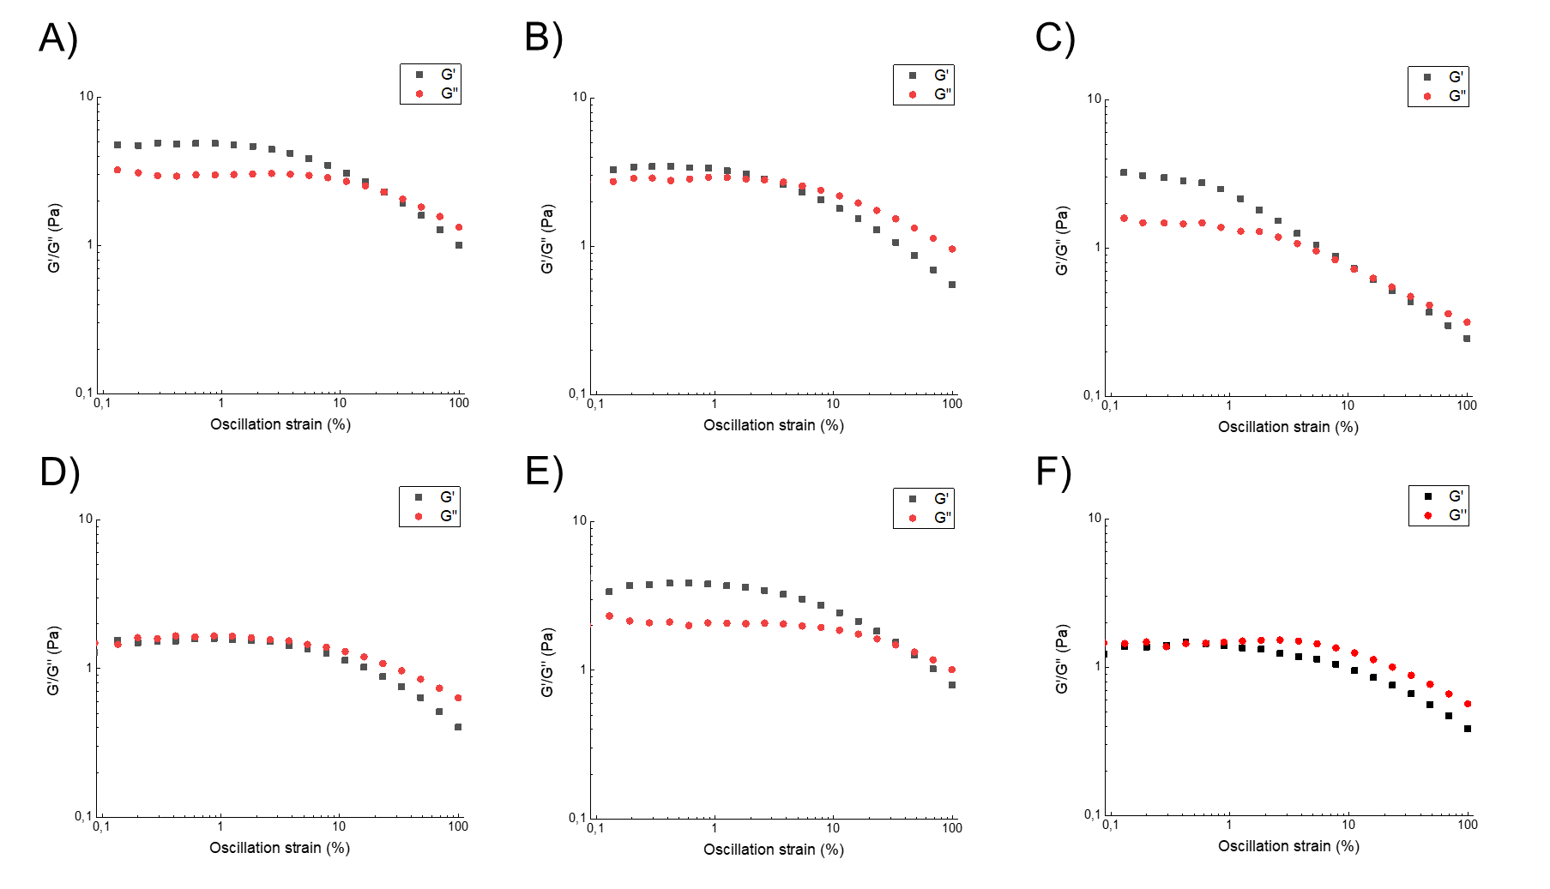
Figure S3: Oscillation strain plots, reporting G’ (storage modulus) and G’’ (loss modulus), for Fmoc-FF/C18-(GK)3 hydrogels encapsulating the dye at different concentrations: 0.05 mmol/L (A), 0.25 mol/L (B), 0.50 mmol/L (C), 0.75 mol/L (D), 1.0 mmol/ L (E), 3.0 mol/L (F). G’ (storage modulus), G’’ (loss modulus) and tanδ (G’’/G’). G’ and G’’ are extrapolated at γ = 1.26% in the Linear Viscoelastic Region (LVR).

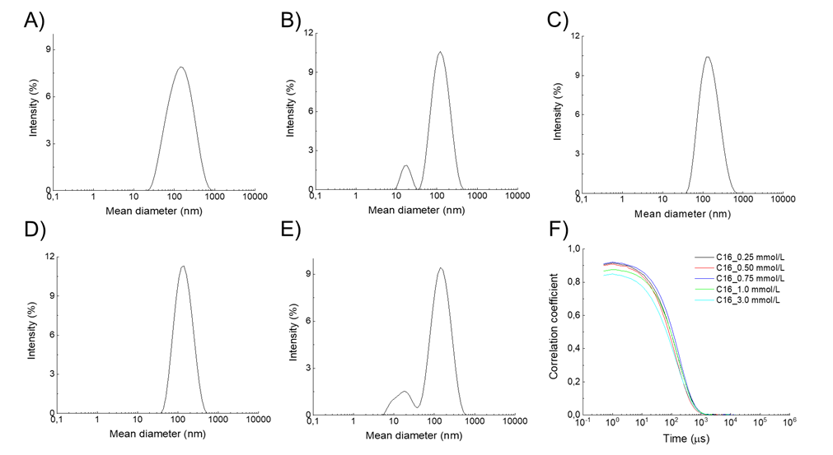
Figure S4: Fmoc-FF/C16-(GK)3 nanogels encapsulating the AlexaFluorTM430 solution at different concentration: (A) 0.25 mmol/L, (B) 0.50 mmol/L, (C) 0.75 mmol/L, (D) 1.0 mmol/L, (E) 3.0 mmol/L. Correlation function plot (F).

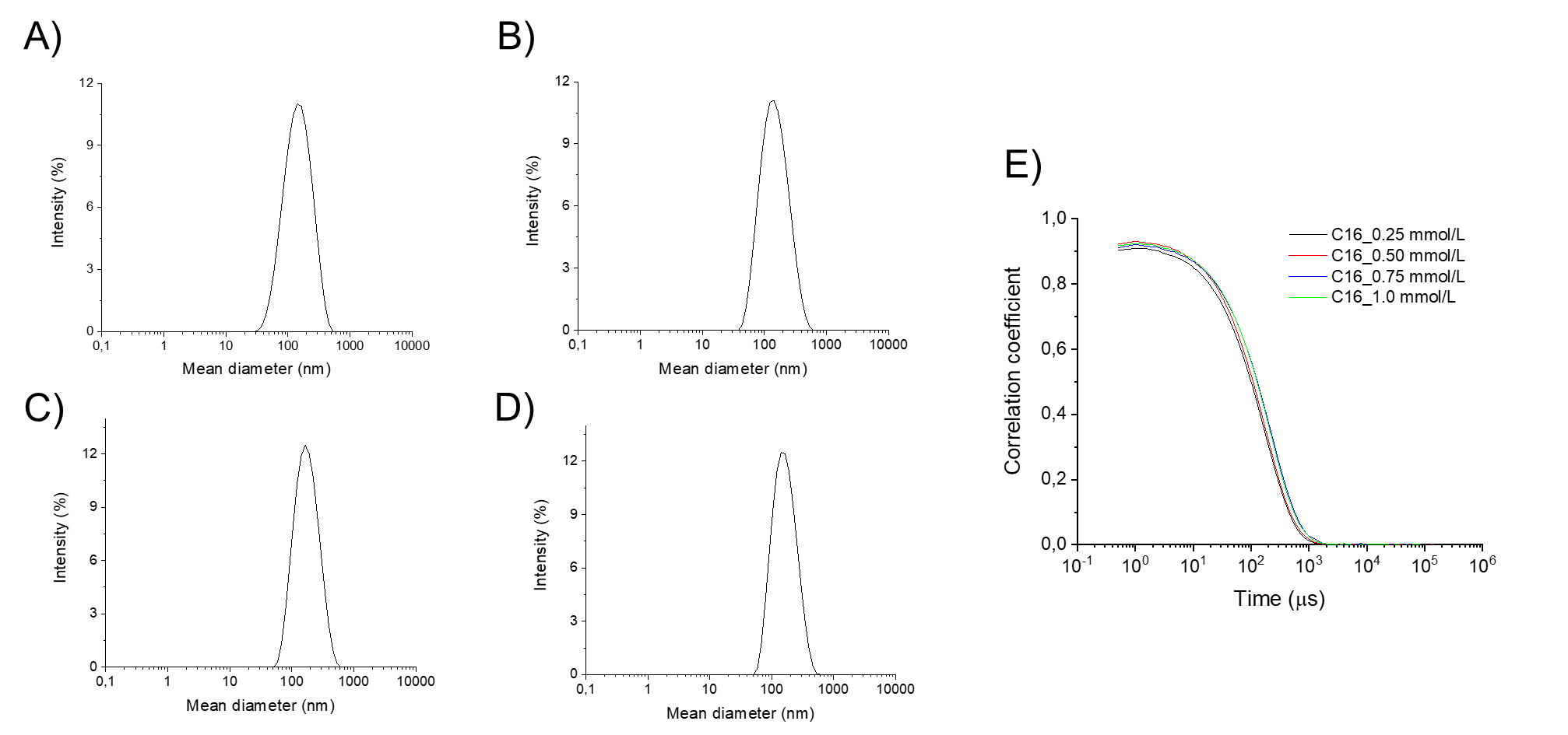
Figure S5: Fmoc-FF/C16-(GK)3 nanogels adsorbing the Alexa FluorTM430 solution at different concentration: (A) 0.25 mmol/L, (B) 0.50 mmol/L, (C) 0.75 mmol/L, (D) 1.0 mmol/L. (E) Correlation function plot of each sample.

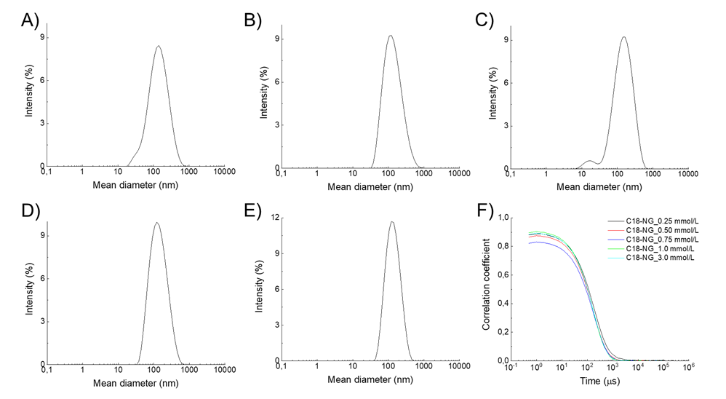
Figure S6: Fmoc-FF/C18-(GK)3 nanogels encapsulating the Alexa FluorTM430 solution at different concentration: (A) 0.25 mmol/L, (B) 0.50 mmol/L, (C) 0.75 mmol/L, (D) 1.0 mmol/L, (E) 3.0 mmol/L. (F) Correlation function plots.

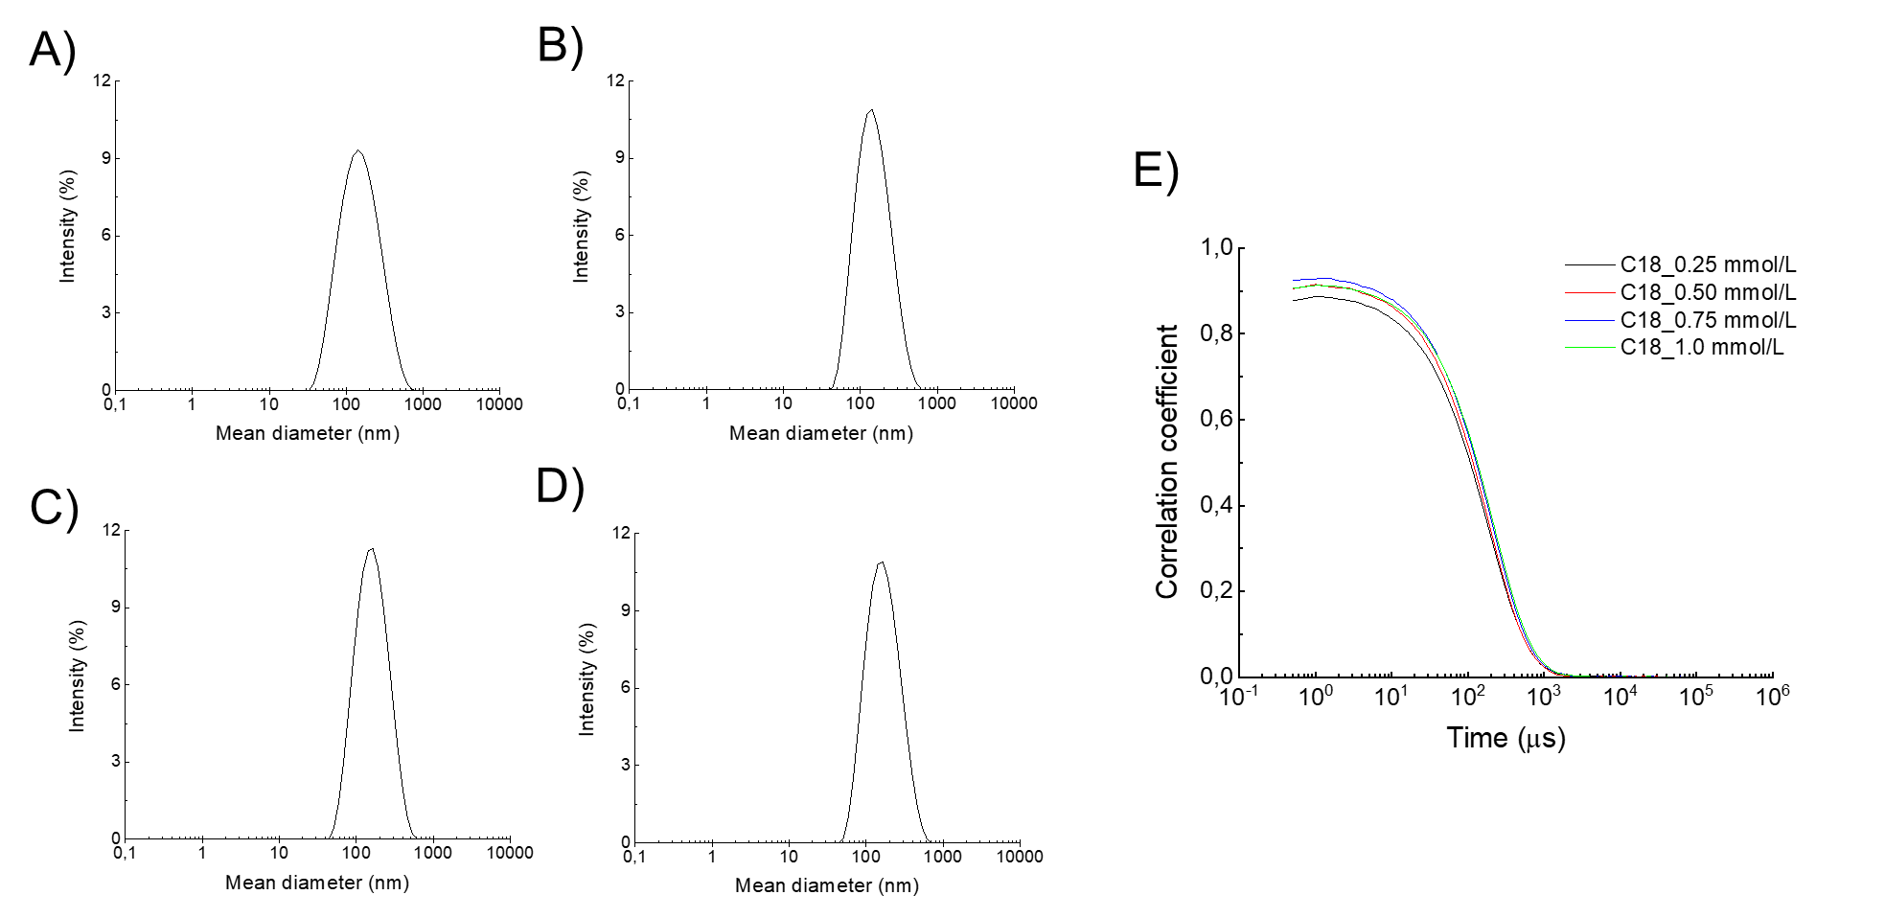
Figure S7: Fmoc-FF/C18-(GK)3 nanogels adsorbing the Alexa FluorTM430 solution at different concentration: (A) 0.25 mmol/L, (B) 0.50 mmol/L, (C) 0.75 mmol/L, (D) 1.0 mmol/L, (E) Correlation function plots.

