Supplementary figures
Fig. S1. Time course of Oxidation-Reduction Potential (ORP) values in the flooded treatments in the soil-water interface during the first experiment. Values are means ± SE of six randomly chosen flooded mesocosms.
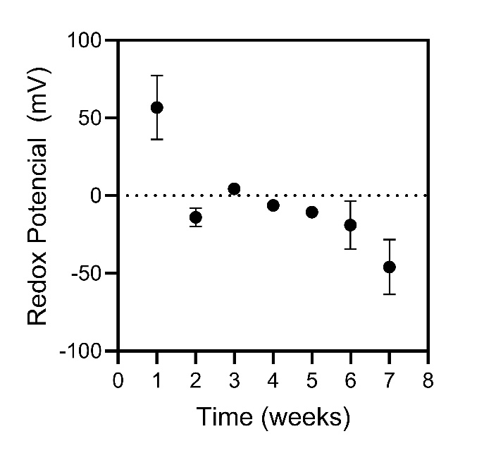
Fig. S2. Midday irradiance measured under the canopy formed by established E. colona plants on December 22, 2021. (a) photosynthetic photon flux density (PPFD) and (b) R:FR of canopy transmitted light. Incident natural light PPDF was of 1740 µmol m⁻² s⁻¹ with an R:FR of 1.15.
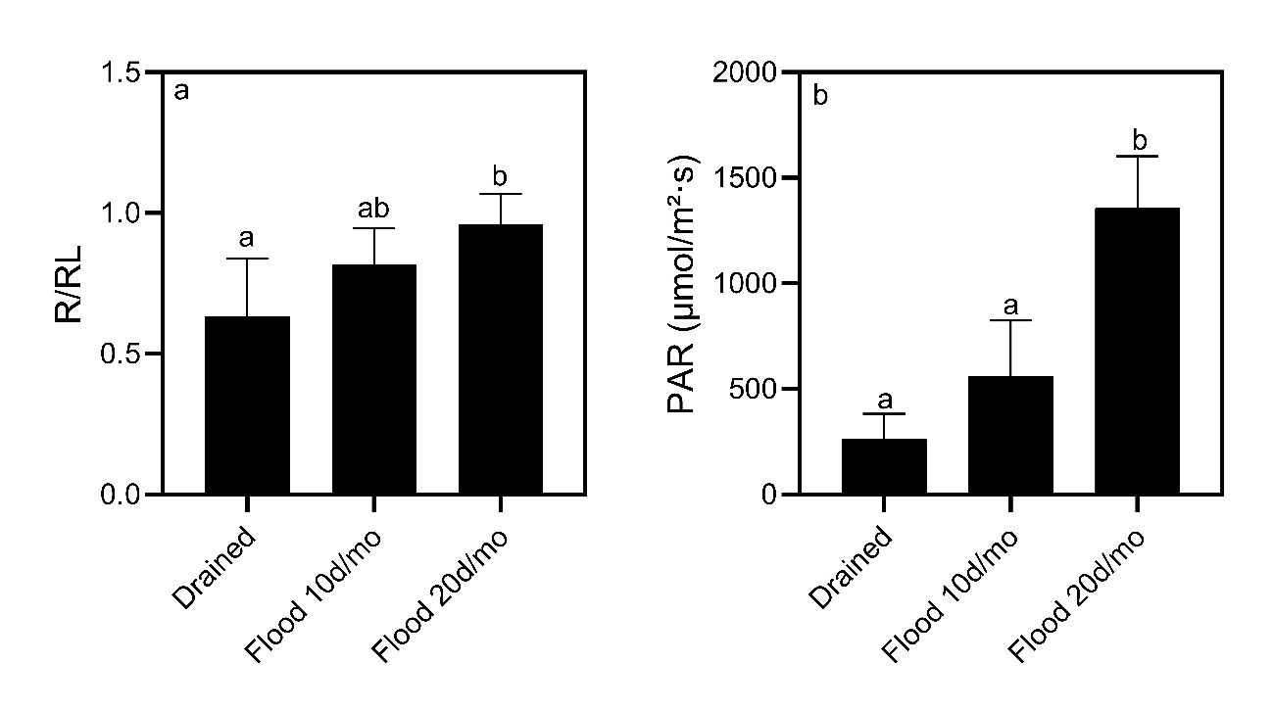
Fig. S3. Oxidation-Reduction Potential (ORP) values measured in perforated Falcon tubes inserted into intermittently flooded mesocosms: I10 = 10-d flood mo⁻¹, I20 = 20-d flood mo⁻¹. Values are means ± SE of six flooded mesocosms measured just before the end of the flooding round.
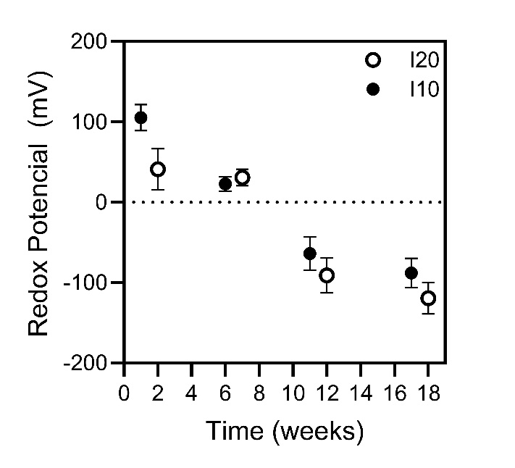
Fig. S4. Final Oxidation-Reduction Potential (ORP) values measured in perforated Falcon tubes inserted into flooded mesocosms during the third experiment (winter flooding). Values are means ± SE of six flooded mesocosms measured just before drainage.
