Bioavailable nickel and zinc in polluted soil alter the growth of non-pioneer trees in the Brazilian Atlantic Forest
Journal name: Plant and Soil
Author name’s: Solange E. Brandão ¹*, Geane Martins Barbosa ¹, Matheus C. Siqueira ², Rafaela de O. A Campos ³, Ana C.F.Dalsin ⁴, Mirian C. S. Rinaldi ¹, Marisa Domingos¹

1. Instituto de Botânica, Núcleo de Pesquisa em Ecologia, 04301-902 - São Paulo, SP, Brasil
2. Instituto de Botânica, Núcleo de Pesquisa em Plantas Ornamentais, 04301-902 - São Paulo, SP, Brasil
3. Centro de Capacitação e Pesquisa Em Meio Ambiente, CEPEMA, POLI, USP,Cubatão. SP, Brasil
4. Departamento de Engenharia Química – Escola Politécnica – (USP), São Paulo, SP, Brasil
* Corresponding author: solangeeu35@gmail.com; +55 11 950894160

Supplementary Information (SI)
Table S1. Doses in aqueous solution of macro and micronutrients (including Zn) and Ni applied to the soil used for cultivating the plants of the six species included in the different treatments (mg.kg¹ of soil).

Treatments | N | P | K | Ca | Mg | S | B | Cu | Fe | Mn | Mo | Zn | Ni | Cl | Na
T_{C}* | 200 | 300 | 100 | 154 | 100 | 230 | 0.1 | 0.05 | 0.3 | 0.5 | 0.001 | 0.05 | 0 | 220 | 0
T_{Ni} | 200 | 300 | 100 | 154 | 100 | 230 | 0.1 | 0.05 | 0.3 | 0.5 | 0.001 | 0.05 | 90 | 220 | 0
T_{Zn} | 200 | 300 | 100 | 154 | 100 | 230 | 0.1 | 0.05 | 0.3 | 0.5 | 0.001 | 258 | 0 | 220 | 0
T_{ZnNi} | 200 | 300 | 100 | 154 | 100 | 230 | 0.1 | 0.05 | 0.3 | 0.5 | 0.001 | 258 | 90 | 220 | 0
* Forest soil with balanced fertilization of macronutrients and micronutrients according to Gonçalves et al., (2000) and Cometti et al., (2006), respectively.

Table S2. Average concentration ratios ± standard deviations of nickel and zinc between treatments with addition of metals and control treatment ([Ni]_{treatments}/[Ni]_{control}; [Zn]_{treatments}/[Zn]_{control}), in the following soil fractions: soluble, exchangeable and carbonate-bound forms (F1), bound to iron and manganese oxides/hydroxides (F2), bound to organic matter (F3) and residual (F4). Distinct letters indicate significant differences in the concentration ratios between fractions (One-Way ANOVA, followed by Tukey test; p < 0.05.
 | F1 | F2 | F3 | F4
Nickel
T_{Ni}/T_{C} | 24.6 ± 6.2 b | 44.9 ± 19.0 a | 17.5 ± 7.4 b | 1.7 ± 0.6 c
T_{Zn}/T_{C} | 3.0 ± 1.1 a | 3.0 ± 1.1 a | 0.7 ± 0.4 b | 0.2 ± 0.1 c
T_{Ni Zn}/T_{C} | 9.3 ± 2.8 b | 16.6 ± 3.8 b | 54.4 ± 21.5 a | 1.2 ± 0.5 c
Zinc
T_{Ni}/T_{C} | 2.1 ± 0.9 a | 0.8 ± 0.5 c | 1.4 ± 0.7 b | 1.7 ± 0.3 a
T_{Zn}/T_{C} | 19.4 ± 5.9 a | 8.1 ± 4.6 b | 2.7 ± 0.8 b | 0.9 ± 0.7 c
T_{Ni Zn}/T_{C} | 13.3 ± 4.3 a | 6.5 ± 1.9 b | 2.4 ± 0.5 c | 3.6 ± 2.1 c

Table S3. Average concentration ratios of nickel and zinc and respective log10 values between treatments with addition of metals and control treatment ([Ni]_{treatments}/[Ni]_{control}; [Zn]_{treatments}/[Zn]_{control}) for leaves, stems and roots of pioneer (Pi) and non-pioneer (NPi) species. Log10 values were used for constructing the heatmap included in the paper. Different lowercase letters indicate differences in the estimated ratios for each organ between species (One-Way ANOVA, followed by Tukey test; p < 0.05)
 |  | Nickel |  |  |  |  | Zinc
Species | Organs | T_{Ni}/T_{C} | Log10 T_{Ni}/T_{C} | T_{ZnNi}/T_{C} | Log10 T_{ZnNi}/T_{C} |  | T_{Zn}/Tc | Log10 TZn/Tc | T_{ZnN}i/T_{C} | Log10 T_{ZnNi}/T_{C}
C. floribundus (Pi) | Leaves | 11.7 b | 1.07 | 5.5 b | 0.74 |  | 4.8 b | 0.68 | 6.7 a | 0.83
 | Stems | 34.5 a | 1.54 | 16.0 a | 1.20 |  | 4.5 b | 0.65 | 7.1 a | 0.85
 | Roots | 14.4 a | 1.16 | 20.3 a | 1.31 |  | 7.5 a | 0.87 | 5.7 a | 0.76
I. sessilis (Pi) | Leaves | 6.4 b | 0.81 | 5.2 b | 0.72 |  | 4.5 b | 0.65 | 4.6 b | 0.66
 | Stems | 20.3 b | 1.31 | 16.4 a | 1.21 |  | 3.7 b | 0.57 | 3.4 b | 0.53
 | Roots | 18.0 a | 1.25 | 14.1 a | 1.15 |  | 14.3 a | 1.15 | 11.3 a | 1.05
R. ferruginea (Pi) | Leaves | 6.3 b | 0.80 | 3.3 c | 0.52 |  | 8.6 a | 0.93 | 1.8 b | 0.25
 | Stems | 12.4 a | 1.09 | 6.3 b | 0.80 |  | 8.8 a | 0.94 | 1.3 b | 0.11
 | Roots | 8.1 b | 0.91 | 11.0 a | 1.04 |  | 7.1 a | 0.85 | 6.8 a | 0.83
E. uniflora (NPi) | Leaves | 7.0 c | 0.84 | 2.4 c | 0.38 |  | 4.3 b | 0.63 | 4.8 b | 0.68
 | Stems | 42.0 a | 1.62 | 23.5 a | 1.37 |  | 2.4 c | 0.38 | 3.0 c | 0.48
 | Roots | 14.0 b | 1.15 | 8.8 b | 0.94 |  | 19.0 a | 1.28 | 7.1 a | 0.85
E. leiocarpa (NPi) | Leaves | 24.2 b | 1.38 | 6.5 c | 0.81 |  | 23.2 a | 1.36 | 8.1 b | 0.91
 | Stems | 55.0 a | 1.74 | 17.4 a | 1.24 |  | 11.0 b | 1.04 | 2.3 c | 0.36
 | Roots | 4.0 c | 0.60 | 9.5 b | 0.98 |  | 28.5 a | 1.45 | 26.1 a | 1.42
O. odorifera (NPi) | Leaves | 12.1 b | 1.08 | 3.0 c | 0.48 |  | 12.0 a | 1.07 | 1.4 b | 0.15
 | Stems | 21.8 a | 1.34 | 16.7 a | 1.22 |  | 10.9 a | 1.04 | 1.1 b | 0.04
 | Roots | 7.0 c | 0.84 | 4.7 b | 0.67 |  | 13.5 a | 1.13 | 8.5 a | 0.93

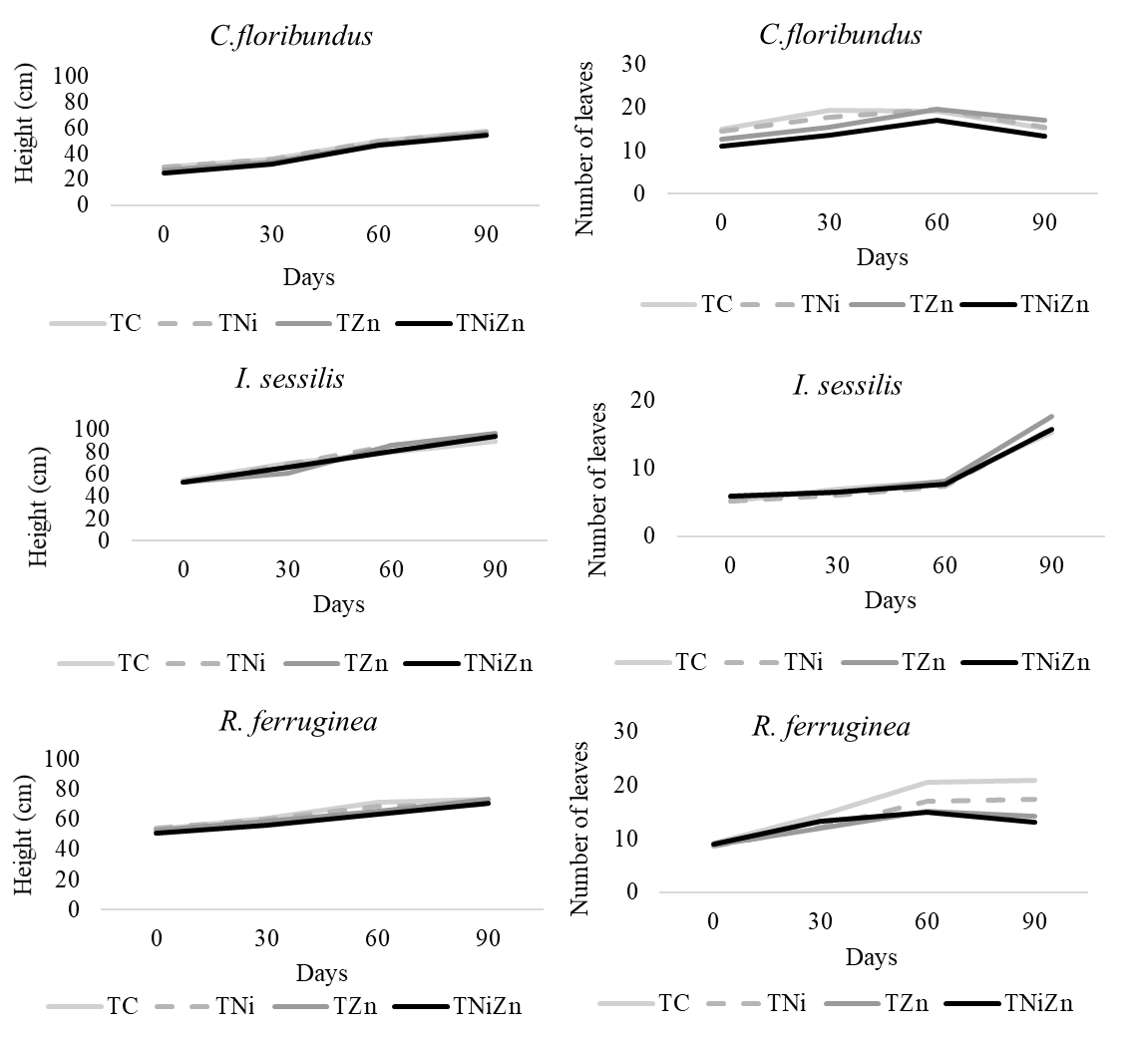
Fig. S1. Growth curves of height and leaf number of pioneer species grown in the control (T_{C}) and metal treatments in the soil (T_{Ni,} T_{Zn} and T_{NiZn}) during the 90 days of experiment.
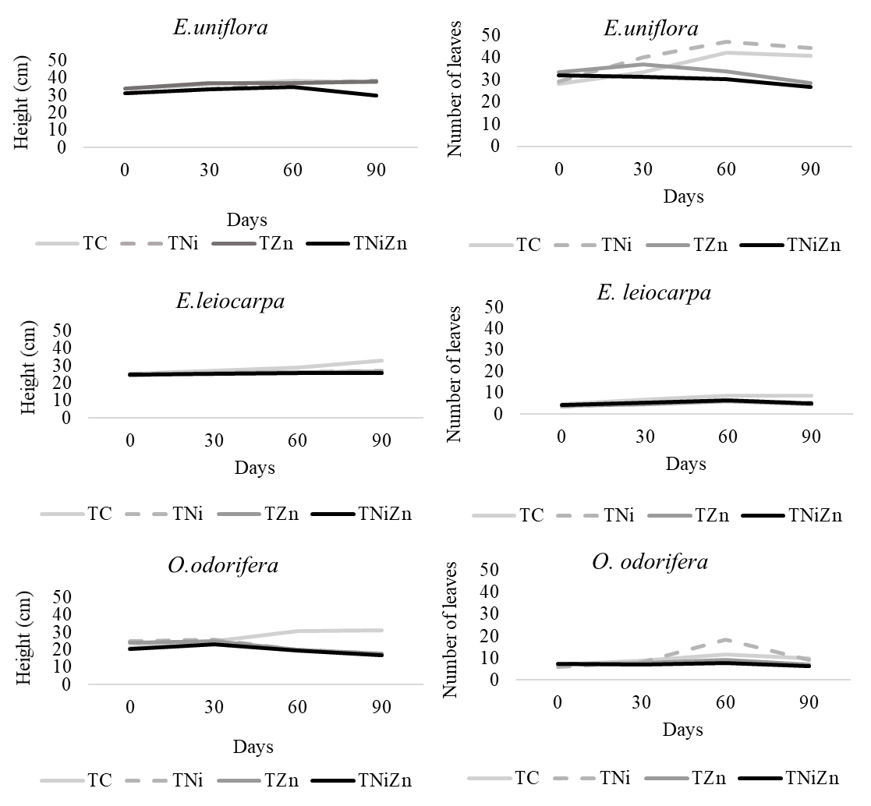
Fig. S2. Growth curves of height and leaf number of non-pioneer species grown in the control (T_{C}) and metal treatments in the soil (T_{Ni,} T_{Zn} and T_{NiZn}) during the 90 days of experiment.

