Appendix

Table A1: Data cleaning steps
Sequential exclusion | # of cases | Characteristics of dropped observation | Justification
Non-gas heated houses | 952,149 |  | Our study focused on gas consumption
Floor area above 1000m² | 16,290 |  | This floor area is considered unrealistic
Houses built before 1200 | 12,411 | 96% of these buildings were built in the year 1005 (according to the micro data)
House type unknown | 6,992 |  | According to CBS this data does not contain sufficient detail to assign one of the standard house type classifications.
Ownership type unknown | 16,649 |  | These are owner-occupied homes that were uninhabited and had non-living function at the time of data collection
Gas m³/m² > 47 | 16,627 | Houses with annual consumption of more than six standard deviations from the national mean. | This annual consumption m³/m² square was considered extreme.
Total cases excluded | 1,021,118
* The dropped cases are based on 2019 data. These cases were also excluded for the 2022 analysis.

Table A2: Descriptives of categorical variables for the Dutch residential sector
 | 2019 |  |  |  |  |  | 2022
Variable | Categories | Freq. | % | Mean | SD |  | Freq. | % | Mean | SD
House type | Detached | 903654 | 13.9 | 2144.36 | 932.09 |  | 915534 | 13.88 | 1819.9 | 835.92
House type | Semi-det & corner | 1526977 | 23.4 | 1516.19 | 612.23 |  | 1542262 | 23.38 | 1295.9 | 561.12
House type | Terraced | 2032774 | 31.2 | 1221.88 | 512.29 |  | 2046690 | 31.02 | 1054.35 | 470.32
House type | Apartments | 2052299 | 31.5 | 886.95 | 495.96 |  | 2093405 | 31.73 | 785.24 | 458.16
Ownership type | Social rental | 1911764 | 29.3 | 957.07 | 468.57 |  | 1869261 | 28.33 | 837.27 | 428.34
Ownership type | Own home | 3987119 | 61.2 | 1506.82 | 768.11 |  | 4042863 | 61.28 | 1290.62 | 681.09
Ownership type | Comm. rental | 616821 | 9.47 | 1166.43 | 692.07 |  | 685767 | 10.39 | 996.99 | 617.21
Construction year | 1200-1919 | 458798 | 7.04 | 1580.45 | 936.14 |  | 479727 | 7.27 | 1350.41 | 820.25
Construction year | 1920-1945 | 743355 | 11.4 | 1599.08 | 840.25 |  | 746449 | 11.31 | 1369.41 | 744.58
Construction year | 1946-1974 | 2165078 | 33.2 | 1354.87 | 716.72 |  | 2136013 | 32.37 | 1157.43 | 632.84
Construction year | 1975-1982 | 812154 | 12.5 | 1361.65 | 688.89 |  | 811598 | 12.3 | 1172.68 | 616.32
Construction year | 1983-1995 | 1150049 | 17.7 | 1150.86 | 601.49 |  | 1151428 | 17.45 | 1007.31 | 547.08
Construction year | 1996-2000 | 369925 | 5.68 | 1167.24 | 618.15 |  | 370421 | 5.61 | 1029.05 | 565.97
Construction year | 2001-2015 | 680381 | 10.4 | 1063.69 | 612.91 |  | 680785 | 10.32 | 952.91 | 562.36
Construction year | 2015-2022 | 135964 | 2.09 | 918.86 | 502.73 |  | 221470 | 3.36 | 825.23 | 451.45
Note: Mean is the mean of gas used in cubic meters per year

Table A3: Descriptives of archetype groups in Fig. 5
Archetype groups | Spatial aspect | Sample | Gini coef. | mean_GAS | sd_GAS | mean_DY | sd_DY | mean_NC | sd_NC | mean_AGE | sd_AGE
Apt Com ,Built 1200-1919 ,5-50m2 | National | 22398 | 0.22 | 749.37 | 306.46 | 30155.89 | 17413.89 | 1 | 1 | 36 | 13
Apt Com ,Built 1200-1919 ,5-50m2 | National | 29124 | 0.23 | 668.67 | 284.05 | 34668.77 | 24405.11 | 1 | 1 | 36 | 13
Apt Com ,Built 1200-1919 ,5-50m2 | Amsterdam | 6939 | 0.28 | 668.40 | 339.17 | 35396.20 | 22464.26 | 1 | 1 | 39 | 15
Apt Com ,Built 1200-1919 ,5-50m2 | Amsterdam | 9515 | 0.28 | 612.00 | 315.56 | 40743.16 | 32712.12 | 1 | 1 | 39 | 15
Apt Com ,Built 1200-1919 ,5-50m2 | Neighbourhood 1 | 464 | 0.24 | 718.72 | 315.10 | 38692.88 | 22371.70 | 1 | 1 | 39 | 14
Apt Com ,Built 1200-1919 ,5-50m2 | Neighbourhood 1 | 478 | 0.26 | 648.86 | 309.40 | 42172.92 | 23195.54 | 1 | 1 | 39 | 15
Apt Com ,Built 1200-1919 ,5-50m2 | Neighbourhood 2 | 38 | 0.23 | 713.82 | 311.55 | 33874.97 | 13856.44 | 2 | 1 | 42 | 14
Apt Com ,Built 1200-1919 ,5-50m2 | Neighbourhood 2 | 41 | 0.25 | 598.46 | 288.15 | 41315.83 | 20788.79 | 2 | 1 | 39 | 15
Apt Com ,Built 1200-1919 ,5-50m2 | Neighbourhood 3 | 472 | 0.31 | 595.35 | 334.54 | 35281.09 | 28857.36 | 1 | 1 | 38 | 14
Apt Com ,Built 1200-1919 ,5-50m2 | Neighbourhood 3 | 517 | 0.29 | 546.66 | 294.86 | 38735.69 | 22047.70 | 1 | 1 | 37 | 15
Apt Own ,Built 1200-1919 ,5-50m2 | National | 6191 | 0.27 | 678.20 | 334.91 | 48634.55 | 32151.60 | 1 | 1 | 40 | 12
Apt Own ,Built 1200-1919 ,5-50m2 | National | 6325 | 0.28 | 612.61 | 314.55 | 56623.06 | 37895.91 | 1 | 1 | 41 | 13
Apt Own ,Built 1200-1919 ,5-50m2 | Amsterdam | 4608 | 0.28 | 642.65 | 321.92 | 51012.90 | 34396.45 | 1 | 1 | 39 | 10
Apt Own ,Built 1200-1919 ,5-50m2 | Amsterdam | 4716 | 0.29 | 584.95 | 306.45 | 59385.22 | 39512.40 | 1 | 1 | 41 | 12
Apt Own ,Built 1200-1919 ,5-50m2 | Neighbourhood 1 | 252 | 0.26 | 736.40 | 350.73 | 56844.59 | 37533.66 | 1 | 1 | 40 | 11
Apt Own ,Built 1200-1919 ,5-50m2 | Neighbourhood 1 | 218 | 0.29 | 650.67 | 347.17 | 67028.92 | 40192.16 | 2 | 1 | 40 | 11
Apt Own ,Built 1200-1919 ,5-50m2 | Neighbourhood 2 | 47 | 0.23 | 655.75 | 269.20 | 47863.91 | 20060.40 | 1 | 1 | 37 | 8
Apt Own ,Built 1200-1919 ,5-50m2 | Neighbourhood 2 | 44 | 0.27 | 582.94 | 282.72 | 55197.84 | 18334.44 | 1 | 1 | 39 | 8
Apt Own ,Built 1200-1919 ,5-50m2 | Neighbourhood 3 | 160 | 0.31 | 594.55 | 333.80 | 52040.54 | 32484.16 | 1 | 1 | 38 | 11
Apt Own ,Built 1200-1919 ,5-50m2 | Neighbourhood 3 | 152 | 0.31 | 540.17 | 304.73 | 60462.36 | 43353.87 | 1 | 1 | 39 | 12
Apt Soc ,Built 1200-1919 ,5-50m2 | National | 13589 | 0.27 | 701.21 | 339.24 | 22844.02 | 16096.99 | 1 | 1 | 45 | 15
Apt Soc ,Built 1200-1919 ,5-50m2 | National | 14157 | 0.27 | 636.40 | 312.65 | 26134.51 | 13823.57 | 1 | 1 | 45 | 16
Apt Soc ,Built 1200-1919 ,5-50m2 | Amsterdam | 8349 | 0.28 | 690.41 | 350.75 | 23507.14 | 13418.00 | 1 | 1 | 47 | 15
Apt Soc ,Built 1200-1919 ,5-50m2 | Amsterdam | 8693 | 0.29 | 626.12 | 325.48 | 26829.65 | 14603.97 | 1 | 1 | 49 | 15
Apt Soc ,Built 1200-1919 ,5-50m2 | Neighbourhood 1 | 194 | 0.25 | 735.58 | 332.46 | 23156.03 | 15434.00 | 1 | 1 | 50 | 14
Apt Soc ,Built 1200-1919 ,5-50m2 | Neighbourhood 1 | 184 | 0.24 | 699.03 | 312.06 | 25084.82 | 12641.94 | 1 | 1 | 51 | 14
Apt Soc ,Built 1200-1919 ,5-50m2 | Neighbourhood 2 | 55 | 0.29 | 782.27 | 406.38 | 23376.20 | 13360.29 | 2 | 1 | 49 | 13
Apt Soc ,Built 1200-1919 ,5-50m2 | Neighbourhood 2 | 64 | 0.29 | 734.38 | 417.14 | 27659.63 | 17821.99 | 2 | 1 | 50 | 12
Apt Soc ,Built 1200-1919 ,5-50m2 | Neighbourhood 3 | 143 | 0.28 | 608.67 | 316.97 | 20787.87 | 11168.88 | 1 | 0 | 46 | 16
Apt Soc ,Built 1200-1919 ,5-50m2 | Neighbourhood 3 | 152 | 0.30 | 543.88 | 304.46 | 24814.63 | 12445.95 | 1 | 0 | 46 | 16

Table A3 continued
Archetype groups | Spatial aspect | Sample | Gini | mean_GAS | sd_GAS | mean_DY | sd_DY | mean_HS | sd_HS | mean_AGE | sd_AGE
Apt Soc ,Built 1200-1919 ,75-100m2 | National | 9666 | 0.27 | 1005.46 | 490.28 | 31153.72 | 23077.10 | 2 | 1 | 52 | 16
Apt Soc ,Built 1200-1919 ,75-100m2 | National | 9158 | 0.27 | 912.87 | 448.82 | 36021.63 | 20972.18 | 2 | 1 | 53 | 16
Apt Soc ,Built 1200-1919 ,75-100m2 | Amsterdam | 2075 | 0.27 | 1042.13 | 512.17 | 38971.81 | 37438.49 | 2 | 1 | 55 | 15
Apt Soc ,Built 1200-1919 ,75-100m2 | Amsterdam | 1935 | 0.26 | 956.59 | 462.14 | 43593.57 | 25414.13 | 2 | 1 | 55 | 15
Apt Soc ,Built 1200-1919 ,75-100m2 | Neighbourhood 1 | 51 | 0.30 | 949.01 | 513.70 | 50041.80 | 30332.05 | 2 | 1 | 49 | 14
Apt Soc ,Built 1200-1919 ,75-100m2 | Neighbourhood 1 | 50 | 0.33 | 769.70 | 464.39 | 50022.38 | 25715.26 | 2 | 1 | 51 | 15
Apt Soc ,Built 1200-1919 ,75-100m2 | Neighbourhood 2 | 19 | 0.26 | 1024.57 | 523.81 | 66468.05 | 47824.71 | 3 | 1 | 40 | 10
Apt Soc ,Built 1200-1919 ,75-100m2 | Neighbourhood 2 | 18 | 0.28 | 953.20 | 559.69 | 63929.61 | 49213.94 | 3 | 2 | 44 | 13
Apt Soc ,Built 1200-1919 ,75-100m2 | Neighbourhood 3 | 18 | 0.28 | 977.21 | 502.31 | 31585.61 | 21229.56 | 2 | 1 | 57 | 10
Apt Soc ,Built 1200-1919 ,75-100m2 | Neighbourhood 3 | 29 | 0.28 | 926.74 | 479.55 | 31223.90 | 22789.59 | 2 | 1 | 59 | 11
Apt Soc ,Built 1983-1995 ,50-75m2 | National | 136373 | 0.2748 | 718.42 | 361.18 | 22598.91 | 9710.16 | 1 | 1 | 61 | 19
Apt Soc ,Built 1983-1995 ,50-75m2 | National | 137492 | 0.29329 | 647.40 | 350.33 | 25723.66 | 11162.65 | 1 | 1 | 61 | 19
Apt Soc ,Built 1983-1995 ,50-75m2 | Amsterdam | 12198 | 0.30183 | 790.09 | 434.36 | 26005.79 | 15255.88 | 2 | 1 | 58 | 15
Apt Soc ,Built 1983-1995 ,50-75m2 | Amsterdam | 11918 | 0.32177 | 725.65 | 430.97 | 29735.23 | 18962.28 | 2 | 1 | 59 | 15
Apt Soc ,Built 1983-1995 ,50-75m2 | Neighbourhood 1 | 39 | 0.33674 | 776.01 | 466.88 | 28278.72 | 20375.45 | 1 | 1 | 59 | 13
Apt Soc ,Built 1983-1995 ,50-75m2 | Neighbourhood 1 | 31 | 0.33101 | 662.93 | 424.51 | 29291.68 | 15239.31 | 1 | 0 | 59 | 14
Apt Soc ,Built 1983-1995 ,50-75m2 | Neighbourhood 2 | 348 | 0.28516 | 797.31 | 413.88 | 25542.23 | 14758.21 | 2 | 1 | 56 | 16
Apt Soc ,Built 1983-1995 ,50-75m2 | Neighbourhood 2 | 345 | 0.29856 | 749.95 | 408.85 | 30976.29 | 16837.74 | 2 | 1 | 57 | 16
Apt Soc ,Built 1983-1995 ,50-75m2 | Neighbourhood 3 | 86 | 0.27456 | 726.65 | 359.36 | 24611.76 | 16855.93 | 1 | 1 | 58 | 14
Apt Soc ,Built 1983-1995 ,50-75m2 | Neighbourhood 3 | 80 | 0.30934 | 655.29 | 367.40 | 28932.84 | 18837.83 | 1 | 1 | 58 | 13

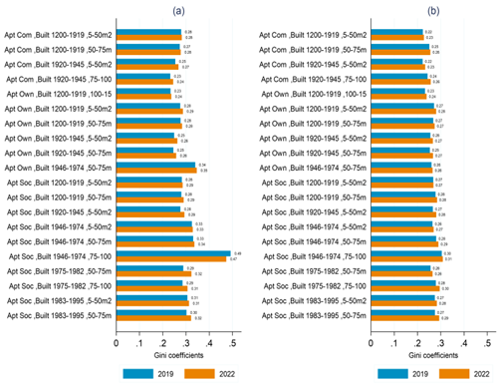
Fig A1 Comparison of gas use variation between archetype groups in Amsterdam and the National level. (a) represents the National case while (b) is Amsterdam. Archetype groups with fewer than ten dwellings as an outlier and excluded it from analysis; the plots therefore display the results for the twenty largest archetype groups in Amsterdam paired with the national cases.

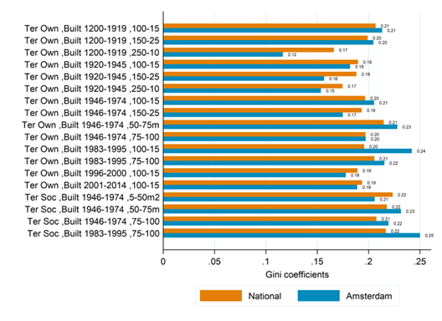
Fig A2 Comparison of gas use variation between archetypes for terraced groups. Note: Plot based on only 2019 data.

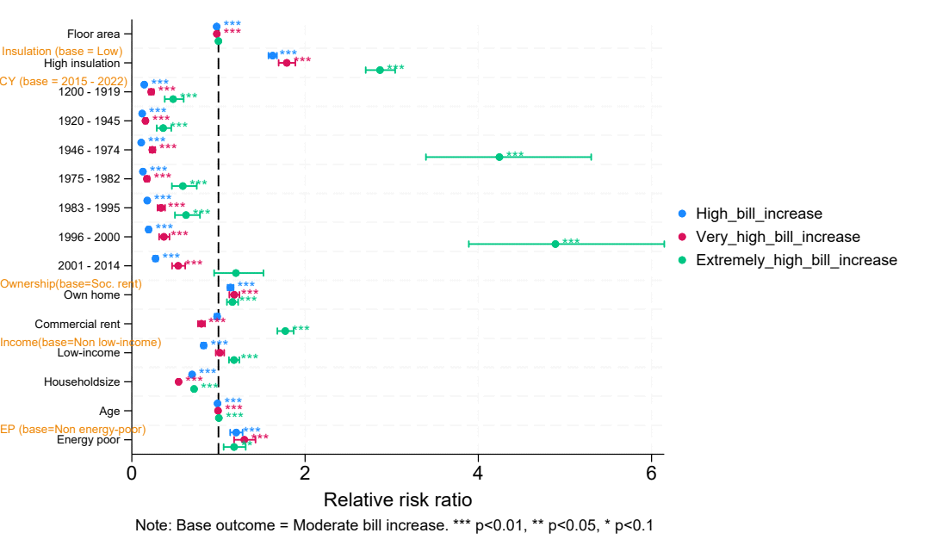
Fig A3 Multinomial logistic results for bill increase groups in Amsterdam for 2022.

