Supplementary Figure 1: Clinical signs during the acute phase of foot-and-mouth disease (FMD) following intrademolingual inoculation with FMDV serotype O in the crossbred HF heifers. Representative gross images showing (A) extensive ulceration at tip of the tongue, (B) ulcers in the dental pad, (C) profuse frothy salivation, (D), purulent nasal discharge, (E) vesicle and (F) ulceration of the inter-digital space.
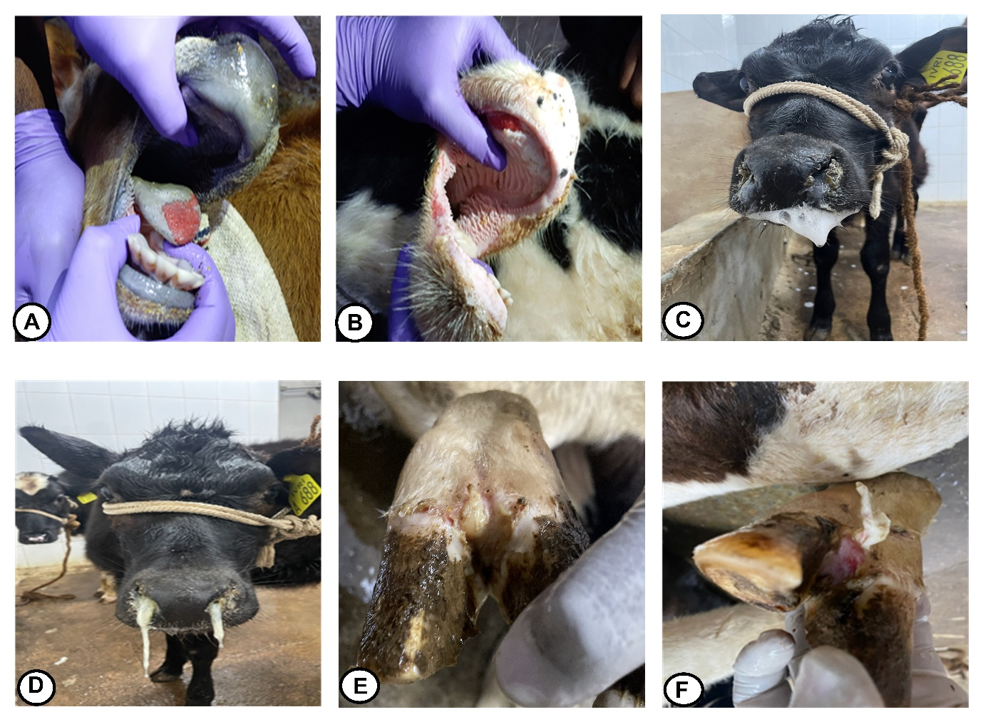

Supplementary Figure 2: Clinical signs in the HF calves that recovered from experimental FMDV infection. Representative gross images showing (A) cracked hoof, (B) over-grown claws (C) open-mouth breathing and (D) rough hair-coat.
