Supplementary Materials

Assistive materials for “Urban blue and green spaces in the UK: Distribution, equity and ecological implications”

Supplementary Table 1: Descriptive statistics of built-up area land cover when aggregated into blue, green, and grey categories

 | N | Mean | SD | Median | Min | Max | Trimmed | MAD
Blue Space (%) | 495 | 3.56 | 3.98 | 1.90 | 0.06 | 25.49 | 2.81 | 1.85
Green Space (%) | 495 | 31.82 | 9.63 | 33.08 | 1.67 | 60.60 | 32.25 | 8.97
Grey Space (%) | 495 | 64.61 | 8.99 | 63.38 | 38.94 | 97.97 | 64.14 | 8.08

Supplementary Table 2: Descriptive statistics of blue, green, and grey cover across deciles

 | N | Mean | SD | Median | Min | Max | Trimmed | MAD
Blue Space (%) | 10 | 3.56 | 3.03 | 1.94 | 0.28 | 12.95 | 2.79 | 1.89
Green Space (%) | 10 | 31.84 | 3.99 | 33.26 | 24.99 | 36.50 | 32.11 | 2.20
Grey Space (%) | 10 | 64.60 | 1.58 | 64.69 | 62.06 | 67.57 | 64.55 | 1.37

Supplementary Table 3: Habitat groupings (col. 1) used in this study and their source materials (col. 2-3).

Grouping: | UK CEH Land Cover | Ordnance Survey Land Use
Grey space | - Urban  - Suburban | -
Greenspace | - Improved grassland  - Neutral grassland  - Calcareous grassland  - Acid grassland  - Arable  - Deciduous woodland  - Coniferous woodland  - Heather grassland  - Heather  - Inland Rock | -
Bluespace | - Freshwater  - Fen  - Bog  - Littoral sediment  - Saltmarsh  - Supralittoral sediment  - Littoral rock  - Supralittoral rock  - Saltwater | - Surface water  - Tidal water  - Foreshore

Supplementary Table 4: Kruskal-Wallis and Dunn’s Test results for grey, green and blue space comparisons across coastal, estuarine and inland built-up areas.

Land Cover | Test | p_value | Chi² | df
Blue Space | Kruskal_Wallis | < 2.2e-16 | 183.15 | 2
Green Space | Kruskal_Wallis | 3.55e-11 | 48.12 | 2
Grey Space | Kruskal_Wallis | 0.31 | 2.34 | 2

Land Cover | Test | Comparison | Z score | Adjusted p-value
Blue Space | Dunn’s | coastal-estuarine | 2.17 | 0.045
Blue Space | Dunn’s | coastal-inland | 12.68 | 1.174424e-36
Blue Space | Dunn’s | estuarine-inland | 6.00 | 2.875832e-09
Green Space | Dunn’s | coastal-estuarine | -0.45 | 0.9758
Green Space | Dunn’s | coastal-inland | -6.24 | 6.725439e-10
Green Space | Dunn’s | estuarine-inland | -3.65 | 3.792939e-04
Grey Space | Dunn’s | coastal-estuarine | -1.41 | 0.2362
Grey Space | Dunn’s | coastal-inland | -0.20 | 1.0000
Grey Space | Dunn’s | estuarine-inland | 1.49 | 0.2051

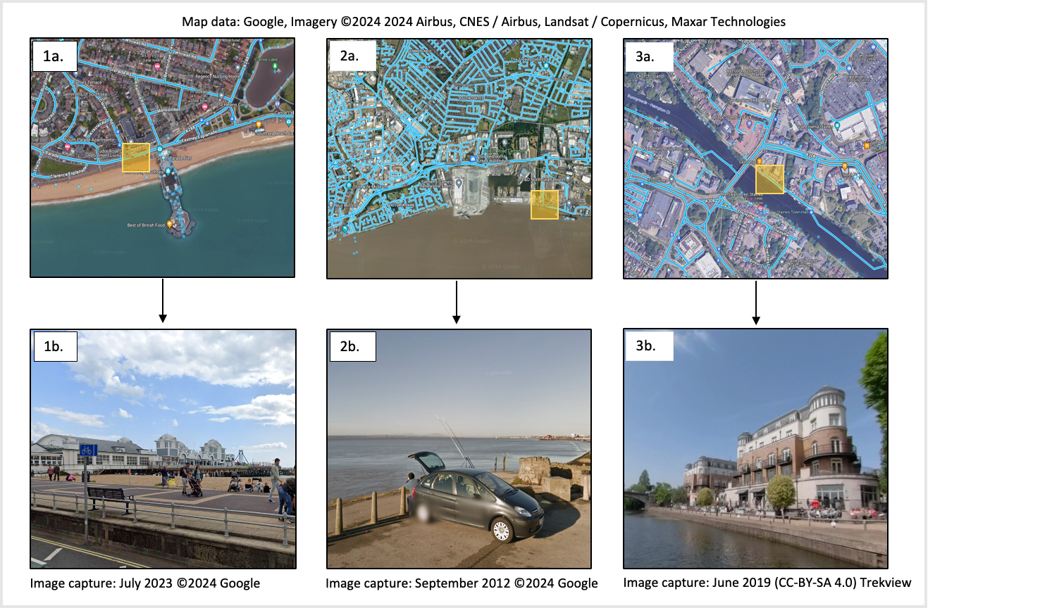

Supplementary Fig. 1: Examples of how Google Street View was used to ground truth assess blue space accessibility: images 1a. and 1b. shows Portsmouth, a coastal city on the south coast of England with a recreational pier and access to the beach; images 2a. and 2b. represents Kingston Upon Hull, an estuarine city in the north of England, which has several access points to the Humber estuary. In 2b., an angler is shown utilising a public access point amongst an industrial sector; images 3a. and 3b. show Staines-upon-Thames, an inland city with access to the River Thames. 3b. shows developments and footpaths alongside the river being used by the public, captured from a paddleboard user.

Supplementary Table 5: Summary of built-up area shape amendments and reasons, before assessments of land cover were carried out.

Built-up Area Name | Modification | Reason
Milford Haven | Removal of Valero refinery on the opposite side of the estuary and the industrial area on the west. | Completely inaccessible and disconnected from the main built-up area.
Tilbury | Removal of Tilbury docks | Completely inaccessible
Canvey Island | Removal of the Coryton refinery on the opposite side of Holehaven Creek | Completely inaccessible and disconnected from the main built-up area.
Holbury | Removal of the Trant refinery | Completely inaccessible
Immingham | Removal of Immingham docks | Completely inaccessible
Grangemouth | Removal of the Ineos refinery | Completely inaccessible
Bootle | Removal of docks | Completely inaccessible
Grimsby | Removal of docks | Completely inaccessible
Wallsend | Removal of docks | Completely inaccessible
Hillingdon | Removal of Heathrow Airport | Completely inaccessible and disconnected from the main built-up area.
Felixstowe | Removal of the Trinity Container Terminal | Completely inaccessible
Stanford-le-Hope | Removal of London Gateway Port | Completely inaccessible
Redcar | Removal of the Redcar bulk terminal | Completely inaccessible
Middlesbrough | Removal of Seal Sands | Completely inaccessible and disconnected from the main built-up area.

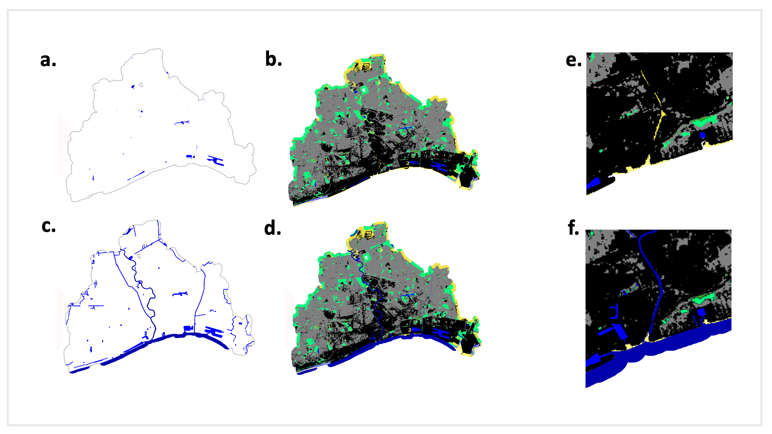
Supplementary Fig. 3: Comparison of land cover and land use data. a. represents Freshwater and Saltwater cover isolated from the land cover dataset (UKCEH). b. represents all land cover types (UKCEH). c. represents Tidal Water and Surface Water land use layers (OS), showing the increase of coverage. d. represents the composite map after combining the land use and land cover data. e. shows a close-up of the blue space representation from UKCEH. f. represents a close-up after the additional land use data has been incorporated.

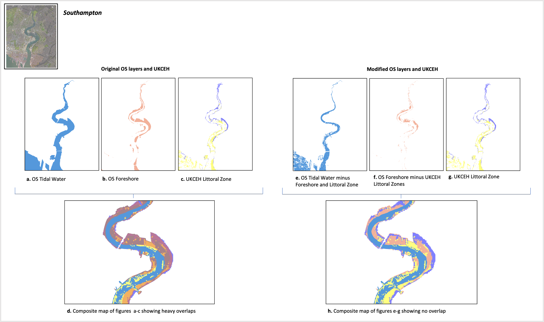

Supplementary Fig. 3: Geoprocessing of littoral zones. Images a. to c. represent available data for intertidal zones and d. displays the overlapping of information. Images e. to g. show how overlaps were handled to ensure as much resolution as possible for littoral habitats, h. shows the final composition with no overlap.

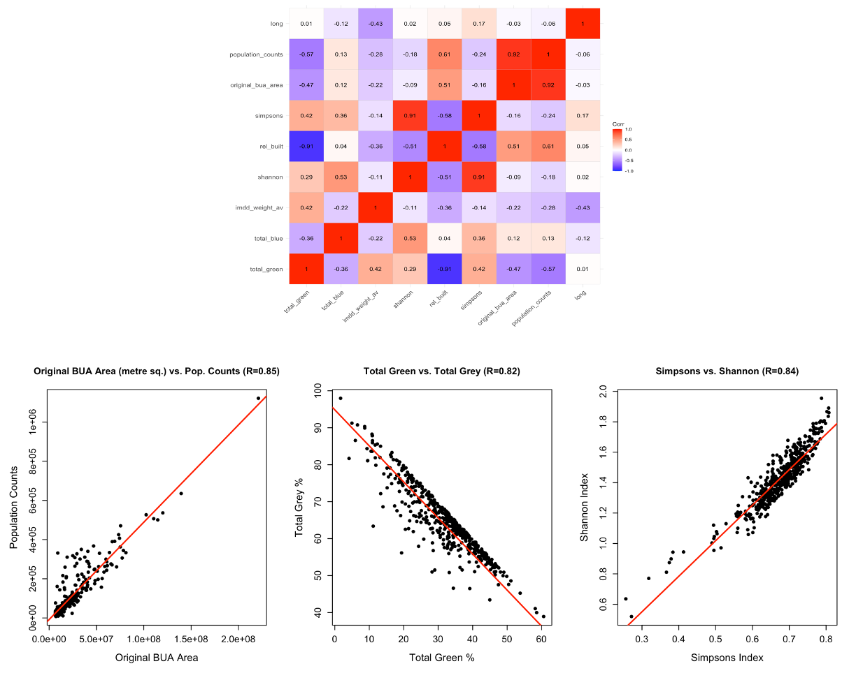

Supplementary Fig. 4: Correlation matrix created with independent variables considered for the GAM.

Supplementary Fig. 5: Linear models for six variables highlighted in the correlation matrix. From left to right: population count and size; grey space and green space; Shannon’s diversity index and Simpson’s diversity index.

Supplementary Table 6: Final GAM comparisons. Model selection was carried out by including all variables and removing non-significant predictors, whilst also alternating between collinear variables (e.g., Shannon’s and Simpson’s diversity indices). The final model was tested with different smoothers to find the best fit.

Model Name | Formula Terms Summary | Smoother Type | Adjusted R² | Deviance Explained | GCV | n
gam_model1 | total_green + s(log(total_blue)) + shannon + s(log(original_bua_area)) + class + lat + long | Thin plate | 0.443 | 45.50% | 2.0965 | 435
gam_model2 | total_green + s(log(total_blue)) + shannon + long | Thin plate | 0.337 | 34.50% | 2.4694 | 435
gam_model3 (selected) | s(total_green) + s(log(total_blue)) + s(simpsons) + s(lat) | Thin plate | 0.524 | 54% | 1.8163 | 435
gam_model4 | s(total_green) + s(log(total_blue)) + s(shannon) + s(lat) | Thin plate | 0.491 | 50.40% | 1.9205 | 435
gam_model3_bs | s(total_green, bs="bs") + s(log(total_blue), bs="bs") + s(simpsons, bs="bs") + s(lat, bs="bs") | Basis spline | 0.518 | 53.20% | 1.8257 | 435
gam_model3_cr | s(total_green, bs="cr") + s(log(total_blue), bs="cr") + s(simpsons, bs="cr") + s(lat, bs="cr") | Cubic regression | 0.508 | 54.10% | 1.9414 | 435

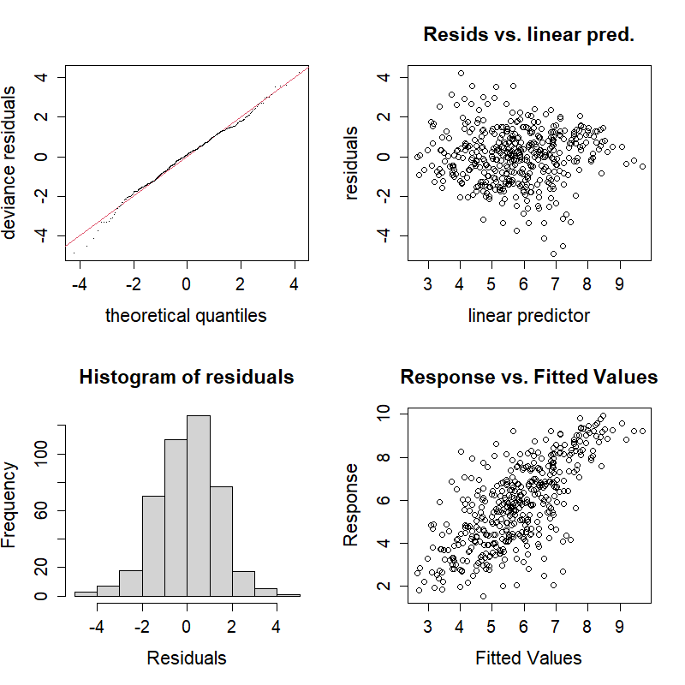
Supplementary Figure 5: Diagnostic plots assessing model assumptions and fit quality of the final model selected.
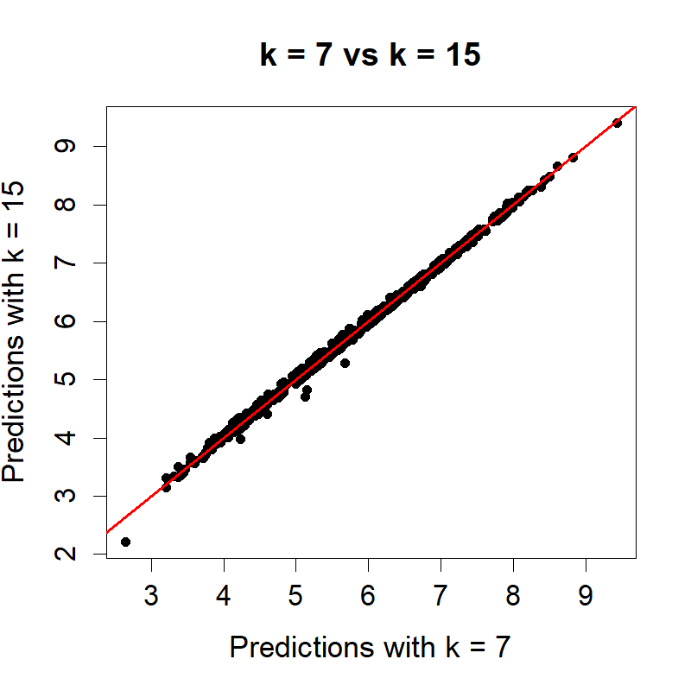
Supplementary Figure 6: Comparison of model predictions using smoothing parameter k=7 versus k=15, comparing the effects of smoother complexity on fitted values.

Supplementary Table 7: Full list of all built-up areas used in the study, ordered by their blue space ranking

Rank | Name | Blue Space (%)
1 | Great Yarmouth | 25.48586694
2 | Peterhead | 24.49671066
3 | Fleetwood | 20.78433437
4 | Staines-upon-Thames | 19.46306999
5 | Barrow-in-Furness | 19.01444975
6 | Canvey Island | 17.76226968
7 | Blyth (Northumberland) | 17.40723138
8 | Wallasey | 16.99610407
9 | Newquay | 15.96850418
10 | Penarth | 15.88002535
11 | Rhyl | 15.32099418
12 | Milford Haven | 14.68216967
13 | Felixstowe | 14.66983915
14 | Port Talbot | 14.53890545
15 | Gosport | 14.42062019
16 | Dover | 14.34854456
17 | Lytham St Anne's | 14.34126126
18 | Tower Hamlets | 14.17372061
19 | Portsmouth | 13.80131483
20 | Crosby (Sefton) | 13.45247152
21 | Workington | 12.82495355
22 | Maldon | 11.59429649
23 | Tilbury | 11.5519745
24 | Lancing and Sompting | 11.51140421
25 | Weymouth | 11.48045574
26 | Poole | 11.07825113
27 | Margate | 10.95093176
28 | Ramsgate | 10.87018681
29 | Lowestoft | 10.68194158
30 | Lee-on-the-Solent | 10.61974607
31 | Barry (Vale of Glamorgan) | 10.5992346
32 | Morecambe | 10.5759391
33 | Eastbourne | 10.49468903
34 | Chafford Hundred and West Thurrock | 10.14329082
35 | Whitstable | 10.02313025
36 | Ash and Ash Vale | 9.990952774
37 | Llanelli | 9.950528303
38 | Neath | 9.813931652
39 | Bognor Regis | 9.760734625
40 | Clydebank | 9.681878707
41 | Bexhill-on-Sea | 9.526133446
42 | Tynemouth | 9.425762161
43 | Newham | 9.335963097
44 | Irvine | 9.3142289
45 | Newport (Newport) | 9.271367863
46 | Exmouth | 9.152075767
47 | Dartford | 9.100355045
48 | Rustington | 9.081222278
49 | Swansea | 8.948127546
50 | Christchurch (Bournemouth, Christchurch and Poole) | 8.905421591
51 | Greenock | 8.790366565
52 | Broadstairs | 8.773670558
53 | Rochester | 8.654855389
54 | Southampton | 8.634078003
55 | Clacton-on-Sea | 8.602739015
56 | Southport | 8.557283971
57 | Aberdeen | 8.530063421
58 | Larkfield | 8.527887781
59 | Widnes | 8.512068588
60 | Renfrew | 8.482638181
61 | Colwyn Bay | 8.440931143
62 | Wath upon Dearne | 8.355945673
63 | Torquay | 8.325874287
64 | Redcar | 8.273230059
65 | Long Eaton | 8.272771823
66 | South Shields | 8.236207801
67 | Folkestone | 8.100692629
68 | Richmond upon Thames | 7.739024419
69 | Hartlepool | 7.728066301
70 | Prestwick | 7.646058171
71 | Ayr | 7.639389094
72 | Seaford | 7.541577652
73 | Blackpool | 7.53139012
74 | Hammersmith and Fulham | 7.500171328
75 | Sittingbourne | 7.380420951
76 | Runcorn | 7.352695076
77 | Arbroath | 7.319219883
78 | Skegness | 7.305552634
79 | Plymouth | 7.305304627
80 | Bridgwater | 7.263243603
81 | Hoddesdon | 7.231048353
82 | Inverness | 7.202204666
83 | Gravesend | 6.968619159
84 | Bridlington | 6.712972886
85 | Paignton | 6.677533806
86 | Kirkcaldy | 6.62333081
87 | Totton | 6.598401198
88 | Barnstaple | 6.589986443
89 | Aldershot | 6.473781472
90 | Whitley Bay | 6.470507227
91 | Hastings | 6.452872362
92 | Jarrow | 6.382356775
93 | Greenwich | 6.332692695
94 | City of Westminster | 6.306657139
95 | Southend-on-Sea | 6.270258199
96 | Grays | 6.250746621
97 | Barking and Dagenham | 6.207937703
98 | Whitehaven | 6.189676432
99 | Dundee | 6.167318285
100 | Rickmansworth | 5.925457453
101 | Worthing | 5.879130664
102 | Alloa | 5.863590901
103 | Southwark | 5.845105075
104 | West Molesey | 5.821456538
105 | Locks Heath | 5.785258049
106 | Kingston upon Hull | 5.779092612
107 | Birkenhead | 5.715301215
108 | Bexley | 5.71233824
109 | Maidenhead | 5.600406457
110 | Gillingham (Medway) | 5.556771747
111 | Caversham | 5.548220709
112 | Old Trafford | 5.513704791
113 | Sunderland | 5.50305181
114 | Brighton and Hove | 5.391759203
115 | Scarborough | 5.299371936
116 | Windsor | 5.299130819
117 | Doncaster | 5.293261381
118 | King's Lynn | 5.251483782
119 | Bebington | 5.198288831
120 | Lancaster | 5.184394353
121 | Grangemouth | 5.136474842
122 | Thornaby-on-Tees | 5.134419076
123 | Weston-super-Mare | 5.033447602
124 | Humberston and New Waltham | 5.006797546
125 | Castleford | 4.950299032
126 | Bournemouth | 4.918666443
127 | Wandsworth | 4.904877989
128 | Spalding | 4.900073239
129 | Reading | 4.891904298
130 | Billingham | 4.887767806
131 | Salford | 4.837336863
132 | Havant | 4.819093638
133 | Cardiff | 4.695993123
134 | Ashington (Northumberland) | 4.546671226
135 | Waltham Forest | 4.41390291
136 | Ellesmere Port | 4.409208252
137 | Chichester | 4.385618309
138 | Havering | 4.366836523
139 | Stirling | 4.366368249
140 | Perth | 4.278899227
141 | Boston | 4.273195546
142 | Gateshead | 4.204410866
143 | Farnborough | 4.004038947
144 | Winchester | 3.977144707
145 | Eccles (Salford) | 3.97278791
146 | Newbury | 3.882083565
147 | Hounslow | 3.869144019
148 | Abingdon-on-Thames | 3.842039077
149 | Kensington and Chelsea | 3.799121007
150 | Droitwich Spa | 3.766062416
151 | Preston (Preston) | 3.672811986
152 | Edinburgh | 3.669480212
153 | Falkirk | 3.653943538
154 | Newark-on-Trent | 3.653281552
155 | Denton (Tameside) | 3.637680787
156 | Newcastle upon Tyne | 3.617537686
157 | Liverpool | 3.600811311
158 | Lincoln | 3.596079765
159 | Bedford | 3.578053453
160 | St Neots | 3.522245026
161 | Hillingdon | 3.45054123
162 | Peterborough | 3.390591641
163 | Beeston (Broxtowe) | 3.38769797
164 | Evesham | 3.385652364
165 | Middlesbrough | 3.369501875
166 | Urmston | 3.369415343
167 | Gainsborough | 3.254612922
168 | Aberdare | 3.250354954
169 | Salisbury | 3.226363941
170 | Burton upon Trent | 3.220093212
171 | Fareham | 3.20779875
172 | Pontypridd | 3.189424773
173 | Truro | 3.176624644
174 | Chatham | 3.143394133
175 | Egham | 3.135284201
176 | Ilkeston | 3.129092224
177 | Hackney | 3.111708482
178 | Fleet | 3.106844435
179 | Eastleigh | 3.08084584
180 | Carlton (Gedling) | 3.062489052
181 | Norwich | 3.056885799
182 | Heswall | 3.026384143
183 | Paisley | 3.01729136
184 | Sevenoaks | 3.009932776
185 | Retford | 2.996791034
186 | Brierley Hill | 2.978847964
187 | Dumfries | 2.972083787
188 | Warrington | 2.844007282
189 | Bletchley | 2.809916307
190 | Northampton | 2.804673825
191 | Congleton | 2.772808425
192 | Formby | 2.771705707
193 | Leigh (Wigan) | 2.740475904
194 | Carlisle | 2.71201834
195 | Leighton Buzzard | 2.705373573
196 | Warwick | 2.699648715
197 | Wakefield | 2.681428231
198 | Milton Keynes | 2.675527292
199 | Shrewsbury | 2.668475612
200 | Lambeth | 2.655550021
201 | Tamworth | 2.653968902
202 | Dewsbury | 2.642587708
203 | Ipswich | 2.624793165
204 | Newport (Isle of Wight) | 2.608563478
205 | Cheshunt | 2.608083477
206 | Huntingdon | 2.56872196
207 | Tipton | 2.565813173
208 | Bury (Bury) | 2.480565782
209 | Chester | 2.427329361
210 | March | 2.414148924
211 | Stafford | 2.406486689
212 | Exeter | 2.405220787
213 | Rugeley | 2.397800095
214 | Bedworth | 2.392894485
215 | Bloxwich | 2.367259059
216 | Thetford | 2.363393959
217 | Enfield | 2.359003475
218 | Larbert and Stenhousemuir | 2.344999104
219 | Stockton-on-Tees | 2.344734632
220 | Wigan | 2.342768139
221 | Oxford | 2.341638652
222 | Rotherham | 2.327093492
223 | West Bridgford | 2.324636656
224 | Glasgow | 2.317860685
225 | York | 2.309664918
226 | Sale | 2.296221866
227 | Wisbech | 2.287862104
228 | Sudbury | 2.239806962
229 | Worcester | 2.139195566
230 | Royal Leamington Spa | 2.118671171
231 | Rowley Regis | 2.115426226
232 | Canterbury | 2.104121685
233 | Wellingborough | 2.100114922
234 | Normanton (Wakefield) | 2.088482241
235 | Bilston (Wolverhampton) | 2.076576938
236 | West Bromwich | 2.068513241
237 | Kirkintilloch | 2.054730459
238 | Winsford | 2.049365633
239 | Cambridge (Cambridge) | 2.041875858
240 | Byfleet | 2.015988944
241 | Tonbridge | 2.009501547
242 | Kendal | 1.973325996
243 | Stratford-upon-Avon | 1.973289168
244 | Hertford | 1.970821394
245 | Ascot | 1.962888875
246 | Hereford | 1.959720171
247 | Newton Abbot | 1.915396088
248 | Camberley | 1.896514395
249 | Hamilton | 1.888442627
250 | Daventry | 1.876894121
251 | Witney | 1.862698567
252 | Bristol | 1.85837194
253 | Heanor | 1.858207511
254 | Cambuslang | 1.838509248
255 | Bolton (Bolton) | 1.833015858
256 | Brighouse | 1.786231199
257 | Slough | 1.779137413
258 | Kettering | 1.749901703
259 | Haringey | 1.749513249
260 | Andover | 1.738571115
261 | Kingswinford | 1.73592501
262 | Banbury | 1.725491493
263 | Durham | 1.71773106
264 | Loughborough | 1.716175666
265 | Rushden | 1.715847944
266 | Bridgend | 1.715486439
267 | Aylesbury | 1.706970888
268 | St Helens (St. Helens) | 1.699159649
269 | Keighley | 1.680131272
270 | Knowle and Dorridge | 1.665081756
271 | Kingston upon Thames | 1.649758504
272 | Dudley (Dudley) | 1.635986235
273 | Scunthorpe | 1.62154081
274 | Thundersley and South Benfleet | 1.605756901
275 | Woking | 1.594332504
276 | Rugby | 1.588733764
277 | Swindon (Swindon) | 1.584572513
278 | Ashford (Ashford) | 1.580987201
279 | St Austell | 1.578521049
280 | Horwich | 1.57207182
281 | Maidstone | 1.564674511
282 | Wokingham | 1.561967193
283 | Blackburn (Blackburn with Darwen) | 1.546221621
284 | Ashton-under-Lyne | 1.536163593
285 | Halifax | 1.520860646
286 | Stanford-le-Hope | 1.51798847
287 | Middleton (Rochdale) | 1.465833376
288 | Chester-le-Street | 1.454652813
289 | Huddersfield | 1.452995767
290 | Rawtenstall | 1.450029444
291 | New Haw, West Byfleet and Sheerwater | 1.446038156
292 | Birmingham | 1.441778812
293 | Nottingham | 1.423597173
294 | Watford (Watford) | 1.423373532
295 | Bathgate | 1.419927518
296 | Solihull | 1.415233342
297 | Bamber Bridge | 1.4070205
298 | Smethwick | 1.404386874
299 | Nuneaton | 1.396943717
300 | Melton Mowbray | 1.396935819
301 | Gloucester | 1.389112344
302 | Coventry | 1.386389066
303 | Derby | 1.385556489
304 | Hyde (Tameside) | 1.366304146
305 | Hemel Hempstead | 1.364697665
306 | Manchester | 1.362185173
307 | Guildford | 1.359085385
308 | Willenhall | 1.358752921
309 | Redhill (Reigate and Banstead) | 1.357490402
310 | Sutton in Ashfield | 1.342989394
311 | Mildenhall (West Suffolk) | 1.341032131
312 | Colchester | 1.329273738
313 | Burnley | 1.32850201
314 | Chorley | 1.322315042
315 | Bicester | 1.321488685
316 | Walsall | 1.319450643
317 | Telford | 1.311257848
318 | Basildon | 1.306241345
319 | Lewisham | 1.303303671
320 | Chelmsford | 1.293624741
321 | Bearsden | 1.288088597
322 | Elgin | 1.284253779
323 | Caerphilly | 1.276064957
324 | Worksop | 1.270254923
325 | Taunton | 1.269699936
326 | Farnham | 1.25150423
327 | East Kilbride | 1.244060229
328 | Heywood | 1.241701549
329 | Cumbernauld | 1.232733398
330 | Little Hulton | 1.230107309
331 | Redbridge | 1.223603785
332 | Kenilworth | 1.220801174
333 | Wilmslow | 1.21159361
334 | Bath | 1.210748299
335 | Stoke-on-Trent | 1.205330174
336 | Kidderminster | 1.204234332
337 | Oldbury (Sandwell) | 1.200882459
338 | Merthyr Tydfil | 1.192237703
339 | Horley (Reigate and Banstead) | 1.187320448
340 | Reigate | 1.171483525
341 | Leeds | 1.162859746
342 | Washington | 1.151979113
343 | Motherwell | 1.147530186
344 | Harlow | 1.140779885
345 | Mansfield | 1.131286371
346 | Ealing | 1.123467898
347 | Corby | 1.119364584
348 | Hinckley | 1.113784765
349 | Airdrie | 1.10944464
350 | Cannock | 1.101452077
351 | Royal Sutton Coldfield | 1.099787324
352 | Chesterfield | 1.08939095
353 | Leicester | 1.08361217
354 | Stockport | 1.074827996
355 | Stowmarket | 1.073611901
356 | Bootle (Sefton) | 1.052593514
357 | Market Harborough | 1.033883745
358 | Rochdale | 1.032589177
359 | Stratton St Margaret | 1.023388227
360 | Camden | 1.016017631
361 | Ripley (Amber Valley) | 1.015211169
362 | Livingston | 0.998071477
363 | Barnsley | 0.995999041
364 | Bury St Edmunds | 0.994574426
365 | Kilmarnock | 0.982788779
366 | Darlington | 0.982097694
367 | Coatbridge | 0.973909725
368 | Ebbw Vale | 0.971339859
369 | Cobham (Elmbridge) | 0.97076212
370 | Sutton (Sutton) | 0.962857195
371 | Witham | 0.962424528
372 | Macclesfield | 0.960721022
373 | Bishop's Stortford | 0.959266079
374 | Amersham | 0.957413039
375 | Brent | 0.957335896
376 | Bracknell | 0.955079384
377 | Swadlincote | 0.948854601
378 | Crawley (Crawley) | 0.938236792
379 | Wishaw | 0.936921996
380 | Horsham | 0.921707909
381 | CwmbrÃ¢n | 0.912947592
382 | Redditch | 0.911846381
383 | Yate | 0.910957294
384 | Stroud | 0.904884932
385 | Chippenham (Wiltshire) | 0.901299374
386 | Sheffield | 0.879464001
387 | Merton | 0.878959897
388 | Pontypool | 0.875960531
389 | Accrington | 0.875844844
390 | Altrincham | 0.865431227
391 | Wolverhampton | 0.860580129
392 | Great Bookham and Fetcham | 0.842684519
393 | Braintree | 0.82403801
394 | Bishop Auckland | 0.810139653
395 | Welwyn Garden City | 0.805359763
396 | Chadderton | 0.801230554
397 | Hucknall | 0.797670216
398 | High Wycombe | 0.788256282
399 | Grimsby | 0.78001373
400 | Lichfield | 0.776668669
401 | Haslemere | 0.771504526
402 | Darwen | 0.769999664
403 | Frome | 0.7610012
404 | Golborne | 0.759973254
405 | Wigston | 0.759825961
406 | Fulwood | 0.758683914
407 | Bellshill | 0.756147671
408 | Beverley | 0.74922081
409 | Trowbridge | 0.738864871
410 | Basingstoke | 0.730712264
411 | Burntwood | 0.728837457
412 | Immingham | 0.721460599
413 | Hale (Trafford) | 0.718171958
414 | Burgess Hill | 0.711643882
415 | Dereham | 0.699446116
416 | Stourbridge | 0.688701739
417 | Rayleigh | 0.68209838
418 | Wrexham | 0.68175045
419 | Chandler's Ford | 0.675764208
420 | Dunstable | 0.663013481
421 | Hitchin | 0.649970708
422 | Kingswood and Fishponds | 0.646038075
423 | Wythenshawe | 0.645546098
424 | Brentwood | 0.640834666
425 | Glenrothes | 0.636523858
426 | Didcot | 0.631016263
427 | Dunfermline | 0.617723087
428 | Loughton | 0.600005773
429 | Bradford | 0.59264914
430 | Ashton-in-Makerfield | 0.586695238
431 | Halesowen | 0.574335496
432 | Waterlooville | 0.570634739
433 | Barnet | 0.56212928
434 | Crewe | 0.555844169
435 | Leyland | 0.555113819
436 | Newton Mearns | 0.553341204
437 | St Albans | 0.548411056
438 | Chorleywood | 0.54518297
439 | Holbury | 0.531687354
440 | Kirkby | 0.530681335
441 | Ewell | 0.525375447
442 | Bromsgrove | 0.505485733
443 | Newcastle-under-Lyme | 0.485457636
444 | Billericay | 0.478241001
445 | Cheltenham | 0.47657587
446 | Royal Tunbridge Wells | 0.463454024
447 | Grantham | 0.460205512
448 | East Grinstead | 0.45940788
449 | Catterick Garrison | 0.459328304
450 | Carterton | 0.449713562
451 | Wallsend | 0.44619719
452 | Haverhill | 0.438939051
453 | Newton Aycliffe | 0.431686788
454 | Coalville | 0.429502838
455 | Prescot | 0.418868055
456 | Cramlington | 0.416586371
457 | Stevenage | 0.412008703
458 | Bromley | 0.392539691
459 | Beaconsfield | 0.391101701
460 | Yeovil | 0.383574675
461 | Bushey | 0.366349572
462 | Huyton with Roby | 0.365084932
463 | Islington | 0.362949441
464 | Epsom | 0.35221594
465 | Harrow | 0.344670125
466 | Pontefract | 0.338230356
467 | Wickersley and Bramley | 0.331880662
468 | Consett | 0.331320758
469 | Haywards Heath | 0.322857281
470 | Peterlee | 0.316387135
471 | Crowborough | 0.312004072
472 | Harrogate | 0.290687433
473 | Pudsey | 0.287875048
474 | Oldham | 0.270031644
475 | Hatfield | 0.266066467
476 | Skelmersdale | 0.25711455
477 | Ormskirk | 0.246320389
478 | Batley | 0.238852758
479 | Borehamwood | 0.237576443
480 | Horndean | 0.233924002
481 | Harpenden | 0.228886921
482 | Arnold | 0.222968348
483 | Willerby and Anlaby | 0.212139399
484 | Morley (Leeds) | 0.204166475
485 | Luton | 0.203810158
486 | Great Malvern | 0.198036858
487 | Sedgley | 0.194006373
488 | Longbenton | 0.192746248
489 | Letchworth | 0.158970426
490 | Tadworth and Epsom Downs | 0.13720395
491 | Eston | 0.125829474
492 | Croydon | 0.113732255
493 | Caterham | 0.077504124
494 | Newmarket | 0.075662736
495 | Hazlemere | 0.055563727

