Supplemental Materials
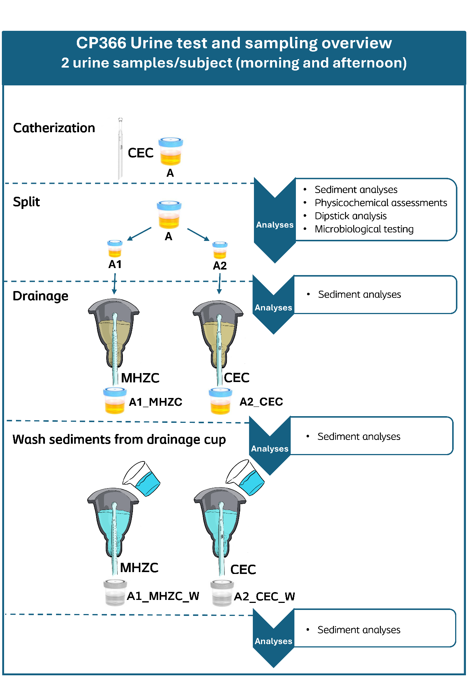
Figure S1. Urine sample processing pipeline and applied analyses at each stage of processing. MHZC = Micro-hole zone catheter. CEC = Conventional Eyelet Catheter.
Urinary dipstick tests | Group A (n=22) | Group B (n=22) | Group C (n=18) | Group D (n=44)
Protein, n (%)
>= 300 mg/dL | 0 (0) | 0 (0) | 0 (0) | 1 (2.3)
100 mg/dL | 0 (0) | 0 (0) | 0 (0) | 3 (6.8)
30 mg/dL | 2 (9.1) | 0 (0) | 0 (0) | 0 (0)
Negative | 19 (86.4) | 22 (100) | 17 (94.4) | 38 (86.4)
Trace | 1 (4.5) | 0 (0) | 1 (5.6) | 2 (4.5)
Blood, n (%)*
Level 1 | 12 (54.4) | 19 (86.4) | 15 (83.3) | 24 (54.5)
Level 2 | 8 (36.4) | 1 (4.5) | 1 (5.6) | 6 (13.6)
Level 3 | 0 (0) | 1 (4.5) | 1 (5.6) | 2 (4.5)
Level 4 | 0 (0) | 0 (0) | 0 (0) | 0 (0)
Level 5 | 2 (9.1) | 1 (4.5) | 1 (5.6) | 3 (6.8)
Level 6 | 0 (0) | 0 (0) | 0 (0) | 4 (9.1)
Level 7 | 0 (0) | 0 (0) | 0 (0) | 5 (11.4)
Leukocytes, n (%)
0 | 14 (63.6) | 14 (63.6) | 10 (55.6) | 9 (20.5)
1+ | 0 (0.0) | 3 (13.6) | 4 (22.2) | 10 (22.7)
2+ | 6 (27.3) | 4 (18.2) | 2 (11.1) | 9 (20.5)
3+ | 0 (0.0) | 1 (4.5) | 2 (11.1) | 9 (20.5)
4+ | 2 (9.1) | 0 (0.0) | 0 (0.0) | 7 (15.9)
Nitrites, n (%)
Positive | 5 (22.7) | 0 (0.0) | 3 (16.7) | 7 (15.9)
Negative | 17 (77.3) | 22 (100) | 15 (83.3) | 37 (84.1)
Glucose, n (%)
100 mg/dL | 3 (13.6) | 0 (0.0) | 0 (0.0) | 1 (2.3)
500 mg/dL | 1 (4.5) | 0 (0.0) | 0 (0.0) | 0 (0.0)
>=1000 mg/dL | 2 (9.1) | 0 (0.0) | 0 (0.0) | 2 (4.5)
Negative | 16 (72.7) | 22 (100) | 18 (100) | 41 (93.2)
Ketones, n (%)
15 mg/dL | 1 (4.5) | 0 (0.0) | 0 (0.0) | 2 (4.5)
40 mg/dL | 1 (4.5) | 0 (0.0) | 0 (0.0) | 0 (0.0)
Negative | 20 (90.9) | 22 (100) | 18 (100) | 42 (95.5)
Bilirubin, n (%)
Positive | 0 (0.0) | 0 (0.0) | 0 (0.0) | 0 (0.0)
Negative | 22 (100) | 22 (100) | 18 (100) | 44 (100)
Urobilinogen, n (%)
0.2 mg/dL | 21 (95.5) | 22 (100) | 18 (100) | 43 (97.7)
1.0 mg/dL | 1 (4.5) | 0 (0.0) | 0 (0.0) | 1 (2.3)
Specific Gravity, n (%)
<= 1.005 | 1 (4.5) | 3 (13.6) | 0 (0.0) | 0 (0.0)
1.010 | 3 (13.6) | 4 (18.2) | 5 (27.8) | 17 (38.6)
1.015 | 6 (27.3) | 8 (36.4) | 8 (44.4) | 10 (22.7)
1.020 | 7 (31.8) | 4 (18.2) | 3 (16.7) | 7 (15.9)
1.025 | 3 (13.6) | 2 (9.1) | 2 (11.1) | 5 (11.4)
>= 1.030 | 2 (9.1) | 1 (4.5) | 0 (0.0) | 5 (11.4)
pH
Mean (SD) | 6.0 (0.7) | 6.4 (0.9) | 6.4 (0.8) | 5.9 (0.7)

Table S1: *Explanation of hematuria levels: Level 1: 0 erythrocytes/mL (non-hemolyzed), Level 2: 10 erythrocytes/mL (non-hemolyzed), Level 3: 80 erythrocytes/mL (non-hemolyzed), Level 4: 10 erythrocytes/mL (hemolyzed), Level 5: 25 erythrocytes/mL (hemolyzed), Level 6: 80 erythrocytes/mL (hemolyzed), Level 7: 200 erythrocytes/mL (hemolyzed). The specified number of samples (n) includes both samples that were collected from each subject.

Figure S2: Examples of large particles (range 400-661 μm) identified as sediment and segmented by the sediment analysis as a single compound. Overlayed images in red frames indicate how the particles in the corresponding image were segmented into separate compounds. Figures 5a-e were found in the freshly drained urine samples (sample A). Figures 5f+g were found in the aliquots which had been passed through a MHZC (A1_MHZC).

