Methylene Blue as a Redox Additive in Electrolytes for Advanced Charcoal-Based Hybrid Supercapacitors

Van Nhat Nguyen ª, An-Giang Nguyen ^{a b}, Thi Viet Bac Phung ^{a b}, Phi Long Nguyen ^{b c}*

ª Center for Environmental Intelligence, VinUniversity, Hanoi 100000, Vietnam.
^{b} College of Engineering & Computer Science, VinUniversity, Hanoi 100000, Vietnam.
^{c} School of Electrical and Electronic Engineering, Hanoi University of Industry, Hanoi 100000, Vietnam.

*Corresponding author: Phi Long Nguyen; E-mail: long.np2@vinuni.edu.vn

Table S1.
Scan rate  (mV s^{–1}) | Specific capacitance (F g^{–1})
Scan rate  (mV s^{–1}) | MB0 | MB5 | MB10 | MB35 | MB60
5 | 83.62 | 161.98 | 157.34 | 274.57 | 348.15
10 | 77.55 | 133.64 | 129.56 | 217.66 | 255.80
20 | 71.40 | 112.37 | 110.87 | 167.84 | 185.89
40 | 63.41 | 93.32 | 93.86 | 127.08 | 133.92
60 | 56.87 | 80.13 | 83.71 | 105.28 | 109.81
80 | 51.36 | 69.30 | 74.25 | 89.99 | 95.30
100 | 46.45 | 60.55 | 66.67 | 75.51 | 83.50

Table S2.
Specific current  (A g^{–1}) | Specific capacitance (F g^{–1})
Specific current  (A g^{–1}) | MB0 | MB5 | MB10 | MB35 | MB60
0.5 | 83.59 | 142.26 | 177.05 | 288.08 | 371.45
1 | 76.90 | 126.19 | 149.90 | 232.79 | 201.56
2 | 67.16 | 111.83 | 131.19 | 187.08 | 113.81
3 | 59.20 | 101.90 | 118.99 | 159.07 | 81.22
4 | 51.84 | 93.61 | 108.66 | 138.67 | 63.38
5 | 45.27 | 86.82 | 101.34 | 123.10 | 63.28
6 | 39.52 | 80.98 | 94.14 | 109.84 | 53.55
7 | 34.24 | 78.71 | 88.64 | 99.68 | 46.48
8 | 30.43 | 66.87 | 84.33 | 90.35 | 41.27
9 | 27.36 | 66.46 | 82.53 | 82.48 | 37.75
10 | 24.25 | 78.07 | 88.87 | 71.62 | 36.45

Table S3.
Scan rate  (mV s^{–1}) | Specific capacitance (F g^{–1})
Scan rate  (mV s^{–1}) | MB0 | MB5 | MB10 | MB35 | MB60
5 | 110.48 | 123.95 | 134.92 | 292.74 | 317.27
10 | 94.51 | 99.16 | 116.00 | 298.93 | 272.37
20 | 72.16 | 82.08 | 99.02 | 227.40 | 227.77
40 | 50.31 | 66.81 | 81.53 | 174.47 | 186.56
60 | 39.66 | 57.78 | 71.11 | 147.30 | 162.68
80 | 33.43 | 51.05 | 63.81 | 129.14 | 146.50
100 | 29.17 | 45.92 | 58.28 | 115.32 | 134.93

Table S4.
Specific current  (A g^{–1}) | Specific capacitance (F g^{–1})
Specific current  (A g^{–1}) | MB0 | MB5 | MB10 | MB35 | MB60
0.5 | 54.29 | 82.33 | 104.43 | 212.23 | 289.14
1 | 33.62 | 57.14 | 77.90 | 165.62 | 254.61
2 | 18.67 | 32.38 | 52.19 | 139.27 | 187.43
3 | 13.14 | 22.29 | 39.14 | 126.06 | 158.86
4 | 9.52 | 16.38 | 31.24 | 112.86 | 138.67
5 | 7.62 | 12.38 | 26.19 | 101.76 | 122.38
6 | 6.29 | 9.71 | 22.86 | 93.14 | 108.57
7 | 5.33 | 8.00 | 20.00 | 82.67 | 95.33
8 | 4.57 | 6.10 | 17.52 | 73.90 | 83.81
9 | 3.43 | 4.29 | 15.43 | 66.00 | 73.71
10 | 1.90 | 2.86 | 13.33 | 59.05 | 66.67

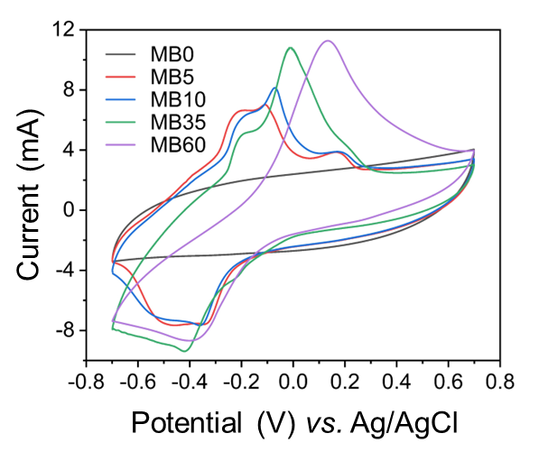

Fig. S1. Comparison of CV curves of all samples at a scan rate of 100 mV s^{–1} in the three-electrode system.

