Graphic abstract
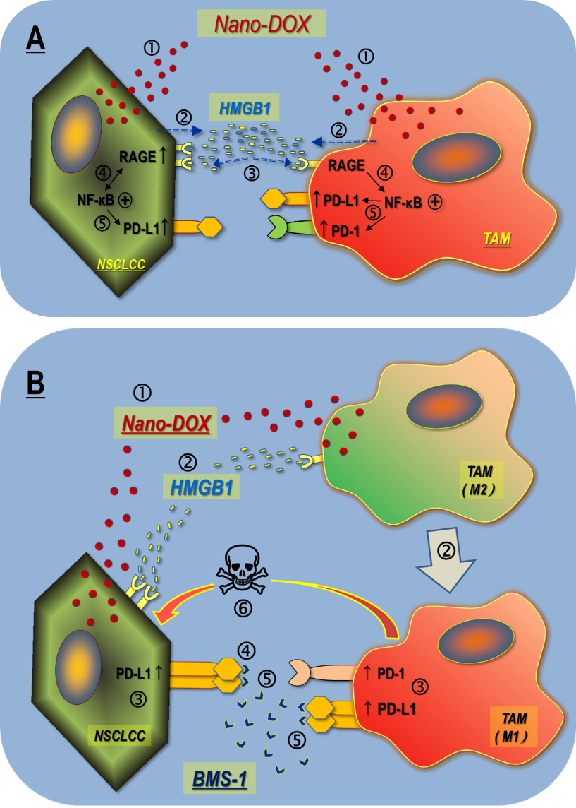
A: Nano-DOX induce PD-L1 and PD-1 in the tumor cell-macrophage interaction through autocrine and paracrine activation of the HMGB1/RAGE/NF-κB pathway. &: Nano-DOX stimulates HMGB1 release from the NSCLCC & TAM. &: HMGB1 binds with RGAE to activate NF-κB in the NSCLCC & TAM. NF-κB activation also upregulates RAGE in the NSCLCC. : Activated NF-κB upregulates PD-L1 in the NSCLCC. Activated NF-κB upregulates PD-L1 & PD-1 in the TAM.
B: PD-L1 blocker BMS-1 enhances Nano-DOX-stimulated M1-like activation (anti-tumor phenotype) of TAM via blocking PD-L1 induced by Nano-DOX in the lung cancer cells (NSCLC) and TAM. : Nano-DOX stimulates HMGB1 release from the NSCLCC & TAM. : HMGB1 bind with RAGE in the NSCLCC and TAM. TAM are repolarized to M1-like phenotype. : PD-L1 are upregulated in the NSCLCC. Both PD-L1 and PD-1 are upregulated in the TAM. : BMS-1 blocks PD-L1 in the NSCLCC leading to growth suppression. : BMS-1 prevents NSCLCC PD-L1 from binding with TAM PD-1 and blocks PD-L1 in the TAM, thus enhancing M1-like TAM activation. : M1-like TAM suppress NSCLCC growth and induce apoptosis.

