Supplement materials

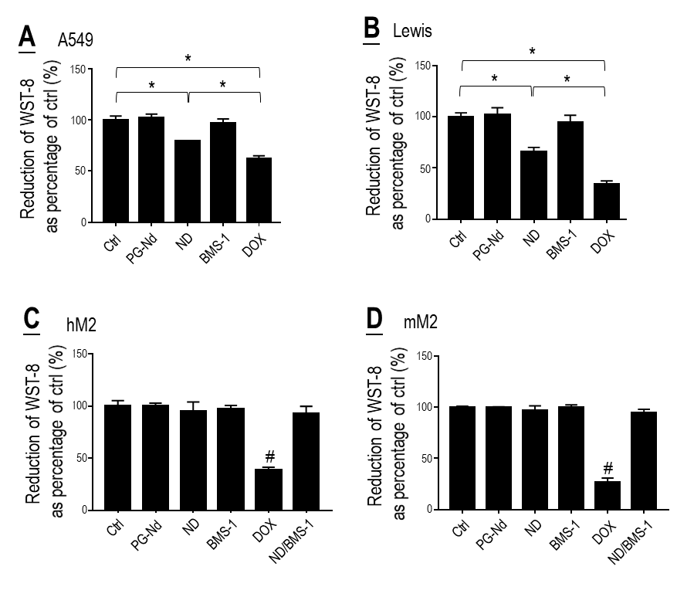
Fig. S1. Effects of polyglycerol-coated nanodiamonds (PG-Nd), Nano-DOX (ND), BMS-1 and doxorubicin (DOX) on viability of lung cancer cells (A, B) and TAM models (C, D). Drug concentration was 2 μg/mL for DOX and Nano-DOX, 24 μg/mL for PG-Nd and 1μM for BMS-1. Treatment duration was 24 hr. Values are means ± SD (n = 3, *p < 0.05; #p < 0.05, compared with all other groups.)

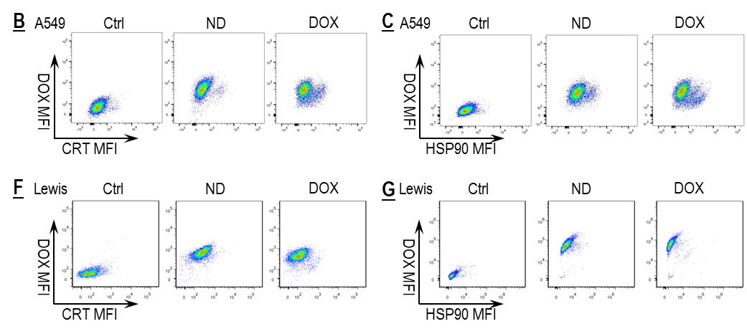
Fig. S2. Representative FACS dot plots for data presented in Fig. S2 B, C, F and G.

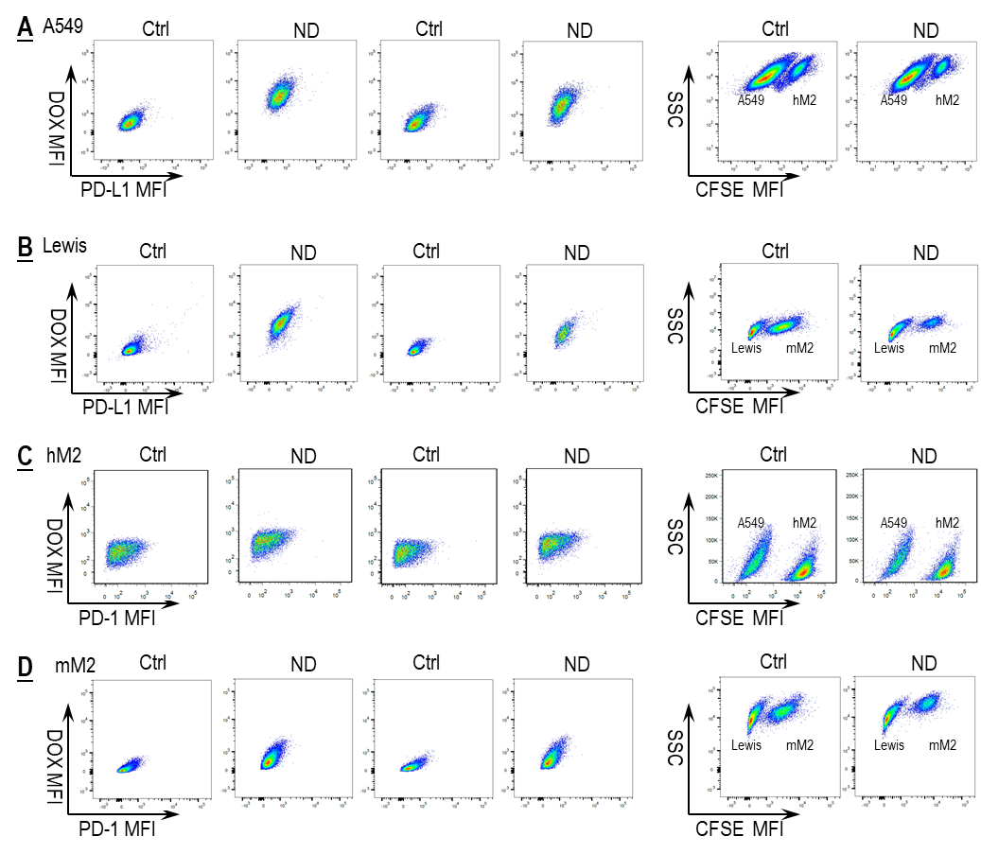
Fig. S3. A-D: Representative FACS dot plots for data presented in Fig. 3 A-D.
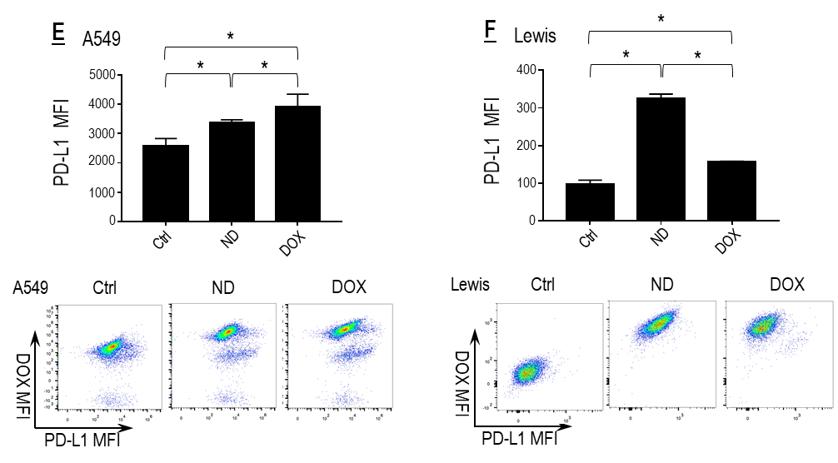
Fig. S3. E, F: Nano-DOX and DOX induced PD-L1 in the NSCLC cells. Cell surface PD-L1 was assayed by FACS analysis of immunofluorescent staining. FACS histogram geometric means were used to quantify mean fluorescence intensity (MFI). Geometric means were used to quantify mean fluorescence intensity (MFI). Values were means ± SD (n = 3, *p < 0.05). Drug concentration was 2 μg/mL for DOX and Nano-DOX. Treatment duration was 24 hr.

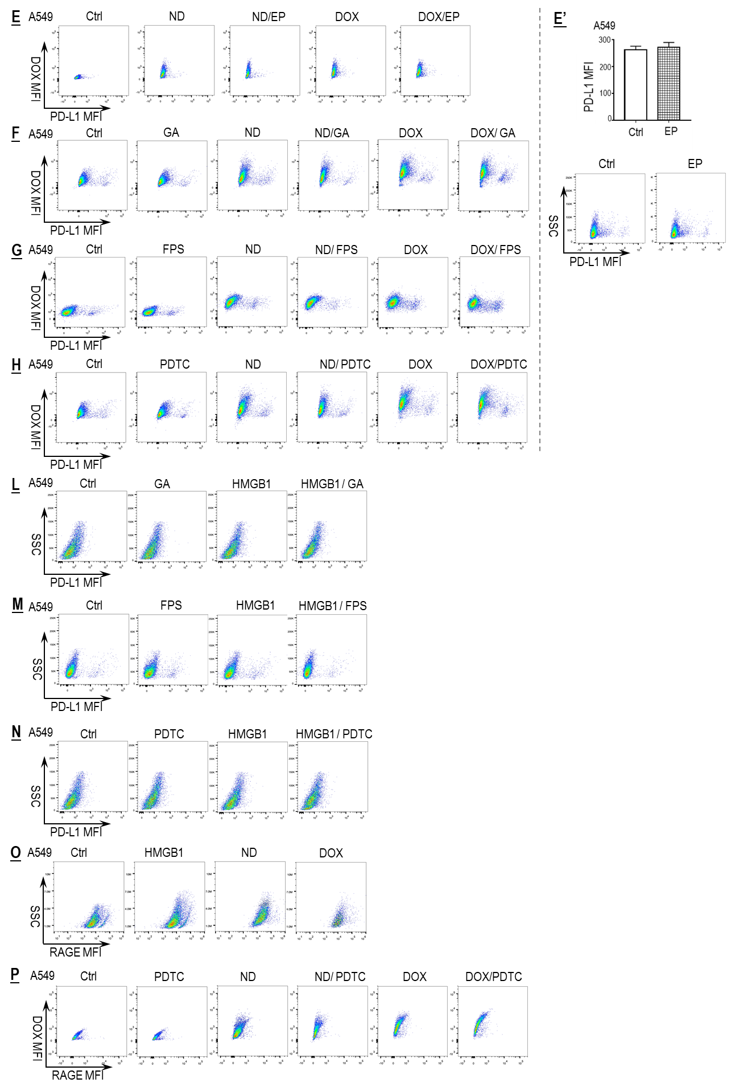
Fig. S4. Representative FACS dot plots for data presented in Fig. 4 E-H and L-P. E’ shows the effect of EP on the expression of PD-L1 in the A549 cells.
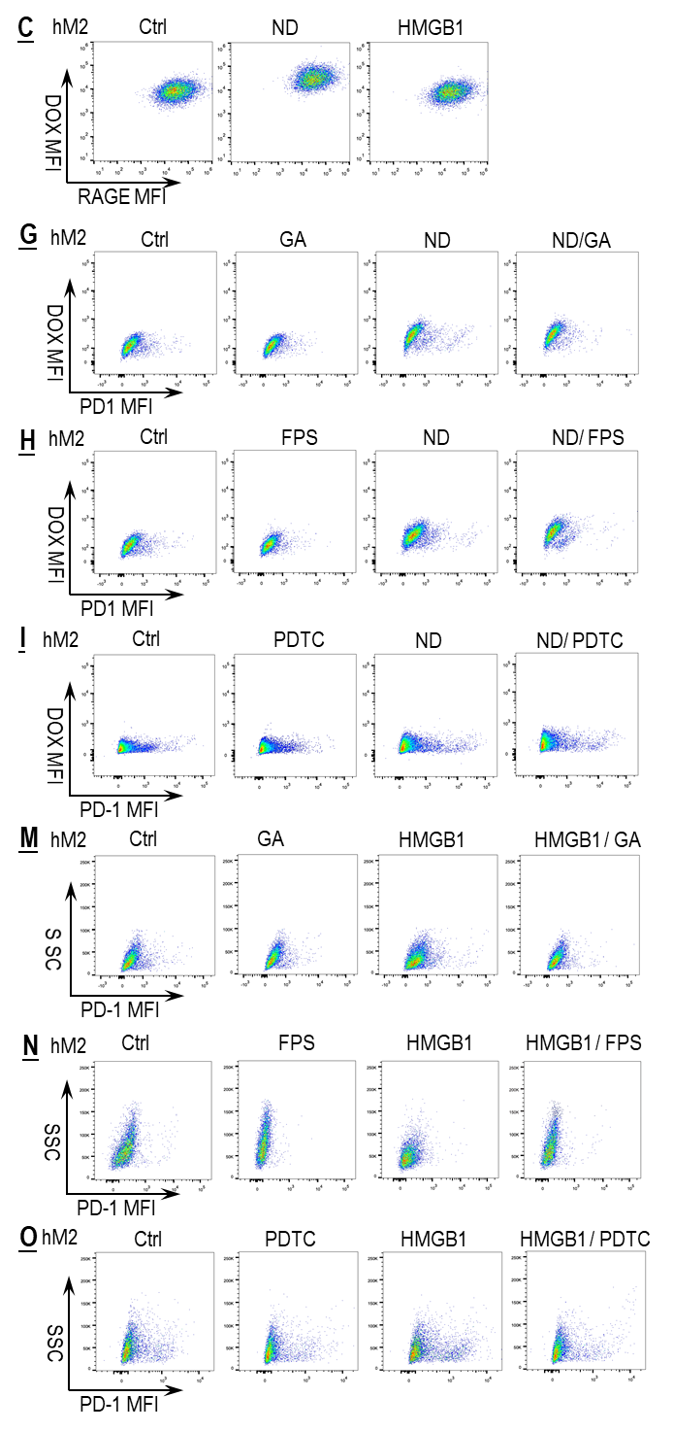
Fig. S5. Representative FACS dot plots for data in Fig. 5 C, G-I and M-O.
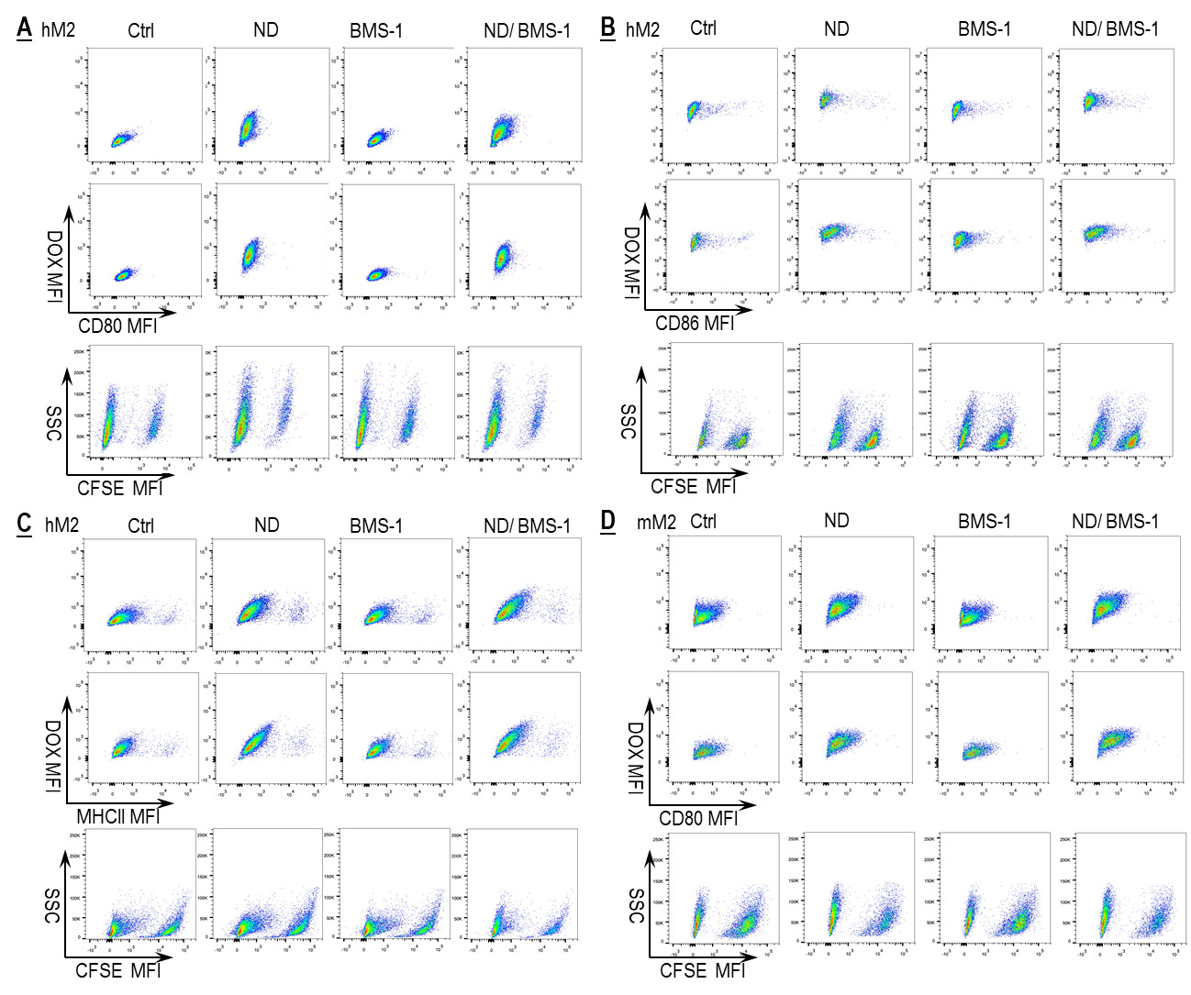
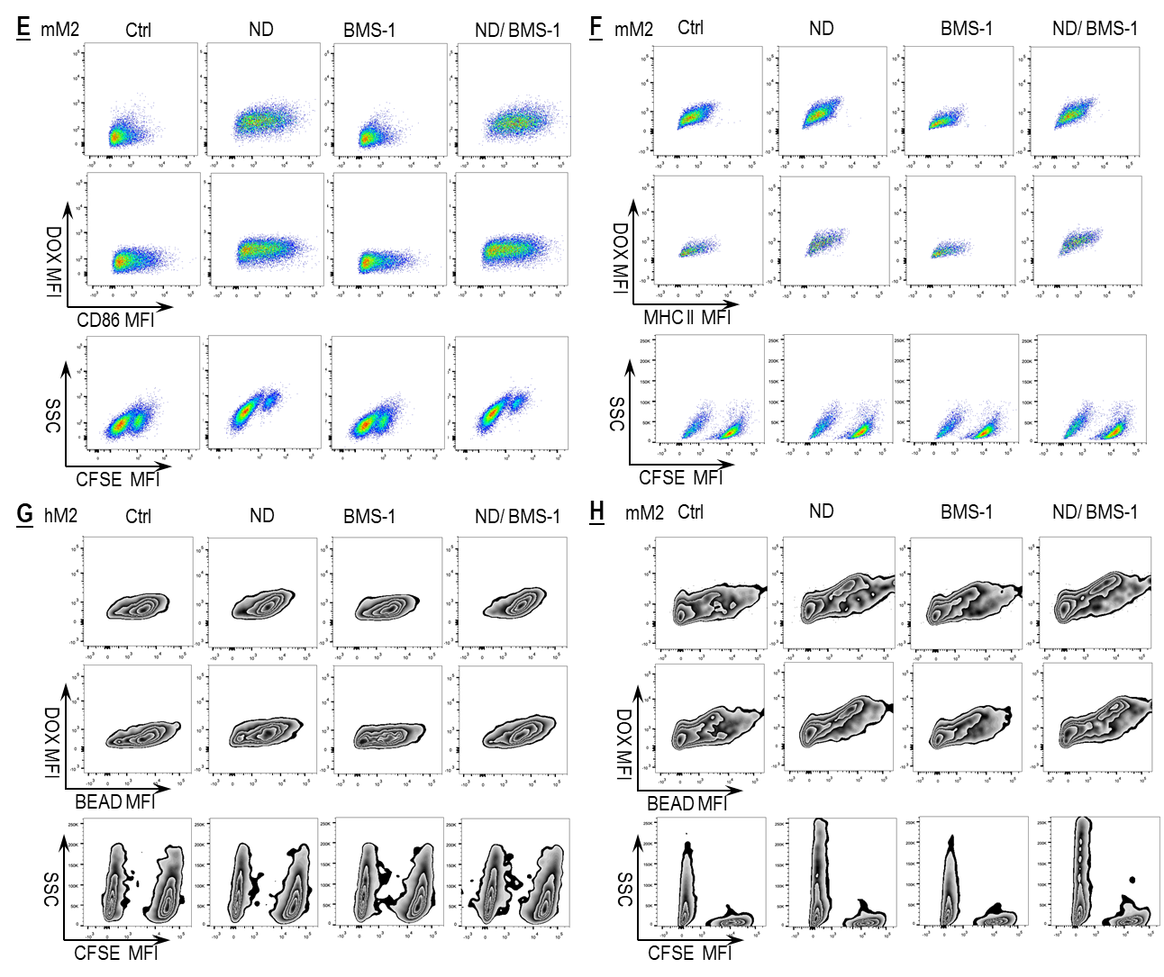
Fig. S6 A-H. Representative FACS dot/zebra plots for data in Fig. 6 A-H.
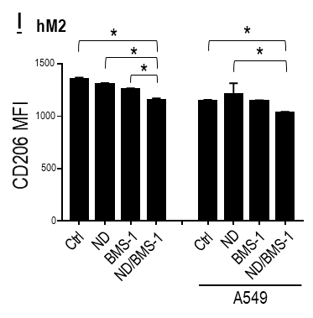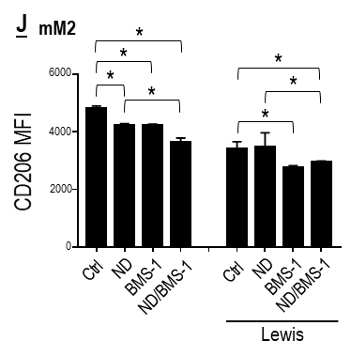
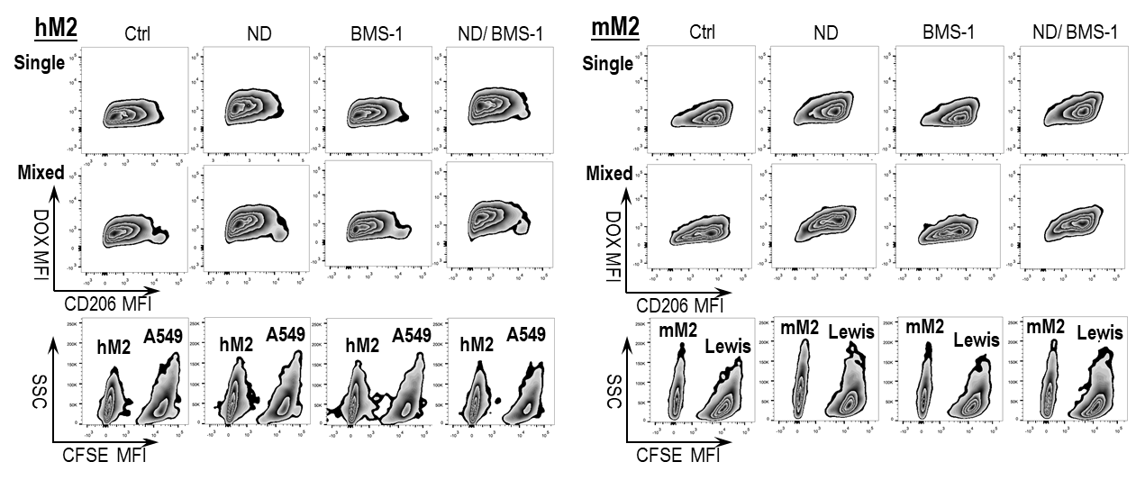
Fig. S6 I, J: BMS-1 and Nano-DOX synergistically downregulated surface CD206 in hM2 and mM2. Cell surface CD206 was assayed by FACS analysis of immunofluorescent staining. FACS histogram geometric means were used to quantify mean fluorescence intensity (MFI). Values were means ± SD (n = 3, *p < 0.05). Drug concentration was 2 μg/mL for DOX and Nano-DOX. Treatment duration was 24 hr.

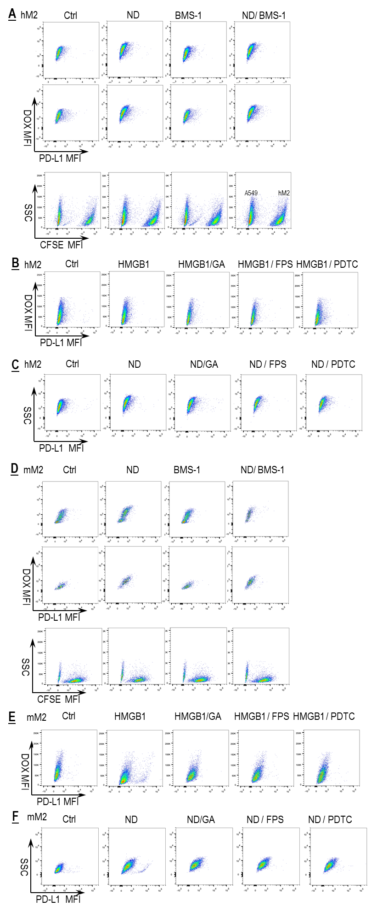
Fig. S7. Representative FACS dot plots for data in Fig. 7 A-F.
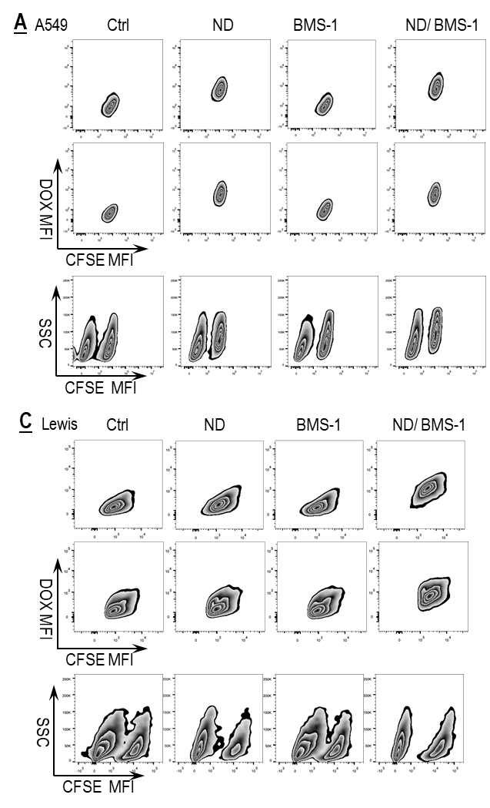
Fig. S8. Representative FACS zebra plots for data in Fig. 8 A-D.
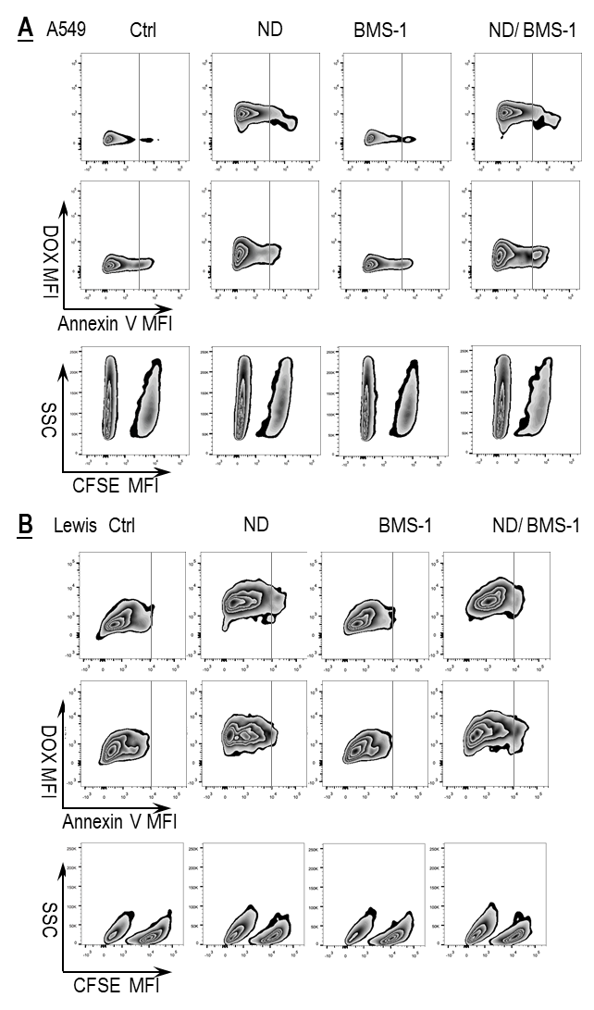
Fig. S9. Representative FACS zebra plots for data in Fig. 9 A and B.
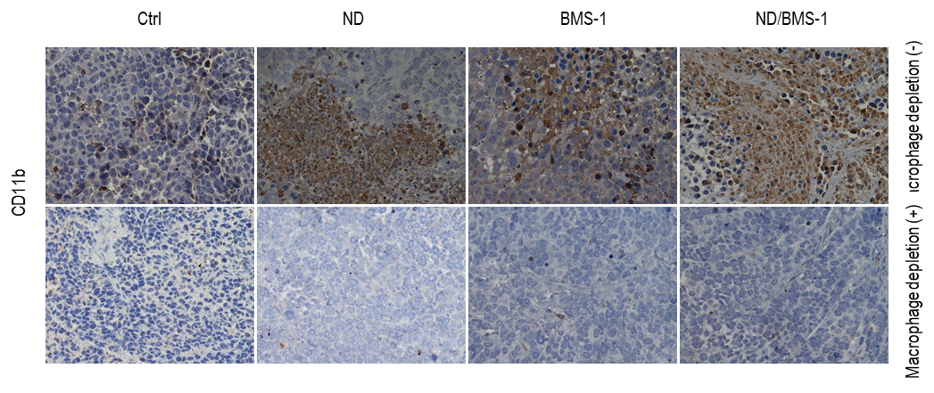
Fig. S10. Macrophage depletion in the tumors confirmed by IHC analysis of macrophage surface marker CD11b.

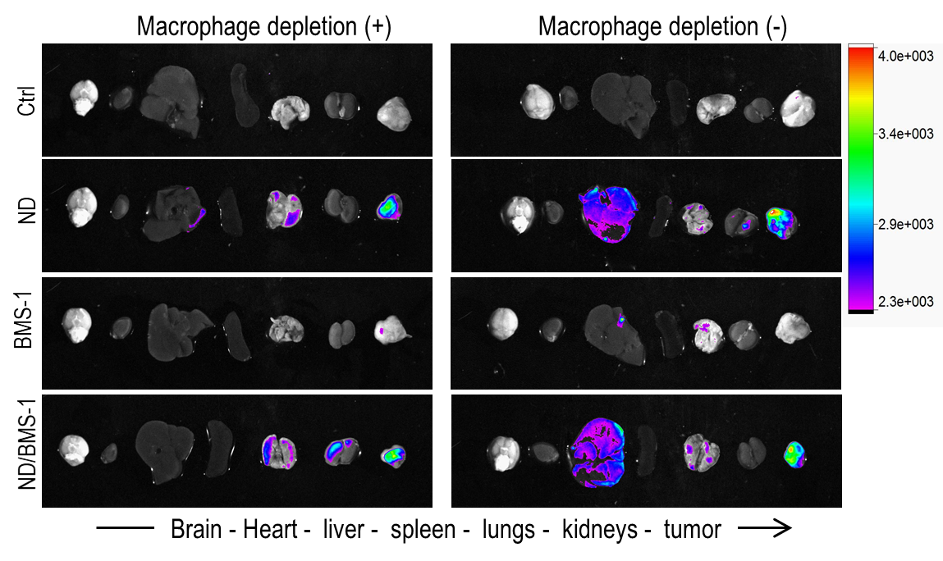
Fig. S11. Ex vivo imaging showing drug fluorescence in tumor xenografts and vital organs. ND: Nano-DOX.
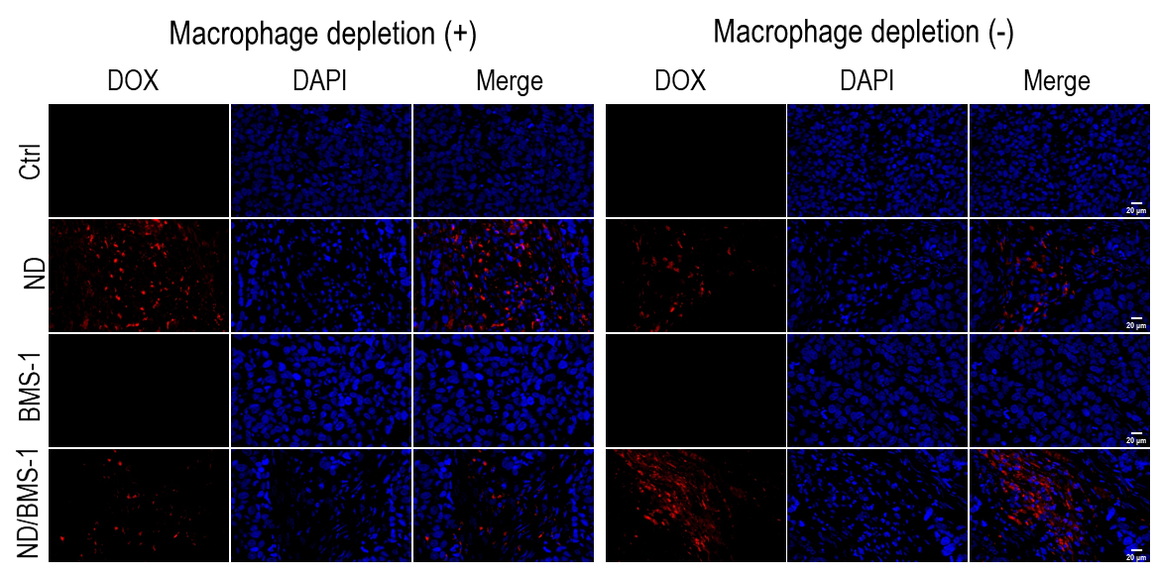
Fig. S12. Fluorescent imaging of tumor shows the presence of Nano-DOX. Blue fluorescence is nuclear staining of DAPI. Red fluorescence comes from Nano-DOX (ND).
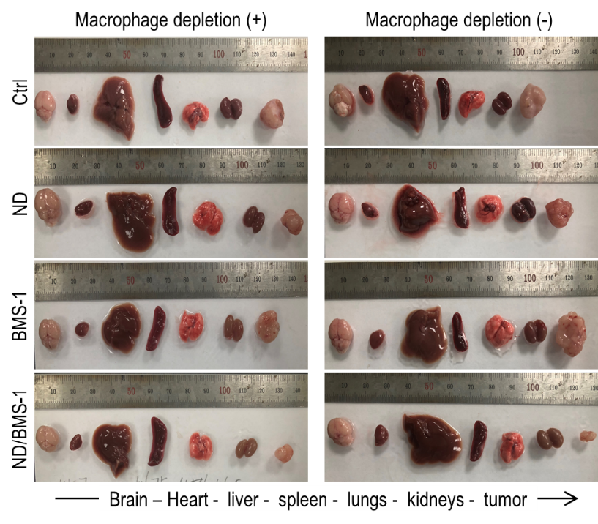
Fig. S13. Tumor xenografts and vital organs excised from sacrificed animals.
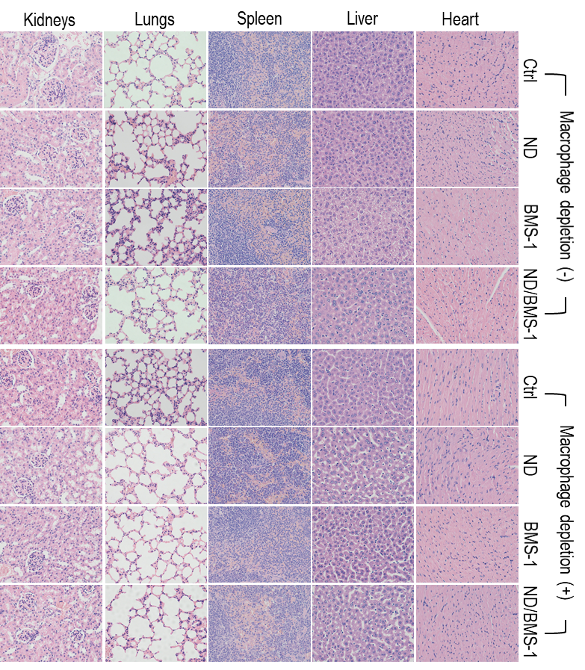
Fig. S14. H&E staining of major organs from the mice.

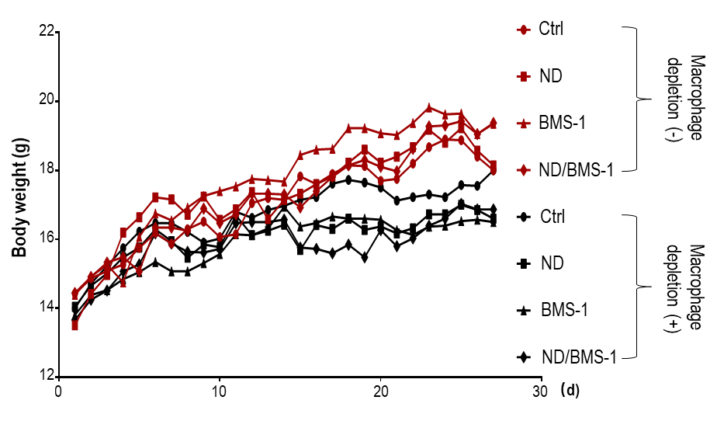
Fig. S15. Body weight curves of tumor bearing mice.

