Enhancing Gas Sensing Recyclability and Recovery Rate by Crystal Engineering of CuI Motif in MOFs

Zi-Wei Li,^{#, 1} Bin Tan,^{#,2} Xiu-Ze Hei,³ Xing-Wu Liu,⁴ Ke Zhao,² Chuan-Zhe Wang,¹ Ke-Feng Li,¹ Yong-Jun Chen,¹ Xiao-Ying Huang,¹ Kui Tan,⁵ Zhao-Feng Wu,*^{, 1} Jing Li,*^{, 6} and Gang Xu,*^{, 1}

¹State Key Laboratory of Structural Chemistry, Fujian Provincial Key Laboratory of Materials and Techniques toward Hydrogen Energy, Fujian Institute of Research on the Structure of Matter, the Chinese Academy of Sciences, Fuzhou, Fujian 350002, P. R. China
²School of Chemistry and Chemical Engineering, Beijing Institute of Technology, Beijing 102488, P. R. China
³Hoffmann Institute of Advanced Materials, Shenzhen Polytechnic University, 7098 Liuxian Blvd, Nanshan District, Shenzhen 518055, P. R. China
⁴Synfuels China Technology Co.Ltd., Leyuan Second South Street Yanqi Development Zone Huairou, Beijing, 101407, P. R. China
⁵Department of Chemistry, University of North Texas, Denton, Texas 76203, USA
⁶ Department of Chemistry and Chemical Biology, Rutgers University, 123 Bevier Rd. Piscataway, NJ 08854, USA
#These authors contributed equally to this work
*Corresponding author. Email: zfwu@fjirsm.ac.cn, jingli@chem.rutgers.edu, gxu@fjirsm.ac.cn.

Contents
1. DFT calculations 3
2. Crystal images, crystallographic data and PXRD patterns 4
3. More structure details 7
4. Physical characterizations 13
5. Gas sensing properties 19
6. References 23

DFT calculations
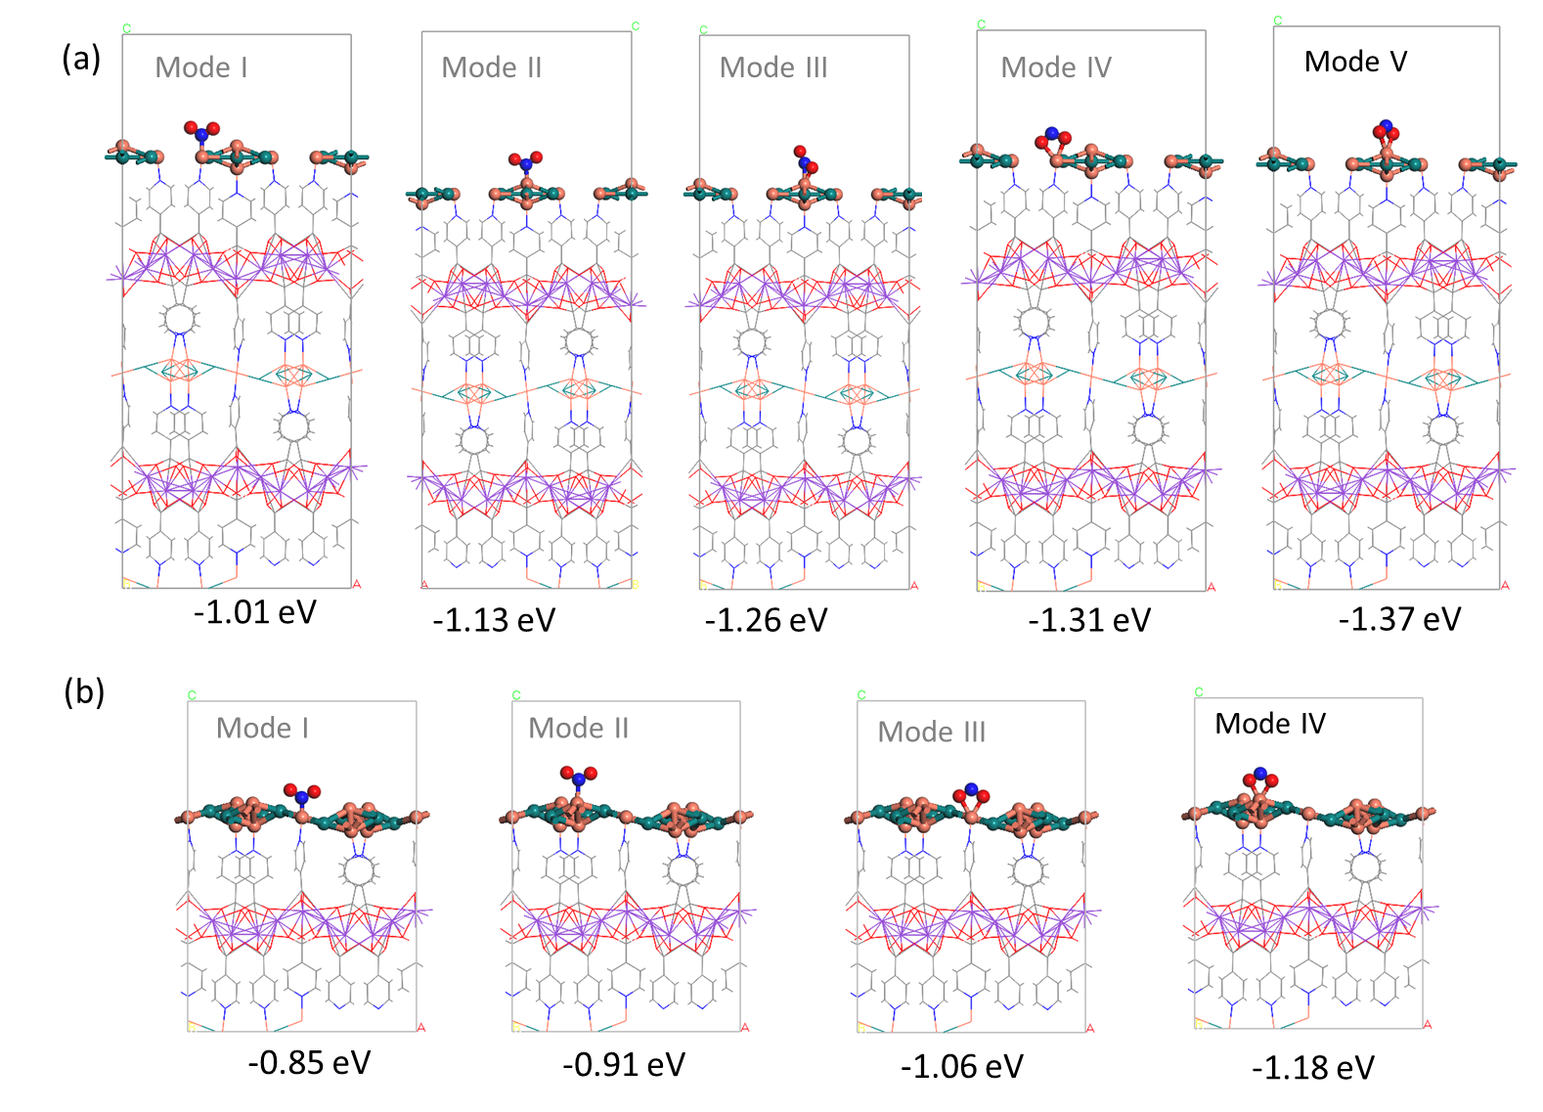
Figure S1. The NO₂ adsorbing modes with the CuI atoms in the 1D {Cu₄I₃}_{n}⁻ chain (a) and 2D {Cu₄I₅}_{n}⁻ layer (b) of K-CuI-K-INA. Color scheme: red ball, O; blue ball, N; gray ball, C; lavender ball, K; light brown ball, Cu; teal ball, I.

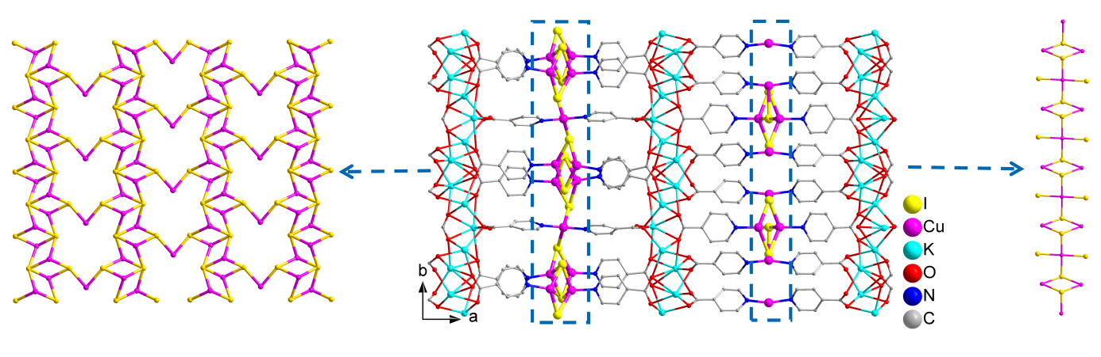
Figure S2. The 3D framework of K-CuI-K-INA with 1D {Cu₄I₃}_{n}⁻ chain and 2D {Cu₄I₅}_{n}⁻ layer in our former work.^{[1]}

Crystal images, crystallographic data and PXRD patterns
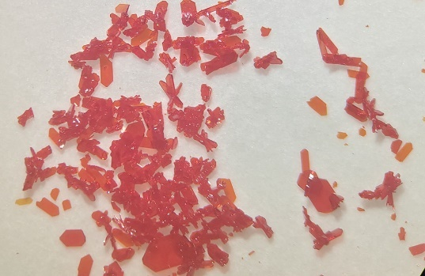
Figure S3. The photograph of the as-made single crystals of Na-CuI-K-INA.

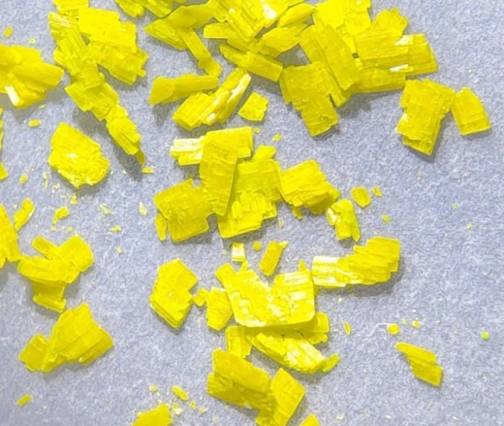
Figure S4. The photograph of the as-made single crystals of Cs-CuI-K-INA.

Figure S5. PXRD patterns of the as-made Na-CuI-K-INA and the sample after gas sensing. Simulated PXRD pattern is included for comparison.
Figure S6. PXRD patterns of the as-made Cs-CuI-K-INA and the sample after gas sensing. Simulated PXRD pattern is included for comparison.

Figure S7. TG curve for Na-CuI-K-INA.

Figure S8. TG curve for Cs-CuI-K-INA.

Table S1 Crystallographic data and structural refinement detail for the title compounds.
Compounds | Na-CuI-K-INA | Cs-CuI-K-INA
CCDC nos. | 2407515 | 2330128
Empirical formula | C₃₆H₂₄Na₂Cu₄I₃K₃N₆O₁₂ | C₃₆H₂₄Cs_{1.25}Cu₅I₄K_{3.75}N₆O₁₂
Formula weight | 1530.795 | 1870.67
Crystal system | orthorhombic | monoclinic
Space group | Pnma | P2/n
T/K | 295.15K | 293(2)K
λ/ Å | 0.71073 | 0.71073
a/ Å | 11.7085(10) | 19.070(18)
b/ Å | 35.063(3) | 7.365(6)
c/ Å | 10.9815(12) | 37.02(3)
α/º | 90 | 90
β/º | 90 | 104.457(12)
γ/º | 90 | 90
V/ Å³ | 4508.4(8) | 5035(7)
Z | 4 | 4
D_{c}/ Mg·m⁻³ | 2.255 | 2.468
μ/mm⁻¹ | 4.279 | 5.793
F(000) | 2933.4 | 3500.0
Measured refls. | 26931 | 24370
Independent refls. | 5823 | 8661
R_{int} | 0.0553 | 0.1155
No. of parameters | 307 | 627
GOF | 1.024 | 1.072
ªR₁, ^{b}wR₂ [I > 2σ(I)] | 0.0417,0.0783 | 0.0924,0.2484
ªR₁, ^{b}wR₂ (all data) | 0.0787,0.0947 | 0.1105,0.2709
ªR₁ = ∑║F_{o}│–│F_{c}║/∑│F_{o}│. ^{b}wR₂ = [ ∑w(F_{o}²F_{c}²)²/∑w(F_{o}²)²]^{1/2}

More structure details
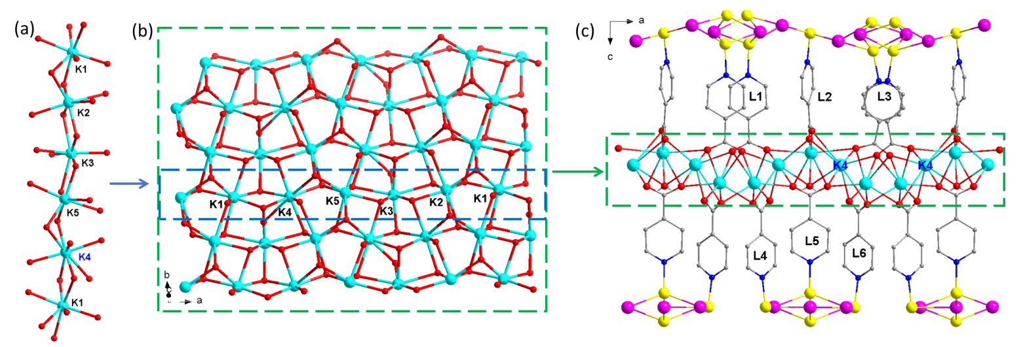
Figure S9. (a) The coordination modes for K⁺ in K-CuI-K-INA. (b) The 2D K-O layer. (c) The coordination sites for CuI created by coordination between K⁺ ions and INA⁻ ligands. Color scheme: pink ball, O; blue ball, N; gray ball, C; turquoise ball, K; bright yellow ball, Cu; purple ball, I..

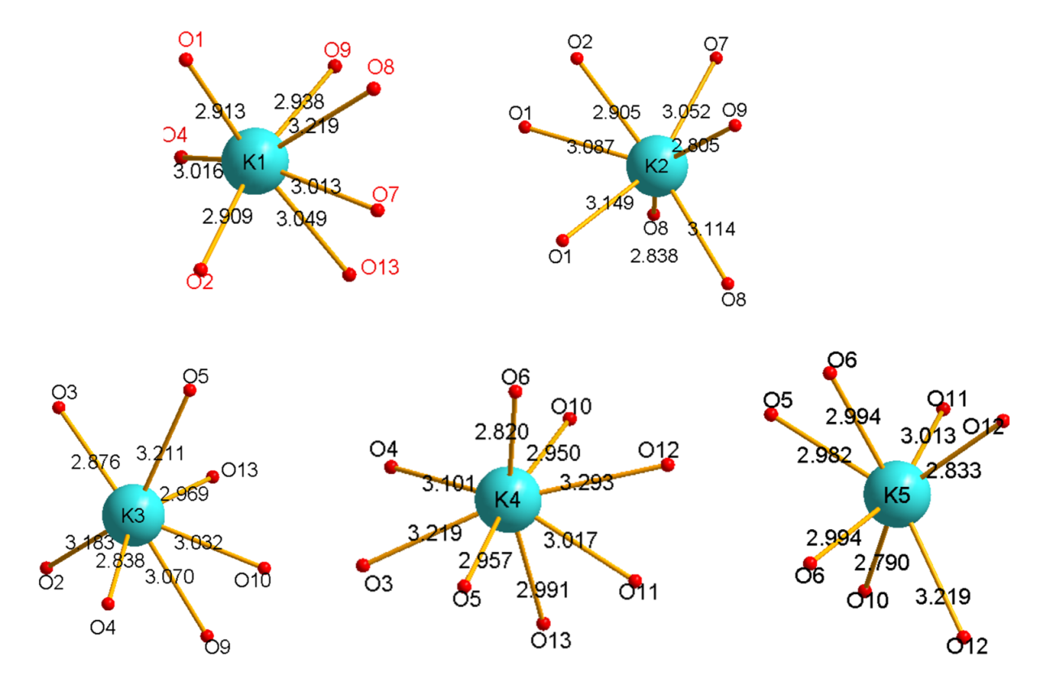
Figure S10. The coordination environments of K⁺ ions in K-CuI-K-INA with bond length values.

Figure S11. The coordination environments for K⁺ and Cs⁺ ions in Cs-CuI-K-INA with bond length values.

Figure S12. (a) The binding modes between the INA⁻ ligand and metals in Cs-CuI-K-INA. (b) The 2D {K-Cs-O}_{n} layer with a highlighting of coordination environments for K⁺ and Cs⁺ ions. (c) The coordination sites for CuI created by coordination between K⁺/Cs⁺ ions and pyridine from INA⁻ ligands.

Figure S13. (a) The 3D framework of Cs-CuI-K-INA viewed along b axis. (b) The 2D {Cu₄I₅}_{n}⁻ layer in Cs-CuI-K-INA viewed along.

Table S2 The selected K-O, Cs-O and Na-O bond lengths (Å) for these compounds.
K-CuI-K-INA
K(1)-O(1) | 2.912 | K(2)-O(2) | 2.905(6) | K(3)-O(9) | 3.070(6) | K(4)-0(12) | 3.293(6)
K(1)-O(2) | 2.910(7) | K(2)-O(7) | 3.052(7) | K(3)-O(10) | 3.032(6) | K(4)-0(12) | 2.991(7)
K(1)-O(4) | 3.016(7) | K(2)-O(8) | 2.838(6) | K(3)-O(13) | 2.969(7) | K(5)-O(5) | 2.982(6)
K(1)-O(7) | 3.013(7) | K(2)-O(8) | 3.114(7) | K(4)-0(3) | 3.218(6) | K(5)-O(6) | 2.994(7)
K(1)-O(8) | 3.219(6) | K(2)-O(9) | 2.805(6) | K(4)-0(4) | 3.101(7) | K(5)-O(10) | 2.790(6)
K(1)-O(9) | 2.937(6) | K(3)-O(2) | 3.184(7) | K(4)-0(5) | 2.958(7) | K(5)-O(11) | 3.013(7)
K(10-O(13) | 3.049(7) | K(3)-O(3) | 2.875(7) | K(4)-0(6) | 2.820(6) | K(5)-O(12) | 2.833(6)
K(2)-O(1) | 3.149(7) | K(3)-O(4) | 2.837(7) | K(4)-0(10) | 2.950(7) | K(5)-O(12) | 3.218(7)
K(2)-O(1) | 3.088(7) | K(3)-O(5) | 3.212(7) | K(4)-0(11) | 3.017(7)

Cs-CuI-K-INA
Cs(1)-O(4) | 3.042 | Cs(2)-O(2) | 3.496 | Cs(3)-O(5) | 3.074 | K(1)-O(6) | 2.94
Cs(1)-O(5) | 3.251 | Cs(2)-O(3) | 3.079 | Cs(3)-O(7) | 2.797 | K(1)-O(7) | 3.00
Cs(1)-O(6) | 3.183 | Cs(2)-O(4) | 3.169 | Cs(3)-O(9) | 3.620 | K(1)-O(8) | 3.10
Cs(1)-O(7) | 3.022 | Cs(2)-O(7) | 3.100 | Cs(3)-O(10) | 3.100 | K(1)-O(11) | 2.82
Cs(1)-O(8) | 3.322 | Cs(2)-O(9) | 2.94 | Cs(3)-O(11) | 3.137 | K(1)-O(12) | 3.08
Cs(1)-O(11) | 2.85 | Cs(2)-O(10) | 3.00 | Cs(3)-O(12) | 3.224 | K(1)-O(4) | 3.34
Cs(1)-O(12) | 2.98 | Cs(2)-O(1) | 3.056 | Cs(3)-O(1) | 2.595 | K(1)-O(5) | 3.17
Cs(1)-O(4) | 3.042 | Cs(2)-O(2) | 3.496 | Cs(3)-O(4) | 2.909 | K(2)-O(1) | 3.13
Cs(1)-O(5) | 3.251 | Cs(3)-O(1) | 2.595 | K(1)-O(4) | 3.34 | K(2)-O(2) | 3.38
Cs(2)-O(1) | 3.056 | Cs(3)-O(4) | 2.909 | K(1)-O(5) | 3.17 | K(2)-O(3) | 2.82
K(2)-O(4) | 3.07 | K(3)-O(4) | 2.93 | K(4)-O(2) | 2.827 | K(5)-O(6) | 2.893
K(2)-O(7) | 3.36 | K(3)-O(5) | 2.84 | K(4)-O(2) | 2.694 | K(5)-O(6) | 2.652
K(2)-O(9) | 3.14 | K(3)-O(7) | 2.80 | K(4)-O(3) | 2.695 | K(5)-O(8) | 2.727
K(2)-O(10) | 2.87 | K(3)-O(10) | 2.91 | K(4)-O(3) | 2.806 | K(5)-O(8) | 3.014
K(2)-O(1) | 3.13 | K(3)-O(11) | 3.31 | K(4)-O(9) | 2.795 | K(5)-O(11) | 2.727
K(2)-O(2) | 3.38 | K(3)-O(12) | 3.34 | K(4)-O(10) | 2.90 | K(5)-O(12) | 3.03
K(3)-O(1) | 2.83 | K(4)-O(1) | 2.907 | K(5)-O(5) | 2.834
Na-CuI-K-INA
K(1)-O(2) | 2.880(4) | K(1)-O(6) | 2.837(4) | K(2)-O(4) | 2.764(3) | Na(1)#2-O(2) | 2.317(4)
K(1)-O(2) | 2.880(4) | K(2)-O(1) | 2.940(3) | K(2)-O(5) | 2.815(4) | Na(1)#3-O(3) | 2.380(3)
K(1)-O(3) | 2.704(3) | K(2)-O(2) | 3.068(4) | K(2)-O(6) | 2.871(4) | Na(1)#3-O(4) | 2.503(3)
K(1)-O(3) | 2.704(3) | K(2)-O(3) | 2.836(3) | Na(1)-O(1) | 2.261(4) | Na(1)#11-O(5) | 2.310(4)
K(1)-O(6) | 2.837(4) | K(2)-O(4) | 2.778(3)
Symmetry transformations used to generate equivalent atoms: #1 x, y, z #2 x+1/2, -y+1/2, -z+1/2 #3 -x, y+1/2, -z

Table S3 The selected Cu-I bond lengths (Å) for for compounds K-CuI-K-INA, Cs-CuI-K-INA and Na-CuI-K-INA.
K-CuI-K-INA
Cu(1)-I(1) | 2.6657(16) | Cu(4)-I(3) | 2.6650(16)
Cu(2)-I(1) | 2.7905(17) | Cu(5)-I(4) | 2.8763(18)
Cu(2)-I(2) | 2.6931(16) | Cu(6)-I(4) | 2.6292(17)
Cu(3)-I(2) | 2.7387(18) | Cu(4)-I(5) | 2.7232(17)
Cu(3)-I(3) | 2.7012(18) | Cu(5)-I(5) | 2.6885(17)
Cs-CuI-K-INA
Cu(1)-I(2)#9 | 2.880(4) | Cu(4)-I(1) | 2.630(3)
Cu(1)-I(2) | 2.880(4) | Cu(4)-I(3)#10 | 2.866(3)
Cu(2)-I(1) | 2.619(3) | Cu(4)-I(4) | 2.591(3)
Cu(2)-I(3) | 2.725(3) | Cu(5)-I(1) | 2.861(3)
Cu(2)-I(4) | 2.679(3) | Cu(5)-I(2) | 2.598(3)
Cu(3)-I(1) | 2.778(3) | Cu(5)-I(3) | 2.657(3)
Cu(3)-I(2)#10 | 2.679(3) | Cu(6)-I(4)#11 | 2.930(4)
Cu(3)-I(3)#10 | 2.633(3) | Cu(6)-I(4) | 2.930(4)
Symmetry transformations: #9 1/2-x, +y, 1/2-z; #10 +x, 1+y, +z; #11 3/2-x, +y, 1/2-z
Na-CuI-K-INA
Cu(2)-I(1) | 2.720(8) | Cu(2)#1-I(3) | 2.757(8)
Cu(2)#1-I(1) | 2.720(8) | Cu(2) -I(3) | 2.757(8)
Cu(1)-I(2) | 2.794(11) | Cu(3)-I(3) | 2.902(16)
Cu(2)#1-I(2) | 2.733(9)
Symmetry transformations: #1 +x, 1/2-y, +z;

Figure S14. (a) and (b) are the 3D structure of Na-CuI-K-INA viewed along a and c axis direction, respectively. (c) The 2D {Na-K-O}_{n} coordination layer. (d) The 1D β-{Cu₄I₃}_{n}⁺ chain in Na-CuI-K-INA highlighted in red line. (e) The coordination environments for K⁺ and Na⁺ ions in Na-CuI-K-INA with bond length values.

Physical characterizations
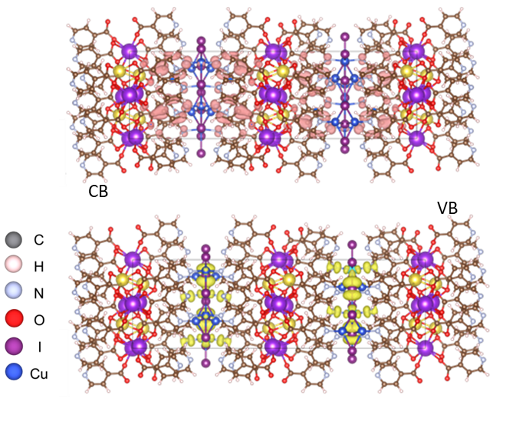
Figure S15. The plot of the highest occupied crystal orbital and lowest unoccupied crystal orbital of Na-CuI-K-INA..

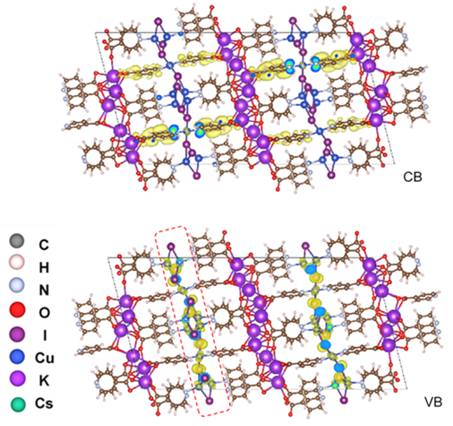
Figure S16. The plot of the highest occupied crystal orbital and lowest unoccupied crystal orbital of Cs-CuI-K-INA.

Figure S17. The UV-Vis optical absorption for Na-CuI-K-INA.

Figure S18. The UV-Vis optical absorption for Cs-CuI-K-INA.

Figure S19. (a) and (b) are the temperature-dependent I–V curves for Na-CuI-K-INA measured along the long and short sides of the single crystal sample, respectively. (c)The temperature dependent conductivity for Na-CuI-K-INA measured along the long and short sides of the selected single crystal sample. (d) Photograph of the single crystal of Na-CuI-K-INA viewed along the long side of the single crystal sample.

Figure S20. (a) The 3D framework of Cs-CuI-K-INA viewed along the b axis, respectively. (b) The 2D {Cu₄I₅}_{n}⁻ layer in Cs-CuI-K-INA viewed along c axis. (c) Photographs of the single crystal of Cs-CuI-K-INA viewed along a (the long side), b and c axis (the short side), respectively.
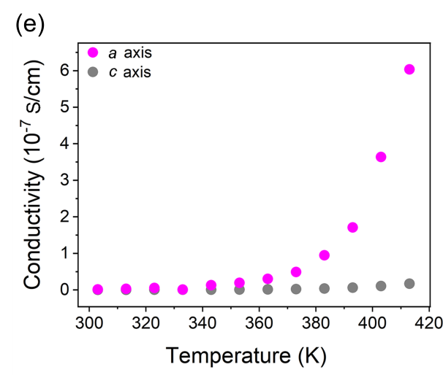
Figure S21. (a) and (b) are photographs of the single crystal sample for Cs-CuI-K-INA used for anisotropic conductivity study. Scale Bar: 100 μm. (c) and (d) are the temperature-dependent I–V curves for Cs-CuI-K-INA measured along the short and long sides of the single crystal sample, respectively. (e) The temperature dependent conductivity for Cs-CuI-K-INA measured along a and c axis of the single crystal.

Figure S22. (a) The temperature-dependent I-V curves for Na-CuI-K-INA. (b) Arrhenius plot of Na-CuI-K-INA at different temperature.

Figure S23. (a) The temperature-dependent I-V curves for Cs-CuI-K-INA. (b) Arrhenius plot of Cs-CuI-K-INA at different temperature.

Figure S24. The Mott-Schottky plots for Cs-CuI-K-INA.

Figure S25. The UPS plots for the as-made Cs-CuI-K-INA.

Gas sensing properties
Figure S26. (a) Response and recovery curve for Cs-CuI-K-INA towards NO₂ with different concentrations measuring at room temperature (RT). (b) Response and recovery curve towards 10 ppm NO₂. (c) Response and recovery time towards 10 ppm NO₂. (d) Log–log linear fitting of the response-concentration plot.

Figure S27. (a) Response and recovery curve for Na-CuI-K-INA towards NO₂ with different concentrations at RT. (b) Response and recovery curve towards 10 ppm NO₂. (c) Response and recovery time towards 10 ppm NO₂. (d) Log–log linear fitting of the response-concentration plot.
Figure S28. The IR spectra for the as-made Cs-CuI-K-INA (black) and the sample after NO₂ sensing (red).
Figure S29. The N₂ adsorption-desorption isotherms for Cs-CuI-K-INA.

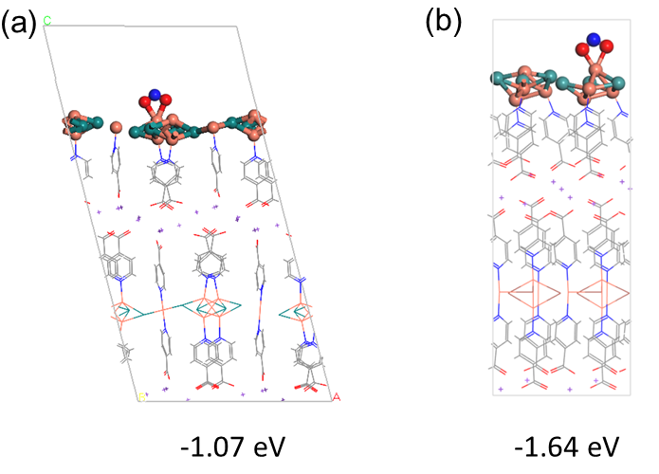
Figure S30. The DFT calculations for NO₂ adsorbing energy with the Cu(I) atoms in a favorable bidentate O,O′-nitrito binding way. (a) NO₂ adsorbed onto the Cu(I) atoms in 2D {Cu₄I₅}_{n}⁻ layer of Cs-CuI-K-INA. (b) NO₂ adsorbed to the Cu(I) atoms from 1D β-{Cu₄I₃}_{n}⁺ chain in Na-CuI-K-INA. Color scheme: red ball, O; blue ball, N; gray ball, C; light brown ball, Cu; teal ball, I.
Table S4. The summary of typical NO₂-sensing performances of MOFs, metal oxide/sulfide and their complexes.
Materials | Conc./ppm | Temperature/Light | Res./% | Res./Rec. time | LOD | Refs.
K-Cs-CuI-INA | 10 | RT/no light | 649% | 67.2 s/86.4 sec. | 5.61 ppb | This work
K-CuI-K-INA | 10 | RT/visible light | 670.3% | 121.2/212.3 sec. | 1.12 ppb | ¹
CuI-K-INA-NO₂ | 10 | RT/visible light | 191.6% | 123.6/312.5 sec. | 0.31 ppm | ¹
CuI-K-INA | 10 | RT/no light | 1434% | 121.8/ 312.6 sec. | 14.12 ppb | ¹
CuI-K-INA-NO₂ | 10 | RT/no light | irreversible | 190.7/526.2 sec. | 44.47 ppb | ¹
Cu-Salphen-MOF | 100 | RT/no light | 766 | 2.25 min/-- | 0.28 ppm | ²
MIL-101(Cr)•PEDOT | 1/10 | RT/no light | ~4/46 | 0.5-2.5 min/irreversible | 0.06 ppm | ³
ZIF-8/Au NW | 1/10 | RT/no light | ~4/46 | 0.12/~11.5 min | 0.19 ppm | ⁴
[Ni(TPyP)(TiF₆)]_{n}/PDVT-10 | 0.025–50 | RT/no light | -- | 0.72/7.3 min | 0.008 ppm | ⁵
ZnCo-ZIF/GN-120 | 100 | RT/no light | 54.61 | 1.07/12 sec | 10 ppb | ⁵
Cu₃(HHTP)₂-NFs | 5 | RT/blue light | 68.9 | 30 min/-- | -- | ⁶
Fe₂O₃-Cu₃(HHTP)₂-NFs | 5 | RT/blue light | 63.5 | 30 min/-- | 11 ppb | ⁶
Fe₂Mn PCN-250 | 0.5 | RT/no light | 2.7 | 1325/5184 sec. | -- | ⁷
Pt@Cu₃(HHTP)₂ | 1 | RT/no light | 12.1 | 14/-- min | 1 ppm | ⁸
Pd@Cu₃(HHTP)₂ | 1 | RT/no light | 13.5 | 13.8/-- min | 1 ppm | ⁸
SnO₂/NRGO | 5 | RT/no light | 1.38 | 45/168 sec. | -- | ⁹
RGO-polythiophene | 10 | RT/no light | 26.36 | <180/<200 sec. | 0.52 ppm | ¹⁰
MoS₂ | 100 | RT/no light | 27.92 | 29/350 sec. | -- | ¹¹
RGO/poly(3,4-ethylenedioxythiophene) | 1 | RT/no light | 0.05 | <180/<70 sec. | -- | ¹²
Mixed p-Type MoS₂ | 10 | RT/no light | 21.78 | 6.09/146.49 sec. | -- | ¹³
PS/WO₃–Pd₆₀ | 2 | RT/no light | 5.2 | 10/339 sec. | 0.25 ppm | ¹⁴
NiO | 3 | RT/no light | 4991 | 30 min/45 min | 200 ppb | ¹⁵
PCDTBT | 10 | RT/no light | 160 | 6.5/33 min | 1 ppm | ¹⁶
ZnO/poly(3-hexylthiophene) | 4 | RT/no light | 59 | <15/<45 min | -- | ¹⁷
ZIF-67 derived WS₂ functionalized carbons | 5 | RT/no light | ~48.2 | ~7/˃10 min | 0.1 ppm | ¹⁸
PdO-Co₃O₄-SWCNTs-700 | 20 | RT/no light | ~27.3 | ~1.5 min/irreversible | 1 ppm | ¹⁹
Pt@Cu₃(HHTP)₂ thin film | 3 | 150°C /no light | 89.9 | 8.2 min/-- | 0.1 ppm | ²⁰
Cu₃(HHTP)₂ thin film | 3 | 150°C /no light | 53.7 | 14 min/-- | 0.1 ppm | ²⁰
Cu₃(HHTP)₂ power | 3 | 150°C /no light | 11.8 | 17.3 min/-- | 1 ppm | ²⁰
Cu₃(HHTP)₂ nanoflakes | 5 | RT/no light | 79.8 | ~30/irreversible | -- | ²⁰
Cu₃(HHTP)₂ nanoflakes | 5 | RT/blue light | 68.9 | ~30/irreversible | -- | ²⁰
Fe₂O₃–Cu₃(HHTP)₂ | 5 | RT/blue light | ~62 | ~30/>60 min | 0.2 ppm | ²⁰
ZIF-67 derived carbon composite-loaded MWCNTs | 5 | RT/no light | 1 | ～3/>3 min | 0.1 ppm | ²¹
Mg-MOFs-I and II | 1 | 200°C /no light | 106/112 | I 2.07/3.68 min  II 3.07/2.83 min | -- | ²²
Ni-MOF-74 | 5 | 50°C /no light | -- | -- | <0.5 ppm | ²³
ZIF-8 | 100 | 350°C /no light | 11850 | 1.89/1.86 min | -- | ²⁴
Cu-MOF250 | 0.14 | 40°C /no light | 105 | --/>2 min | -- | ²⁵
Pd-SnO₂/rGO | 100 | RT/no light | 792 | 0.95/0.37 min | 37.8 ppb | ²⁶
SV-MoS₂/ZnO | 0.2 | RT/visible light | 226 | 75/111 sec. | 0.1 ppb | ²⁷
SnS₂/rGO | 0.01 | RT/visible light | 586 | 1.5/0.54 min | 0.15 ppb | ²⁸
SnS₂ | 5 | RT/visible light | 34 | 300/-- sec. | 2.5 ppb | ²⁹
ZnO/PbS | 1 | RT/visible light | 118–122 | 3/4 min | 26 ppb | ³⁰
ZnO/g-C₃N₄ | 7 | RT/visible light | 4480 | 142/190 sec. | 38 ppb | ³¹
SnS₂ | 8 | RT/visible light | 1080 | 164/236 sec. | 38 ppb | ³²
Au-WS₂ | 0.25 | RT/visible light | 20 | -- | 250 ppb | ³³
WS₂-rGO | 1 | RT/visible light | 127 | 16/18 min | 400 ppb | ³⁴
ZnO-Ag nanoparticles | 5 | RT/visible light | 154.5 | 150/50 sec. | < 500 ppb | ³⁵
WO₃@rGO | 0.9 | RT/visible light | 63.73 | 18.6/23.3 min | -- | ³⁶
WO₃ | 0.16 | RT/visible light | 400 | 20/42.5 min | -- | ³⁷
WO₃ | 0.4 | RT/visible light | 9200 | 51/60 min | -- | ³⁸
FIR-120 | 1 | RT/visible light | 116 | 2.48/2.60 min | 0.04 ppm | ³⁹
MnPS₃ | 35 | RT/no light | 9530% | 96/220 sec. | 50ppb | ⁴⁰
HIOTP-Ni | 10 | RT/no light | 405% | 1.69/10.32 min | 0.21 ppm | ⁴¹
Ag(SPh-NH2) | 10 | RT/no light | 852.6% | 1.0/2.3 min | 0.9 ppb | ⁴²
PbS CQDs | 50 | RT/no light | 21.7 | 12/37 sec. | 84ppb | ⁴³
PbCdSe QD gels | -- | RT/no light | 0.06%/ppb | 28/60 sec. | 3ppb | ⁴⁴
PbBDT OIHSL nanosheets | 0.04 | RT/no light | 5.512 | 16.2/47.4 sec. | 0.51ppb | ⁴⁵
PbSe QD gel | 1.32 | RT/no light | 98% | 35/279 sec. | 3 ppb | ⁴⁶
PbSe QD gel | 1.32 | RT/Violet light | 50% | 27/102 sec. | -- | ⁴⁶
Note: -- is no mentioned, RT = room temperature, sec. = seconds, min. = minutes.

References

1. Wu, Z.F. et al. Confinement of 1D Chain and 2D Layered CuI Modules in K-INA-R Frameworks via Coordination Assembly: Structure Regulation and Semiconductivity Tuning. J. Am. Chem. Soc. 145, 19293-19302 (2023).
2. Su, X. et al. Facile Synthesis of Metallosalphen-Based 2D Conductive Metal-Organic Frameworks for NO₂ Sensing: Metal Coordination Induced Planarization. Angew. Chem. Int. Ed. 62, e202302645 (2023).
3. Le Ouay, B. et al. Nanostructuration of PEDOT in Porous Coordination Polymers for Tunable Porosity and Conductivity. J. Am. Chem. Soc. 138, 10088-10091 (2016).
4. Li, P.P. et al. Sequential Ligand Exchange of Coordination Polymers Hybridized with In Situ Grown and Aligned Au Nanowires for Rapid and Selective Gas Sensing. ACS Appl. Mater. Interfaces 11, 13624-13631 (2019).
5. He, L., Zhang, W.Y., Wu, H.Y. & Zhao, Y. Zn-Co Zeolitic Imidazolate Framework Nanoparticles Intercalated in Graphene Nanosheets for Room-Temperature NO₂ Sensing. ACS Appl. Nano Mater. 4, 3998-4006 (2021).
6. Jo, Y.M. et al. Visible-Light-Activated Type II Heterojunction in Cu-3(hexahydroxytriphenylene)(2)/Fe₂O₃ Hybrids for Reversible NO₂ Sensing: Critical Role of π-π * Transition. ACS Cent. Sci. 7, 1176-1182 (2021).
7. Khan, M.W. et al. Hetero-metallic metal-organic frameworks for room-temperature NO₂ sensing. J. Colloid Interface Sci. 610, 304-312 (2022).
8. Koo, W.T., Kim, S.J., Jang, J.S., Kim, D.H. & Kim, I.D. Catalytic Metal Nanoparticles Embedded in Conductive Metal-Organic Frameworks for Chemiresistors: Highly Active and Conductive Porous Materials. Adv. Sci. 6, 1900250 (2019).
9. Wang, Z.Y. et al. High-performance reduced graphene oxide-based room-temperature NO₂ sensors: A combined surface modification of SnO₂ nanoparticles and nitrogen doping approach. Sens. Actuators B Chem. 242, 269-279 (2017).
10. Bai, S.L. et al. Enhancement of NO₂-Sensing Performance at Room Temperature by Graphene-Modified Polythiophene. Ind. Eng. Chem. Res. 55, 5788-5794 (2016).
11. Kumar, R., Goel, N. & Kumar, M. UV-Activated MoS2 Based Fast and Reversible NO₂ Sensor at Room Temperature. ACS Sens. 2, 1744-1752 (2017).
12. Yang, Y.J. et al. In Situ Polymerization Deposition of Porous Conducting Polymer on Reduced Graphene Oxide for Gas Sensor. ACS Appl. Mater. Interfaces 6, 13807-13814 (2014).
13. Agrawal, A.V. et al. Photoactivated Mixed In-Plane and Edge-Enriched p-Type MoS₂ Flake-Based NO₂ Sensor Working at Room Temperature. ACS Sens. 3, 998-1004 (2018).
14. Qiang, X.Y. et al. Effect of the Functionalization of Porous Silicon/WO₃ Nanorods with Pd Nanoparticles and Their Enhanced NO₂-Sensing Performance at Room Temperature. Materials 11, 764 (2018).
15. Benedict, S., Singh, M., Naik, T.R.R., Shivashankar, S.A. & Bhat, N. Microwave-Synthesized NiO as a Highly Sensitive and Selective Room-Temperature NO₂ Sensor. ECS J Solid State Sci Technol 7, Q3143-Q3147 (2018).
16. Kumar, A. et al. Modeling of gate bias controlled NO₂ response of the PCDTBT based organic field effect transistor. Chem. Phys. Lett. 698, 7-10 (2018).
17. Wang, J. et al. Hierarchical ZnO Nanosheet-Nanorod Architectures for Fabrication of Poly(3-hexylthiophene)/ZnO Hybrid NO₂ Sensor. ACS Appl. Mater. Interfaces 8, 8600-8607 (2016).
18. Koo, W.T. et al. Few-Layered WS2 Nanoplates Confined in Co, N-Doped Hollow Carbon Nanocages: Abundant WS₂ Edges for Highly Sensitive Gas Sensors. Adv. Funct. Mater. 28, 1802575 (2018).
19. Choi, S.J. et al. Metal-Organic Framework-Templated PdO-Co₃O₄ Nanocubes Functionalized by SWCNTs: Improved NO₂ Reaction Kinetics on Flexible Heating Film. ACS Appl. Mater. Interfaces 9, 40593-40603 (2017).
20. Kim, J.O. et al. Large-area synthesis of nanoscopic catalyst-decorated conductive MOF film using microfluidic-based solution shearing. Nat. Commun. 12, 4294 (2021).
21. Rui, K. et al. Dual-Function Metal-Organic Framework-Based Wearable Fibers for Gas Probing and Energy Storage. ACS Appl. Mater. Interfaces 10, 2837-2842 (2018).
22. Lee, J.H. et al. Gas Sensing Properties of Mg-Incorporated Metal-Organic Frameworks. Sensors 19, 3323 (2019).
23. Small, L.J. et al. Near-Zero Power MOF-Based Sensors for NO₂ Detection. Adv. Funct. Mater. 30, 2003598 (2020).
24. Zhan, M.M. et al. Facet controlled polyhedral ZIF-8 MOF nanostructures for excellent NO₂ gas-sensing applications. Mater. Res. Bull. 136, 111133 (2021).
25. Arul, C. et al. Temperature modulated Cu-MOF based gas sensor with dual selectivity to acetone and NO₂ at low operating temperatures. Sens. Actuators B Chem.l 329, 129053 (2021).
26. Bai, H.N. et al. A room-temperature chemiresistive NO₂ sensor based on one-step synthesized SnO₂ nanospheres functionalized with Pd nanoparticles and rGO nanosheets. Appl. Surf. Sci. 575, 151698 (2022).
27. Xia, Y. et al. Sulfur-Vacancy-Enriched MoS₂ Nanosheets Based Heterostructures for Near-Infrared Optoelectronic NO₂ Sensing. Acs Applied Nano Materials 3, 665-673 (2020).
28. Huang, Y.F. et al. Ultrasensitive room temperature ppb-level NO₂ gas sensors based on SnS₂/rGO nanohybrids with P-N transition and optoelectronic visible light enhancement performance. J. Mater. Chem. C 7, 8616-8625 (2019).
29. Yan, W.J. et al. Photo-enhanced gas sensing of SnS₂ with nanoscale defects. Rsc Advs. 9, 626-635 (2019).
30. Chen, R.S., Wang, J., Xia, Y. & Xiang, L. Near infrared light enhanced room-temperature NO₂ gas sensing by hierarchical ZnO nanorods functionalized with PbS quantum dots. Sens. Actuators B Chem. 255, 2538-2545 (2018).
31. Wang, H.T. et al. Visible light activated excellent NO₂ sensing based on 2D/2D ZnO/g-C₃N₄ heterojunction composites. Actuators B Chem. 304 , 127287(2020).
32. Gu, D. et al. Visible-light activated room temperature NO₂ sensing of SnS₂ nanosheets based chemiresistive sensors. Actuators B Chem. 305, 127455 (2020).
33. Polyakov, A.Y. et al. Gold Decoration and Photoresistive Response to Nitrogen Dioxide of WS₂ Nanotubes. Chem. Eur. J. 24, 18952-18962 (2018).
34. Paolucci, V., Emamjomeh, S.M., Ottaviano, L. & Cantalini, C. Near Room Temperature Light-Activated WS₂-Decorated rGO as NO₂ Gas Sensor. Sensors 19 ,2617 (2019).
35. Zhang QP, et al. Visible light-assisted room temperature gas sensing with ZnO-Ag heterostructure nanoparticles. Sens. Actuators B Chem. 259, 269-281 (2018).
36. Geng, X., You, J.J., Wang, J. & Zhang, C. Visible light assisted nitrogen dioxide sensing using tungsten oxide - Graphene oxide nanocomposite sensors. Mater. Chem. Phys.191, 114-120 (2017).
37. Zhang, C. et al. Room temperature responses of visible-light illuminated WO₃ sensors to NO₂ in sub-ppm range. Sens. Actuators B Chem. 181, 395-401 (2013).
38. Giancaterini, L., Emamjomeh, S.M., De Marcellis, A., Palange, E. & Cantalini, C. in Conference on Eurosensors, Vol. 120, Freiberg, Germany, 2015, pp. 791-794 (2015).
39. Li, H.Z. et al. Rationally designed titanium-based metal-organic frameworks for visible-light activated chemiresistive sensing. J. Mater. Chem.A 11, 965-971 (2023).
40. Kumar, R., Jenjeti, R.N. & Sampath, S. Two-Dimensional, Few-Layer MnPS₃ for Selective NO₂ Gas Sensing under Ambient Conditions. ACS Sens. 5, 404-411 (2020).
41. Chen, P. et al. Two-Dimensional Conjugated Metal-Organic Frameworks with Large Pore Apertures and High Surface Areas for NO₂ Selective Chemiresistive Sensing. Angew. Chem. Int. Ed. 62, e202306224 (2023).
42. Jiang, H. et al. Organic “receptor” fully covered few-layer organic–metal chalcogenides for high-performance chemiresistive gas sensing at room temperature. Chem. Commun. 56, 5366-5369 (2020).
43. Liu, H. et al. Physically Flexible, Rapid-Response Gas Sensor Based on Colloidal Quantum Dot Solids. Adv. Mater. 26, 2718-2724 (2014).
44. Geng, X. et al. Atomically dispersed Pb ionic sites in PbCdSe quantum dot gels enhance room-temperature NO₂ sensing. Nat. Commun. 12, 4895 (2021).
45. Wen, Y. et al. A Covalent Organic–Inorganic Hybrid Superlattice Covered with Organic Functional Groups for Highly Sensitive and Selective Gas Sensing. Angew. Chem. Int. Ed. 60, 19710-19714 (2021).
46. Geng, X. et al. Photoexcited NO₂ Enables Accelerated Response and Recovery Kinetics in Light-Activated NO₂ Gas Sensing. ACS Sens. 6, 4389-4397 (2021).

