Supplementary Table S4: the Egger’s test of different subgroup
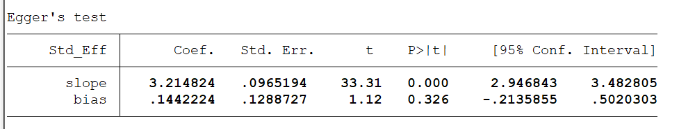
1.Sample size ≥60
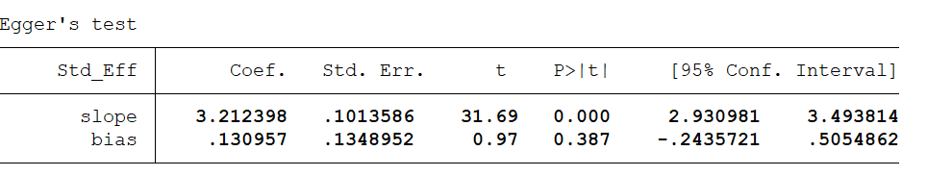
2.Quality scores ≥80
3.median group
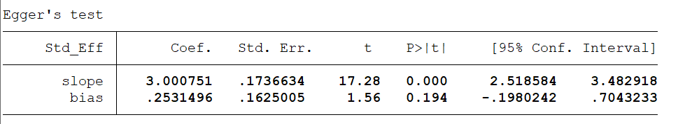

Supplementary Table S5: the Egger’s test of different subgroup
1. tumor stage subgroup
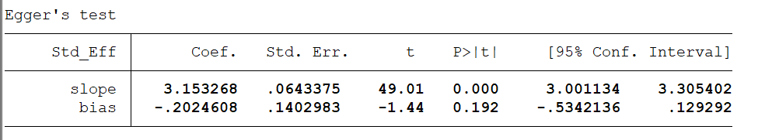

2. distant metastasis subgroup
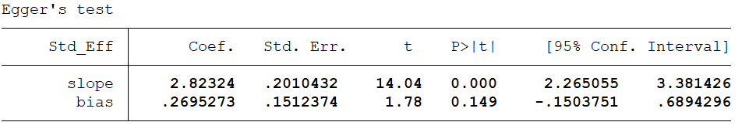

3. Lymphatic metastasis subgroup
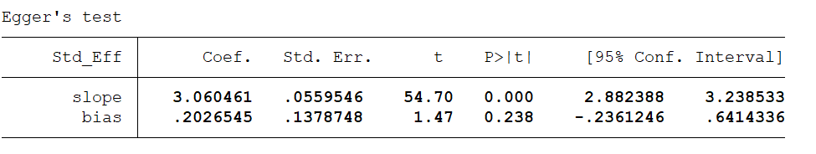

4. tumor size subgroup
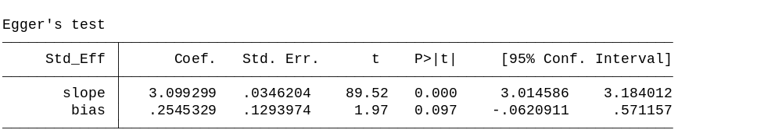

Supplementary Figure1：Sensitivity analysis of the effect of the individual subgroup on the pooled ORs.
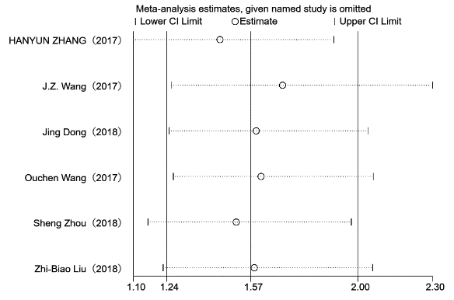
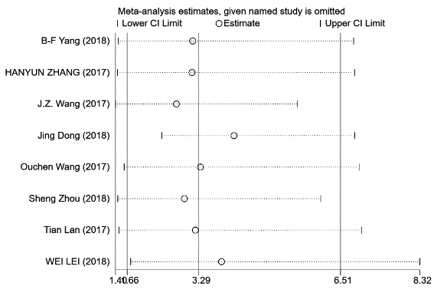
A B

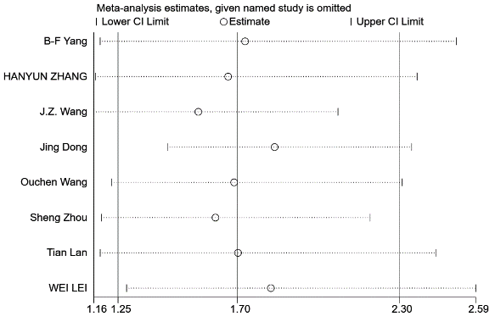
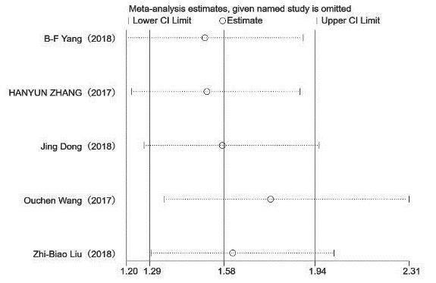
C D

A：Sensitivity analysis of tumor stage subgroup. B：Sensitivity analysis of distant metastasis subgroup.
C：Sensitivity analysis of Lymphatic metastasis subgroup. D：Sensitivity analysis of tumor size subgroup.

