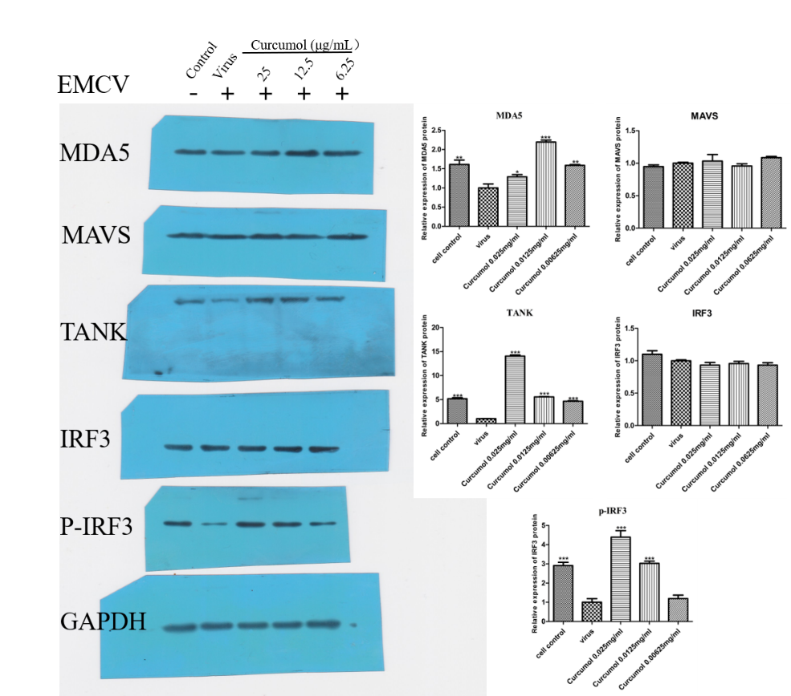
Figure 5. Western blot analysis of 0.025mg/ml curcumol EMCV infection of HEK-293T cells for 24 h, detection of MDA5, MAVS, TANK, IRF3, P-IRF3 protein expression changes.

