Online Supplement
Treatment outcomes of paediatric blepharokeratoconjunctivitis without systemic antibiotics

Authors: Haryung Park, Young Joon Choi

List of materials included
Supplemental Figure 3
Supplemental Table 1

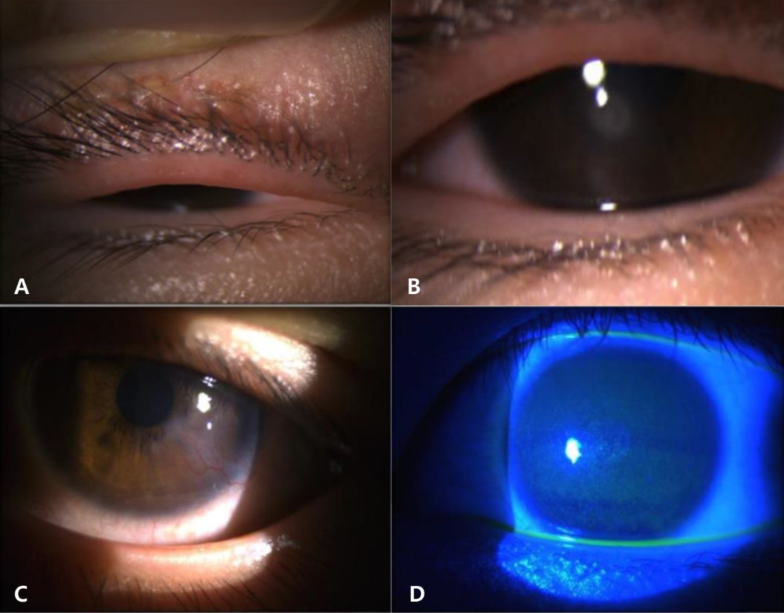
Supplemental Figure 1. Clinical signs seen in pediatric blepharokeratoconjunctivitis (PBKC). (A) Meibomitis. (B) Corneal inflammatory cellular infiltration. (C) Superficial corneal neovascularisation. (D) Superficial punctate keratopathy.

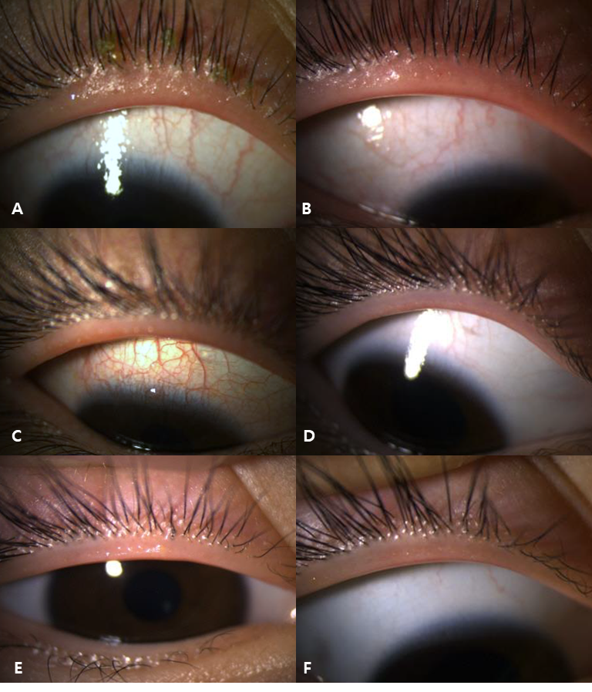
Supplemental Figure 2. Pre- and posttreatment changes in the eyelids in the patients with pediatric blepharokeratoconjunctivitis (PBKC)
A-B. The eyelid of 14-year-old male (Case 5) before (A) and 1 year after treatment (B).
C-D: The eyelid of 13-year-old female (Case 8) before (C) and 1 year after treatment (D).
E-F: The eyelid of 7-year-old female (Case 15) before (F) and 9 months after treatment (G).

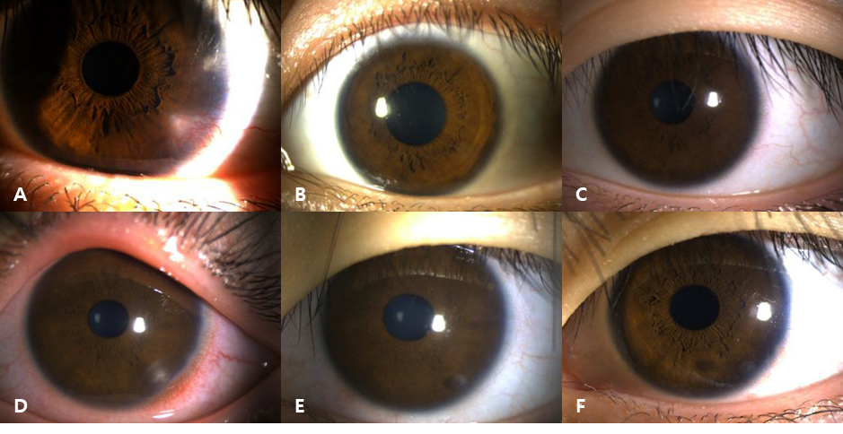
Supplemental Figure 3. Pre- and posttreatment changes in corneal phlyctenulosis in the patients with pediatric blepharokeratoconjunctivitis (PBKC)
A-C: The cornea of a 17-year-old female (Case 6) before treatment (A), 3 months after treatment (B), and 1 year 8 months after treatment (C)
D-F: The cornea of a 12-year-old female (Case 21) before treatment (D), 1 month after treatment (E), and 3 months after treatment (F)

Supplemental Table 1: Patient characteristics

Case number | Mean age (years) | Mean F/U duration (months) | Sex | Laterality | History of chalazia | Dermatologic rosacea | Meibomian gland abnormality | Corneal infiltrates | Corneal NV | Phlycten type
1 | 14 | 19 | F | U | - | - | + | + | + | +
2 | 5 | 6 | M | B | + | - | + | + | + | -
3 | 13 | 5 | F | B | - | - | + | + | + | +
4 | 8 | 6 | F | B | + | - | + | + | - | -
5 | 14 | 12 | M | U | - | - | + | + | + | -
6 | 17 | 20 | F | B | + | - | + | + | + | +
7 | 14 | 7 | M | B | + | - | + | + | + | -
8 | 13 | 19 | F | B | - | - | + | + | + | +
9 | 8 | 17 | F | U | + | - | + | + | + | -
10 | 12 | 11 | M | B | + | - | + | + | - | -
11 | 12 | 12 | F | B | + | - | + | + | + | -
12 | 16 | 6 | F | U | - | - | + | + | + | -
13 | 15 | 11 | F | U | + | - | - | + | - | -
14 | 6 | 11 | M | U | - | - | + | + | - | -
15 | 7 | 9 | F | U | + | - | + | + | - | -
16 | 10 | 10 | M | U | - | - | + | + | + | -
17 | 11 | 10 | F | U | - | - | + | + | + | -
18 | 5 | 10 | F | U | + | - | - | + | + | -
19 | 11 | 8 | F | B | + | - | + | + | + | +
20 | 2 | 3 | F | U | + | - | + | + | - | -
21 | 12 | 3 | F | U | - | - | - | + | + | +
Abbreviations: F/U, follow up; NV, neovascularisation; F, female; M, male; U, unilateral; B, bilateral

