Supporting Information for
A transcription factor-based framework for monitoring stress status in oysters: applications in conservation and restoration

Shen-Tong Wang ^{b,c,e}, Li Li ^{a,b,c,e,f*}, Qi Yang ^{c}, Wei Wang ^{b,c,e}, Ao Li ^{a,c,d,e}, Xinxing Wang ^{c}, Yu Wang ^{g}, Guo-Fan Zhang ^{a,c,d,e,f}

*Corresponding authors:
*Li Li, Laboratory of Experimental Marine Biology, Institute of Oceanology, Chinese Academy of Sciences, Qingdao, Shandong, China.
Email address: lili@qdio.ac.cn
Phone number: 13969696697

Number of pages: 18
Number of tables: 9
Number of figures: 9

Table S1. Number of samples per group used in enzyme activity, RNA-seq and ATAC-seq and gene expression analyses.
 | Enzyme  activity | RNA-seq | ATAC-seq | Gene expression
Number of individuals analyzed at each tidal level | 15 | 15 | 15 | 9
Number of individuals combined to one biological replicate | 3 | 3 | 5 | 3
Number of biological replicates analyzed at each tidal level | 5 | 5 | 3 | 3

Table S2. Latitude and longitude of sampling stations in the DaShentang Reserve
Station | Longitude (E) | Latitude (N) | Depth (m)
A1 | 117.96948 | 39.12010 | 7.4
A2 | 117.98950 | 39.12200 | 5.7
A3 | 117.98080 | 39.11410 | 7.7
A4 | 117.97027 | 39.10538 | 5.8
A5 | 117.98607 | 39.10193 | 6.1

Table S3. Primer sequences used in the study
Gene | Forward (5’-3’) | Reverse (5’-3’)
BORIS | CATGCCTCAAGATGGAAGCC | TTCCTCCACCGCATCTTTCT
MYB73 | AAGTTTTCCGCTGTTCCGTC | CTACGATGTCTTTGGGCTGC
Ef-1α | AAGGGATGGTCCGTTGAG | GTGGAAGACGAAGAGGTAAGT
BORIS_2071 | GGUCAUUGUUGCAAAUAAACU | UUUAUUUGCAACAAUGACCUC
MYB73_246 | GGUGGUGUAAAGUACUCAACC | UUGAGUACUUUACACCACCUG

Table S4. Seawater temperature at different tide levels
 | Mean (°C) | SD (°C) | CV (%） | Median (°C)
HT | 20.37 | 8.34 | 40.94% | 21.86
MT | 19.55 | 6.94 | 35.52% | 21.47
LT | 19.09 | 6.26 | 32.72% | 21.22
note: HT: high tide; MT: middle tide; LT: low tide; SD: standard deviation; CV: coefficient of variation.
Table S5. The quality of reads in RNA-seq
Sample | Total raw read (M) | Total clean read (M) | Total clean base (G) | Clean read Q20 (%) | Clean read Q30 (%) | Clean read ratio (%)
HT_1 | 40.78 | 40.29 | 5.99 | 96.99 | 91.66 | 98.79
HT_2 | 42.02 | 41.57 | 6.19 | 97.13 | 91.9 | 98.93
HT_3 | 40.78 | 40.34 | 6.00 | 97.28 | 92.30 | 98.91
HT_4 | 40.35 | 39.90 | 5.93 | 97.47 | 92.63 | 98.89
HT_5 | 40.78 | 40.35 | 6.00 | 97.29 | 92.29 | 98.94
MT_1 | 42.38 | 41.85 | 6.22 | 96.71 | 91.13 | 98.75
MT_2 | 41.32 | 40.89 | 6.08 | 97.35 | 92.41 | 98.95
MT_3 | 43.85 | 43.28 | 6.42 | 96.86 | 91.40 | 98.70
MT_4 | 42.32 | 41.84 | 6.22 | 97.21 | 92.15 | 98.87
MT_5 | 40.84 | 40.35 | 6.00 | 96.96 | 91.59 | 98.79
LT_1 | 40.47 | 39.97 | 5.94 | 97.19 | 92.11 | 98.77
LT_2 | 40.22 | 39.79 | 5.91 | 97.16 | 92.01 | 98.94
LT_3 | 41.84 | 41.39 | 6.15 | 97.10 | 91.87 | 98.93
LT_4 | 42.71 | 42.26 | 6.27 | 97.19 | 92.09 | 98.94
LT_5 | 48.15 | 47.59 | 7.08 | 97.14 | 91.98 | 98.85
note: HT: high tide; MT: middle tide; LT: low tide.
Table S6. Mapped reads of RNA-sequencing data
Sample | Total clean reads (M) | Total mapping (%) | Uniquely mapping (%) | Multiple mapping (%)
HT_1 | 40.29 | 70.93 | 66.40 | 4.53
HT_2 | 41.57 | 72.45 | 68.01 | 4.44
HT_3 | 40.34 | 72.38 | 67.26 | 5.12
HT_4 | 39.90 | 72.58 | 68.00 | 4.58
HT_5 | 40.35 | 72.87 | 67.59 | 5.28
MT_1 | 41.85 | 71.94 | 66.65 | 5.29
MT_2 | 40.89 | 71.88 | 66.81 | 5.07
MT_3 | 43.28 | 71.47 | 66.46 | 5.01
MT_4 | 41.84 | 71.35 | 65.98 | 5.37
MT_5 | 40.35 | 72.56 | 67.89 | 4.67
LT_1 | 39.97 | 72.57 | 67.72 | 4.85
LT_2 | 39.79 | 72.86 | 67.60 | 5.26
LT_3 | 41.39 | 72.03 | 65.93 | 6.10
LT_4 | 42.26 | 72.65 | 67.40 | 5.25
LT_5 | 47.59 | 72.27 | 67.12 | 5.15
note: HT: high tide; MT: middle tide; LT: low tide.
Table S7. The quality of clean reads in ATAC-seq data
Sample | Clean reads (M) | Clean bases (G) | Clean Q20 (%) | Clean Q30 (%) | Clean GC (%)
HT_1 | 200721420 | 13.20 | 99.01 | 96.17 | 37.19
HT_2 | 235460248 | 14.55 | 99.21 | 96.83 | 37.05
HT_3 | 211927596 | 13.02 | 99.18 | 96.64 | 36.35
LT_1 | 223482874 | 15.42 | 99.21 | 96.94 | 35.29
LT_2 | 210319992 | 14.26 | 99.16 | 96.68 | 35.82
LT_3 | 158884182 | 8.96 | 99.26 | 96.89 | 35.38
note: HT: high tide; MT: middle tide; LT: low tide.
Table S8. Mapped reads of ATAC-seq data
Sample | Total reads (M) | Total mapped (%) | Non unique (%) | Unique  (%) | Un mapped reads (%)
HT_1 | 200721420 | 151282084  (75.37) | 89969549  (59.47) | 61312535  (40.53) | 49439336  (24.63)
HT_2 | 235460248 | 180692026  (76.74) | 105533549  (58.41) | 75158477  (41.59) | 54768222  (23.26)
HT_3 | 211927596 | 164182577  (77.47) | 97602320  (59.45) | 66580257  (40.55) | 47745019  (22.53)
LT_1 | 223482874 | 180336901  (80.69) | 108074292  (59.93) | 72262609  (40.07) | 43145973  (19.31)
LT_2 | 210319992 | 172105943(  81.83) | 98969177  (57.50) | 73136766  (42.50) | 38214049  (18.17)
LT_3 | 158884182 | 127577452  (80.30) | 75497142  (59.18) | 52080310  (40.82) | 31306730  (19.70)
note: HT: high tide; MT: middle tide; LT: low tide.
Table S9. Expression profiles of transcription factors (TFs) in oysters under high and low tidal levels
TFs | HT_vs_LT_Log₂FC | HT_vs_LT_p-value | HT_vs_MT_Log₂FC | HT_vs_MT_p-value
Fkh-9 | 1.051509 | 0.739378 | -1.942742 | 0.351065
Mab-3 | -0.000816 | 0.996244 | -0.269923 | 0.045096
MYB73 | 0.440652 | 0.008685 | 0.368217 | 0.009754
Dve | 0.022904 | 0.858382 | 0.251030 | 0.029190
Mcm1 | 0.061039 | 0.614490 | 0.264610 | 0.033613
SOX-5 | 0.430940 | 0.002947 | 0.146433 | 0.287016
TOS8 | -0.040346 | 0.742557 | 0.051126 | 0.697045
RELB | -0.254308 | 0.000131 | -0.205581 | 0.018959
MEF2B | -0.003947 | 0.969402 | 0.014446 | 0.905795
USV1 | -0.182603 | 0.103883 | 0.023962 | 0.855376
NEUROD1 | -0.313530 | 0.674294 | -0.009990 | 0.989806
BORIS | 0.633788 | 0.002956 | 0.808691 | 0.000381
PROX1 | 0.160519 | 0.275575 | -0.090066 | 0.383348
OVOL2 | -0.233008 | 0.473947 | -0.089443 | 0.763980
ZBTB32 | 2.177333 | 0.181193 | -0.267708 | 0.847989
Bcl11a | 0.205108 | 0.096658 | 0.351970 | 0.012518
ZBTB26 | -0.097562 | 0.426531 | -0.016310 | 0.900486
Slbo | -0.327214 | 0.176503 | -0.334930 | 0.236335
note: HT: high tide; MT: middle tide; LT: low tide; FC: foldchange
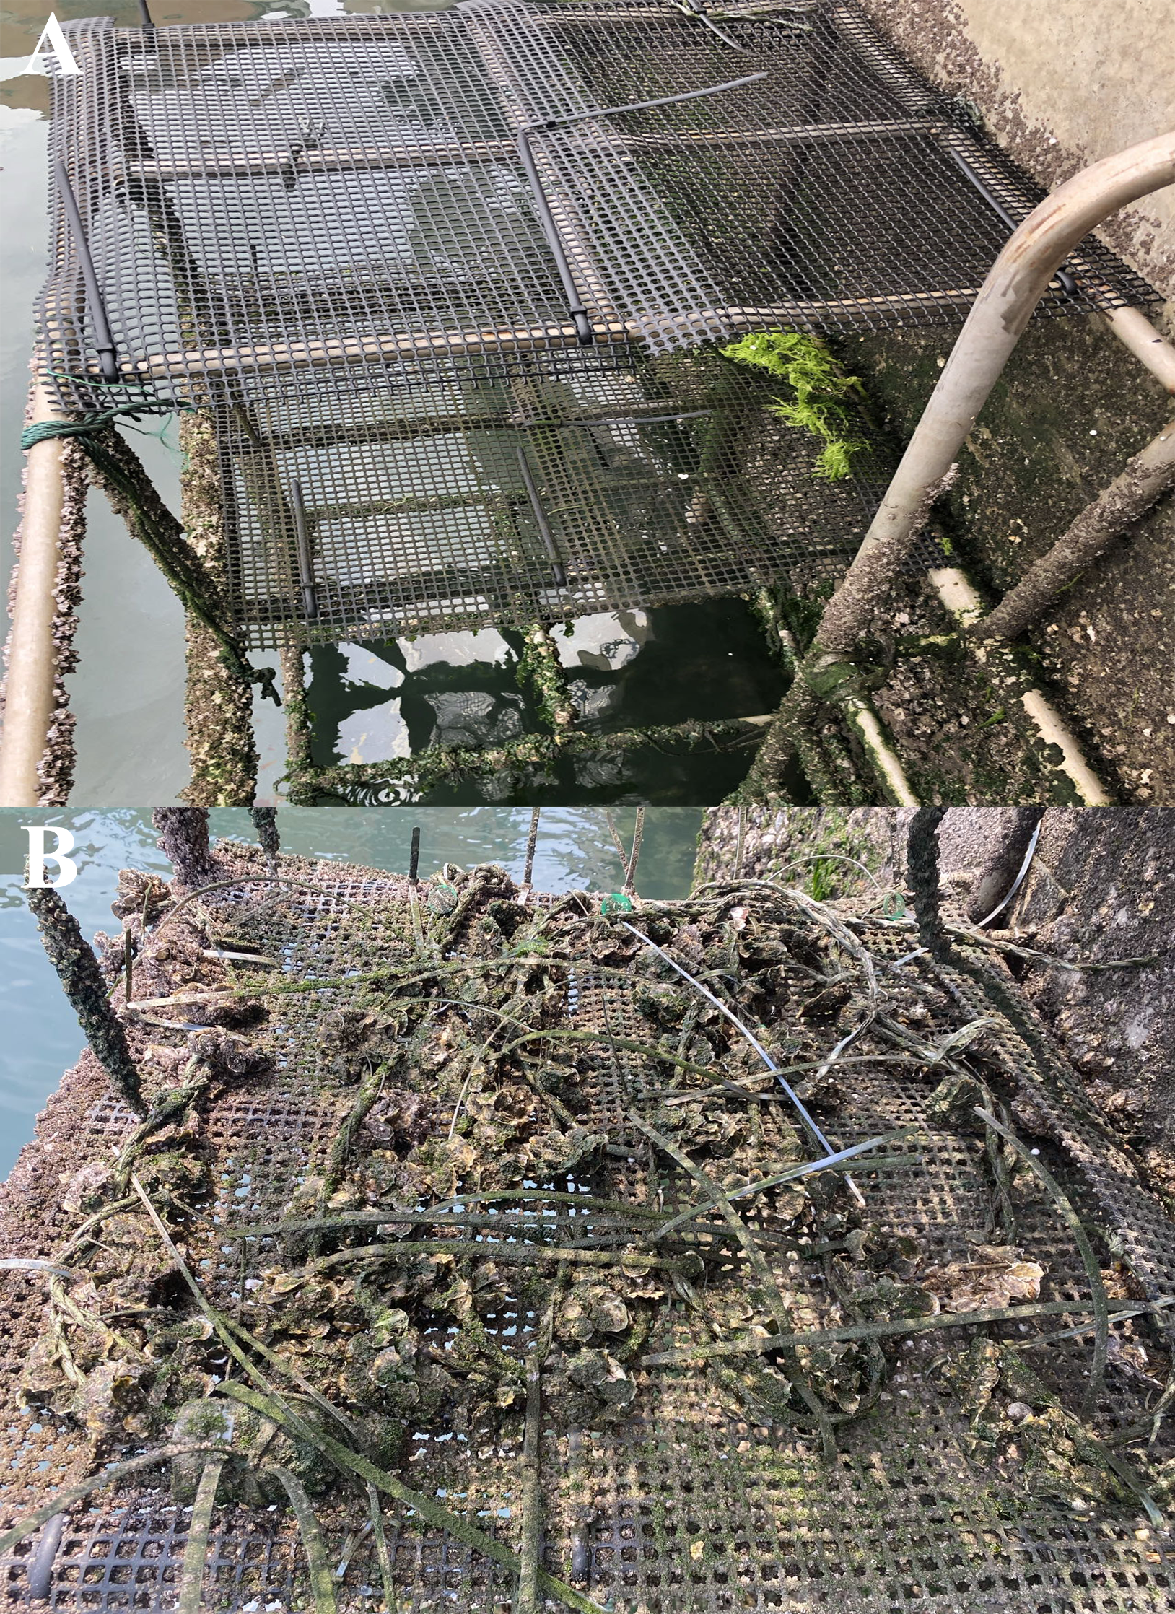
Figure S1. Photographic records document the field experimental site showing (A) pre-deployment conditions and (B) post-deployment status of oyster specimens.
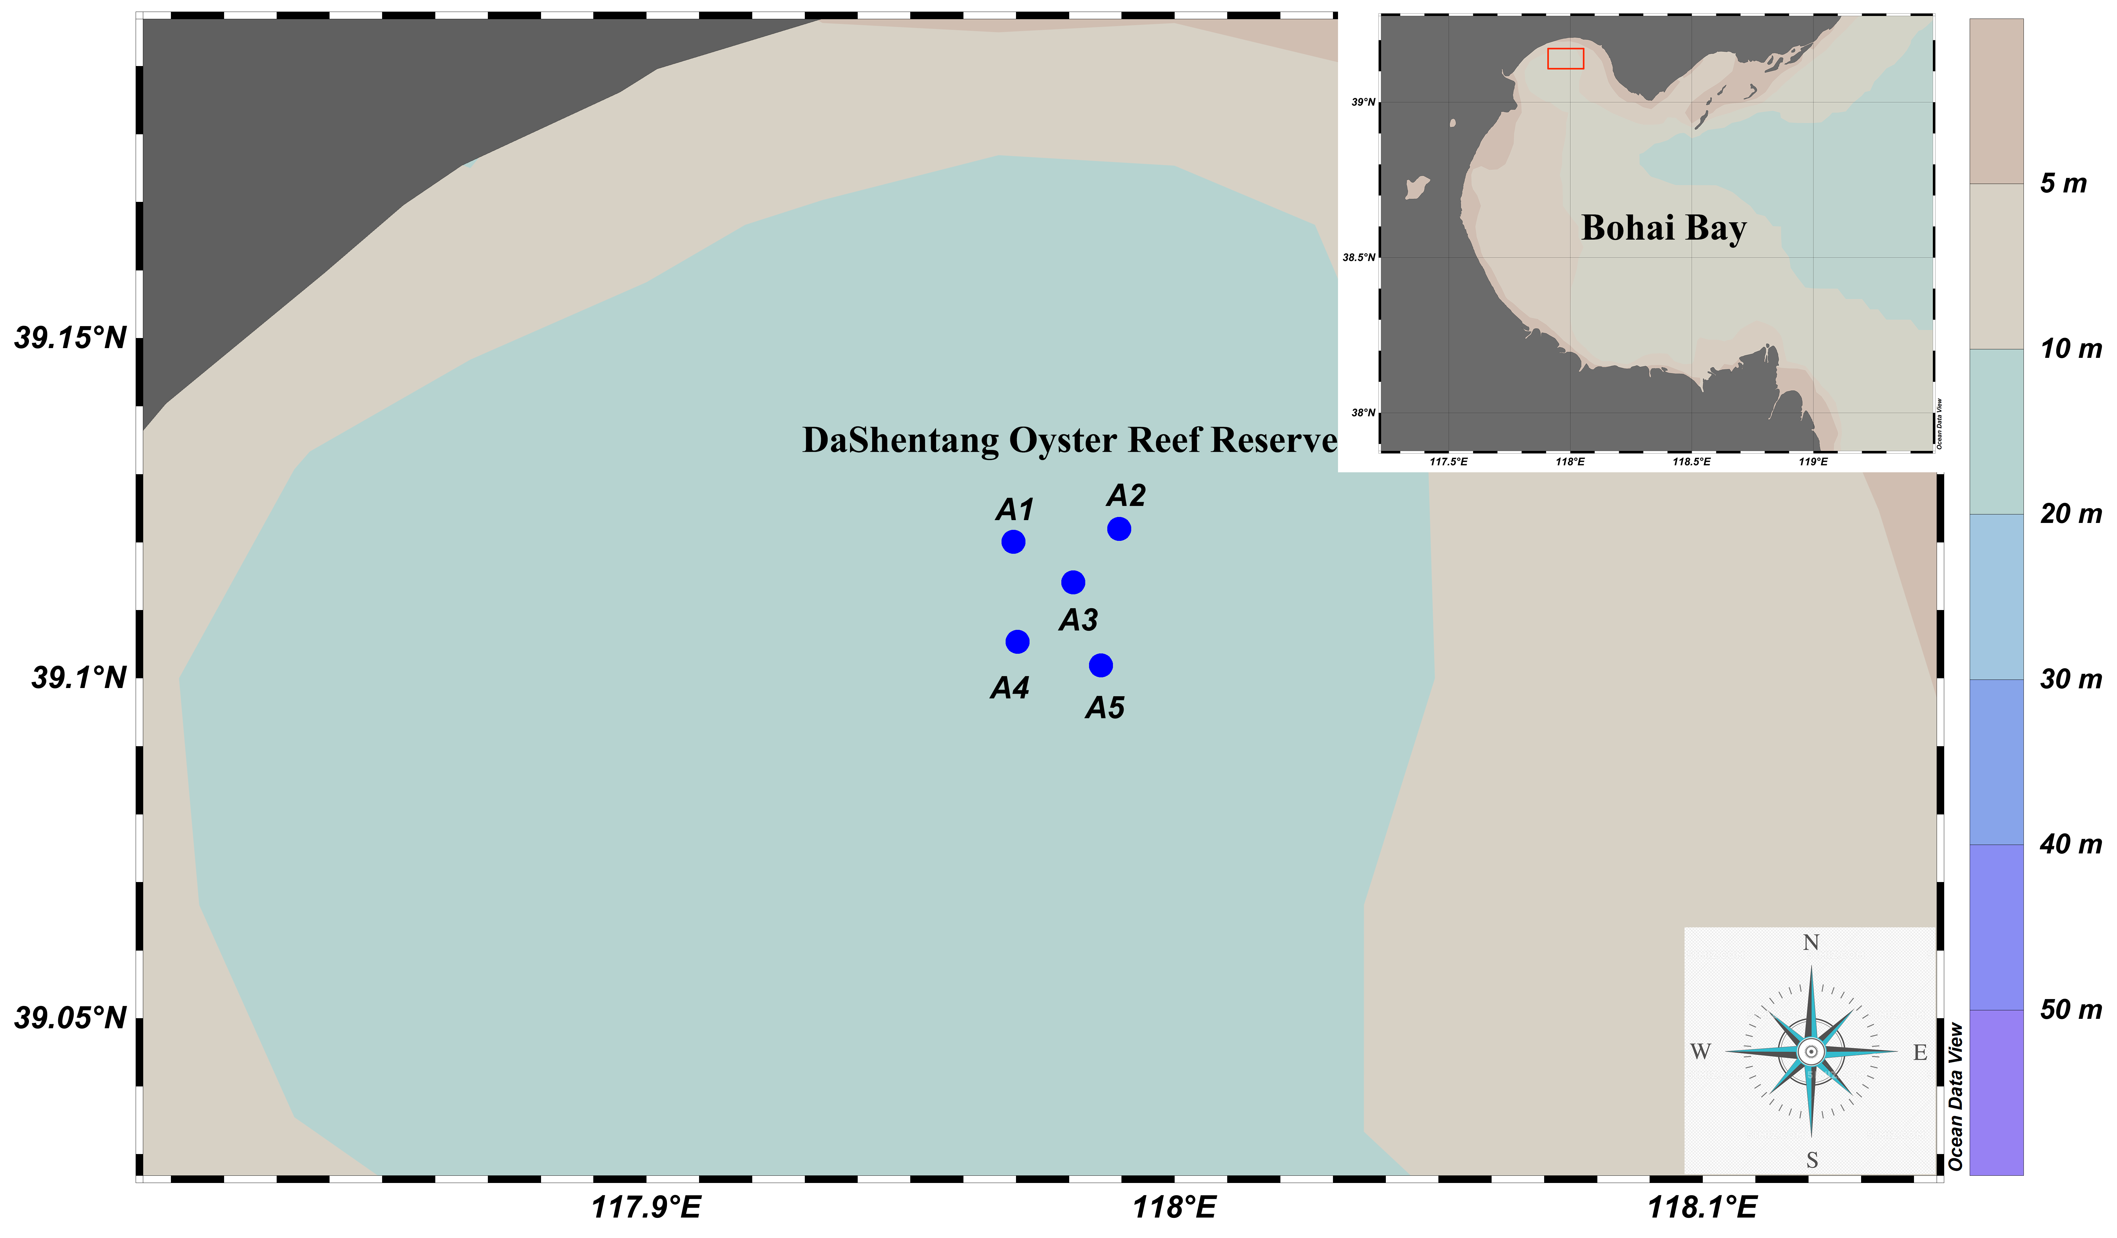
Figure S2. Sampling sites for collecting the oysters from DaShentang Reserve (39.17824°N, 117.96467°E) on Bohai Bay, northern China. Red rectangle represents DaShentang oyster reef reserve. The darker colors in the right column indicate greater depth.
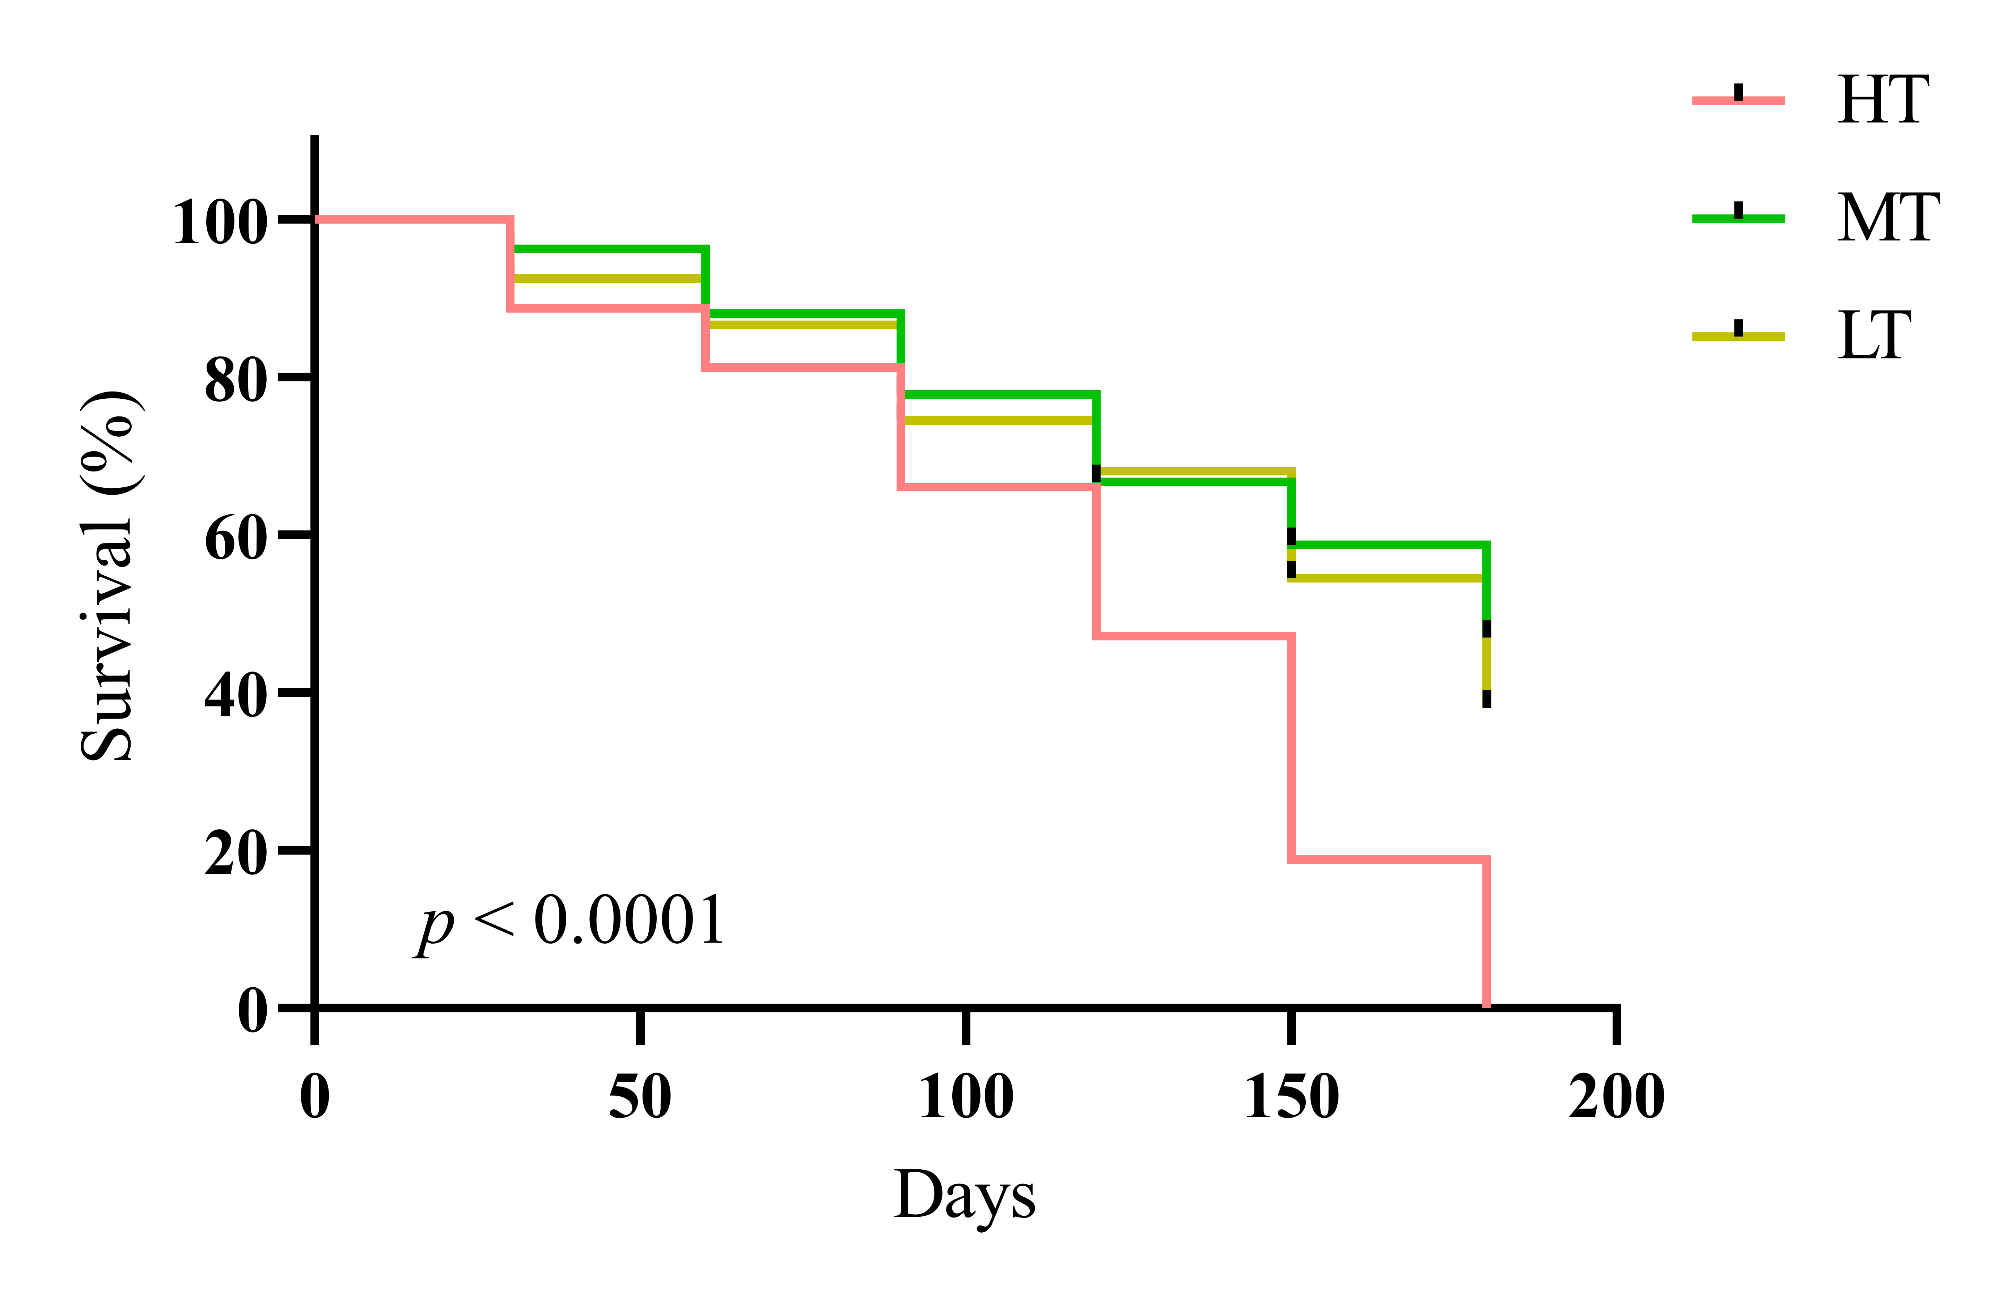
Figure S3. The survival of oyster under high (HT), middle (MT), and low (LT) tidal levels during experimental period.

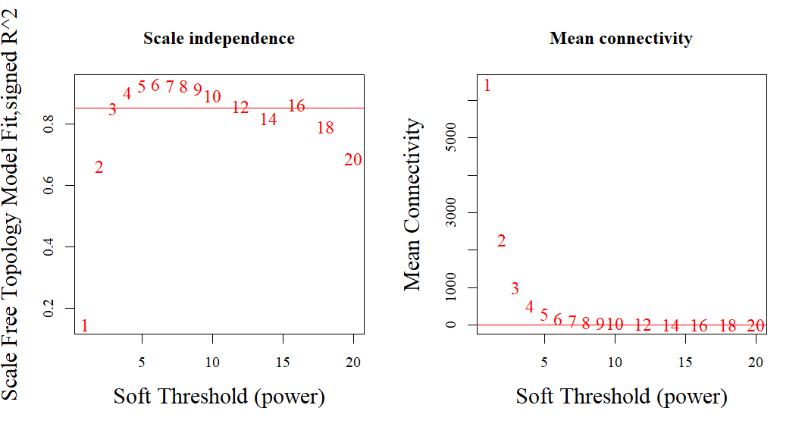Figure S4. The analysis of network topology for various soft thresholding. As illustrated in the left panel, the scale-free topology model fit is demonstrated as a function of the soft-thresholding. The right panel provides a visual representation of the mean connectivity as a function of the soft thresholding.
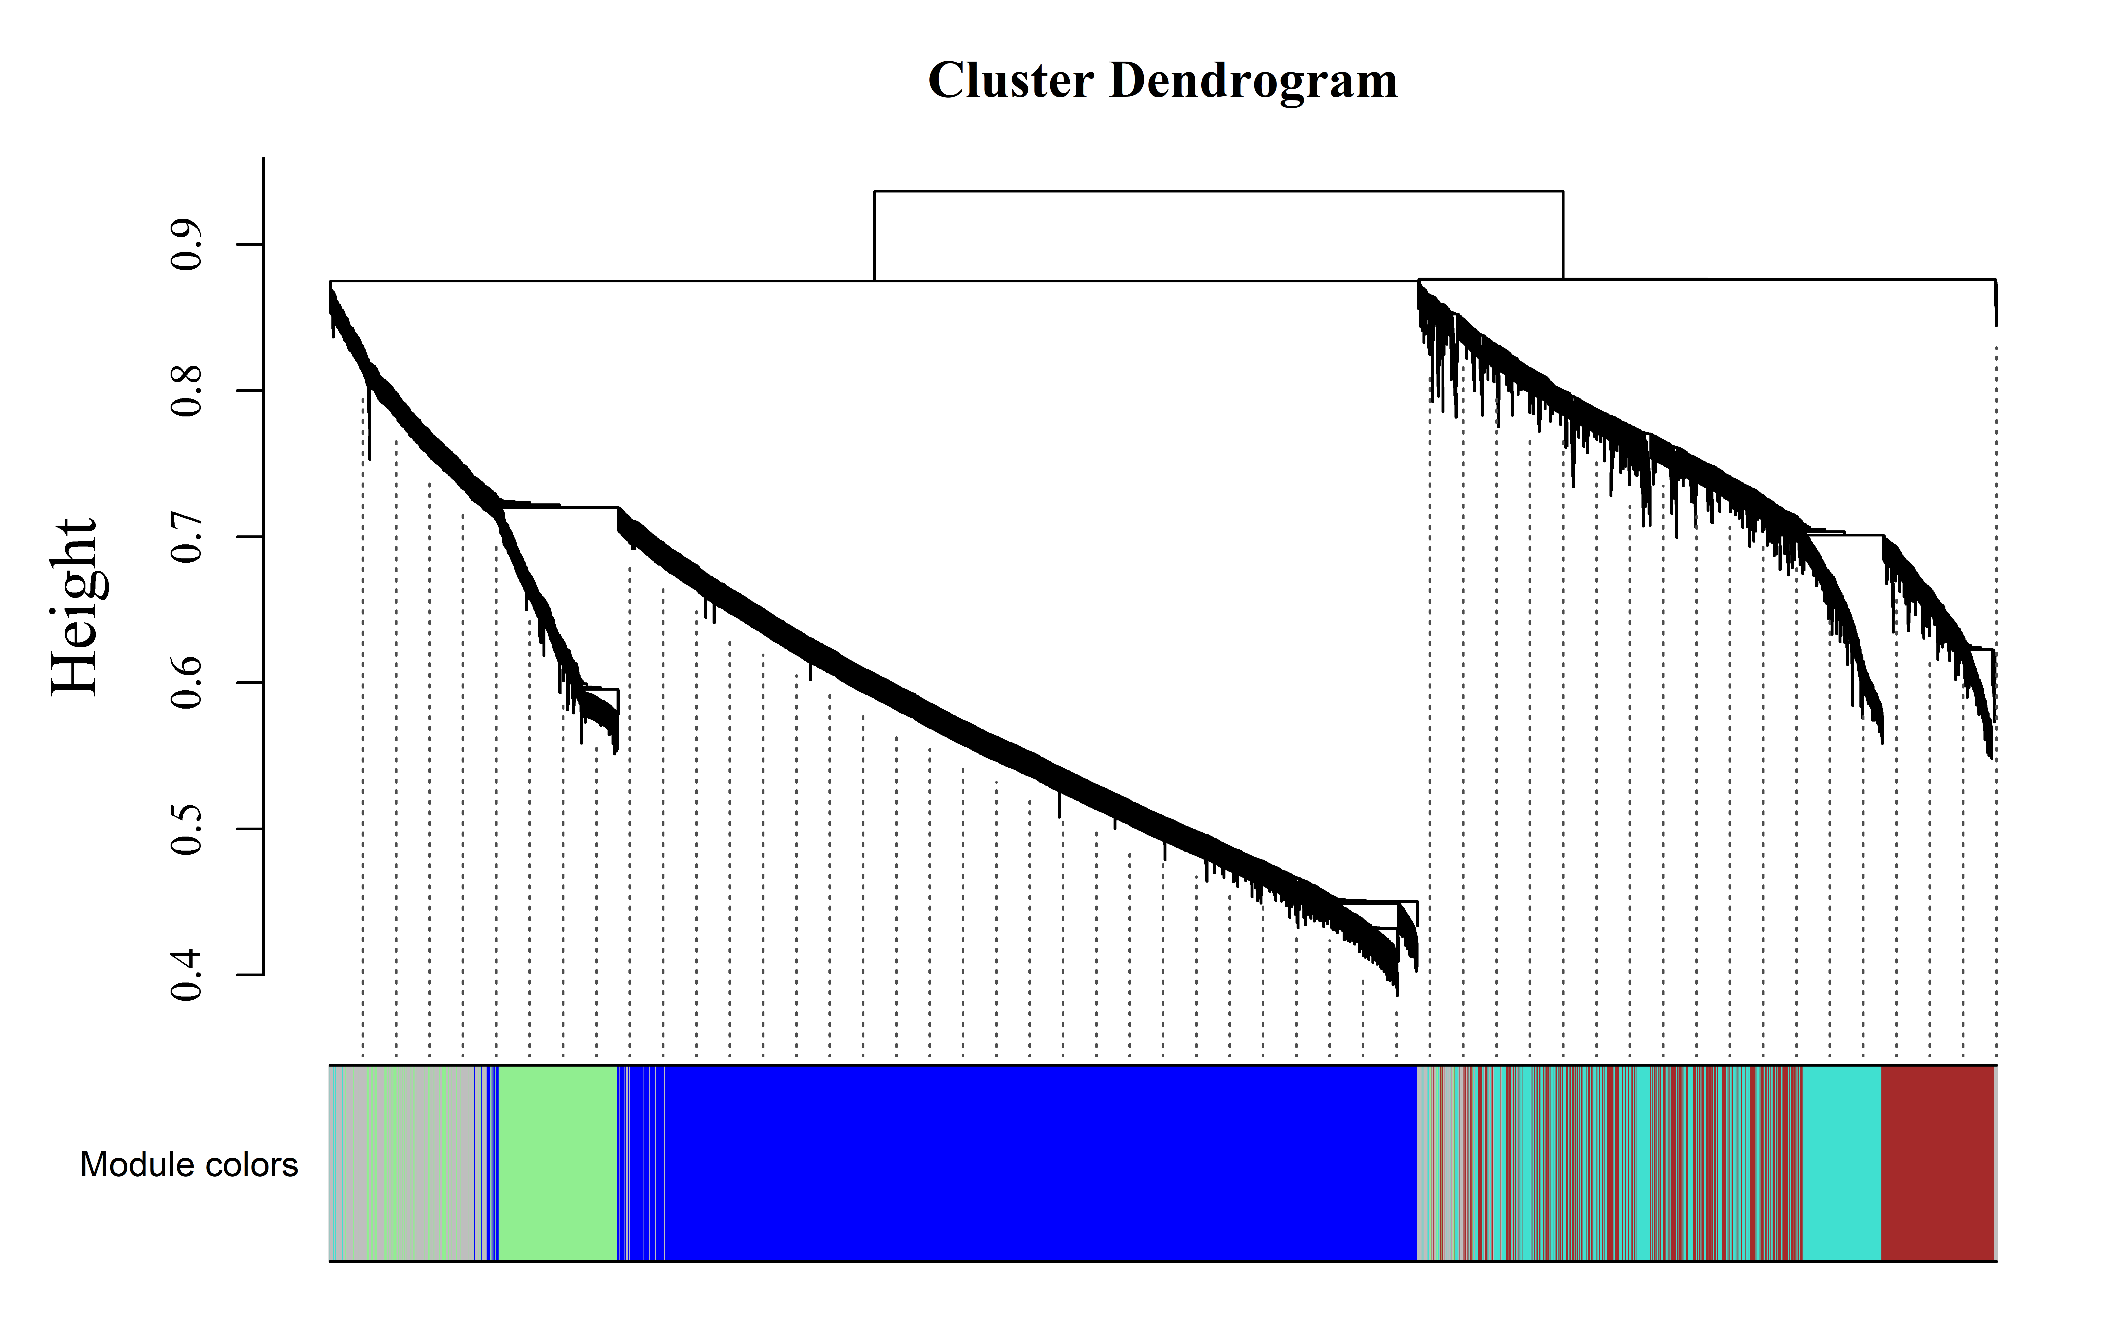
Figure S5. Dendrogram, created through dissimilarity clustering, displays various modules in different colors.
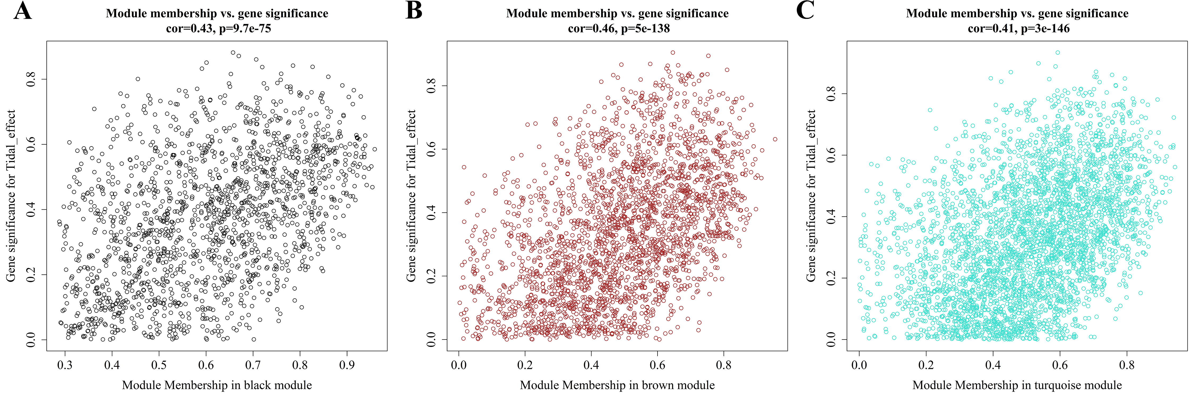
Figure S6. Scatter plots depicting gene significance and module membership in the (A) black, (B) brown, and (C) turquoise modules. One dot represents one gene. Cro: correlation.
Figure S7. Insert size histogram of all reads from samples at (A, B and C) high and (D, E and F) low tidal levels.
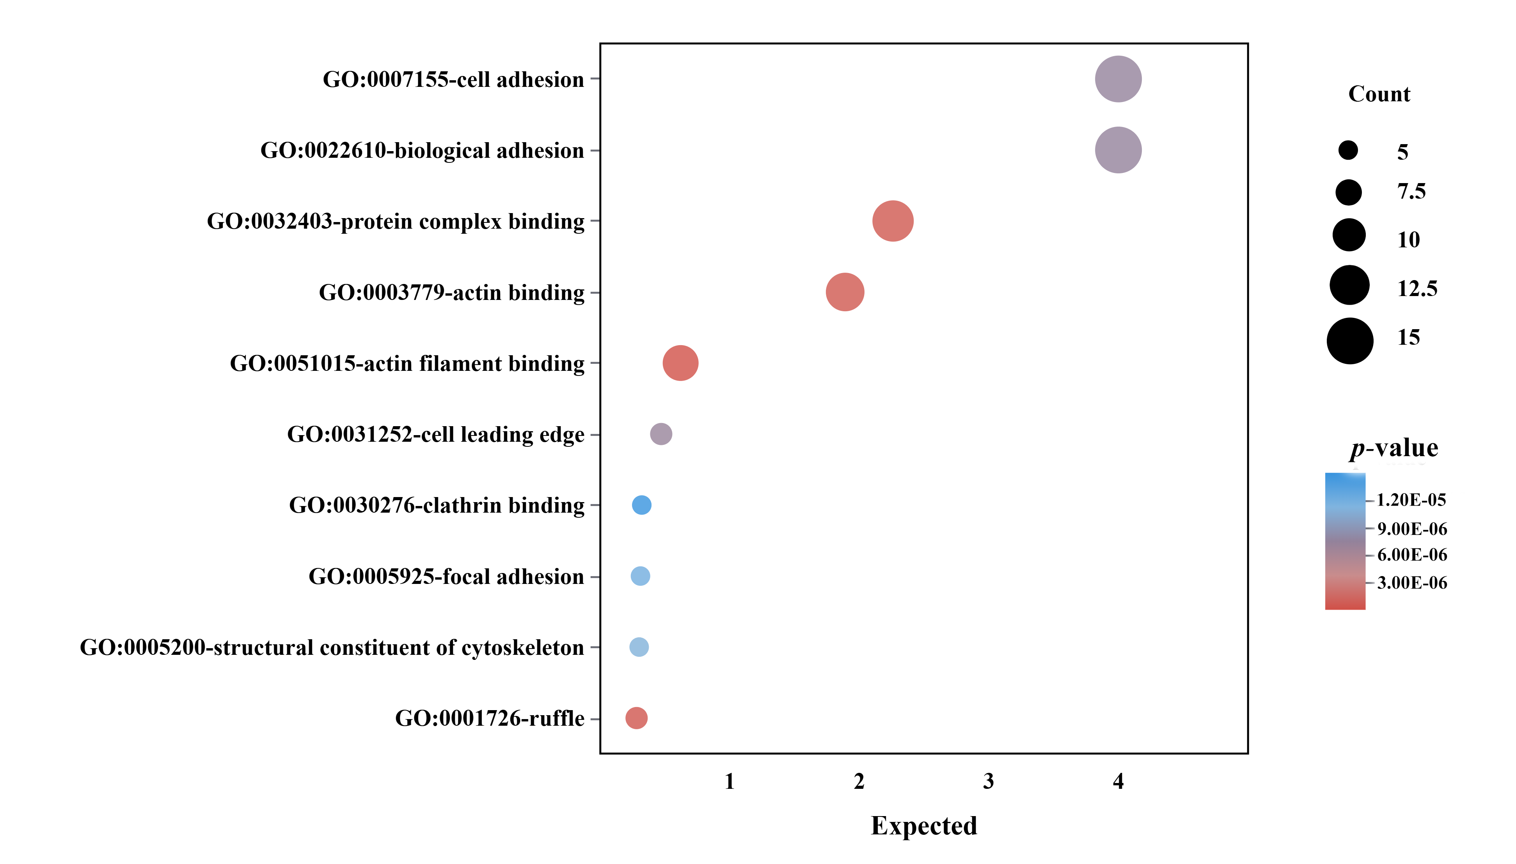
Figure S8. Functional enrichment analysis of genes associated with differentially accessible chromatin peaks. Color corresponds to p-value. Size represents for genes counts.

Figure S9. Relative expression levels of BORIS and MYB73 in RNAi experiments. Relative expression levels of the (A) BORIS and (B) MYB73 in mantle tissues of oysters injected with siRNA “BORIS-2071” and “MYB73-246” at 12h, 24h, 48h, and 72h. Relative expression levels of (C) BORIS and (D) MYB73 in the formal experiments when injected with siRNA or NC strands at 24h. The values with different letters are representative of significant differences. Error bars indicate standard deviation. * p < 0.05, *** p < 0.001. NC: negative control.

Figure S10. The survival of oyster during heat-lethal experiments following (A) BORIS-2071 and (B) MYB73-246 -siRNA interference, respectively. The curves in different colors represent the survival rate changes of oysters injected with NC or siRNA under 37 ℃, respectively. * p < 0.05, ** p < 0.01. NC: negative control.

Figure S11. Seawater temperature, oxygen, pH and salinity in the DaShentang Reserve. The values with different letters are representative of significant differences. Error bars indicate standard deviation.

