Supplementary Materials for

Evapotranspiration Changes Driven by Soil Moisture are Misrepresented in Climate Models

Hsin Hsu^{1*}, Kirsten Findell^{2*}, Paul A. Dirmeyer³, Min-Hui Lo^{4,5}, Andrew Feldman^{6,7}, Sha Zhou⁸, Eunkyo Seo⁹, Diego G. Miralles¹⁰, Stephan Fueglistaler¹

¹Atmospheric and Oceanic Sciences, Princeton University, USA.
²Geophysical Fluid Dynamics Laboratory/NOAA, USA.
³Center for Ocean-Land-Atmosphere Studies, George Mason University, USA.
⁴Department of Atmospheric Sciences, National Taiwan University, Taiwan.
⁵International Degree Program in Climate Change and Sustainable Development, National Taiwan University, Taiwan.
⁶Biospheric Sciences Laboratory, NASA Goddard Space Flight Center, USA.
⁷Earth System Science Interdisciplinary Center, University of Maryland, USA.
⁸State Key Laboratory of Earth Surface Processes and Resource Ecology, Beijing Normal University, China.
⁹Department of Environmental Atmospheric Sciences, Pukyong National University, South Korea.
¹⁰Hydro-Climate Extremes Lab (H-CEL), Ghent University, Belgium.

*Corresponding authors: hh9736@princeton.edu, kirsten.findell@noaa.gov

The file includes:

Figs. S1 to S12

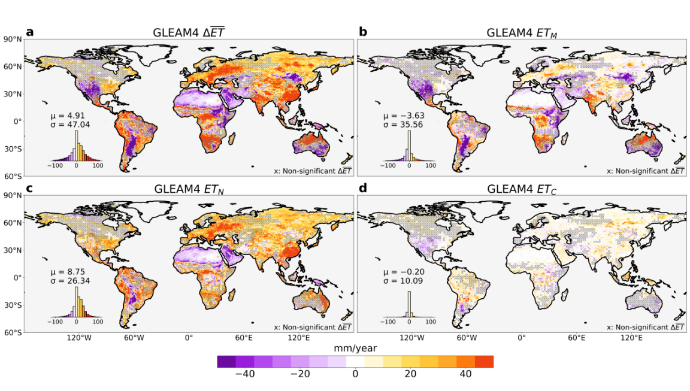Figure S1. (a) Total change in evapotranspiration $∆\overline{ET}$ contributed by the (b) moisture pathway ET_{M}, (c) non-moisture pathway ET_{N}, and (d) combined pathway ET_{C}, calculated as the annual mean for 2000–2014 minus 1985–1999, in GLEAM4. The subset displays the area-weighted density distribution of each quantity. The hatching in all panels indicates that $∆$ET is not statistically significant at the 95% level, based on a Monte Carlo technique performed at each grid cell by permuting the time series of annual-mean ET 1000 times.

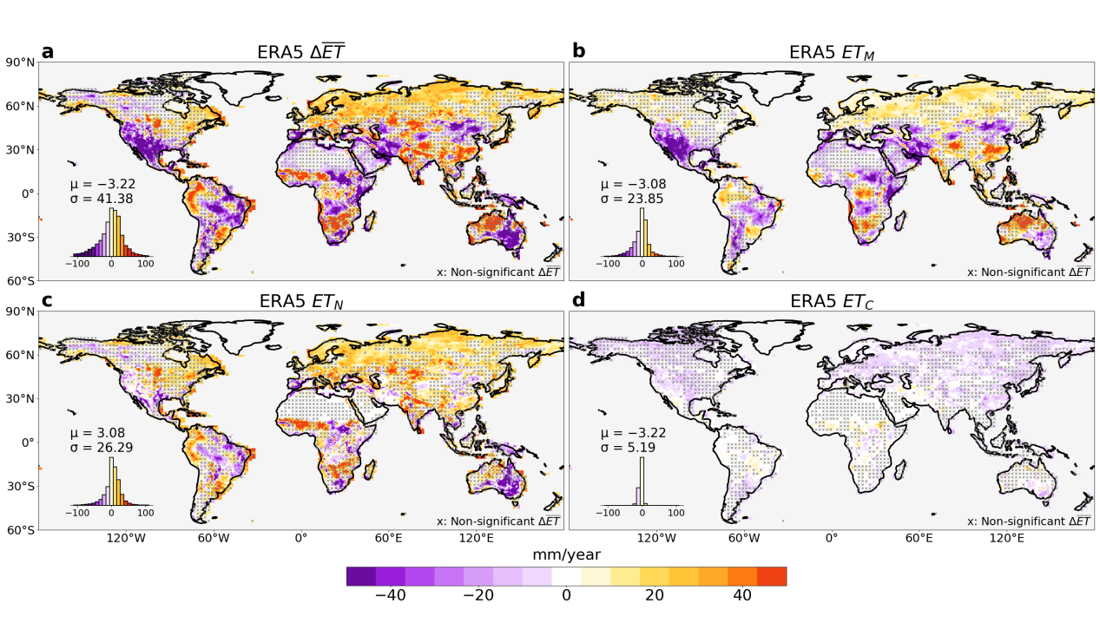
Figure S2. Same as Figure S1 but for ERA5.
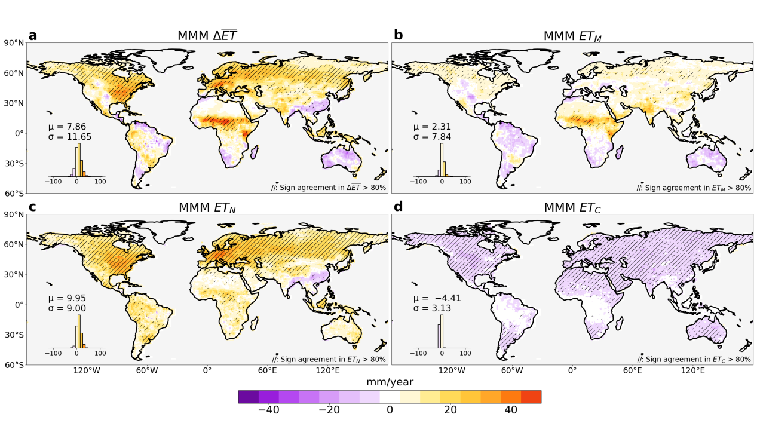
Figure S3. Multi-model median (MMM) of (a) total change in evapotranspiration $∆\overline{ET}$contributed by the (b) moisture pathway ET_{M}, (c) non-moisture pathway ET_{N}, and (d) combined pathway ET_{C}, calculated as the annual mean for 2000–2014 minus 1985–1999. Hatching in each panel indicates regions where models agree on the sign of change for the corresponding quantity. Following the IPCC AR6 robustness criterion, high consensus is defined as at least 80% of models (11 out of 14) agreeing on the sign of change.
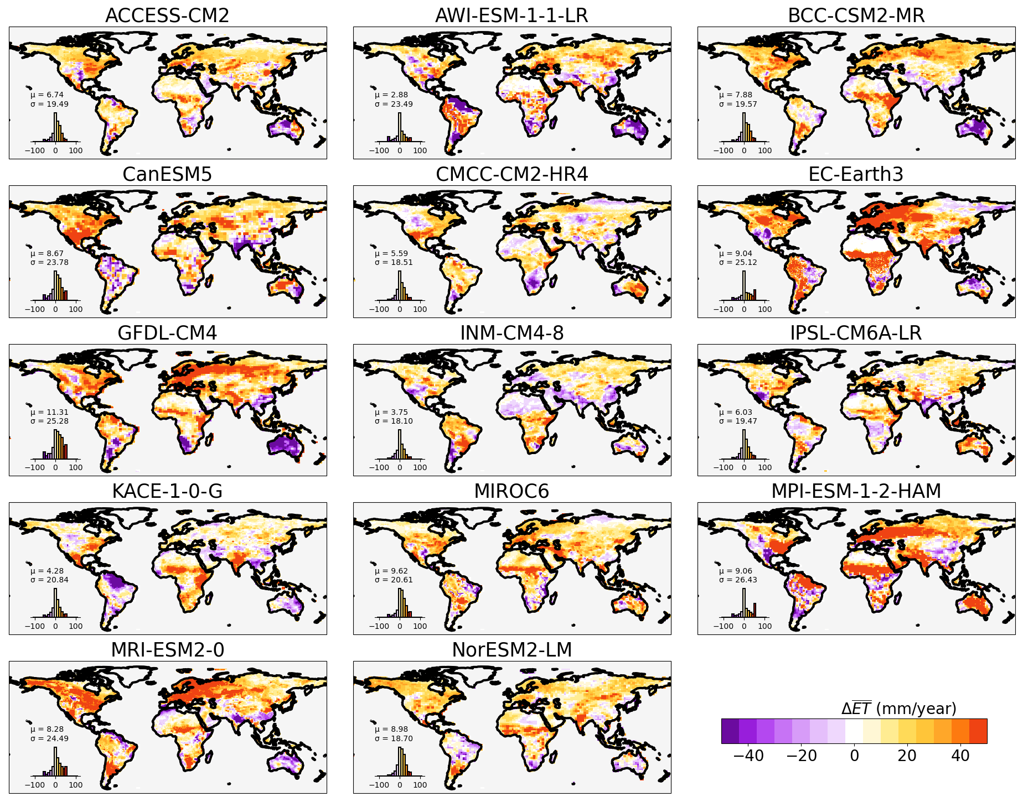
Figure S4. Total change in annual-mean ET ($∆\overline{ET}$; mm/year) in each climate model used in our analysis.

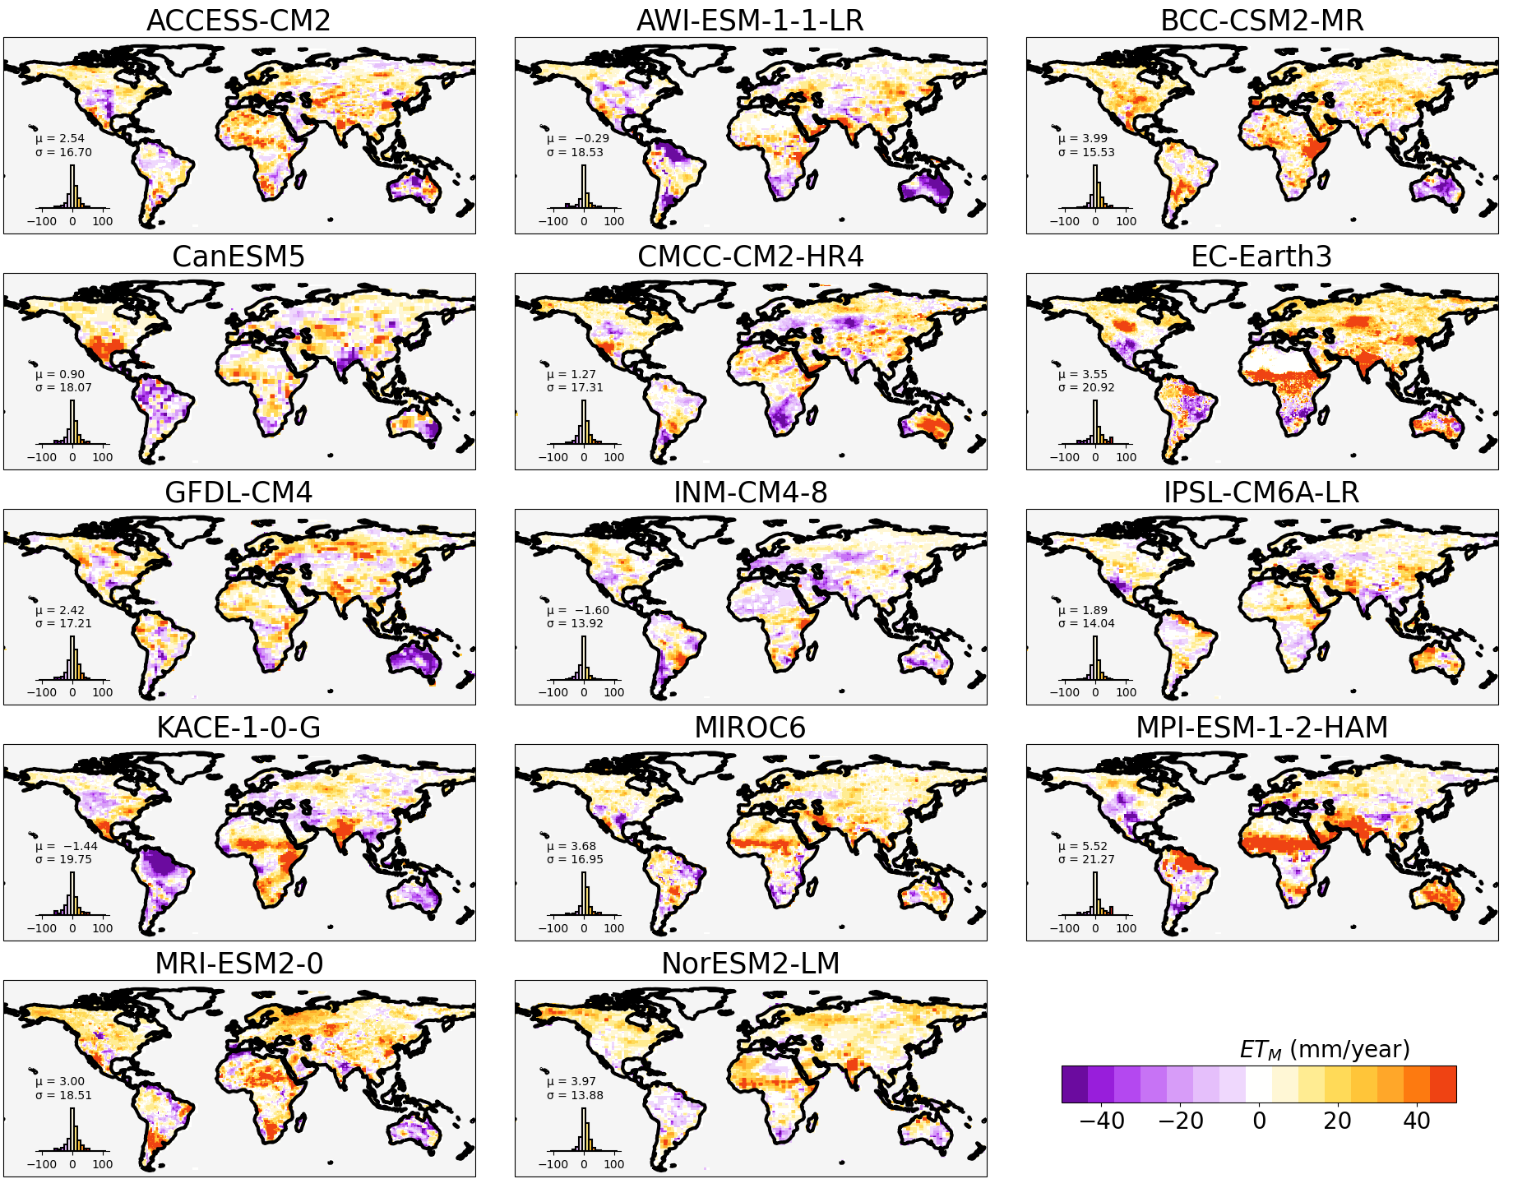
Figure S5. Change in $∆\overline{ET}$ due to the moisture pathway ET_{M} in each climate model used in our analysis.

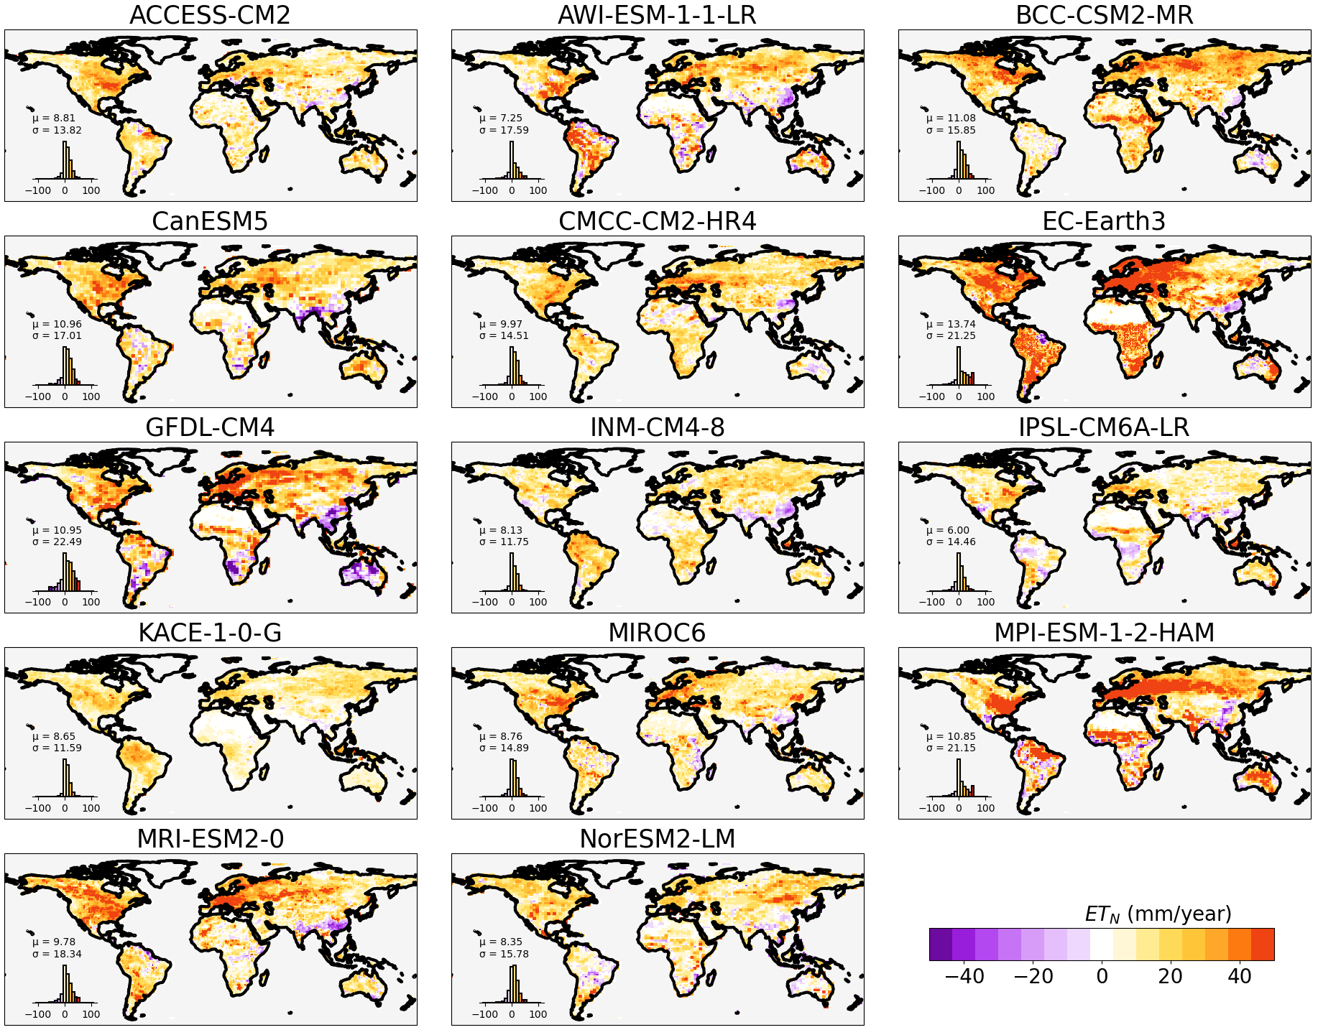
Figure S6. Change in $∆\overline{ET}$ due to the non-moisture pathway ET_{N} in each climate model used in our analysis.

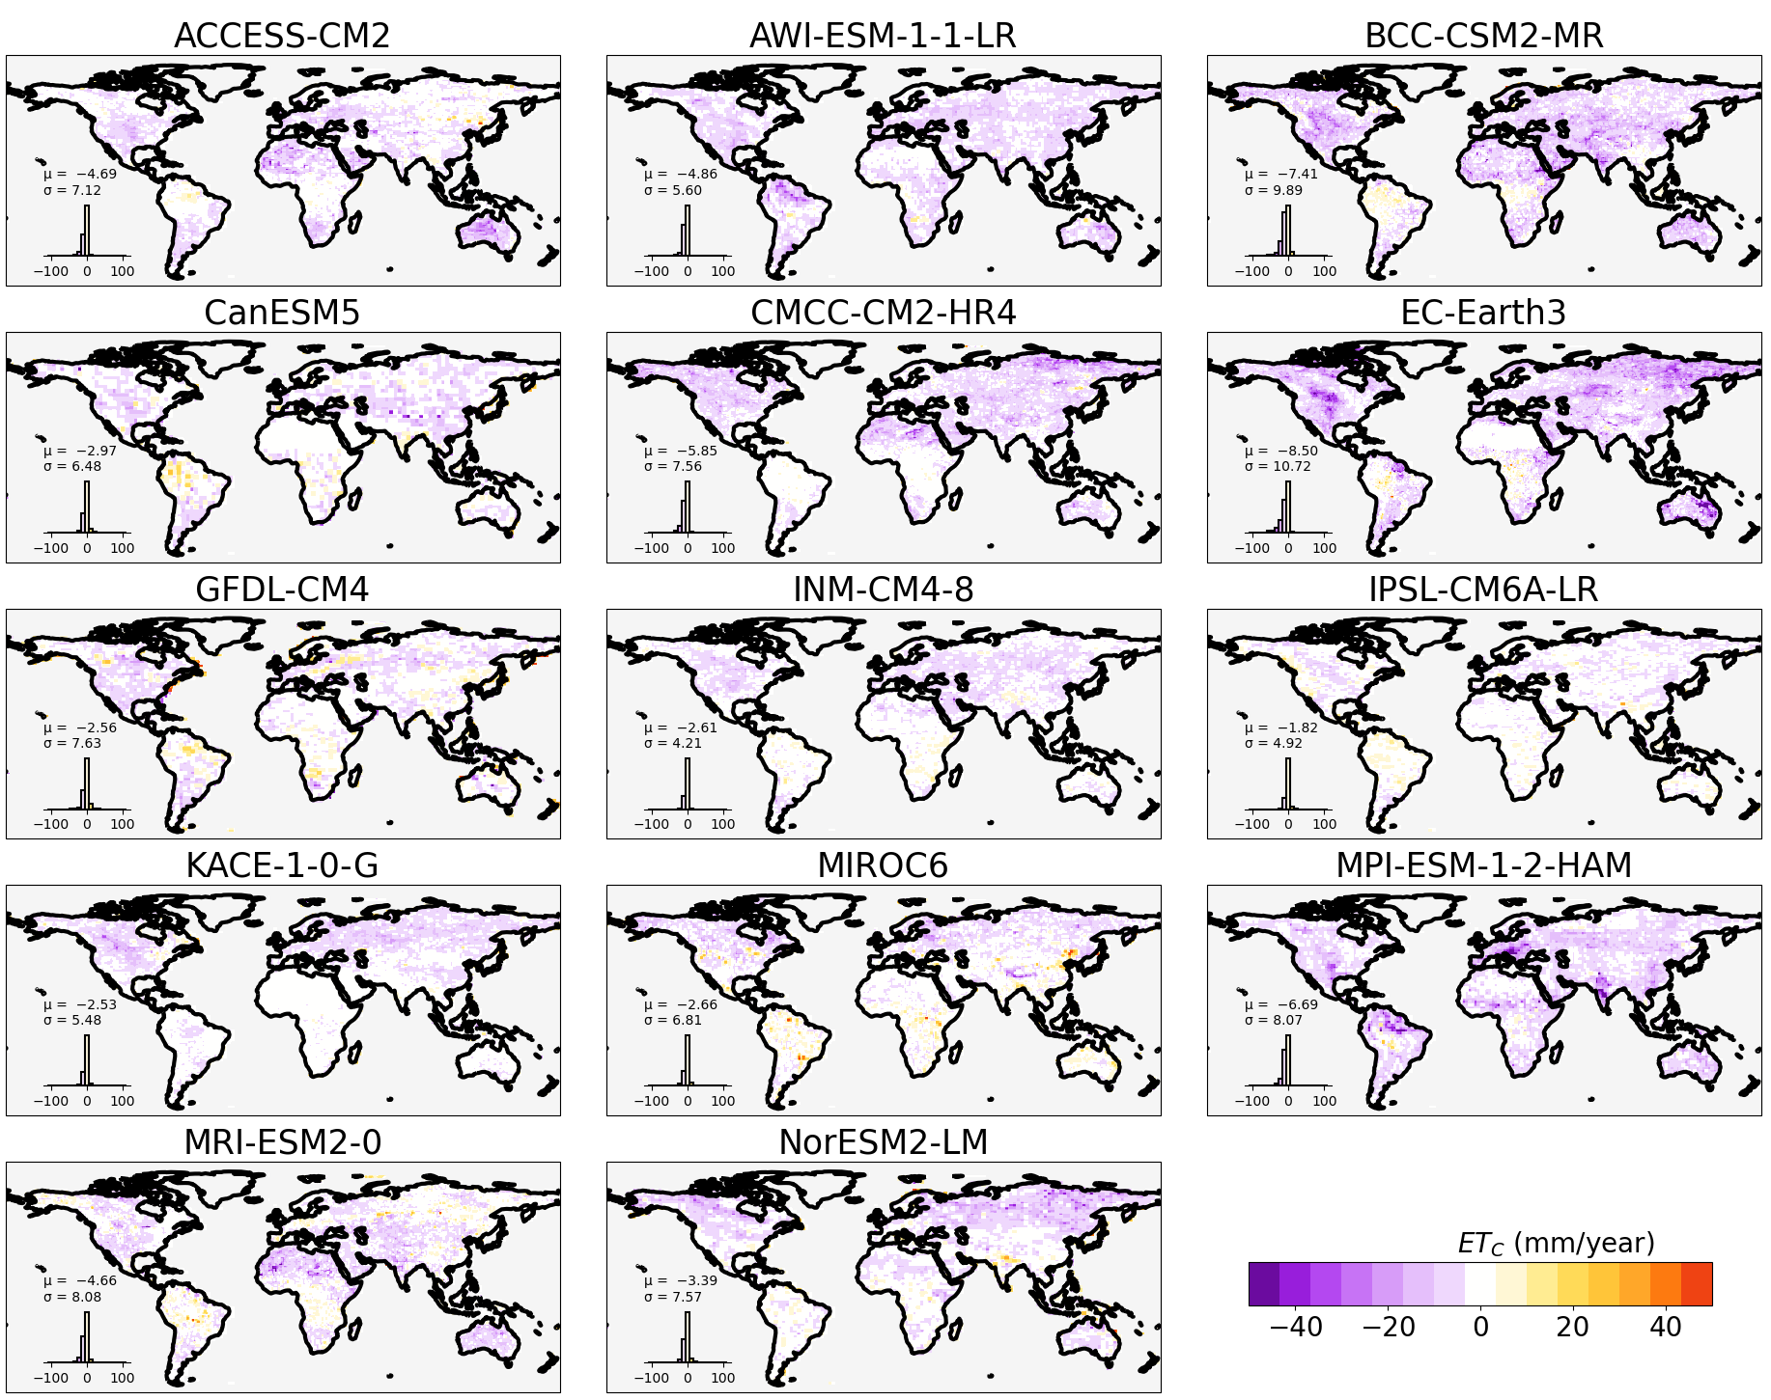
Figure S7. Change in $∆\overline{ET}$ due to the combined pathway ET_{C} in each climate model used in our analysis.

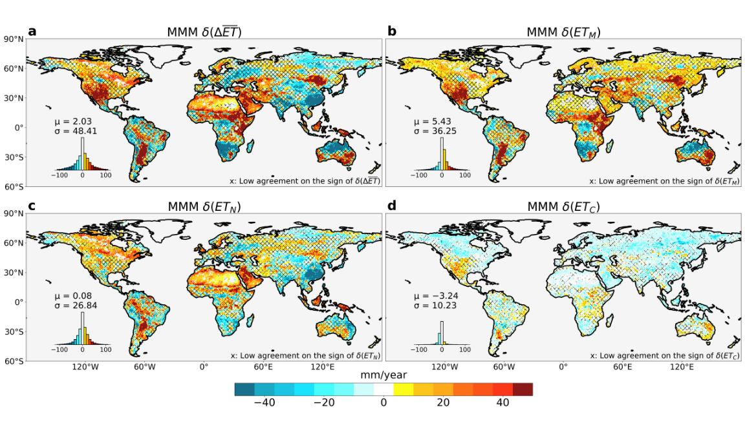
Figure S8. MMM deviation of ET change and its contributing pathways from 14 CMIP6 historical simulations using GELAM4 results as the reference. (a) MMM deviation in total change in evapotranspiration δ($∆\overline{ET}$) decomposed as (b) deviation in moisture pathway δ(ET_{M}), (c) deviation in non-moisture pathway δ(ET_{N}), and (d) deviation in combined pathway δ(ET_{C}). Hatching in each panel indicates regions where models disagree on the sign of change for the corresponding quantity. Following the IPCC AR6 robustness criterion, high consensus is defined as at least 80% of models (11 out of 14) agreeing on the sign of change.

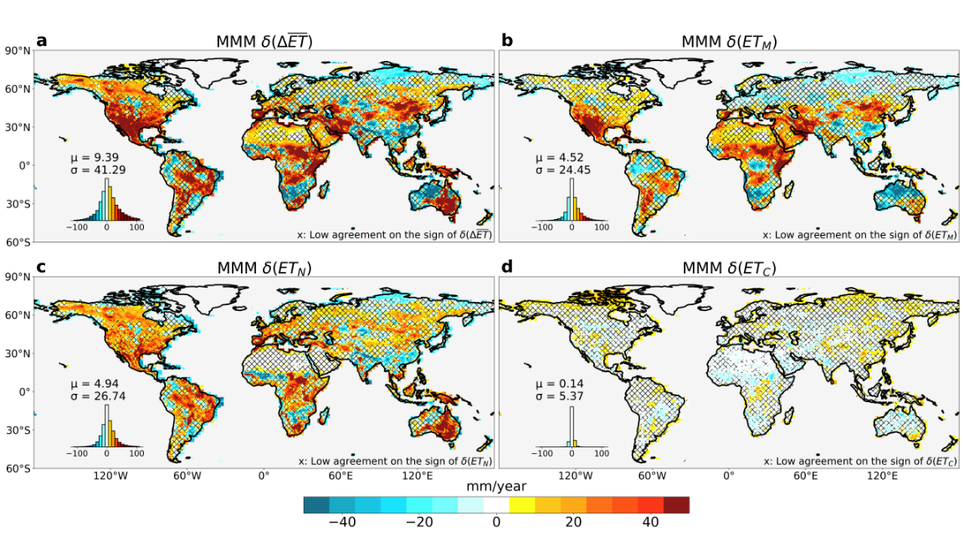
Figure S9. Same as Figure S8 but using ERA5 as the reference.
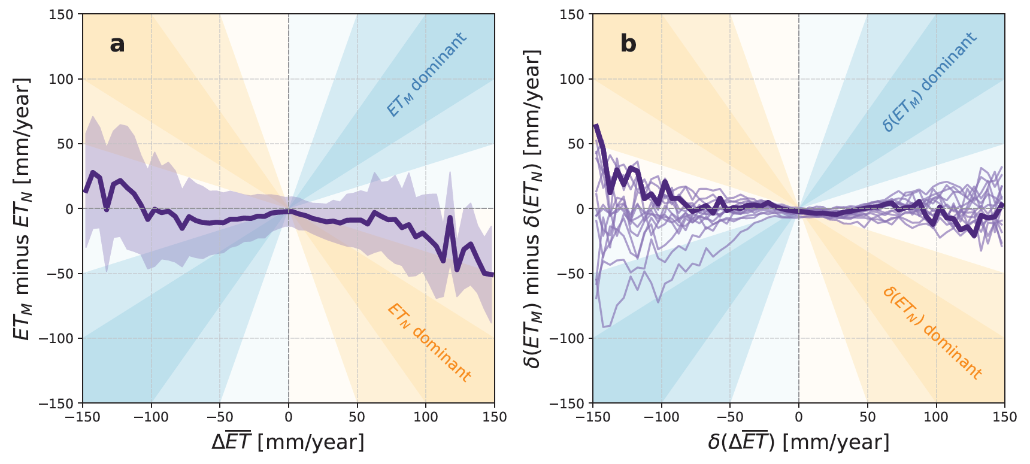Figure S10. (a) Relative importance of the moisture pathway ET_{M} and non-moisture pathway ET_{N}, quantified as the difference (ET_{M} minus ET_{N}) as a function of ET change $∆\overline{ET}$, based on ERA5. The bold line shows the mean difference within each 5 mm/year $∆\overline{ET}$ bin, and the purple area represents the corresponding ±1 standard deviation. Blue zones indicate the conditions where $∆\overline{ET}$ is primarily dominated by ET_{M}, while orange zones indicate the conditions where $∆\overline{ET}$ is primarily dominated by ET_{N} (the dark color indicates a stronger dominance of the pathway). Results over Greenland and Antarctica are excluded from the calculation. (b) Same as (a), but for CMIP6 model deviations relative to GLEAM4 The bold line reflects the spatial pattern based on the multi-model median (MMM), while thin lines show results from individual models.

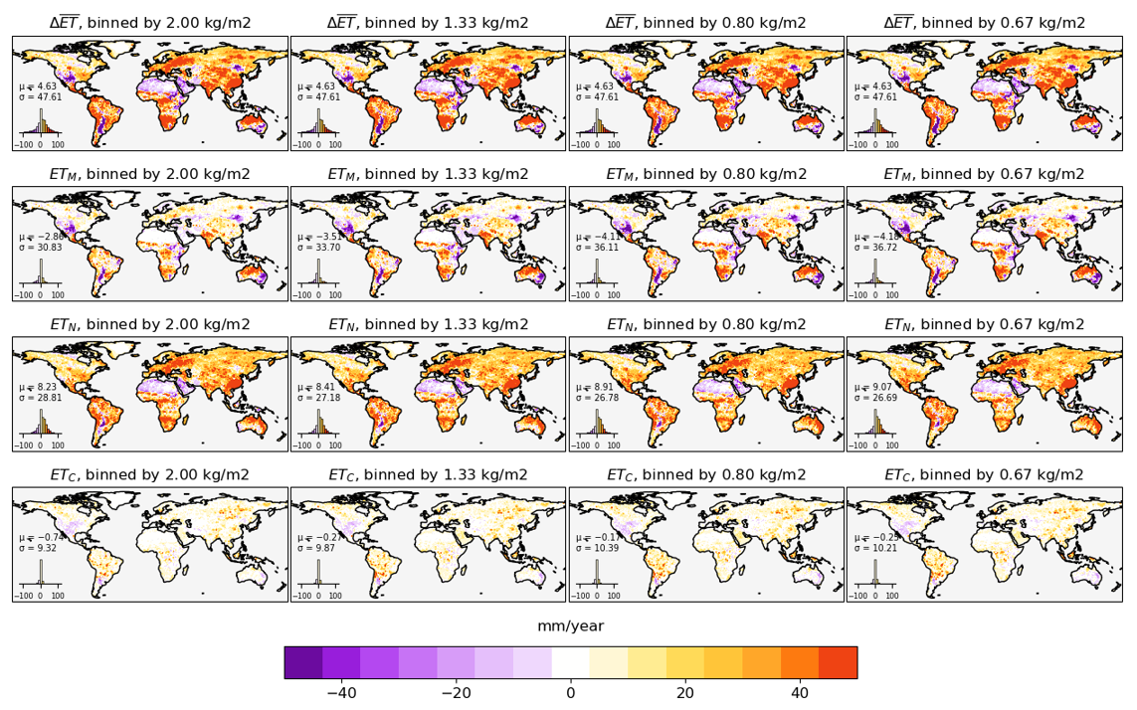
Figure S11. Sensitivity test using different bin sizes to perform Segmented Soil Moisture-Evapotranspiration Method on GLEAM4 (2000–2014 minus 1985–1999).

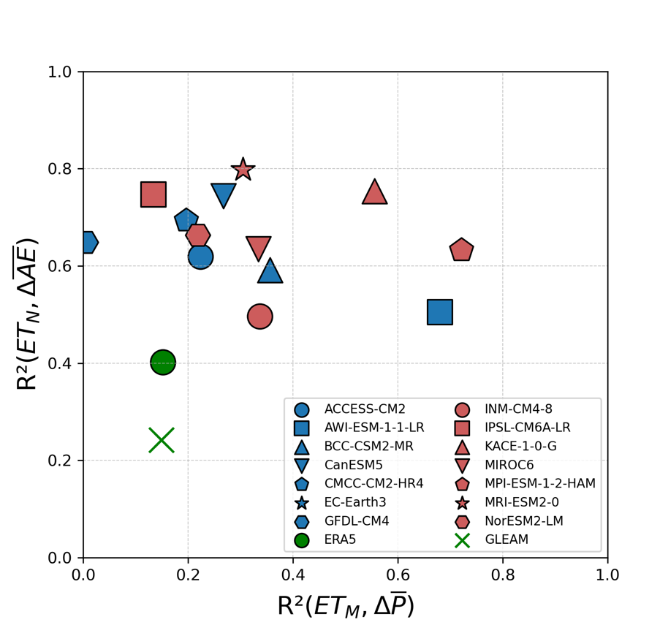
Figure S12. Spatial correlation between the moisture pathway (ET_{M}) and the change in precipitation (P) (x-axis), and between the non-moisture pathway (ET_{N}) and the change in available energy (AE) (y-axis), for each data product used in this study. Changes in each variable are calculated as the difference between the 15-year periods 2000–2015 and 1985–1999.

