Supplementary B
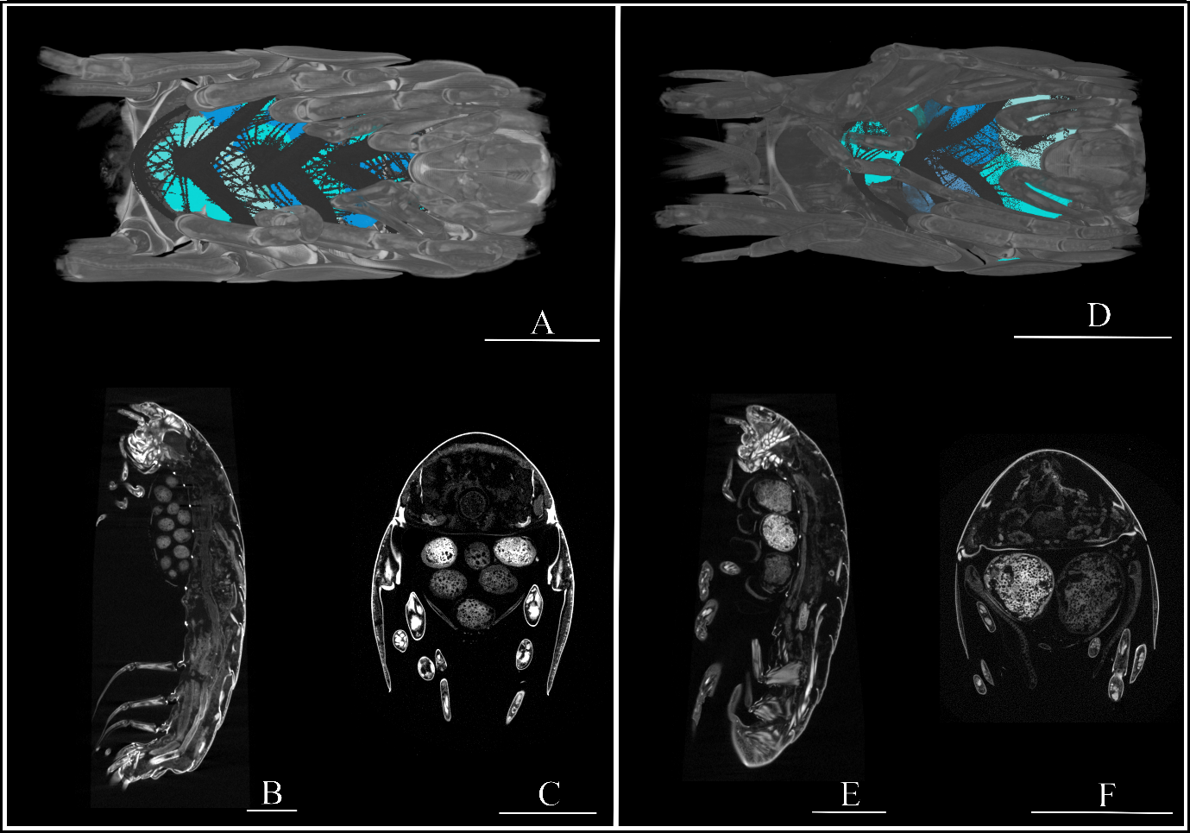
Figure S1. 3D reconstructions and slices of the brood pouches of Profundum solomoni gen. nov. sp. nov. and Galathella ovaimmensus sp. nov. A) 3D reconstruction of the brood pouch of Profundum solomoni gen. nov. sp. nov. with oostegites highlighted in grey B) Sagittal slice of Profundum solomoni gen. nov. sp. nov. C) Transverse slice of Profundum solomoni gen. nov. sp. nov. D) 3D reconstruction of the brood pouch of Galathella ovaimmensus sp. nov. with oostegites highlighted in grey E) Sagittal slice Galathella ovaimmensus sp. nov. F) Transverse slice of Galathella ovaimmensus sp. nov. Scale bars represent 2 mm.

Supplementary oxygen data
There were no oxygen measurements taken during the cruises where the samples were collected. Therefore, publicly available data from the CCHDO (CLIVAR and Carbon Hydrographic Data Office) were accessed to provide reasonable measurements of bottom oxygen concentrations within the two regions. These measurements reach a maximum of 5000 m, however given the large difference in oxygen concentration between the two areas and the shape of the profiles, and the rate of change in oxygen to the seafloor, our deduction is reasonable. The data presented below is directly obtained from the referenced data sources therefore any discrepancies are data-specific.

For the South Sandwich Trench region, the most recent dataset from the GO-SHIP (Global Ocean Ship-Based Hydrographic Investigations Programme) repeat section of A23 in 2021 was used with 16 profiles within the latitudinal bounds of 68° S to 55° S and longitudinal bounds of 35° W to 25° W (Figure S1).
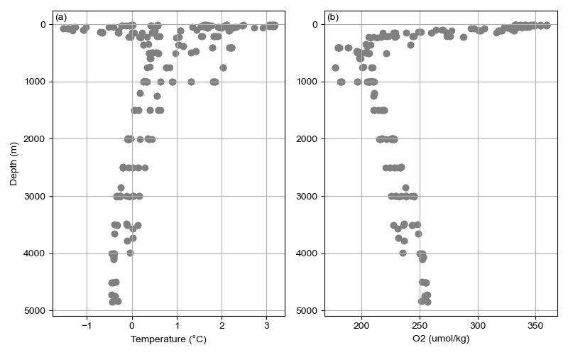
Figure S2. A) Temperature (°C) and B) Oxygen concentration (mmol/kg) over depth for CTD profiles and bottle samples collected on the JC21 cruise (BAS 2024).

For the Solomon Islands, Santa Cruz and San Cristobal region, the most recent dataset collected in the region was on cruise RF18.06 in 2018 by the Japanese Meteorological Agency (JMA 2024). This overlaps the original GO-SHIP P13 section. There were 7 profiles within the latitudinal bounds of 0° to 20° S and longitudinal bounds of 150° E to 170° E (Figure S2).

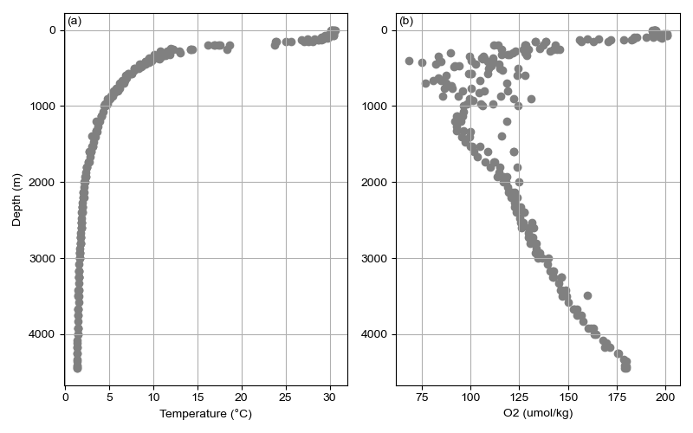

Figure S3. A) Temperature (°C) and B) Oxygen concentration (mmol/kg) over depth for CTD profiles and bottle samples collected on the JC21 cruise (JMA 2024).

References

Japanese Meteorological Agency. 2024. CTD and bottle data from cruise RF18.06 in 2018, 49UP20180614. Accessed from CCHDO https://cchdo.ucsd.edu/cruise/49UP20180806. Access date 12 June 2024. UC San Diego Library Digital Collections.

British Antarctic Survey. 2024. CTD and bottle data from cruise JC21 in 2021, 740H20210202. Accessed from CCHDO https://cchdo.ucsd.edu/cruise/740H20210202. Access date 12 June 2024. UC San Diego Library Digital Collections.

